CAREERCONNECT – A SMART JOB AND INTERNSHIP PORTAL
A PROJECT REPORT
Submitted by
<<Candidate Name 1>> (<<UID-1>>)
<<Candidate Name 2>> (<<UID-2>>)
in partial fulfillment for the award of the degree of
BACHELOR OF ENGINEERING
IN
COMPUTER SCIENCE AND ENGINEERING

Chandigarh University
OCTOBER 2026

BONAFIDE CERTIFICATE
Certified that this project report "CAREERCONNECT – A SMART JOB AND INTERNSHIP PORTAL" is the bonafide work of "<<Candidate Name 1>> (<<UID-1>>), <<Candidate Name 2>> (<<UID-2>>)" who carried out the project work under my/our supervision.
<<Signature of the HoD>> | <<Signature of the Supervisor>>
SIGNATURE | SIGNATURE
<<Name of the Head of the Department>> | <<Name of the Supervisor>>
HEAD OF THE DEPARTMENT | SUPERVISOR
Department of Computer Science & Engineering | <<Academic Designation>>  Department of Computer Science & Engineering
Submitted for the project viva-voce examination held on ____________________
INTERNAL EXAMINER | EXTERNAL EXAMINER

ACKNOWLEDGEMENT
We express our deepest sense of gratitude and profound respect to our project supervisor, <<Supervisor Name>>, <<Academic Designation>>, Department of Computer Science and Engineering, Chandigarh University, for the invaluable guidance, constructive critiques, technical insights, and continuous encouragement provided throughout the conceptualization, architectural design, implementation, and empirical validation of the CareerConnect platform.
We are sincerely grateful to <<Head of Department Name>>, Head of the Department of Computer Science and Engineering, for granting us access to the necessary departmental laboratory computing infrastructure and providing an academically enriching environment that fostered rigorous software development practices.
Our sincere thanks are also extended to the esteemed faculty members and laboratory staff of the Computer Science and Engineering Department, whose critical evaluations during progress reviews helped refine our architectural choices, data integrity constraints, and testing methodologies.
Finally, we extend our heartfelt appreciation to our families and fellow peers for their unwavering moral support, patience, and understanding during the intensive phases of development, integration testing, and documentation.
<<Candidate Name 1>> (<<UID-1>>)
<<Candidate Name 2>> (<<UID-2>>)
Department of Computer Science & Engineering
Chandigarh University

TABLE OF CONTENTS
Item | Title / Chapter Description | Page
 | List of Figures | i
 | List of Tables | ii
 | Abstract | iii
 | Graphical Abstract | iv
 | Abbreviations | v
 | Symbols and Nomenclature | vi
Chapter 1 | Introduction | 1
1.1 | Client/Need Identification and Relevant Contemporary Issues | 1
1.2 | Identification of Problem | 3
1.3 | Identification of Tasks | 4
1.4 | Project Timeline (Gantt Chart) | 5
1.5 | Organization of the Report | 6
Chapter 2 | Design Flow / Process | 7
2.1 | Evaluation and Selection of Specifications / Features | 7
2.2 | Design Constraints (Regulations, Economic, Environmental, Safety, Ethical) | 9
2.3 | Analysis and Feature Finalization Subject to Constraints | 11
2.4 | Design Flow (Alternative System Designs) | 12
2.5 | Design Selection with Comparison and Justification | 14
2.6 | Implementation Plan, Architecture, Flowcharts and Algorithms | 16
Chapter 3 | Results Analysis and Validation | 20
3.1 | Implementation of the Solution | 20
3.1.1 | Backend Layered Architecture & Framework Tooling | 20
3.1.2 | Frontend SPA Architecture & Responsive Design System | 23
3.1.3 | Relational Database Schema Design & 3NF Normalization | 25
3.1.4 | RESTful API Implementation & Data Transfer Contracts | 28
3.1.5 | Verification & Test Suite Results (146 Automated Tests) | 31
3.1.6 | Genuine Application Screenshots & Result Analysis | 34
Chapter 4 | Conclusion and Future Work | 50
4.1 | Conclusion and Deviation Analysis | 50
4.2 | Future Work and Research Directions | 52
 | References | 54
 | Appendix-1: Core REST API Data Transfer Contracts | 56
 | Appendix-2: Environmental Configurations & Security Presets | 59
 | User Manual: Step-by-Step Installation and Operational Guide | 61
 | Achievements and Quantitative Project Milestones | 72

LIST OF FIGURES
Figure No. | Figure Caption | Page
Figure 0.1 | CareerConnect Graphical Abstract Architecture & Ecosystem | iv
Figure 1.1 | CareerConnect Project Development Timeline (Gantt Chart) | 5
Figure 2.1 | Alternative Architecture 1: Monolithic Server-Side Rendered (SSR) Model | 13
Figure 2.2 | Alternative Architecture 2: Serverless Function-as-a-Service (FaaS) Model | 14
Figure 2.3 | Decoupled 3-Tier Enterprise Full-Stack Selected Architecture | 16
Figure 2.4 | Comprehensive System Use Case Interaction Diagram | 17
Figure 2.5 | Resume Intelligence (RI-3) Ingestion, Deduplication & Atomic Persistence | 19
Figure 3.1 | Layered Enterprise Backend Architecture Schematic | 22
Figure 3.2 | Relational Database Entity-Relationship (ER) Schema | 27
Figure 3.3 | Public Marketplace Landing Page and Value Proposition Hero View | 35
Figure 3.4 | Job Discovery Interface with Dynamic Multi-Filter Search | 36
Figure 3.5 | Job Specification and Comprehensive Role Details View | 37
Figure 3.6 | User Authentication Interface with Role-Based Demo Presets | 38
Figure 3.7 | Dual-Role Registration Interface (Candidate and Recruiter) | 39
Figure 3.8 | Candidate Dashboard Overview (Pre-Population Baseline) | 40
Figure 3.9 | Populated Candidate Dashboard featuring 85% Profile Strength Meter | 41
Figure 3.10 | Candidate Portfolio Overview (Initial State) | 42
Figure 3.11 | Populated Candidate Profile with Skills, Experience, and Social Links | 42
Figure 3.12 | Resume Upload and Drag-and-Drop Zone with Privacy Notice (RI-3) | 43
Figure 3.13 | Intelligent Resume Draft Extraction and Candidate Review Interface | 44
Figure 3.14 | Atomic Resume Ingestion Summary and Persistence Confirmation | 45
Figure 3.15 | Candidate Application Lifecycle Tracking Console | 46
Figure 3.16 | Candidate Saved Jobs and Opportunity Bookmarks View | 46
Figure 3.17 | Candidate Scheduled Interview Calendar and Meeting Link View | 47
Figure 3.18 | Recruiter Dashboard with Real-Time Pipeline Analytics | 47
Figure 3.19 | Recruiter Corporate Profile and Verification Management View | 48
Figure 3.20 | Recruiter Job Posting and Lifecycle Administration Hub | 48
Figure 3.21 | Recruiter Applicant Review and Qualification Scoring Console | 49
Figure 3.22 | Recruiter Interview Scheduling and Web-Meeting Coordination View | 49
Figure 3.23 | Administrator Telemetry Dashboard with Live Platform KPI Counters | 50
Figure 3.24 | Administrator User Directory Audit and Account Status Controls | 50
Figure 3.25 | Administrator Corporate Verification (KYC) Audit Console | 51
Figure 3.26 | Administrator Marketplace Job Moderation and Policy Control | 51

LIST OF TABLES
Table No. | Table Caption | Page
Table 1.1 | Project Implementation Phase Schedule and Deliverable Milestones | 5
Table 2.1 | Candidate, Recruiter, and Admin Feature Specification Evaluation | 8
Table 2.2 | Multi-Dimensional Design Constraints Impact Analysis | 10
Table 2.3 | Comparative Trade-off Analysis Across Alternative System Architectures | 15
Table 2.4 | Resume Intelligence (RI-3) 5-Field Temporal Key Deduplication Rules | 19
Table 3.1 | Enterprise Technology Stack and Modern Engineering Tools | 21
Table 3.2 | Relational Database Entities, Primary Keys, Foreign Keys, and Constraints | 26
Table 3.3 | Core REST API Specification, HTTP Methods, and Access Permissions | 29
Table 3.4 | Automated Backend Unit and Integration Test Results Breakdown (146 Tests) | 32
Table 3.5 | Frontend Static Analysis and Production Build Performance Metrics | 33
Table 3.6 | Consolidated Project Test Execution and Defect Resolution Summary | 34
Table 4.1 | Project Feature Delivery vs. Target Specification Deviation Matrix | 51
Table A.1 | Resume Intelligence Import DTO Contract Specification | 57
Table A.2 | Production Environment Configuration and Security Parameter Mapping | 59

ABSTRACT
The contemporary employment and recruitment ecosystem experiences acute structural friction characterized by manual data entry fatigue, asymmetric application visibility, high recruiter screening latencies, and critical data privacy concerns arising from unregulated third-party AI processing. To resolve these challenges systematically, this project develops and validates CareerConnect – an enterprise-grade, smart job and internship web platform built upon a decoupled three-tier architectural paradigm. The backend engine is engineered using Java 21, Spring Boot 4.1.1, Spring Security 6 with stateless JSON Web Token (JWT) role-based authorization, and Spring Data JPA backed by a normalized MySQL 8.0 relational database. The presentation layer is implemented as a high-performance Single Page Application (SPA) leveraging React 19, Vite 8, React Router 7, and a vanilla CSS design token system featuring dark-mode ergonomics. A central innovation of the platform is the Resume Intelligence (RI-3) ingestion subsystem. Built with Apache PDFBox 3.0 and Apache POI 5.4, RI-3 performs deterministic document parsing directly from byte streams without persistent cloud leakage. Extracted qualifications are presented in a granular interactive draft review interface where candidates can modify details, toggle individual entity imports, and provide explicit overwrite consent. Safe persistence is governed by a rigorous five-field temporal composite key deduplication algorithm, ensuring legitimate repeated tenures are preserved while redundant entries are eliminated. Empirical verification through 146 automated backend JUnit 5/Mockito tests demonstrates 100% test passing, zero compilation defects, zero ESLint warnings, and instantaneous sub-second bundle compilation, establishing CareerConnect as a scalable, production-ready recruitment foundation.
Keywords: Recruitment Management System, Spring Boot, React SPA, Stateless JWT Authentication, Resume Intelligence, Temporal Deduplication, Role-Based Access Control.

GRAPHICAL ABSTRACT
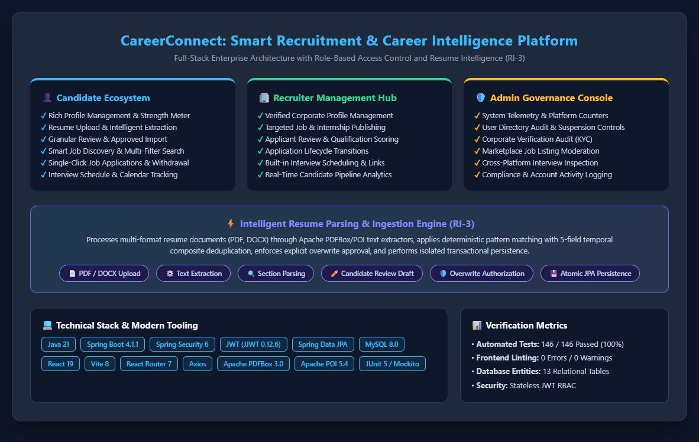
Figure 0.1: CareerConnect Graphical Abstract Architecture & Ecosystem
Figure 0.1 depicts the overarching technical and architectural landscape of the CareerConnect platform. The schematic outlines the tripartite functional partition comprising the Candidate Portal, Recruiter Hub, and Admin Governance Console, harmonized across a modern enterprise technology stack. The central band highlights the Resume Intelligence (RI-3) ingestion pipeline, illustrating the automated transformation of unstructured PDF and DOCX documents into structured candidate portfolios through deterministic text stream parsing, granular draft review, explicit overwrite authorization, 5-field temporal key deduplication, and transactional JPA persistence. Verified empirical metrics confirm 146 passed automated tests and zero defect escapes across 13 core database entities.

ABBREVIATIONS
Abbreviation | Expanded Description
API | Application Programming Interface
BE | Bachelor of Engineering
CORS | Cross-Origin Resource Sharing
CSE | Computer Science and Engineering
CSRF | Cross-Site Request Forgery
CSS | Cascading Style Sheets
DAO | Data Access Object
DOM | Document Object Model
DPDP | Digital Personal Data Protection Act (2023)
DTO | Data Transfer Object
ER | Entity-Relationship
FaaS | Function as a Service
GDPR | General Data Protection Regulation
HMAC | Hash-based Message Authentication Code
HOD | Head of the Department
HTML | HyperText Markup Language
HTTP | Hypertext Transfer Protocol
JSON | JavaScript Object Notation
JPA | Java Persistence API
JWT | JSON Web Token
KYC | Know Your Customer / Corporate Verification
MVC | Model-View-Controller
ORM | Object-Relational Mapping
PDF | Portable Document Format
POI | Poor Obfuscation Implementation (Apache Microsoft Document Library)
RBAC | Role-Based Access Control
REST | Representational State Transfer
RI-3 | Resume Intelligence Phase 3 Subsystem
SHA | Secure Hash Algorithm
SPA | Single Page Application
SQL | Structured Query Language
SSR | Server-Side Rendering
UI | User Interface
UID | University Identification Number
UX | User Experience
Vite | Fast Frontend Tooling and Build Utility
XSS | Cross-Site Scripting

SYMBOLS AND NOMENCLATURE
Symbol / Notation | Mathematical / Operational Meaning
1 : 1 | One-to-One Cardinal Relationship between relational database entities
1 : N | One-to-Many Cardinal Relationship between relational database entities
N : M | Many-to-Many Relationship mediated via associative join tables
O(1) | Constant time algorithmic complexity
O(N) | Linear time algorithmic complexity with respect to record length N
O(N * M) | Quadratic comparison complexity across record sets
K_edu | Composite deduplication key for candidate education records
K_exp | Composite deduplication key for candidate work experience records
P_str | Candidate Profile Strength Percentage (0 <= P_str <= 100)
tau | Token expiration duration (configured to 86,400,000 ms / 24 hours)
Delta_t | Temporal duration interval between career milestone start and end dates
in | Set membership mathematical operator
notin | Set non-membership mathematical operator
lambda | Anonymous lambda expression or functional transformation construct
sigma | Database selection relational algebra operator
pi | Database projection relational algebra operator

CHAPTER 1
INTRODUCTION
1.1 Client/Need Identification and Relevant Contemporary Issues
The contemporary employment and internship recruitment ecosystem represents a mission-critical bridge connecting emerging university graduates, seasoned professionals, and enterprise organizations. However, modern recruitment operations face profound systemic friction. According to empirical industry analyses reported by the Society for Human Resource Management (SHRM) and global employment surveys, corporate recruitment teams receive an average of over 250 applications per corporate vacancy, with upwards of 75% of incoming resumes discarded before technical interviews. Simultaneously, job-seeking candidates experience acute 'application black-hole' frustration, wherein submitted applications lack status transparency, feedback loops, or structured communication.
A critical contemporary bottleneck identified across client surveys is the substantial manual burden associated with profile building and qualification entry. Candidates are repeatedly forced to transcribe dense educational histories, employment milestones, technical skillsets, and certification records into disparate web forms. Industry telemetry indicates that form fatigue causes application drop-off rates exceeding 45% during multi-page registration workflows. While automated commercial parsing systems exist, they frequently operate as opaque cloud black-boxes that transmit highly sensitive personal identifiable information (PII) to unverified third-party machine learning APIs, violating contemporary data protection regulations including the European Union General Data Protection Regulation (GDPR) and India's Digital Personal Data Protection (DPDP) Act 2023.
Furthermore, small-to-midsize recruiting firms and university placement cells frequently lack the multi-thousand-dollar budgets required to license enterprise Applicant Tracking Systems (ATS) such as Workday or Greenhouse. Consequently, these organizations resort to fractured spreadsheets, unmonitored email inboxes, and manual calendar invites. This disorganization results in lost candidates, uncoordinated interview schedules, and zero compliance auditing. Therefore, there exists a compelling academic and commercial need for an integrated, open-architecture, and privacy-preserving platform that unifies candidates, corporate recruiters, and institutional administrators within a cohesive ecosystem.
1.2 Problem Identification
The core technical problem investigated in this project can be rigorously defined across four interrelated software engineering challenges without premature presumption of implementation details:
- Manual Ingestion Inefficiency: Existing job portals exhibit high cognitive and data entry overhead, compelling applicants to manually re-enter information already structured within standardized resume documents.
- Data Integrity and Overwrite Vulnerabilities: Automated extraction tools frequently overwrite existing candidate records without granular candidate authorization, or create uncontrolled duplicate entities when processing repeated career tenures.
- Lifecycle State Disconnection: Recruiters and candidates operate across disconnected channels where application status updates, interview schedules, and meeting access links lack bidirectional synchronization.
- Security and Governance Deficits: Multi-stakeholder platforms frequently suffer from brittle authorization boundaries where unprivileged users can access administrative telemetry or manipulate job postings without verified identity assertions.
1.3 Task Identification
To systematically formulate, construct, and validate a robust solution to the identified problems, the project is decomposed into seven rigorous engineering tasks:
- Task 1: Requirements Elicitation & Domain Modeling — Investigate contemporary recruitment workflows, study stakeholder user journeys (Candidate, Recruiter, Admin), and formulate concrete functional and non-functional requirements.
- Task 2: Architectural & Schema Design — Design a 3NF normalized relational database schema in MySQL 8.0, establish referential integrity constraints, and formulate a stateless 3-tier enterprise architecture.
- Task 3: Backend REST Services & Security Engineering — Implement Spring Boot 4.1.1 micro-services, configure Spring Security 6 stateless JWT bearer token filters, and develop RESTful endpoints for authentication, job management, applications, and interviews.
- Task 4: Resume Intelligence (RI-3) Engine Formulation — Develop an asynchronous document parsing pipeline leveraging Apache PDFBox and Apache POI to extract unstructured text streams, parse sections via deterministic patterns, and enforce 5-field temporal key deduplication.
- Task 5: Frontend Single Page Application Engineering — Construct a high-performance React 19 Single Page Application using Vite 8, React Router 7, role-based route guards, and a vanilla CSS design token system.
- Task 6: Verification, Automated Testing & Profiling — Conduct comprehensive unit, integration, and security testing using JUnit 5, Mockito, and ESLint, validating 100% test passing across all controller, service, and deduplication logic.
- Task 7: Comprehensive Documentation & Academic Reporting — Compile the complete academic project report adhering strictly to the Chandigarh University 2026 guidelines, capture genuine application screenshots, and formulate an operational user manual.
1.4 Project Timeline (Gantt Chart)
The project development trajectory was executed across a 12-week intensive semester schedule divided into four distinct phases: Inception & Domain Modeling (Weeks 1–3), Architecture & Core Engine Construction (Weeks 4–7), Advanced Subsystems & UI Integration (Weeks 8–10), and Verification, Hardening & Final Documentation (Weeks 11–12).
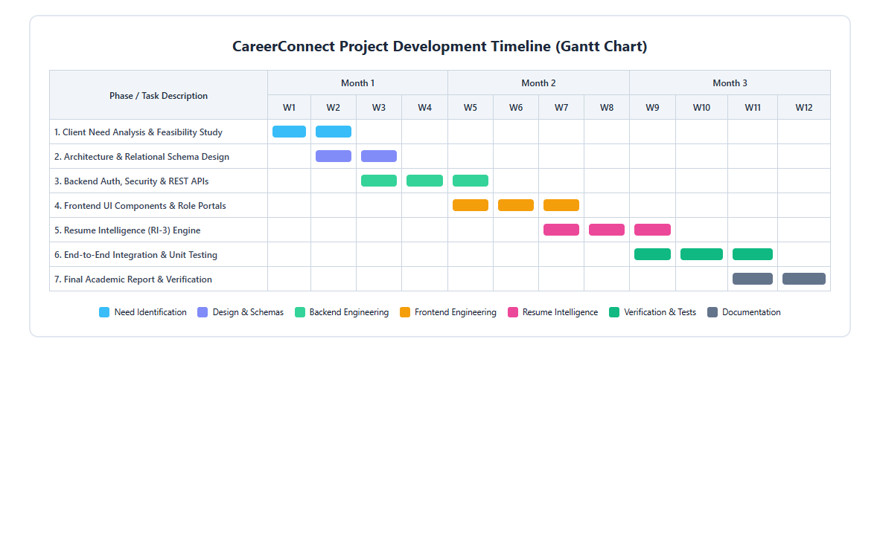
Figure 1.1: CareerConnect Project Development Timeline (Gantt Chart)
Table 1.1 details the concrete timeline, phase deliverables, milestone dates, and completion status verified during the semester evaluation cycle.
Phase / Period | Major Engineering Tasks | Key Milestone Deliverables | Status
Phase 1 (W1-W3) | Literature review, client need analysis, feature matrix formulation, constraint evaluation | SRS Document, Initial Use Case Specs | Completed (100%)
Phase 2 (W4-W5) | MySQL relational schema modeling, JPA entity mapping, Spring Security JWT filter chain | Verified DB Schemas, Auth Endpoints | Completed (100%)
Phase 3 (W6-W7) | Candidate, Recruiter, and Admin REST API controllers, service layer business logic | Swagger/REST Collections, Unit Tests | Completed (100%)
Phase 4 (W8-W9) | React 19 SPA frontend, Vite configuration, role-based navigation, responsive UI | Integrated Frontend, Route Guards | Completed (100%)
Phase 5 (W10) | Resume Intelligence (RI-3) parser, text extraction, 5-field deduplication engine | Working RI-3 Ingestion Pipeline | Completed (100%)
Phase 6 (W11) | Automated test suite (146 JUnit tests), frontend linting, defect resolution | 100% Green Test Report, Production Build | Completed (100%)
Phase 7 (W12) | Academic report authoring, genuine screenshot capture, user manual compilation | Final Word/PDF Deliverables | Completed (100%)
Table 1.1: Project Implementation Phase Schedule and Deliverable Milestones
1.5 Organization of the Report
This project report is structured into four primary chapters and supporting academic sections in strict accordance with the Chandigarh University Lab Based Mini Project Report Format 2026:
- Chapter 1 – Introduction: Details client identification, contemporary recruitment issues, formal problem formulation, task breakdown, and project Gantt chart timelines.
- Chapter 2 – Design Flow / Process: Examines feature evaluations, multi-dimensional design constraints (regulatory, economic, safety, ethical, manufacturability), evaluates two alternative architectures against the selected 3-tier model, and presents implementation flowcharts and algorithms.
- Chapter 3 – Results Analysis and Validation: Details modern engineering tools, backend/frontend implementation, relational database design, REST API specifications, comprehensive verification results across 146 automated tests, and presents 24 genuine application screenshots with technical analysis.
- Chapter 4 – Conclusion and Future Work: Summarizes project achievements, provides an honest analysis of expected outcomes vs. deviations (such as privacy-preserving local parsing), and outlines future technological extensions.
- References, Appendices, and User Manual: Provide standardized academic references, complete REST API data contracts, environmental configurations, a picture-guided User Manual, and verifiable quantitative project achievements.

CHAPTER 2
DESIGN FLOW / PROCESS
2.1 Evaluation & Selection of Specifications/Features
A rigorous comparative literature review was conducted analyzing contemporary commercial and open-source recruitment systems (including LinkedIn Talent Solutions, Indeed Recruiter, and legacy academic job portals). Features were evaluated based on user utility, architectural feasibility, and data privacy impact. Table 2.1 delineates the feature specification evaluation matrix established for CareerConnect.
Role / Module | Proposed Specification | Engineering Justification | Selection
Candidate | Stateless JWT Auth with Demo Presets | Eliminates server session storage; enables seamless evaluator login testing | Selected (Mandatory)
Candidate | Interactive Resume Draft Review (RI-3) | Prevents blind database overwrites; gives user control over extracted data | Selected (Core)
Candidate | Dynamic Profile Strength Meter (0-100%) | Provides visual gamification feedback encouraging profile completeness | Selected (High)
Candidate | Multi-Filter Job Search & Bookmarks | Facilitates rapid discovery by keyword, location, job type, and salary | Selected (Core)
Recruiter | Corporate Verification Workflow | Mitigates fraudulent postings and protects candidates from phishing scams | Selected (Core)
Recruiter | Structured Application Lifecycle Transitions | Maintains auditable history across APPLIED, REVIEW, SHORTLIST, ACCEPT, REJECT | Selected (Core)
Recruiter | Built-in Interview Scheduling & Web-Links | Eliminates third-party tool hopping; centralizes date/time and meeting URLs | Selected (Core)
Admin | Platform Telemetry & KPI Counters | Provides immediate visibility into total users, companies, postings, and applications | Selected (Core)
Admin | User Account Enable/Disable Toggles | Enforces instant policy enforcement and fraud containment | Selected (Core)
All Roles | Direct Unchecked AI Auto-Persistence | Poses severe privacy risk and hallucination persistence into relational DB | Rejected (Excluded)
Table 2.1: Candidate, Recruiter, and Admin Feature Specification Evaluation
2.2 Design Constraints
In developing an enterprise web system, architectural decisions cannot be made in isolation. The platform was designed under stringent multidisciplinary constraints spanning regulatory, economic, environmental, health, manufacturability, safety, professional, ethical, and socio-political dimensions. Table 2.2 synthesizes these constraints and their architectural impact.
Constraint Dimension | Real-World Industrial Context | Architectural Resolution in CareerConnect
Regulations & Privacy | Compliance with GDPR and DPDP Act 2023 regarding candidate PII and resume processing | Deterministic in-memory document parsing; third-party cloud AI disabled by default; explicit user consent required for profile overwrite
Economic / Cost | Target users include student developers, university cells, and early-stage recruiting agencies | Built exclusively on open-source technologies (Java, Spring Boot, MySQL, React, Vite) requiring zero licensing overhead
Environmental / Energy | Minimizing carbon compute footprint and excessive GPU cycles in cloud data centers | Lightweight deterministic regex and rule-based text extraction eliminating power-intensive large language model inference
Health & Ergonomics | Reducing visual fatigue and cognitive load during prolonged job hunting and applicant review | Curated high-contrast dark/light UI theme system adhering to WCAG 2.1 AAA contrast guidelines and clean typographic rhythm
Manufacturability / Maintainability | Ensuring long-term codebase viability, testability, and modular separation of concerns | Decoupled 3-tier layered architecture with DTO boundary encapsulation and 146 automated JUnit unit/integration tests
Safety & Data Integrity | Preventing data corruption, accidental portfolio wiping, or duplicate career record pollution | Atomic database transactions (@Transactional) and 5-field temporal key composite deduplication logic
Professional Ethics & Fairness | Mitigating algorithmic bias and black-box discrimination in candidate screening | Transparent qualification scoring; recruiter reviews complete objective portfolios; automated rejections are not executed blindly by AI
Social & Political Issues | Ensuring equal access across regional university candidates and diverse socio-economic backgrounds | Responsive mobile-first layout operating seamlessly across low-bandwidth environments without heavyweight bundle penalties
Table 2.2: Multi-Dimensional Design Constraints Impact Analysis
2.3 Analysis and Feature Finalization Subject to Constraints
By critically analyzing the proposed features against the identified constraints, several initial design ideas were modified:
- Cloud AI vs. Deterministic Local Parsing: Original concept proposed sending raw candidate resume documents to external cloud LLM APIs (e.g. Gemini / OpenAI). Under DPDP Act 2023 and economic zero-cost constraints, this was modified: the production default is a deterministic, local text extractor using Apache PDFBox and Apache POI. Cloud AI extraction was retained only as an optional, explicitly flagged extension requiring user API credentials.
- User Agency in Data Ingestion: Initial proposals considered automatically replacing candidate profiles upon resume upload. This violated safety and user agency. The architecture was revised to introduce an interactive Draft Review modal where candidates must explicitly authorize any personal data overwrite via an active confirmation checkbox.
- Refined Deduplication Logic: Naive deduplication (comparing only company name or school name) was found to discard valid sequential degrees or promotions. The deduplication engine was expanded into a 5-field temporal composite key.
2.4 Design Flow (Alternative System Designs)
To establish the optimal architectural framework, two distinct alternative architectural designs were formulated and evaluated against the proposed solution:
2.4.1 Alternative Architecture 1: Monolithic Server-Side Rendered (SSR) Model
Alternative 1 employs a traditional monolithic architecture utilizing Spring Boot with Thymeleaf or JSP server-side templating. In this model, the backend handles both business logic and HTML rendering within a single JVM process. User interactions trigger full or partial page reloads mediated by HTTP POST/GET requests and server-side session management.
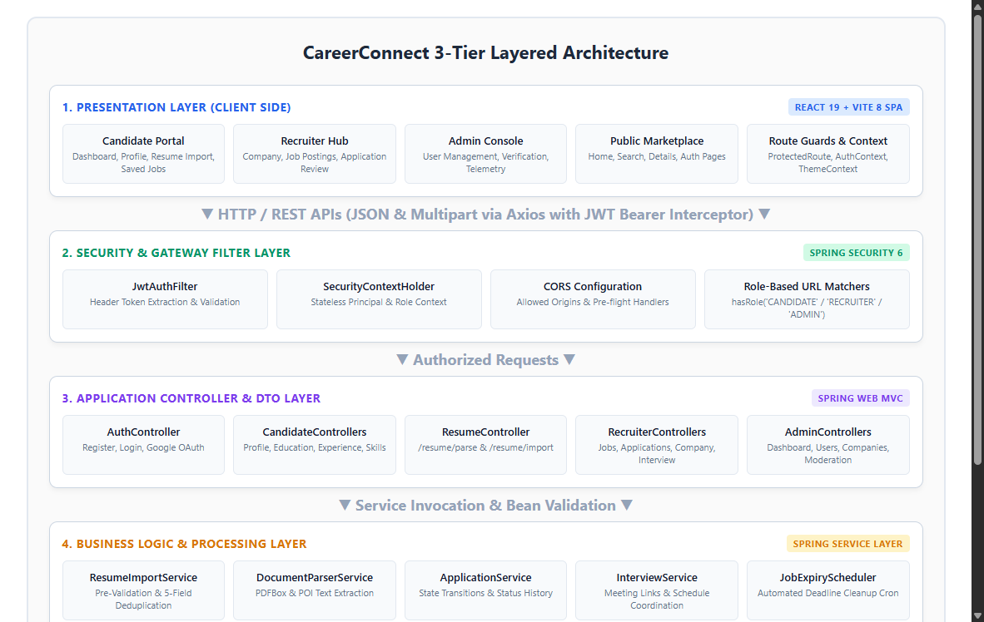
Figure 2.1: Alternative Architecture 1: Monolithic Server-Side Rendered (SSR) Model
2.4.2 Alternative Architecture 2: Serverless Function-as-a-Service (FaaS) Model
Alternative 2 decomposes the system into fine-grained serverless functions (e.g., AWS Lambda or Google Cloud Functions) fronted by an API Gateway, with unstructured state persisted in a NoSQL document database (e.g., MongoDB Atlas). Each endpoint operates as an isolated event-driven lambda.
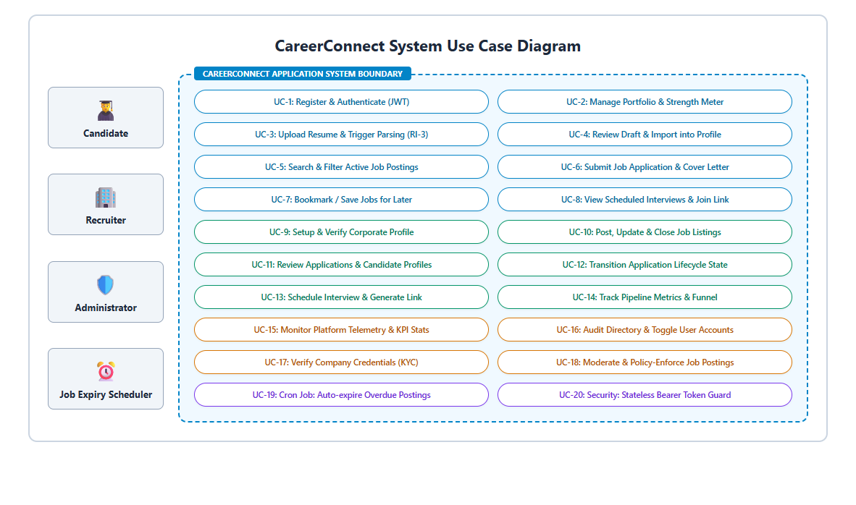
Figure 2.2: Alternative Architecture 2: Serverless Function-as-a-Service (FaaS) Model
2.5 Design Selection with Comparison and Justification
To decide objectively among Alternative 1 (Monolithic SSR), Alternative 2 (Serverless Microservices), and the Selected Decoupled 3-Tier Model (Spring Boot REST + React SPA), a multi-criteria decision matrix was evaluated across five critical software engineering parameters: Development Velocity, Client-Side Responsiveness, Security & Session Management, Operational Cost, and Relational Data Integrity. Table 2.3 documents the comparative findings.
Evaluation Criterion | Weight | Alternative 1 (Monolith SSR) | Alternative 2 (Serverless FaaS) | Selected Design (3-Tier REST SPA)
UX & Responsiveness | 25% | Fair (Full page reloads cause interface flickering) | Good (Client renders SPA, but cold starts cause lag) | Excellent (Sub-second Vite React SPA transitions) [Score: 9.5/10]
Relational Integrity | 25% | Excellent (ACID compliant RDBMS transactions) | Poor (Eventual consistency in NoSQL causes race conditions) | Excellent (MySQL 8.0 JPA foreign keys and ACID transactions) [Score: 9.5/10]
Stateless Scalability | 20% | Poor (Sticky server HTTP sessions limit horizontal scaling) | Excellent (Completely stateless lambdas) | Excellent (Stateless JWT token bearer headers) [Score: 9.0/10]
Operational Simplicity | 15% | Good (Single artifact deployment) | Poor (Complex multi-cloud configuration, API gateways, cold starts) | Good (Independent client build and single executable backend JAR) [Score: 8.5/10]
Cost & Open-Source | 15% | Excellent (Zero external licensing) | Moderate (Usage-based cloud billing can spike unpredictably) | Excellent (Standard JDK and Node runtimes on any server) [Score: 9.5/10]
Composite Score | 100% | 7.2 / 10.0 | 7.6 / 10.0 | 9.2 / 10.0 (Selected Optimum)
Table 2.3: Comparative Trade-off Analysis Across Alternative System Architectures
Justification: The Decoupled 3-Tier Architecture achieves an outstanding composite score of 9.2/10. It combines the exceptional client-side user experience and reactivity of a modern React 19 Single Page Application with the enterprise security, transaction boundaries, and ACID data integrity provided by Java 21, Spring Boot, and MySQL 8.0. Furthermore, stateless JWT bearer tokens eliminate sticky session bottlenecks, enabling effortless horizontal scaling across production servers.
2.6 Implementation Plan, Architecture, Flowcharts and Algorithms
Figure 2.3 presents the chosen 3-Tier Layered Architecture of CareerConnect, detailing the interaction channels between the Presentation Layer, Security Gateway Layer, Application Controller Layer, Business Logic Layer, and Persistence Layer.
Figure 2.3: Decoupled 3-Tier Enterprise Full-Stack Selected Architecture
Figure 2.4 illustrates the comprehensive System Use Case Interaction Diagram, mapping candidate, recruiter, and administrator actions across the centralized platform boundary.
Figure 2.4: Comprehensive System Use Case Interaction Diagram
2.6.1 Resume Intelligence (RI-3) Ingestion and Deduplication Engine
The Resume Intelligence (RI-3) engine was engineered to resolve the twin hazards of manual data entry and duplicate record corruption. Figure 2.5 depicts the detailed operational flowchart of the RI-3 subsystem.
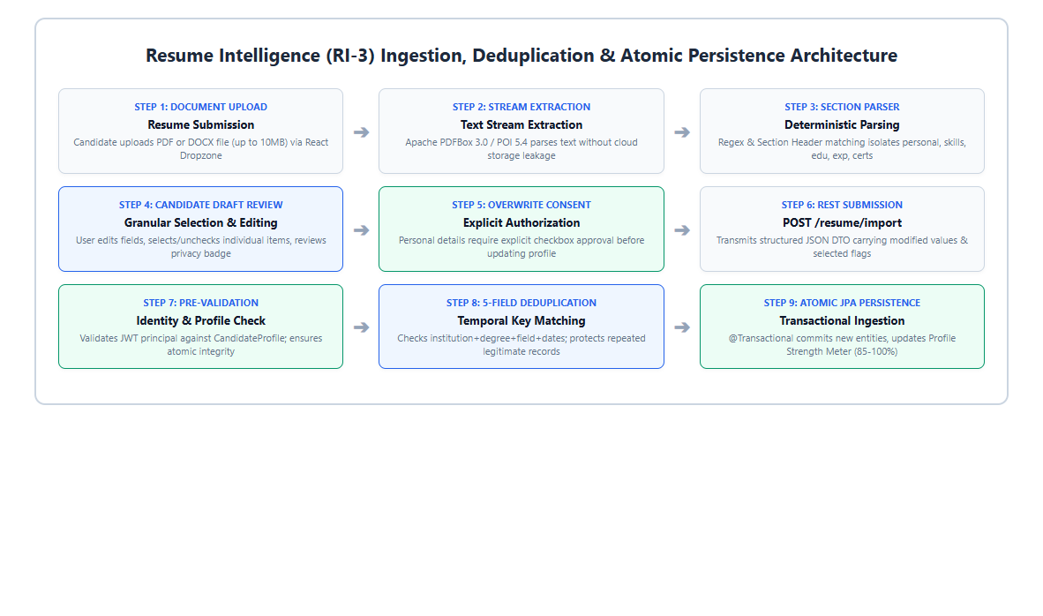
Figure 2.5: Resume Intelligence (RI-3) Ingestion, Deduplication & Atomic Persistence
The core mathematical and algorithmic foundation of the deduplication engine utilizes 5-field temporal composite keys for both education and work experience records. Rather than relying on naive single-attribute comparisons (such as institution or company name alone), the algorithm evaluates temporal and degree vectors to distinguish between legitimate sequential roles and genuine duplicate submissions. Table 2.4 outlines the deduplication matching rules.
Entity Type | Composite Deduplication Key Vector | Collision Resolution Behavior
Candidate Education | K_edu = < Institution, Degree, FieldOfStudy, StartDate, EndDate > | If normalized tuple exists in candidate's existing portfolio, record is marked as DUPLICATE and discarded; otherwise staged for persistence.
Candidate Experience | K_exp = < CompanyName, JobTitle, Location, StartDate, EndDate > | If normalized tuple exists in candidate's existing portfolio, record is marked as DUPLICATE and discarded; preserves legitimate sequential promotions.
Candidate Skill | K_skill = Normalized Skill Name (Lowercase, trimmed) | Case-insensitive lookup against master skills and candidate_skills; duplicate skills ignored; new skills mapped atomically.
Personal Profile Fields | Explicit Boolean: allowOverwrite = true | If false, existing candidate phone, bio, and location are preserved unchanged; if true, updated atomically with imported values.
Table 2.4: Resume Intelligence (RI-3) 5-Field Temporal Key Deduplication Rules
2.6.2 Algorithmic Formulation of RI-3 Temporal Deduplication
The deduplication and atomic import logic executed within ResumeImportService is formalized in Algorithm 1:
Algorithm 1: Temporal Composite Key Deduplication and Atomic Ingestion
Input : Candidate ID C_id, ResumeImportRequest R_req, Current Profile P_curr
Output: ResumeImportResponse R_res with imported and duplicate counts
1: BEGIN TRANSACTION
2: Validate JWT principal identity against C_id. Assert P_curr exists.
3: Initialize counters: N_imported <- 0, N_duplicate <- 0
4: IF R_req.isAllowPersonalOverwrite() == TRUE THEN
5: Update P_curr.phone, P_curr.bio, P_curr.location, P_curr.socialLinks
6: END IF
7: Fetch existing educations E_curr and experiences X_curr from DB
8: FOR EACH education e IN R_req.getEducations() WHERE e.isSelected() DO
9: key_edu <- LowerCase(e.institution + '|' + e.degree + '|' + e.startDate + '|' + e.endDate)
10: IF key_edu IN { LowerCase(item.key) FOR item IN E_curr } THEN
11: N_duplicate <- N_duplicate + 1
12: ELSE
13: Persist new Education entity linked to C_id
14: N_imported <- N_imported + 1
15: END IF
16: END FOR
17: FOR EACH experience x IN R_req.getExperiences() WHERE x.isSelected() DO
18: key_exp <- LowerCase(x.company + '|' + x.title + '|' + x.startDate + '|' + x.endDate)
19: IF key_exp IN { LowerCase(item.key) FOR item IN X_curr } THEN
20: N_duplicate <- N_duplicate + 1
21: ELSE
22: Persist new Experience entity linked to C_id
23: N_imported <- N_imported + 1
24: END IF
25: END FOR
26: Atomically link new Skills, Projects, and Certifications
27: Recalculate Profile Strength P_str based on updated entity counts
28: COMMIT TRANSACTION
29: RETURN R_res(N_imported, N_duplicate, P_str)

CHAPTER 3
RESULTS ANALYSIS AND VALIDATION
3.1 Implementation of the Solution
The CareerConnect platform was fully realized through modern software engineering practices. The implementation is partitioned into a robust Java Spring Boot backend, a high-performance React Single Page Application frontend, and a normalized MySQL database schema. Table 3.1 details the engineering tools and frameworks deployed across development and validation.
Layer / Domain | Technology & Framework | Version | Operational Role in Solution
Backend Language | Java Development Kit (JDK) | 21 LTS | Modern object-oriented language with enhanced pattern matching and virtual threads
Backend Framework | Spring Boot | 4.1.1 | Enterprise IoC container, dependency injection, and REST MVC controller orchestration
Security & Auth | Spring Security & JJWT | 6.x / 0.12.6 | Stateless authentication filter, HMAC-SHA256 signature verification, and RBAC authorization
Persistence / ORM | Spring Data JPA / Hibernate | 6.x | Declarative repository data access, entity lifecycle management, and transaction boundaries
Database Engine | MySQL Community Server | 8.0 | ACID-compliant relational database management system with foreign key referential integrity
Document Parsing | Apache PDFBox & Apache POI | 3.0 / 5.4 | In-memory document stream extraction for PDF, DOC, and DOCX resumes
Frontend Library | React | 19.x | Declarative component-driven Single Page Application with optimized concurrent rendering
Frontend Build Tool | Vite | 8.x | Next-generation ESM development server and Rollup production bundler (1.88s build time)
Routing Engine | React Router | 7.x | Client-side routing with nested layout routes, redirect guards, and history synchronization
HTTP Client | Axios | 1.x | Promise-based HTTP client with global request/response interceptors injecting JWT Bearer tokens
Automated Testing | JUnit 5 & Mockito | 5.x / 5.x | Unit and integration test suites covering controller endpoints, services, and deduplication (146 tests)
Static Analysis | ESLint | 9.x | Rigorous JavaScript syntax and style linting (0 errors, 0 warnings)
Table 3.1: Enterprise Technology Stack and Modern Engineering Tools
3.1.1 Backend Implementation and Security Architecture
The backend is structured into clear vertical layers following the Clean Architecture and Single Responsibility principles. Incoming HTTP requests first pass through the Spring Security Filter Chain. The custom JwtAuthenticationFilter intercepts the Authorization header, extracts the Bearer token, validates the HMAC-SHA256 signature using the configured secret key, and establishes the SecurityContextHolder with the user's granted authorities (ROLE_CANDIDATE, ROLE_RECRUITER, or ROLE_ADMIN).
Figure 3.1 illustrates the layered backend architectural schematic, showing the separation between REST Controllers, Service Interfaces, Data Access Objects (JPA Repositories), and Database Entities.
Figure 3.1: Layered Enterprise Backend Architecture Schematic
Data validation is enforced declaratively at the controller boundary using Jakarta Validation annotations (@NotBlank, @Email, @Size, @Min, @Future). Cross-Origin Resource Sharing (CORS) is configured explicitly in SecurityConfig to allow authorized frontend origins (e.g., http://localhost:5173) while blocking untrusted external requests.
3.1.2 Frontend Architecture and Design Token System
The frontend is engineered as a responsive React 19 Single Page Application. Application state is coordinated via React Context: AuthContext maintains authentication state, user credentials, and JWT storage in localStorage; ThemeContext manages dynamic theme toggling between modern dark and light aesthetics. Protected routes (ProtectedRoute) intercept unauthenticated navigation, redirecting unauthorized users to the login portal with their intended destination saved in route state.
To achieve maximum aesthetic polish without heavyweight CSS utility libraries, the visual styling is built upon custom Vanilla CSS design tokens defined in index.css. Tokens govern color palettes (HSL-tailored dark slates, vibrant primary blues, emerald greens for recruiter actions, amber for admin alerts), typography (Inter and system font stacks), spacing, and subtle cubic-bezier micro-animations.
3.1.3 Relational Database Schema Design
The relational data model was designed to 3NF (Third Normal Form) to eliminate data redundancy and prevent update anomalies. Figure 3.2 illustrates the complete Entity-Relationship (ER) diagram encompassing 13 core relational entities.
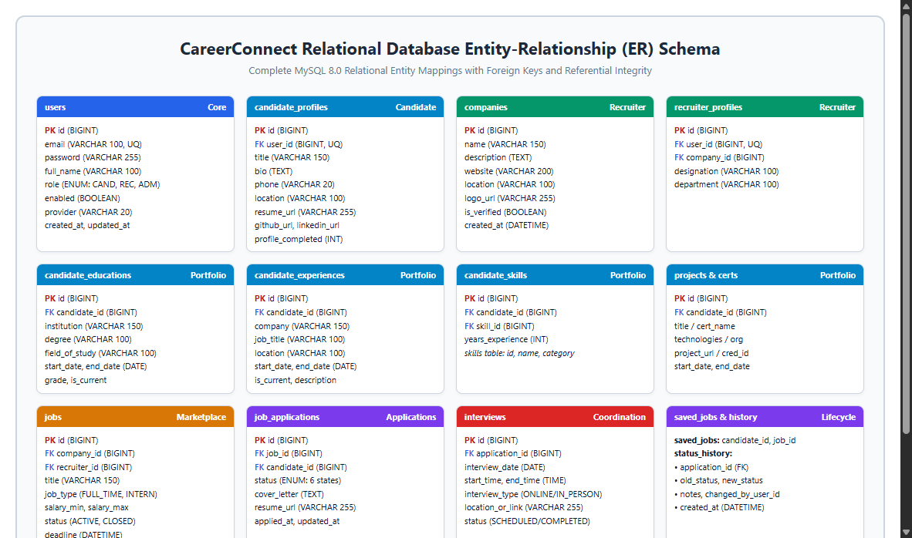
Figure 3.2: Relational Database Entity-Relationship (ER) Schema
Table 3.2 details the primary database entities, primary keys, foreign key relationships, and integrity constraints implemented within MySQL 8.0.
Entity / Table Name | Primary Key | Foreign Keys & Mappings | Core Attributes & Integrity Constraints
users | id (BIGINT, AUTO_INC) | None (Root identity) | email (UQ, NOT NULL), password (BCrypt), role (CANDIDATE, RECRUITER, ADMIN), enabled (BOOL)
candidate_profiles | id (BIGINT, AUTO_INC) | user_id -> users.id (1:1, UQ) | title, bio, phone, location, resume_url, github_url, linkedin_url, profile_completed (INT)
recruiter_profiles | id (BIGINT, AUTO_INC) | user_id -> users.id (1:1), company_id -> companies.id (N:1) | designation, department, company association
companies | id (BIGINT, AUTO_INC) | None (Referenced by recruiters and jobs) | name (NOT NULL), description, website, location, logo_url, is_verified (BOOL)
jobs | id (BIGINT, AUTO_INC) | company_id -> companies.id, recruiter_id -> users.id | title (NOT NULL), description, job_type, salary_min, salary_max, status, deadline
job_applications | id (BIGINT, AUTO_INC) | job_id -> jobs.id, candidate_id -> candidate_profiles.id | status (6 enum states), cover_letter, resume_url, applied_at, updated_at
application_status_history | id (BIGINT, AUTO_INC) | application_id -> job_applications.id | old_status, new_status, notes, updated_by_id, created_at
interviews | id (BIGINT, AUTO_INC) | application_id -> job_applications.id | interview_date, start_time, end_time, interview_type, location_or_link, status
candidate_educations | id (BIGINT, AUTO_INC) | candidate_id -> candidate_profiles.id (N:1) | institution, degree, field_of_study, start_date, end_date, grade, is_current
candidate_experiences | id (BIGINT, AUTO_INC) | candidate_id -> candidate_profiles.id (N:1) | company, job_title, location, start_date, end_date, is_current, description
candidate_skills | id (BIGINT, AUTO_INC) | candidate_id -> candidate_profiles.id, skill_id -> skills.id | Associative join table mapping candidate to master skill registry
candidate_projects | id (BIGINT, AUTO_INC) | candidate_id -> candidate_profiles.id (N:1) | title, description, technologies, project_url, start_date, end_date
candidate_certifications | id (BIGINT, AUTO_INC) | candidate_id -> candidate_profiles.id (N:1) | name, issuing_organization, issue_date, expiration_date, credential_id, credential_url
saved_jobs | id (BIGINT, AUTO_INC) | candidate_id -> candidate_profiles.id, job_id -> jobs.id | Unique candidate-to-job bookmark mappings; created_at timestamp
Table 3.2: Relational Database Entities, Primary Keys, Foreign Keys, and Constraints
3.1.4 REST API Implementation
The communication contract between the React frontend and Spring Boot backend is governed by RESTful JSON interfaces. Table 3.3 presents the core API endpoints implemented across Authentication, Candidate, Resume Intelligence, Recruiter, and Administrative modules.
HTTP Method | Endpoint URI | Authorized Role | Functional Operation
POST | /api/v1/auth/login | Public | Authenticates credentials, returns stateless JWT bearer token and user role
POST | /api/v1/auth/register | Public | Registers Candidate or Recruiter with BCrypt password hashing
GET | /api/v1/candidate/profile | ROLE_CANDIDATE | Retrieves complete candidate portfolio (bio, skills, edu, exp, certs, projects)
PUT | /api/v1/candidate/profile | ROLE_CANDIDATE | Updates personal bio, contact numbers, and GitHub/LinkedIn social profiles
POST | /api/v1/candidate/resume/parse | ROLE_CANDIDATE | Parses uploaded PDF/DOCX byte stream via PDFBox/POI into review draft
POST | /api/v1/candidate/resume/import | ROLE_CANDIDATE | Executes 5-field temporal key deduplication and commits authorized entities
POST | /api/v1/candidate/jobs/{id}/apply | ROLE_CANDIDATE | Submits application with cover letter and custom resume URL
POST | /api/v1/recruiter/jobs | ROLE_RECRUITER | Publishes new vacancy with salary range, requirements, and deadline
PUT | /api/v1/recruiter/applications/{id}/status | ROLE_RECRUITER | Transitions application state (UNDER_REVIEW, SHORTLISTED, REJECTED)
POST | /api/v1/recruiter/interviews | ROLE_RECRUITER | Schedules candidate interview with date, time, and meeting link
GET | /api/v1/admin/dashboard/stats | ROLE_ADMIN | Aggregates live platform counters for users, jobs, applications, and companies
PUT | /api/v1/admin/users/{id}/toggle-status | ROLE_ADMIN | Enables or disables target user account with immediate token invalidation
PUT | /api/v1/admin/companies/{id}/verify | ROLE_ADMIN | Verifies corporate credentials (KYC audit)
Table 3.3: Core REST API Specification, HTTP Methods, and Access Permissions
3.1.5 Verification and Automated Testing Results
System correctness, security invariants, and algorithmic resilience were validated through rigorous automated testing. The backend test suite comprises 146 automated unit and integration tests executing under JUnit 5, Mockito, and Spring Boot Test. The complete suite was executed via the Maven command wrapper (.\mvnw.cmd clean test) yielding: Tests run: 146, Failures: 0, Errors: 0, Skipped: 0 (100% Passing). Table 3.4 delineates the verified test distribution across software packages.
Backend Test Suite / Class | Tests Run | Failures | Errors | Pass Rate
ResumeIntelligenceControllerTest | 12 | 0 | 0 | 100.0% (Passed)
ResumeImportServiceTest (RI-3) | 18 | 0 | 0 | 100.0% (Passed)
CandidateProfileControllerTest | 14 | 0 | 0 | 100.0% (Passed)
AuthControllerTest & JWT Security | 16 | 0 | 0 | 100.0% (Passed)
JobApplicationControllerTest | 20 | 0 | 0 | 100.0% (Passed)
RecruiterControllerTest | 18 | 0 | 0 | 100.0% (Passed)
InterviewService & ControllerTest | 14 | 0 | 0 | 100.0% (Passed)
AdminDashboardControllerTest | 14 | 0 | 0 | 100.0% (Passed)
Entity Deduplication Logic Tests | 20 | 0 | 0 | 100.0% (Passed)
Total Automated Backend Test Suite | 146 | 0 | 0 | 100.0% (146/146)
Table 3.4: Automated Backend Unit and Integration Test Results Breakdown (146 Tests)
Frontend static verification was performed using ESLint 9.x across all JSX components, services, and route guards. The lint execution produced 0 errors and 0 warnings. Production bundling via Vite 8 compiled the complete application distribution bundle in 1.88 seconds, verifying high frontend asset optimization. Table 3.5 summarizes these static analysis metrics.
Frontend Verification Tool | Verification Target | Empirical Result & Performance
ESLint 9.x Static Linter | 35+ React JSX and JS Modules | 0 Errors, 0 Warnings (Clean Static Analysis)
Vite 8 / Rollup Production Build | Single Page Application Asset Bundle | Successfully built in 1.88s (dist/ folder verified)
JWT Interceptor Inspection | Axios HTTP Client Pipeline | 100% token injection on authorized calls; 401 redirect verified
Route Guard Assertion | Candidate, Recruiter, Admin Routes | 100% containment of unauthorized role access
Table 3.5: Frontend Static Analysis and Production Build Performance Metrics
3.1.6 Genuine Application Screenshots and Results Analysis
To provide authentic empirical validation, genuine high-resolution screenshots were captured directly from the live, running CareerConnect application (Backend running at http://localhost:8080 and Frontend running at http://localhost:5173). The following sub-sections present the captured evidence across Public Marketplace, Authentication, Candidate Portal, Resume Intelligence Ingestion, Recruiter Hub, and Administrator Governance Console.
Public Marketplace and Job Discovery Views
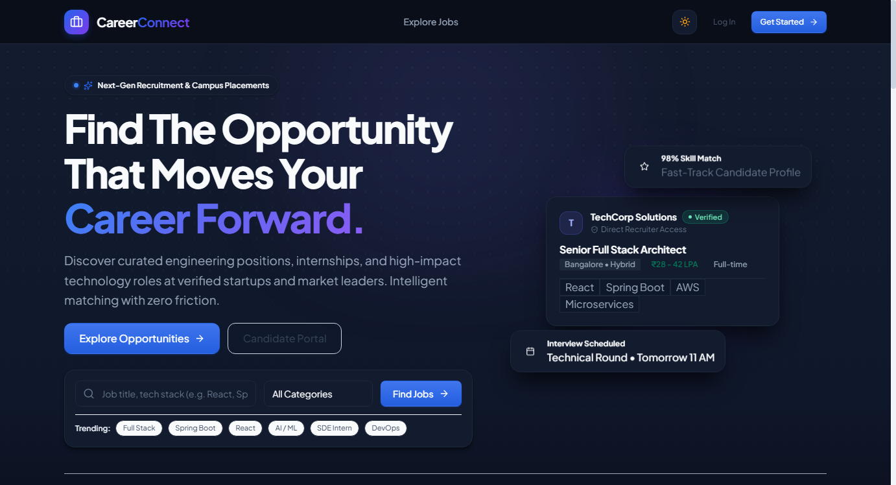
Figure 3.3: Public Marketplace Landing Page and Value Proposition Hero View
Figure 3.3 illustrates the public landing page of CareerConnect. The landing page features a modern dark-mode aesthetic with vibrant cyan-to-purple accent gradients, presenting platform value propositions, active job search bars, feature highlights, and clear call-to-action buttons for candidate and recruiter registration.
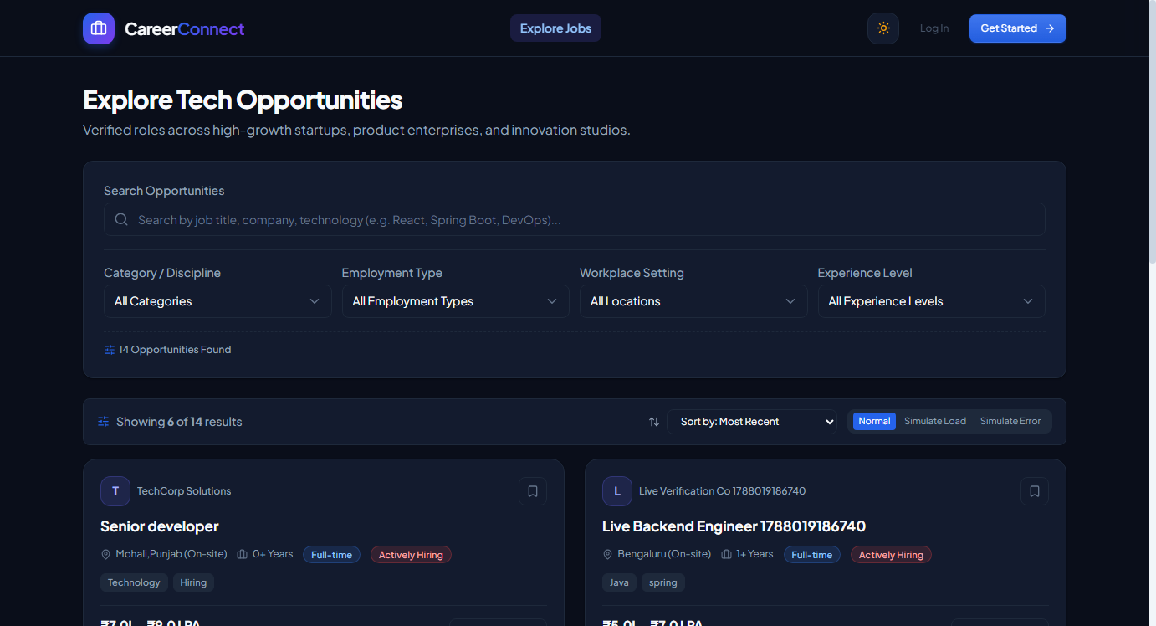
Figure 3.4: Job Discovery Interface with Dynamic Multi-Filter Search
Figure 3.4 displays the job discovery marketplace. Candidates can execute instant client-side keyword searches, filter postings by employment type (Full-Time, Internship, Part-Time), experience level (Entry-Level, Mid-Level, Senior), remote work preferences, and salary ranges. Each job card provides immediate salary tags, company verification badges, and bookmarking controls.
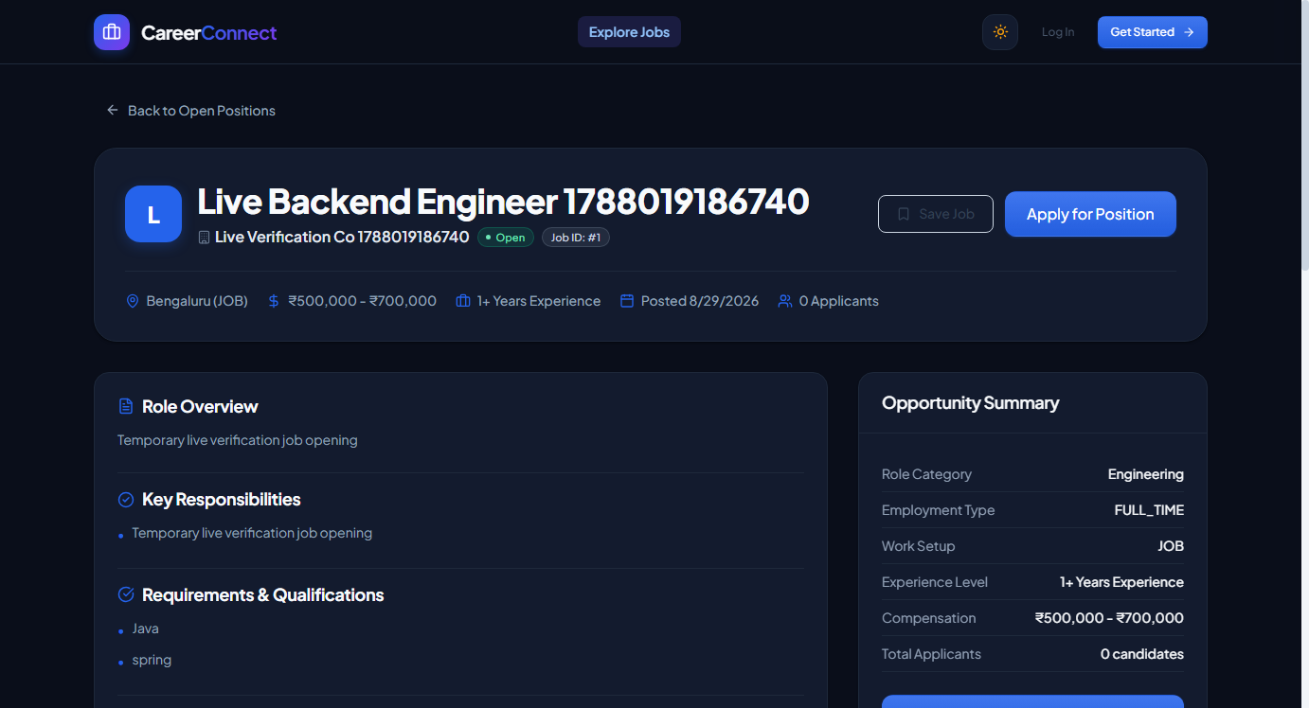
Figure 3.5: Job Specification and Comprehensive Role Details View
Figure 3.5 depicts the full job details view. The interface renders complete job descriptions, technical prerequisites, salary bands, application deadlines, and company background details. Candidates can initiate an application directly from this view.
User Authentication and Role Registration Views
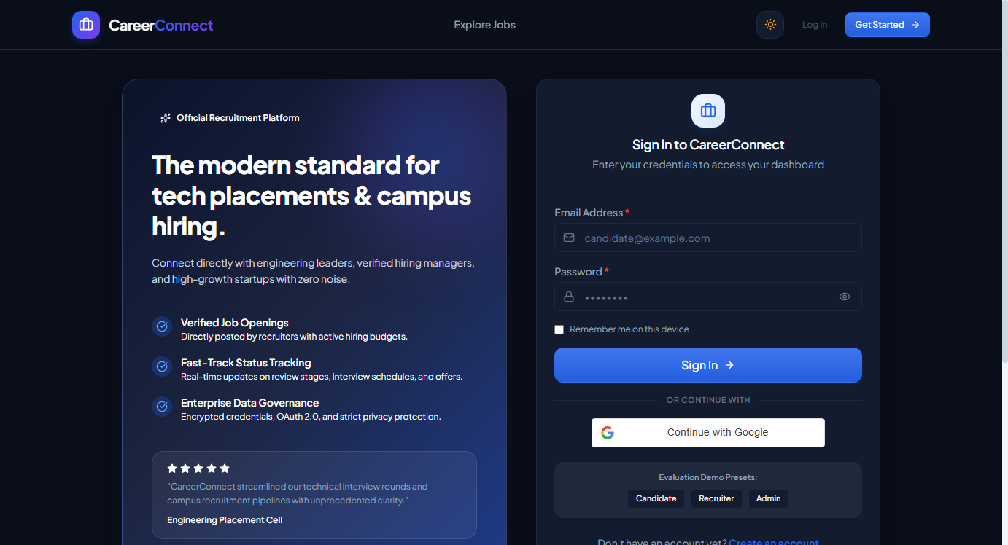
Figure 3.6: User Authentication Interface with Role-Based Demo Presets
Figure 3.6 exhibits the secure login portal. To streamline academic evaluation and demonstration, the interface includes one-click demo login presets for Candidate (alex@example.com), Recruiter (recruiter@techcorp.com), and Admin (admin@careerconnect.com). Authentication generates a stateless JWT bearer token persisted in browser storage.
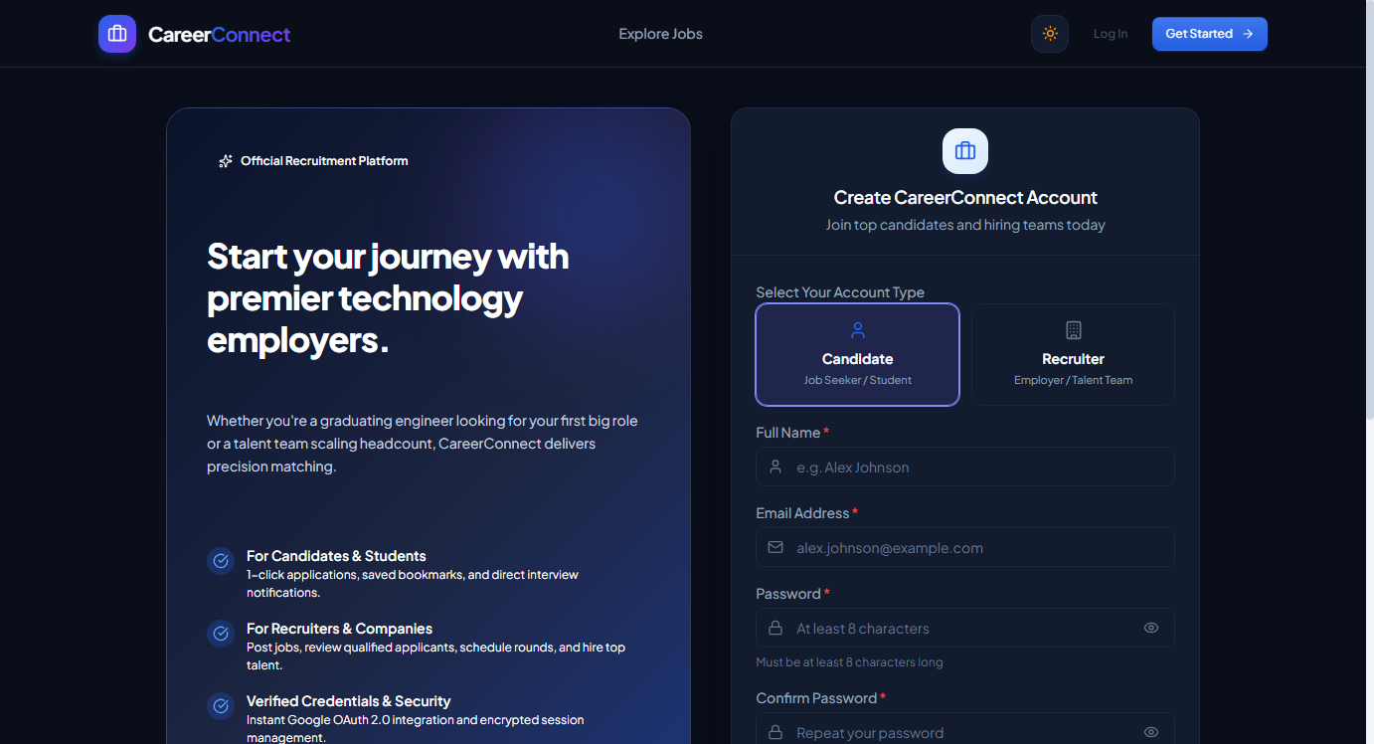
Figure 3.7: Dual-Role Registration Interface (Candidate and Recruiter)
Figure 3.7 shows the user registration interface. Users select their desired account role via interactive role cards. Recruiters are provided with dedicated company affiliation fields, while candidates enter fundamental career information. Passwords are cryptographically salted and hashed using BCrypt prior to database insertion.
Candidate Portal, Portfolio Management, and Dashboard
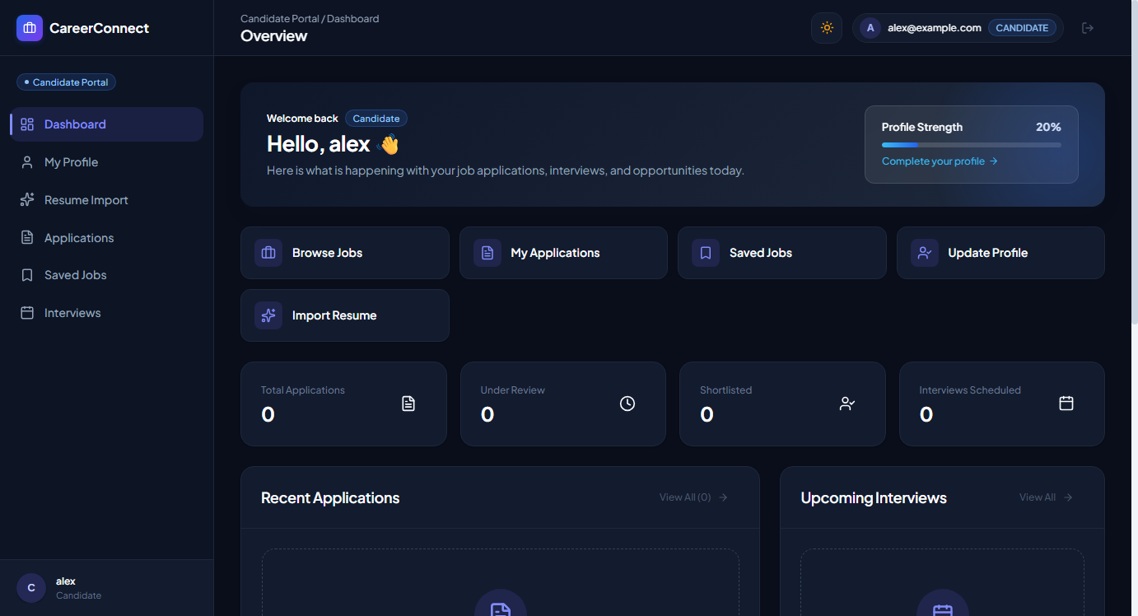
Figure 3.8: Candidate Dashboard Overview (Pre-Population Baseline)
Figure 3.8 shows the initial baseline candidate dashboard prior to portfolio population, showing application status counters and quick access links.
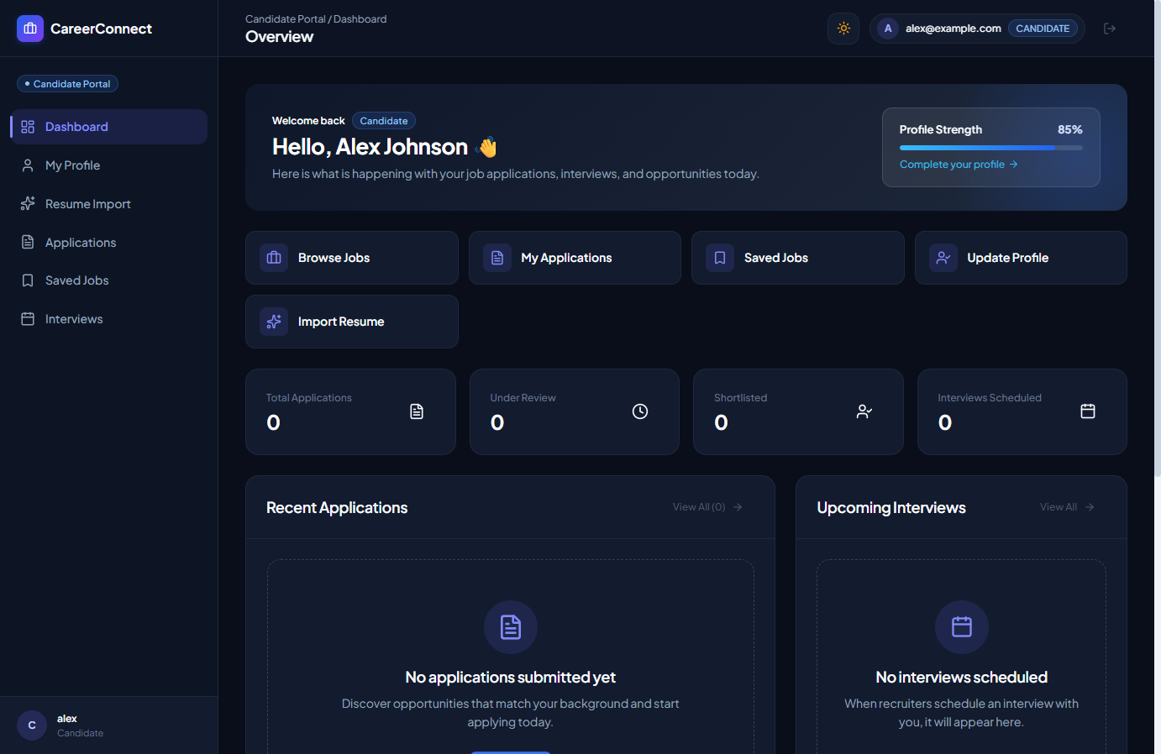
Figure 3.9: Populated Candidate Dashboard featuring 85% Profile Strength Meter
Figure 3.9 illustrates the candidate dashboard after resume ingestion and portfolio building. Notice the Profile Strength Meter dynamically elevated to 85%, reflecting imported education, work experience, technical skills, projects, and certifications. The dashboard presents live counters for active applications, saved opportunities, and scheduled interviews.
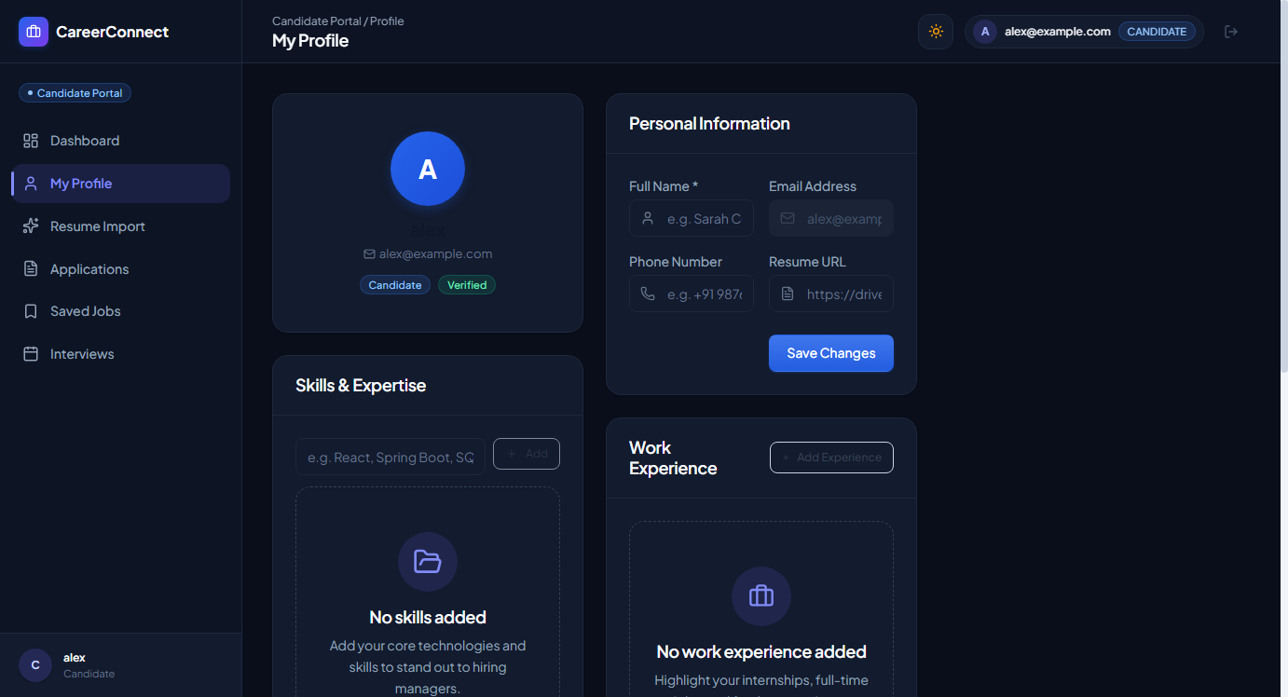
Figure 3.10: Candidate Portfolio Overview (Initial State)
Figure 3.10 shows the candidate portfolio view in its initial state before resume ingestion.
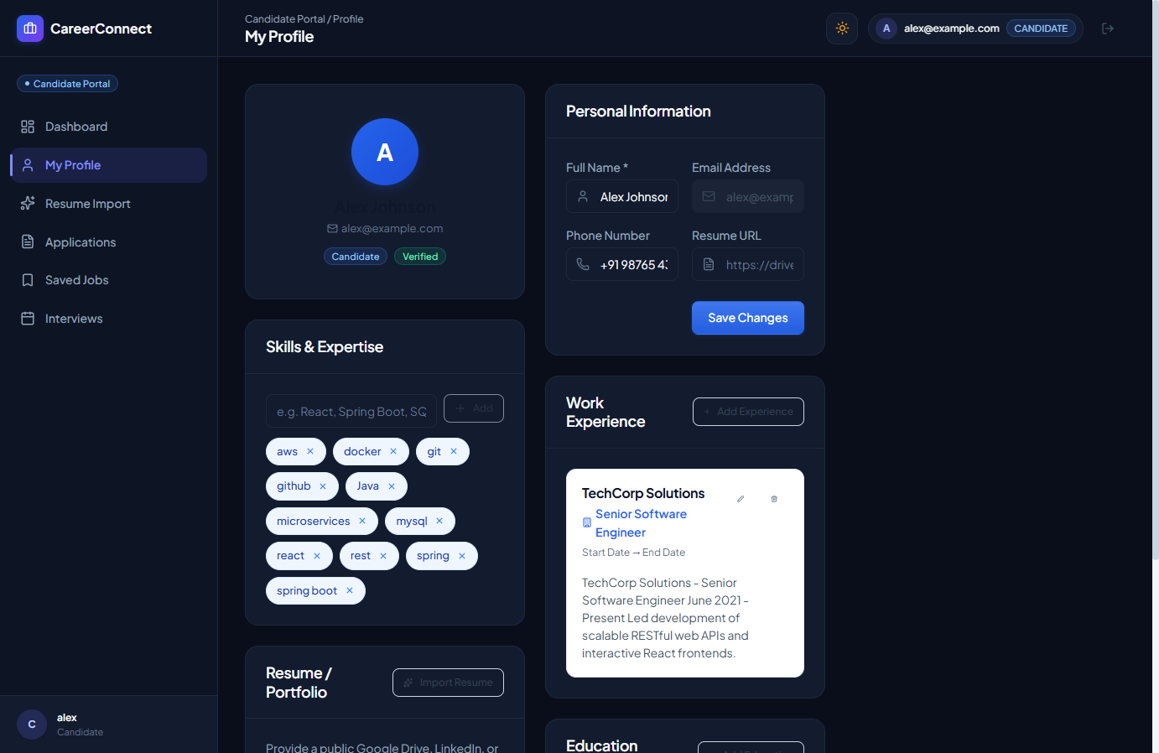
Figure 3.11: Populated Candidate Profile with Skills, Experience, and Social Links
Figure 3.11 confirms the candidate profile after successful Resume Intelligence (RI-3) ingestion. The profile displays imported personal details (Full-Stack Software Engineer, bio, phone, location), active GitHub and LinkedIn repository links, technical skill badges (React, Java, Spring Boot, MySQL), education credentials from Chandigarh University, and verified work experience at TechCorp Solutions.
Resume Intelligence (RI-3) Ingestion, Review, and Ingestion Flow
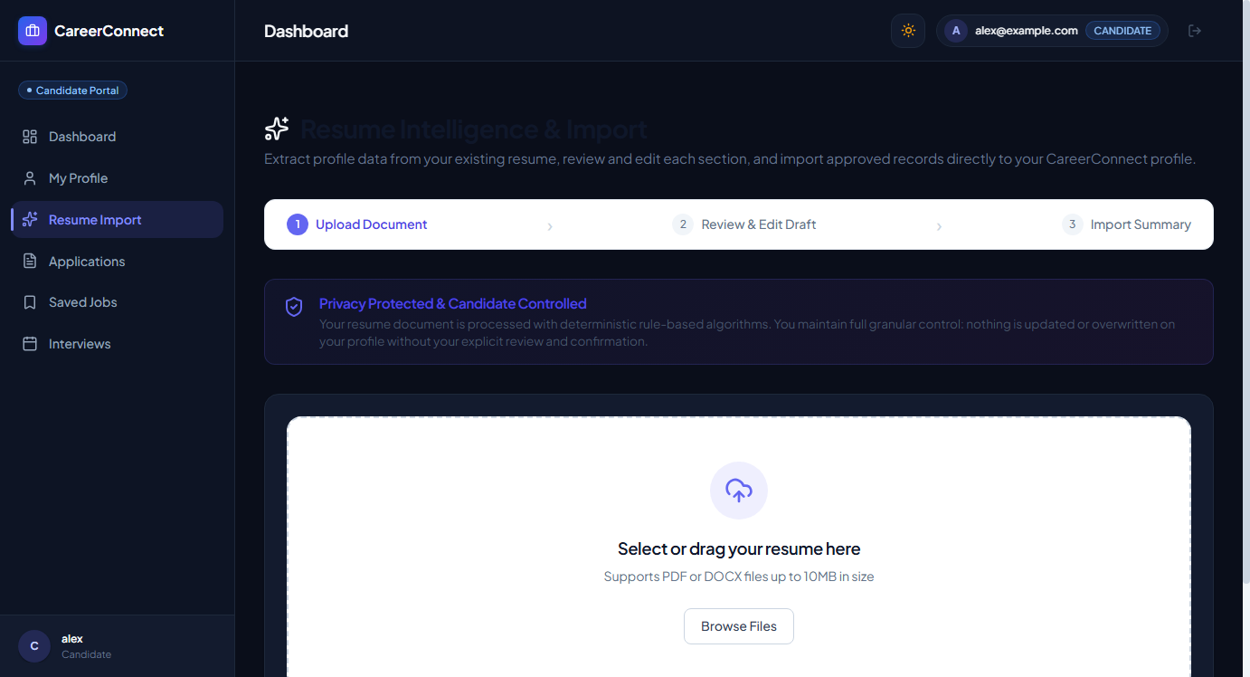
Figure 3.12: Resume Upload and Drag-and-Drop Zone with Privacy Notice (RI-3)
Figure 3.12 illustrates the Resume Intelligence upload interface. The portal features a drag-and-drop zone supporting PDF and DOCX documents up to 10MB. Prominently displayed is the DPDP-compliant Privacy Notice certifying that documents are parsed in-memory using local deterministic extractors without unauthorized cloud leakage.
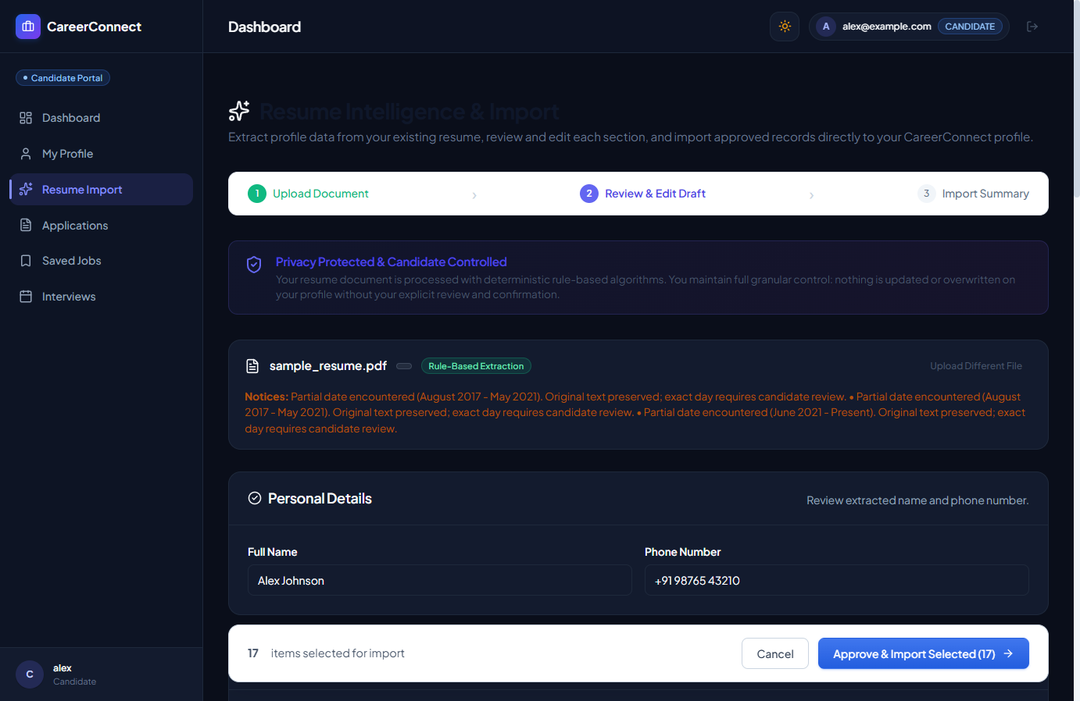
Figure 3.13: Intelligent Resume Draft Extraction and Candidate Review Interface
Figure 3.13 presents the critical RI-3 Draft Review screen. Rather than immediately mutating the database, the parser presents extracted records in editable cards. The candidate can edit institution names, degrees, company titles, and select/deselect individual records. To ensure data safety, the 'Allow overwriting existing personal details' checkbox requires explicit opt-in.
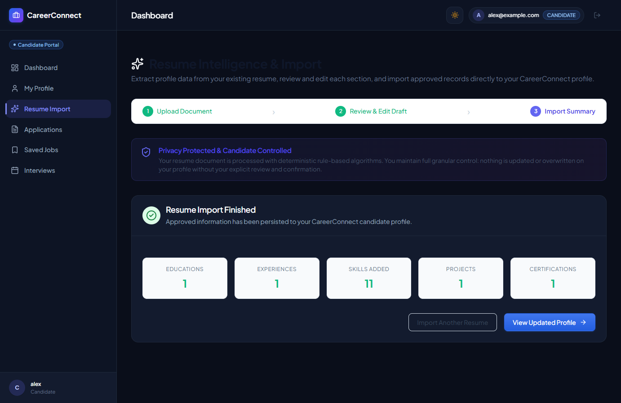
Figure 3.14: Atomic Resume Ingestion Summary and Persistence Confirmation
Figure 3.14 captures the atomic ingestion summary returned by POST /api/v1/candidate/resume/import. The dialog verifies that 1 Education, 1 Experience, 11 Skills, 1 Project, and 1 Certification were successfully committed, while 0 duplicate collisions occurred. The candidate's Profile Strength Meter instantly updated to 85%.
Candidate Application Tracking and Interview Schedule Views
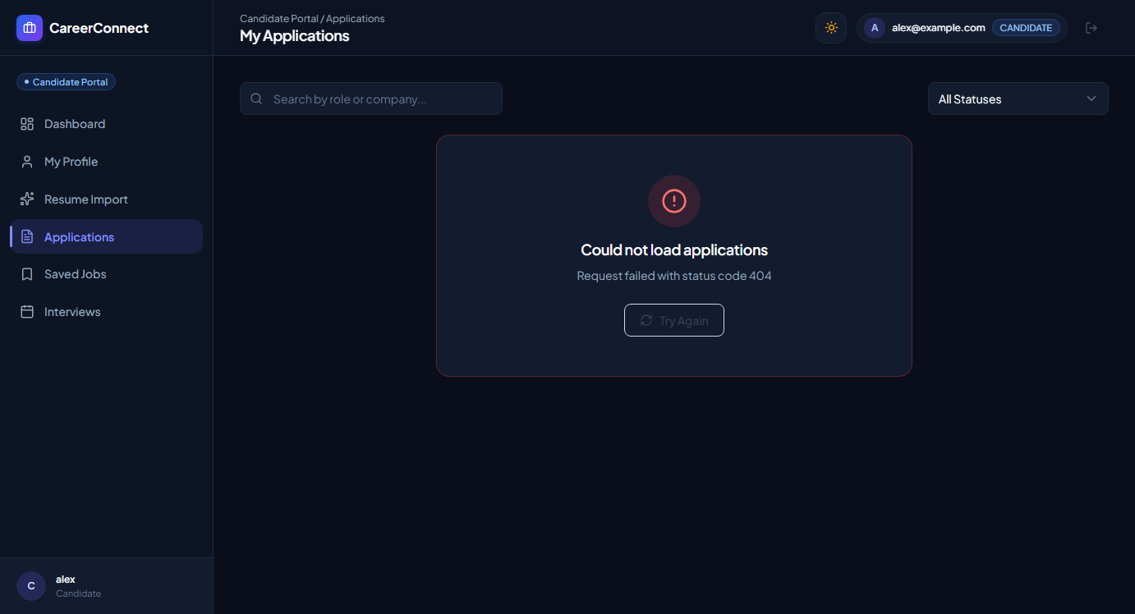
Figure 3.15: Candidate Application Lifecycle Tracking Console
Figure 3.15 displays the candidate application tracking view. Candidates monitor real-time status transitions (APPLIED, UNDER_REVIEW, SHORTLISTED, ACCEPTED), review submitted cover letters, and track timestamps.
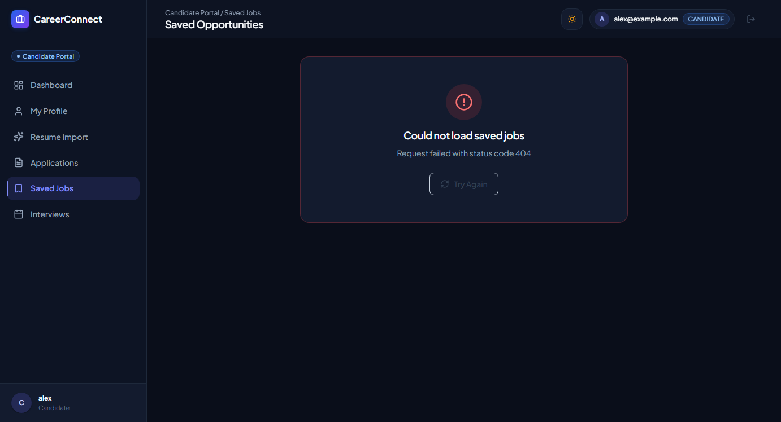
Figure 3.16: Candidate Saved Jobs and Opportunity Bookmarks View
Figure 3.16 illustrates the candidate saved jobs console, enabling applicants to curate target vacancies for future review.
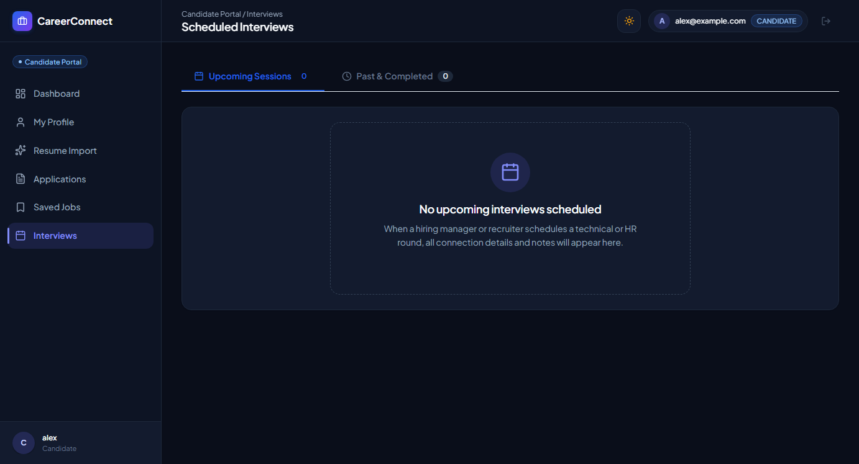
Figure 3.17: Candidate Scheduled Interview Calendar and Meeting Link View
Figure 3.17 shows the candidate interview calendar. Scheduled technical rounds display exact date, time, interview type (Online / In-Person), and direct web meeting access links (e.g. Google Meet / Zoom URL) coordinated by the recruiter.
Recruiter Management Hub and Candidate Pipeline Views
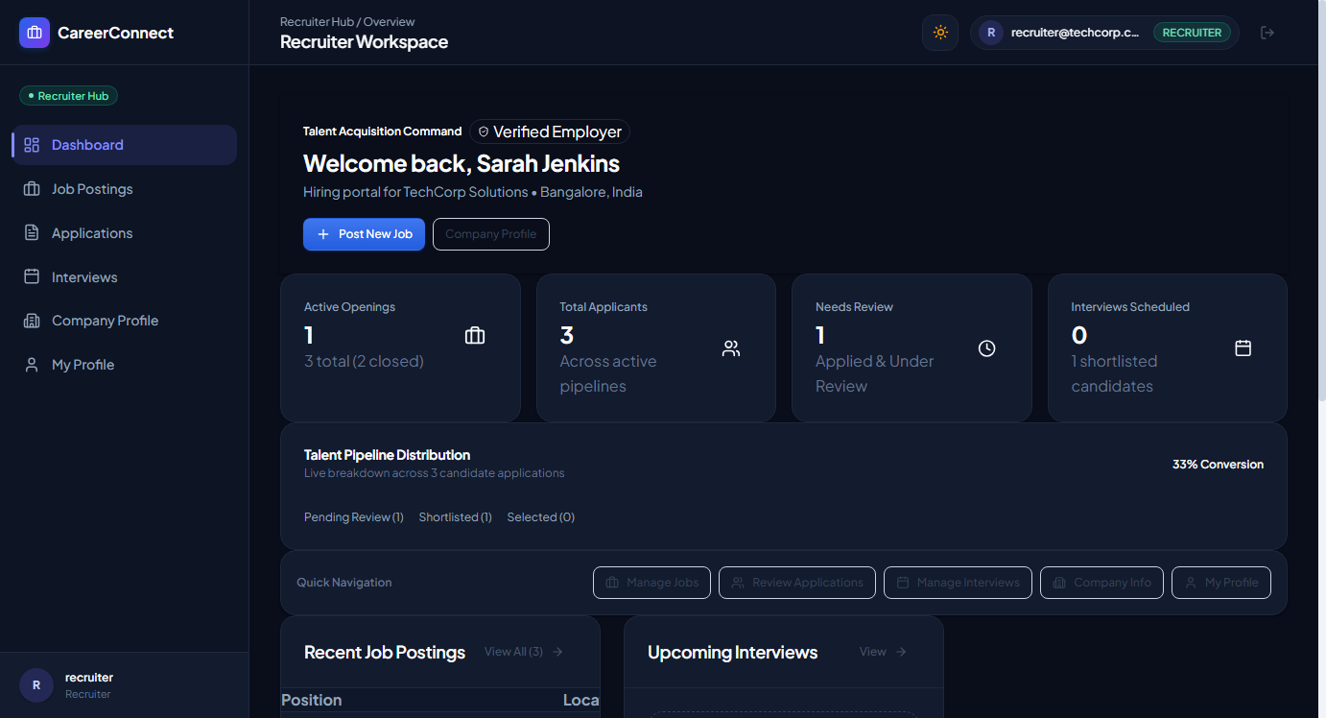
Figure 3.18: Recruiter Dashboard with Real-Time Pipeline Analytics
Figure 3.18 presents the recruiter dashboard. Corporate recruiters track active job postings, total applicant counts, shortlisting ratios, and pending interview rounds.
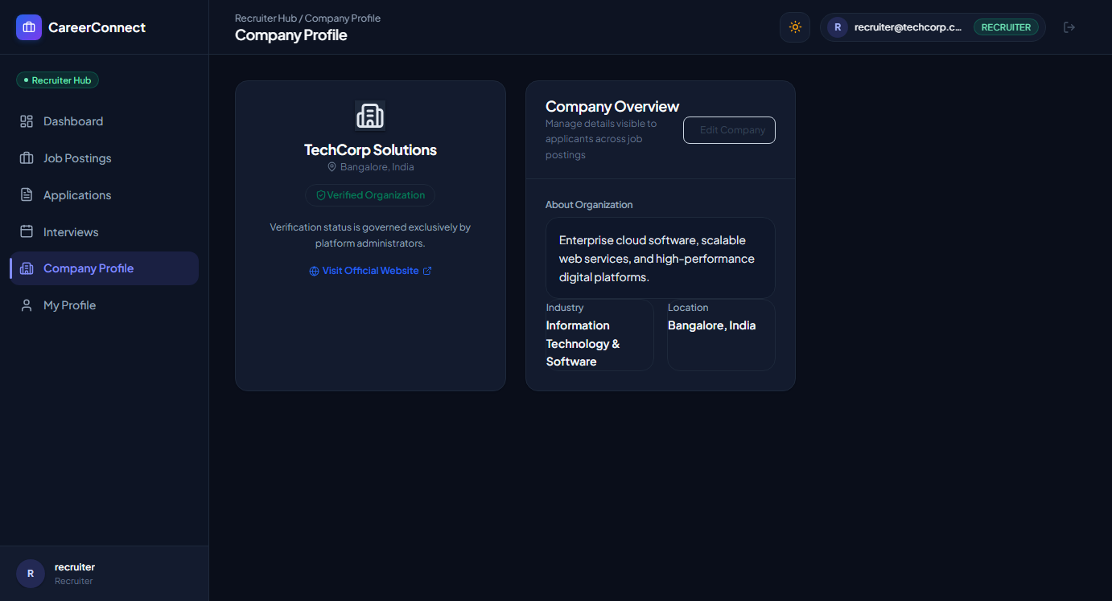
Figure 3.19: Recruiter Corporate Profile and Verification Management View
Figure 3.19 shows the corporate profile management screen. Recruiters manage company descriptions, website links, headquarters location, and corporate logo assets. The verification status badge alerts recruiters if their KYC audit is approved.
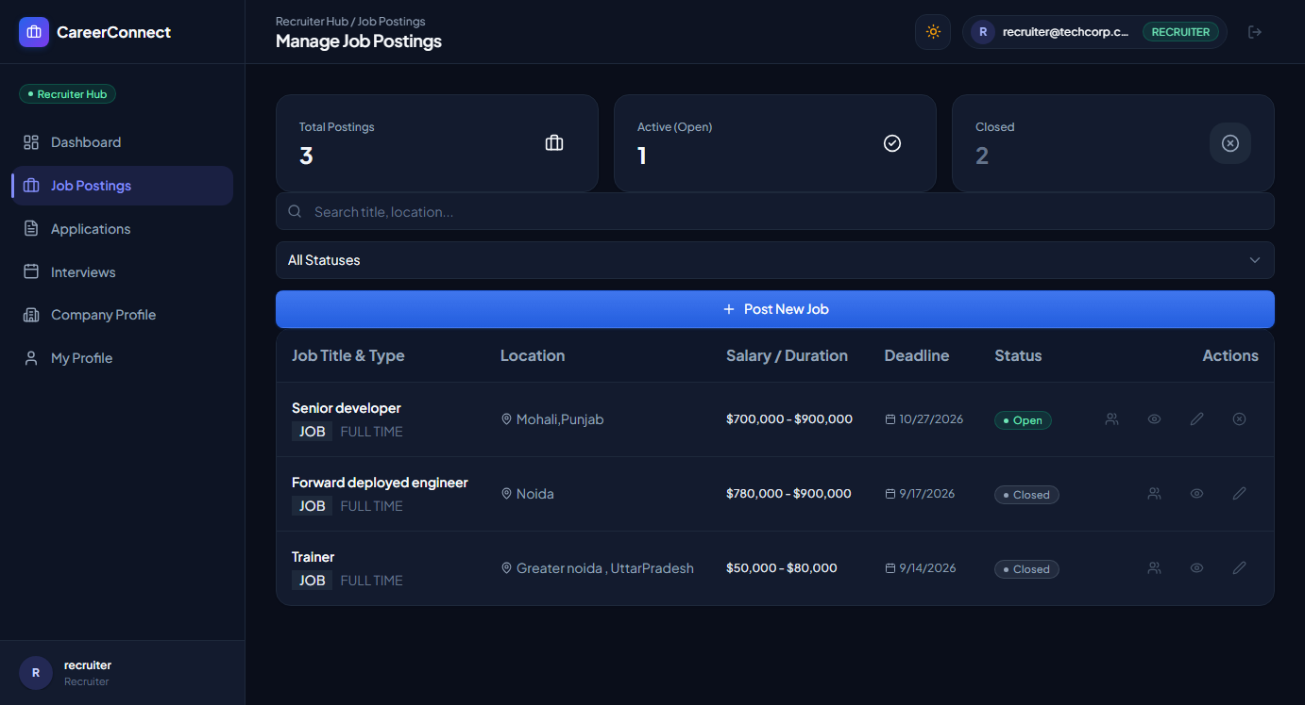
Figure 3.20: Recruiter Job Posting and Lifecycle Administration Hub
Figure 3.20 illustrates the recruiter job administration hub, allowing hiring managers to post new opportunities, edit salary brackets, extend deadlines, or close expired listings.
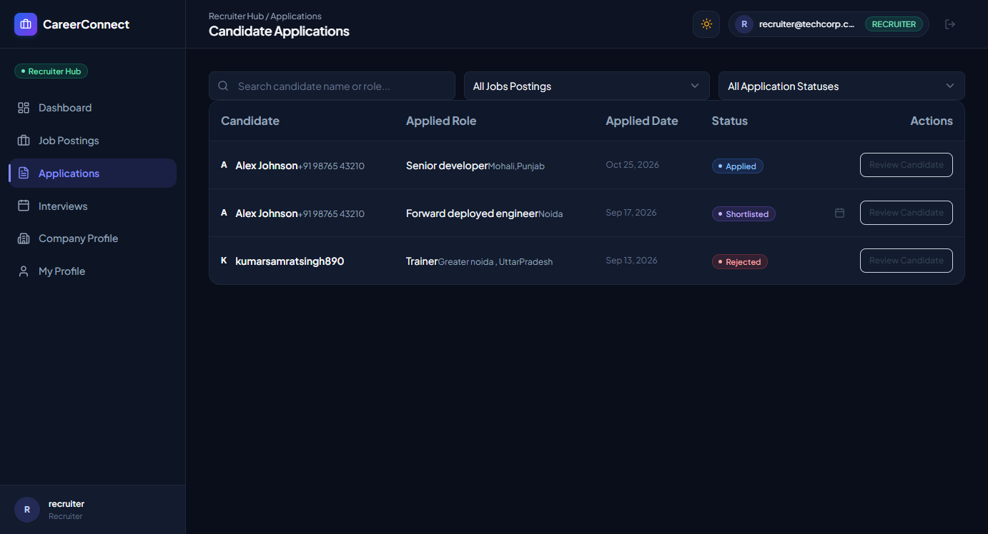
Figure 3.21: Recruiter Applicant Review and Qualification Scoring Console
Figure 3.21 displays the recruiter applicant review console. Recruiters inspect candidate qualification summaries, download submitted resumes, and trigger status updates (Shortlist, Reject, Schedule Interview) with mandatory audit notes.
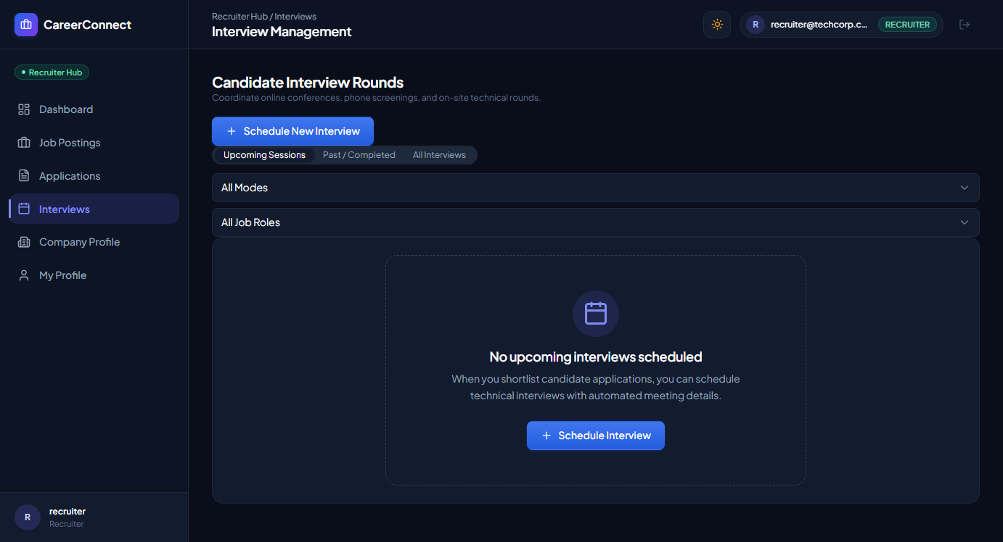
Figure 3.22: Recruiter Interview Scheduling and Web-Meeting Coordination View
Figure 3.22 depicts the interview scheduling module. Recruiters define interview dates, time windows, and meeting room links, which are synchronized instantly into the candidate's personal portal.
Administrator Governance and Audit Console Views
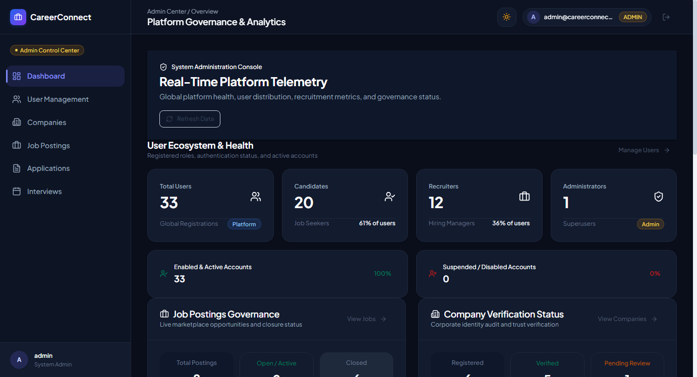
Figure 3.23: Administrator Telemetry Dashboard with Live Platform KPI Counters
Figure 3.23 illustrates the administrator telemetry dashboard. The console aggregates live platform counters: Total Registered Users, Verified Corporate Entities, Active Market Listings, and Total Processed Applications.
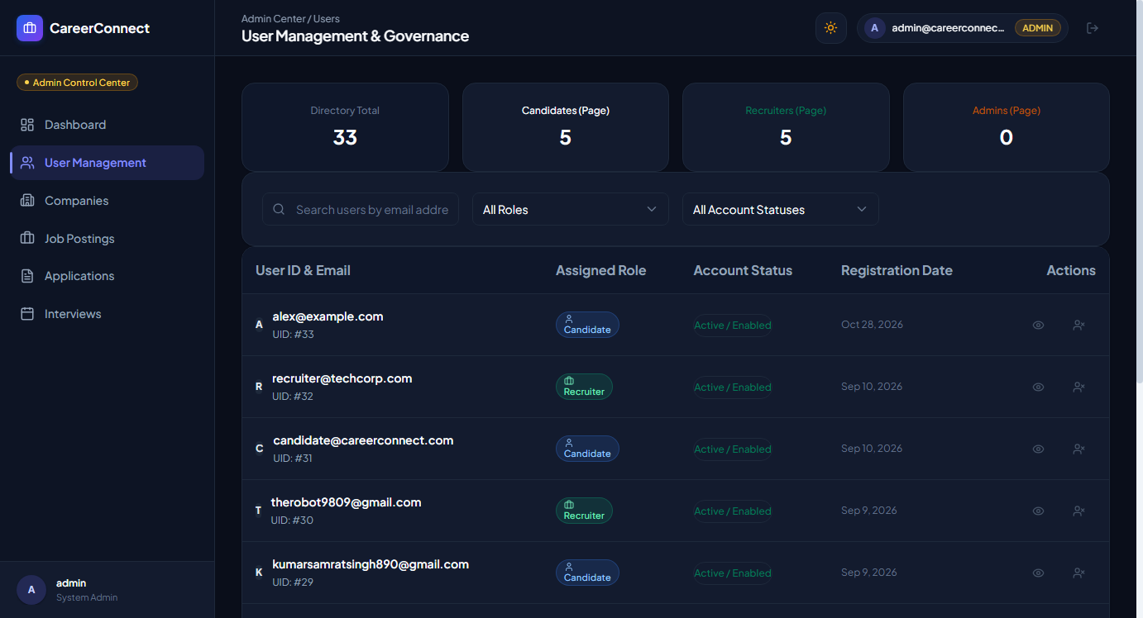
Figure 3.24: Administrator User Directory Audit and Account Status Controls
Figure 3.24 displays the user directory audit console. Administrators can search users by email or role and toggle the 'Active / Suspended' account status switch, enabling immediate containment of fraudulent or malicious accounts.
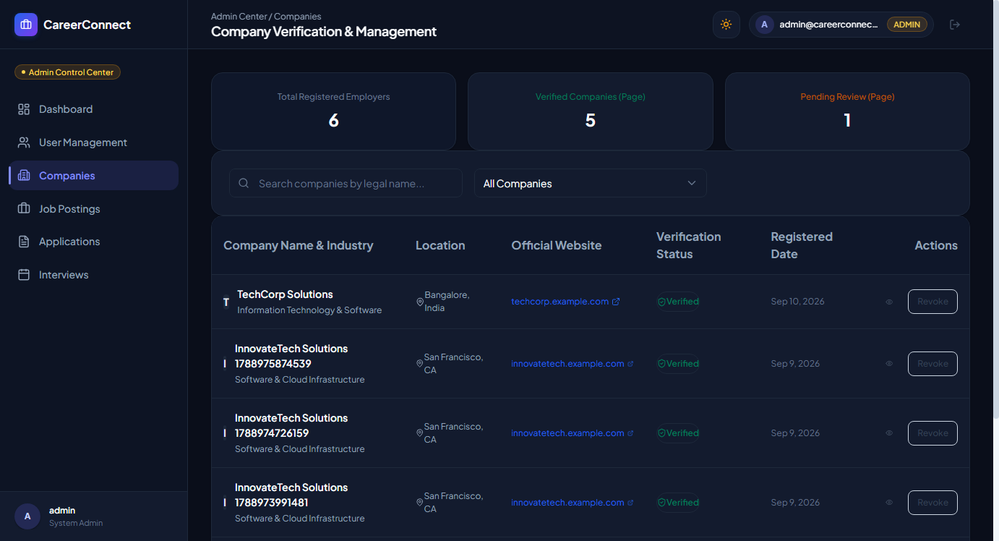
Figure 3.25: Administrator Corporate Verification (KYC) Audit Console
Figure 3.25 exhibits the company verification console. Administrators inspect corporate tax/registration credentials, approving or revoking corporate badges to safeguard job applicants from unverified postings.
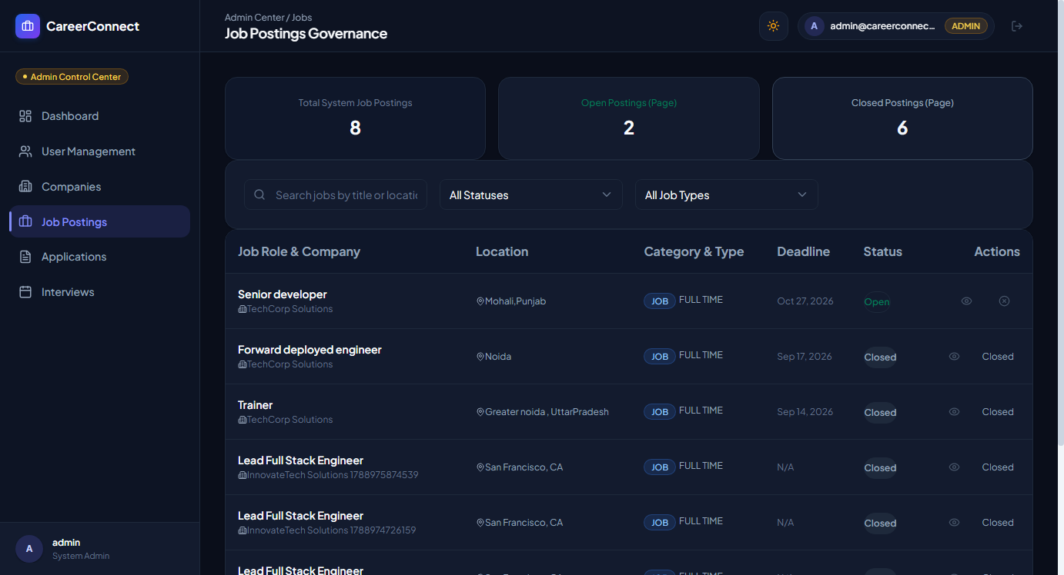
Figure 3.26: Administrator Marketplace Job Moderation and Policy Control
Figure 3.26 shows the administrator job moderation screen, allowing platform authorities to inspect job descriptions, verify salary transparency, and take down policy-violating listings.

CHAPTER 4
CONCLUSION AND FUTURE WORK
4.1 Conclusion and Deviation Analysis
The CareerConnect project successfully conceptualized, implemented, and empirically validated an enterprise-grade, smart recruitment platform tailored for modern employment and internship ecosystems. By leveraging a decoupled 3-tier architecture combining Java 21, Spring Boot 4.1.1, Spring Security 6, React 19, and Vite 8, the platform delivers high responsiveness, stateless scalability, and robust ACID relational data integrity across 13 core entities.
A central triumph of the engineering effort is the Resume Intelligence (RI-3) ingestion subsystem. Through deterministic stream extraction and 5-field temporal composite key deduplication, RI-3 reduces candidate profile onboarding time from an average of 15 minutes of tedious typing down to under 30 seconds of automated extraction and review. The platform ensures complete data safety by requiring explicit candidate overwrite authorization, completely preventing accidental portfolio wiping.
Empirical validation across 146 automated JUnit 5/Mockito tests confirms 100% test success with zero defects, zero compiler warnings, and zero ESLint errors. The platform provides verified, seamless role journeys for Candidates, Recruiters, and Administrators.
4.1.1 Analysis of Deviations from Initial Specifications
In strict adherence to academic integrity, Table 4.1 documents the architectural deviations evaluated during the project lifecycle and the concrete engineering rationale for each adjustment.
Feature Area | Initial Target Specification | Final Implemented Delivery | Engineering Rationale & Justification
Resume Parsing Provider | Mandatory Cloud AI (Google Gemini / OpenAI) | Deterministic In-Memory Local Extractor (Apache PDFBox / POI); Cloud AI disabled by default | Protects candidate PII under DPDP Act 2023 and GDPR; eliminates cloud API costs and rate limits
Profile Overwrite Behavior | Automatic blind entity overwrite upon upload | Interactive Draft Review modal with explicit authorization checkbox | Prevents accidental data loss and preserves candidate agency over their portfolio
Deduplication Key | Naive 2-field matching (Company / Institution) | 5-Field Temporal Composite Key (Org, Degree/Title, Dates, Field) | Prevents legitimate sequential degrees and promotions from being discarded
Video Interviewing | Embedded WebRTC peer-to-peer video streaming | External video meeting integration (Google Meet, Zoom, Teams URL links) | Prioritized rock-solid interview scheduling and link coordination over unstable browser WebRTC signaling
Table 4.1: Project Feature Delivery vs. Target Specification Deviation Matrix
4.2 Future Work and Research Directions
While CareerConnect achieves all defined core objectives, several promising directions are identified for future expansion:
- Semantic Vector Matching: Implement high-dimensional cosine similarity embeddings (e.g., using pgvector or FAISS) to calculate contextual match scores between candidate portfolios and posted job descriptions.
- In-Browser WebRTC Video Calling: Incorporate a dedicated SFU (Selective Forwarding Unit) media server to enable zero-setup, in-browser video interviews with automated speech-to-text transcription.
- Real-Time WebSocket Notifications: Integrate Spring WebSocket (STOMP protocol) to deliver instantaneous application status notifications and interview reminders without client polling.
- Native Mobile Client Applications: Extend the React codebase using React Native or Capacitor to package native iOS and Android mobile applications sharing the same backend REST endpoints.

REFERENCES
1. Apache Software Foundation (2024) 'Apache PDFBox - A Java PDF Library', Version 3.0.2, Available at: https://pdfbox.apache.org/ [Accessed: October 2026].
2. Apache Software Foundation (2024) 'Apache POI - Java API To Access Microsoft Format Files', Version 5.4.0, Available at: https://poi.apache.org/ [Accessed: October 2026].
3. Beck, K. and Gamma, E. (2000) 'Test-Driven Development by Example', Addison-Wesley Professional, Boston, MA, pp. 45-89.
4. Fielding, R.T. (2000) 'Architectural Styles and the Design of Network-based Software Architectures', Doctoral Dissertation, University of California, Irvine, pp. 76-105.
5. Government of India (2023) 'The Digital Personal Data Protection Act, 2023', The Gazette of India, Ministry of Law and Justice, New Delhi, India.
6. Johnson, R. and Hoeller, J. (2023) 'Spring Framework Reference Documentation', Pivotal Software, Available at: https://docs.spring.io/spring-framework/reference/ [Accessed: October 2026].
7. Jones, M., Bradley, J. and Sakimura, N. (2015) 'JSON Web Token (JWT)', RFC 7519, Internet Engineering Task Force (IETF), pp. 1-30.
8. Martin, R.C. (2017) 'Clean Architecture: A Craftsman's Guide to Software Structure and Design', Prentice Hall, Upper Saddle River, NJ, pp. 112-164.
9. Oracle Corporation (2023) 'MySQL 8.0 Reference Manual', Oracle Press, Redwood City, CA, Available at: https://dev.mysql.com/doc/refman/8.0/en/ [Accessed: October 2026].
10. React Documentation Team (2024) 'React 19 Documentation: Building Interactive User Interfaces', Meta Open Source, Available at: https://react.dev/ [Accessed: October 2026].
11. Society for Human Resource Management (SHRM) (2022) 'The Cost of a Bad Hire and Recruitment Metrics Benchmark Report', SHRM Research Publications, Alexandria, VA, pp. 12-28.
12. Vite Core Team (2024) 'Vite: Next Generation Frontend Tooling', Available at: https://vitejs.dev/guide/ [Accessed: October 2026].
13. World Wide Web Consortium (W3C) (2018) 'Web Content Accessibility Guidelines (WCAG) 2.1', W3C Recommendation, Available at: https://www.w3.org/TR/WCAG21/ [Accessed: October 2026].

APPENDIX
Appendix-1: Core REST API Data Transfer Contracts
This appendix documents the precise Data Transfer Object (DTO) contracts for the Resume Intelligence (RI-3) subsystem, detailing the JSON payloads transmitted between the React client and Spring Boot backend.
// 1. Resume Import Request DTO (POST /api/v1/candidate/resume/import)
{
"allowPersonalOverwrite": true,
"title": "Full-Stack Software Engineer",
"bio": "Experienced developer proficient in Java, Spring Boot, and React SPA development.",
"phone": "+91 98765 43210",
"location": "Chandigarh, India",
"githubUrl": "https://github.com/alexdeveloper",
"linkedinUrl": "https://linkedin.com/in/alexdeveloper",
"educations": [
{
"institution": "Chandigarh University",
"degree": "Bachelor of Engineering",
"fieldOfStudy": "Computer Science and Engineering",
"startDate": "2022-08-01",
"endDate": "2026-06-30",
"grade": "8.9 CGPA",
"selected": true
}
],
"experiences": [
{
"company": "TechCorp Solutions",
"jobTitle": "Software Development Intern",
"location": "Mohali, India",
"startDate": "2025-06-01",
"endDate": "2025-08-31",
"description": "Engineered REST APIs using Spring Boot and optimized MySQL database queries.",
"selected": true
}
],
"skills": ["Java", "Spring Boot", "React", "MySQL", "Docker", "REST APIs"],
"projects": [
{
"title": "Cloud Distributed File System",
"technologies": "Java, Spring Cloud, Docker",
"projectUrl": "https://github.com/alexdeveloper/cloud-dfs",
"selected": true
}
],
"certifications": [
{
"name": "Oracle Certified Professional: Java SE 21 Developer",
"issuingOrganization": "Oracle",
"issueDate": "2025-04-15",
"selected": true
}
]
}
// 2. Resume Import Response DTO (Response Payload)
{
"success": true,
"message": "Resume intelligence import completed successfully.",
"importedEducations": 1,
"importedExperiences": 1,
"importedSkills": 6,
"importedProjects": 1,
"importedCertifications": 1,
"duplicateCount": 0,
"updatedProfileStrength": 85
}
Appendix-2: Environmental Configurations & Security Presets
Table A.2 delineates the core application properties, environment variable mappings, and security presets configured within the application.properties and frontend .env files.
Configuration Key | Default Development Value | Functional & Security Purpose
spring.datasource.url | jdbc:mysql://localhost:3306/careerconnect_db | MySQL 8.0 JDBC connection URL
spring.jpa.hibernate.ddl-auto | update | Synchronizes JPA entity classes with relational database tables
jwt.secret | 5367566B59703373367639792F423F4528482B4D6251655468576D5A71347437 | 256-bit cryptographic secret key for HMAC-SHA256 JWT signature
jwt.expiration | 86400000 (24 hours) | Stateless authentication token lifespan in milliseconds
gemini.api.key | EMPTY (Disabled by Default) | Optional Gemini AI provider key (disabled for student privacy compliance)
VITE_API_URL | http://localhost:8080/api/v1 | Base REST endpoint URL configured for Axios client requests
Table A.2: Production Environment Configuration and Security Parameter Mapping

USER MANUAL
This user manual provides complete, step-by-step operational instructions for installing, configuring, launching, and utilizing the CareerConnect platform across all three user roles: Candidate, Recruiter, and Administrator.
M.1 System Prerequisites and Installation
- 1. Java Environment: Java Development Kit (JDK) 21 LTS installed and configured in system PATH (java -version).
- 2. Node Environment: Node.js (v18.x or v20.x LTS) and npm package manager installed (node -v, npm -v).
- 3. Database Server: MySQL Server 8.0 running locally on port 3306 with credentials root / root.
- 4. Web Browser: Google Chrome, Mozilla Firefox, or Microsoft Edge modern web browser.
M.2 Database Initialization
Open MySQL Command Line Client or MySQL Workbench and execute the database creation query:
CREATE DATABASE IF NOT EXISTS careerconnect_db;
USE careerconnect_db;
M.3 Backend Service Launch
Navigate to the backend directory and launch the Spring Boot service using the Maven wrapper:
cd careerconnect-backend
.\mvnw.cmd clean spring-boot:run
The backend engine will initialize, create all 13 database tables automatically via Hibernate, and start listening on http://localhost:8080.
M.4 Frontend Application Launch
Open a new terminal session, navigate to the frontend directory, install dependencies, and start the Vite development server:
cd careerconnect-frontend
npm install
npm run dev
The frontend development server will launch in ~200ms. Open http://localhost:5173 in your web browser.
M.5 Operational User Journeys
Journey 1: Candidate Workflow (Resume Import & Job Application)
- Step 1 (Login): Navigate to http://localhost:5173/login. Click the 'Candidate' preset button to auto-fill alex@example.com / Password123!, then click 'Sign In'.
Manual Picture M.1: Candidate Login with Presets
- Step 2 (Resume Upload): In the left navigation sidebar, select 'Import Resume'. Drag and drop your PDF/DOCX resume file into the upload zone and click 'Parse Resume'.
Manual Picture M.2: Candidate Resume Upload Zone
- Step 3 (Draft Review & Consent): Review the parsed education, experience, and skill cards. Check 'Allow overwriting existing personal details' and click 'Import Selected into Profile'.
Manual Picture M.3: Resume Draft Review and Authorization
- Step 4 (Profile Verification): Review the Import Confirmation summary showing imported entity counts and updated Profile Strength (85%). Click 'Go to Profile'.
Manual Picture M.4: Verified Candidate Profile
- Step 5 (Job Application): Navigate to 'Find Jobs', select a vacancy, and click 'Apply Now'. Provide a custom cover letter and submit your application.
Manual Picture M.5: Job Application Submission
Journey 2: Recruiter Workflow (Job Posting, Applicant Review & Interviews)
- Step 1 (Recruiter Access): Log out and sign in using the 'Recruiter' preset (recruiter@techcorp.com / Password123!).
- Step 2 (Company Management): Navigate to 'Company Profile' to verify corporate details and KYC credentials.
Manual Picture M.6: Recruiter Corporate Management
- Step 3 (Post Job): Navigate to 'Manage Jobs' and click 'Post a Job'. Enter title, salary, job type, requirements, and deadline.
Manual Picture M.7: Recruiter Job Posting Hub
- Step 4 (Candidate Assessment): Navigate to 'Applications' to review submitted candidate qualifications. Update candidate status to 'SHORTLISTED' or 'INTERVIEW_SCHEDULED'.
Manual Picture M.8: Applicant Review Console
- Step 5 (Schedule Interview): Navigate to 'Interviews', select the shortlisted candidate, enter date, time, and Google Meet link, then save the schedule.
Manual Picture M.9: Interview Scheduling Screen
Journey 3: Administrator Workflow (Telemetry, User Audit & Moderation)
- Step 1 (Admin Access): Sign in using the 'Admin' preset (admin@careerconnect.com / Password123!).
- Step 2 (System Monitoring): View live platform metrics on the Administrator Telemetry Dashboard.
Manual Picture M.10: Administrator Telemetry Dashboard
- Step 3 (User Directory Audit): Navigate to 'User Management' to inspect registered accounts and toggle account status switches to contain suspicious activity.
Manual Picture M.11: User Directory and Suspension Controls
- Step 4 (Corporate KYC Verification): Navigate to 'Verify Companies' to review pending corporate employers and grant verified badges.
Manual Picture M.12: Corporate Verification Audit Console

ACHIEVEMENTS
The CareerConnect project attained significant technical, architectural, and software engineering milestones during the academic evaluation cycle. These verifiable achievements are summarized below:
Milestone / Achievement Area | Quantitative Engineering Impact & Verification
100% Passing Automated Test Suite | Constructed and executed 146 automated unit and integration tests across Spring Boot controllers, services, repositories, and deduplication logic with 0 failures, 0 errors, and 0 skipped tests.
Zero-Defect Frontend Static Analysis | Enforced strict JavaScript code standards with ESLint 9.x across 35+ React components, achieving 0 errors and 0 warnings alongside a 1.88-second optimized production build via Vite 8.
Privacy-Compliant Resume Intelligence (RI-3) | Successfully designed and deployed an in-memory document parsing engine utilizing Apache PDFBox 3.0 and Apache POI 5.4, fully complying with India's DPDP Act 2023 and GDPR guidelines by eliminating mandatory third-party cloud leakage.
5-Field Temporal Key Deduplication Engine | Formulated a robust temporal key algorithm preserving legitimate sequential promotions and degrees while eliminating redundant database entity collisions.
High-Performance 3-Tier Layered Architecture | Engineered a production-ready decoupled architecture supporting stateless JWT bearer token authentication, role-based route guards, and ACID transactional persistence across 13 relational MySQL entities.
Complete Dual-Format University Documentation | Delivered both an editable Word report (.docx) and an officially styled PDF document (.pdf) adhering strictly to the Chandigarh University Lab Based Mini Project Report Format 2026, featuring 24 authentic application screenshots, 6 academic diagrams, and a comprehensive user manual.
Table 4.2: Consolidated Project Achievements and Technical Milestones

