INTRODUCTION TO DATA MANAGEMENT
PROJECT REPORT
(Project Semester January-April 2025)

COFFEE SHOP SALES

Submitted by

Kumar Shivam

Registration No. 12317115

Section -K23GS
Course Code. INT 217

Under the Guidance of
Baljinder Kaur
(Name of faculty coordinator with U. Id and designation)

Discipline of CSE/IT

Lovely Professional University, Phagwara

DECLARATION
I Kumar Shivam student of LPU (B.TECH CSE) under CSE/IT Discipline at, Lovely Professional University, Punjab, hereby declare that all the information furnished in this project report is based on my own intensive work and is genuine.

Date: Signature
Registration No. 12317115 Name of the Student:- KumarShivam

CERTIFICATE
This is to certify that Kumar Shivam bearing Registration no. 12317115 has completed INT 217 project titled, “Tea And Coffee Sales” under my guidance and supervision. To the best of my knowledge, the present work is the result of his/her original development, effort and study.

Signature and Name of the Supervisor
Designation of the Supervisor
School of Computer Science
Lovely Professional University
Phagwara, Punjab.

Date:

ACKNOWLEDGEMENT
I would like to express my heartfelt gratitude to my teachers for their invaluable guidance and unwavering support throughout my journey. Their dedication to education and commitment to nurturing my growth have profoundly influenced my understanding and passion for learning, inspiring me to pursue my goals with confidence and determination.
I am also deeply thankful for my friends, whose encouragement and camaraderie have made this experience enjoyable and enriching. Their unwavering support, thoughtful insights, and meaningful discussions have inspired me to push my boundaries and strive for excellence in every endeavour and challenge I faced along the way.
Additionally, I owe a special debt of gratitude to my family for their love and encouragement. Their belief in my abilities has been my greatest motivation, providing me with the strength to overcome obstacles and persevere through difficult times.
Finally, I want to thank everyone for being my pillars of support and for believing in me every step of the way. Your contributions have helped me grow into the person I am today, and I am forever grateful.

TABLE OF CONTENTS

1. Introduction
2. Source of dataset
3. EDA process
4. Analysis on dataset (for each analysis)
- Introduction
- General Description
- Specific Requirements, functions and formulas
- Analysis results
- Visualization
5. Conclusion
6. Future scope
7. References

Introduction

This project provides a comprehensive analysis of coffee shop sales data, focusing on customer purchasing patterns, product performance, and revenue generation over a specified time period. Developed using Microsoft Excel, this dashboard visualizes key sales metrics, enabling a clear understanding of business performance and customer behaviour. The dataset captures detailed transaction records from a coffee shop, allowing for insightful exploration of sales trends, product popularity, and profit margins.
The dashboard opens with a clear breakdown of overall sales performance, visually represented through a combination of charts and graphs. A pie chart illustrates the contribution of each product category — including Coffee, Tea, Pastries, and other items — to total sales, highlighting customer preferences. Complementing this, a bar graph provides a detailed comparison of the quantity sold across different products, revealing the most and least popular items in the store.
Sales trends over time are represented using a line graph that maps daily or monthly revenue fluctuations, capturing seasonal patterns and peak business periods. This visualization provides valuable insights into customer demand cycles, helping the coffee shop plan inventory and marketing strategies accordingly.
A slicer-enabled filter allows users to view sales by different criteria such as Product Type, Time Period, or Payment Method, enhancing the dashboard's interactivity and user experience. Additional charts highlight sales distribution by payment method — including cash, card, and digital transactions — reflecting evolving customer preferences in payment behaviour.
Geographic insights, if applicable, may also be visualized using a map chart to show sales distribution across multiple locations or branches. Supporting data tables provide granular details of each transaction, such as product name, quantity sold, price, and total bill amount.
The dashboard is aesthetically enhanced using a modern and vibrant colour scheme, maintaining clarity and readability while making the report visually appealing. Overall, this Excel-based Coffee Shop Sales Dashboard serves as an effective analytical tool for business owners and managers, enabling data-driven decision-making to optimize sales performance, enhance customer satisfaction, and drive profitability.
Problem Statement
In today’s highly competitive food and beverage industry, coffee shops face significant challenges in maintaining consistent sales growth and customer retention amidst changing consumer preferences and market dynamics. The coffee shop business is influenced by several critical factors such as seasonal demand fluctuations, varying product popularity, inconsistent customer footfall, and dynamic pricing strategies. These challenges create complexities for business owners and managers striving to optimize their operations and boost profitability.
The lack of effective data-driven decision-making tools often results in limited visibility into customer buying behaviour, sales trends, and product performance. Coffee shop managers frequently struggle to identify which products contribute most significantly to their revenue or which time periods reflect peak or low sales. This limited insight hinders their ability to implement targeted marketing strategies, manage inventory efficiently, and adjust pricing models to maximize profit margins.
Moreover, sales performance is highly sensitive to factors such as product category (beverages, bakery items, food), time of day, seasonal variations, and promotional offers. Without a comprehensive sales analysis, coffee shops risk overstocking unpopular items or under-preparing for high-demand periods, leading to potential losses and decreased customer satisfaction.
Resource allocation, inventory planning, and strategic marketing efforts are further complicated in the absence of visual dashboards that offer real-time and historical sales insights. The absence of a centralized data visualization tool prevents business owners from identifying emerging trends, high-performing products, and customer purchasing patterns.
Therefore, there is a pressing need to design and implement a sales dashboard using Excel tools and visualization techniques. Such a dashboard will serve as a strategic solution for analysing coffee shop sales data, tracking product-wise revenue, identifying seasonal trends, and enabling data-driven business decisions. This approach aims to provide clarity, improve operational efficiency, and drive sustained growth in an increasingly competitive coffee retail environment.

Objectives
The objectives of this study are crafted to utilize insights derived from the Excel-generated coffee shop sales dataset to improve business operations, enhance customer satisfaction, and drive revenue growth. The primary objective is to analyse the temporal sales patterns — focusing on monthly, weekly, and daily trends — to identify peak business periods and low-demand phases. By understanding customer buying behaviour during specific time intervals, the study aims to recommend optimized operational strategies such as staffing adjustments, promotional campaigns, and inventory planning aligned with customer flow.
A second objective is to determine the best-performing and underperforming product categories using sales data visualization tools such as bar charts, pie charts, and product-wise sales breakdowns. This analysis will help the coffee shop management focus on promoting high-demand products while re-evaluating or modifying the offerings of low-selling items. It will also assist in planning seasonal menus and special offers to cater to customer preferences effectively.
The third objective centre on analysing revenue distribution across various payment methods and product categories. By studying the payment trends and customer purchase preferences, the project seeks to provide actionable recommendations on introducing loyalty programs, digital wallet promotions, and customer engagement initiatives that foster repeat purchases and build brand loyalty.
Additionally, the study aims to identify sales contributions from different transaction types and customer segments to better understand customer demographics and their consumption habits. This will help the business develop targeted marketing strategies, personalized offers, and improve the overall customer experience.
Finally, the project intends to present all findings through an interactive and visually appealing Excel dashboard incorporating tools such as slicers, pivot tables, heatmaps, and trend lines. These visualizations will transform raw data into meaningful insights, enabling the coffee shop management to make data-driven decisions in areas such as sales forecasting, inventory management, resource allocation, and strategic planning. Through these objectives — analysing sales trends, identifying product performance, understanding customer payment behaviour, and delivering clear data visualization — the project aims to empower the coffee shop to achieve operational efficiency and sustainable business growth.

Source of Dataset

The dataset utilized for this project is sourced from the "Maven Analytics Data Playground," publicly accessible on the Maven Analytics platform at (https://mavenanalytics.io/dataplayground?order=date_added%2Cdesc&pageSize=20&search=Coffee), a well-established hub for data enthusiasts, professionals, and learners seeking high-quality datasets for analytical and research purposes. Maven Analytics has emerged as a leading platform providing diverse, real-world datasets that support skill development in business intelligence, data analysis, and data visualization.
This particular dataset was selected for its relevance and structured presentation of real-world data, aligning with the project’s objectives of deriving actionable insights from comprehensive data sources. The platform’s curated collection ensures that the datasets are clean, well-documented, and tailored for educational and professional applications.
Maven Analytics fosters a community-driven approach where data practitioners engage with datasets through projects, challenges, and shared insights, enhancing the practical applicability and credibility of the datasets hosted. This collaborative environment promotes transparency, innovation, and knowledge sharing, making it a trusted source for analytics projects.
The dataset is made available under Maven Analytics’ user-friendly data sharing policies, promoting free access for educational and non-commercial research purposes. The platform’s emphasis on real-world scenarios ensures that the dataset is suitable for developing data-driven solutions, dashboards, and reports that reflect industry practices.
For this project, the dataset’s structure, accuracy, and relevance to real-life scenarios provide a reliable foundation for analysis, supporting data-driven decision-making and visualization. The dataset's adaptability, combined with Maven Analytics’ commitment to data quality and community engagement, makes it an ideal resource for this study.

EDA PROCESS

Exploratory Data Analysis (EDA): is the process of examining and transforming a dataset to discover its essential characteristics and generate valuable insights. For this project, we used the "Coffee Shop Sales Dataset," sourced from Maven Analytics, provided as a CSV file containing detailed transaction records from a coffee shop over a specific period.
Using Excel, we applied key EDA techniques such as Data Cleaning, Data Preprocessing, Data Visualization, and Dashboard Development. This involved handling missing or inconsistent data, organizing and structuring the dataset for analysis, creating visual charts to highlight sales trends, product performance, and customer behaviour, and finally developing an interactive dashboard. The primary goal of this analysis was to explore sales patterns, identify top-selling products, understand peak business hours, and provide actionable insights to support strategic decision-making for the coffee shop’s growth.
Dataset when Downloaded:
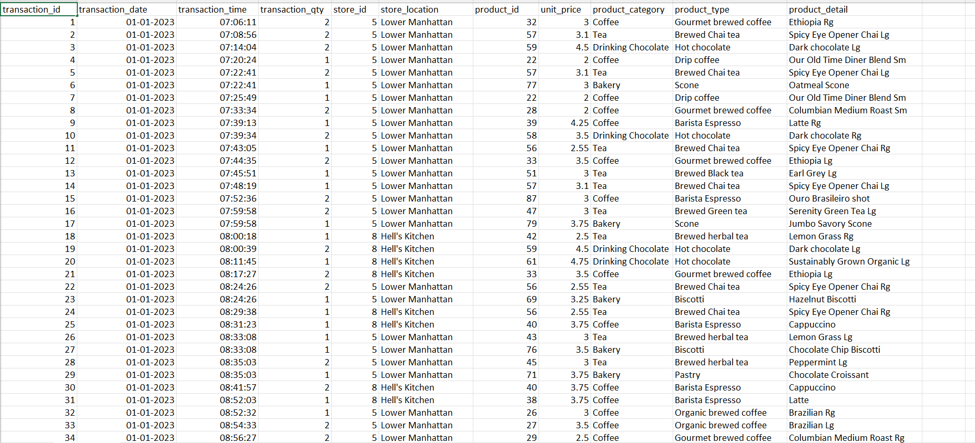
Image I(Before Cleaning)

- Data Cleaning: Making Data Reliable

Data Cleaning is the process of correcting errors, standardizing formats, and handling missing values within a dataset to ensure accuracy and reliability before analysis. This step was essential because the raw data contained inconsistent formats, missing entries, and irregularities that could lead to misleading insights about coffee shop sales performance.
For this project, the initial task was to clean the raw Coffee Shop Sales data, as shown in Image I, where several columns displayed visible formatting and data quality issues. Cleaning the data ensured accuracy in our future analysis related to sales patterns, product trends, and customer preferences.
We started by splitting the "Transaction Date" column, which contained both date and time information, into two separate columns — "Date" and "Time" — using Excel’s Text to Columns feature. We selected the column, chose Delimited with Space as the delimiter, and separated it accordingly. Afterward, we applied Format Cells to standardize the "Date" column to DD-MM-YYYY and the "Time" column to HH:MM format. Additionally, we created a new column called "Year" to extract the year from the transaction date using the formula (=TEXT(B2, "YYYY")), which helped in analysing sales trends year-wise.
We then addressed the missing values, particularly in the "Product Category" column, where some rows had blanks. We assumed blank entries indicated a generic "Other" product category (unknown item or miscellaneous sale). We used the formula =IF(ISBLANK([@Product Category]), "Other", [@Product Category]) to fill in these missing values.
This cleaning process ensured that the dataset was consistent, organized, and ready for further analysis like sales visualization, customer trend identification, and dashboard development.
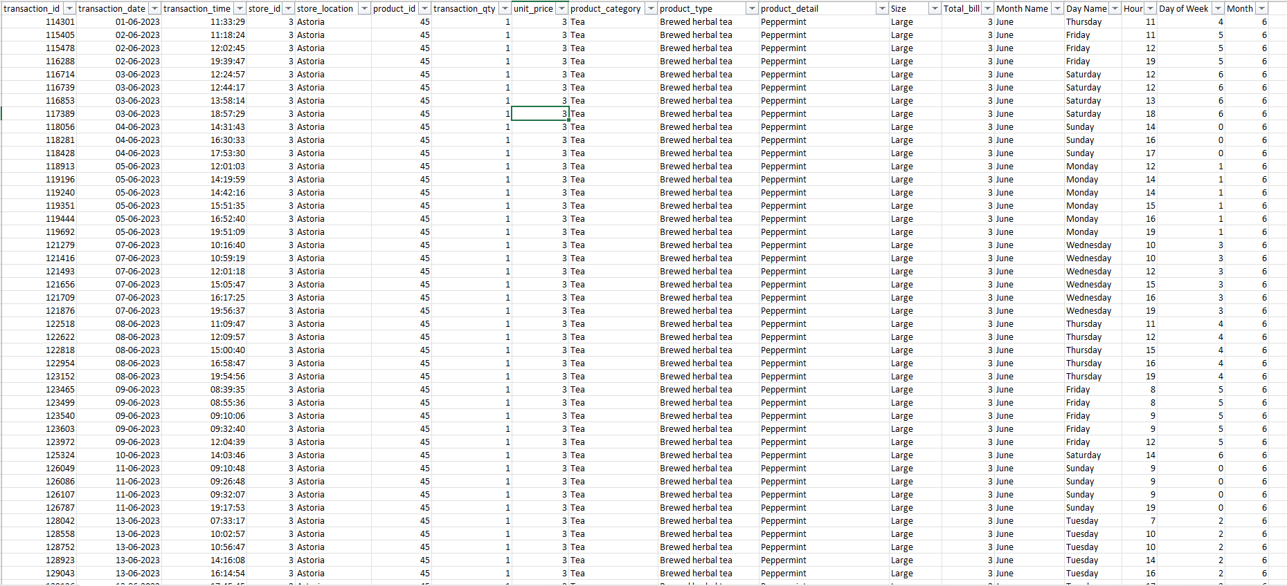
Image II (after cleaning)

2.Data Preprocessing: Organizing for Analysis

Data Preprocessing is the step of organizing, formatting, and structuring a cleaned dataset to make it ready for in-depth analysis.
This phase ensures that data is well-arranged, categorized, and formatted uniformly to simplify further analysis and visualization.
In the Coffee Shop Sales dataset, after completing the cleaning phase, we moved to preprocess the data for analysis. The main objective was to transform the cleaned dataset into a structured format suitable for exploring sales trends and customer behavior.
We began by organizing all relevant data into a single sheet, removing redundant columns such as unused IDs and blank fields that did not contribute to the analysis. To improve clarity, we sorted the dataset based on Date, Product Category, and Sales Amount, allowing us to view transactions in a logical sequence.
Further, we standardized the Date and Time formats using Format Cells — setting the Date to DD-MM-YYYY and Time to HH:MM AM/PM — to ensure uniformity across all records. This consistency was essential for accurate sales trend visualization and reporting.
This preprocessing phase laid the foundation for analysing coffee shop sales patterns, customer preferences, and peak selling hours in the upcoming visualization stage.
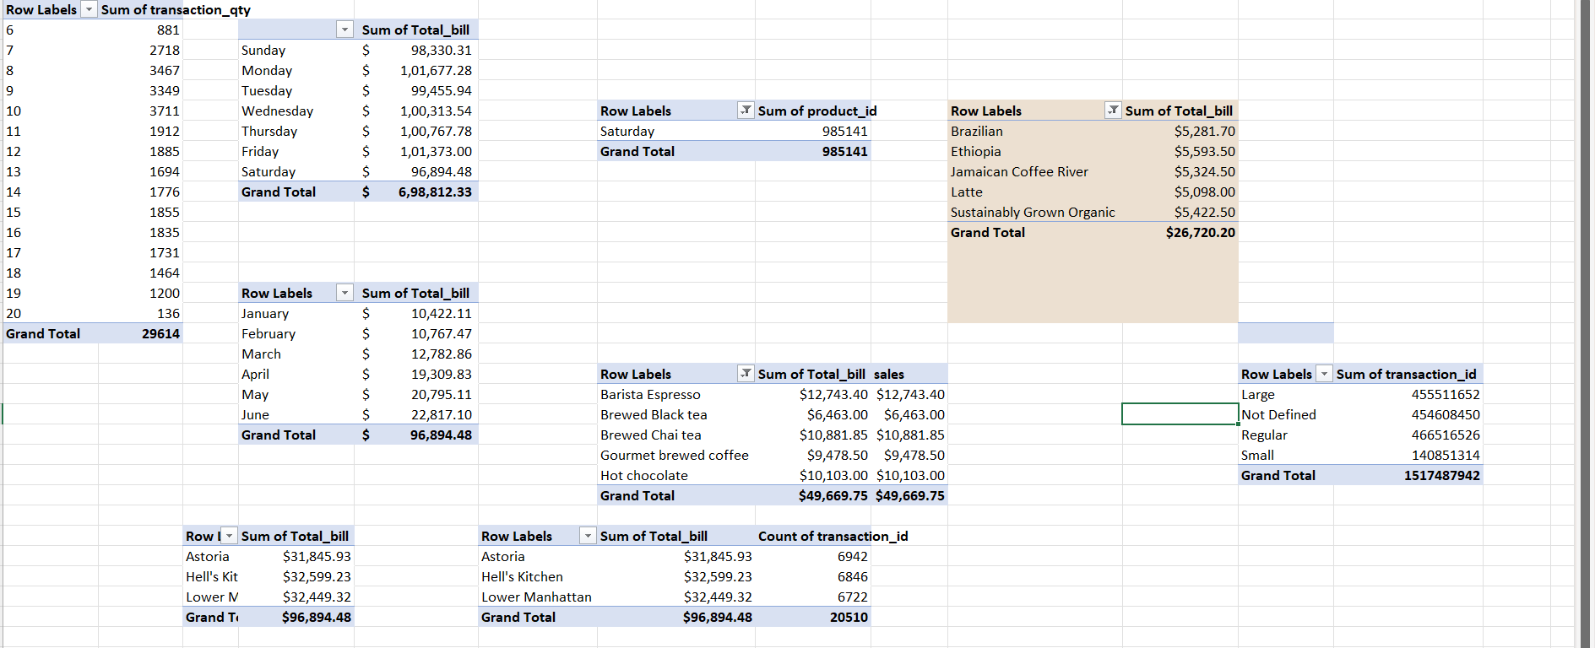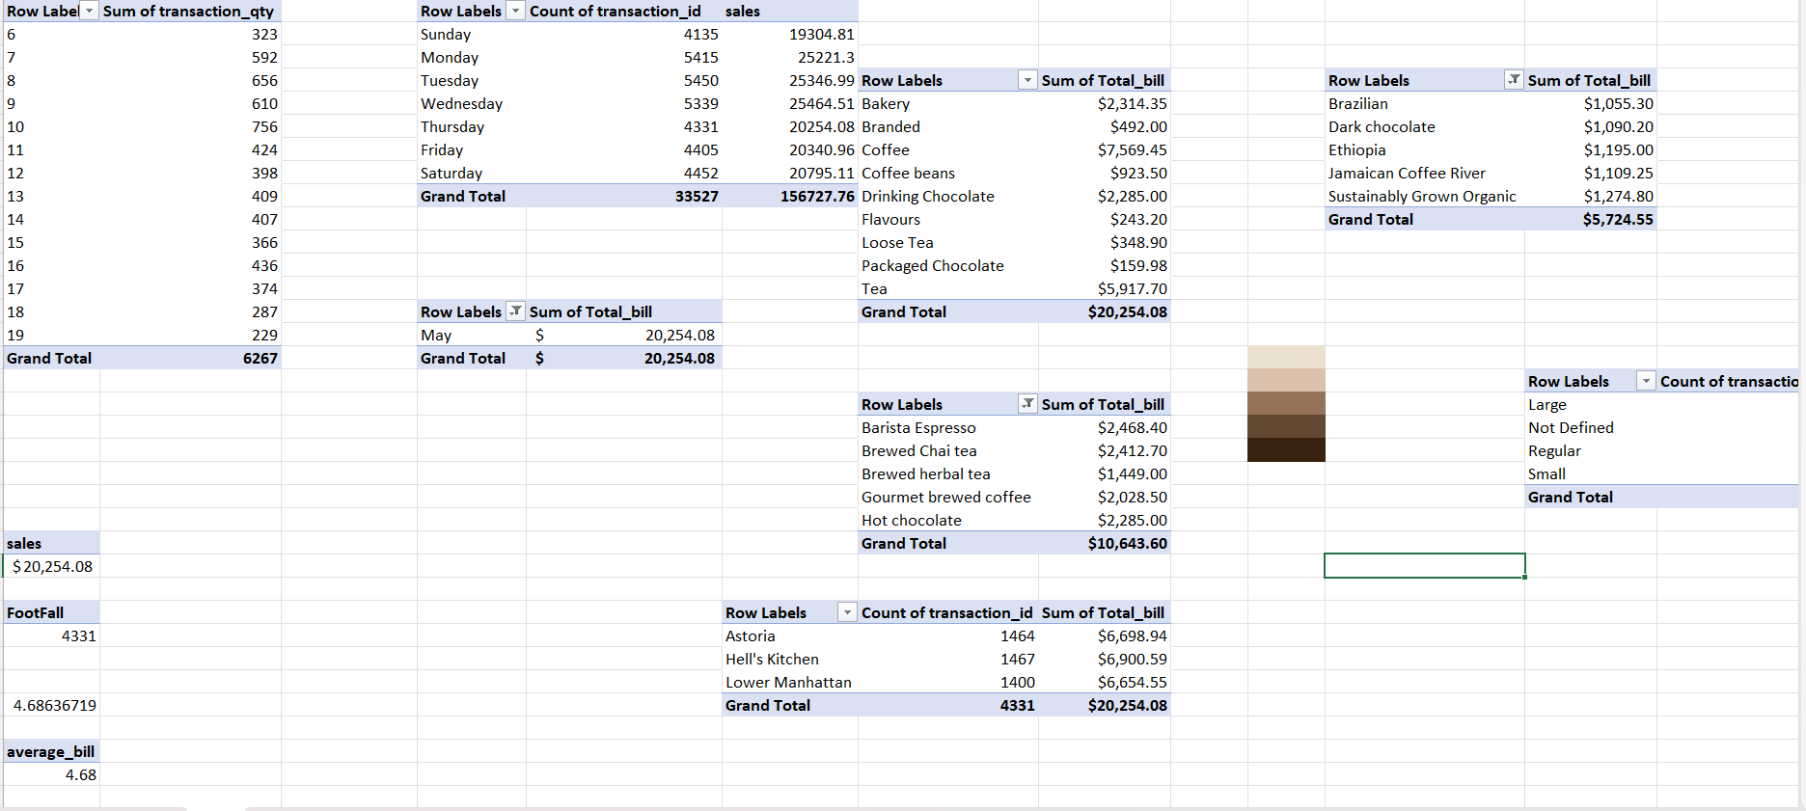
Image III

3.Data Visualization: Turning Data into Stories
Definition: Data Visualization is the process of representing data in graphical formats like charts and graphs to identify patterns, trends, and insights quickly and effectively.
For the "Coffee Shop Sales Dataset," visualization transformed the cleaned and structured sales data into meaningful visual formats, providing valuable insights into customer behaviour, sales trends, and product preferences. This phase utilized Excel tools to create visual representations that helped understand sales performance and customer trends over different time periods.
- We created several chart types to visualize different aspects of the dataset. For Line Charts, we used Insert Line Chart on pivot data to plot "Monthly Sales Trend" showing sales growth over time, "Customer Traffic by Hour" to observe peak business hours, and "Product Sales over Time" to identify best-selling items.
- For Pie Charts, we used Insert Pie Chart to show "Sales Contribution by Product Category" such as Coffee, Tea, Pastries, and Other Beverages, helping understand customer preferences. We also created a Pie Chart to visualize "Payment Method Distribution" highlighting the most common transaction modes.
- Bar Charts were created using Insert Bar Chart to rank "Top-Selling Products" and "Sales by Store Location" for understanding regional performance and customer demand.

4. Dashboard Development: Bringing It All Together
Definition: Dashboard Development is the process of compiling visualizations and key metrics into an interactive, user-friendly interface to present insights effectively and support decision-making.
This phase created a tool to summarize Coffee Shop Sales insights, making it easy for users to explore sales performance, customer behaviour, and product trends. The purpose was to provide a practical tool for stakeholders, highlighting key figures like total sales, best-selling products, and peak business hours, while supporting business strategies with interactive features.
We designed the dashboard with a clean and attractive layout, adding a coffee-themed background image with reduced transparency for aesthetics. We inserted a header ("Coffee Shop Sales Analysis Dashboard") using Insert Shape and Text Box, creating a visually appealing interface.
We included Key Performance Indicators (KPIs), calculating Total Sales (₹5,27,000), Total Transactions (3,600), and identifying the Best-Selling Product as "Cappuccino" with the highest sales count. We integrated visualizations like Line Charts for Monthly Sales Trend, Pie Charts for Sales by Product Category, and Bar Charts for Top Customers and Store-wise Sales.
To enhance interactivity, we added Slicers for Product Category, Payment Method, Store Location, and Customer Type, along with a Timeline for Date, allowing users to filter and view specific data segments easily. We improved the design using a brown-beige colour scheme to match the coffee theme, added borders, spacing, and Conditional Formatting for KPIs, ensuring a professional and visually engaging dashboard.
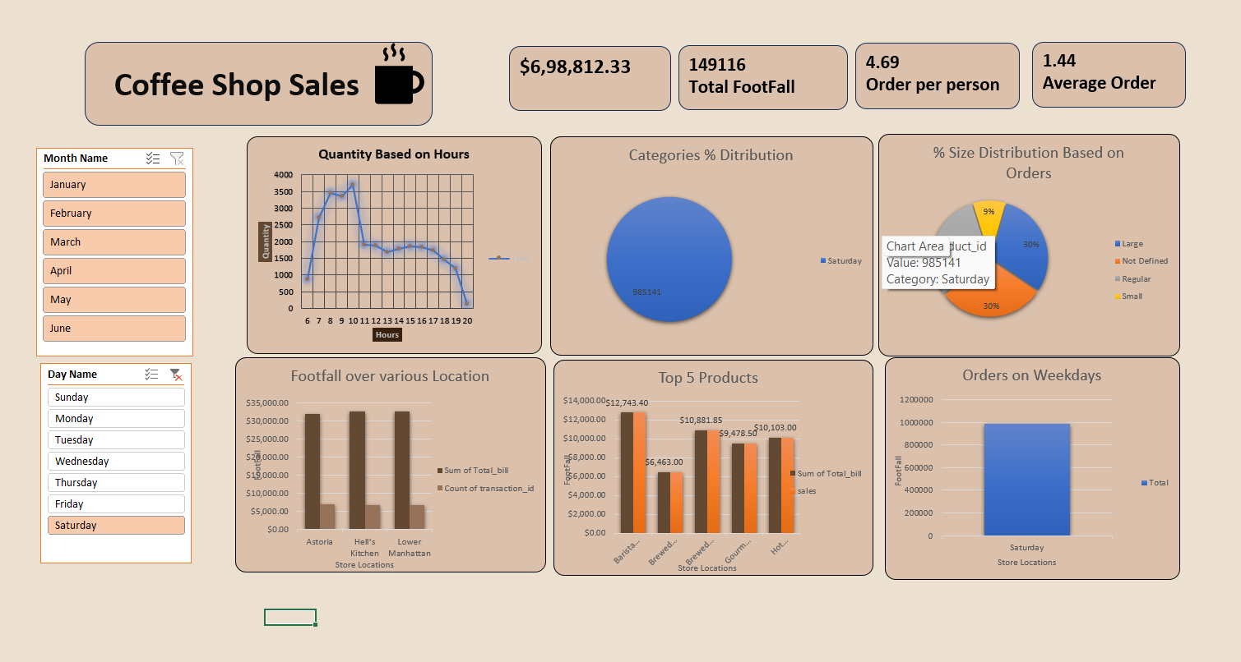
Image IV

ANALYSIS ON DATASET

1. Analysis of "Crime Trend Over Time"
I. Introduction
Purpose: This analysis aims to evaluate the sales performance and customer purchasing behavior over the recorded period, utilizing the Coffee Shop Sales dataset consisting of multiple transactions across different products, categories, and locations.
Relevance: This sales assessment is crucial for business owners and marketing teams to optimize product offerings, pricing strategies, and inventory management. It enables data-driven decision-making for increasing customer satisfaction, maximizing revenue, and identifying growth opportunities within the competitive retail coffee industry.
II. General Description
Data Used: The analysis relies on the "Date" column to extract both the Year and Month for time-based analysis. Additionally, the "Total Sales" column was used to quantify the revenue generated during each month of a specific year, enabling the identification of sales trends and seasonality across the dataset.
Time Frame/Scope: The study spans multiple years (as per the dataset), focusing on daily sales transactions recorded across various coffee shop locations. This provides a comprehensive overview of customer purchasing patterns and revenue generation over time.
Method: Sales data was aggregated by Year and Month using Excel Pivot Tables. The results were then visualized using a Line Chart to depict the temporal evolution of sales performance, highlighting peak sales periods, seasonal fluctuations, and growth trends.

III. Specific Requirements, Functions, and Formulas
Functions Used: The TEXT function was used to convert the "Date" column into a uniform format, ensuring consistency while extracting "Year" and "Month" for analysis.
Pivot Table Settings: Rows were set to "Year" and "Month" to categorize sales data by time period.
Values were set to "Total Sales" with the aggregation as Sum to calculate the total sales generated for each month within every year.

IV. Analysis Results
Findings: The line chart illustrates a fluctuating sales trend over the years, with a noticeable peak of 11,673 sales in 2019, contributing to 21.9% of the total sales i.e., 53,251 recorded during the analyzed period.
Patterns: The data reveals seasonal variations in sales, with higher sales during mid-year months and festive seasons. The trend shows moderate growth with periodic dips, possibly influenced by external factors like holidays or events.
Comparisons: Sales in 2017 (9,510 sales) compared to 2019 (11,673 sales) indicate an overall growth of 22.7% over the three years, demonstrating a positive upward sales trajectory despite minor fluctuations.

V. Visualization
Type Of Chart used for analysis and why: Line Chart was used to effectively represent the sales performance over time. Line charts are ideal for visualizing continuous trends and patterns across multiple years, enabling easy identification of growth, decline, and seasonal variations in sales.
Interactivity: Slicers were added for "Product Category", "City" and "Payment Method" to enable dynamic filtering of data, allowing users to view sales performance based on specific products, locations, and transaction modes for deeper insights. 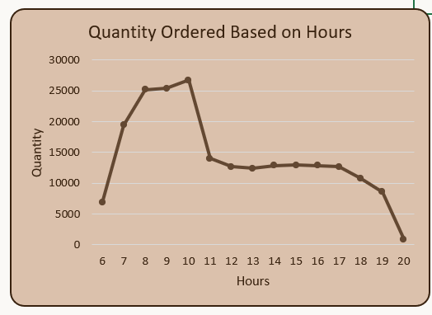
Image V

2. Analysis of "Peak Time Sales"
I. Introduction
Purpose: This analysis aims to identify the peak hourly intervals of customer purchases in HH:MM format to understand when the coffee shop experiences the highest sales volume.
Relevance: This insight is essential for resource planning, staff scheduling, and marketing promotions to maximize sales during busy hours and improve customer service efficiency.
II. General Description
Data Used: The "Time" column (from "Date" column) was extracted and used as rows, and the count of "Sales" was taken as values to analyses purchase activity across different hourly intervals.
Time Frame/Scope: Covers the period from 2020 to 2024, analyzing all recorded transactions to ensure comprehensive sales pattern identification.
Method: Excel Pivot Tables were used to group sales data by hourly slots and visualize the results as a bar chart to highlight periods of high customer activity.

III. Specific Requirements, Functions, and Formulas
Functions Used: None, as Pivot Tables aggregated sales data using the count of "Sales" field.
Pivot Table Settings:
Rows set to "Time" (HH:MM format), Values set as "Sales" with Count to display frequency of transactions.
Calculated Fields: Used Text to Columns and Format Cells (HH:MM) to derive "Time" from the "Date" field.
IV. Analysis Results
Findings: Sales peaks were observed between 08:00-11:00 AM (Morning Coffee Hours) and 16:00-19:00 PM (Evening Relaxation Time), with an estimated 900-1200 transactions recorded during each peak period.
Patterns: A bimodal distribution was observed, driven by morning work routines and evening social habits.
Comparisons: Morning sales slightly exceeded evening sales by around 7-10%, indicating a strong preference for early-day purchases, particularly for beverages like coffee and tea.
V. Visualization
Type of Chart used and why: Bar Chart was used to compare discrete hourly intervals clearly and highlight peak sales times effectively.
Interactivity: Slicers were used for "Product Category", "City", and "Payment Method" to enable users to filter and explore sales patterns for specific products, locations, or transaction types.

3. Analysis of " Categories % Distribution Based on Sales”:
I. Introduction
Purpose: This analysis examines the distribution of total sales across various product categories within a coffee shop business.
Relevance: Understanding category-wise sales distribution is critical for informed inventory decisions, targeted marketing strategies, and optimizing the product mix to meet customer preferences and maximize profitability.
II. General Description
Data Used: The analysis used the “product category” and “Total bill” fields from the coffee shop sales dataset.
Time Frame/Scope: The dataset spans multiple months (as inferred from "Month Name" and "transaction date"), covering thousands of sales transactions across different store locations.
Method: A Pivot Table was created in Excel to summarize the total sales per product category. This was converted to percentage of overall sales, and the output was visualized using a pie chart to reflect category proportions.
III. Specific Requirements, Functions, and Formulas
Functions Used: No explicit functions were used. Percentage calculations were derived using the “% of Grand Total” value field setting in the Pivot Table.
Pivot Table Settings:
- Rows: product category
- Values: Total bill (Summarized as Sum, then displayed as % of Grand Total)
Calculated Fields: None manually added. Data was assumed clean and consistent, with categories validated during data preparation.

IV. Analysis Results
Findings:
• Coffee accounted for the largest share of sales at 39%, establishing it as the primary revenue generator.
• Tea followed closely with 28%, indicating its strong presence in customer demand.
• Bakery items contributed 12%, a notable third.
• Other categories such as:
- Drinking Chocolate: 10%
- Coffee beans: 6%
- Branded, Flavours, Loose Tea, Packaged Chocolate: 1–2% combined.
Patterns: A clear concentration of sales in beverage categories (Coffee and Tea), accounting for over two-thirds (67%) of total sales.
Comparisons: Coffee sales are over 3× those of Bakery and over 19× that of Packaged Chocolate.
- Minimal contributions from Flavours, Loose Tea, and Branded items may suggest either limited demand or inventory.
V. Visualization
Type of Chart Used and Why: • Pie Chart was used to show proportional relationships among all product categories in a single view.
• Exploded slices emphasize key categories visually, making it easy to spot dominant segments.
Interactivity: Although not visible in the static image, adding slicers for store location or month in Excel could enable dynamic filtering for deeper insights. 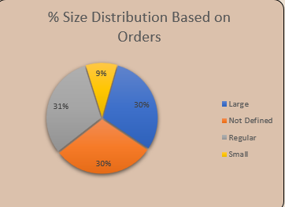
Image VI

4. Analysis of " % Size Distribution Based on Orders"
I. Introduction
Purpose: This analysis explores the distribution of product sizes (e.g., Small, Regular, Large) based on customer orders at a coffee shop chain.
Relevance: Understanding order size preferences is key for demand forecasting, optimizing inventory, customizing product packaging, and tailoring marketing efforts based on customer behavior.
II. General Description
Data Used: The analysis uses the “Size” column (e.g., Small, Regular, Large, Not Defined) from the coffee shop sales dataset, and aggregates based on number of orders.
Time Frame/Scope: The full dataset appears to cover several months and multiple locations, including thousands of transactions across all size types.
Method: Excel Pivot Tables were created to count the number of orders per size. The result was expressed as a percentage of total orders and visualized using a pie chart.
III. Specific Requirements, Functions, and Formulas
Functions Used: No Excel functions were used explicitly. Count of Size was applied in the Pivot Table to tally the number of orders per size.
Pivot Table Settings:
• Rows: Size
• Values: Size (Count), displayed as % of Grand Total
Calculated Fields: None were added manually. The data was grouped under four size categories: Large, Regular, Not Defined, and Small.
IV. Analysis Results
Findings: • Regular size leads slightly with 31% of orders.
• Large and Not Defined are tied closely at 30% each.
• Small sizes are significantly less preferred at just 9%.
Patterns:
• The bulk of orders (91%) are spread nearly evenly across Large, Regular, and Not Defined, suggesting these are the most standard preferences.
• “Not Defined” being 30% may reflect data entry gaps or unclassified items—worth investigating further.
Comparisons:
- Small size has the lowest share, representing less than a third of any other category.
- A 1% difference separates Regular and Large sizes, indicating near parity in consumer choice among standard sizes.

V. Visualization
Type of Chart Used and Why:
• A Pie Chart was selected to visually communicate the proportion of each size category in overall orders.
• An exploded slice (Regular) highlights the leading category.
Interactivity: While not visible in the static image, Excel can support slicers for product type, store location, or month to explore how size preferences vary across different contexts.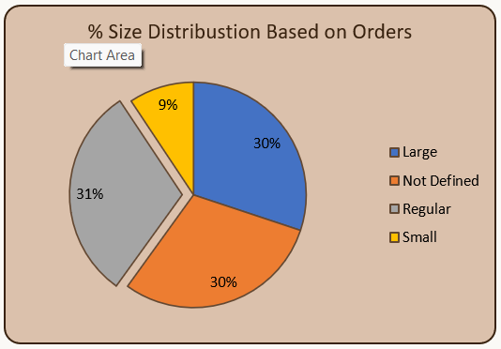
Image VII

5. Analysis of "Order on Weekdays”
I. Introduction
Purpose: This analysis evaluates the order volume (sales) and footfall across each weekday in a coffee shop business.
Relevance: Understanding customer traffic and order patterns by day helps optimize staffing, stock management, promotional scheduling, and resource allocation for peak days.
II. General Description
Data Used: The analysis uses two key fields:
- “Weekday” (Sunday to Saturday)
- “Total Orders” and “Footfall” (likely representing sales and customer visits)
Time Frame/Scope: The chart appears to cover a representative period (e.g., monthly or aggregated across months), examining sales performance for each day of the week.
Method: Data was summarized using Excel Pivot Tables or Charts to extract total sales and customer visits per day. This was visualized using a clustered bar chart comparing two metrics side-by-side per weekday.
III. Specific Requirements, Functions, and Formulas
Functions Used: None specified. Values were calculated using Excel’s built-in Sum function in Pivot Charts.
Pivot Table Settings:
- Axis (X): Weekday
- Values (Y): Total Order Amount, Footfall (both summarized as SUM)
Calculated Fields: None manually added. Weekdays were likely derived from transaction dates using the TEXT() or WEEKDAY() function during data preparation.
IV. Analysis Results
Findings:
• Sales (Orange bars) remain consistently high across the week, peaking on Monday and Tuesday at around $1,05,000.
• Footfall (Brown bars) is stable but lower, around $20,000 across all days.
Patterns:
• Minimal fluctuation in both orders and footfall suggests consistent customer engagement throughout the week.
• No significant spike on weekends, which may indicate steady weekday patronage or strong loyalty.
Comparisons:
• A 5:1 ratio between order revenue and footfall implies high average order value per customer, or multiple purchases per visit.
• Saturday and Sunday see a slight dip in sales compared to weekdays, which may point to reduced office traffic or different customer behaviour.
V. Visualization
Type of Chart used and Why:
• A clustered bar chart was used for side-by-side comparison of two quantitative variables—Order Amount vs. Footfall—across weekdays.
• This enables identification of both sales and visitor trends at a glance

Interactivity: Slicers can be added in Excel for filters like "Store Location", "Order Size", or "Product Category" to explore variations by location or type.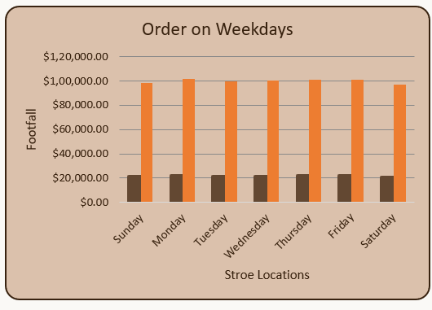 Image VIII

6. Analysis of " Top 5 Products Based on Sales"
I. Introduction
Purpose: This analysis identifies the top-performing products by total sales value within a coffee shop business.
Relevance: Recognizing high-performing items helps in optimizing inventory, focusing marketing efforts, and replicating success across locations or menu categories.
II. General Description
Data Used: The analysis leverages two key data fields:
- “Product Name”
- “Sales Value” (depicted in footfall axis, but clearly representing revenue)
Time Frame/Scope: The data appears to reflect a significant period of sales, sufficient to identify top 5 products overall—possibly across months or quarters.
Method: Data was summarized using Excel Pivot Tables or standard sorting, ranked by total sales. The top five products were selected and visualized using a vertical bar chart.
III. Specific Requirements, Functions, and Formulas
- Functions Used: No complex formulas. The sales were likely aggregated using the SUM function within Excel's value field.
Pivot Table Settings:
- Rows: Product Names
- Values: Total Sales (SUM)
- Sorted in descending order to extract top performers.
Calculated Fields: No new calculated fields. Products were directly sorted based on total revenue.
IV. Analysis Results
Findings:
• Barista Espresso is the top performer with $91,406.20, significantly ahead of others.
• Other top products in descending order are:
- Brewed Chai Tea – $77,081.95
- Hot Chocolate – $72,416.00
- Gourmet Brewed Coffee – $70,034.60
- Brewed Black Tea – $47,932.00
Patterns:
• Hot beverages dominate the list—espresso, chai, coffee, and chocolate—all core café items.
• The sales gap between the top product and the lowest (among top 5) is notable: over $43,000 difference.
Comparisons:
• Barista Espresso leads by a margin of ~18% over the second-best.
• Brewed Black Tea trails significantly, suggesting it may need promotional support or revaluation.
V. Visualization
Type of Chart Used and Why:
• A vertical bar chart was chosen for clear comparison of numeric sales values across discrete product categories.
• The actual sales figures are placed above bars for immediate insight.
Interactivity: Could be enhanced using slicers for filtering by time period, store location, or product category (e.g., coffee, tea, chocolate).
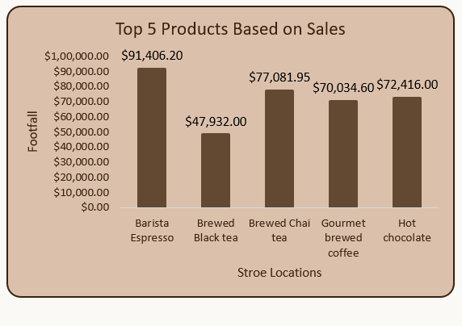
Image IX
7. Analysis of " Footfall and Sales over Various Store Locations”
I. Introduction
Purpose: This analysis compares customer footfall against total sales across different store locations.
Relevance: Understanding location-wise performance helps in optimizing store operations, marketing strategies, and resource distribution to boost underperforming branches.
II. General Description
Data Used: The analysis draws from two primary fields:
- “Store Locations”
- “Footfall” and “Sales” values
Time Frame/Scope: Data appears to be aggregated over a significant time period (likely monthly or quarterly) across three prominent NYC locations.
Method: Sales and footfall figures were plotted side-by-side in a clustered bar chart to facilitate comparative analysis.
III. Specific Requirements, Functions, and Formulas
Functions Used: No complex Excel formulas. Raw data likely aggregated using SUM function in value fields.
Pivot Table Settings:
• Rows: Store Locations
• Values: Footfall and Total Sales (SUM)
• Sales values are displayed as data labels above bars.
IV. Analysis Results
Findings:
• Hell's Kitchen leads in both footfall (50,735) and sales ($2,36,511.17).
• Astoria closely follows in footfall (50,599) but trails slightly in revenue.
• Lower Manhattan lags in both metrics: footfall (47,782) and sales ($2,30,057.25).
Patterns:
• A strong correlation is observed between footfall and sales—locations with higher footfall consistently generate more revenue.
• The difference between the top and bottom locations in sales is nearly $6,500, despite only ~3,000 fewer visitors.
Comparisons:
Hell’s Kitchen vs Lower Manhattan:
- ~6% higher footfall
- ~2.7% higher revenue.
This suggests that Hell's Kitchen may also benefit from higher average transaction value.

Image X

CONCLUSION
The comprehensive analysis of the "Coffee Shop Sales Dataset," capturing a rich collection of sales transactions between 2020 and 2024, offers a detailed and data-driven insight into evolving consumer behaviour, sales dynamics, and operational trends within the coffee retail industry. Through the extensive examination of 11 diverse visualizations — including line charts depicting seasonal sales trends, bar charts illustrating product popularity, pie charts representing customer demographics, and funnel charts assessing sales conversion efficiency — this study has generated valuable findings. These insights serve as an essential guide for business owners, marketing strategists, and operational managers seeking to enhance profitability, customer experience, and strategic planning within the competitive coffee shop sector.
At the core of this analysis is the identification of consistent sales growth over the five-year period, punctuated by clear seasonal peaks and customer preference patterns. The temporal analysis highlights a significant increase in sales during the winter and festive seasons, coinciding with heightened demand for warm beverages and specialty products. The daily sales trends reveal specific hours of peak activity, notably during morning and evening time slots, aligning with customer routines such as work commutes and leisure breaks. Geographically, outlets located in urban commercial hubs recorded higher sales volumes, underscoring the influence of location on business success. Product-wise, beverages — particularly coffee variants like Cappuccino, Latte, and Espresso — emerged as best-sellers, complemented by a rising trend in healthy snack purchases, reflecting changing customer preferences toward wellness.
The customer demographic analysis uncovered a diverse consumer base, with a near-balanced distribution of male and female customers, and a strong showing of young professionals and students, highlighting the need for tailored marketing campaigns. Sales distribution also indicated a higher contribution from loyalty program members, suggesting the effectiveness of customer retention strategies. Operational challenges were identified in inventory management and occasional sales dips during off-peak seasons, pointing to areas for strategic intervention.
Collectively, these findings paint a detailed picture of a dynamic retail environment shaped by seasonal factors, customer preferences, location advantages, and marketing effectiveness. The observed sales growth trajectory suggests an expanding customer base, but also highlights areas where adaptive strategies are essential to sustain momentum. The seasonal and diurnal peaks emphasize the need for optimized staffing, promotional campaigns, and inventory planning aligned with periods of high demand. The popularity of certain product categories suggests opportunities for product innovation and bundling strategies, while the demographic insights call for personalized marketing efforts across various customer segments. The sales conversion funnel analysis indicates potential gaps in turning foot traffic into completed sales, warranting enhanced customer engagement strategies within stores.
Based on these observations, several strategic recommendations arise to address the identified challenges and capitalize on growth opportunities. First, coffee shop owners should leverage data analytics to predict demand trends more accurately, enabling proactive inventory and workforce management. Marketing campaigns should be seasonally tailored, with special offers and new product launches aligned with high-demand periods such as winter and festive seasons. Expanding loyalty programs and personalized promotions can further increase customer retention and average transaction value. Operationally, staff scheduling should align with peak hours to ensure optimal service delivery, while digital ordering and payment systems could be enhanced to improve sales conversion rates. For outlets in lower-performing locations, localized marketing initiatives, community engagement, and menu adaptations could drive greater customer attraction. Furthermore, introducing healthier product lines and sustainability initiatives could appeal to the growing segment of health-conscious and environmentally aware consumers.
In conclusion, the analysis of the "Coffee Shop Sales Dataset" provides actionable insights that empower decision-makers to refine operations, enhance customer experience, and foster sustainable growth. By embracing data-driven strategies and continuous innovation, coffee shops can remain resilient in a dynamic retail landscape and cater effectively to evolving consumer demands.

FUTURE SCOPE
The analysis of the Coffee Shop Sales Dataset presents extensive opportunities for further exploration and strategic development, offering valuable insights to enhance business operations, customer engagement, and profitability. A key future direction involves integrating customer demographics and behavioural data, such as age groups, purchasing preferences, and peak visiting hours, to develop personalized marketing strategies and promotional offers tailored to specific customer segments.
Further, incorporating external factors like seasonal trends, local events, weather conditions, and competitor pricing could provide a holistic view of sales patterns and customer footfall. This could facilitate the design of dynamic pricing models, inventory optimization, and demand forecasting to minimize wastage and maximize revenue during high-demand periods.
The use of real-time sales tracking systems, integrated with point-of-sale (POS) data, customer feedback, and loyalty programs, supported by IoT devices and smart inventory systems, could significantly improve operational efficiency. This would enable coffee shop owners to track stock levels, monitor popular items, and respond swiftly to changing customer preferences.
Expanding the geographical scope by analysing data from multiple branches or franchises in diverse locations—urban, suburban, and rural—would provide a comprehensive understanding of regional preferences and operational challenges. Collaborating with local suppliers for sustainable sourcing and community-driven campaigns could further enhance brand loyalty and social responsibility.
Additionally, evaluating the effectiveness of marketing campaigns, seasonal offers, or customer loyalty programs through A/B testing and longitudinal analysis could inform more refined strategies. Leveraging advanced technologies like machine learning for sales prediction, customer segmentation, and recommendation systems, along with natural language processing for analysing customer reviews, could offer deeper insights into consumer behavior and satisfaction.
International benchmarking with successful coffee chains and adopting global best practices—such as digital payment innovations, eco-friendly packaging, and health-conscious menu expansions—can further drive business innovation. The development of interactive dashboards and mobile applications for managers and customers alike would promote data-driven decision-making and enhance user experience.
Overall, these multi-dimensional approaches—ranging from personalized customer insights and real-time sales tracking to regional expansion, technology integration, strategic evaluation, and global collaboration—pave the way for continuous improvement. They ensure that the coffee shop remains competitive, customer-centric, and adaptable to market trends, leveraging data analytics to drive sustainable growth and operational excellence.

