Report
Of
Internship as Junior ReactJS Developer at YuvaIntern

Submitted
To
School of Computer Science and Engineering
IILM University, Greater Noida, U.P.
In partial fulfilment of the requirement of degree of
B.Tech CSE

By
Roll Number of Student: 2410030882
Name of Student: KUMAR SWATANTRA
Batch: 2026-27

2026-27

TABLE OF CONTENTS
Chapter No. | Chapter Name | Page Nos.
 | Cover Page | ----
1. | Candidate's Declaration | ii
2. | Acknowledgment | iii
3. | Internship Completion Certificate | iv
4. | Project Description  4.1 Introduction  4.2 Organization Profile  4.3 Problem Statement  4.4 Project Objectives  4.5 Scope of the Project  4.6 Technologies and Tools Used  4.7 System Architecture  4.8 Methodology  4.9 Expected Outcomes  4.10 Certificates of completion and other communication mail proof must be attached | 1
5. | Bibliography/References | 2

CANDIDATE'S DECLARATION
I, KUMAR SWATANTRA, do hereby declare that the internship report titled "Internship as Junior ReactJS Developer at YuvaIntern" has been completed by me to fulfil the requirement for the award of the degree of Bachelor of Technology in CSE. All the references have been quoted and I have not taken as such any material from any other source. I affirm to you that this report is my own and has not been submitted to any other institute for any degree/diploma requirement and further I shall be solely responsible for any kind of copyright violation in this regard.
Signature
Student Name: KUMAR SWATANTRA
Roll No.: 2410030882

ACKNOWLEDGEMENT
I am using this opportunity to express my gratitude to everyone who supported me throughout the Internship Program. I am thankful for their aspiring guidance, invaluably constructive criticism and friendly advice during this work. I am sincerely grateful to them for sharing their truthful and illuminating views on a number of issues related to this work.
I express my gratitude to my parents for their blessings.
Signature
Student Name: KUMAR SWATANTRA
Roll No.: 2410030882

INTERNSHIP COMPLETION CERTIFICATE
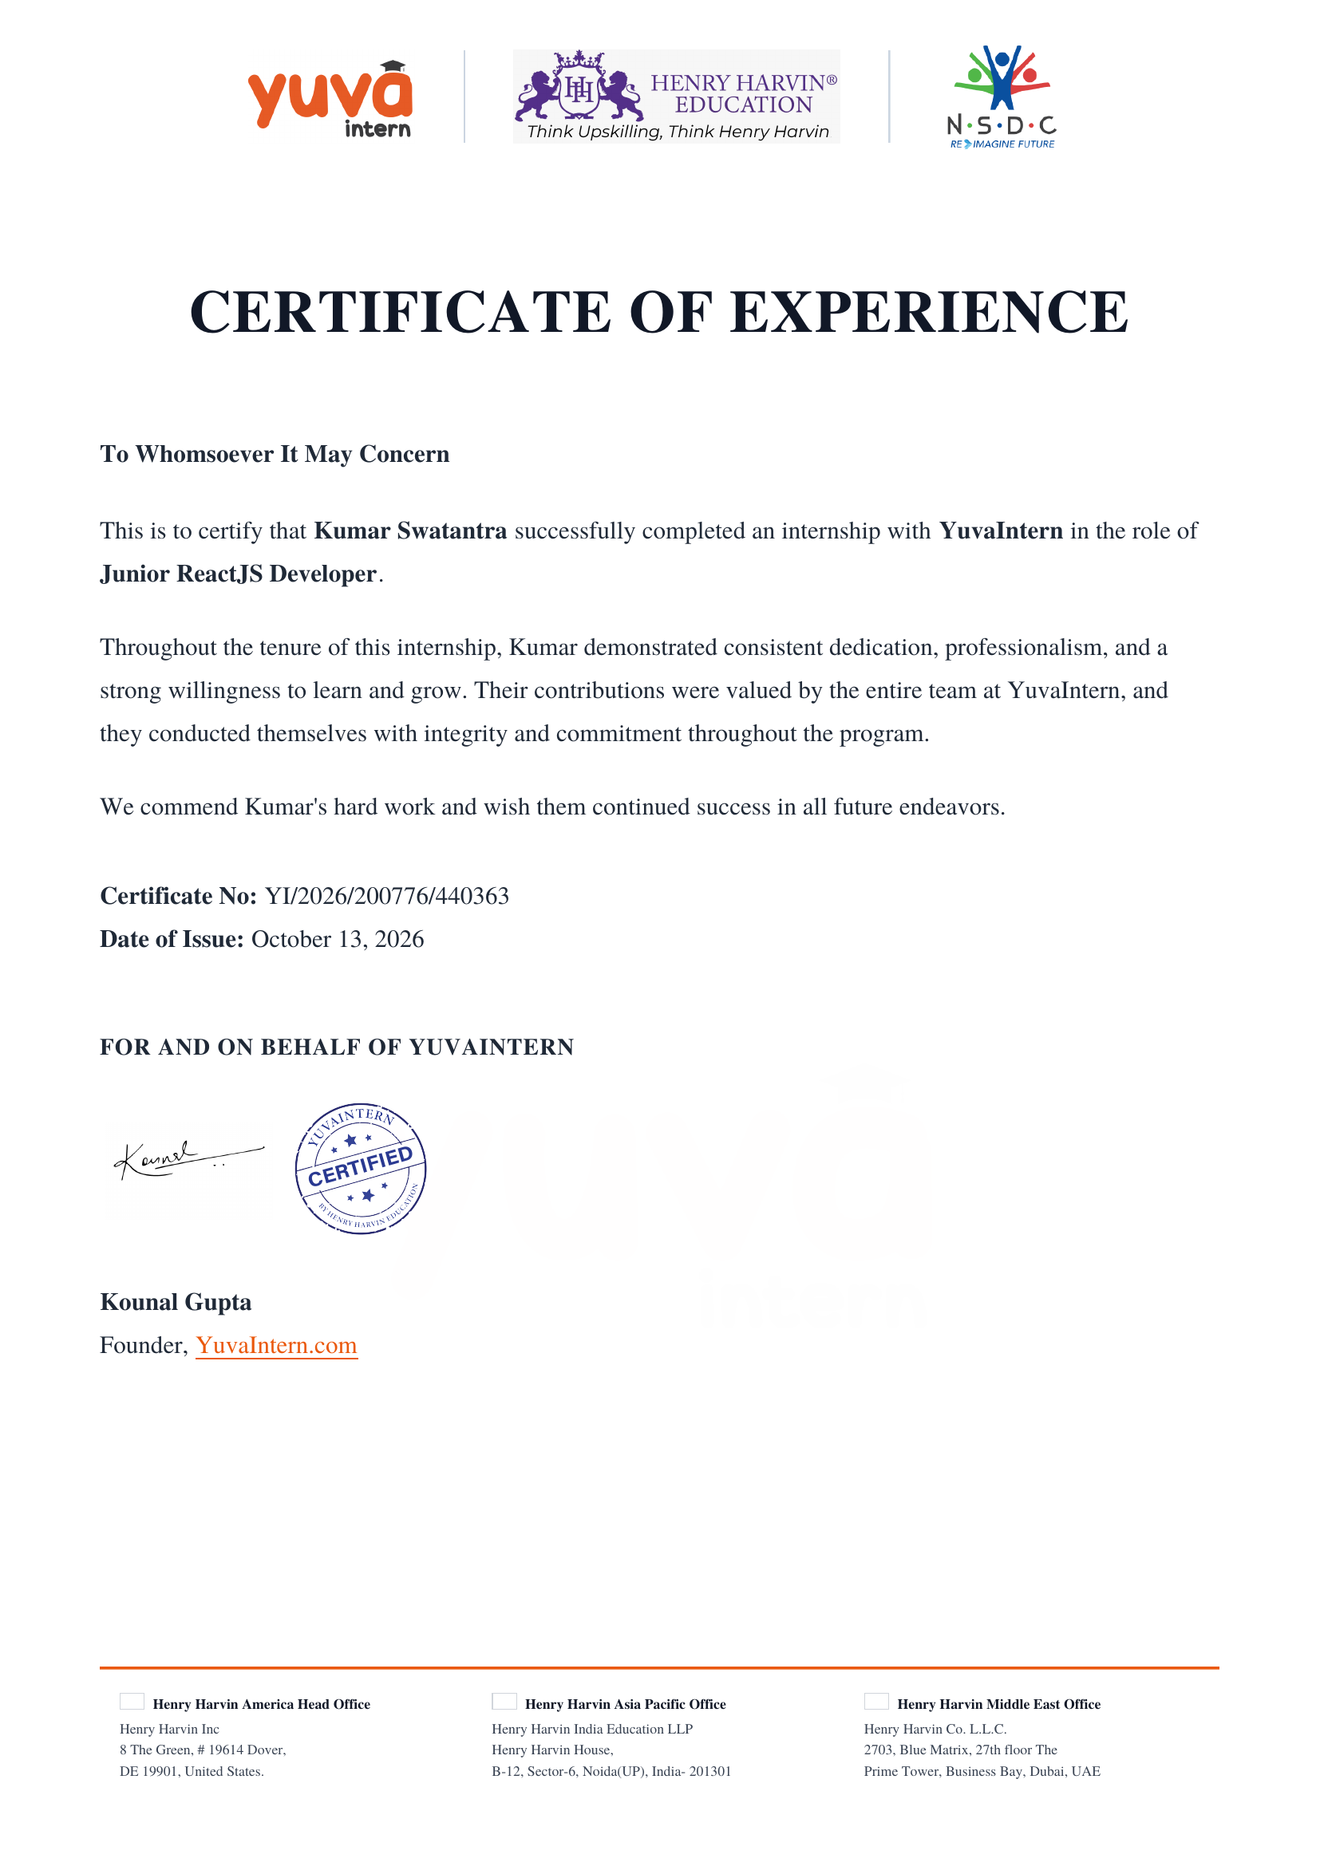

4. PROJECT DESCRIPTION
4.1 Introduction
[Introduce the internship undertaken as a Junior ReactJS Developer at YuvaIntern, the duration of the internship, and a brief overview of the work carried out.]
4.2 Organization Profile
[Provide a brief profile of YuvaIntern — the organization where the internship was completed, including its area of work and the team/department you were placed in.]
4.3 Problem Statement
[State the problem or requirement that your internship project addressed.]
4.4 Project Objectives
[List the specific objectives you aimed to achieve during the internship/project.]
4.5 Scope of the Project
[Describe the scope and boundaries of the work undertaken.]
4.6 Technologies and Tools Used
[List the technologies and tools used, for example: ReactJS, JavaScript, HTML/CSS, Git/GitHub, and any other frameworks or libraries used during the internship.]
4.7 System Architecture
[Describe/diagram the architecture of the application or system you worked on.]
4.8 Methodology
[Explain the development approach followed, e.g., Agile/iterative development, sprints, version control workflow, etc.]
4.9 Expected Outcomes
[Describe the outcomes/results expected or achieved from the internship project.]
4.10 Certificates of Completion and Other Communication
The Internship Completion Certificate issued by YuvaIntern (Certificate No. YI/2026/200776/440363, dated October 13, 2026) has been attached in Chapter 3 of this report.

5. BIBLIOGRAPHY/REFERENCES
[List the books, articles, websites, and other resources referred to during the internship in proper citation format.]

