BIOTECHTREK
NGS & Bioinformatics Internship Program
Genomics + NGS Internship
CLINICAL GENOMICS
INTERNSHIP REPORT
Clinical Genomics Analysis of a Pediatric Whole Exome Sequencing (WES)
Sample for Disease-Causing Variant Identification and Candidate Gene
Prioritization Using an End-to-End NGS Bioinformatics Pipeline

Submitted by
Kumara
M.Sc. Bioinformatics
Pondicherry University
Internship Guide: HS Prithvi, Bioinformatician (Founder, BI23)
Internship Organization: BIOTECHTREK
Internship Duration: 7 Weeks

A report submitted in partial fulfillment of the requirements for the
completion of the Genomics + NGS Internship Program at Biotechtrek.
Submission Date: 27/06/2026

Acknowledgement

I would like to express my sincere gratitude to BIOTECHTREK for providing me with the opportunity to undertake the Genomics + NGS Internship. This internship provided valuable practical exposure to Next-Generation Sequencing (NGS), clinical genomics, and bioinformatics data analysis.

I am especially thankful to my mentor, Mr. HS Prithvi (Bioinformatician), for his continuous guidance, technical support, and encouragement throughout the internship. His mentorship greatly enhanced my understanding of genomic data analysis and variant interpretation.

I also extend my appreciation to the BIOTECHTREK team for organizing a well-structured training program and providing hands-on experience with various bioinformatics tools and databases, including Linux, FastQC, BWA-MEM, SAMtools, BCFtools, ANNOVAR, ClinVar, gnomAD, OMIM, HPO, and IGV.

Finally, I sincerely thank my teachers, family, and everyone who supported and encouraged me throughout this internship. Their motivation and guidance helped me successfully complete this project and strengthen my interest in clinical genomics and bioinformatics.

1.Introduction

  - About the Organization

BIOTECHTREK is a biotechnology and bioinformatics training organization that provides industry-oriented education and practical training in modern life science technologies. The organization offers structured internship programs, workshops, and project-based learning to help students develop technical skills required in genomics, bioinformatics, computational biology, and Next-Generation Sequencing (NGS).
Main Areas of Work
The organization primarily focuses on providing hands-on training in:
- Genomics and Next-Generation Sequencing (NGS)
- Clinical Genomics
- Bioinformatics and Computational Biology
- Linux-based Bioinformatics Workflows
- Genomic Data Analysis
- Variant Calling and Functional Annotation
- Clinical Variant Interpretation
- Research Project Development and Scientific Reporting
Importance in Biotechnology and Bioinformatics
BIOTECHTREK plays an important role in enhancing practical knowledge and technical competency in biotechnology and bioinformatics by exposing students to real-world genomic data analysis. Through training in widely used bioinformatics software, databases, and analytical workflows, the organization helps students understand the complete process of sequencing data analysis, variant interpretation, and clinical genomics. Such practical exposure bridges the gap between academic learning and current industry practices, preparing students for careers in genomics research, precision medicine, clinical diagnostics, and bioinformatics.

  - About the Internship

The Genomics + NGS Internship was conducted at BIOTECHTREK to provide practical training in Next-Generation Sequencing (NGS), clinical genomics, and bioinformatics. During the internship, an end-to-end clinical genomics workflow was performed using a real Whole Exome Sequencing (WES) dataset. The training combined theoretical concepts with hands-on analysis using Linux-based bioinformatics tools and publicly available genomic databases.
Duration of the Internship
- Internship Title: Genomics + NGS Internship
- Duration: 7 Weeks
- Organization: BIOTECHTREK
Mode of Internship
The internship was conducted in Online Mode, allowing participants to perform practical bioinformatics analyses using a Linux environment (WSL/Ubuntu), open-source software, and publicly available genomic datasets. Regular guidance and project support were provided throughout the internship.
Objectives of the Training
The major objectives of the internship were:
- To understand the complete workflow of Next-Generation Sequencing (NGS) data analysis.
- To gain practical experience with Linux command-line operations for bioinformatics.
- To perform quality assessment and preprocessing of Whole Exome Sequencing (WES) data.
- To align sequencing reads to the human reference genome (GRCh38).
- To identify genomic variants using variant calling pipelines.
- To perform functional annotation and clinical interpretation of variants.
- To prioritize disease-associated candidate genes using biological and clinical evidence.
- To validate candidate variants using the Integrative Genomics Viewer (IGV).
- To develop practical skills in clinical genomics, variant interpretation, and scientific report preparation.

  - Introduction to Next-Generation Sequencing (NGS)

What is Next-Generation Sequencing (NGS)?
Next-Generation Sequencing (NGS) is a high-throughput sequencing technology that enables millions of DNA fragments to be sequenced simultaneously. Compared with conventional Sanger sequencing, NGS offers higher speed, greater accuracy, and lower sequencing cost, making it an essential technology in modern genomics.
Whole Exome Sequencing (WES), one of the most widely used NGS approaches, targets the protein-coding regions (exons) of the genome, which contain the majority of known disease-causing genetic variants.

Applications of NGS
NGS has a wide range of applications in biological and medical research, including:
- Diagnosis of rare genetic disorders
- Cancer genomics
- Precision medicine
- Pharmacogenomics
- Infectious disease research
- Population genetics
- Whole Genome and Whole Exome Sequencing
- RNA Sequencing (RNA-Seq)

Importance in Genomics and Precision Medicine
NGS has transformed clinical genomics by enabling rapid identification of disease-associated genetic variants. It supports accurate diagnosis, personalized treatment, and improved understanding of inherited disorders. In this internship, NGS-based Whole Exome Sequencing (WES) data were analyzed using a complete bioinformatics pipeline for variant identification, annotation, and clinical interpretation.

2. Learning Objectives

The primary learning objectives of this Genomics + NGS Internship were:
- To understand the complete workflow of Next-Generation Sequencing (NGS) and Whole Exome Sequencing (WES).
- To gain practical experience with Linux (Ubuntu/WSL) command-line operations for bioinformatics analysis.
- To perform quality assessment and preprocessing of raw sequencing data using FastQC and fastp.
- To learn sequence alignment and post-alignment processing using BWA-MEM and SAMtools.
- To identify genomic variants through variant calling and filtering using BCFtools.
- To perform functional and clinical annotation of variants using ANNOVAR and ClinVar.
- To interpret candidate disease-associated variants using OMIM, HPO, gnomAD, and IGV.
- To prioritize clinically relevant candidate genes based on genomic and phenotypic evidence.
- To develop skills in clinical genomics data analysis, variant interpretation, and scientific report preparation.

3. Tools and Software Used:

Operating System
- Ubuntu Linux (WSL)

NGS Tools
- FastQC
- fastp
- BWA-MEM
- SAMtools
- BCFtools
- ANNOVAR
- IGV (Integrative Genomics Viewer)

Clinical Databases
- ClinVar
- OMIM
- HPO (Human Phenotype Ontology)
- gnomAD

Other Software
- Visual Studio Code
- Microsoft Word
- Microsoft PowerPoint
- GitHub

4. Methodology / Workflow

Step 1: Data Acquisition

Dataset Source:
The Whole Exome Sequencing (WES) dataset used in this project was obtained from the National Center for Biotechnology Information (NCBI) Sequence Read Archive (SRA). A publicly available clinical genomics dataset was selected for downstream bioinformatics analysis.

Data Format:
The sequencing data were downloaded in paired-end FASTQ (.fastq.gz) format, which contains raw sequencing reads along with their corresponding quality scores.

Sample Information:
- BioProject ID: PRJNA1212196
- SRA Run ID: SRR32062769
- Sample: Sibling 1 (Pediatric)
- Library Strategy: Whole Exome Sequencing (WES)
- Sequencing Platform: Illumina NextSeq 2000
- Number of Samples: 1 (Paired-End WES Sample)
- Reference Genome: GRCh38 (hg38)

Step 2: Quality Control

FastQC Analysis
The quality of the raw paired-end Whole Exome Sequencing (WES) reads was evaluated using FastQC. This analysis was performed before read preprocessing to assess the overall quality of the sequencing data and identify any potential quality issues.

Quality Assessment Metrics
The following quality metrics were evaluated:
- Per base sequence quality
- Per sequence quality scores
- Per sequence GC content
- Sequence length distribution
- Sequence duplication levels
- Adapter content
- Overrepresented sequences

The FastQC results were used to determine the quality of the raw sequencing data and to guide the subsequent read trimming and quality filtering steps.

Step 3: Read Trimming

Adapter Removal
Raw sequencing reads were preprocessed using fastp to remove adapter sequences introduced during library preparation. Adapter removal improves read quality and minimizes alignment errors in downstream analyses.

Quality Filtering
Low-quality bases and poor-quality reads were filtered using fastp to obtain high-quality clean reads for sequence alignment. This preprocessing step enhanced the overall reliability and accuracy of the subsequent variant calling and annotation analyses.

Step 4: Sequence Alignment

Reference Genome Used
The GRCh38 (hg38) human reference genome was used as the reference for sequence alignment. Prior to alignment, the reference genome was indexed using BWA to facilitate efficient mapping of sequencing reads.

Alignment Using BWA
High-quality paired-end reads obtained after preprocessing were aligned to the GRCh38 reference genome using BWA-MEM. The alignment process generated a Sequence Alignment/Map (SAM) file, which served as the input for downstream BAM processing and variant calling.

Step 5: Post-Alignment Processing

BAM Conversion and Sorting
The SAM alignment file generated by BWA-MEM was converted into Binary Alignment/Map (BAM) format using SAMtools. The BAM file was then sorted based on genomic coordinates to facilitate efficient downstream analysis.

BAM Indexing
The sorted BAM file was indexed using SAMtools to enable rapid retrieval and visualization of aligned reads during variant analysis and validation.
\
Note: Duplicate marking was not performed in this project, as the analysis workflow focused on variant discovery and interpretation using the processed BAM files.

Step 6: Variant Calling

SNP and InDel Identification
Variant calling was performed using BCFtools to identify Single Nucleotide Polymorphisms (SNPs) and small Insertions and Deletions (InDels) by comparing the aligned sequencing reads with the GRCh38 human reference genome.

VCF Generation
The identified variants were stored in Variant Call Format (VCF), producing a high-confidence variant dataset for downstream filtering, functional annotation, and clinical interpretation.

Step 7: Variant Annotation

Functional Annotation of Variants
Functional annotation of the filtered variants was performed using ANNOVAR. The identified variants were annotated with gene information, genomic location, functional region (exonic, intronic, UTR, or splicing), and predicted functional consequences such as synonymous, nonsynonymous (missense), stopgain, frameshift, and stoploss variants. The annotated variant file served as the basis for downstream clinical interpretation and candidate gene prioritization.

Step 8: Variant Interpretation

Clinical Significance
The annotated variants were evaluated using ClinVar to determine their clinical significance and classify them as Pathogenic, Likely Pathogenic, Benign, or Variants of Uncertain Significance (VUS). Population allele frequencies were assessed using gnomAD to prioritize rare and potentially disease-associated variants.

Biological Relevance
The prioritized variants were further interpreted using OMIM to investigate gene–disease associations and Human Phenotype Ontology (HPO) to correlate the identified variants with the patient's clinical phenotype. The candidate variant was visually validated using the Integrative Genomics Viewer (IGV). Based on the combined clinical, biological, and phenotypic evidence, OTUD6B was prioritized as the most clinically relevant candidate gene and summarized in the final Clinical Genomics Variant Interpretation Report.

5. Project Work

5.1 Project Title

Clinical Genomics Analysis of a Pediatric Whole Exome Sequencing (WES) Sample for Disease-Causing Variant Identification and Candidate Gene Prioritization Using an End-to-End NGS Bioinformatics Pipeline

5.2 Project Objective

Problem Statement
Rare genetic disorders often present with complex and overlapping clinical features, making accurate molecular diagnosis challenging using conventional diagnostic approaches. Whole Exome Sequencing (WES), combined with advanced bioinformatics analysis, enables comprehensive detection and interpretation of disease-associated genetic variants. This project aims to implement a complete Clinical Genomics workflow to identify clinically relevant variants and prioritize candidate genes associated with the patient's phenotype.

Aim of the Project
To perform an end-to-end Clinical Genomics analysis of a pediatric Whole Exome Sequencing (WES) dataset using a standardized Next-Generation Sequencing (NGS) bioinformatics pipeline for the identification, annotation, prioritization, and clinical interpretation of disease-associated genetic variants.
Project Objectives
- Perform comprehensive quality assessment of paired-end Whole Exome Sequencing (WES) data to evaluate sequencing quality and data integrity.
- Preprocess raw sequencing reads by removing adapter sequences and low-quality bases using the fastp quality control pipeline.
- Align high-quality sequencing reads to the human reference genome (GRCh38) using the BWA-MEM alignment algorithm.
- Process alignment files through SAM-to-BAM conversion, sorting, and indexing using SAMtools to generate analysis-ready alignment files.
- Identify high-confidence genomic variants using the BCFtools variant calling pipeline.
- Functionally annotate identified variants using ANNOVAR and clinically interpret them using the ClinVar database.
- Prioritize candidate disease-associated genes and variants through functional annotation, gene-based filtering, and phenotype-driven analysis.
- Evaluate prioritized variants by integrating biological evidence from OMIM, Human Phenotype Ontology (HPO), gnomAD, ClinVar, and the Integrative Genomics Viewer (IGV).
- Identify clinically relevant candidate variants with potential association to the patient's phenotype and underlying genetic condition.
- Generate a comprehensive Clinical Genomics Variant Interpretation Report summarizing the complete end-to-end WES analysis, key findings, prioritized candidate variants, and their clinical significance.

5.3 Dataset Description
The Clinical Genomics project was performed using a publicly available pediatric Whole Exome Sequencing (WES) dataset obtained from the NCBI Sequence Read Archive (SRA). The dataset consisted of paired-end sequencing reads generated using the Illumina NextSeq 2000 platform and served as the input for the complete NGS bioinformatics workflow.

Parameter | Description
Organism | Homo sapiens
BioProject ID | PRJNA1212196
SRA Run ID | SRR32062769
Sample | Pediatric Patient (Sibling 1)
Number of Samples | 1 Paired-End Whole Exome Sequencing (WES) Sample
Sequencing Platform | Illumina NextSeq 2000
Library Strategy | Whole Exome Sequencing (WES)
Data Format | Paired-End FASTQ (.fastq.gz)
Reference Genome | GRCh38 (hg38)

Patient Information

The study analyzed Whole Exome Sequencing (WES) data from Sibling 1, a pediatric patient belonging to a family investigated for a suspected rare genetic disorder. The family was reported to have a history of immunodeficiency and neurodevelopmental abnormalities, making the patient a suitable candidate for clinical genomic analysis. The objective of the study was to identify disease-associated genetic variants that could explain the patient's clinical phenotype through an end-to-end WES analysis pipeline.

The sequencing dataset was obtained from the NCBI Sequence Read Archive (SRA) under BioProject PRJNA1212196, using SRA Run SRR32062769. Sequencing was performed on the Illumina NextSeq 2000 platform using a paired-end Whole Exome Sequencing (WXS) strategy. All sequence reads were aligned against the human reference genome (GRCh38/hg38) and analyzed using a standardized Clinical Genomics workflow consisting of quality control, read preprocessing, alignment, variant calling, functional annotation, clinical interpretation, and candidate variant prioritization.

"Pediatric sibling from a family investigated for immunodeficiency and neurodevelopmental disorders."

5.4 Workflow Followed
The complete workflow followed during this Clinical Genomics
project is illustrated below.

Public Clinical Whole Exome Sequencing (WES) Dataset (NCBI SRA)
│
▼
Paired-End FASTQ Files (.fastq.gz)
│
▼
Quality Assessment (FastQC)
│
▼
Read Trimming and Quality Filtering (fastp)
│
▼
Reference Genome Preparation (GRCh38 & BWA Indexing)
│
▼
Sequence Alignment (BWA-MEM)
│
▼
SAM to BAM Conversion (SAMtools)
│
▼
BAM Sorting and Indexing (SAMtools)
│
▼
Variant Calling (BCFtools)
│
▼
VCF Generation
│
▼
Functional Variant Annotation (ANNOVAR)
│
▼
Clinical Annotation (ClinVar)
│
▼
Variant Filtering and Candidate Prioritization
│
▼
Candidate Gene Identification
│
▼
Biological Interpretation
(ClinVar + OMIM + HPO + gnomAD)
│
▼
Variant Validation (IGV)
│
▼
Candidate Variant Interpretation
│
▼
Clinical Genomics Variant Interpretation Report

The above workflow represents the complete end-to-end bioinformatics pipeline followed during this project, from raw Whole Exome Sequencing (WES) data acquisition to clinical interpretation and generation of the final Clinical Genomics Variant Interpretation Report.

Pipeline Summary

The clinical Whole Exome Sequencing (WES) data were analyzed using a comprehensive end-to-end Clinical Genomics pipeline. Raw paired-end FASTQ files were initially assessed for sequencing quality using FastQC, followed by read preprocessing with fastp to remove adapter sequences and low-quality bases.

The high-quality reads were aligned to the GRCh38 (hg38) human reference genome using BWA-MEM, and the resulting alignments were processed through SAMtools for BAM conversion, sorting, and indexing. High-confidence genomic variants were identified using the BCFtools variant calling and filtering pipeline.

The filtered variants were converted into ANNOVAR input format and functionally annotated using ANNOVAR, followed by clinical annotation using the ClinVar database.

Candidate variants were prioritized based on functional impact, clinical significance, and population allele frequency using gnomAD, and further interpreted using OMIM and the Human Phenotype Ontology (HPO). The prioritized OTUD6B variant was subsequently evaluated through biological interpretation and summarized in the final Clinical Genomics Variant Interpretation Report.

6. Results and Discussion

6.1 Quality Control Results
Quality assessment of the raw Whole Exome Sequencing (WES) reads was performed using FastQC before read preprocessing. The analysis provided an overview of sequencing quality and identified quality-related issues that required correction prior to downstream analysis.

Read Quality
The per-base sequence quality scores indicated that the majority of sequencing reads were of high quality, with most bases having Phred quality scores within the acceptable range for downstream bioinformatics analysis.
FastQC

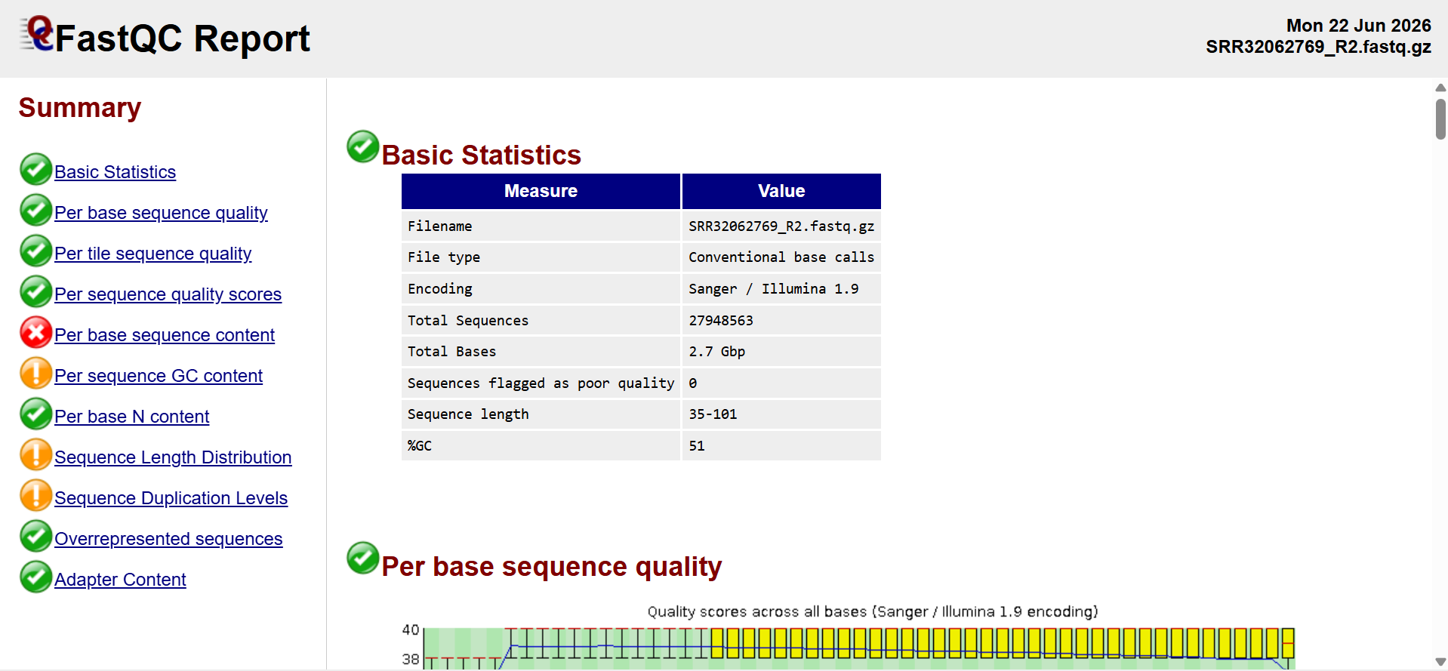
Per base sequence content

Per sequence quality score


GC Content
The per-sequence GC content showed the expected distribution for human Whole Exome Sequencing data, indicating no evidence of significant GC bias or sample contamination.
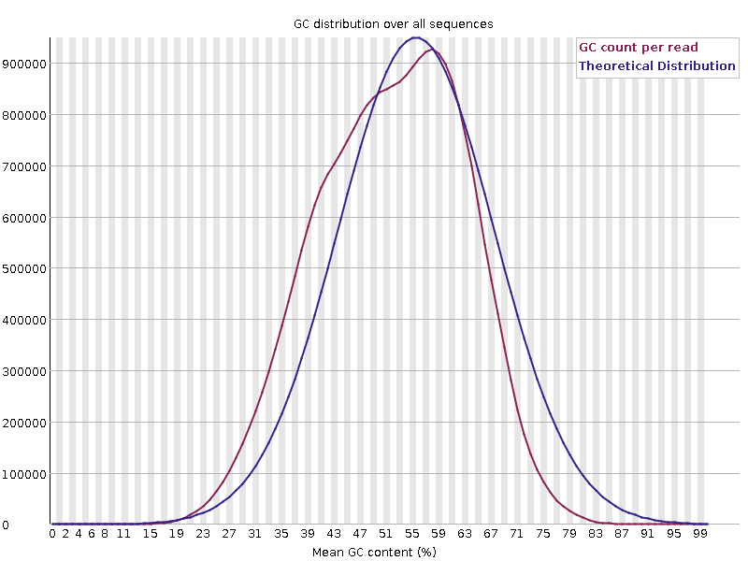
Duplication levels
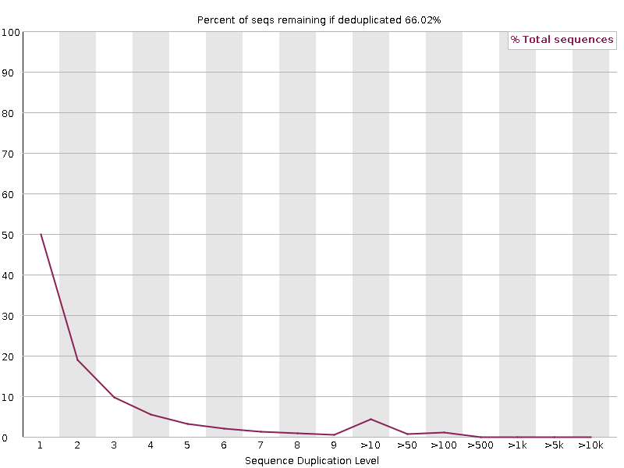

Adapter Contamination
FastQC detected the presence of adapter sequences in the raw reads. These adapter sequences were successfully removed during the read preprocessing step using fastp. Post-trimming FastQC analysis confirmed improved read quality and a substantial reduction in adapter contamination, producing high-quality reads suitable for sequence alignment and variant analysis.



6.2 Alignment Results
The high-quality trimmed sequencing reads were aligned to the human reference genome (GRCh38) using BWA-MEM. The alignment quality was assessed using SAMtools flagstat, which demonstrated excellent mapping performance.

Mapping Statistics

Parameter | Result
Total Reads | 55,149,976
Mapped Reads | 55,148,745
Mapping Rate | 100.00%
Properly Paired Reads | 54,402,300
Properly Paired Rate | 98.70%
Singletons | 641

The alignment results indicate that nearly all sequencing reads were successfully mapped to the reference genome, demonstrating high-quality sequencing data and reliable alignment suitable for downstream variant calling.

BAM
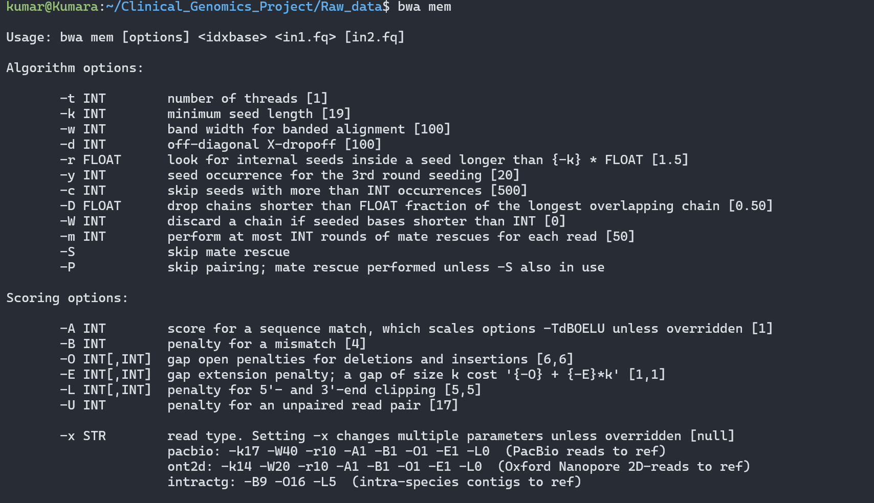

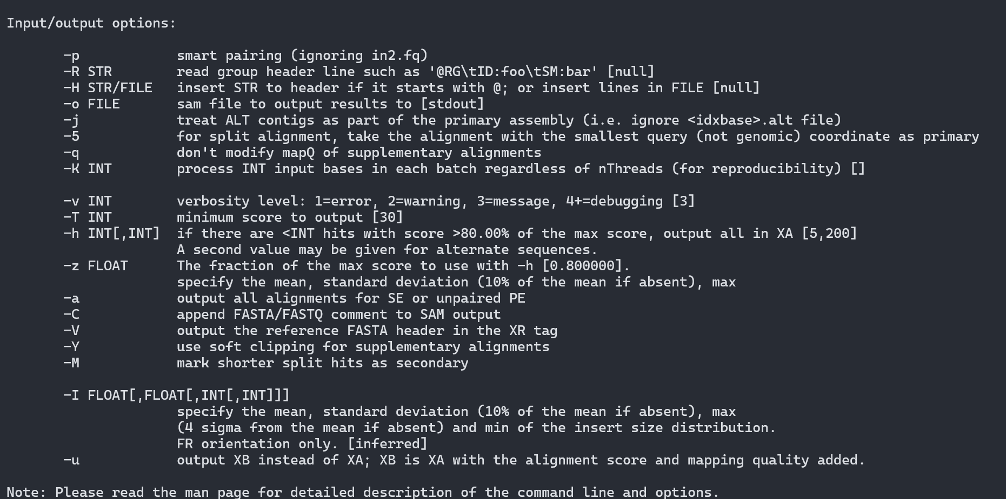
SAM TOOLs
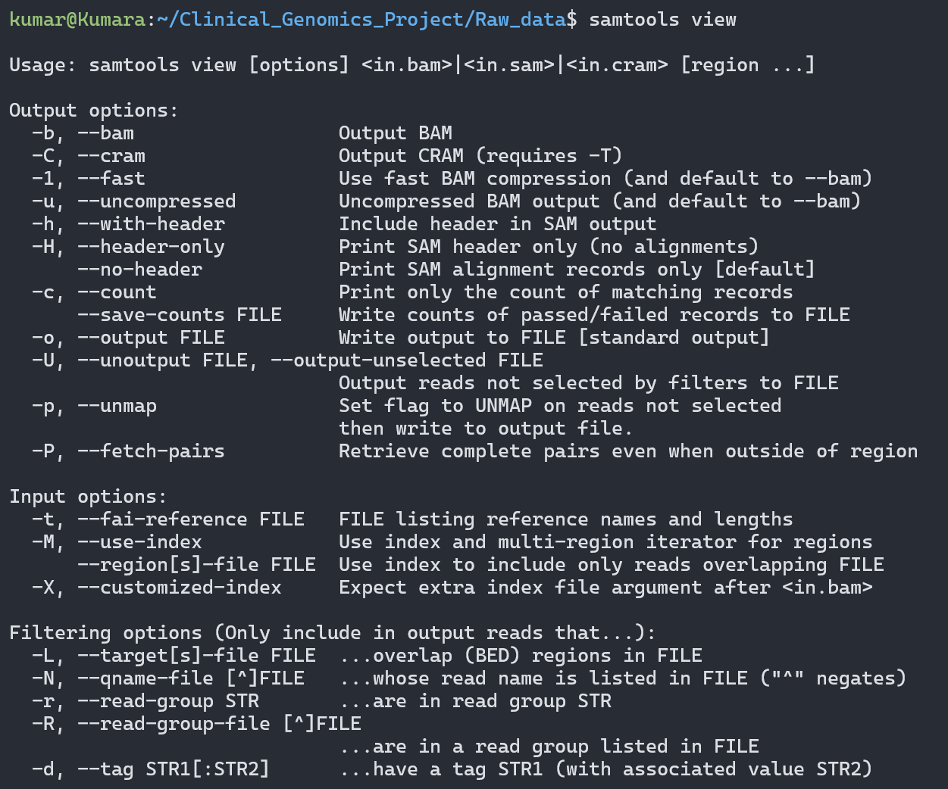

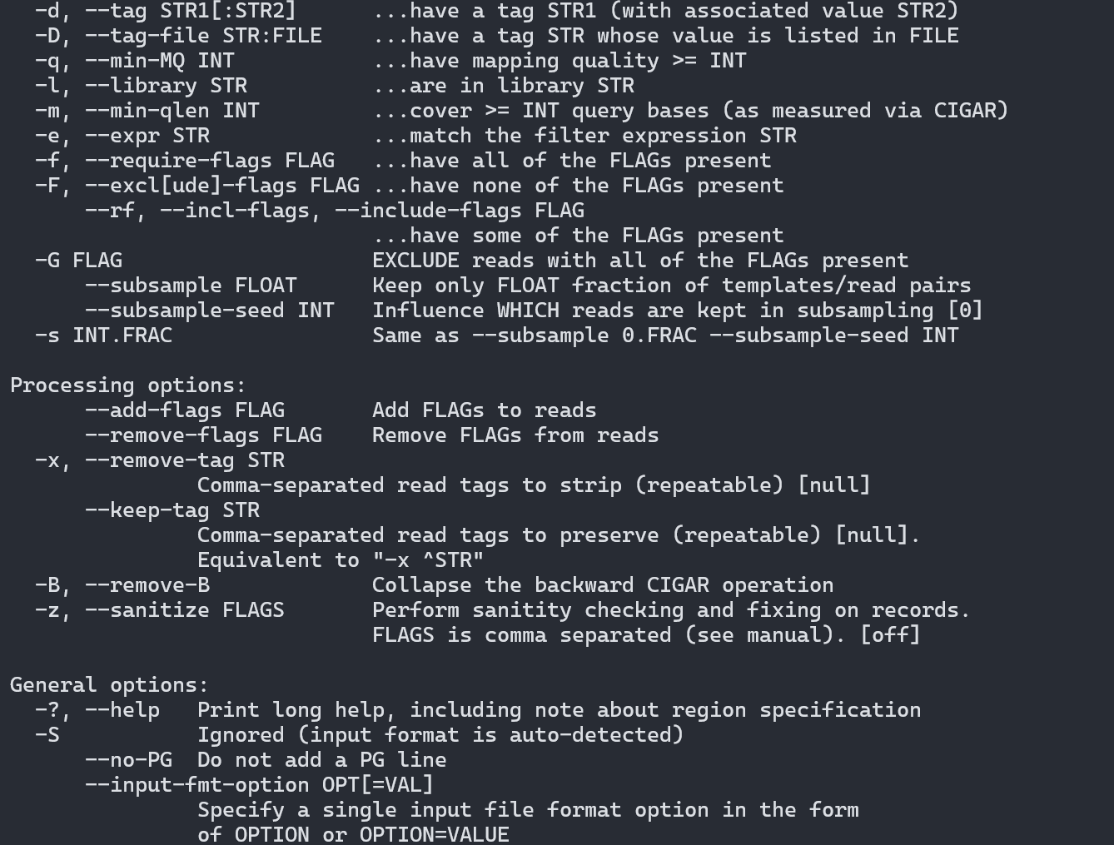
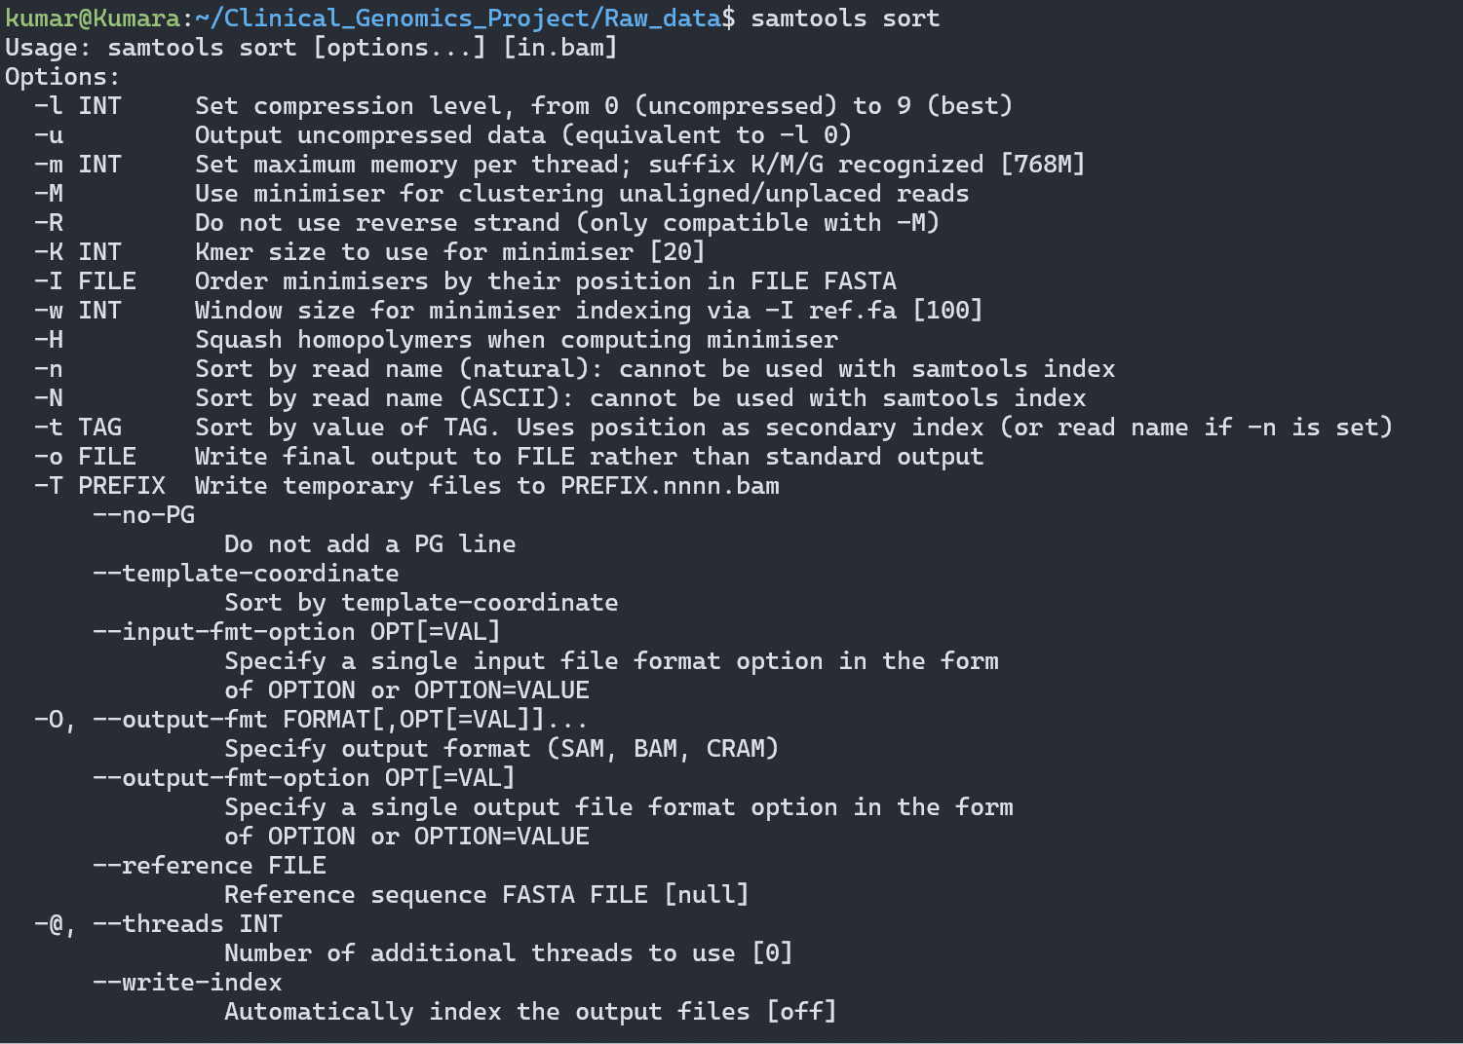

Coverage Information:
The sorted and indexed BAM file was generated successfully and used for variant calling and downstream analyses. Coverage depth analysis was not performed as part of this project; therefore, no average coverage statistics are reported.

6.3 Variant Analysis Results
Variant calling was performed using BCFtools, followed by
quality filtering and functional annotation using ANNOVAR.
High-confidence variants were retained for downstream clinical
interpretation and candidate gene prioritization.

Variant Summary
Parameter | Result
Total Variants Identified | 587,502
High-Quality Variants After Filtering | 278,785
Functionally Annotated Variants | 277,703
Exonic Variants | 21,204
Nonsynonymous (Missense) Variants | 9,693
Stopgain Variants | 83
Frameshift Variants | 391

Clinically Important Annotated Variants:
The ClinVar annotation identified one Pathogenic variant and one Likely Pathogenic variant. After integrating evidence from ClinVar, OMIM, HPO, gnomAD, and IGV, the OTUD6B gene was prioritized as the strongest candidate gene associated with the patient's phenotype.

Candidate Gene | Variant | Clinical Classification
OTUD6B | chr8:91080726 T>C (p.L229P) | Likely Pathogenic
PERM1 | chr1:976215 A>G | Pathogenic
ACKR1 | chr1:159204893 T>C | Pathogenic / Association / Protective

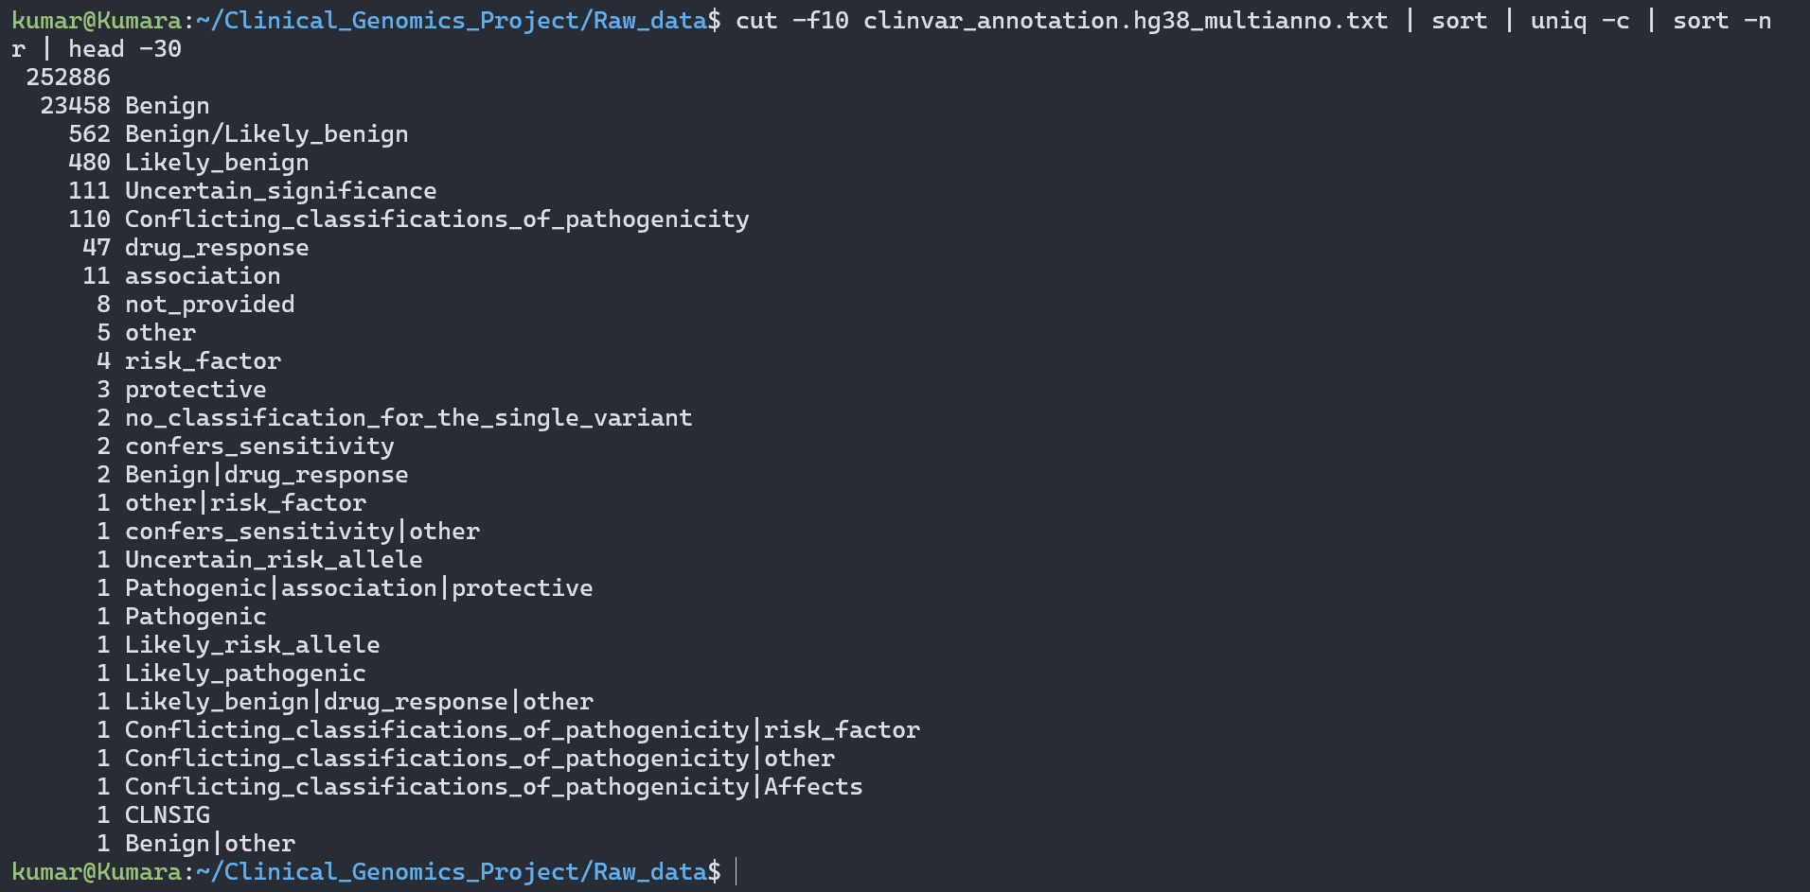

6.3 Variant Analysis Results
Variant calling using BCFtools identified a total of 587,502 genomic variants from the Whole Exome Sequencing dataset. After applying quality filtering, 278,785 high-confidence variants were retained for downstream analysis. Functional annotation using ANNOVAR successfully annotated 277,703 variants.

Among the annotated variants, 21,204 were located in protein-coding exonic regions. Functional classification identified 9,693 nonsynonymous (missense) variants, 83 stopgain variants, and 391 frameshift variants, representing variants with potential functional impact.

Clinical annotation using ClinVar identified one Pathogenic variant and one Likely Pathogenic variant. Further biological interpretation using OMIM, HPO, gnomAD, and IGV prioritized OTUD6B (chr8:91080726 T>C; p.L229P) as the most clinically relevant candidate gene associated with the patient's phenotype.

Summary of Variant Analysis

Parameter | Result
Total Variants Identified | 587,502
High-Quality Variants After Filtering | 278,785
Functionally Annotated Variants | 277,703
Exonic Variants | 21,204
Nonsynonymous (Missense) Variants | 9,693
Stopgain Variants | 83
Frameshift Variants | 391
ClinVar Pathogenic Variants | 1
ClinVar Likely Pathogenic Variants | 1
Prioritized Candidate Gene | OTUD6B

Candidate Variant

Parameter | Result
Gene | OTUD6B
Variant | NM_016023.5:c.686T>C (p.Leu229Pro)
Frequency | 0.0001158
Clinical Significance | Likely Pathogenic
Frequency (gnomAD):0.0001158 (Rare Variant) | 0.0001158 (Rare Variant)

GenomAd brower :

Database used: gnomAD Browser v4.1.1

Gene: OTUD6B

Candidate variant: c.686T>C (p.Leu229Pro)

Variant ID: 8-91080726-T-C (GRCh38)

dbSNP ID: rs150848976

gnomAD Total Allele Frequency: 0.0001158 (≈0.01158%)

Total Allele Count: 185

Number of Homozygotes: 0

The variant is rare, therefore it was retained for downstream clinical interpretation.

Discussion

Interpretation of Findings

The complete Clinical Genomics workflow was successfully implemented using a publicly available pediatric Whole Exome Sequencing (WES) dataset. The quality assessment confirmed that the sequencing reads were suitable for downstream analysis after adapter trimming and quality filtering. High-quality sequence alignment to the human reference genome (GRCh38) resulted in an excellent mapping rate, providing a reliable foundation for accurate variant identification.
A total of 587,502 genomic variants were identified, of which 278,785 high-confidence variants passed quality filtering. Functional annotation using ANNOVAR identified 277,703 annotated variants, including 21,204 exonic variants. Further clinical interpretation using ClinVar, OMIM, Human Phenotype Ontology (HPO), gnomAD, and Integrative Genomics Viewer (IGV) enabled systematic prioritization of candidate disease-associated variants. Based on the integrated biological and clinical evidence, the OTUD6B variant (chr8:91080726 T>C; p.L229P) was identified as the most clinically relevant candidate and classified as Likely Pathogenic, demonstrating a strong association with the reported neurodevelopmental phenotype.

Challenges Encountered
- Processing Whole Exome Sequencing data required substantial computational resources and storage.
- Managing large sequencing files (FASTQ, BAM, and VCF) required efficient file organization.
- Installation and configuration of bioinformatics tools in the Linux environment required careful troubleshooting.
- Interpretation of large numbers of genomic variants required integration of multiple biological and clinical databases.
Possible Improvements
- Incorporate additional population and disease databases to improve variant interpretation.
- Apply comprehensive ACMG/AMP evidence scoring using dedicated interpretation tools.
- Perform family-based or trio analysis to improve candidate variant prioritization.
- Validate prioritized variants using complementary experimental methods, such as Sanger sequencing, where appropriate.
- Integrate additional functional prediction tools to strengthen biological interpretation.

7. Biological Interpretation

The biological interpretation step was performed to identify the genetic variant most likely to be associated with the patient's condition. After variant calling and functional annotation, the identified variants were evaluated using multiple clinical and biological databases to determine their clinical significance and disease relevance.
Initially, a large number of genomic variants were detected from the Whole Exome Sequencing (WES) data. After quality filtering, functional annotation using ANNOVAR was performed to identify variants located in coding regions and to determine their predicted functional effects.

The annotated variants were then evaluated using ClinVar to determine their clinical significance. Variants classified as Pathogenic or Likely Pathogenic were given higher priority for further analysis. Population frequency was assessed using the gnomAD database, where rare variants were considered more likely to contribute to genetic disease.

Further biological interpretation was performed using OMIM to investigate known gene–disease associations and Human Phenotype Ontology (HPO) to compare the reported disease phenotypes with the available clinical information. The prioritized variant was also visually examined using the Integrative Genomics Viewer (IGV) to confirm good read support and sequencing quality.

Based on the combined evidence from ANNOVAR, ClinVar, OMIM, HPO, gnomAD, and IGV, the OTUD6B gene was identified as the strongest candidate gene in this study. The detected variant (chr8:91080726 T>C; p.L229P) was classified as Likely Pathogenic in ClinVar and has been reported to be associated with a rare neurodevelopmental disorder.

Although complete clinical phenotype information for the patient was not available in the public dataset, the integrated analysis consistently supported OTUD6B as the most biologically relevant candidate gene identified in this project.
Overall, this study demonstrates how an end-to-end Clinical Genomics bioinformatics pipeline can efficiently reduce thousands of genomic variants to a small number of clinically significant candidates, enabling systematic identification and prioritization of disease-associated genetic variants.

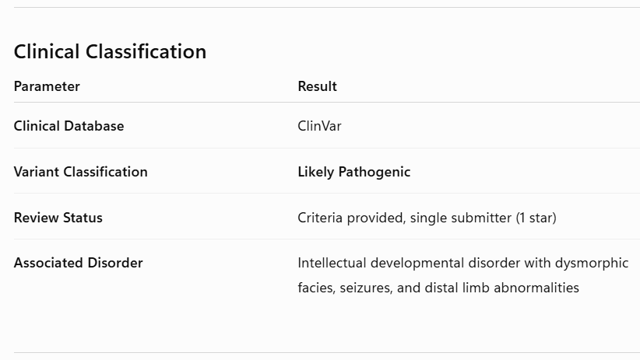

7.3 IGV Validation

IGV Validation:

Tool: Integrative Genomics Viewer (IGV)

Variant: OTUD6B (Chr8:91080726 T>C; GRCh38)

Purpose: To visually validate the candidate variant by confirming read alignment quality, sequencing depth, and variant support at the genomic locus.

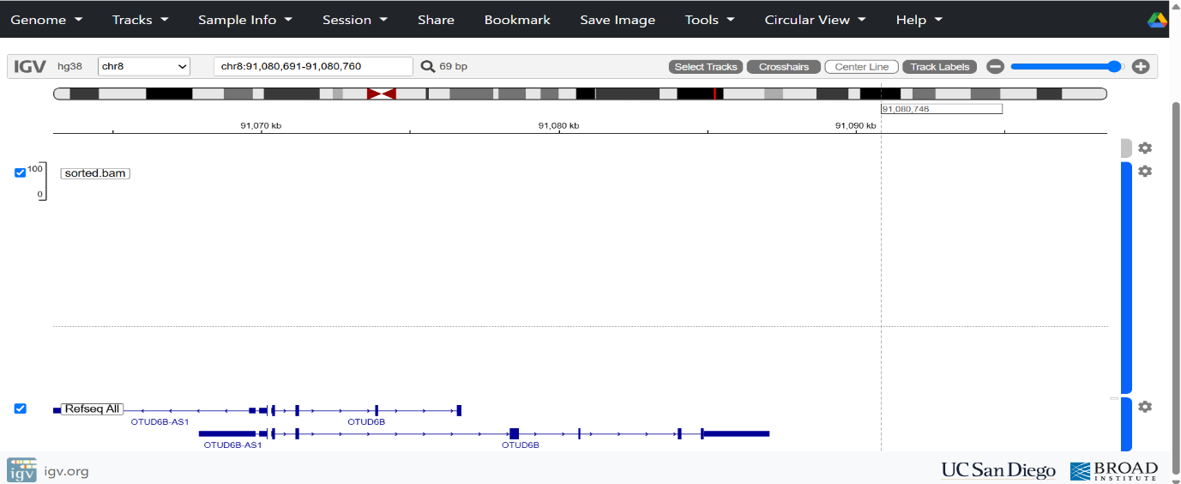
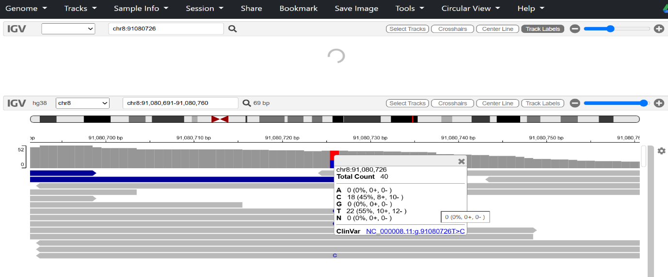
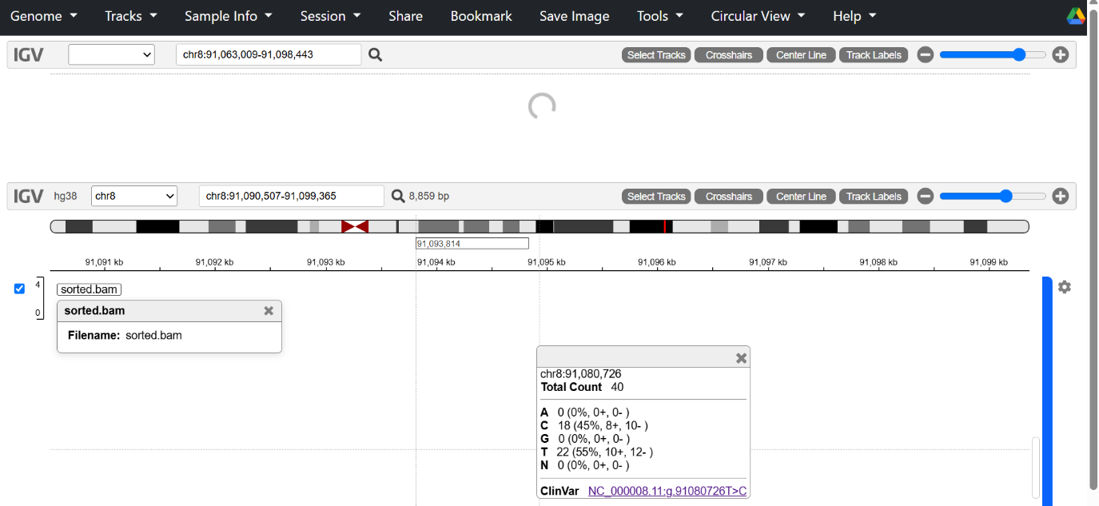
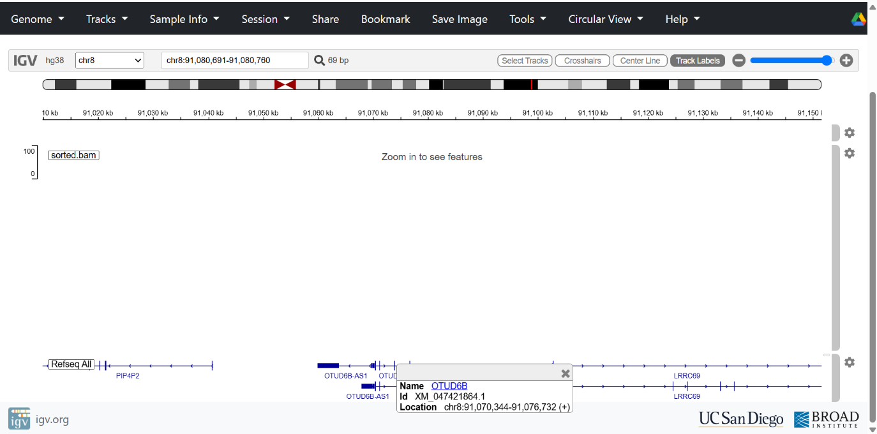

Observation: The OTUD6B variant was clearly supported by aligned sequencing reads with good mapping quality and consistent read evidence. Visual inspection confirmed the presence of the variant at the expected genomic position, supporting the reliability of the variant call.

Conclusion: IGV validation provided independent visual evidence supporting the authenticity of the OTUD6B candidate variant identified through the bioinformatics pipeline.

7.4 Clinical Conclusion

This project successfully implemented a complete end-to-end Clinical Genomics workflow for the analysis of Whole Exome Sequencing (WES) data obtained from a pediatric sibling belonging to a family investigated for immunodeficiency and neurodevelopmental abnormalities. The workflow included sequencing quality assessment, read preprocessing, genome alignment, alignment processing, variant calling, functional annotation, clinical annotation, population frequency analysis, phenotype-based interpretation, and variant validation.

Through systematic variant prioritization, a rare missense variant in the OTUD6B gene (NM_016023.5:c.686T>C; p.Leu229Pro) was identified as the highest-priority candidate variant. Clinical annotation using ClinVar classified this variant as Likely Pathogenic, while population frequency analysis using gnomAD indicated that it is a rare variant in the general population. Gene–disease information obtained from OMIM and phenotype correlation using the Human Phenotype Ontology (HPO) supported the biological relevance of OTUD6B in relation to the reported neurodevelopmental phenotype. Visual inspection using Integrative Genomics Viewer (IGV) further supported the reliability of the identified variant.

Overall, the integrated analysis prioritized the OTUD6B variant as the most clinically relevant candidate identified in this study. Although the findings provide strong genomic evidence supporting its potential clinical significance, definitive diagnosis requires correlation with detailed clinical evaluation, family segregation studies, and additional functional validation. This project demonstrates the practical application of a standardized Clinical Genomics pipeline for the identification, annotation, prioritization, and interpretation of disease-associated variants from Whole Exome Sequencing data.

Variant Prioritization & Evidence
The pipeline systematically narrowed down the data to highlight a primary candidate variant. The evidence supporting this finding is structured below:
Feature / Tool | Data & Clinical Relevance
Candidate Gene | OTUD6B
Variant Details | NM_016023.5:c.686T>C; p.Leu229Pro (Rare missense variant)
ClinVar Classification | Likely Pathogenic
gnomAD Frequency | Confirmed as highly rare in the general population
OMIM & HPO | Supported a strong biological link to the neurodevelopmental phenotype
IGV Inspection | Visual verification confirmed the variant call is clean and reliable

Sample: SRR32062769
Reference: GRCh38

Alignment Statistics:
Total reads: 55,149,976
Mapped reads: 55,148,745 (100%)
Properly paired: 54,402,300 (98.70%)

Variants:
Raw variants: 587,502
Filtered variants: 278,785

Annotation:
Exonic: 21,204
Intronic: 134,447
Intergenic: 92,990

High-impact variants:
Stopgain: 83
Frameshift-related: 391
Nonsynonymous SNV: 9,693

8. Skills GainedTechnical Skills

- Linux (Ubuntu/WSL) Commands
- Next-Generation Sequencing (NGS) Data Analysis
- Quality Control using FastQC
- Read Trimming using fastp
- Sequence Alignment using BWA-MEM
- Variant Calling using BCFtools
- Variant Annotation using ANNOVAR
- Clinical Variant Interpretation
- GitHub Usage
- Scientific Report Preparation

9. Challenges Faced and Solutions

Challenge | Solution
Large Whole Exome Sequencing (WES) data files | Efficient file organization and storage management
Linux command-line errors | Debugging and troubleshooting commands
Installation of bioinformatics tools | Proper software configuration and dependency management
Processing large sequencing datasets | Stepwise execution of the NGS analysis pipeline
Variant prioritization from thousands of variants | Functional annotation and clinical database integration (ANNOVAR, ClinVar, OMIM, HPO, gnomAD)
Managing multiple analysis files | Systematic folder structure and file naming
Interpretation of candidate variants | Integration of biological evidence and literature resources

10. Conclusion

The Genomics + NGS Internship provided valuable hands-on experience in Clinical Genomics and bioinformatics. During the internship, I learned the complete Whole Exome Sequencing (WES) analysis workflow, beginning with raw sequencing data and progressing through quality control, read preprocessing, sequence alignment, variant calling, functional annotation, and biological interpretation.

Through this project, I gained practical experience using Linux-based bioinformatics tools, including FastQC, fastp, BWA-MEM, SAMtools, BCFtools, ANNOVAR, and clinical databases such as ClinVar, OMIM, HPO, and gnomAD. The project also strengthened my understanding of candidate gene prioritization and clinical variant interpretation, leading to the identification of OTUD6B as the most clinically relevant candidate gene.
Overall, this internship significantly enhanced my technical skills in Next-Generation Sequencing (NGS) data analysis, problem-solving, and scientific report preparation. The knowledge and practical experience gained through this internship will be valuable for future studies, research in clinical genomics, and careers in bioinformatics, precision medicine, and genomic data analysis.

11. References

Research Articles

- Koboldt, D. C. (2020). Best practices for variant calling in clinical sequencing. Genome Medicine.
- Roychowdhury, S., & Chinnaiyan, A. M. (2016). Translating genomics for precision cancer medicine. Annual Review of Genomics and Human Genetics.
- National Center for Biotechnology Information (NCBI). Sequence Read Archive (SRA). BioProject: PRJNA1212196.

Software Documentation
- FastQC: A Quality Control Tool for High Throughput Sequence Data. FastQC Documentation
- BWA-MEM Documentation.
- SAMtools Documentation.
- BCFtools Documentation.
- ANNOVAR Documentation. ANNOVAR Documentation

Databases Used
•ClinVar Database.
• OMIM (Online Mendelian Inheritance in Man).
• Human Phenotype Ontology (HPO).
• Genome Aggregation Database (gnomAD).
• NCBI Sequence Read Archive (SRA).

Training Materials

• BIOTECHTREK – Genomics + NGS Internship Training Materials.
• Internship Practical Notes and Linux Command Documentation.

12. Appendix

The appendix contains supporting documents and supplementary materials generated during the Clinical Genomics project.

Appendix A: FastQC Reports
- Raw Read FastQC Report (R1)\
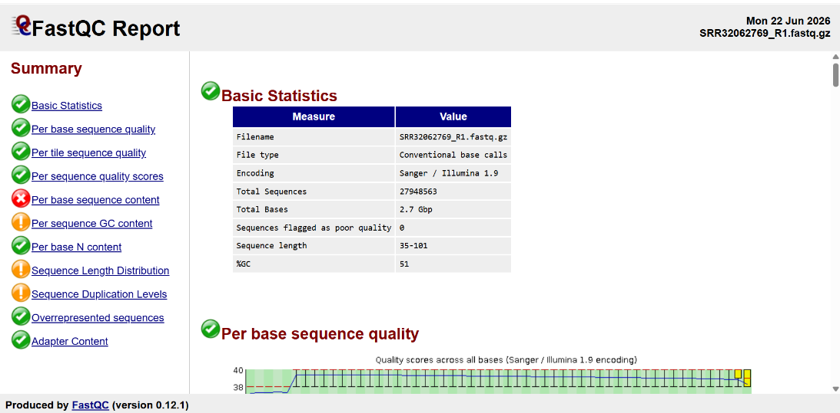
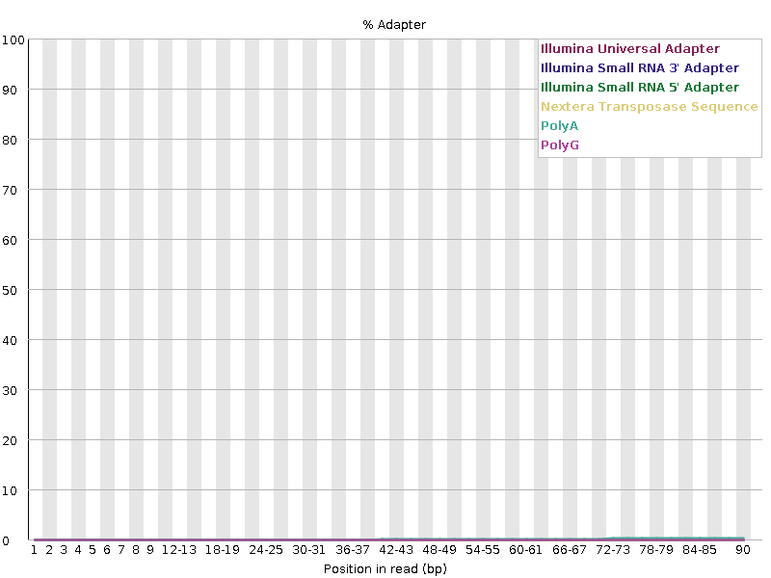


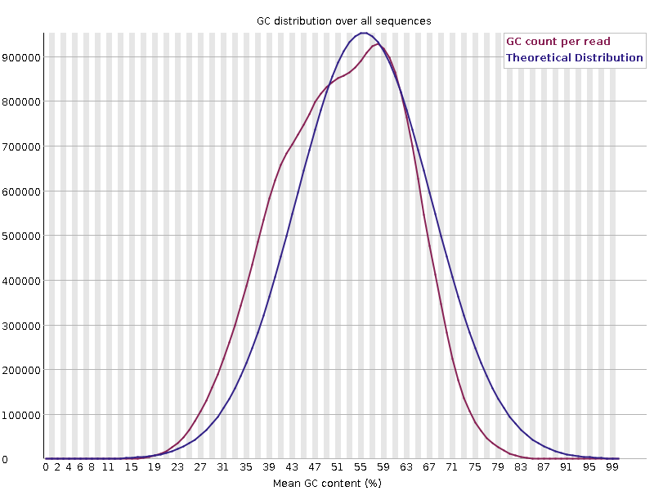

- Raw Read FastQC Report (R2)
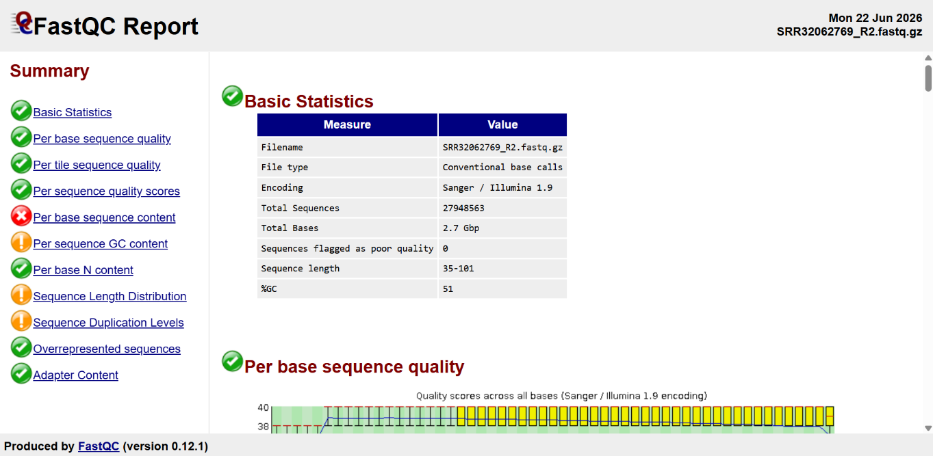


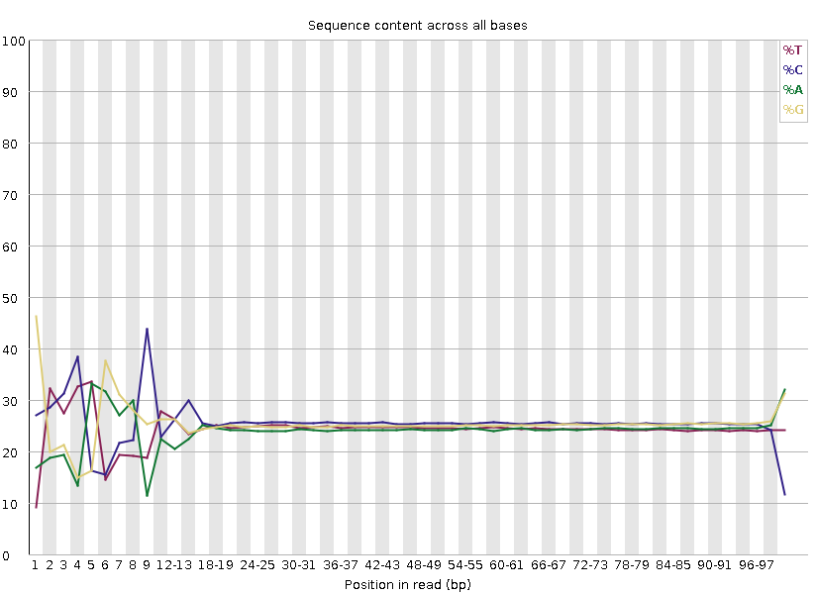



- Post-trimming FastQC Report (R1)
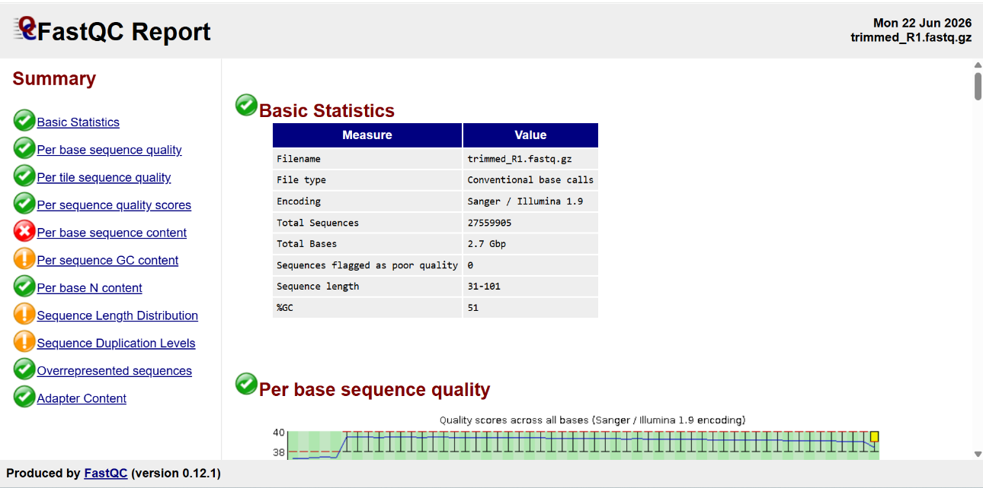

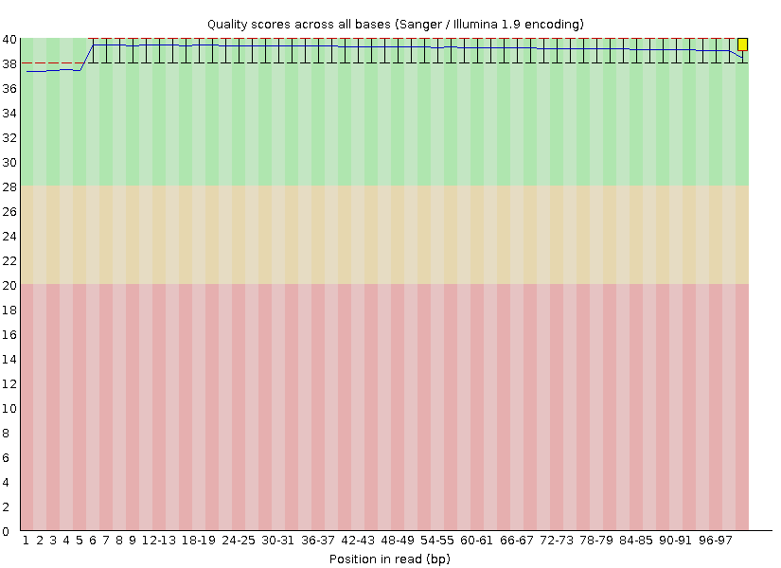
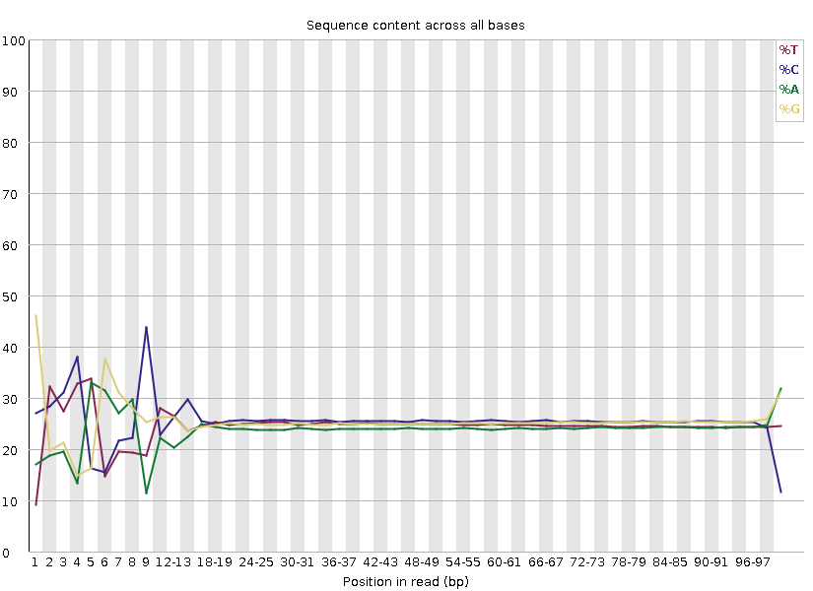
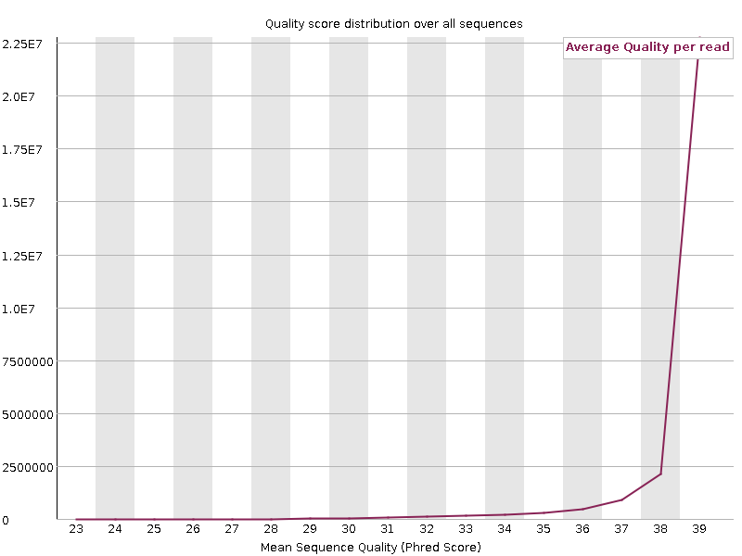

- Post-trimming FastQC Report (R2)
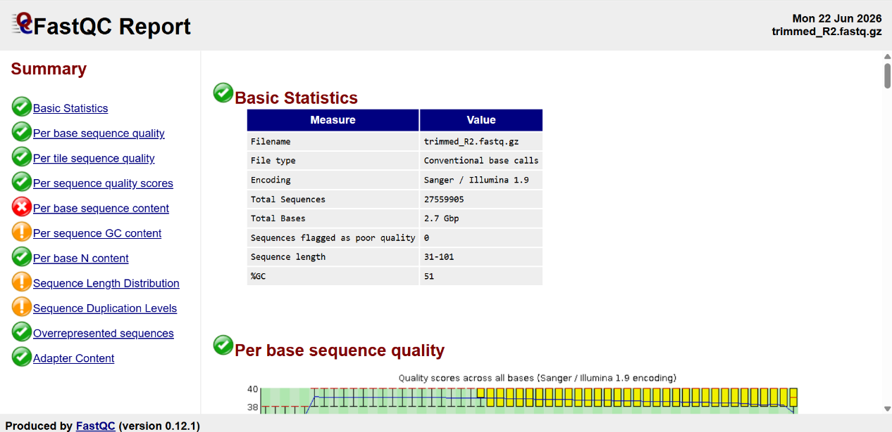

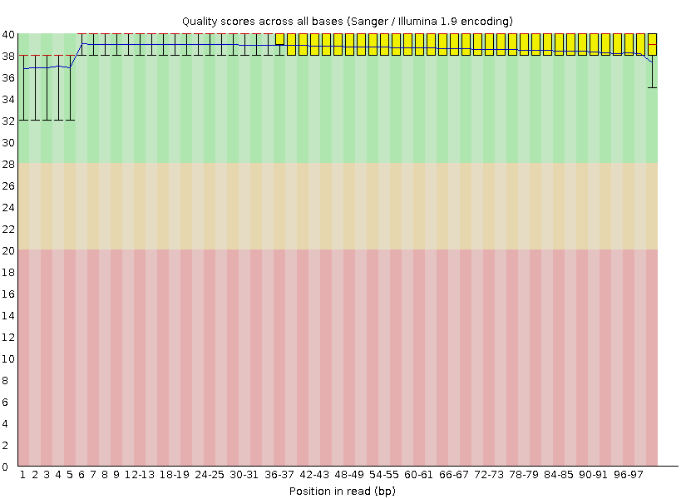
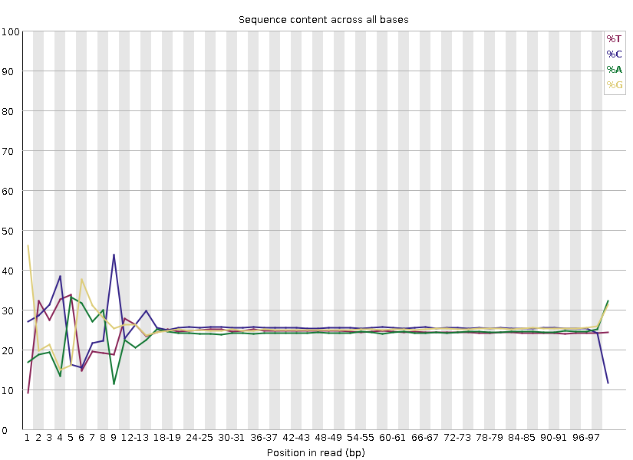
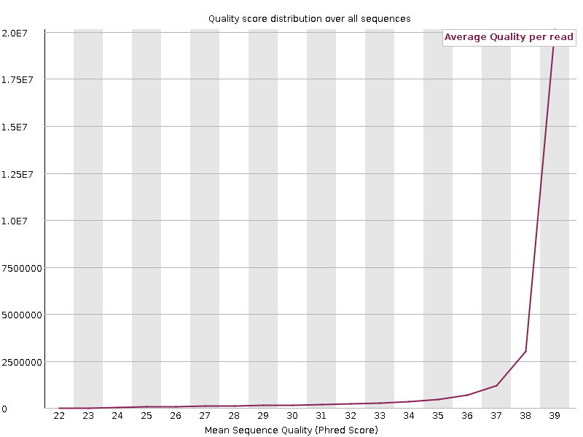
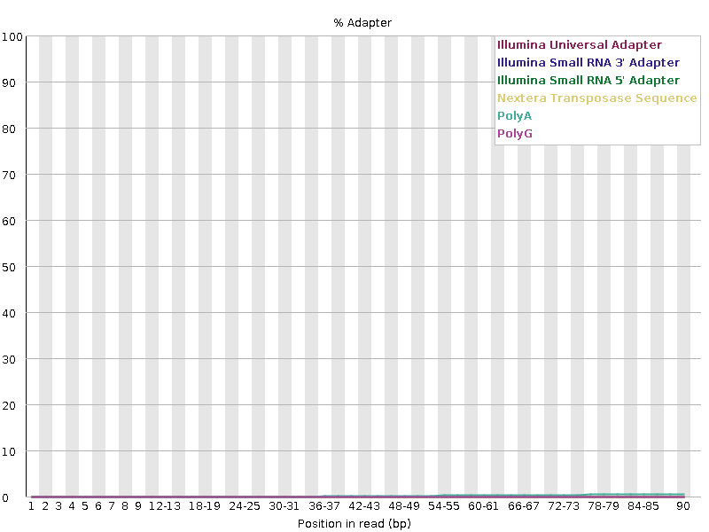

Appendix B: fastp Quality Report
- HTML quality report
- JSON summary report

Appendix C: Important Output Files
- Variant Call Format (VCF) file
annotated_chr.hg38_multianno.txt
clinvar_annotation.hg38_multianno.txt
- ANNOVAR annotation output
- ClinVar annotation results
- Candidate gene prioritization results
- SRR32062769_R1_fastqc.html
- SRR32062769_R2_fastqc.html
- trimmed_R1_fastqc.html
- trimmed_R2_fastqc.html
- aligned.sam
- aligned.bam
- sorted.bam
- sorted.bam.bai
- variants.vcf
- filtered_variants.vcf
- annotated_chr.hg38_multianno.txt
- clinvar_annotation.hg38_multianno.txt
- clinvar_top_hits.txt
- OTUD6B_variants.txt
- prioritized_genes.txt

Appendix D: Expected Deliverables
FastQC Reports
Trimmed Reads
Variant File
Annotated Variant Files
Candidate Variant Reports
Final Clinical Report

Appendix D: GitHub Repository
GitHub Repository Link:
GitHub Repository
Repository Link
README
Commands
Screenshots
Workflow

URL :

Appendix E: Workflow and Figures
- Clinical Genomics project workflow
- Key analysis screenshots (FastQC, BWA-MEM, ANNOVAR, ClinVar, IGV)

