**Objective :**

Smart car parking project aims at providing a confusion free and easy parking. This project helps the drivers of the cars to park their vehicles with minimum wastage of time with accurate information of the availability of the space to park It includes an Arduino Uno as the microcontroller unit to which the servo motors, LCD display ultrasonic sensors (HC-05) are interfaced. The LCD displays the availability of the space, the ultrasonic sensors keeps the check of the number of cars entering and exiting the parking space. The ultrasonic sensors detect the availability of the parking space.

**THEORY**

An automated car parking system is a process through which car parking can be done more efficiently and easily than manual method. The system will provide the user better services.

The system counts the number of cars in the space and checks if there’s any vacancy. There’s an entry and exit path. When vehicle enters, the display shows the number of cars inside. When any vehicle leaves, the count decreases and shown on display. If the space is full. The display will show a message regarding that.

This whole process includes the use of Arduino, Display and sonar. The sonar detects whether the vehicle is entering or leaving. The report then showed on display.

**Hardware Design**

Hardware equipment that we need in order to build the project are given below:

1) Arduino UNO (1 Nos)

2) Ultrasonic Sensor (3 Nos)

3) IR Sensor (1 Nos)

4) LCD display (1 Nos)

5) Servo Motor (1 Nos)

6) Red Led (3 Nos)

7) Green Led (3 Nos)

**Code Implementation**

#include <LiquidCrystal.h>

#include <Servo.h>

LiquidCrystal lcd(12, 11, 5, 4, 3, 2);

#define t1 10

#define t2 9

#define t3 8

#define IR_SENSOR_PIN 7

#define SERVO_PIN 6

#define GREEN_LED1 A0

#define GREEN_LED2 A2

#define GREEN_LED3 A4

#define RED_LED1 A1

#define RED_LED2 A3

#define RED_LED3 A5

Servo servoMotor;

int distanceThreshold = 150;

void setup() {

lcd.begin(16,2);

lcd.setCursor(0,0);

pinMode(IR_SENSOR_PIN, INPUT_PULLUP);

pinMode(GREEN_LED1, OUTPUT);

pinMode(GREEN_LED2, OUTPUT);

pinMode(GREEN_LED3, OUTPUT);

pinMode(RED_LED1, OUTPUT);

pinMode(RED_LED2, OUTPUT);

pinMode(RED_LED3, OUTPUT);

servoMotor.attach(SERVO_PIN);

Serial.begin (9600);

}

long readDistance(int triggerPin, int echoPin) {

pinMode(triggerPin, OUTPUT);

digitalWrite(triggerPin, LOW);

delayMicroseconds(2);

digitalWrite(triggerPin, HIGH);

delayMicroseconds(10);

digitalWrite(triggerPin, LOW);

pinMode(echoPin, INPUT);

return pulseIn(echoPin, HIGH);

}

void handleLEDs(float distance, int greenLedPin, int redLedPin) {

if (distance >= distanceThreshold){

digitalWrite(greenLedPin, HIGH);

digitalWrite(redLedPin, LOW);

Serial.println("Empty slot!!");

} else {

digitalWrite(redLedPin, HIGH);

digitalWrite(greenLedPin, LOW);

Serial.println("Car is parked");

}

}

void loop() {

//... same code as above ...

float d1 = 0.01723 * readDistance(t1, t1);

float d2 = 0.01723 * readDistance(t2, t2);

float d3 = 0.01723 * readDistance(t3, t3);

Serial.println("d1 = " + String(d1) + "cm");

Serial.println("d2 = " + String(d2) + "cm");

Serial.println("d3 = " + String(d3) + "cm");

if (digitalRead(IR_SENSOR_PIN) == LOW) { // Vehicle detected by IR sensor

if (d1 > 100 || d2 > 100 || d3 > 100) {

servoMotor.write(90); // Assuming 90 degrees opens the gate

delay(500);

servoMotor.write(0); // Assuming 0 degrees closes the gate after some time

delay(500);

} else {

// Do nothing or maybe sound a buzzer to indicate parking full

}

}

// Handle LEDs based on the distance readings

handleLEDs(d1, GREEN_LED1, RED_LED1);

handleLEDs(d2, GREEN_LED2, RED_LED2);

handleLEDs(d3, GREEN_LED3, RED_LED3);

if (d1>100 & d2>100 & d3>100){

lcd.setCursor(0,0);

lcd.print("3 Slots Free");

lcd.setCursor(0,1);

lcd.print("Slot 1 2 3 Free");

delay(500);

}

else if((d1>100 & d2>100)|(d2>100 & d3>100)|(d3>100 & d1>100))

{

lcd.setCursor(0,0);

lcd.print("2 Slots Free");

lcd.setCursor(0,1);

if(d1>100 & d2>100)

lcd.print("Slot 1 & 2 Free");

else if(d1>100 & d3>100)

lcd.print("Slot 1 & 3 Free");

else

lcd.print("Slot 2 & 3 Free");

delay(500);

}

else if(d1<100 & d2<100 & d3<100)

{

lcd.setCursor(0,0);

lcd.print("No Slot Free");

lcd.setCursor(0,1);

lcd.print("Parking Full");

delay(500);

}

else if((d1<100 & d2<100)|(d2<100 & d3<100)|(d3<100 & d1<100))

{

lcd.setCursor(0,0);

lcd.print("1 Slot Free");

lcd.setCursor(0,1);

if(d1>100)

lcd.print("Slot 1 is Free");

else if (d2>100)

lcd.print("Slot 2 is Free");

else

lcd.print("Slot 3 is Free");

delay(500);

}

delay(100);

}

**Block Diagram (Sensor Setup):**

Block Diagram of our proposed system is given below

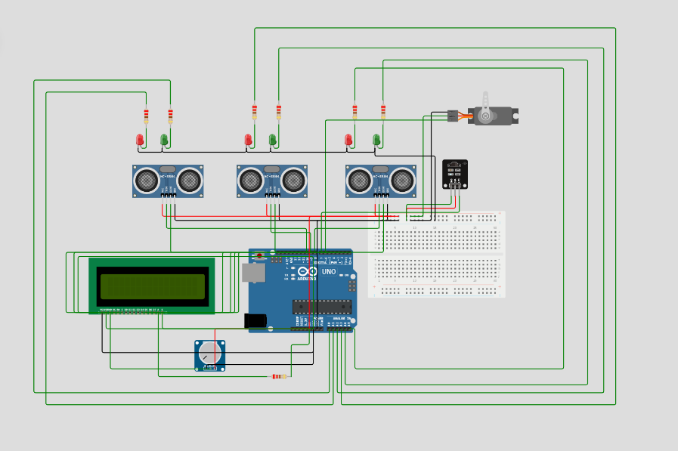

**Flow Chart**

The flow chart includes how the system works. The program flow chart is given below:

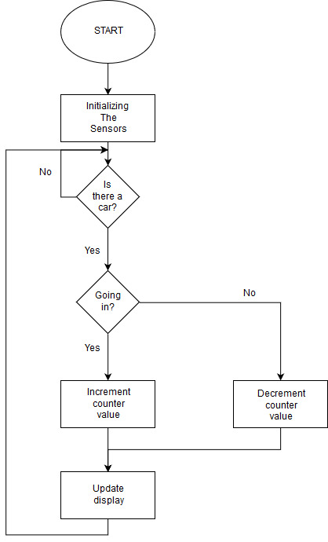

Figure-2 : Flow chart of Smart Car Parking System

**Explain how the real-time parking availability system can benefit drivers and alleviate parking issues**

Convenience: By utilizing a real-time parking availability system, drivers can quickly access parking spaces near their destination without spending unnecessary time circling around the block

Accurate Data: Real-time parking availability systems can rely on sensors, cameras, and algorithms to accurately track the number of available parking spaces.

Environmental Benefits: A real-time parking availability system can encourage more efficient parking habits by providing drivers with accurate data on parking availability

**App Interface :**

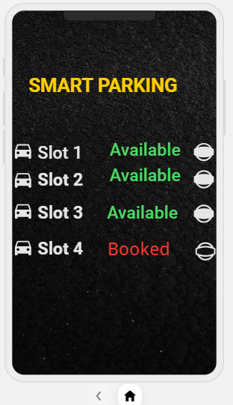

**Real-time parking availability system can benefit drivers and alleviate parking issues**