**IMPORTING THE LIBRARIES:**

READ THE DATASET:

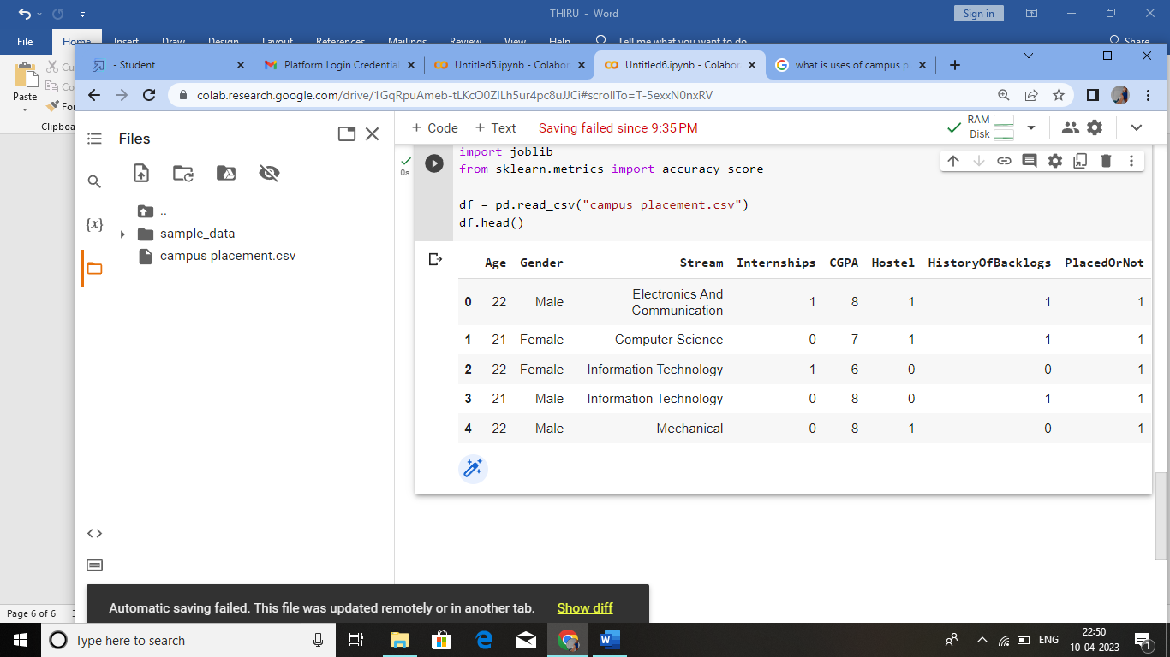

HANDLING MISSING VALUES:

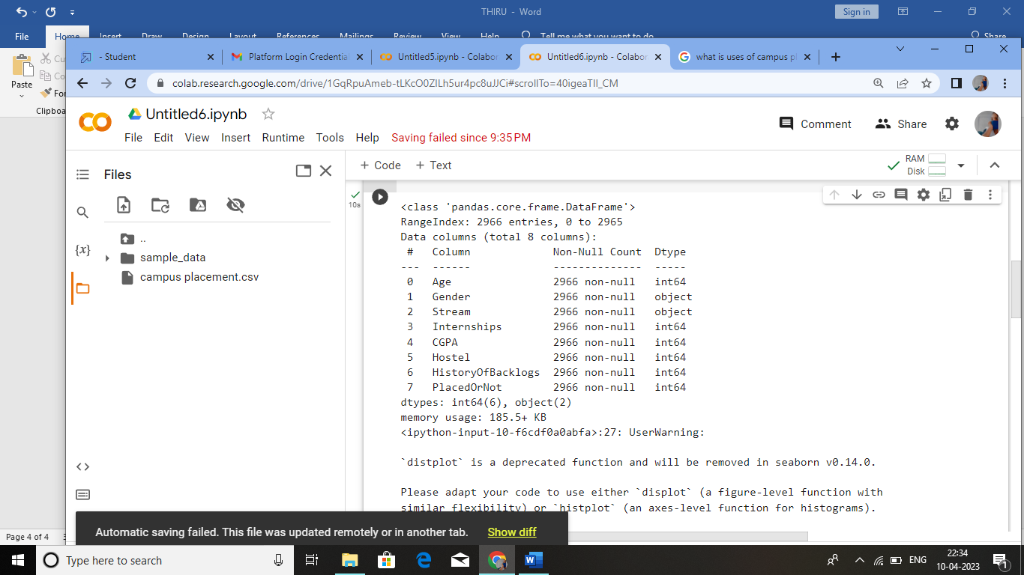

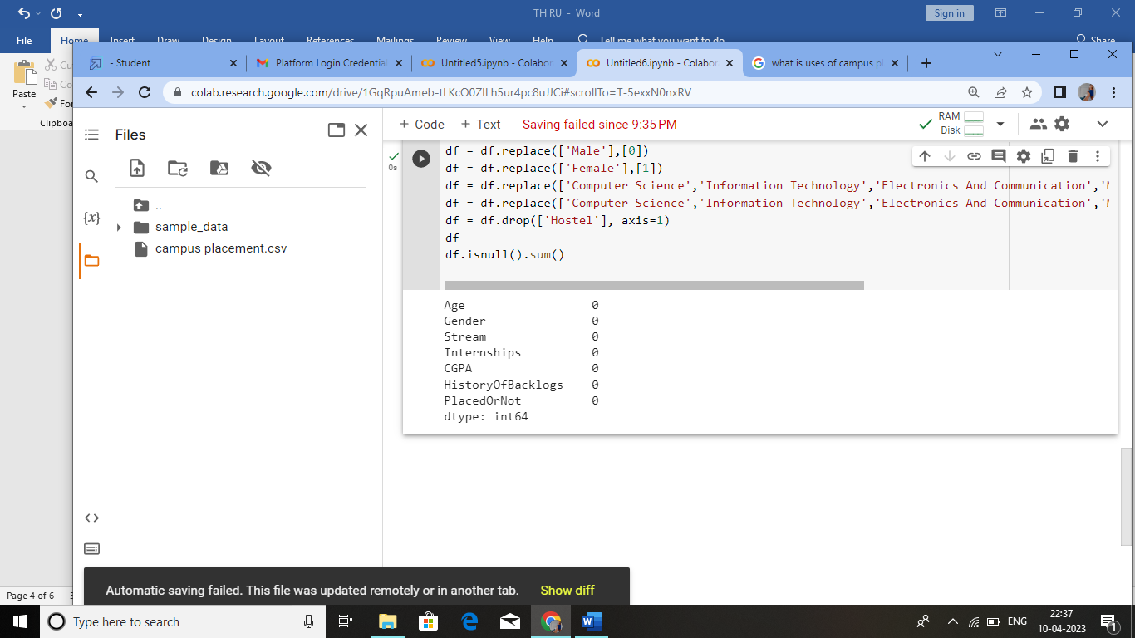

HANDLING OUTLIERS: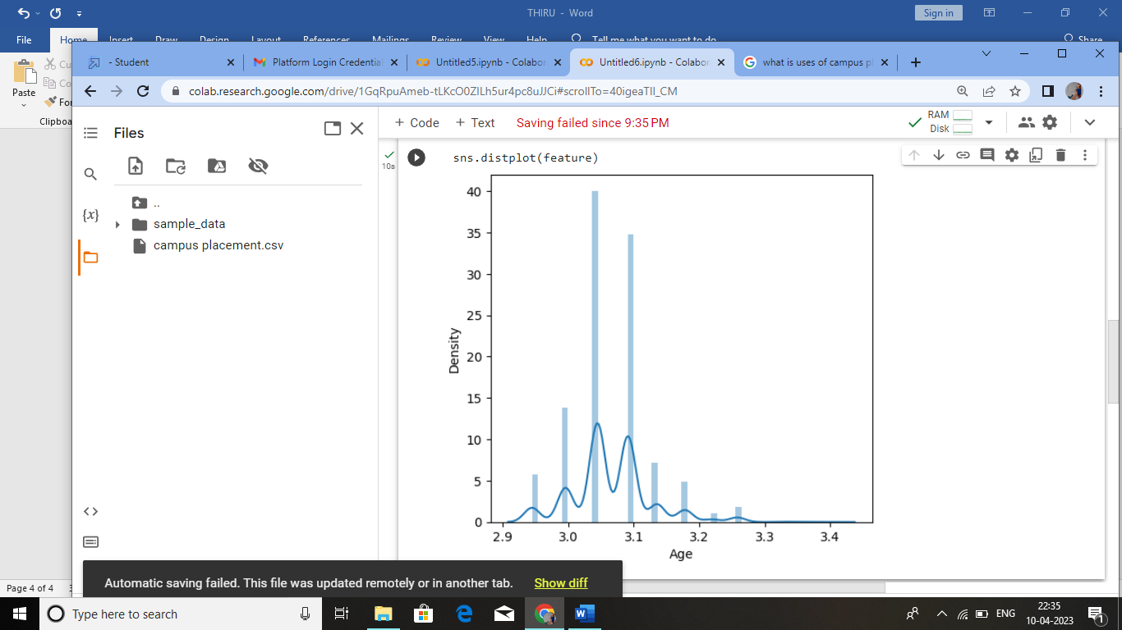

HANDLING CATEGORICAL VALUES: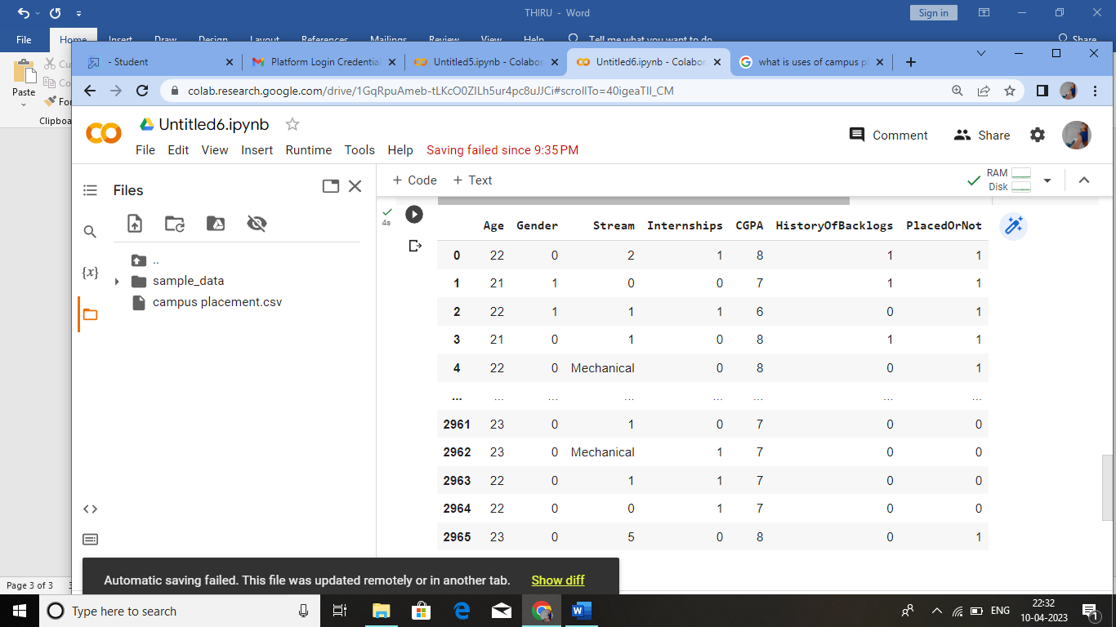

**EXPLORATORY DATA ANALYSIS:**

**UNIVARIATE ANALYSIS:**

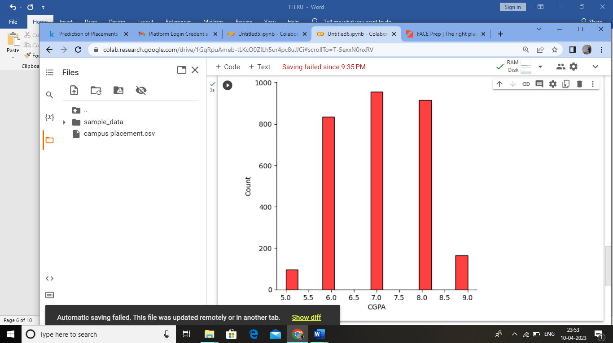

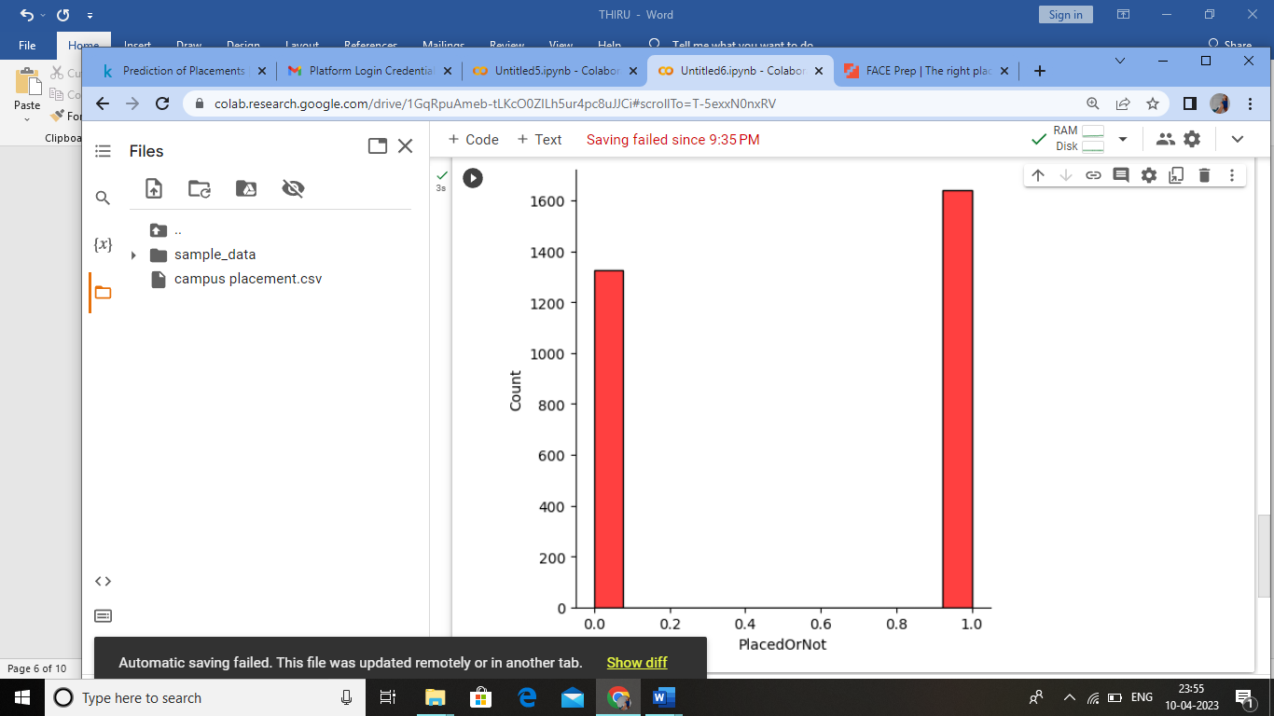

**BIBARIATE ANALYSIS:**

