FireTwins (PyFDS)
Client demonstrations - step-by-step user manual
Example 1: room fire with door, window and heat detector
Example 2: burning couch (FDS example case)
Example 3: tenability and comparing runs (chapter 4)
Revised 29 October 2026: every screenshot and run taken again with the current version; new menus and tools in chapter 4

Software | Version used for this manual
PyFDS model editor and PyFDS Results | 0.3.0 (repository E:\firetwins)
FDS (Fire Dynamics Simulator, NIST) | FDS-6.10.1 release
Smokeview (NIST) | SMV-6.10.1 release
Python / PySide6 / PyVista / VTK | 3.10 / 6.12.0 / 0.49.0 / 9.3.1
Screen used for every screenshot | 1360 x 768, 100 % scaling, windows maximized

Contents
Contents 2
1 Before you start 3
1.1 Launching the programs 3
1.2 The demonstration files 3
2 Example 1 - Room fire with door, window and heat detector 4
A Introduction 4
B Opening the program 4
C Building and configuring the model 5
D Validation and running the simulation 22
E Post-processing 26
F Results and interpretation 36
G Troubleshooting 36
H Quick reference 37
3 Example 2 - Burning couch (FDS example case) 38
A Introduction 38
B Opening the example 38
C Inspecting and configuring the case 39
D Validation and running the simulation 44
E Post-processing 48
F Results and interpretation 59
G Troubleshooting 59
H Quick reference 59
4 New and changed in the version of 29 October 2026 61
4.1 The menus 61
4.2 Finding objects: the Project Explorer filter 72
4.3 Fire Engineering Calculators 74
4.4 Opening a run in Smokeview 76
4.5 Example 3 - Tenability and comparing two runs 77

1 Before you start
FireTwins demonstrations use three programs. All screenshots in this manual were taken from the running programs while the two cases were built, run and post-processed; nothing is a mock-up.
- PyFDS (model editor). Builds and checks the FDS model, writes the FDS input file and starts FDS.
- PyFDS Results. A Smokeview-style 3D viewer for FDS results that comes with PyFDS.
- Smokeview. NIST's own viewer, installed with FDS (fds_smv\SMV6\smokeview.exe); PyFDS can open a run in it and drive it with Smokeview scripts.

1.1 Launching the programs
The installer is not yet available. Until it is, the programs are started from the PyFDS folder in the Python environment that has PyFDS installed (here: the conda environment 'agent'):
Program | Command (run in E:\firetwins)
PyFDS model editor | python main.py (or: pyfds-gui)
PyFDS Results | python results_main.py (or: pyfds-results)
Smokeview | fds_smv\SMV6\smokeview.exe <case>.smv (or double-click the .smv file)

FDS and Smokeview 6.10.1 are in E:\firetwins\fds_smv; PyFDS finds them there. Both programs open maximized. A log of each session is written to user_data\logs\ (pyfds.log, pyfds_results.log); send it with any problem report.

1.2 The demonstration files
Folder | Contents
client_demos\example_1 | Room fire: example_1.pyfds (project), example_1.fds (FDS input), run\ (FDS output), results\ (pictures and movie), example_1.pyfdsv (saved viewer setup)
client_demos\example_2 | Couch fire: couch_original.fds (the unchanged FDS example), couch.pyfds, couch.fds, run\, results\, couch.pyfdsv
client_demos\example_3 | Example 1 with the door closed and gas devices at head height (chapter 4): example_3.pyfds, example_3.fds, run\, scripts\make_case.py
documentation | This manual, the screenshots (screenshots\example_1, \example_2, \whats_new), the screen recordings (videos\) and validation_report.md
examples | The earlier versions of both examples, kept unchanged as the reference

2 Example 1 - Room fire with door, window and heat detector

A Introduction
Purpose. A propane burner fire in a small room with an open door and window, with a heat detector and a thermocouple tree above the fire. The case is built from an empty project, so it shows the model editor's dialogs one by one.
Scenario. Room 4.8 x 3.3 x 2.4 m (inside 25 mm gypsum-board walls) in a 6 x 4.5 x 3 m computational domain open to the outside on its sides and top. Door 0.9 x 2.1 m (south wall), window 1.2 x 1.05 m with 0.9 m sill (east wall). A 0.6 x 0.6 m burner in the middle of the floor releases 500 kW/m2 on its top face, i.e. 180 kW, reached along a t-squared curve in 15 s, and burns propane (soot yield 0.024, CO yield 0.005). Simulated time 60 s.
Engineering objectives. Follow the hot gas layer and smoke as they form under the ceiling and leave through the openings; find the time the heat detector (RTI 5 (m s)^0.5, 74 C) activates; read the temperature profile above the fire; check visibility at head height.
- Building a model from scratch: mesh, library construction, Draw Room, burner, reaction, vents
- Devices (heat detector, thermocouples) and output slices (temperature, visibility)
- Model validation, the Run dialog and the live Run Monitor
- Post-processing in PyFDS Results (slices, 3D smoke, devices, time histories, pictures, movie) and in Smokeview
Prerequisites. PyFDS, FDS 6.10.1 and Smokeview 6.10.1 (section 1), about 2 GB of free disk space, and time for the run: it took 44 minutes of wall clock time on the test computer (one MPI process). For a live demonstration, open the finished run instead (section E).
Screen recordings. documentation\videos\example_1_build_and_run.mp4 records the whole of sections B to D on screen (the FDS run as a time-lapse, one frame per 10 s); example_1_post_processing.mp4 records section E.

B Opening the program
Start the PyFDS model editor (section 1.1). It opens maximized with an empty project. The main areas are: the menu bar and toolbar at the top; the drawing tools on the left edge; the Project Explorer (every object of the model, grouped by kind) with the Properties panel under it; the 3D view in the centre with its icon strip (rendering mode, standard views, grid, snapping, screenshot, show/hide); and the status bar.
To demonstrate a finished case instead of building it, use File > Open and choose client_demos\example_1\example_1.pyfds, then continue at section D.
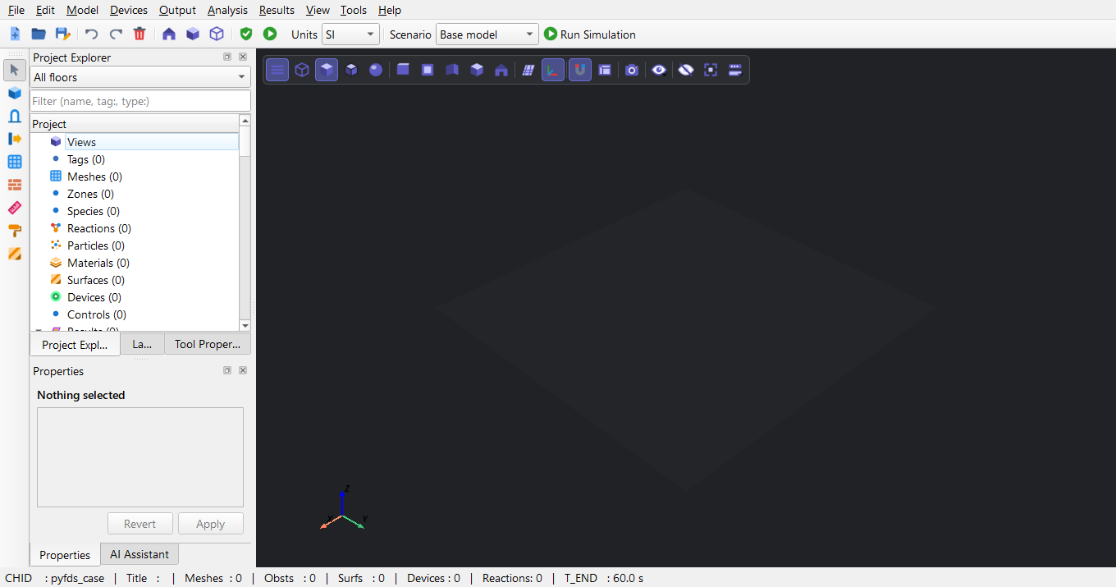
Figure 1. PyFDS opens maximized with an empty project: menus and toolbars at the top, the Project Explorer and Properties on the left, the 3D view in the centre.
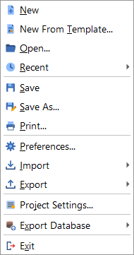
Figure 2. File menu: New, Open, Save, Preferences, Import, Export and Project Settings.

C Building and configuring the model
Each dialog below is shown completed, with the values used for this case. Press OK to apply a dialog; every change can be undone with Edit > Undo (Ctrl+Z). Values are in SI units (m, s, kW, C).
Step 1 - Project settings. CHID is the base name of every file FDS writes.
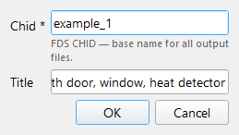
Figure 3. File > Project Settings: CHID (the name of every output file) and the case title.
Step 2 - Simulation parameters. Only the end time is changed (T_END = 60 s); the other tabs show the values used. Environment, Pressure and Radiation hold FDS's own defaults (the velocity tolerance is left unset: FDS works it out from the cell size), so PyFDS writes no &PRES line. The Output tab's intervals (1 s, Plot3D 10 s) are PyFDS's choice; FDS on its own would save 1000 frames over the run.
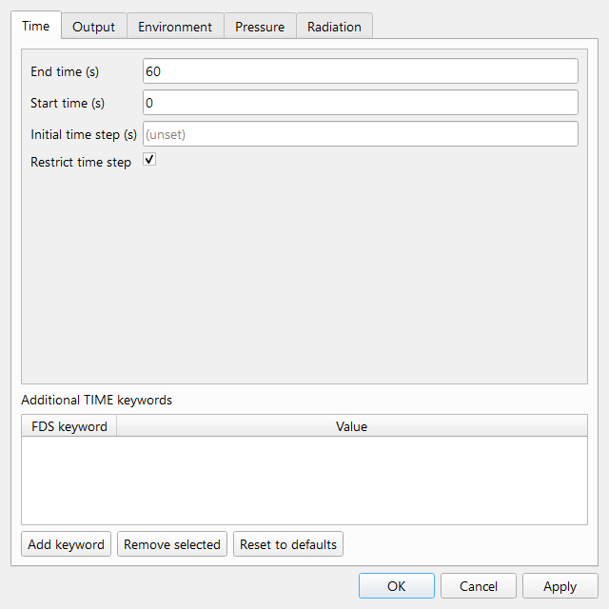
Figure 4. Model > Simulation Parameters, Time tab: the simulation ends at T_END = 60 s.
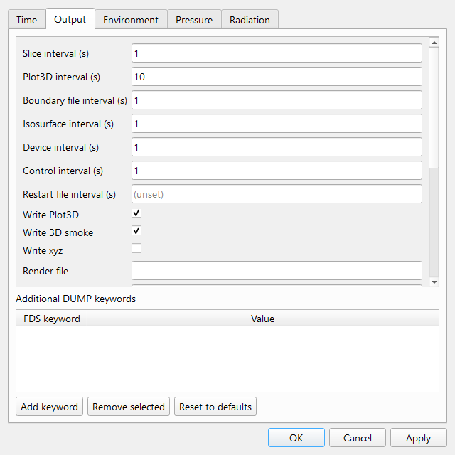
Figure 5. Model > Simulation Parameters: Output tab
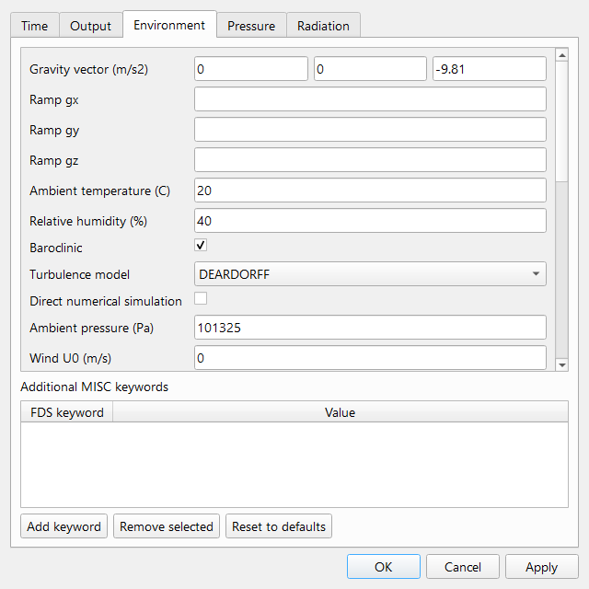
Figure 6. Model > Simulation Parameters: Environment tab
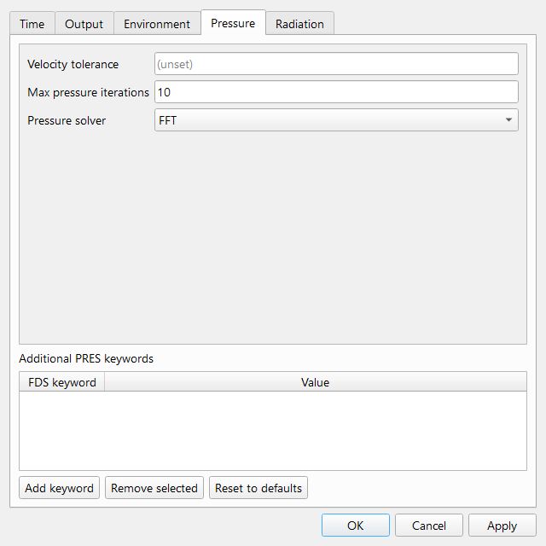
Figure 7. Model > Simulation Parameters: Pressure tab
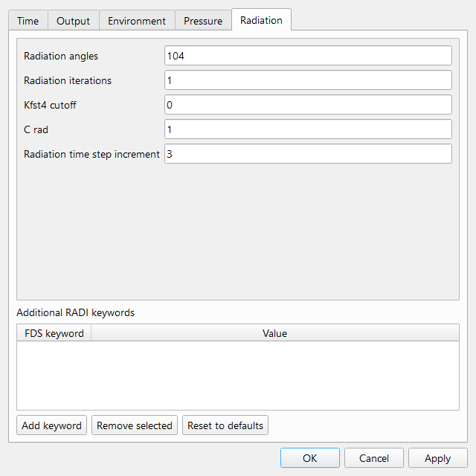
Figure 8. Model > Simulation Parameters: Radiation tab
Step 3 - Mesh. The cell size is 6 m / 60 = 0.1 m in every direction. The cell size has to resolve the fire: FDS guidance uses D*/dx, the characteristic fire diameter over the cell size. For 180 kW, D* = 0.48 m; 0.15 m cells give only 3.2, which PyFDS's validation rejects (below 4), while 0.1 m cells give 4.8.
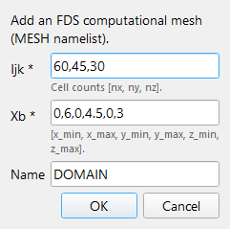
Figure 9. Model > Add Mesh: a 6 x 4.5 x 3 m domain in 60 x 45 x 30 cells (0.1 m cells, 81,000 in all). 0.1 m is the coarsest cell that resolves this 180 kW fire (validation: D*/dx at least 4).
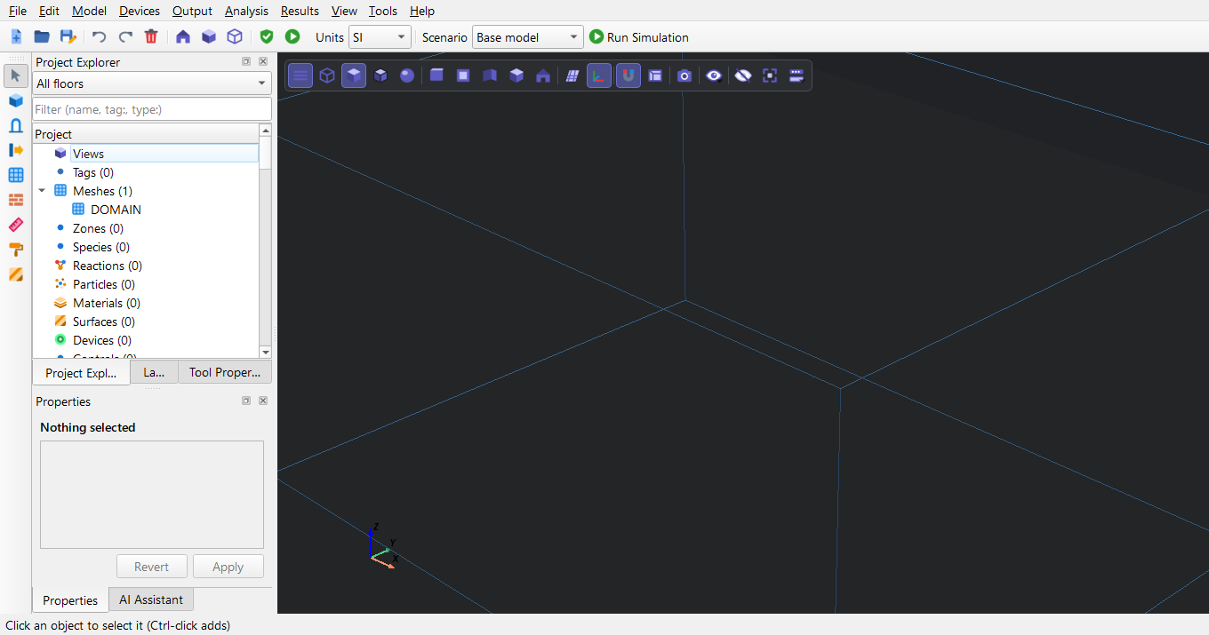
Figure 10. The mesh appears in the 3D view and under Meshes in the Project Explorer.
Step 4 - Wall construction from the library.
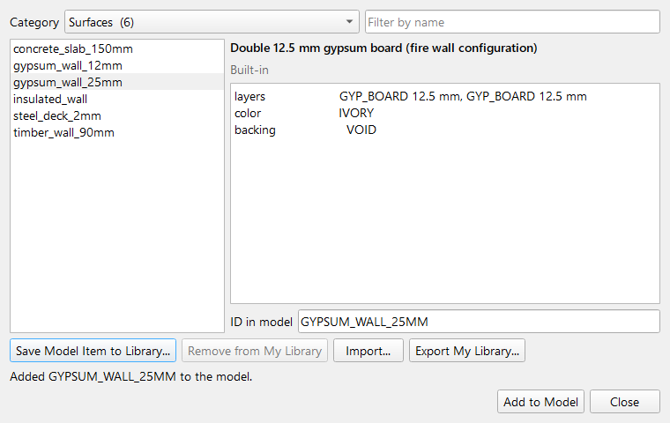
Figure 11. Model > Library: the 25 mm gypsum wall construction (two 12.5 mm boards) is added to the project.
Step 5 - Draw the room with its two openings.
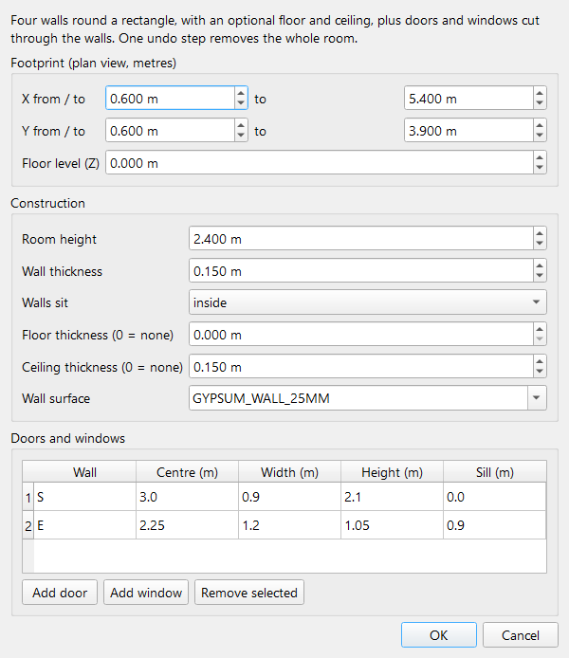
Figure 12. Model > Draw > Draw Room: walls, ceiling and two openings - a 0.9 x 2.1 m door in the south wall and a 1.2 x 1.05 m window (sill 0.9 m) in the east wall.
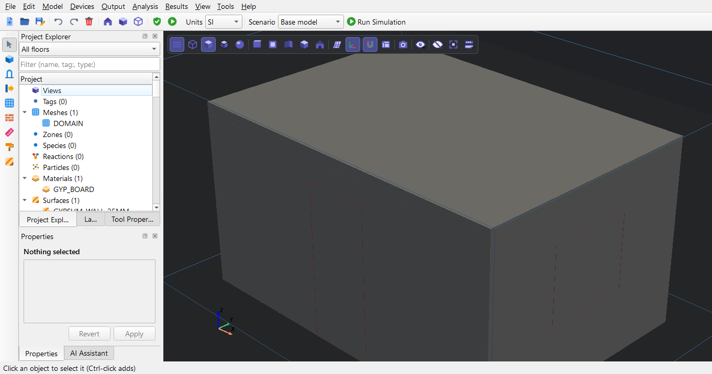
Figure 13. The room (4.8 x 3.3 x 2.4 m inside the mesh) with its door and window.
Step 6 - The fire: a burner surface, the burner body, the burning face and the reaction.
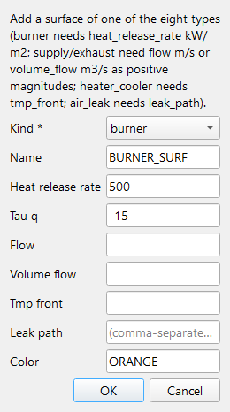
Figure 14. Model > Add Special > Add Typed Surface, burner: 500 kW/m2, reached along a t-squared curve in 15 s (TAU_Q = -15).
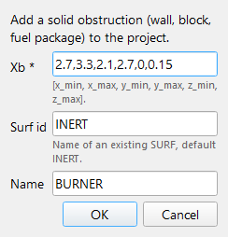
Figure 15. Model > Add Obstruction: the burner body, a 0.6 x 0.6 x 0.15 m inert block in the middle of the room.
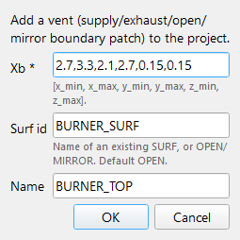
Figure 16. Model > Add Vent: the burning surface is a vent on the top face of the block only (0.36 m2 x 500 kW/m2 = 180 kW). Giving the whole block the burner surface would also burn its four sides and double the fire.
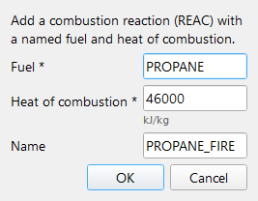
Figure 17. Model > Add Reaction: propane, heat of combustion 46,000 kJ/kg.
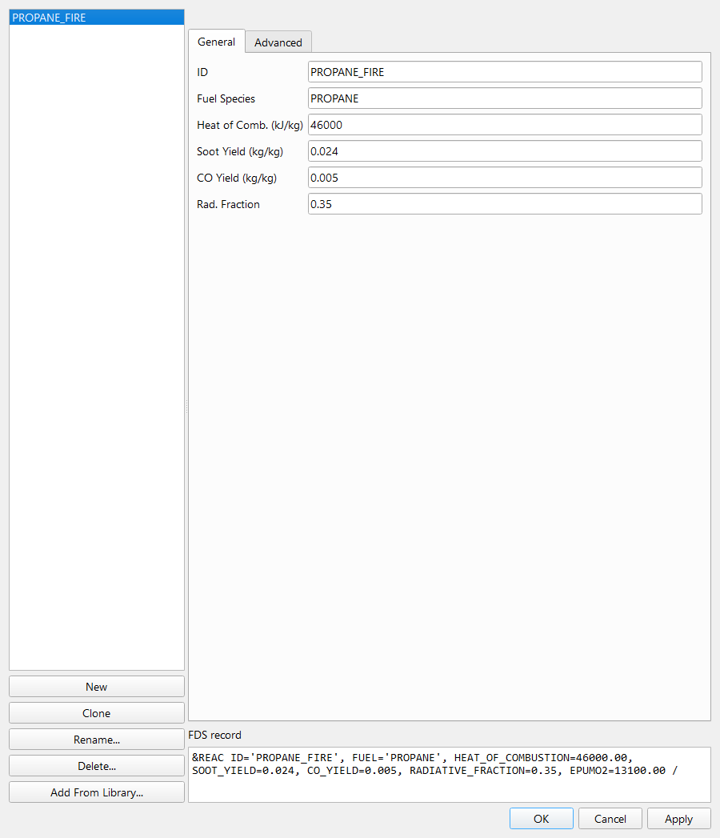
Figure 18. Model > Edit Reactions: soot yield 0.024 kg/kg and CO yield 0.005 kg/kg for propane (well-ventilated values, SFPE Handbook, Tewarson). With the default yield of 0 the fire would make no smoke.
Step 7 - Outer boundaries. Model > Open Mesh Boundaries makes the sides and the top of the mesh OPEN, so smoke can leave the domain. The floor stays closed, because the room stands on the ground.
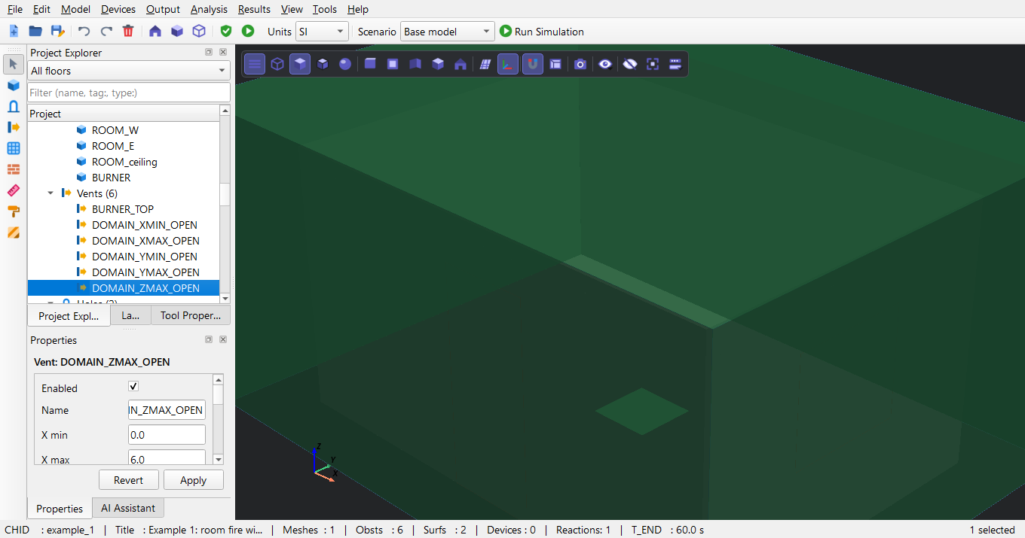
Figure 19. Model > Open Mesh Boundaries: 5 OPEN vents on the sides and the top of the mesh (listed under Vents). The floor stays closed: the room stands on the ground.
Step 8 - Instruments and outputs.
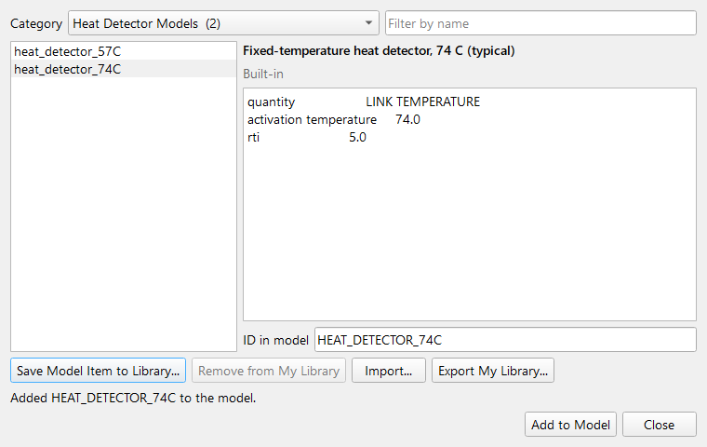
Figure 20. Model > Library: a heat detector property (RTI 5, activation 74 C).
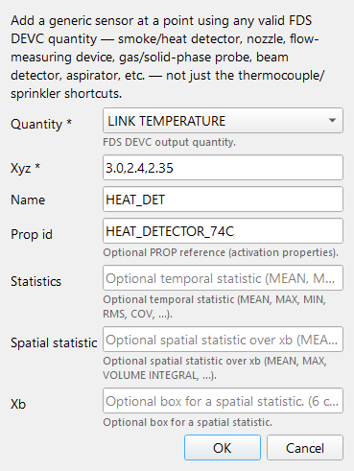
Figure 21. Devices > Add Device (by Quantity): the heat detector 5 cm below the ceiling above the burner.
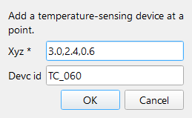
Figure 22. Devices > Add Thermocouple: a vertical tree of four thermocouples at 0.6, 1.2, 1.8 and 2.3 m above the burner centre (the same dialog is used four times).
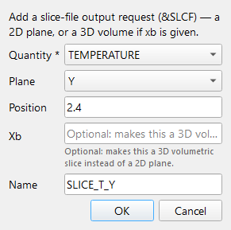
Figure 23. Output > Add Slice: a temperature slice through the burner (Y = 2.4 m).
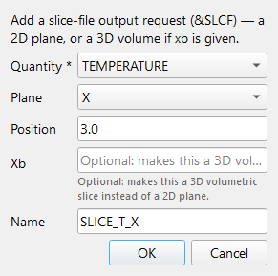
Figure 24. Output > Add Slice: a second temperature slice across the room (X = 3.0 m).
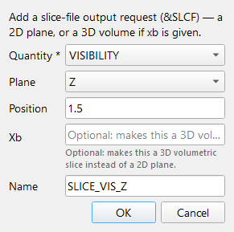
Figure 25. Output > Add Slice: a visibility slice at head height (Z = 1.5 m).
Step 9 - Check the finished model.
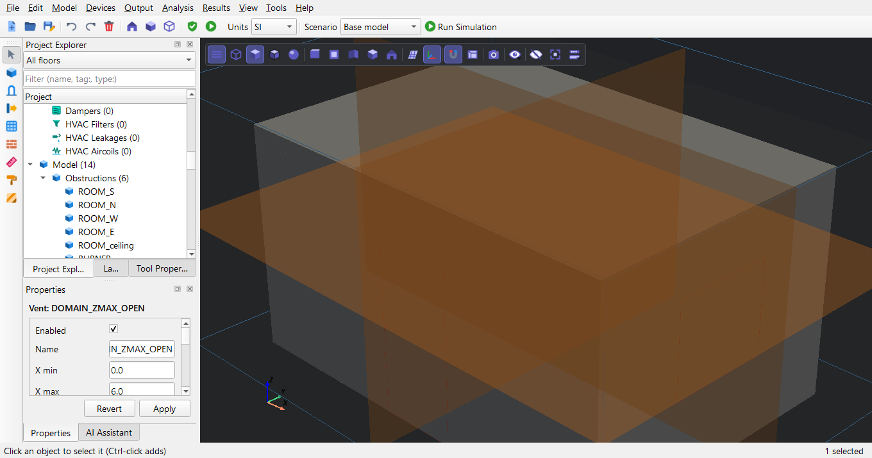
Figure 26. The complete model (open-boundary vents hidden): room, door, window, burner, detector and thermocouple tree, and the three slice planes.
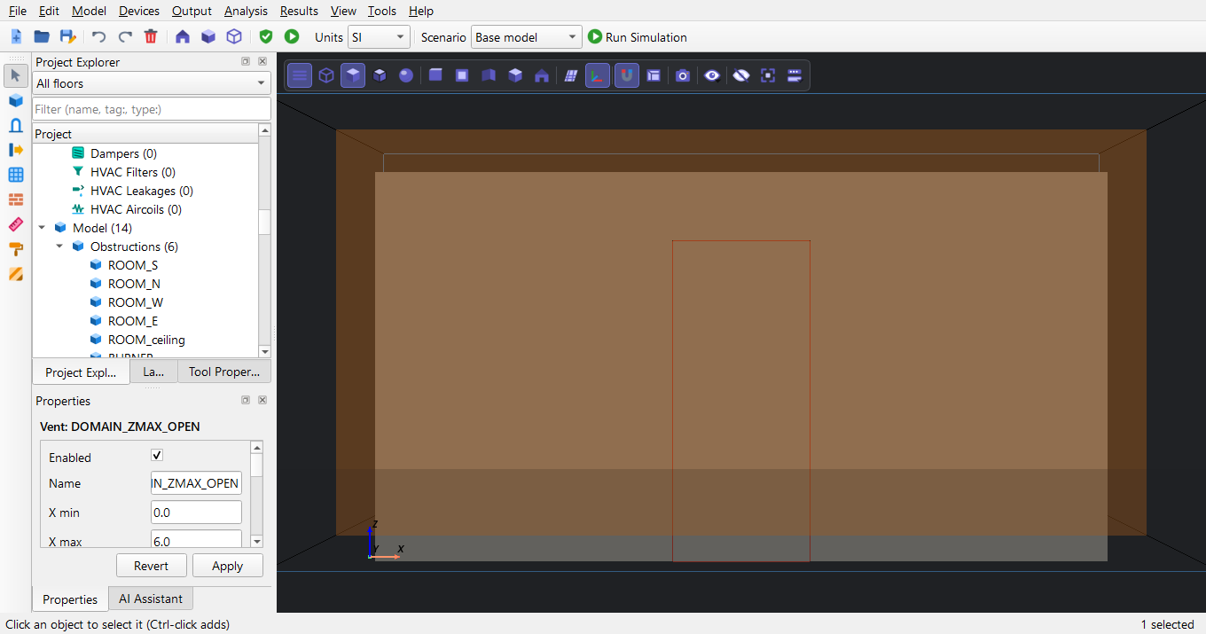
Figure 27. Front view (View > Front): the door in the south wall and the burner behind it.
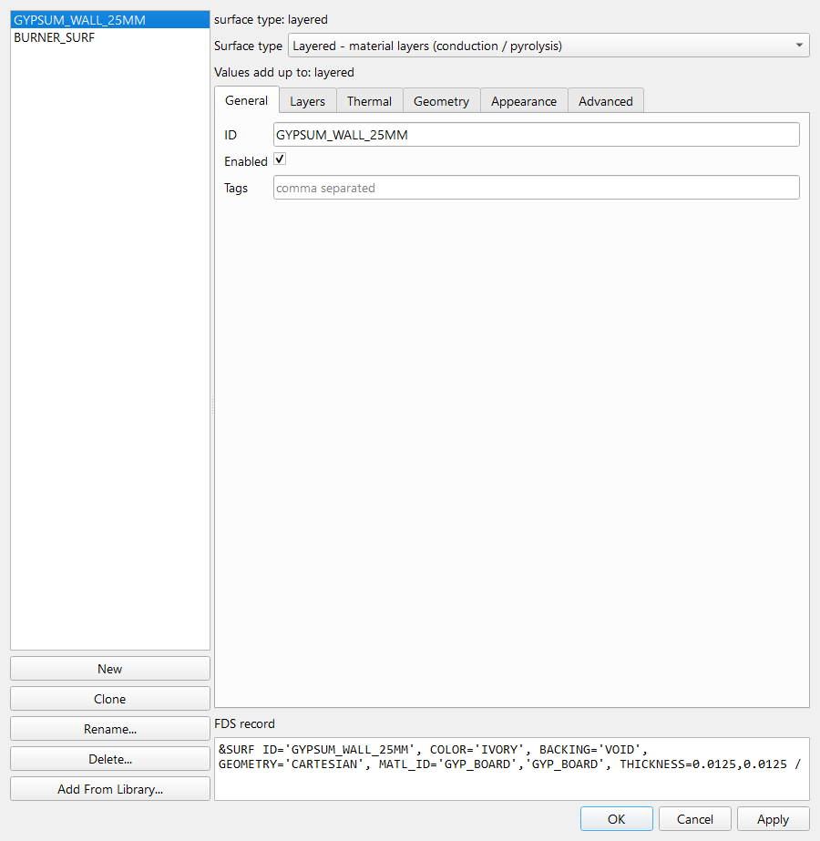
Figure 28. Model > Edit Surfaces: every object of the kind in one list, its settings on the right and the FDS text it will write at the bottom.
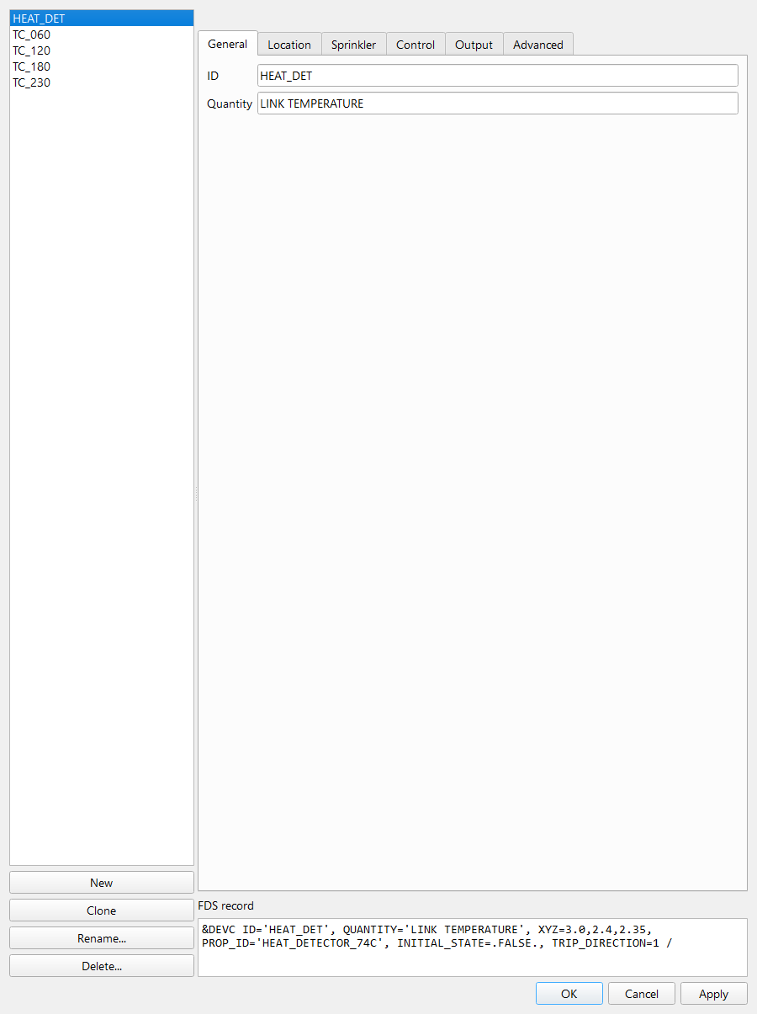
Figure 29. Model > Edit Devices: every object of the kind in one list, its settings on the right and the FDS text it will write at the bottom.
Save the project with File > Save As (example_1.pyfds). File > Export > Export as FDS writes the FDS input file example_1.fds, which is also written automatically when the run starts.

D Validation and running the simulation
Model > Validate Project checks the model before it is run: meshes and their resolution, objects outside the mesh, references to surfaces, materials and properties, ramps, controls, HVAC and the time and output settings.
Result for this case: 0 errors, 1 warning(s). Warning: Mesh 'DOMAIN': D*/dx ≈ 4.8 — borderline resolution. Recommended ratio is ≥ 10.0. Errors block a run; warnings do not, but should be understood. A resolution warning (D*/dx between 4 and 10) is expected for a demonstration mesh: the plume is resolved, but coarsely (see section F).
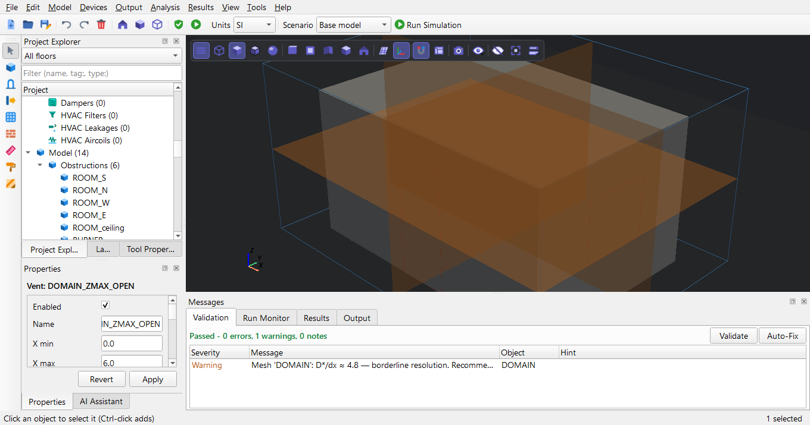
Figure 30. Model > Validate Project: the findings appear in the Validation tab at the bottom. Double-click a finding to select the object it is about.
Analysis > Run Simulation (or Run Simulation on the toolbar) opens the Run dialog. For a one-mesh model it proposes 'This computer' with one process. Choose the folder for the input and results (Browse...), check the FDS version (PyFDS uses the bundled FDS 6.10.1 when none is configured; Locate FDS... picks another), read the 'Before you run' summary, and press Run. 'Check the model first' stops the run if the model has errors.
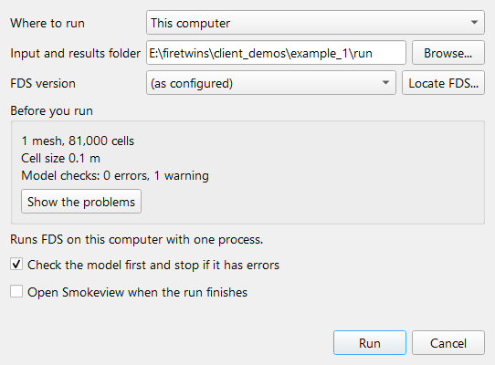
Figure 31. Analysis > Run Simulation: where to run (this computer, one process - the model has one mesh), the folder for the input and results, the FDS version, and the 'Before you run' summary of the model and its checks.
The Messages panel opens with the Run Monitor: progress (simulated time / end time), the heat release rate curve as FDS computes it, and the last lines of the FDS log (.out file), refreshed twice a second. The status bar shows the progress too. Analysis > Stop Simulation asks FDS to finish cleanly and write a restart file; Analysis > Cancel Simulation ends it at once.
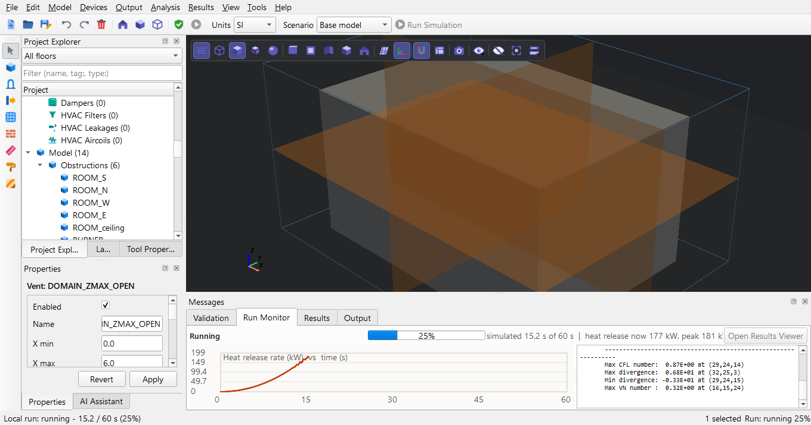
Figure 32. Run Monitor at 25 %: progress, heat release rate curve and the last lines of the FDS log.
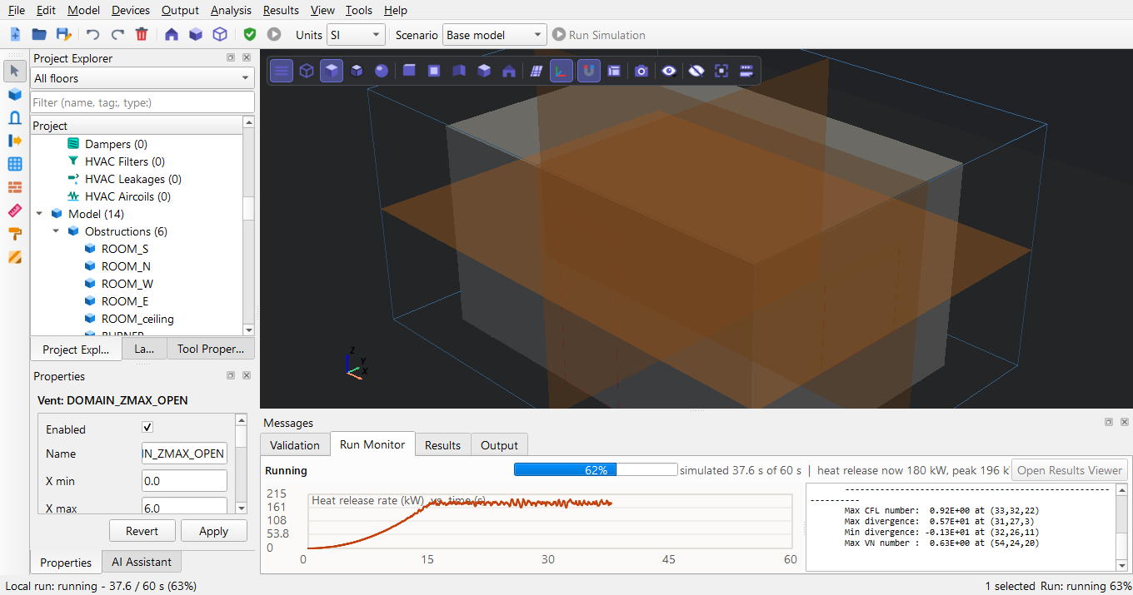
Figure 33. Run Monitor at 60 %: progress, heat release rate curve and the last lines of the FDS log.
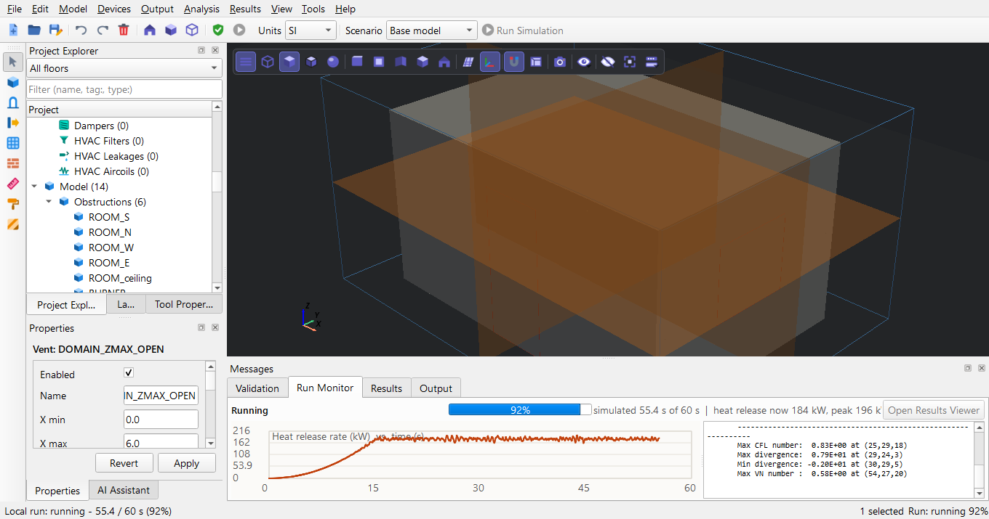
Figure 34. Run Monitor at 90 %: progress, heat release rate curve and the last lines of the FDS log.
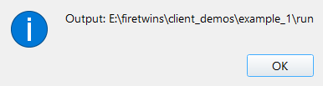
Figure 35. Message: Simulation complete
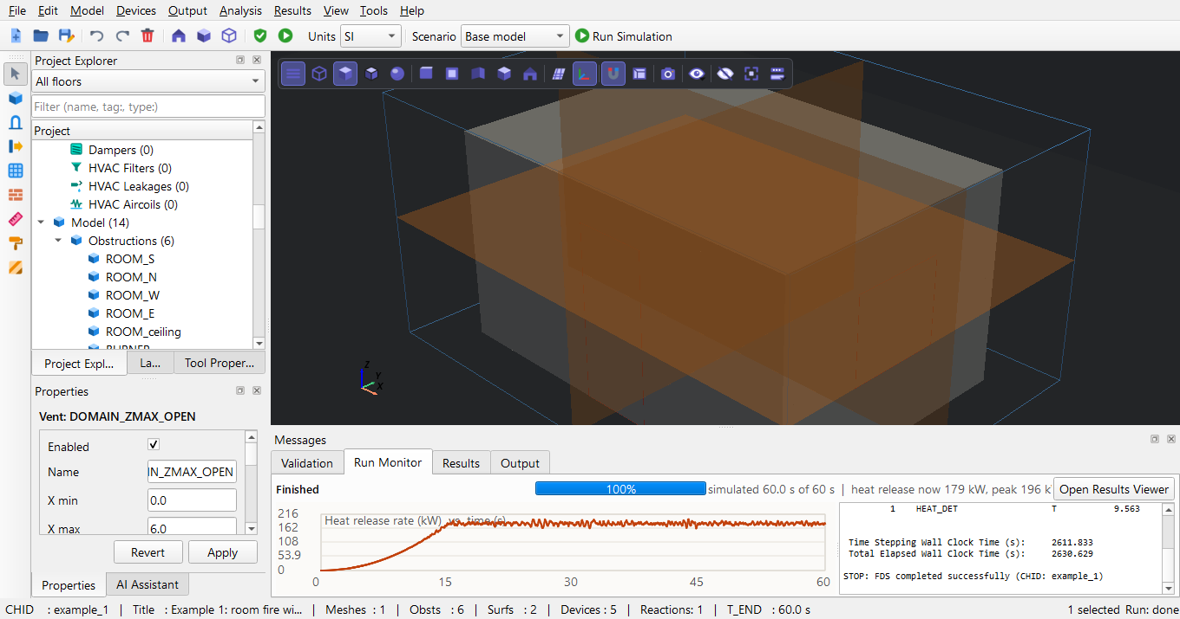
Figure 36. Run finished: 'STOP: FDS completed successfully' in the log, Open Results Viewer enabled.
Outcome on the test computer: FDS reported 'STOP: FDS completed successfully'; wall clock time 2630.629 s for 60 s of simulated time.

E Post-processing

E.1 PyFDS Results
Open the viewer from the editor with Results > Open PyFDS Results (or start it on its own, section 1.1) and load the run with File > Open Results (.smv): choose client_demos\example_1\run\example_1.smv. The Navigation View lists everything the run wrote: geometry, devices, views, 3D smoke, Plot3D, slices. Click a result to show it; use the time bar at the bottom (Play, step, drag the slider) to move through the run.
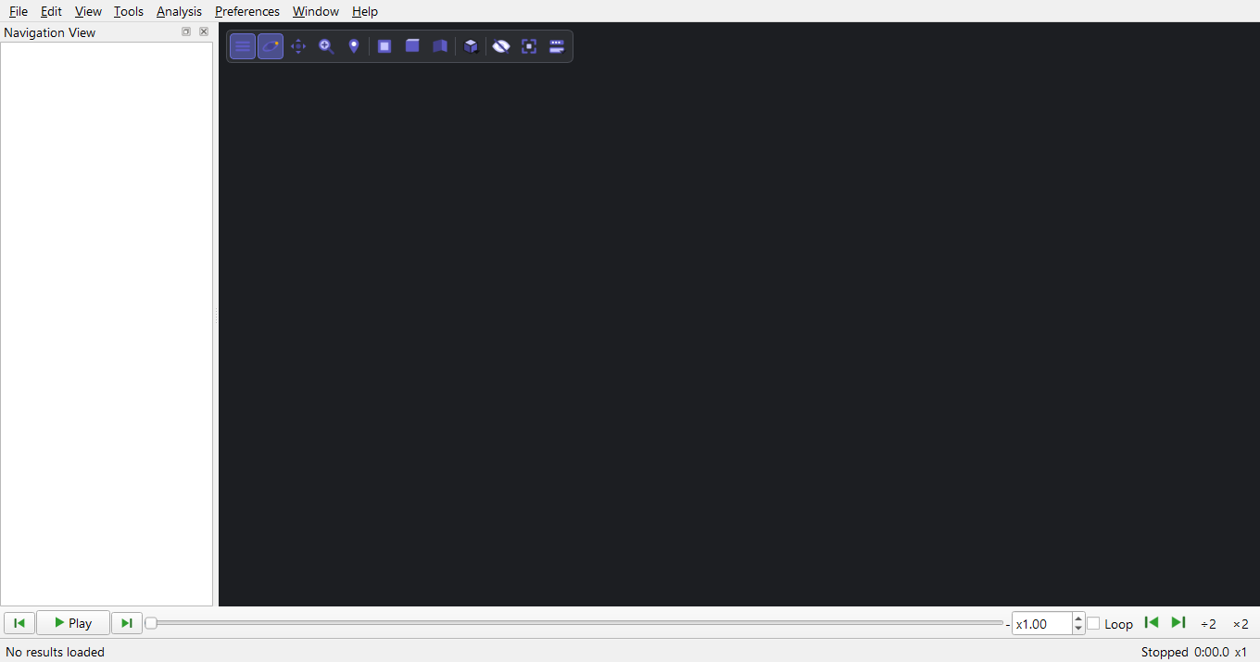
Figure 37. PyFDS Results (Results > Open PyFDS Results in the editor, or the PyFDS Results shortcut) before a run is loaded.
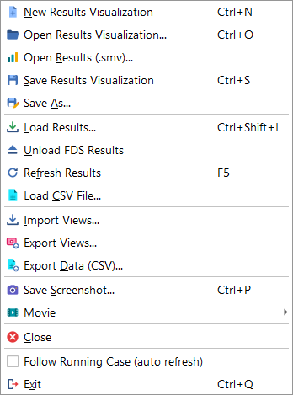
Figure 38. PyFDS Results, File menu: Open Results (.smv) opens the .smv file of a run.
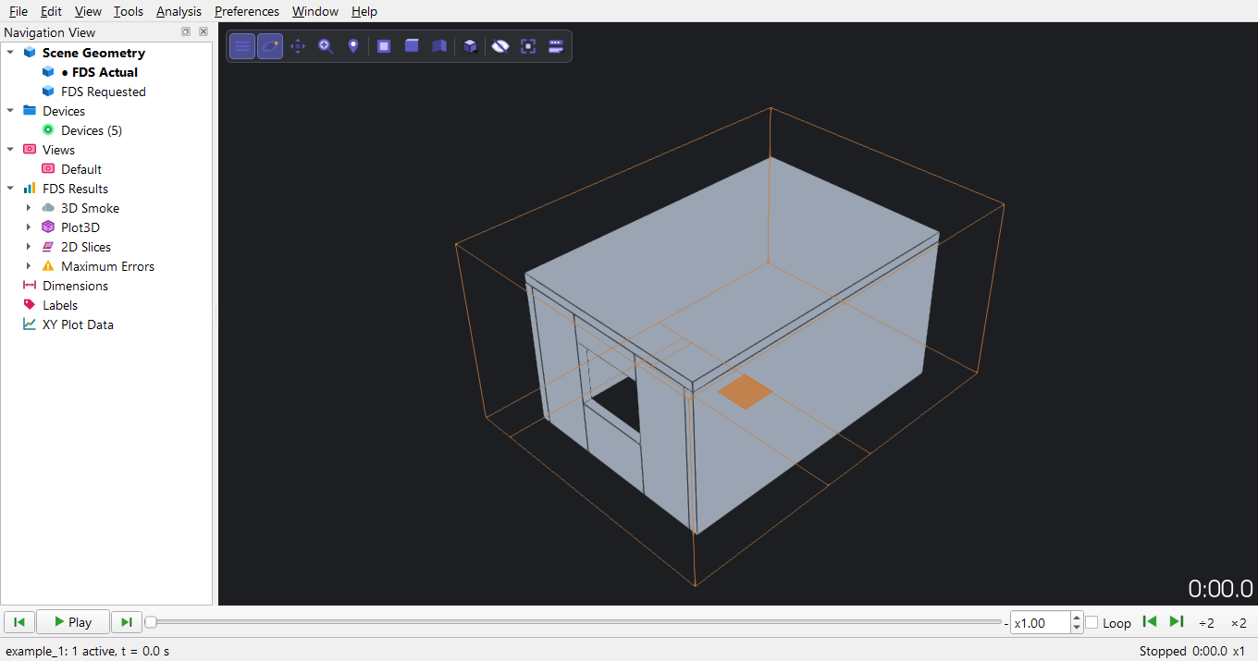
Figure 39. File > Open Results (.smv) with example_1.smv: the geometry is shown and the Navigation View on the left lists every result of the run.
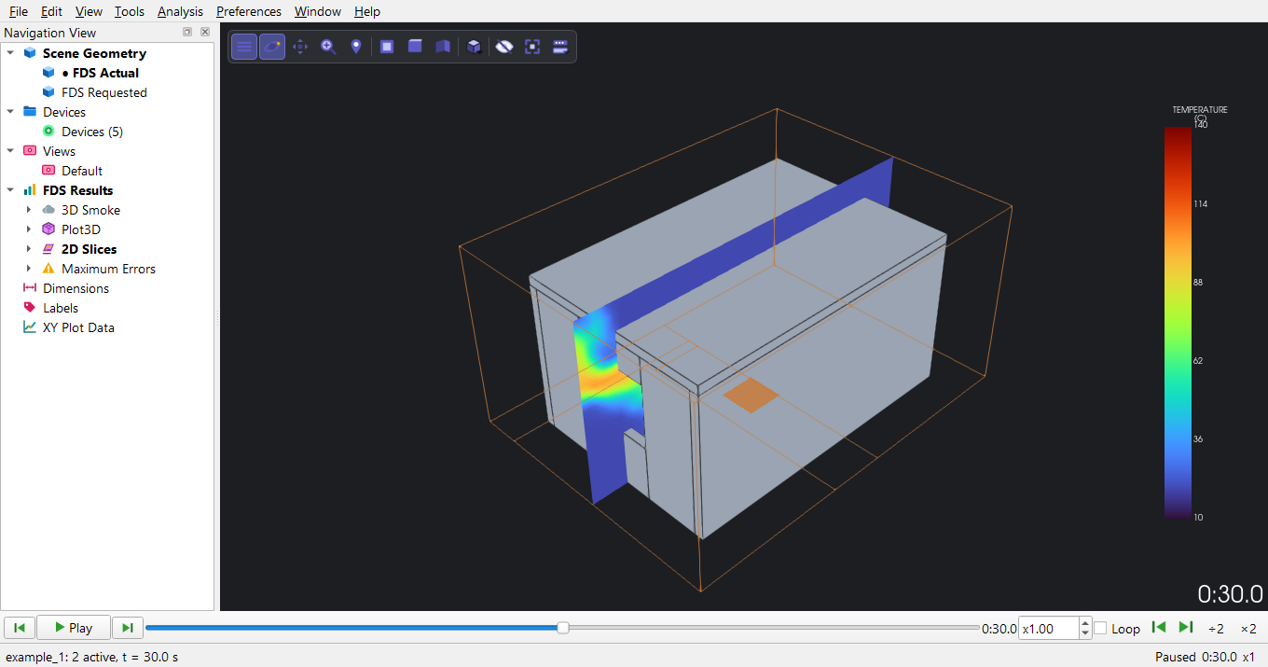
Figure 40. Temperature slice through the burner (Y = 2.4 m) at 30 s: the plume rises to the ceiling and the hot layer spreads under it.
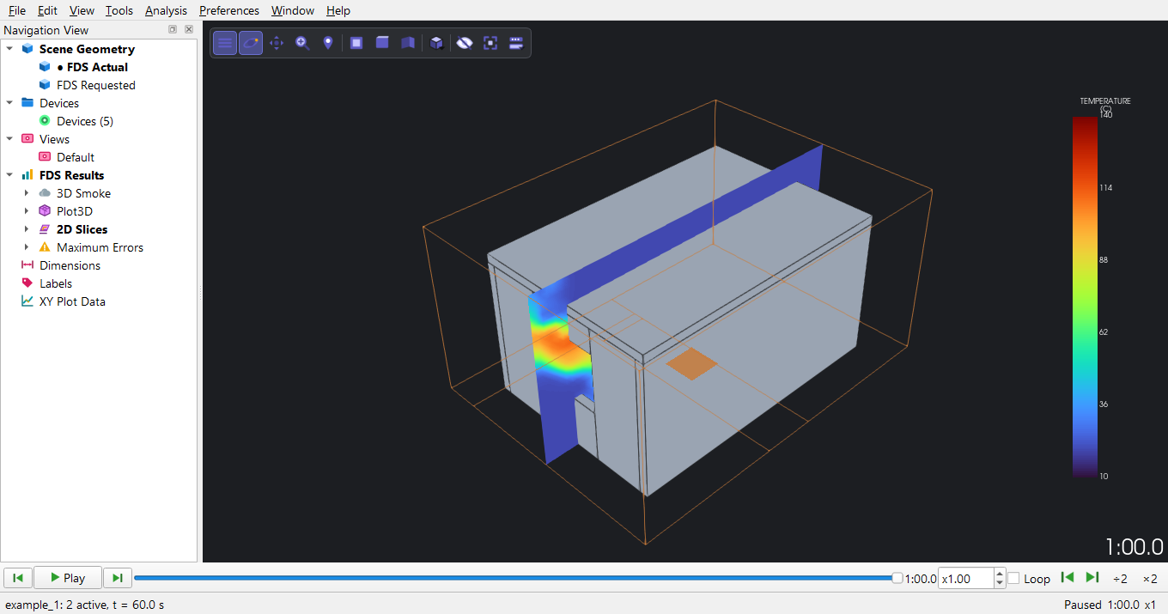
Figure 41. The same slice at the end of the run (60 s).
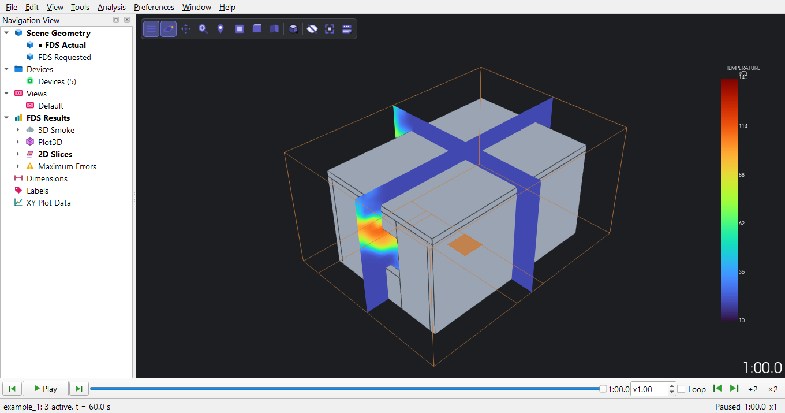
Figure 42. Two temperature slices at 60 s: along the room (Y = 2.4 m) and across it (X = 3.0 m).
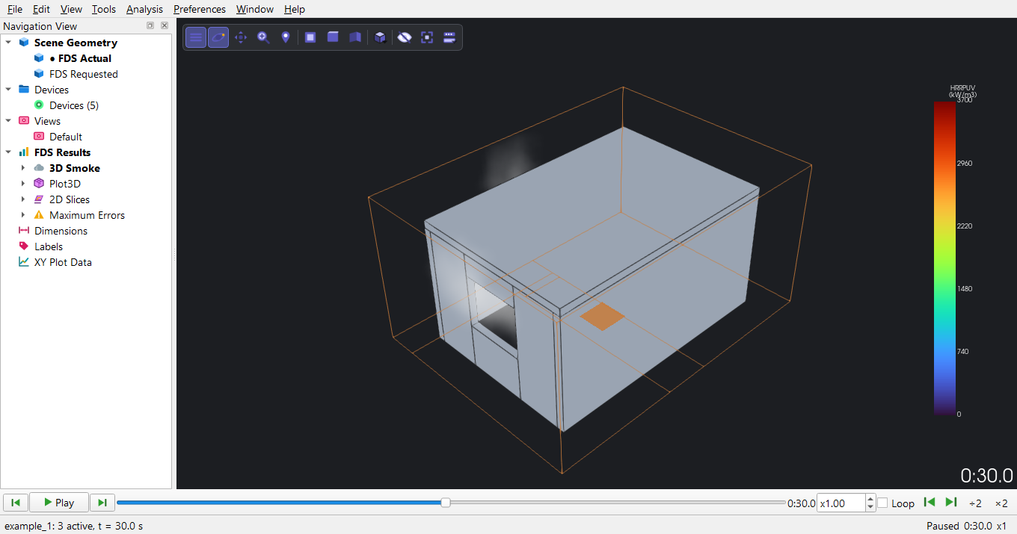
Figure 43. 3D smoke (soot density) and the flame (heat release rate per unit volume) at 30 s.
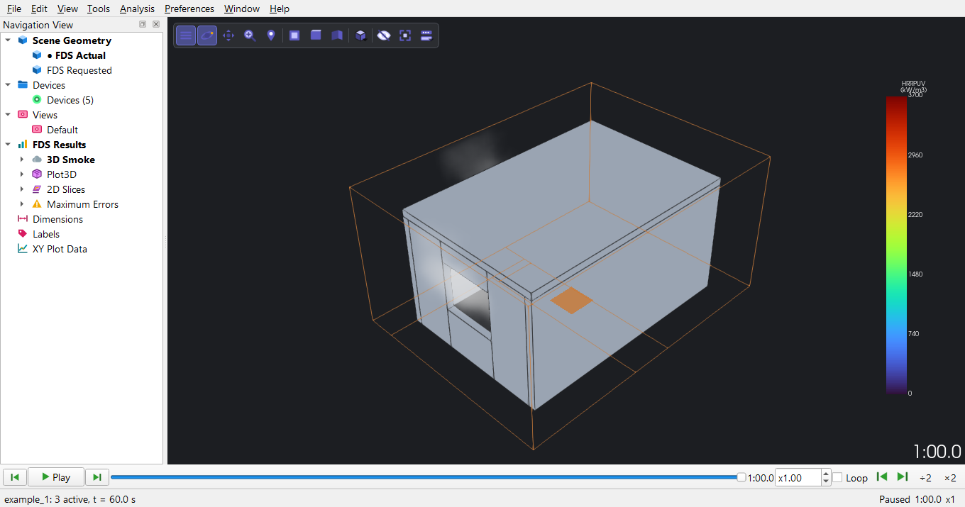
Figure 44. 3D smoke at 60 s: smoke leaves through the top of the door and the window.
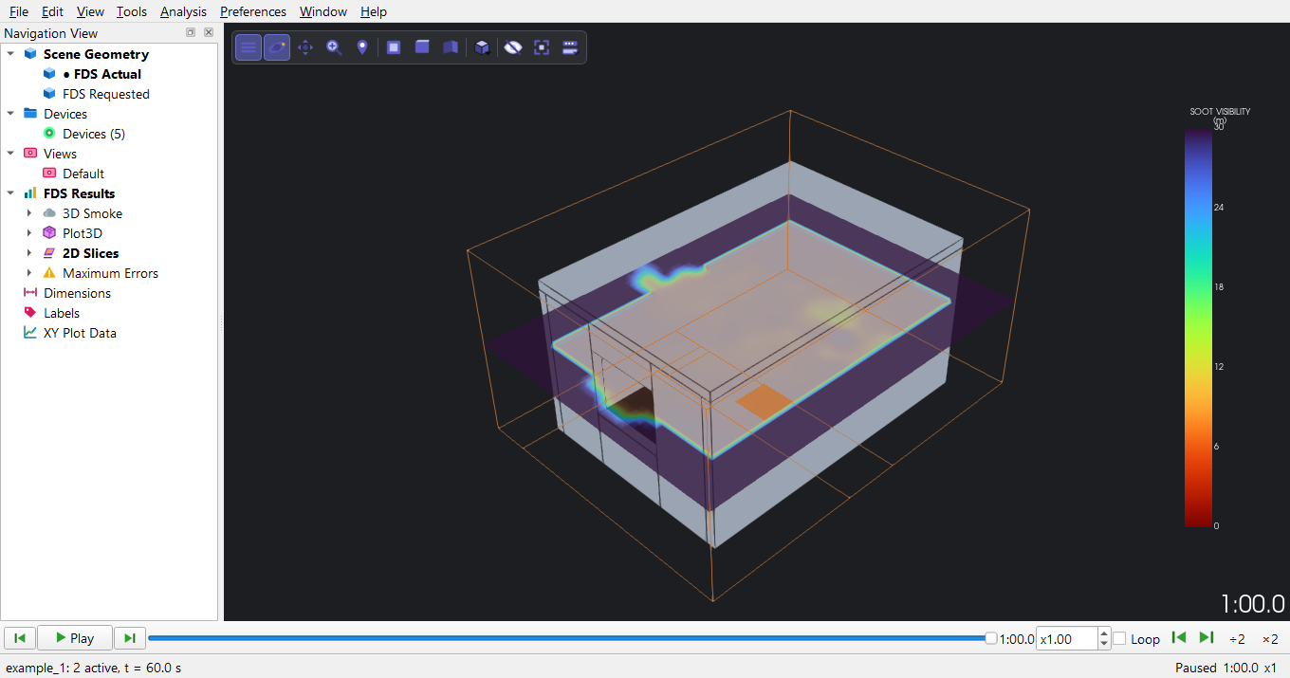
Figure 45. Visibility at head height (Z = 1.5 m) at 60 s (metres; 30 m is the FDS upper limit, clear air).
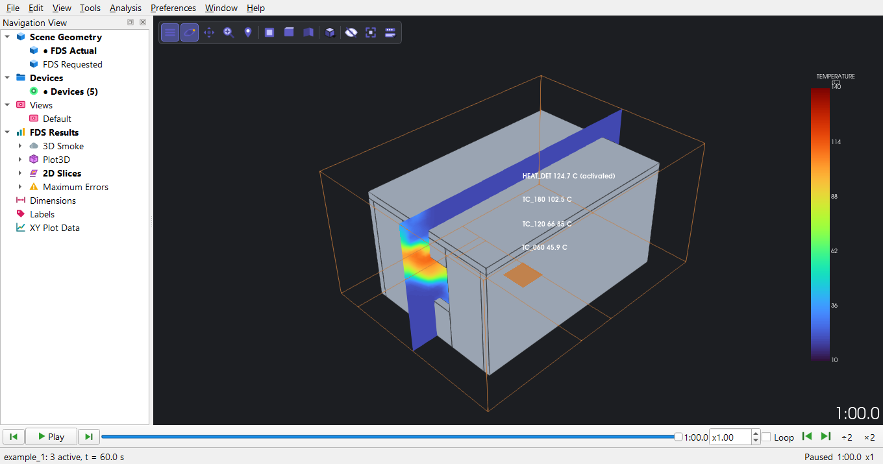
Figure 46. Devices at 60 s: the heat detector and the thermocouple tree above the burner, coloured by their current value.
Time histories: File > Load CSV File with example_1_hrr.csv and example_1_devc.csv, then Tools > Time History Plot and tick the series.
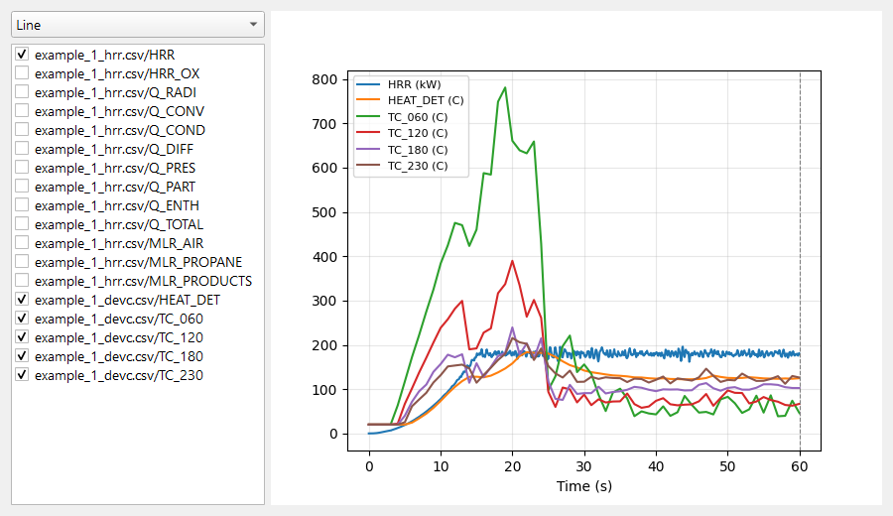
Figure 47. Tools > Time History Plot after File > Load CSV File with the heat release (_hrr.csv) and device (_devc.csv) files: tick the series to plot.
Pictures and movies: Preferences > Colorbar adjusts a colour bar; File > Save Screenshot and File > Movie > Save Movie write pictures and MP4 files. File > Save Results Visualization keeps the whole viewer setup (example_1.pyfdsv) so the same views open next time.
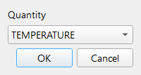
Figure 48. Preferences > Colorbar: range mode, limits, colour map and labels of a quantity's colour bar.
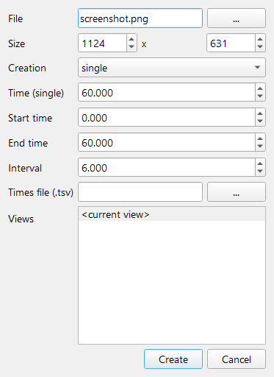
Figure 49. File > Save Screenshot: one picture, a series over time, or one per saved view, at a chosen size.
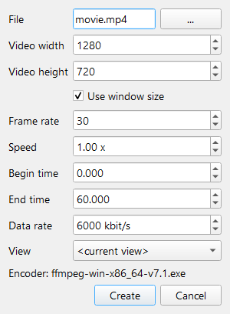
Figure 50. File > Movie > Save Movie: an MP4 of the time range at a chosen frame rate and speed.

E.2 Smokeview
The same run opens in NIST's Smokeview. There are three ways to open it:
- Automatically after the run. Tick 'Open Smokeview when the run finishes' in the Run dialog (it follows Analysis > Open Smokeview After Run, on by default). When FDS ends, Smokeview opens <CHID>.smv from the run folder (section 4.4).
- From the editor at any time. Results > Open Smokeview... and choose the .smv file, here client_demos\example_1\run\example_1.smv. Results > Open Results Folder... shows the folder.
- From Windows. Double-click example_1.smv (when .smv files open with Smokeview), or run fds_smv\SMV6\smokeview.exe example_1.smv in the run folder.
PyFDS uses the Smokeview set in File > Preferences (smv_binary); when none is set it uses the bundled fds_smv\SMV6\smokeview.exe. Smokeview starts in the run folder, so it finds the slice, boundary and smoke files next to the .smv. Right-click in the Smokeview window for its menus: Load/Unload > Slice file, 3D smoke; the time bar runs the animation; File/Bookmark/Render saves pictures. The pictures below were made by a Smokeview script (client_demos\results_walkthrough.py writes it), the same commands a user can type in a .ssf file.
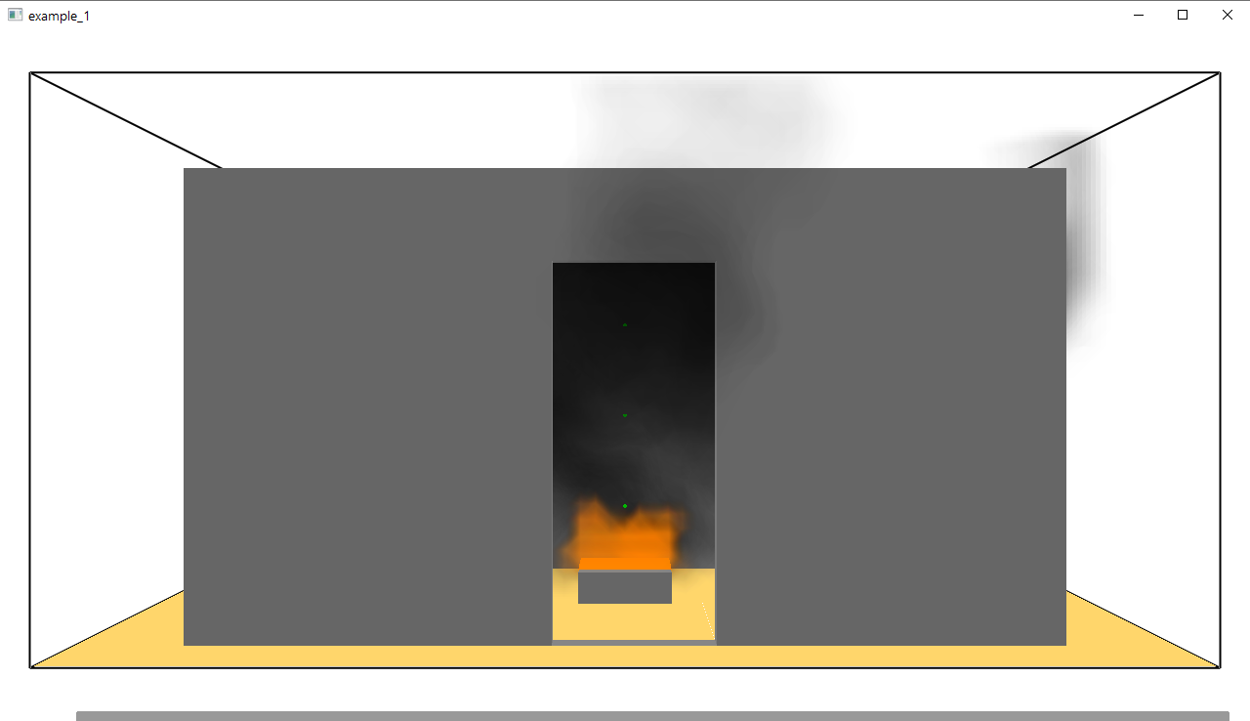
Figure 51. Smokeview 6.10.1 (Results > Open Smokeview... in the editor, or double-click the .smv file) while the script renders: the case's geometry with the scripted data loaded; right-click in the window for the menus.
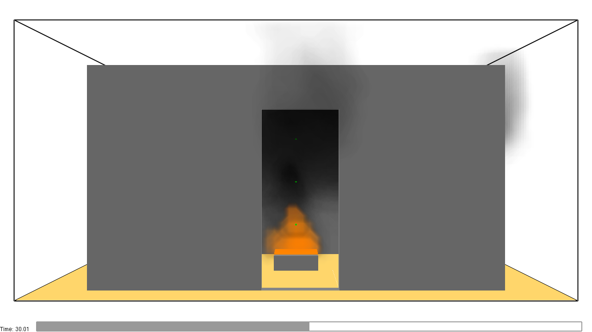
Figure 52. Rendered by Smokeview from the script: smv_smoke_t30.png
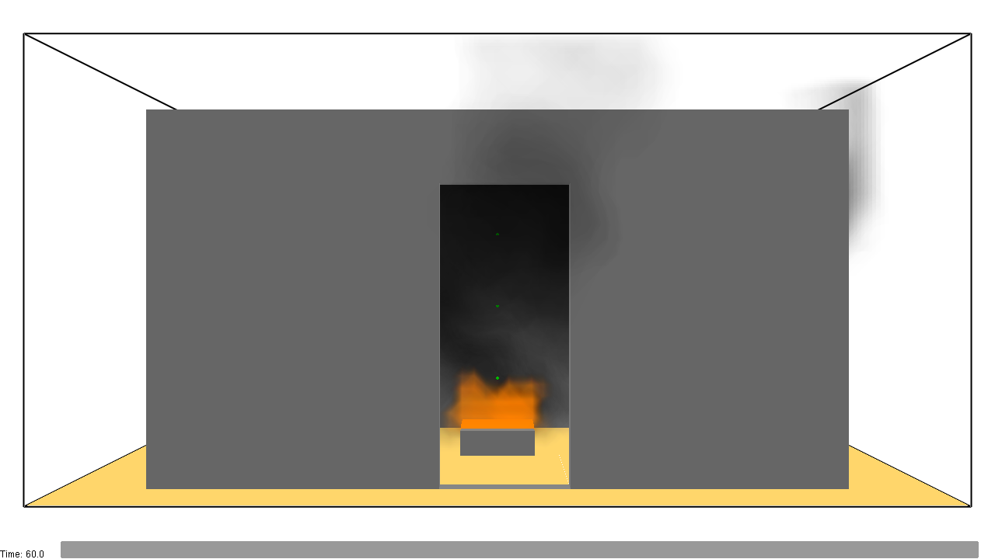
Figure 53. Rendered by Smokeview from the script: smv_smoke_t60.png
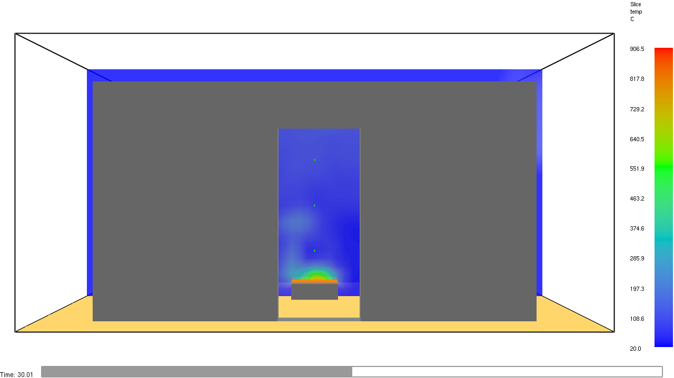
Figure 54. Rendered by Smokeview from the script: smv_temperature_slice_t30.png
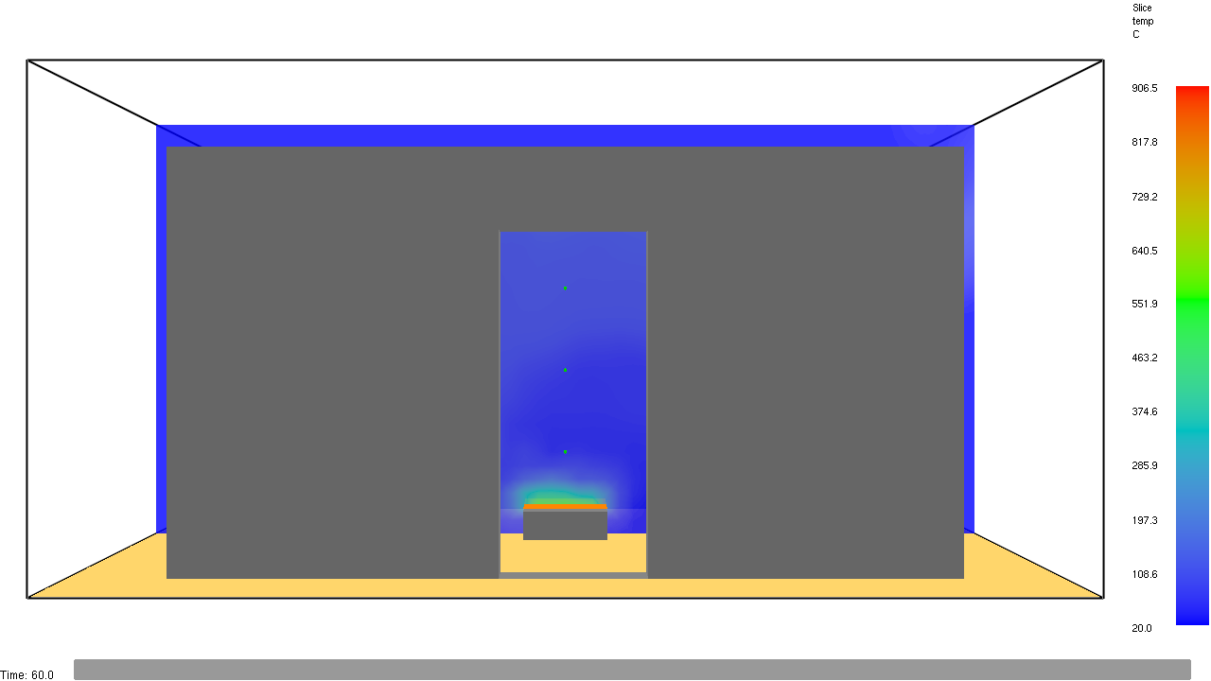
Figure 55. Rendered by Smokeview from the script: smv_temperature_slice_t60.png

F Results and interpretation
Quantity (from the run's CSV files) | Value
Heat release rate at 15 s (end of the t-squared growth) | 177 kW
Mean heat release rate 20-60 s (design 180 kW) | 180 kW
Heat detector (74 C, RTI 5) activation | 11 s
Gas temperature above the burner at 60 s: 0.6 / 1.2 / 1.8 / 2.3 m | 46 / 67 / 102 / 126 C

- The temperature slices show the plume rising from the burner and a hot layer forming under the ceiling, spilling out through the top of the door and the window - the openings are the vents of the room.
- The thermocouples sit in the plume centreline, so they read plume temperatures, not the room's average layer temperature.
- The 3D smoke shows where soot goes; its density follows from the assumed soot yield (0.024 kg/kg).
- Visibility at 1.5 m stays near its maximum where smoke has not reached head height; where it drops, smoke has come down to that level.
Limitations. This is a demonstration case. The mesh resolves the fire only coarsely (D*/dx about 4.8; 10 or more is recommended for quantitative work), the run covers 60 s, the burner is a prescribed heat release (no fire growth from materials), and the soot and CO yields are handbook values for well-ventilated propane burning. The results show what the model computes; they are not a validated fire-engineering assessment of a real room, which would need a mesh-sensitivity study and case-specific inputs.

G Troubleshooting
Symptom | Cause and remedy
Run button disabled; red text 'choose a folder' | Set 'Input and results folder' in the Run dialog.
'FDS was not found on this computer' | Use Locate FDS... and pick fds.exe (for example fds_smv\FDS6\bin\fds.exe).
'the model has errors; see Model Checks' | Model > Validate Project (or Model > Model Checks), fix each error (double-click it to select the object), or untick 'Check the model first'.
Run Monitor stays at 'Waiting for FDS to start' | FDS has not written the .out file yet; if it never does, check the folder is writable and read the Messages panel.
'FDS stopped with an error' | Read the last lines in the Run Monitor (the ERROR line names the namelist); the full log is <CHID>.out in the run folder.
Heat release about twice the expected value | The burner surface was put on the whole obstruction: use an INERT block with a burner vent on its top face.
Validation error 'D*/dx ... Minimum acceptable ratio is 4.0' | The cells are too large for the fire: refine the mesh (0.1 m here) or check the heat release rate is the one intended.
PyFDS Results shows an empty view | Tick an item in the Navigation View (geometry, a slice ...).
Smokeview shows no data | Load it from the right-click menu (Load/Unload); check the .smv and the data files are in the same folder.

H Quick reference
1. Start PyFDS; File > Project Settings: CHID example_1
2. Model > Simulation Parameters: T_END 60 s
3. Model > Add Mesh: 60,45,30 cells over 0,6,0,4.5,0,3 (0.1 m)
4. Model > Library: gypsum_wall_25mm; Model > Draw > Draw Room: door S 0.9 x 2.1, window E 1.2 x 1.05 sill 0.9
5. Model > Add Special > Add Typed Surface: burner 500 kW/m2, TAU_Q -15; Add Obstruction (INERT) and Add Vent (BURNER_SURF) on its top; Add Reaction: propane, then Edit Reactions: soot 0.024, CO 0.005
6. Model > Open Mesh Boundaries (sides and top; the floor stays closed)
7. Library: heat_detector_74C; Devices > Add Device (LINK TEMPERATURE); 4 thermocouples; 3 slices
8. Model > Validate Project (0 errors); File > Save As
9. Analysis > Run Simulation: folder, Run; watch the Run Monitor until 'Finished'
10. PyFDS Results: File > Open Results (.smv), example_1.smv, tick slices / 3D smoke / devices, use the time bar
11. Smokeview: open example_1.smv, right-click > Load/Unload

3 Example 2 - Burning couch (FDS example case)

A Introduction
Purpose. Shows that a case written for FDS by hand opens in PyFDS, can be inspected and run in parallel, and post-processed - the route a consultant's existing FDS models take.
Scenario. The case is 'Examples/Fires/couch.fds' from the FDS 6.10.1 distribution (a teaching case; its material properties are marked 'completely fabricated'). A couch of fabric over foam on a gypsum base stands in a 5 x 5 x 2.4 m room with one open vent; a hot (1000 C) static particle on the seat ignites it. Burning materials make the fire grow on its own - there is no prescribed heat release rate.
Engineering objectives. Watch the fire spread over the couch surfaces, the flame and smoke, and the heat release rate it produces.
- Opening an existing FDS input file
- Multiplied meshes (MULT) and a 4-process MPI run
- Layered, burning-away surfaces and pyrolysis materials
- Boundary-file results on the couch surfaces
Prerequisites. The original runs for 600 s. Here T_END is set to 25 s in the GUI so the demo stays short: it took 16 minutes on the test computer on 4 MPI processes. Nothing else in the physics is changed.
Screen recordings. documentation\videos\example_2_open_and_run.mp4 (sections B to D, the run as a time-lapse) and example_2_post_processing.mp4 (section E).

B Opening the example
Start PyFDS, then File > Open and choose client_demos\example_2\couch_original.fds (a copy of the untouched FDS example). PyFDS reads the FDS namelists into objects; anything it has no editor for is kept and written back unchanged.
What was read: 1 &MESH line with a multiplier, giving 4 meshes; 5 obstructions; surfaces UPHOLSTERY, WALL, ignitor; materials FABRIC, FOAM, GYPSUM PLASTER; T_END 600.0 s.
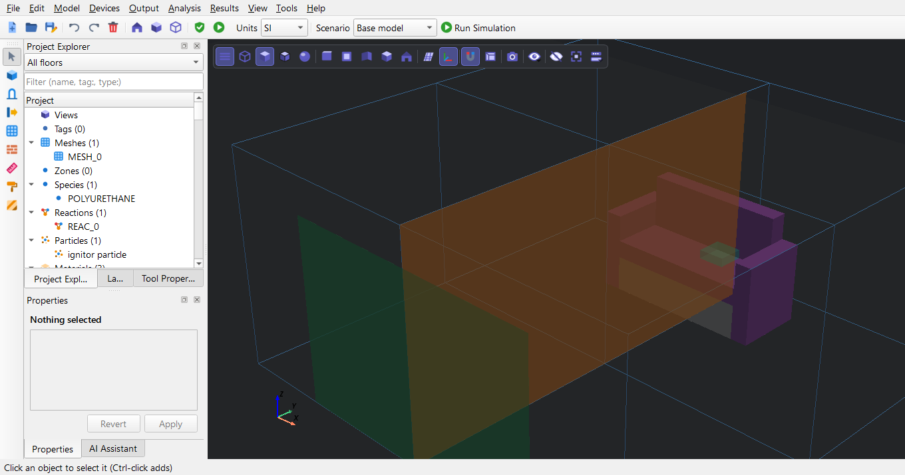
Figure 56. File > Open with couch_original.fds: the couch (purple upholstery on a gypsum base) and the four meshes made by the MULT line are listed in the Project Explorer and drawn in the 3D view.

C Inspecting and configuring the case
The editors under Model show what the file defines. Nothing is changed in them for this demonstration.
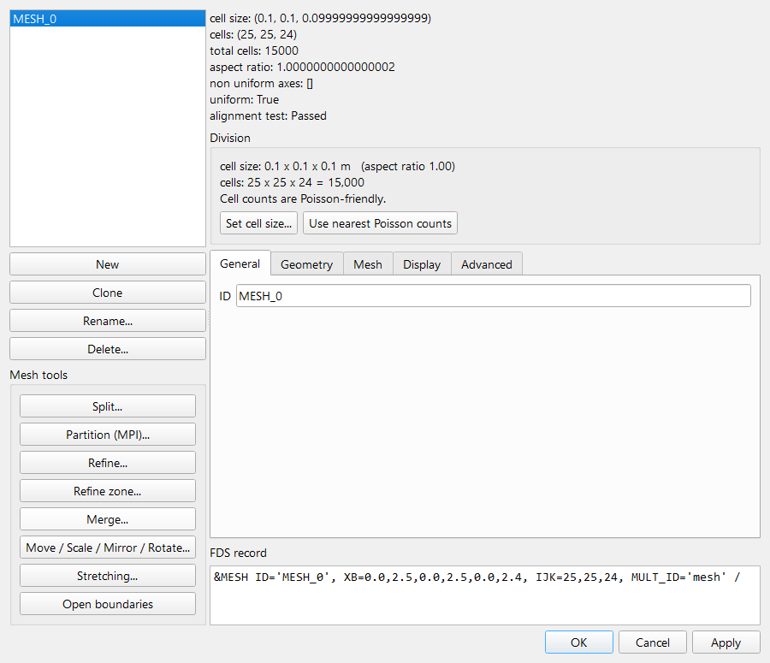
Figure 57. Model > Edit Meshes: one 2.5 x 2.5 x 2.4 m mesh of 25 x 25 x 24 cells (0.1 m); its multiplier (MULT_ID) repeats it 2 x 2 to cover 5 x 5 m.
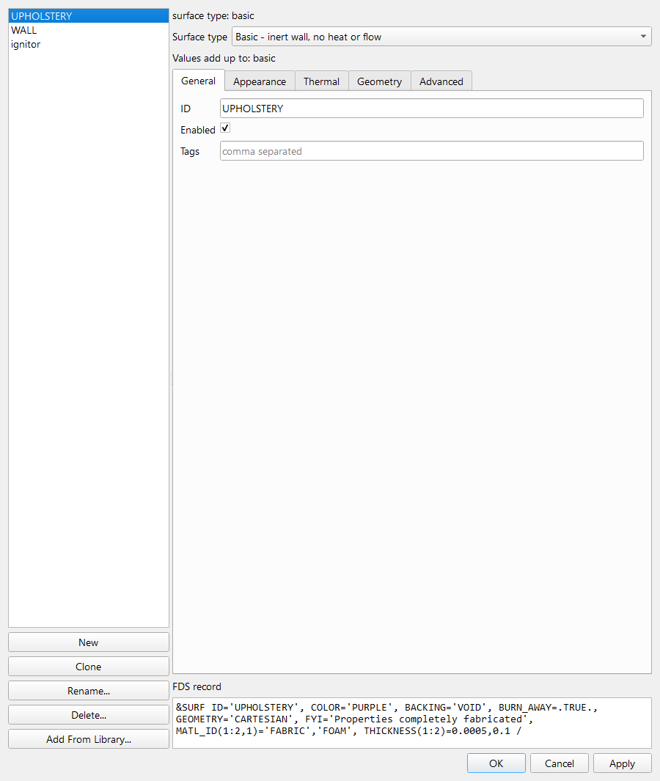
Figure 58. Model > Edit Surfaces, UPHOLSTERY: fabric (0.5 mm) over foam (100 mm), burns away; the properties are the FDS example's (marked 'fabricated').
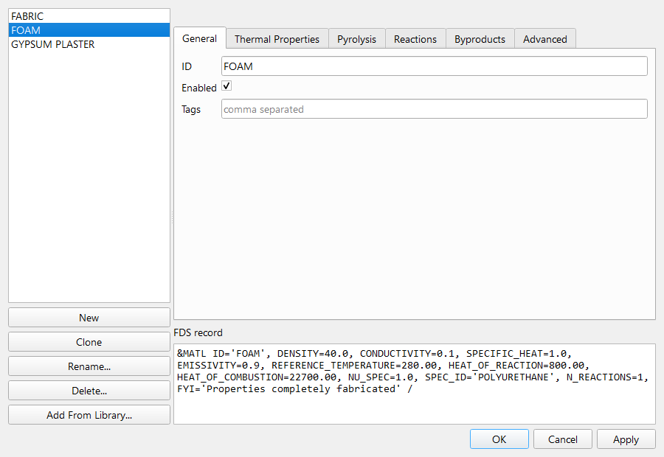
Figure 59. Model > Edit Materials, FOAM: density, conductivity, specific heat and the pyrolysis reaction that produces POLYURETHANE fuel gas.
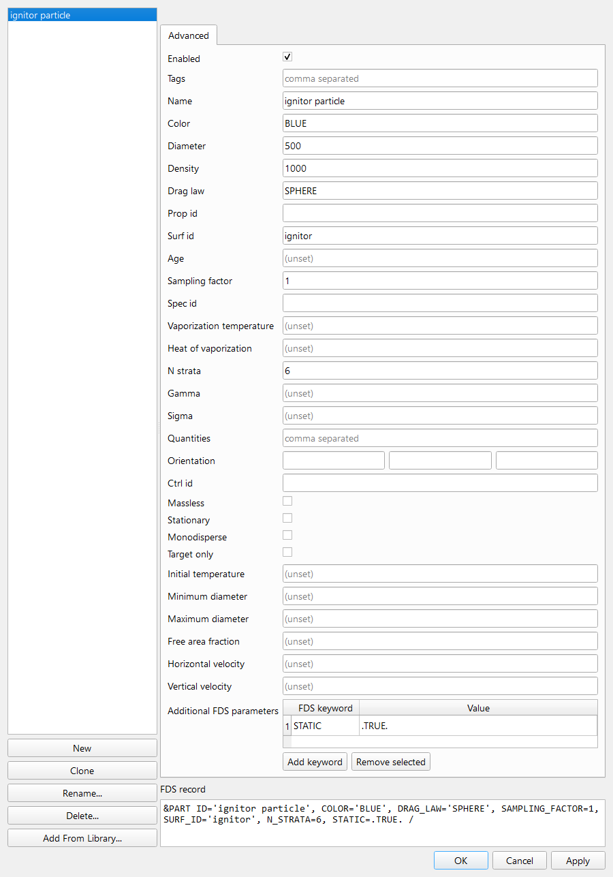
Figure 60. Model > Edit Particles: the static 'ignitor particle', a 1000 C cylinder placed on the seat cushion that starts the fire.
The only change: Model > Simulation Parameters, T_END from 600 s to 25 s.
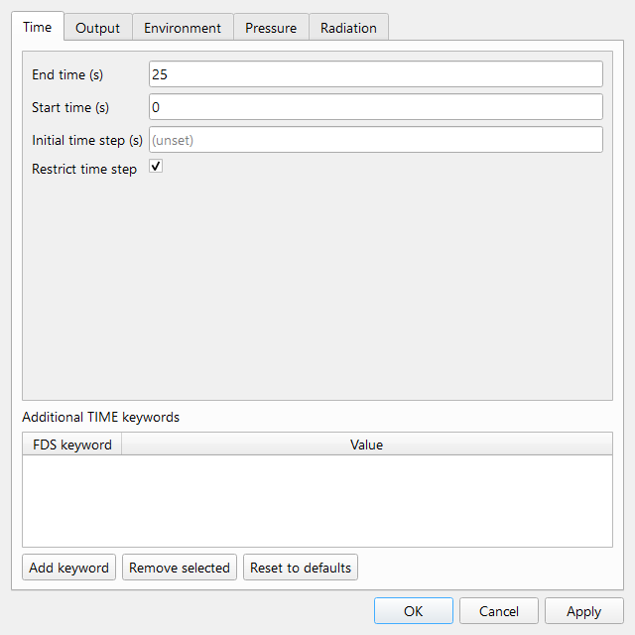
Figure 61. Model > Simulation Parameters: T_END reduced from 600 s to 25 s so the demo run stays short; nothing else in the case is changed.
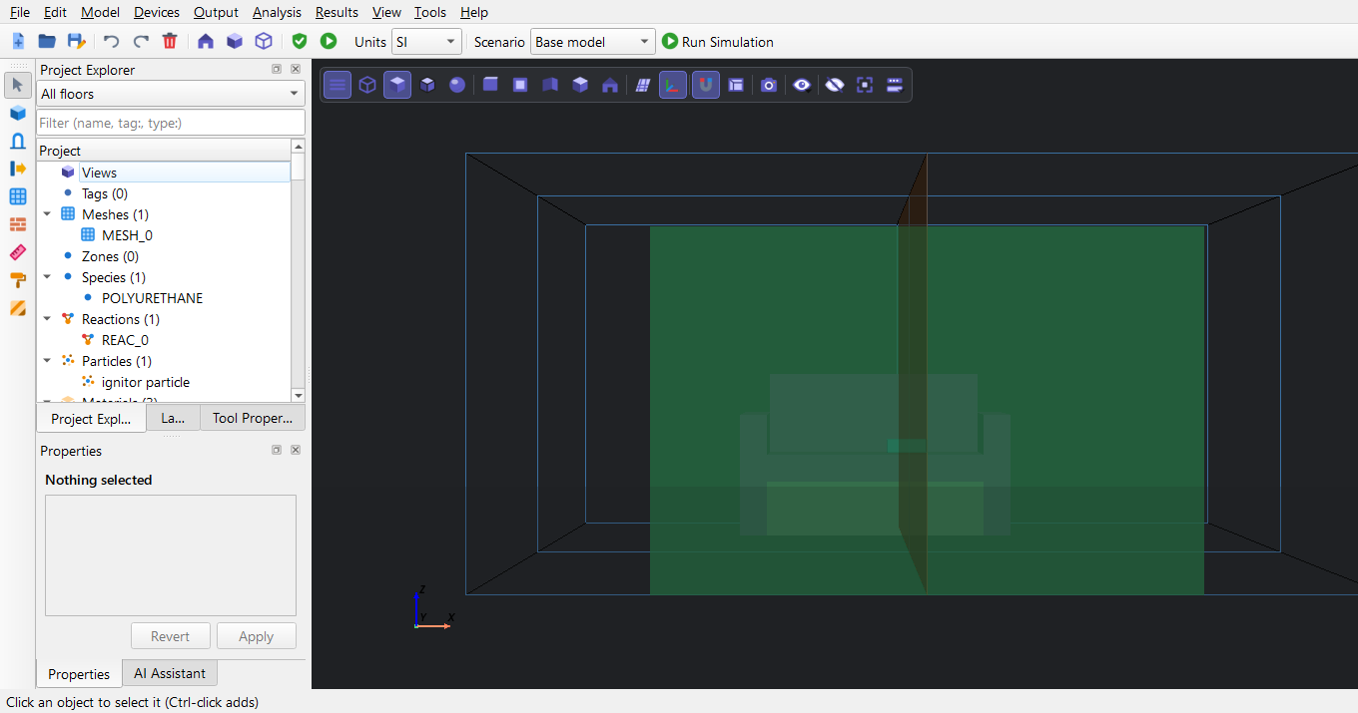
Figure 62. Front view: the open vent in the south wall (green) is the only opening; the other boundaries are the default solid wall surface.
Note. When the project is saved and written back to FDS, PyFDS keeps the original &DUMP settings (NFRAMES=3000, devices and heat release every 5 s) and adds its standard intervals for the files the original leaves to NFRAMES: slices, boundary files and isosurfaces every 1 s, Plot3D every 10 s, 3D smoke on. It also writes &MISC and &RADI with FDS's default values; &PRES is written only when a pressure-solver setting differs from FDS's default. These change how often results are saved, not the physics.

D Validation and running the simulation
Model > Validate Project: 0 errors, 0 warning(s).
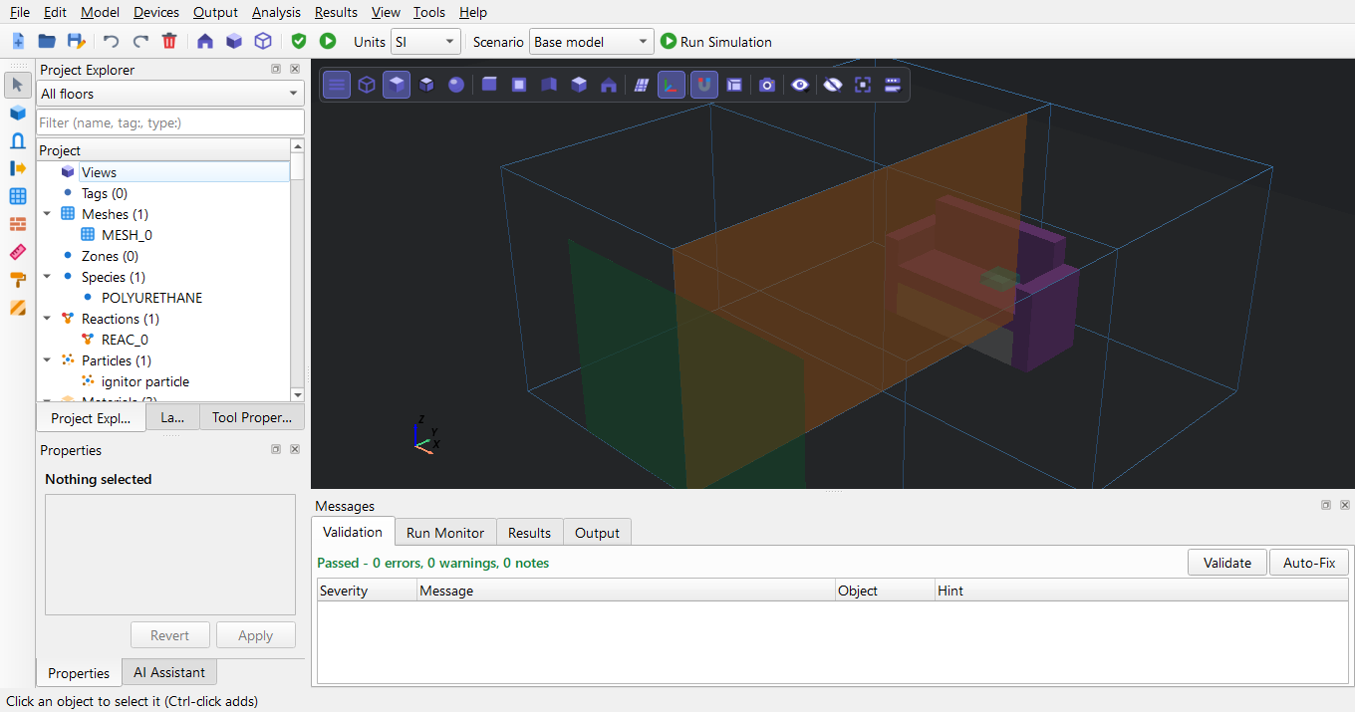
Figure 63. Model > Validate Project on the imported case.
Analysis > Run Simulation. Because the model has 4 meshes, the dialog proposes 'This computer, in parallel (MPI)' with 4 processes - FDS needs one process per mesh - and shows which mesh each process computes.
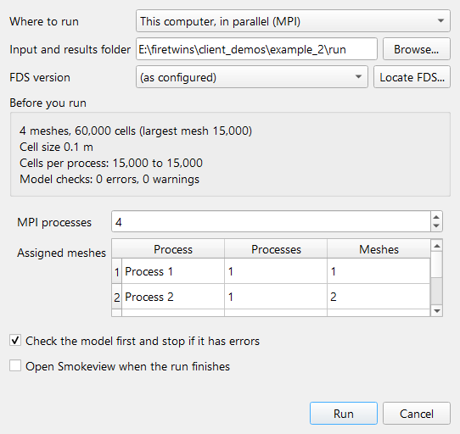
Figure 64. Analysis > Run Simulation with four meshes: 'This computer, in parallel (MPI)' is preselected with one process per mesh; the table shows which mesh each process computes and the summary shows the cells per process.
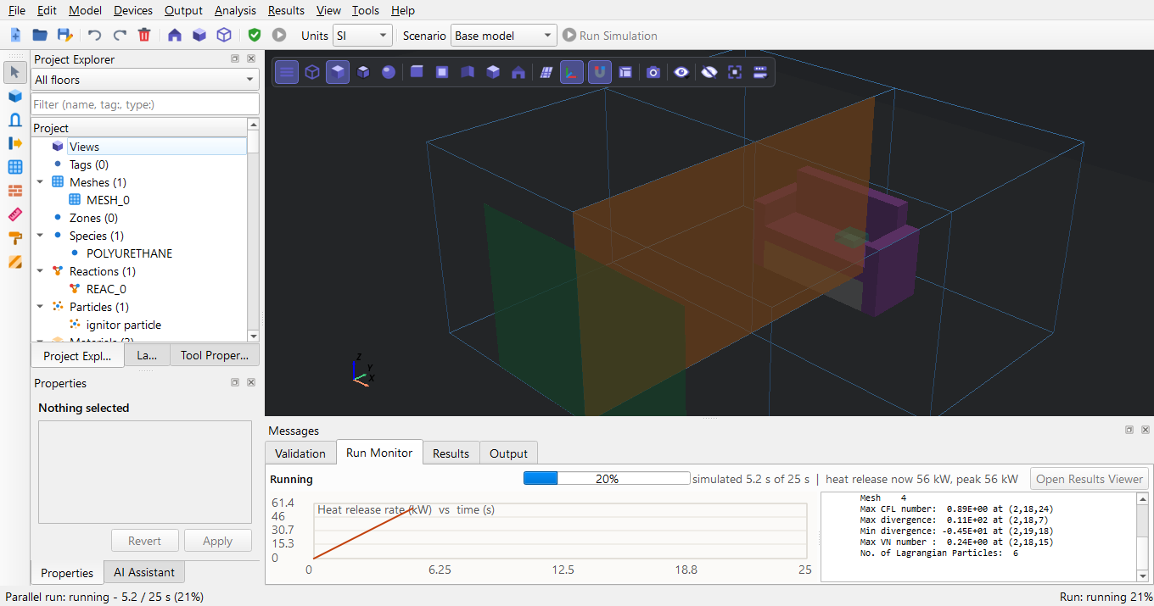
Figure 65. Run Monitor at 20 %.
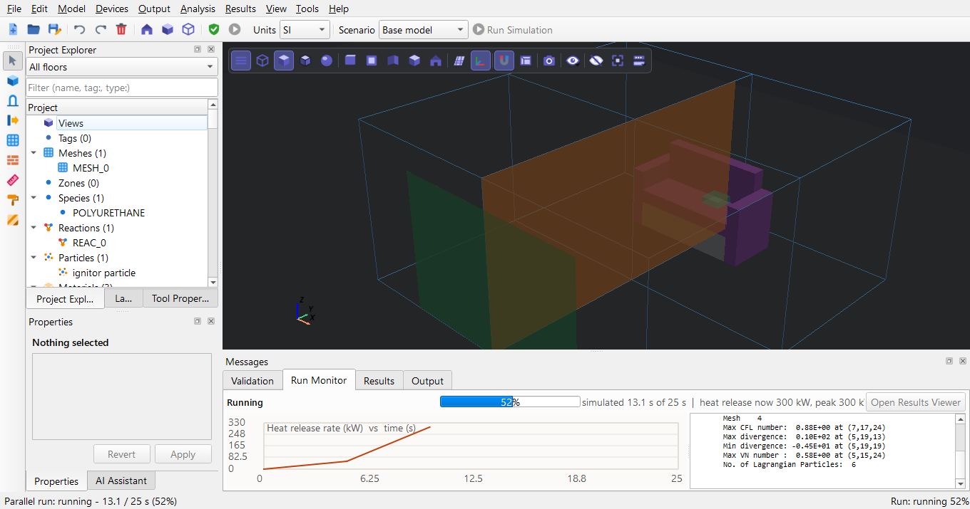
Figure 66. Run Monitor at 50 %.
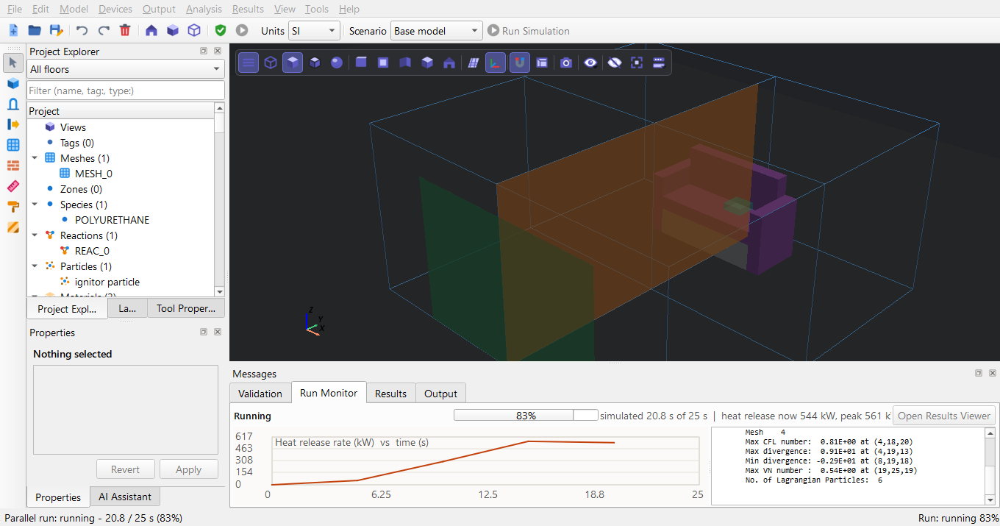
Figure 67. Run Monitor at 80 %.
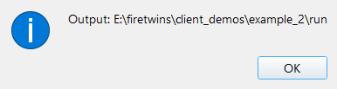
Figure 68. Message: Simulation complete
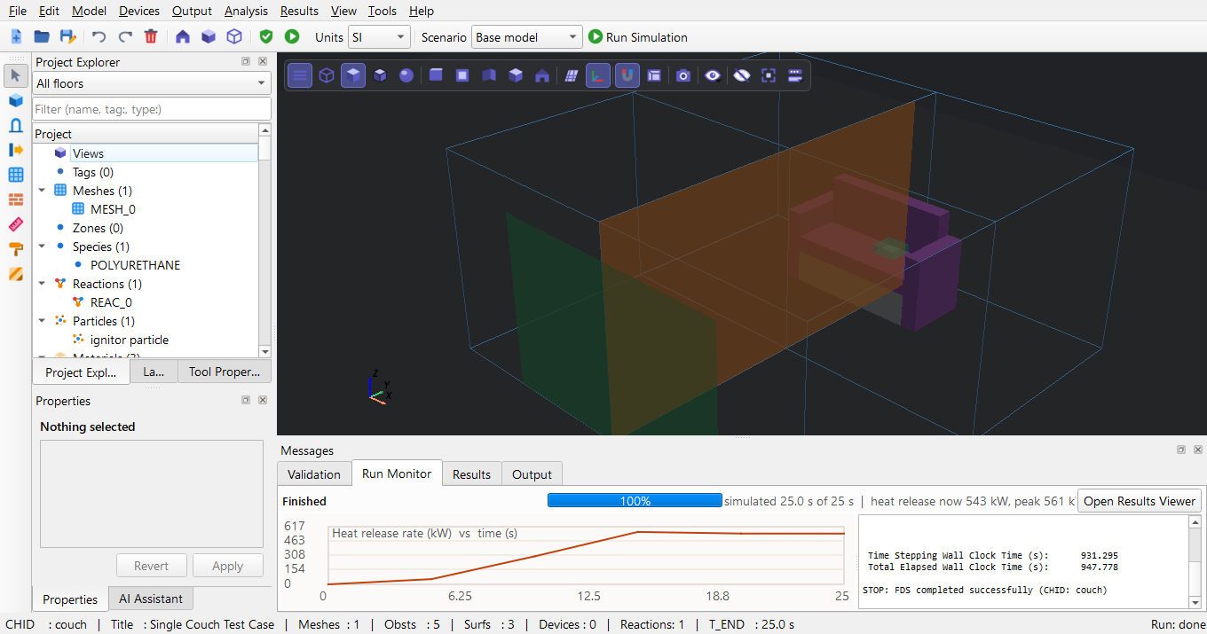
Figure 69. Run finished on 4 MPI processes.
Outcome on the test computer: FDS completed successfully; wall clock time 947.778 s for 25 s of simulated time on 4 MPI processes.

E Post-processing

E.1 PyFDS Results
File > Open Results (.smv) with client_demos\example_2\run\couch.smv. Results of the four meshes are listed per mesh; tick all four to see the whole plane or surface.
Figure 70. PyFDS Results (Results > Open PyFDS Results in the editor, or the PyFDS Results shortcut) before a run is loaded.
Figure 71. PyFDS Results, File menu: Open Results (.smv) opens the .smv file of a run.
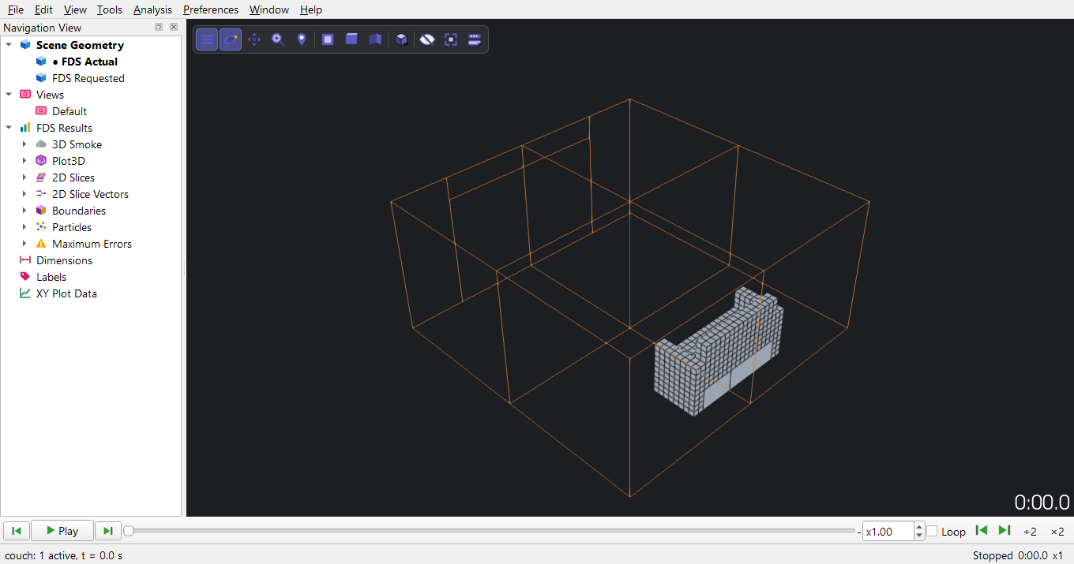
Figure 72. File > Open Results (.smv) with couch.smv: the geometry is shown and the Navigation View on the left lists every result of the run.
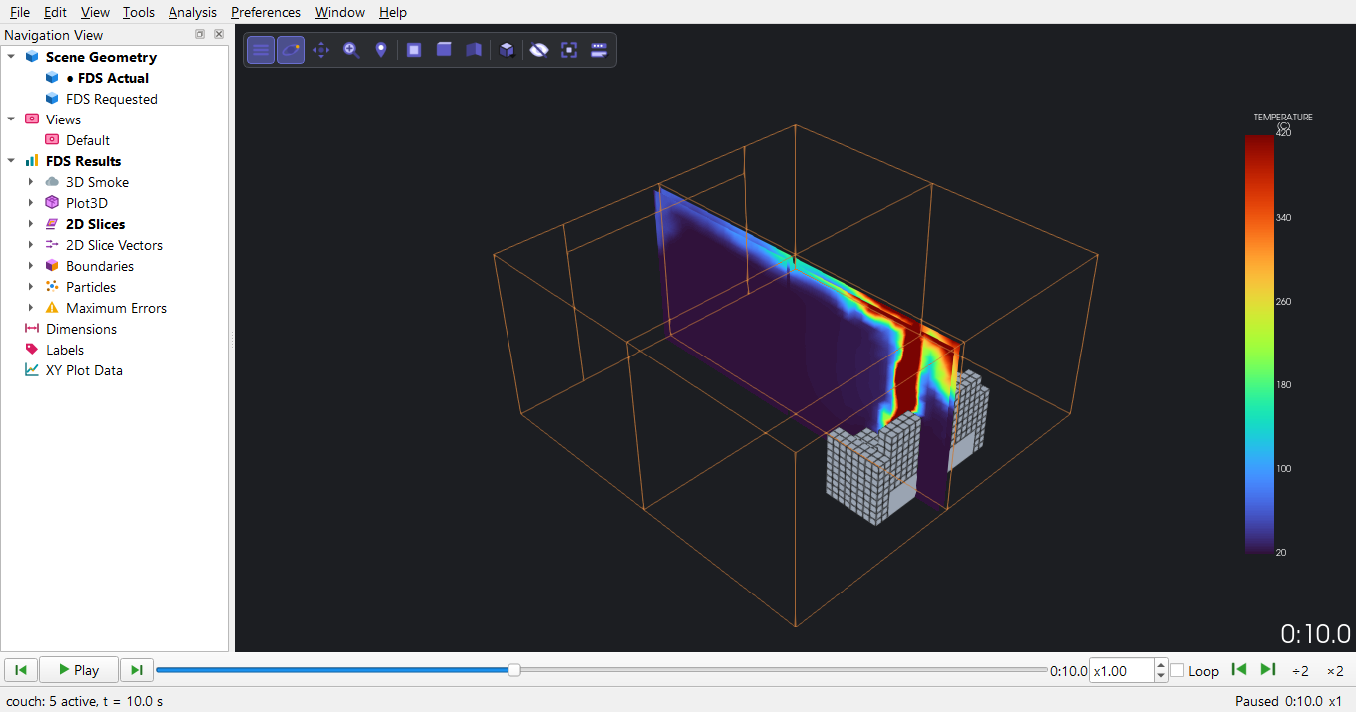
Figure 73. Temperature slice through the couch (X = 2.5 m) at 10 s.
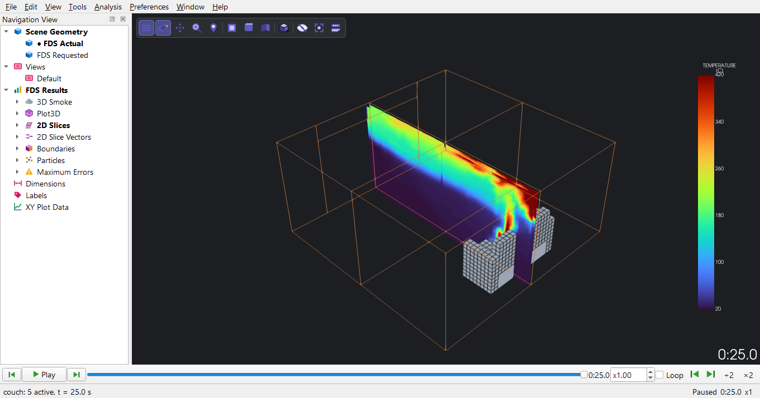
Figure 74. The same slice at the end of the run (25 s): the flame plume over the seat cushion.
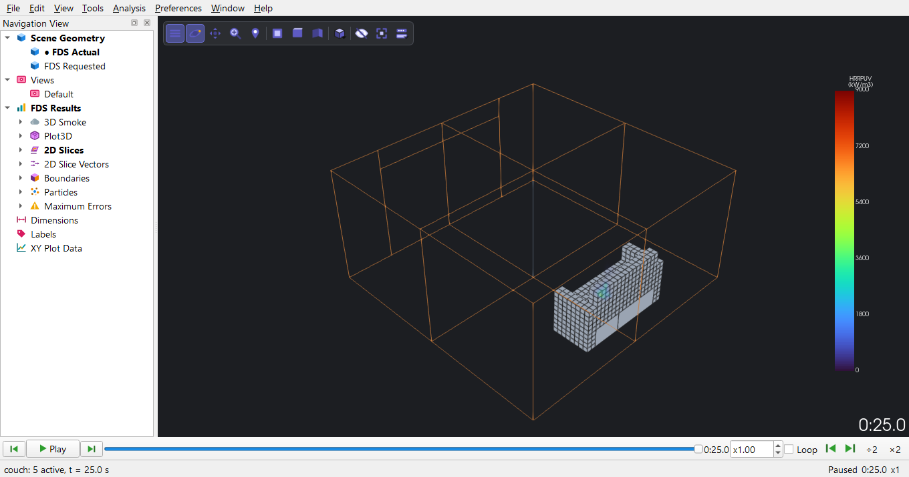
Figure 75. Heat release rate per unit volume (the flame) on the same plane at 25 s.
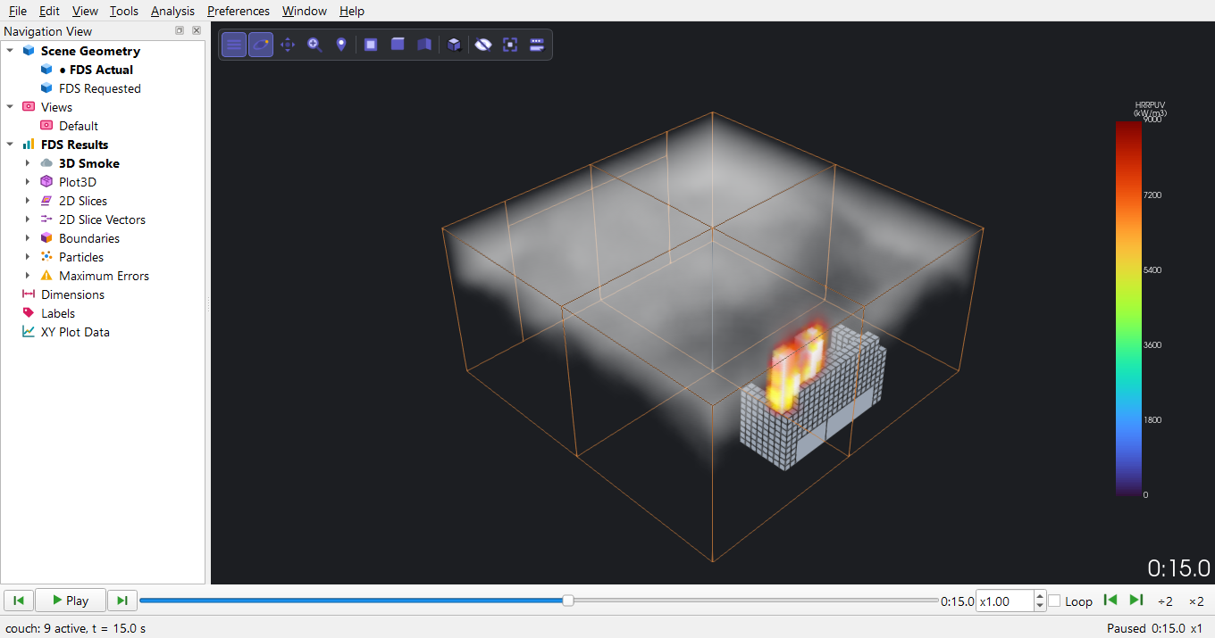
Figure 76. 3D smoke (soot density) and flame at 15 s.
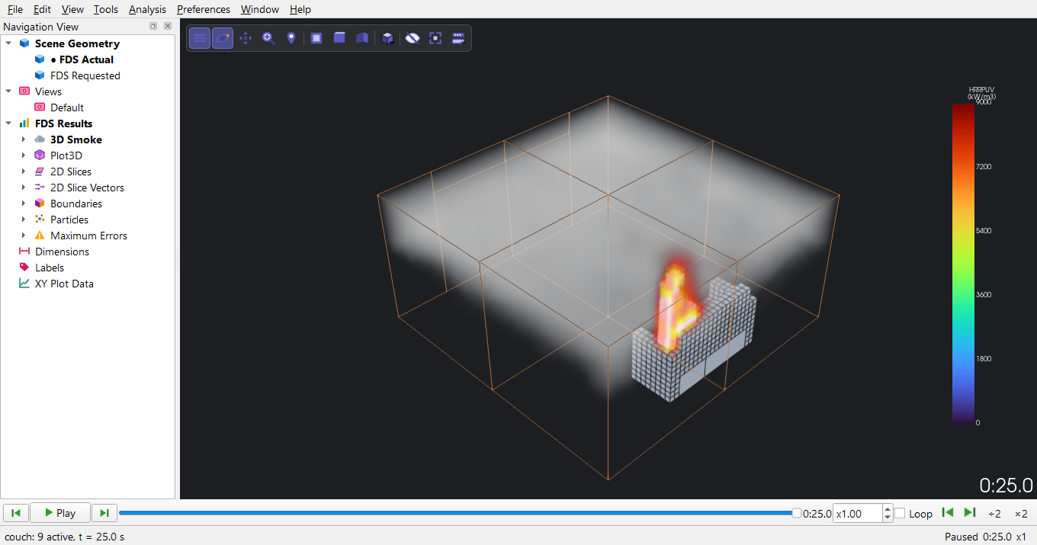
Figure 77. 3D smoke and flame at 25 s.
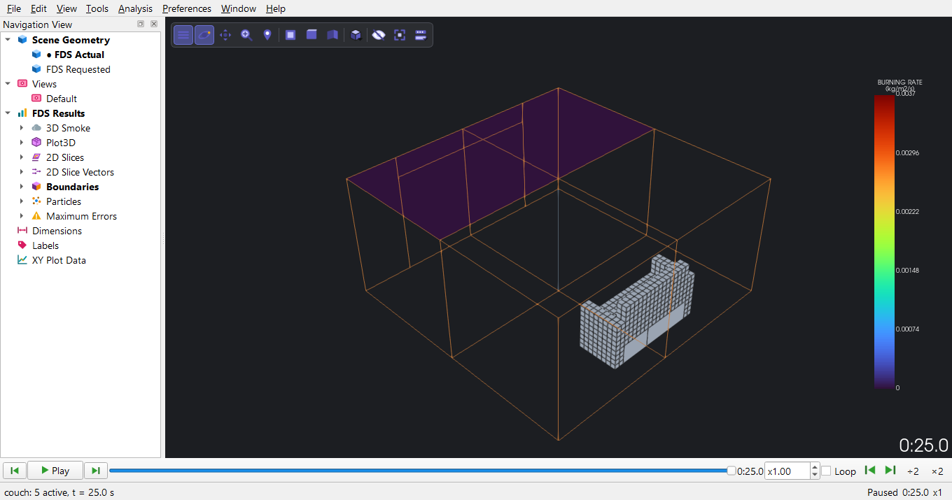
Figure 78. Boundary file, burning rate on the couch surfaces at 25 s (kg/m2/s).
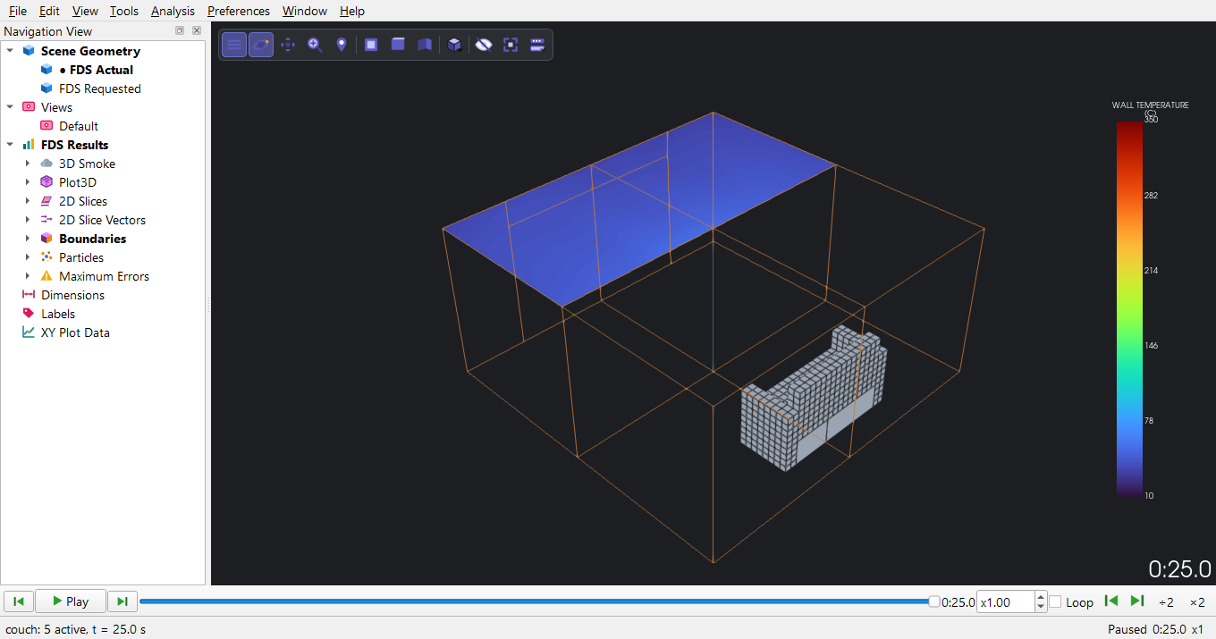
Figure 79. Boundary file, wall temperature at 25 s.
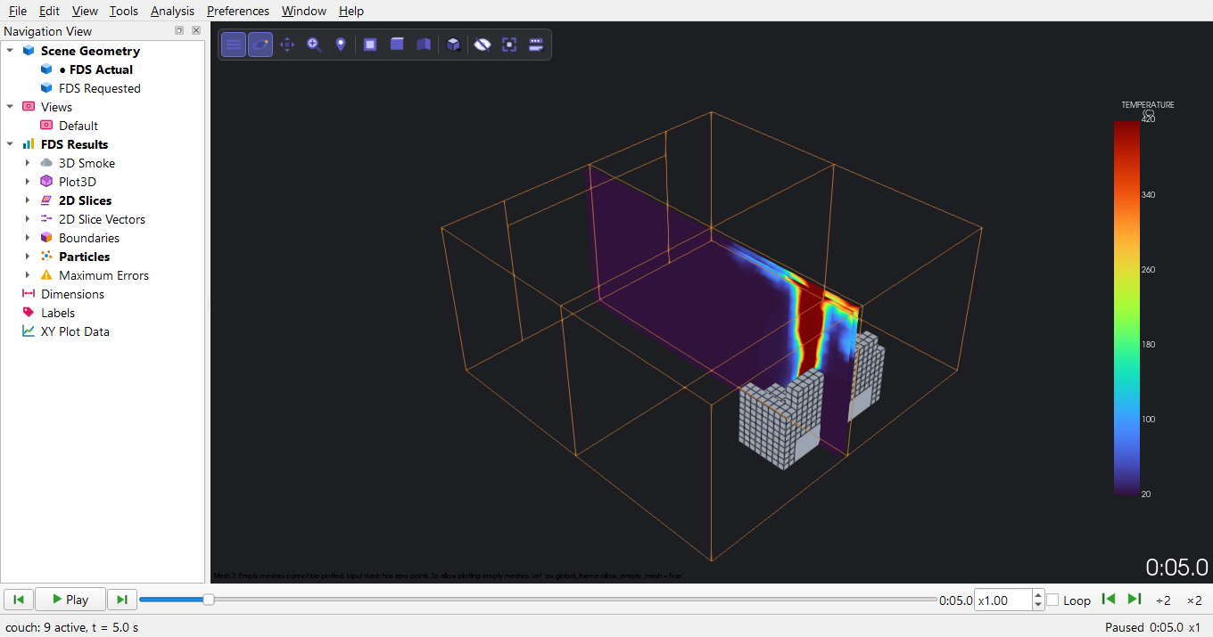
Figure 80. Static ignitor particle and the temperature slice at 5 s.
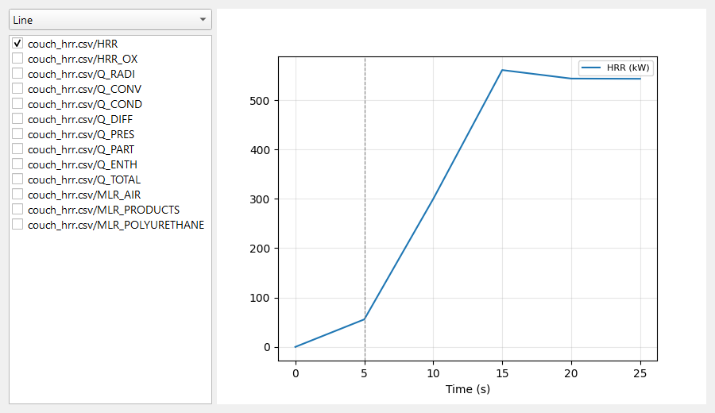
Figure 81. Tools > Time History Plot after File > Load CSV File with the heat release (_hrr.csv) and device (_devc.csv) files: tick the series to plot.
Figure 82. Preferences > Colorbar: range mode, limits, colour map and labels of a quantity's colour bar.
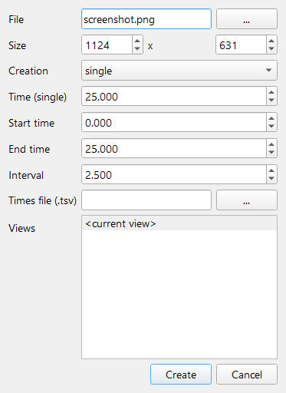
Figure 83. File > Save Screenshot: one picture, a series over time, or one per saved view, at a chosen size.
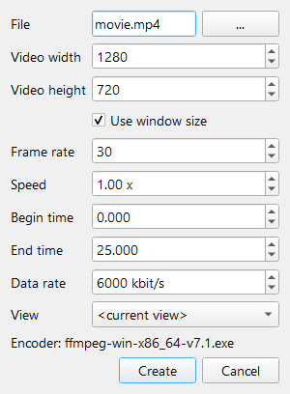
Figure 84. File > Movie > Save Movie: an MP4 of the time range at a chosen frame rate and speed.

E.2 Smokeview
Open couch.smv in Smokeview (double-click). Right-click > Load/Unload for slices, boundary files and 3D smoke; the pictures below come from a Smokeview script.
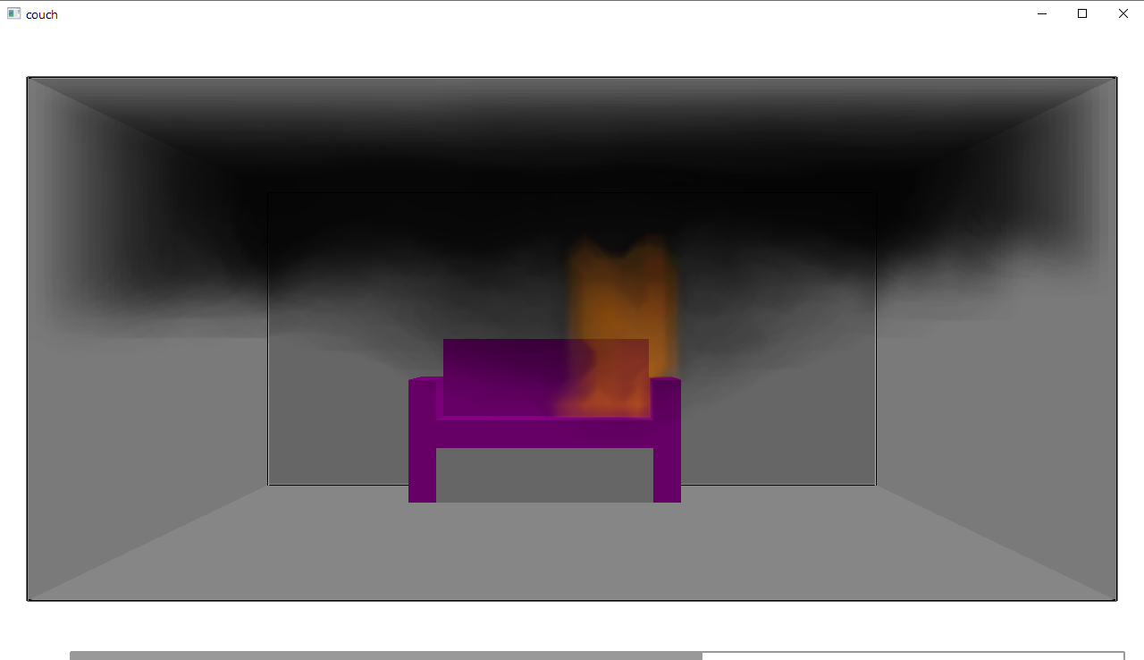
Figure 85. Smokeview 6.10.1 (Results > Open Smokeview... in the editor, or double-click the .smv file) while the script renders: the case's geometry with the scripted data loaded; right-click in the window for the menus.
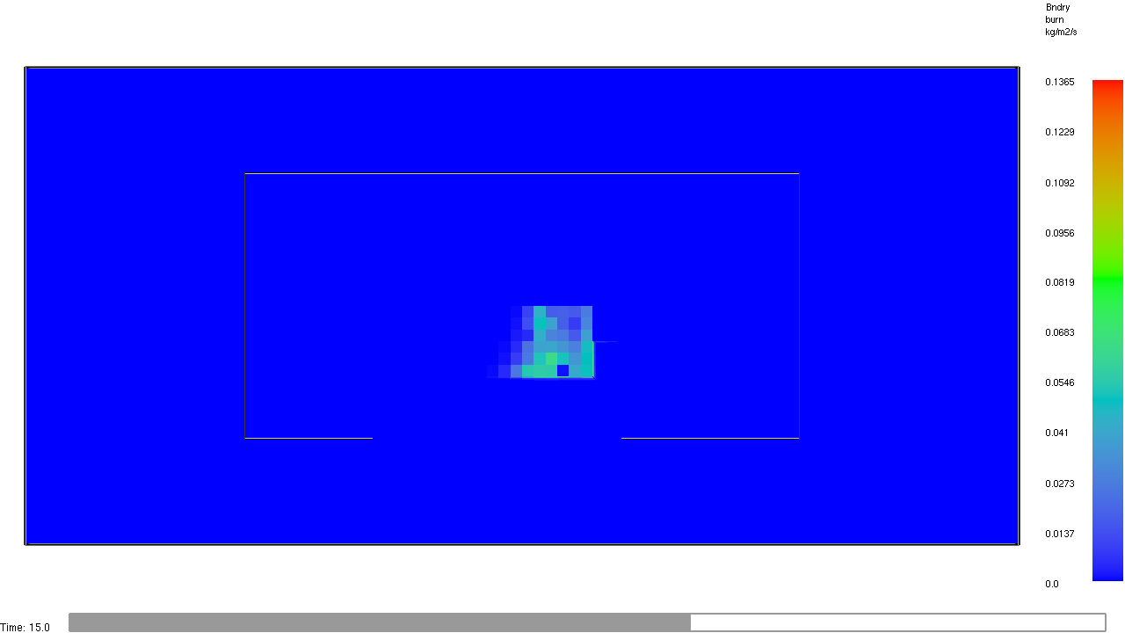
Figure 86. Rendered by Smokeview from the script: smv_burning_rate_t15.png
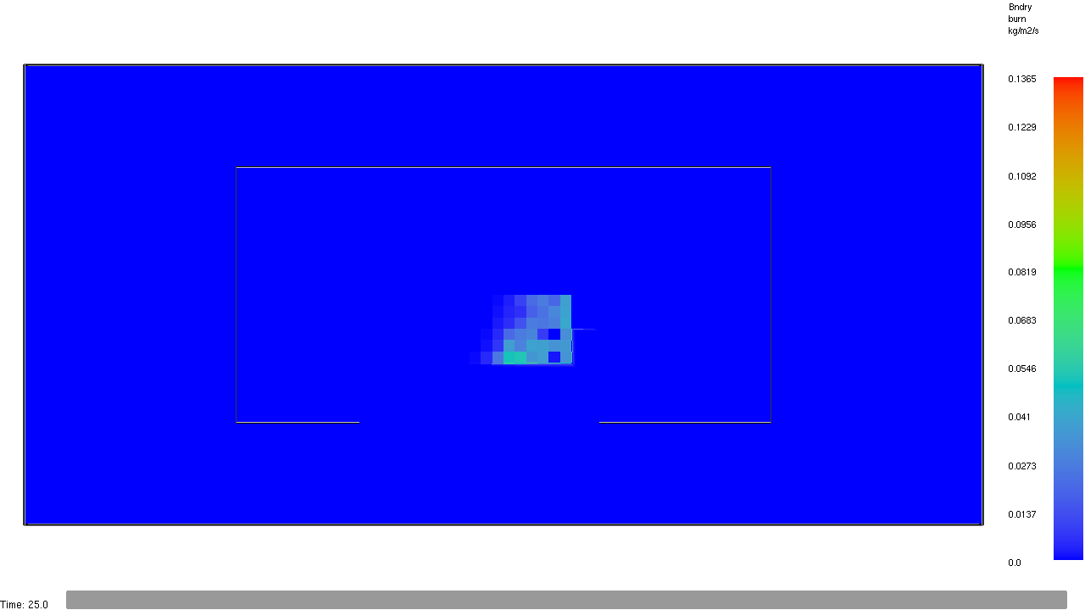
Figure 87. Rendered by Smokeview from the script: smv_burning_rate_t25.png
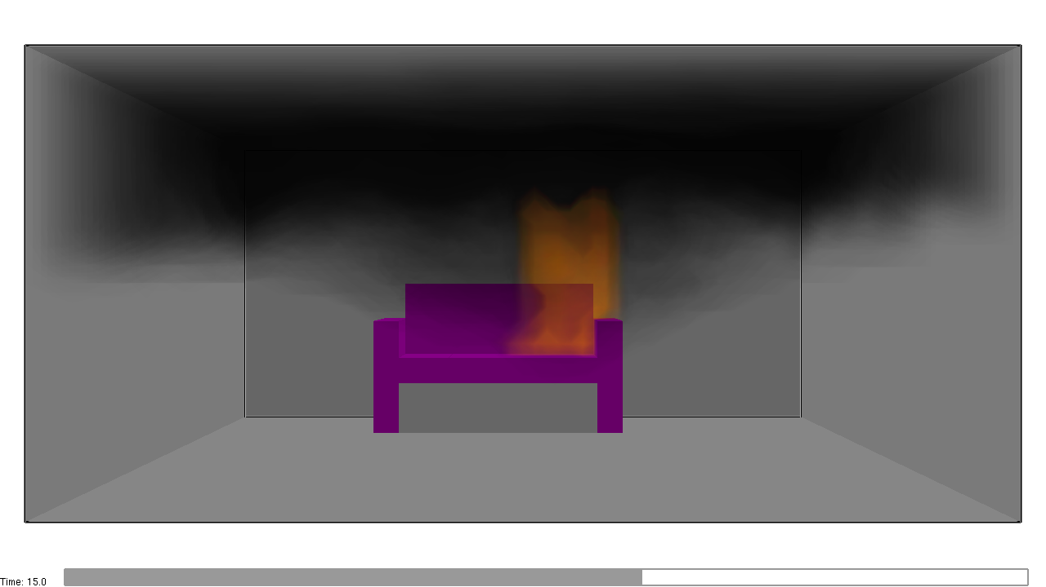
Figure 88. Rendered by Smokeview from the script: smv_smoke_t15.png
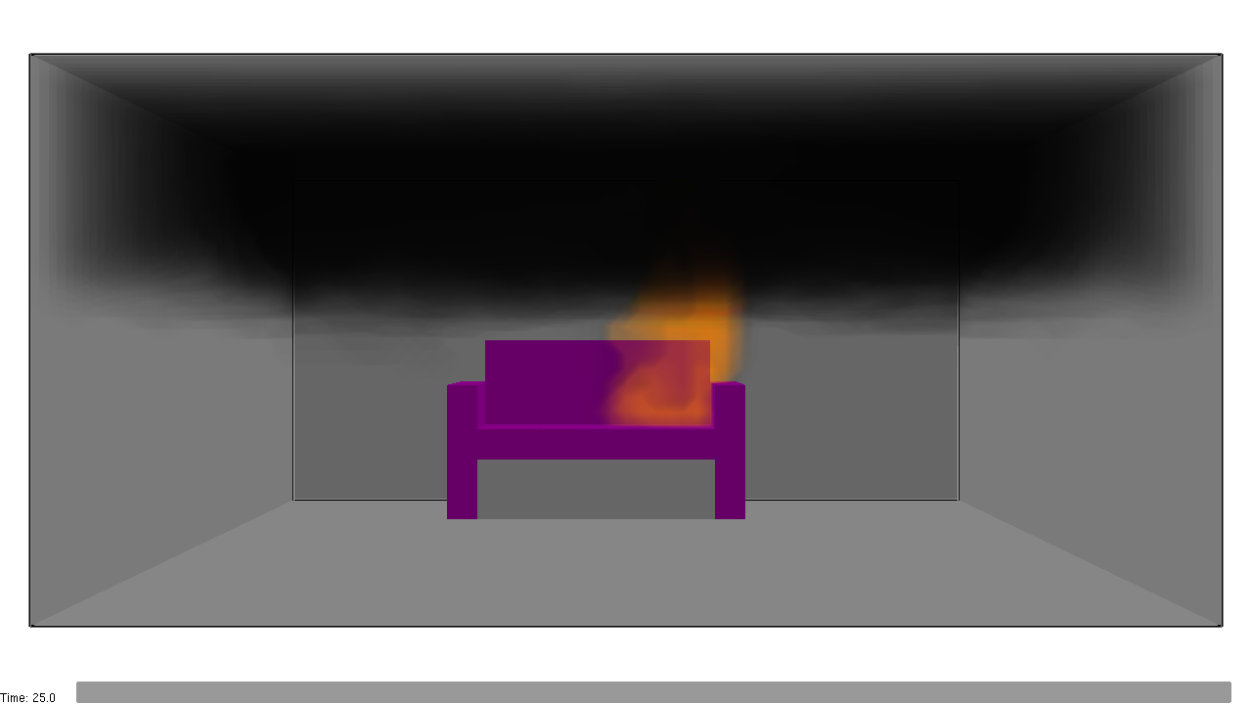
Figure 89. Rendered by Smokeview from the script: smv_smoke_t25.png

F Results and interpretation
Time (s) | 5 | 10 | 15 | 20 | 25
Heat release rate (kW) | 56 | 300 | 561 | 544 | 543

- The ignitor heats the seat fabric; flames spread over the seat and up the back - the burning-rate boundary file shows where material is pyrolysing.
- The heat release rate rises as more surface burns, to 561 kW at 15 s, and averages 549 kW from 15 to 25 s (peak 561 kW) while the couch keeps burning - the run is stopped long before the original 600 s.
- Wall temperatures rise only near the couch in this short time.
Limitations. The material properties are the FDS example's invented values, the run covers the first 25 s only, and the 0.1 m mesh is the example's. The case demonstrates the workflow; its heat release rate is not a prediction for a real couch.

G Troubleshooting
Symptom | Cause and remedy
'4 processes for N meshes: FDS needs one process per mesh' | Set MPI processes to the number of meshes (4) or use 'This computer' with one process.
MPI run does not start | FDS's MPI (mpiexec) must be installed with FDS; Locate FDS... picks an install that has it.
Run takes far longer than expected | Each of the 4 processes needs a free CPU core; close other heavy programs or reduce T_END.
Only a quarter of a slice is shown | Results are per mesh: tick the slice for all four meshes.
A Smokeview script stops with 'Slice files of type TEMPERATURE failed to load' | This case's slices are cell-centred and LOADSLICE cannot load them; use LOADSLCF with QUANTITY='TEMPERATURE' PBX=2.5 CELL_CENTERED=T (PyFDS's script builder does this with cell_centered=True), or load the slice from Smokeview's right-click > Load/Unload menu.

H Quick reference
1. Start PyFDS; File > Open: couch_original.fds
2. Inspect: Model > Edit Meshes / Surfaces / Materials / Particles
3. Model > Simulation Parameters: T_END 25 s
4. Model > Validate Project; File > Save As couch.pyfds
5. Analysis > Run Simulation: parallel (MPI), 4 processes, folder, Run
6. PyFDS Results: File > Open Results (.smv), couch.smv; tick all 4 meshes of a result
7. Smokeview: open couch.smv

4 New and changed in the version of 29 October 2026
This chapter shows what a code review of 29 October 2026 added or changed in the programs. The pictures were taken from the running programs, like the rest of the manual (client_demos\whats_new_walkthrough.py). Chapters 2 and 3 were captured again with this version, runs included.
- Menus. Long menus are grouped into submenus (Edit > Visibility and Transform, Model > Add from Library, Add Special and Model Checks, View > Rendering Mode; in PyFDS Results File > Movie, View > Section Box and Units). Every command kept its shortcut and icon.
- Project Explorer filter. A filter box over the object tree (section 4.2).
- Fire Engineering Calculators. Tools > Fire Engineering Calculators: hand calculations to check a model (section 4.3).
- Tenability (FED) and Compare Runs. Two new commands in the Analysis menu of PyFDS Results (section 4.5).
- Help. The FDS User Guide and the Smokeview Verification Guide open from Help; the PyroSim manual entry was removed.
- Fixes that change the FDS input. Open Mesh Boundaries leaves the floor closed; &PRES is written only when a pressure-solver setting differs from FDS's default (earlier versions always wrote VELOCITY_TOLERANCE=0.05, a PyFDS value that FDS does not use by default); Draw Room coordinates are rounded (1.95, not 1.9500000000000002); an HVAC fan or aircoil shared by several ducts is written once with all its ducts.
- Other fixes. The FED calculation uses FDS's own constants (FDS User Guide eq. 22.42-22.49) and, like FDS's FED device, counts the oxygen term only below 20 % O2; Tenability takes the gas temperature from the gases' own place; Compare Runs shows '-' instead of 'nan' for a device that only one run has; on/off menu entries show a tick; the AI Assistant no longer changes the model from a background thread.

4.1 The menus
The model editor's menu bar is File, Edit, Model, Devices, Output, Analysis, Results, View, Tools, Help. Running FDS is in the Analysis menu (and on the toolbar: Run Simulation); drawing tools are in Model > Draw and on the left edge of the window.
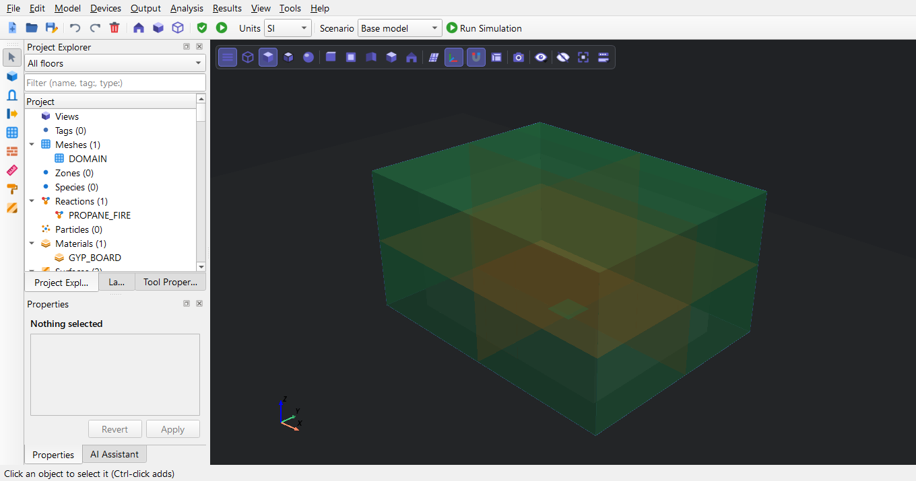
Figure 90. The model editor with client_demos\example_1\example_1.pyfds open (File > Open). The menu bar: File, Edit, Model, Devices, Output, Analysis (running FDS), Results, View, Tools, Help.
Figure 91. File menu.
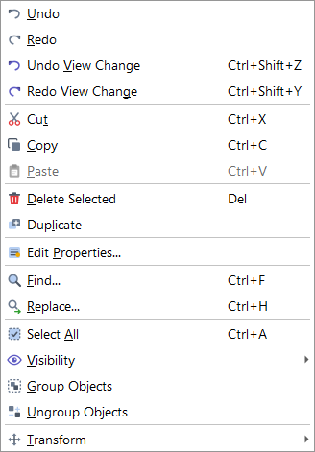
Figure 92. Edit menu: Undo/Redo, clipboard, and the new Visibility and Transform submenus.
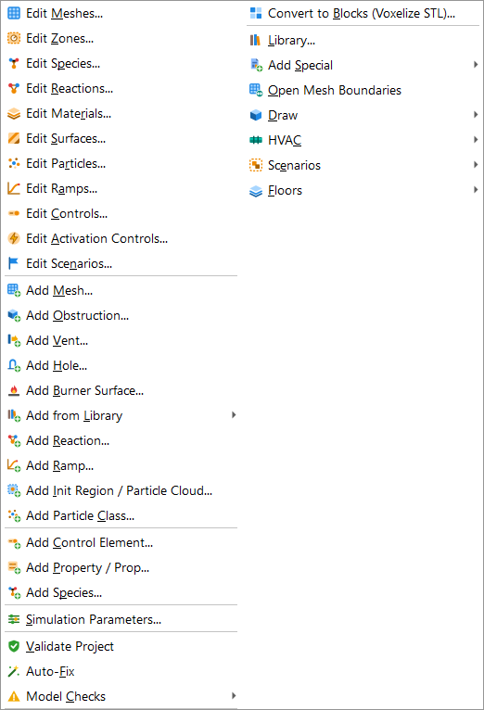
Figure 93. Model menu: the editors, the Add... commands, Add from Library, Model Checks, and (right column) Add Special, Open Mesh Boundaries and the Draw, HVAC, Scenarios and Floors submenus.
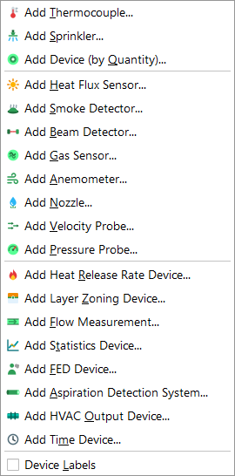
Figure 94. Devices menu.
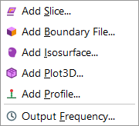
Figure 95. Output menu.
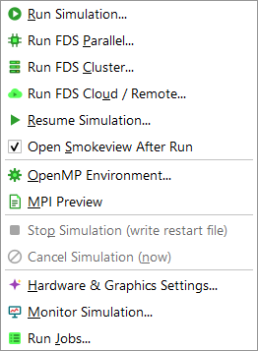
Figure 96. Analysis menu (running FDS): Run Simulation, parallel/cluster/cloud runs, Open Smokeview After Run, Stop and Cancel, Monitor Simulation.
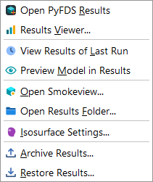
Figure 97. Results menu of the editor: Open PyFDS Results, View Results of Last Run, Open Smokeview... (any .smv in Smokeview) and Open Results Folder.
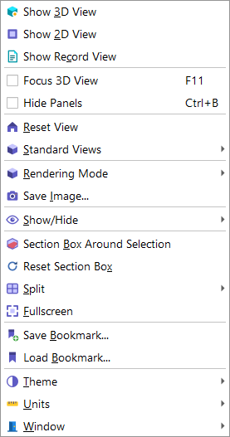
Figure 98. View menu: standard views, display options and the Rendering Mode submenu.
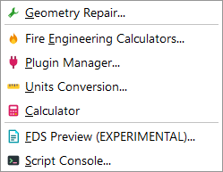
Figure 99. Tools menu, with the new Fire Engineering Calculators.
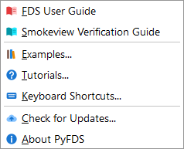
Figure 100. Help menu: the FDS User Guide and the Smokeview Verification Guide open in the PDF viewer.
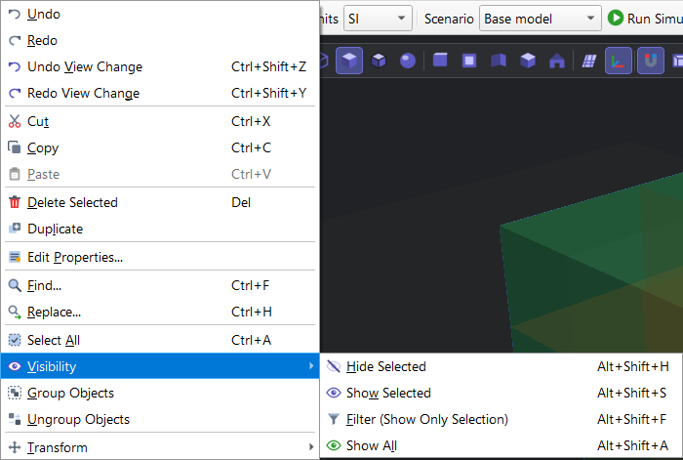
Figure 101. Edit > Visibility: hide and show objects.
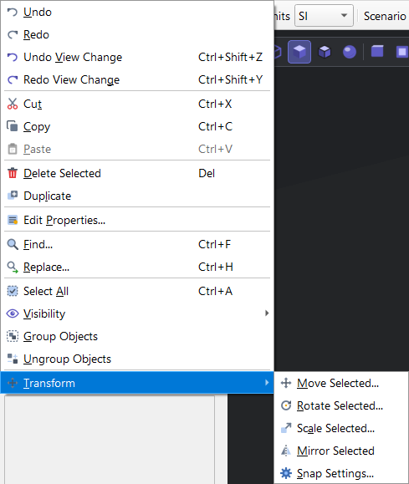
Figure 102. Edit > Transform: move, rotate, scale and mirror the selection.
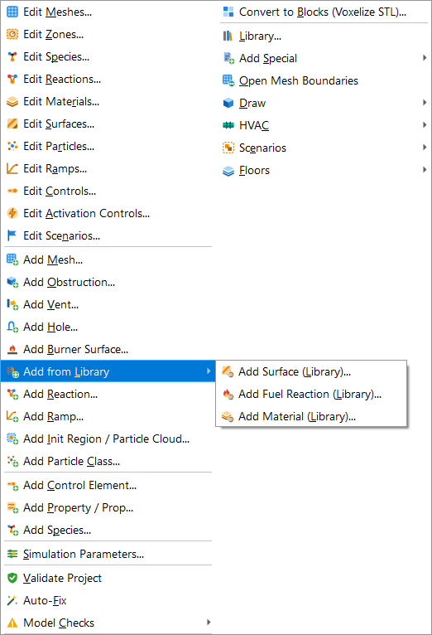
Figure 103. Model > Add from Library: surfaces, fuels and materials from the library.
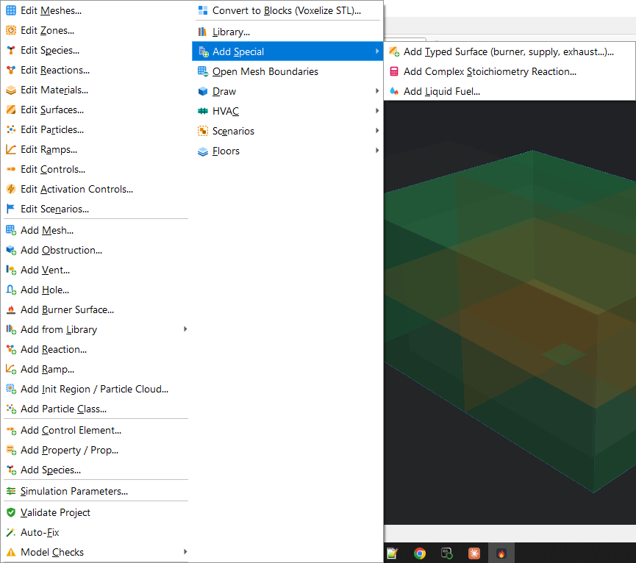
Figure 104. Model > Add Special: typed surfaces (burner, supply, exhaust), complex stoichiometry reactions, liquid fuels.
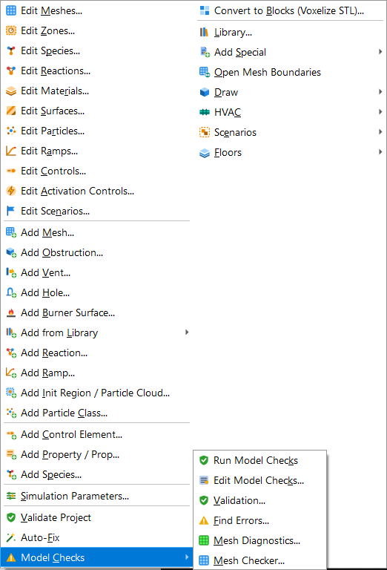
Figure 105. Model > Model Checks: every 'check my model' command in one place (some used to be under Tools).
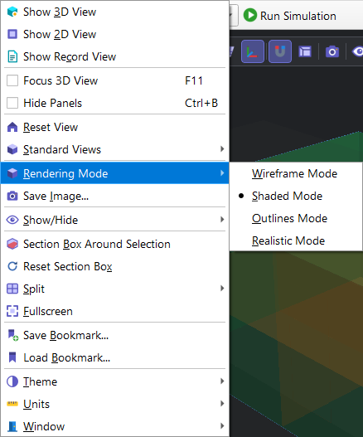
Figure 106. View > Rendering Mode: wireframe, shaded, outlines, realistic.

4.2 Finding objects: the Project Explorer filter
Type in the box above the Project Explorer to show only the objects whose name contains the text. 'tag:' searches the tags and 'type:' the kind of object (type:vent, type:device). The clear button (x) shows everything again; the groups that were open stay open.
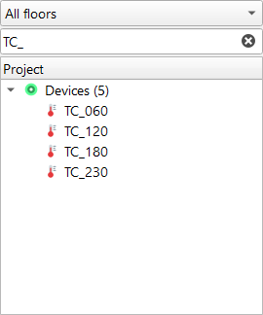
Figure 107. Project Explorer filter: typing TC_ leaves only the four thermocouples (and the groups that hold them). It also takes tag: and type: (for example type:vent).
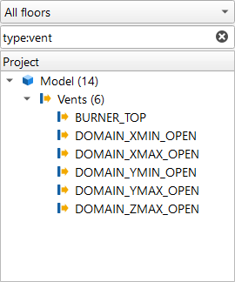
Figure 108. The same filter with type:vent - every vent of the model, nothing else.

4.3 Fire Engineering Calculators
Tools > Fire Engineering Calculators. Choose a calculation, enter its inputs (SI units) and press Calculate; every number the method returns is listed. The calculations: fire size and cell size (D*, D*/dx), Heskestad plume, Alpert ceiling jet, smoke filling time (NFPA 92), a two-layer zone model, heat detector response and tunnel critical velocity (Kennedy). They do not change the model.
For example 1's 180 kW burner the calculator gives D* = 0.4839 m and a cell size of 0.04839 m or less for D*/dx of at least 10. Example 1 uses 0.1 m cells (D*/dx about 4.8), which is why chapter 2 calls its resolution coarse.
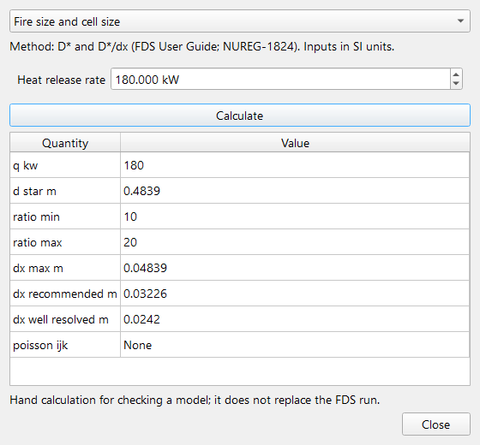
Figure 109. Tools > Fire Engineering Calculators, 'Fire size and cell size' for example 1's 180 kW burner: the characteristic diameter D* = 0.48 m and the cell sizes for D*/dx from 10 to 20.
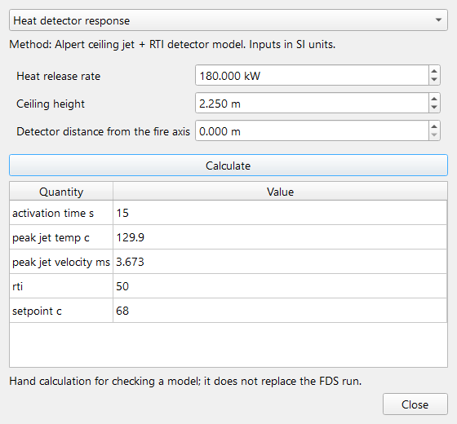
Figure 110. 'Heat detector response' for the same fire, the ceiling 2.25 m above the burner top and the detector on the fire axis. The calculator uses a standard sprinkler-type link (RTI 50, 68 C), not example 1's fast detector.
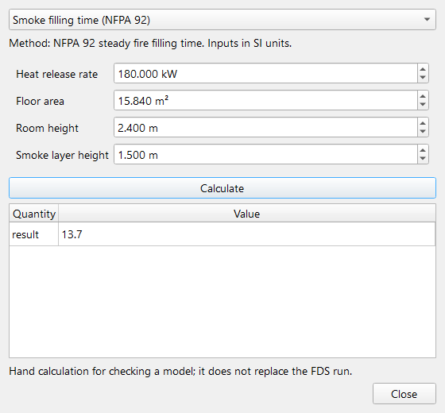
Figure 111. 'Smoke filling time (NFPA 92)' for example 1's room (4.8 x 3.3 m, 2.4 m high): the time for the smoke layer to come down to 1.5 m with no openings, steady 180 kW from the start.

4.4 Opening a run in Smokeview
When 'Open Smokeview when the run finishes' is ticked in the Run dialog, Smokeview opens the run's <CHID>.smv as soon as FDS ends. At any later time use Results > Open Smokeview... (any .smv file), or Results > View Results of Last Run to open the last run in PyFDS Results instead. PyFDS uses the Smokeview set in File > Preferences (smv_binary) and otherwise the bundled fds_smv\SMV6\smokeview.exe.
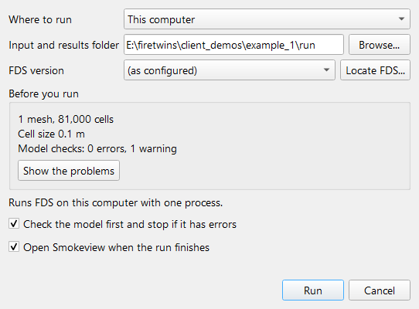
Figure 112. Analysis > Run Simulation with 'Open Smokeview when the run finishes' ticked: when FDS ends, Smokeview opens <CHID>.smv from the run folder (the dialog was closed here without running).
In the Analysis menu, 'Open Smokeview After Run' shows a tick when it is on (like every on/off entry of the menus); the Run dialog's check box starts from it.

4.5 Example 3 - Tenability and comparing two runs
Scenario. Example 1's room with the door closed: the only opening is the window. Gas devices at head height (1.5 m) in the back of the room, out of the plume, record carbon monoxide, carbon dioxide and oxygen (volume fractions), temperature, visibility and FDS's own fractional effective dose (QUANTITY='FED'). Everything else is example 1. client_demos\example_3\scripts\make_case.py builds it from example_1.pyfds.
Run. FDS 6.10.1, one process: completed successfully, wall clock time 1965.056 s for 60 s of simulated time.
Open the run in PyFDS Results (File > Open Results (.smv), example_3.smv) and load its device file with File > Load CSV File (example_3_devc.csv). The new commands are in the Analysis menu.
Figure 113. PyFDS Results, File menu: Open Results (.smv), Load CSV File, Save Screenshot, and the Movie submenu.
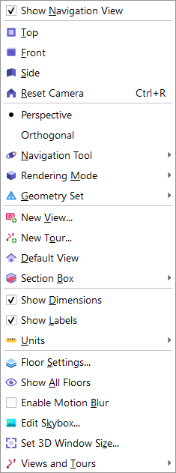
Figure 114. PyFDS Results, View menu, with the Section Box and Units submenus.
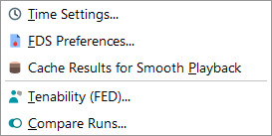
Figure 115. PyFDS Results, Analysis menu, with the new Tenability (FED) and Compare Runs (Time History Plot is in Tools).
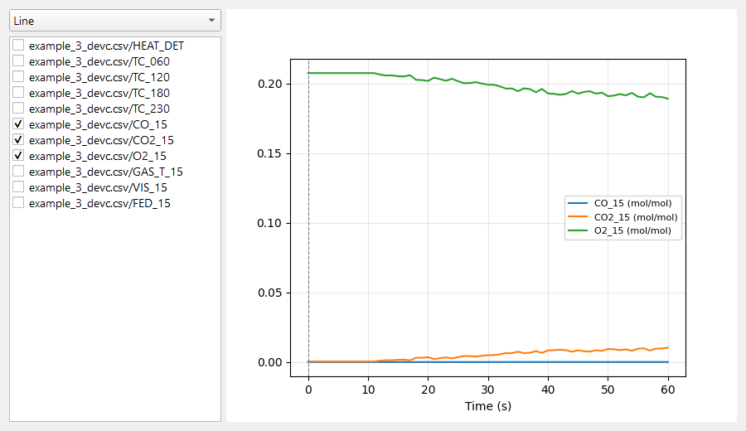
Figure 116. Example 3, Tools > Time History Plot: carbon monoxide, carbon dioxide and oxygen (volume fractions) at head height in the room.
Analysis > Tenability (FED) computes Purser's fractional effective dose from the chosen device columns. It picks the CO, O2, CO2 and temperature columns by name, uses FDS's constants, and reports the time to FED 0.3 (incapacitation, used as ASET), a separate heat dose, and the margin to the required safe egress time (RSET) you enter. For the gas temperature it takes the column named for the same place as the CO column (GAS_T_15 for CO_15), not just the first temperature in the file (here TC_060, a plume thermocouple). Check the columns it picked before you calculate.
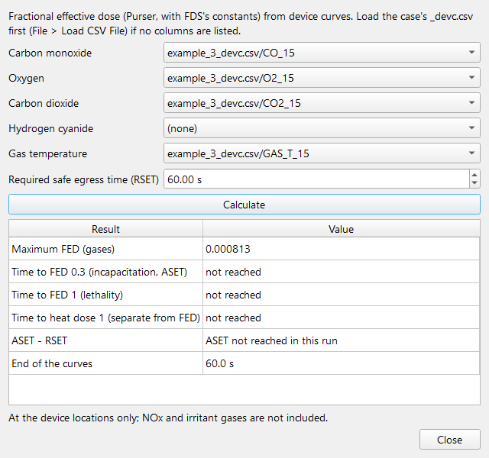
Figure 117. Analysis > Tenability (FED) for example 3: the gas columns are picked from the loaded _devc.csv, the gas temperature from the same place as the gases (GAS_T_15 for CO_15); the dose uses FDS's own constants. RSET 60 s here.
Quantity at the device (1.5 m) | Value
Peak carbon monoxide | 27 ppm
Peak carbon dioxide | 1.04 %
Lowest oxygen | 18.92 %
Peak gas temperature | 150 C
Lowest visibility | 3.3 m
FED from FDS's FED_15 device at 60 s | 0.000819
PyFDS Tenability: Maximum FED (gases) | 0.000813
PyFDS Tenability: Time to FED 0.3 (incapacitation, ASET) | not reached
PyFDS Tenability: Time to FED 1 (lethality) | not reached
PyFDS Tenability: Time to heat dose 1 (separate from FED) | not reached
PyFDS Tenability: ASET - RSET | ASET not reached in this run
PyFDS Tenability: End of the curves | 60.0 s

The dose is very small: nobody at this point would be incapacitated by the gases in the first 60 s. PyFDS's value (0.000813) agrees with FDS's own FED_15 device (0.000819) to about 1 %; the rest comes from FDS adding up the dose every time step, PyFDS from the 1 s device output. Like FDS's device, PyFDS counts the oxygen term only below 20 % O2 (humid ambient air here has 20.76 %); FDS's User Guide (eq. 22.48) does not state this cutoff, it was found by comparing with this run.
Analysis > Compare Runs compares the devices of two run folders. The folder of the open run is filled in as the baseline; choose the other run, set the threshold and press Compare. Each device is listed with its peak and mean in both runs and the difference; devices that only one run has are listed as such. Here example 1 (door open) is the baseline and example 3 (door closed) the variant. A device that only one run has shows its own peak, '-' for the other run, and the status 'variant only' or 'baseline only'.
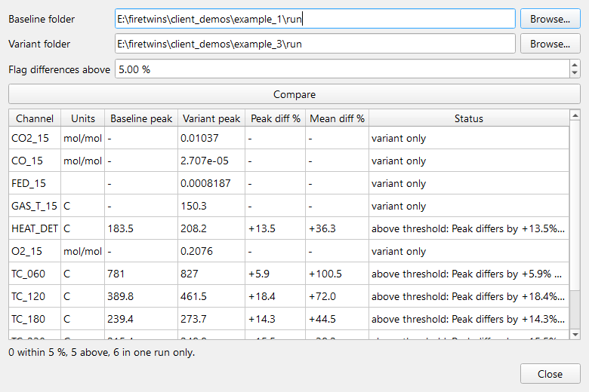
Figure 118. Analysis > Compare Runs: example 1 (door open, baseline) against example 3 (door closed), device by device; differences above 5 % are flagged, and devices that only one run has are listed as such.
Devices in both runs: HEAT_DET +13.5 % (above threshold); TC_060 +5.9 % (above threshold); TC_120 +18.4 % (above threshold); TC_180 +14.3 % (above threshold); TC_230 +15.5 % (above threshold). In example 3 only: CO2_15, CO_15, FED_15, GAS_T_15, O2_15, VIS_15.
Limitations. A demonstration on example 1's coarse mesh (section 2F), for 60 s only, with one device location. FED is evaluated where the devices are, not along an escape route, and leaves out irritant gases. The numbers show how the tools work; they are not a tenability assessment of a real room.

