LAPP Products Used in Equipment

1. Drag Chains
Matching LAPP Products: LAPP SILVYN® CHAIN
LAPP's SILVYN® CHAIN systems are designed for cable protection and management in dynamic applications.
Application in Equipment: | LAPP Product:
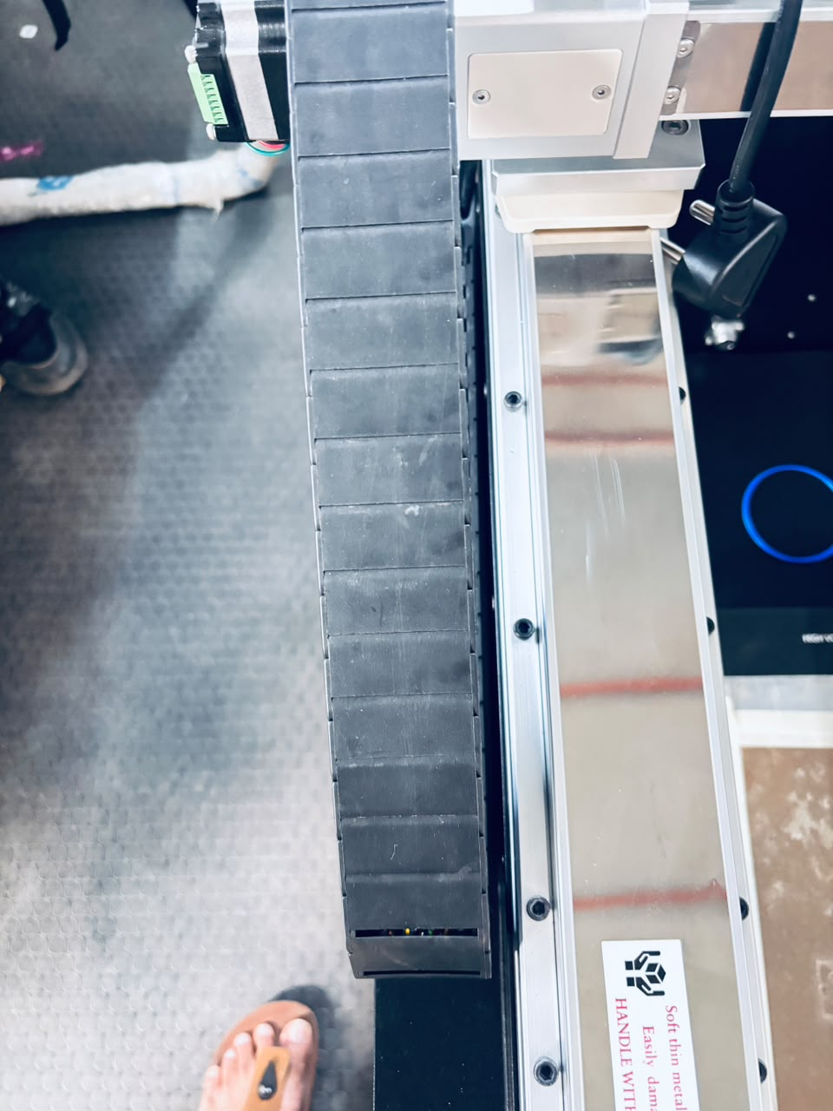 | 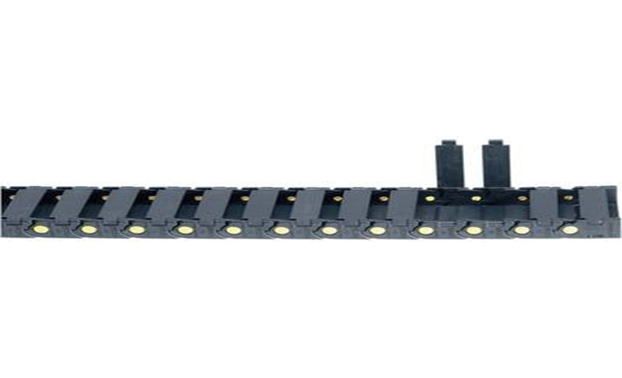

2. Continuous Movement Cables
Matching LAPP Products: LAPP ÖLFLEX® SERVO FD
ÖLFLEX® FD cables are highly flexible cables specifically engineered for continuous movement within drag chains. Suitable for applications due to their high flexibility and durability in constantly moving parts.
Application in Equipment: | LAPP Product:
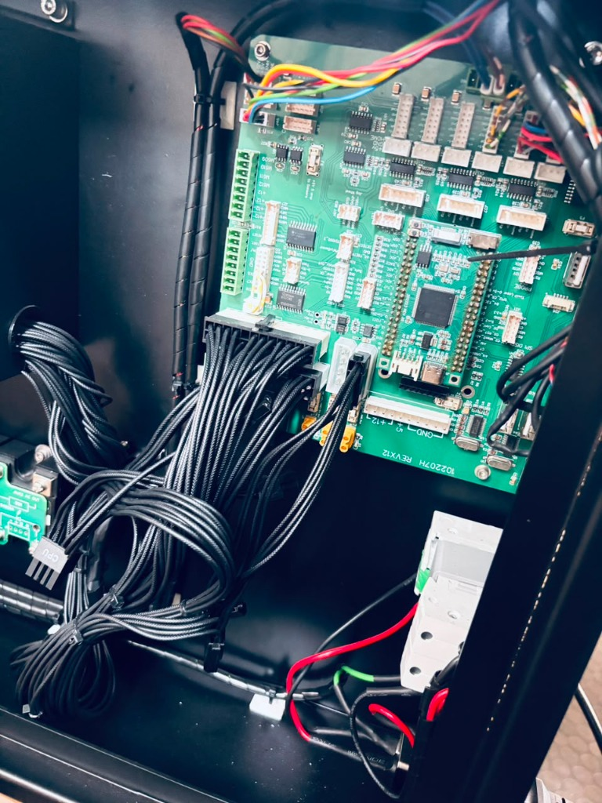 | 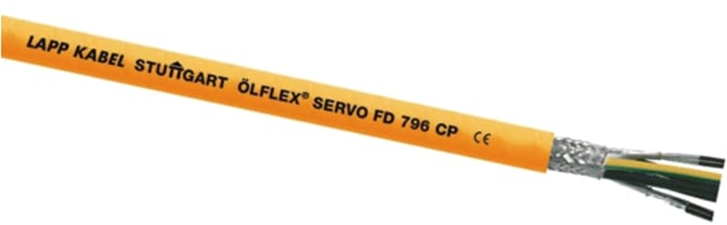

3. Control Cabinet and Cable Glands
Matching LAPP Products: LAPP SKINTOP® Cable Gland
SKINTOP® cable glands provide secure, strain-relieved, and often liquid-tight cable entry into control cabinets.
Application in Equipment: | LAPP Product:
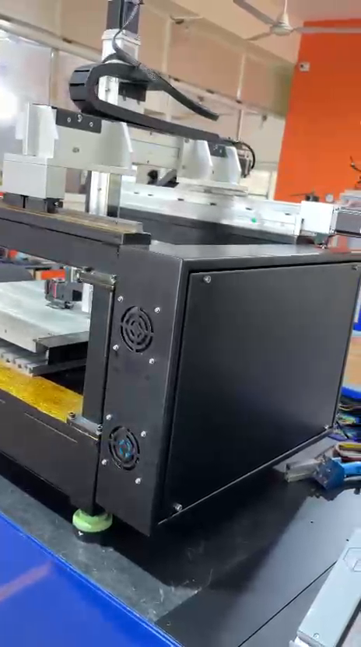 | 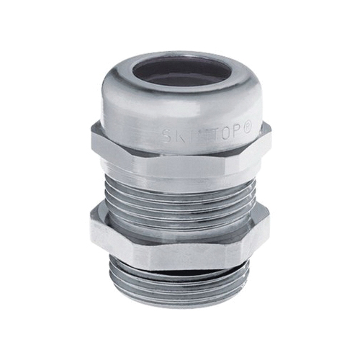

4. Control Cabinet Wiring
Matching LAPP Products: LAPP ÖLFLEX® UNIPLUS
ÖLFLEX® UNIPLUS single-core cables are ideal for internal wiring of devices and control cabinets.
Application in Equipment: | LAPP Product:
 | 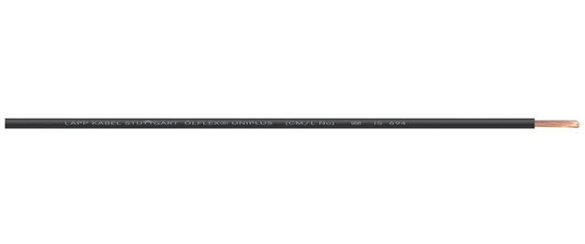

5. Cable Bundling
Matching LAPP Products: LAPP KW Plastic Coil
KW plastic coils are used for easy and quick bundling of cables, providing mechanical protection and organization.
Application in Equipment: | LAPP Product:
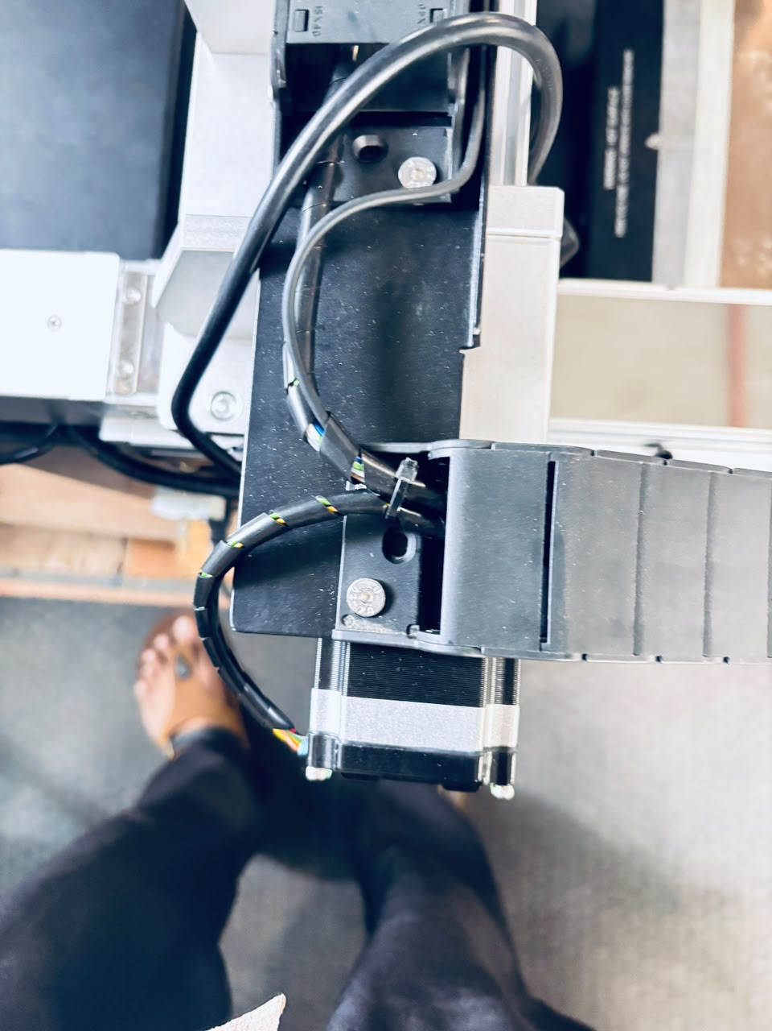 | 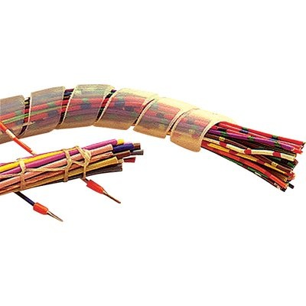

6. Circular Connectors
Matching LAPP Products: LAPP EPIC® M12
EPIC® circular connectors, such as M12 connectors, are suitable for robust data, signal, and power connections in industrial applications, offering vibration protection and easy assembly.
Application in Equipment: | LAPP Product:
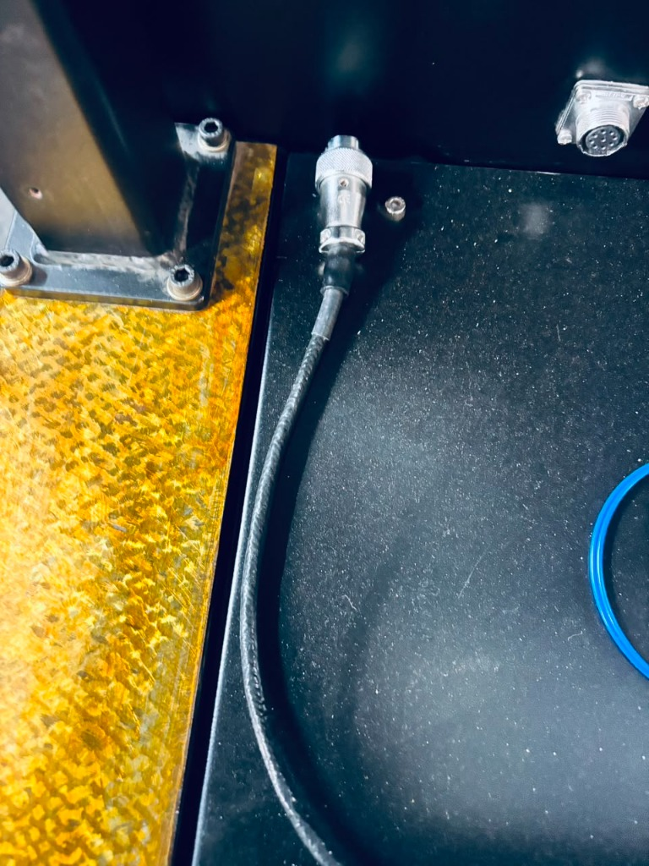 | 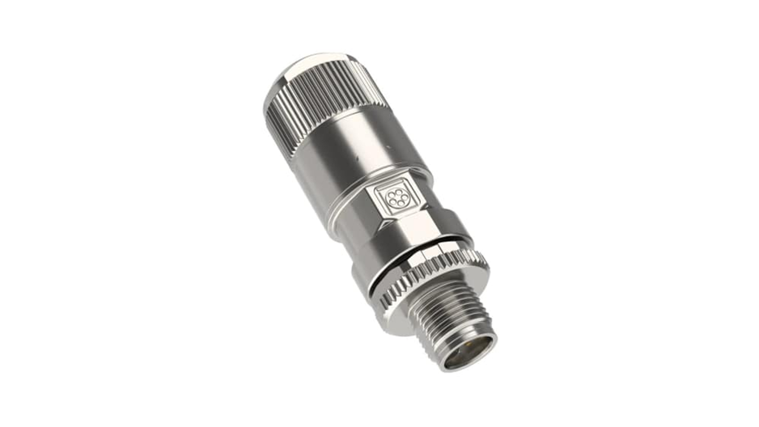

7. Laptop Connection and Data Cables
Matching LAPP Products: UNITRONIC® & ETHERLINE®
UNITRONIC® (Data & Communication Cables) and ETHERLINE® (Industrial Ethernet Cables) are used for reliable data transmission and network connectivity.
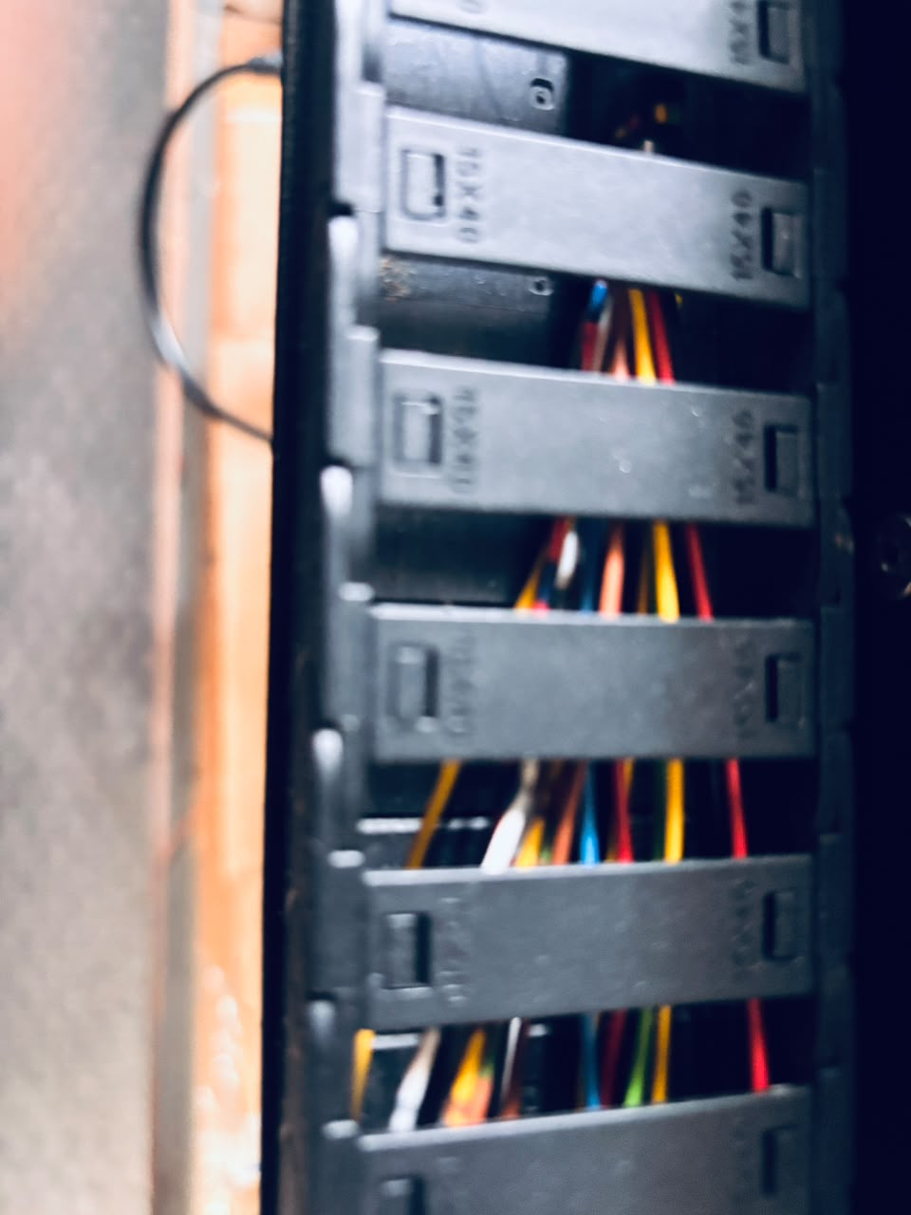 | LAPP Product:  