Lab 1: Push an Application

Description: During this lab we will push a simple Node.js application.

Note that commands are in *italics* and the X should be replaced with a unique number or participant’s initials.

1. Change to the parent directory. We will push a simple “Hello World” Node.js application called web.js (web.js).

During this first installation we will see how easy it is to push applications to Cloud Foundry. The command below pushes an application named web.js to Pivotal Web Services (PWS).

The first step is to open the manifest-web.yml file using your favorite editor and modify the application name to be unique.

---

applications:

- name: webjs-<user number or initials>

memory: 256M

Then the app can be pushed to your account in cloud foundry with the following command:

*cf push -f manifest-web.yml –i 2*

Open a web browser and visit <http://webjsX.cfapps.io>.

There is not much to see yet but you’ll notice that for the developer there was no environment to install. Node.js is a supported “buildpack” and was ready and available for deployment. We only had to push our app to enjoy the benefits.

1. Now log into “run.pivotal.io” and let’s check the health, running instances, route and other details for the application we’ve pushed. Access http://run.pivital.io with your credentials.

You’ll need to select the same space you’ve first targeted your environment to.

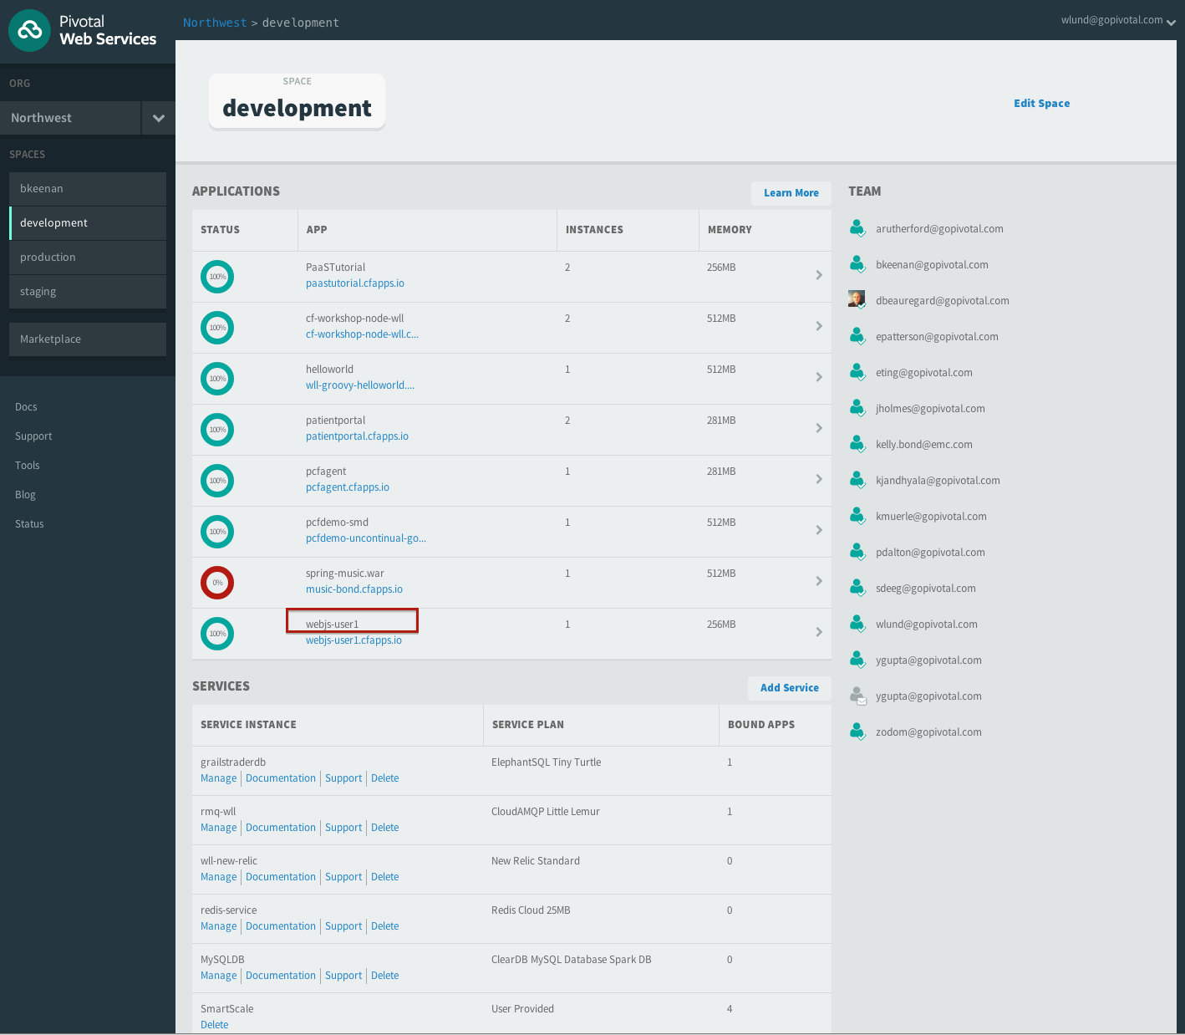

Now you can select your app as highlighted and see the details.

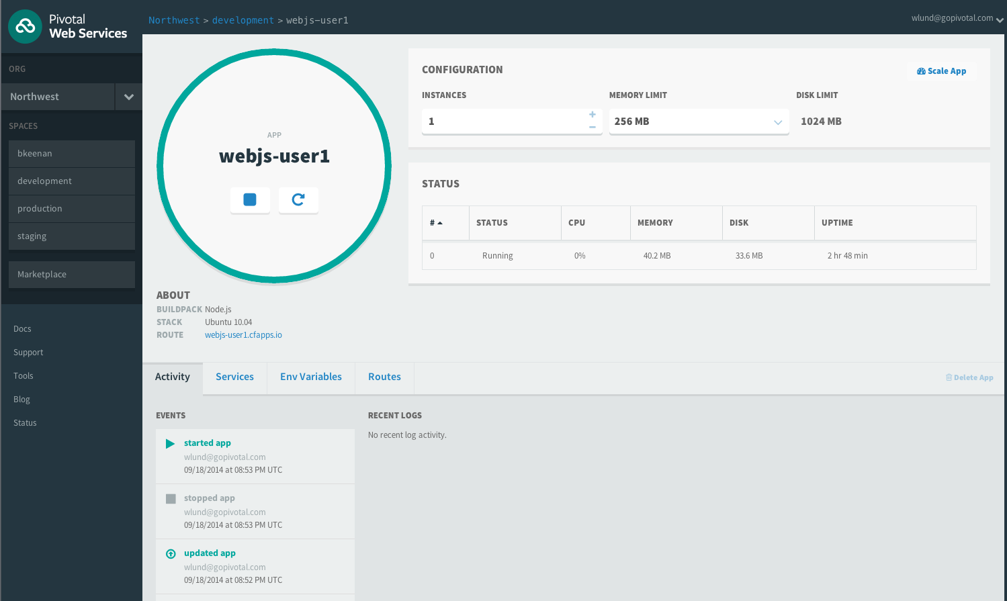

That completes how to push an application to cloudfoundry.