Lab 3a: Services

Description: This lab will familiarize you with provisioning Cloud Foundry services, binding the service to an application and auto-configuration of your application.

Note that commands are in *italics* and the X should be replaced with a unique number or participant’s initials.

1. Check the services available in the marketplace. These services are installed and maintained from the Operations Manager console. Services have associated plans that the developer selects during the creation process. You will need to log into your account at Pivotal Web Services (<https://run.pivotal.io>).

From the Web Console, click “Marketplace” and select “MongoLab”.

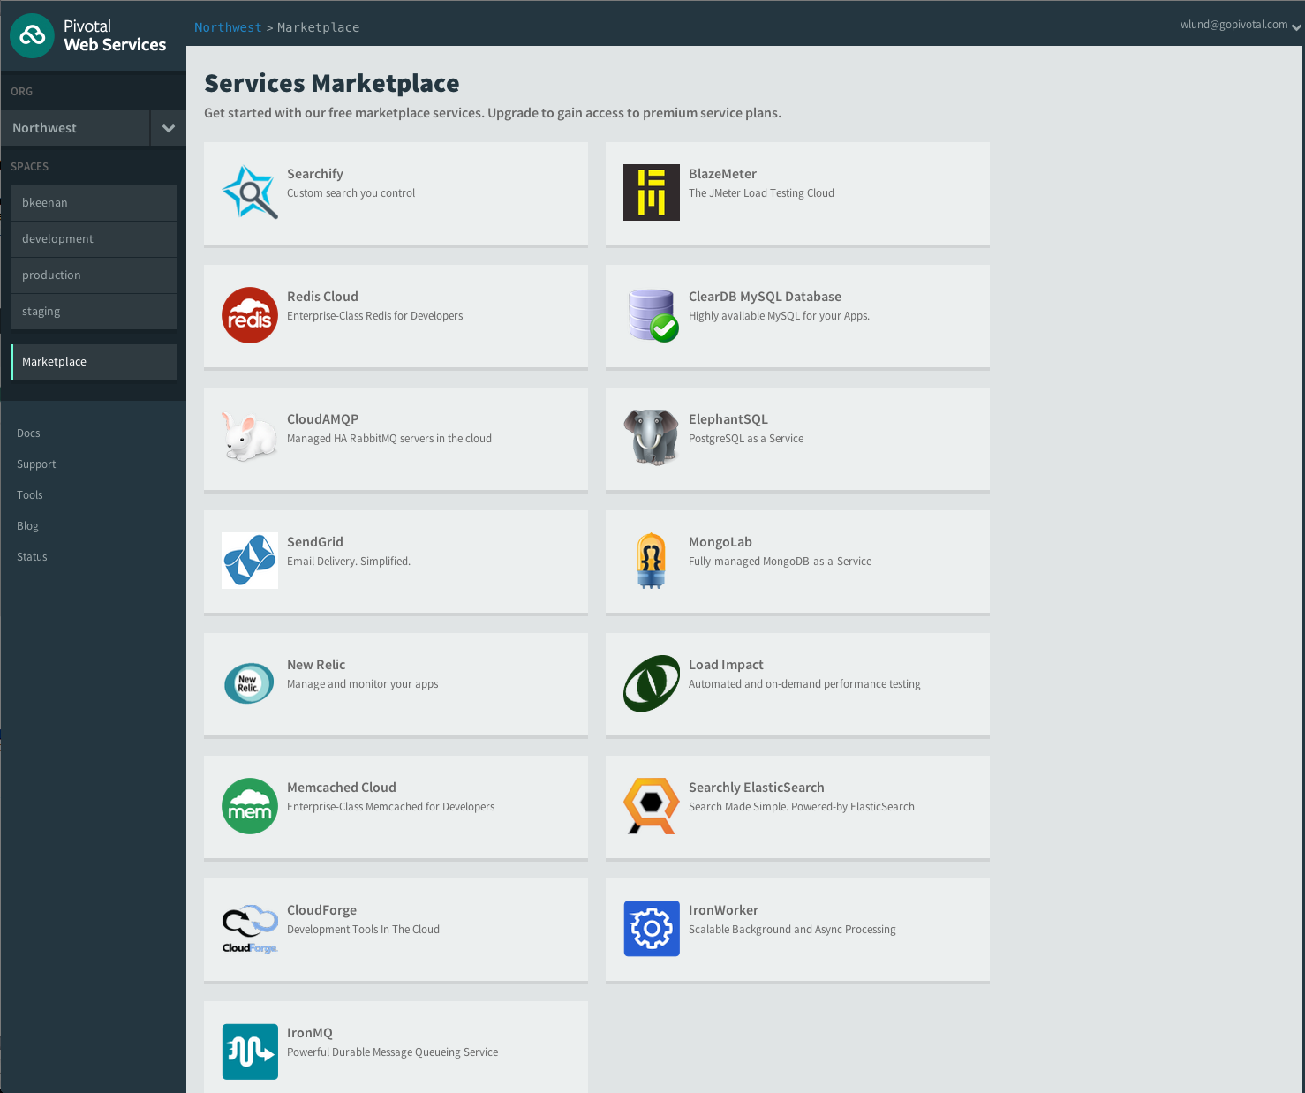

You can also use the command-line:

*cf marketplace*

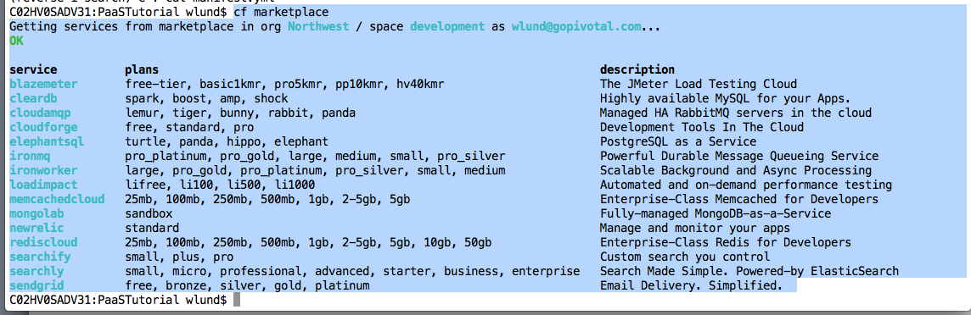

1. Create a service to bind to our previous application. Service creation requires a developer to select a plan and a name. Service designers have complete freedom to design a service and make it easy to consume.

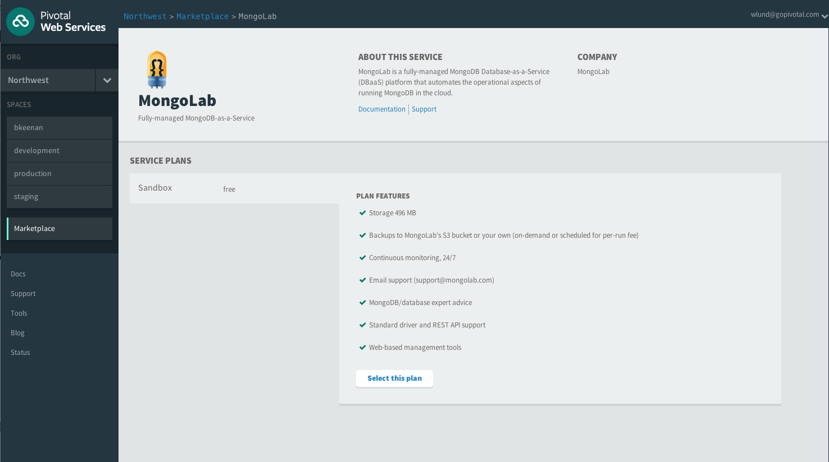

1. Select the “Free” plan and click “Create a Service”

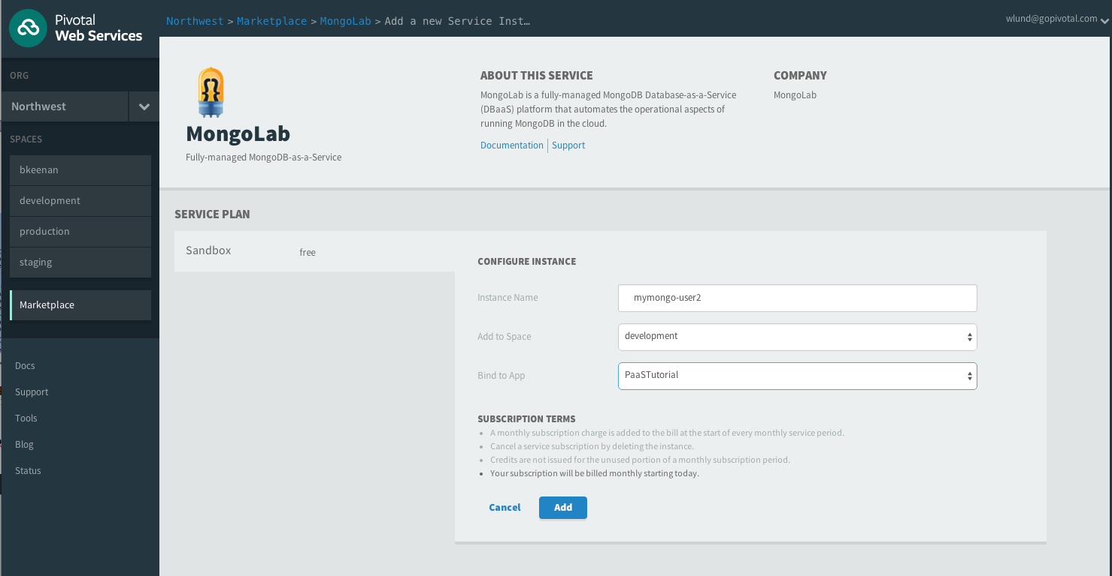

Give the service a unique name such as “mymongo-userX”, select the space you’re deploying your applications to and bind it to your app:

You can also use the command line to create the service

*cf create-service mongolab sandbox mymongo-userX*

and bind it to the app

*cf bind-service PaaSTutorial-<userX> mymongo_userX*

1. We now have the required service available to be able to deploy our sample app. On the application list page you will see your new service at the bottom of the page.

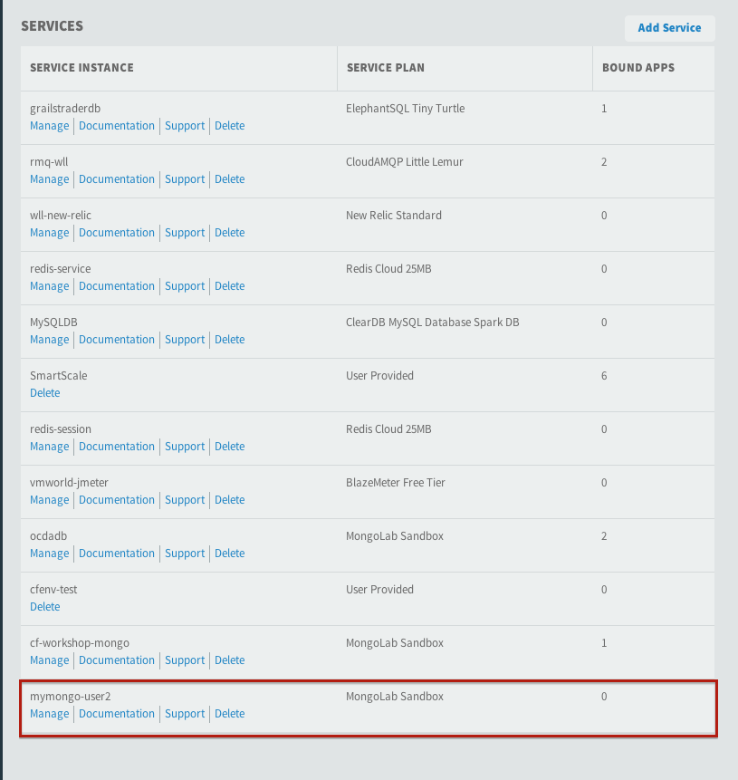

1. In the next lab we will tell our application what the service is via a manifest file and prepare to launch the application without having had to install mongo. Its simply available as a service.