Lab 4: Application High Availability and Scaling.

Description: This lab demonstrates an awesome feature of Pivotal CF called Application High Availability.

1. Application High Availability is a feature built into every application running on the Pivotal CF platform. Let start but accessing our application cf-workshop-node. If necessary you can setup by:

cd cf-workshop-node

cf push

Now open a Browser and Visit your application at <https://cf-workshop-node-userX.cfapps.io>.

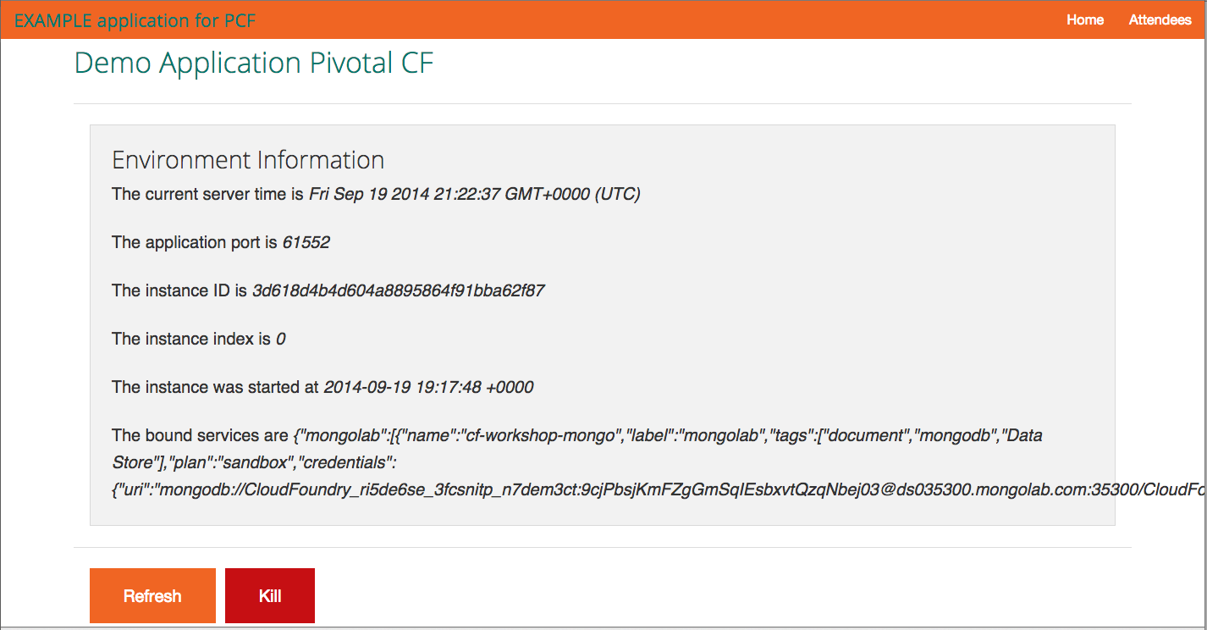

1. In the middle of the screen you’ll see the assigned IP address for the container serving your application. Click the “Kill App” button, refresh your browser and notice how the IP address changes. Pivotal CF re-routed the request to another instance, since the first one failed.

You observed absolutely no downtime.

1. Now get back to the Web Console and check the health of your application. One of the instances will be shown as “Down” or if you take too long, it will already be “Starting”

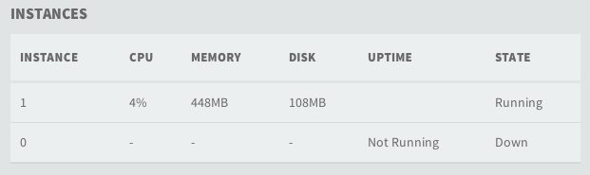

1. Refresh the Web Console and you’ll verify Pivotal CF automatically restarts the failed instance to you. Check the “Uptime” column and see it was just restarted.

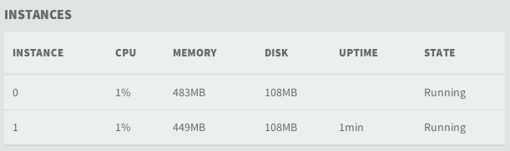

1. Now scale your application, adding other instances. Hit the “Kill App” button several times and see you may still kill several instances, Pivotal CF will still re-route the new requests to the available ones (if any) and keep restarting the failed ones. (Note: you will want to use the back browser button or remove the /kill on the url to get back to the page we were on.