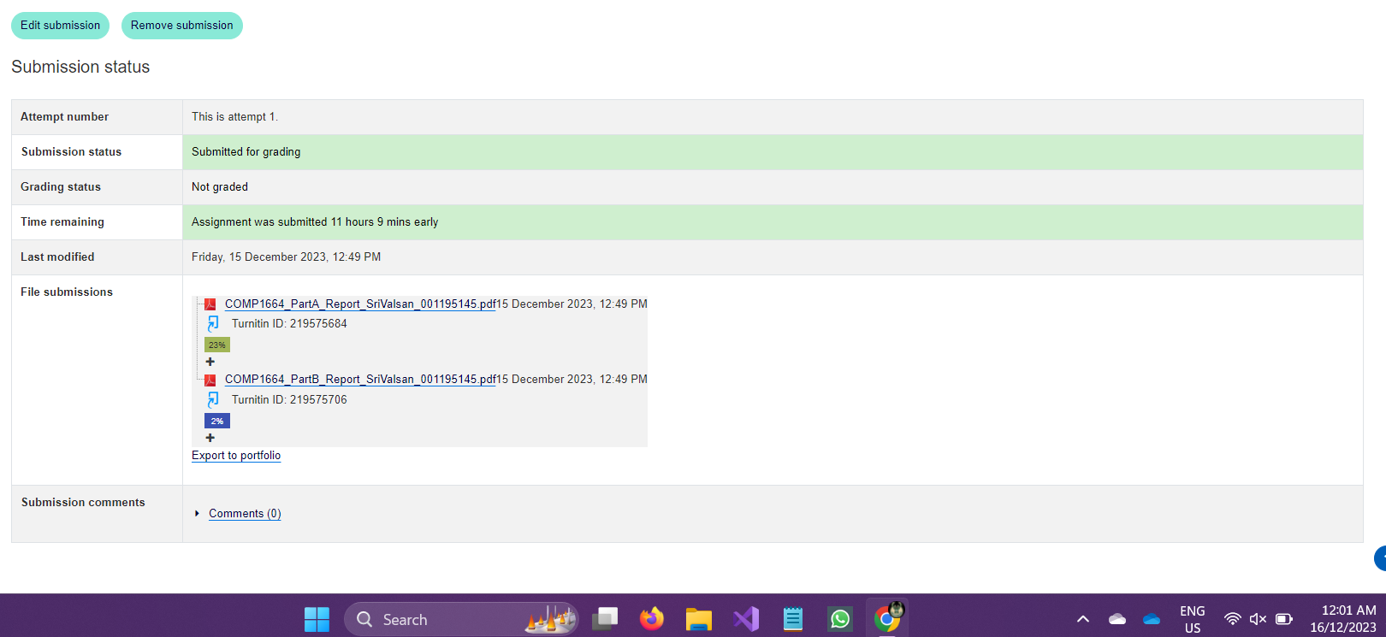

Min topology

MAX Topology

# Min _ low trafiic

# Min _ high Trafiic

# MAX Topology – Low Traffic

# MAX Topology – HIGH traffic

