

CAPSTONE PROJECT

(Loan Management System)
Enterprise-Grade Secure Full-Stack Web Application

INDEX

(flight app with angular)

S.
No.
Main Category Details Included

- All Files
1 Code Coverage Report
- Code Coverage Breakdown
- Test Run (UI) • UI Test Execution Results
- Home Page • Home Page UI & Functional Testing

Register Page (Create Account)
4
  - User Registration Flow• Account Creation Validation

- Login Page • User Login Functionality
- Search Flights Page • Flight Search UI
  - Search Functionality

- Login for Searching Flights

- Validation Errors
- Authentication Required for Flight Search
- Search Flights Validation Errors
- Login Validation Errors
- Email Validation Errors
- Registration Page Validation Errors

- Build Success • Successful Build Confirmation
- Clean Flight Search Page • No Pre-filled Data
  - UI Reset Validation
- Clean Login Page • Empty Fields Validation
- Password Mismatch Error • Incorrect Password Handling
- MongoDB Data • Database Records Verification
- MySQL Workbench • Relational Database Validation

- Password Eligibility Cases
- Length Check
- Strength Rules
- Format Validation

- User Already Exists Case • Duplicate User Registration Handling
- Postman Reports • API Testing Reports
  - Request–Response Validation

INDEX
Content |  | Page | No.
1. JACOCO Code Coverage Report | 1
2. SonarQube Report & Issues | 3
3. System Architecture, ER Diagram | 5
4. JMeter & RabbitMQ dashboard | 6
— JMeter Result Tree | 6
— JMeter Summary Report | 6
— Apache JMeter Dashboard | 7
5. Logs | 9
— RabbitMQ Dashboard | 9
— Eureka server, Booking Service | 10
— Flight Service, API Gateway, Notification service | 10
6. MongoDB Screenshots | 11
7. Postman Screenshots | 11
— Circuit Breaker, Message broker | 11
— — JWT security through API Gateway | 12
— — Status,Events | 12
— Health Checks | 13
— — API Gateway Health | 13
— — Booking Service Health | 13
— — Eureka Server Health | 14
— — Flight Service Health | 14
— Add Flight | 15
— Book Flight, get flight by PNR, get flight by ID | 15
— Cancel Booking, FALLBACK CASE | 15
— Get Booking by PNR | 16
— Get Booking History | 16
8. Email | 17
— With PDF | 17
— Without PDF | 17
— Fallback Case | 17
9. Eureka Dashboard, MySQL Workbench | 17

Purpose of the document
This document serves as the authoritative technical and architectural reference for the Loan Management System (LMS).
Its primary objectives are to:
  - Explain the business rationale and system vision
  - Provide a high-level system overview for stakeholders
  - Describe the architectural style, core components, and design decisions
  - Detail the microservice responsibilities, APIs, and data ownership
  - Define security, error handling, validation, and non-functional requirements
  - Present a robust testing and quality assurance strategy

System Overview

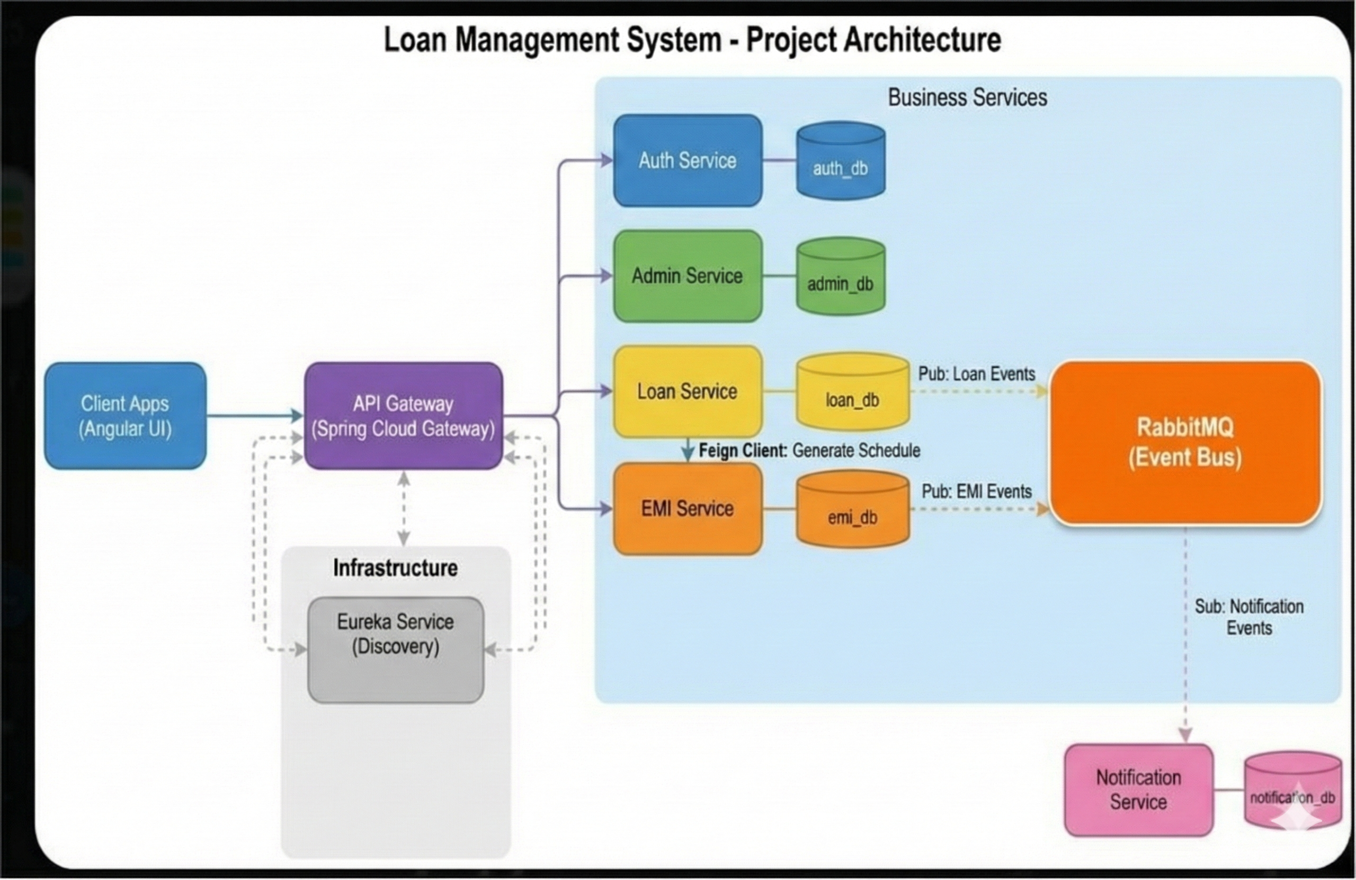

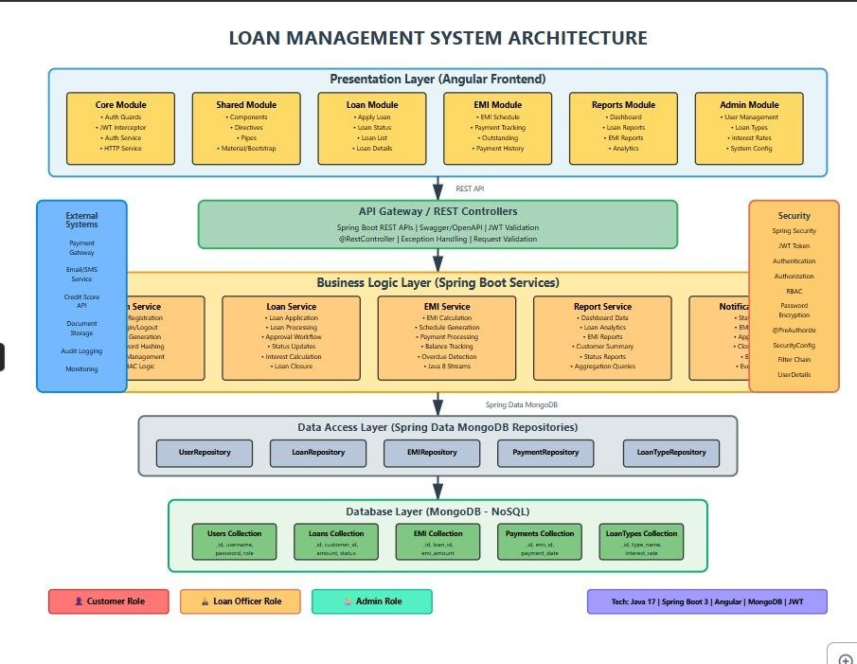

  - Business Objective
The Loan Management System is designed to digitize and automate the end- to-end loan lifecycle for banks, NBFCs, and financial institutions.
The system replaces manual and semi-automated workflows with a secure, scalable, and audit-ready platform.
Key business goals include:
    - Faster loan application processing
    - Transparent approval workflows
    - Accurate EMI computation and repayment tracking
    - Secure handling of sensitive financial data
    - Real-time dashboards and operational reports
    - Cloud-ready, API-first architecture
  - High-Level Features
    - Multi-role system: Admin, Loan Officer, Customer
    - Online loan application and tracking

    - Configurable loan types, interest rates, and tenures
    - Automated EMI schedule generation
    - Repayment tracking and loan closure
    - Secure authentication using JWT
    - Role-based authorization (RBAC)
    - Reporting and dashboard analytics
    - Production-ready REST APIs

Architecture Style
  - Architectural Pattern
The system follows a Microservices-Oriented Architecture combined with Layered Design Principles.
Key characteristics:
    - Loose coupling between services
    - Independent data ownership
    - REST-based inter-service communication
    - Stateless backend services
    - Frontend-backend separation (SPA + APIs)
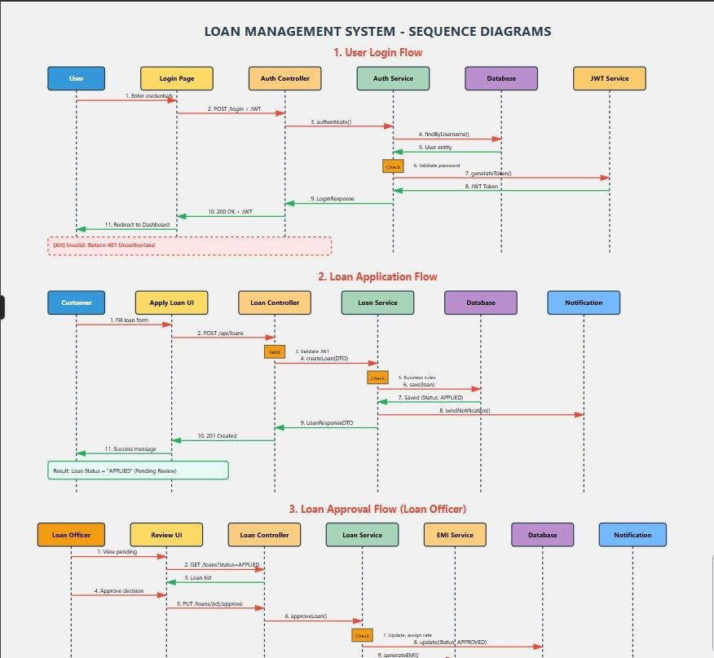

Core System Components

Frontend Layer
    - Single Page Application (SPA)
    - Handles UI rendering, form validation, and role-based navigation
    - Communicates with backend via secured REST APIs

Backend Layer
- Stateless REST services
- Implements business logic, validation, security, and workflows
- Exposes versioned APIs

Persistence Layer
- Independent databases per service
- Ensures data isolation and scalability

Security Layer
    - · JWT authentication
    - · Role-based authorization
    - · Encrypted password storage
    - · Secure API endpoints

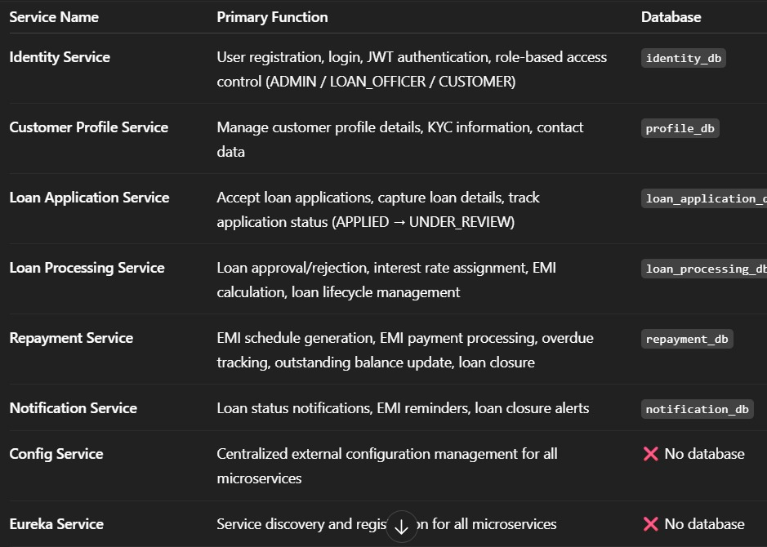

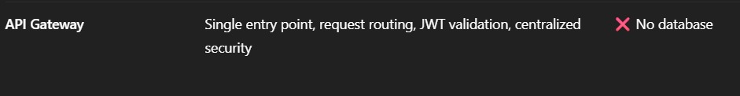

Technology Stack

Backend
    - Java 17+
    - Spring Boot 3.x
    - Spring Web (REST APIs)
    - Spring Data JPA
    - Hibernate ORM
    - Spring Security with JWT
    - Swagger / OpenAPI
    - Maven

Frontend
    - Angular (latest)
    - TypeScript
    - Angular Material / Bootstrap
    - Reactive Forms
    - HTTP Interceptors
    - Route Guards

Database
    - PostgreSQL / MySQL
    - Separate schema per microservice

DevOps & Tools
- Git & GitHub
- Postman
- Environment-based configuration (dev/test/prod)

Testing
- JUnit 5
- Mockito
- Postman collections

Microservice Design

6.1 User Service
Responsibilities
- User registration and authentication
- Role and permission management
- JWT generation and validation
- Password hashing and security policies

Global API Conventions
Base URL: /api
Authentication: JWT Bearer Token
Header: Authorization: Bearer <token>
All APIs follow REST principles and return JSON responses.

6.1 Auth Service (Identity & Access Management)

Description
The User Service acts as the central authority for identity and access management. It handles user onboarding, authentication, and authorization across the system using secure authentication mechanisms and role-based access control (RBAC).

Responsibilities
User Registration: Validates and stores new user accounts.
Authentication: Authenticates users and issues JWT tokens.
Authorization: Manages roles such as ROLE_ADMIN, ROLE_CUSTOMER, and ROLE_LOAN_OFFICER.
Security: Enforces password hashing (BCrypt) and access control policies.

API Specification
Method | Endpoint | Description
POST | /auth/register | Registers a new user
POST | /auth/login | Authenticates user and returns JWT
GET | /users | Retrieves all users (Admin only)
GET | /users/{id} | Retrieves user profile by ID
PUT | /users/{id} | Updates user profile details
DELETE | /users/{id} | Soft deletes or deactivates a user

Database Schema

User Table
Column | Type
id (PK) | UUID
username | String
email | String
password_hash | String
first_name | String
last_name | String
created_at | Timestamp

Role Table
Column | Type
id (PK) | UUID
role_name | String (ADMIN, CUSTOMER, LOAN_OFFICER)

User_Role Table
Column | Type
user_id (FK) | UUID
role_id (FK) | UUID

6.2 Loan Service

Description
The Product Service manages loan offerings and the lifecycle of loan applications, from submission to approval or rejection.

Responsibilities
Product Management: Define loan products (Personal, Home, Education).
Application Processing: Accept and validate loan applications.
Lifecycle Management: Track application states.
Rule Enforcement: Validate tenure and loan amount based on product rules.

API Specification
Method | Endpoint | Description
POST | /loans/apply | Submit a new loan application
GET | /loans/{id} | Retrieve loan details
GET | /loans/customer/{customerId} | Retrieve all loans for a customer
PUT | /loans/{id}/approve | Approve loan (Admin/Officer)
PUT | /loans/{id}/reject | Reject loan with reason

Database Schema

Loan_Type Table
Column | Type
id (PK) | UUID
type_name | String
max_amount | Decimal
interest_rate | Decimal

Loan Table
Column | Type
id (PK) | UUID
customer_id | UUID
loan_type_id (FK) | UUID
principal_amount | Decimal
tenure_months | Integer
status | ENUM (APPLIED, APPROVED, REJECTED)
application_date | Date

Loan_Status_History Table
Column | Type
id (PK) | UUID
loan_id (FK) | UUID
old_status | String
new_status | String
updated_at | Timestamp
remarks | String

6.3 (EMI Service)

Description
The Order Service manages EMI calculations, repayment schedules, and loan closure processes after approval.

Responsibilities
EMI Calculation: Computes monthly installment values.
Schedule Generation: Generates repayment schedules.
Repayment Tracking: Records EMI payments and updates balances.
Loan Closure: Marks loans as closed upon full repayment.

API Specification
Method | Endpoint | Description
GET | /emis/loan/{loanId} | Retrieve EMI schedule for a loan
POST | /emis/pay | Process EMI payment
GET | /repayments/customer/{customerId} | Get repayment history

Database Schema

Loan_Balance Table
Column | Type
id (PK) | UUID
loan_id | UUID
total_amount_to_pay | Decimal
amount_paid | Decimal
remaining_balance | Decimal

EMI_Schedule Table
Column | Type
id (PK) | UUID
loan_id | UUID
installment_amount | Decimal
due_date | Date
status | ENUM (PENDING, PAID)
payment_date | Date

Repayment_Transaction Table
Column | Type
id (PK) | UUID
emi_id (FK) | UUID
amount | Decimal
transaction_reference | String
transaction_date | Date

6. Notification Service APIs
Base Path: /api/notifications
GET /my – View notifications (CUSTOMER)
POST /send – Send notification (Internal only)

7.Config Service
Centralized configuration service.
No business APIs exposed.

8. Eureka Service
Service discovery and registration.
No business APIs exposed.

9. API Gateway
Single entry point for all requests.
Routes /api/** calls.
Validates JWT & enforces RBAC.
End-to-End API Flow
POST /api/auth/login
POST /api/loan-applications/apply
PUT /api/loan-applications/{id}/review
POST /api/loans/{id}/approve
GET /api/repayments/loan/{loanId}
POST /api/repayments/emi/{emiId}/pay

6.2 Product Service (Loan Service)
Responsibilities
- Loan type management
- Interest rate and tenure rules
- Loan application submission
- Loan status lifecycle management

Database
- Loan table
- Loan type table
- Loan status history table

6.3 Order Service (EMI & Repayment Service)

Responsibilities
- EMI calculation
- EMI schedule generation
- Repayment tracking
- Outstanding balance computation
- Automatic loan closure

Database
- · EMI schedule table
- · Repayment table
- · Loan balance table

Data Design (Low-Level Design)

7.1 User Document
- userId
- name
- email
- password (hashed)
- role
- status
- createdAt

7.2 Product (Loan) Document
- · loanId
- · customerId
- · loanType
- · principalAmount
- · interestRate
- · tenure
- · status
- · approvalRemarks
7.3 Order (EMI) Document
- · emiId
- · loanId
- · dueDate
- · emiAmount
- · paidAmount
- · outstandingBalance
- · paymentStatus

API Design & Validation
- RESTful conventions followed
- DTOs used for request/response
- Input validation using @Valid
- Custom validators for:
- Loan amount limits
- Tenure constraints
- · EMI payment rules

Error Handling Strategy

Global Exception Handling
    - Centralized exception management using @ControllerAdvice
    - Custom exceptions:
    - ResourceNotFoundException
    - ValidationException
    - UnauthorizedAccessException
    - Standardized error response format:
    - timestamp
    - status
    - errorCode
    - message
    - Pat

Security Design
- JWT-based authentication
- Stateless session management
- Role-based access control
- Password hashing using BCrypt
- Secured endpoints with method-level authorization
- HTTP interceptors for token propagation

Non-Functional Requirements
- Scalability: Horizontally scalable services
- Security: Encrypted credentials and secure APIs
- Performance: Optimized queries and pagination
- Maintainability: Clean layered architecture
- Availability: Fault-tolerant stateless services
- Auditability: Complete loan lifecycle traceability

Testing Strategy

12.1 Unit Testing
- Service-layer tests using JUnit and Mockito
- Mocked repositories and external dependencies

12.2 API Testing
- Postman collections for all endpoints
- Authentication and authorization test cases

12.3 Validation & Security Testing
- Input validation tests
- Unauthorized access tests
- Token expiry handling

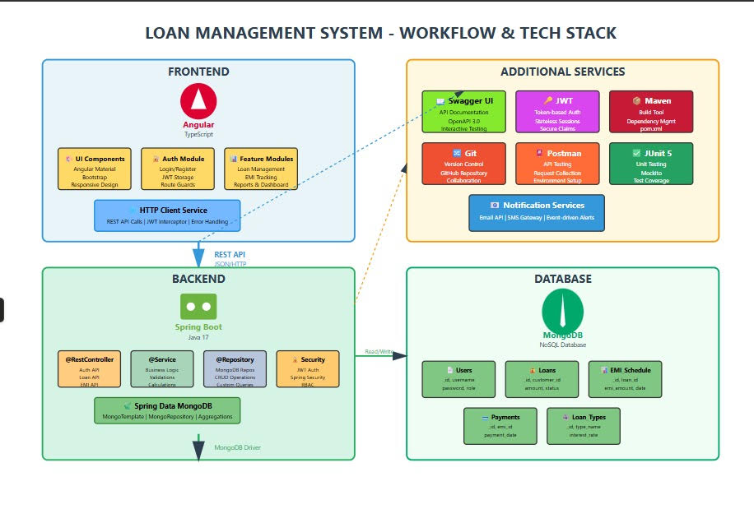

Business Rules
Loan Application Rules:
1. Customer Eligibility
A customer must be registered and verified before applying for a loan.
A customer can have multiple loans, but:
Only one active loan of the same type is allowed at a time (for example, only one personal loan).
2. Loan Amount Rules
The loan amount must be within the allowed minimum and maximum limits set by the system.
Users cannot request an amount outside this range.
3. Loan Tenure Rules
The loan duration (tenure) must be selected from predefined options (for example: 12, 24, or 36 months).
Custom or random tenures are not allowed.
4. Loan Application Modification
Once a loan application is submitted, it cannot be edited.
If changes are needed, the user must submit a new application.
Loan Approval Rules
1. Who Can Approve Loans
Only users with the Loan Officer role can approve or reject loan applications.
Customers cannot approve their own loans.
2. Criteria for Approval
A loan is approved based on:
Customer’s credit score
Income eligibility
Existing financial liabilities
3. Rejection Rules
If a loan is rejected, the system must store a reason (e.g., low credit score, insufficient income).
4. Actions After Approval
Once a loan is approved:
An EMI (monthly installment) schedule is automatically created.
The customer receives a notification about approval and EMI details.

Conclusion
The Loan Management System demonstrates enterprise-level system design, secure full-stack development, and real-world financial workflows.
It is production-ready, cloud-deployable, and built using industry best practices, making it a strong representation of modern backend and frontend engineering capabilities.

