

CAPSTONE PROJECT

(Loan Management System)
Enterprise-Grade Secure Full-Stack Web Application

INDEX

(flight app with angular)

S.
No.
Main Category Details Included

- All Files
1 Code Coverage Report
- Code Coverage Breakdown
- Test Run (UI) • UI Test Execution Results
- Home Page • Home Page UI & Functional Testing

Register Page (Create Account)
4
  - User Registration Flow• Account Creation Validation

- Login Page • User Login Functionality
- Search Flights Page • Flight Search UI
  - Search Functionality

- Login for Searching Flights

- Validation Errors
- Authentication Required for Flight Search
- Search Flights Validation Errors
- Login Validation Errors
- Email Validation Errors
- Registration Page Validation Errors

- Build Success • Successful Build Confirmation
- Clean Flight Search Page • No Pre-filled Data
  - UI Reset Validation
- Clean Login Page • Empty Fields Validation
- Password Mismatch Error • Incorrect Password Handling
- MongoDB Data • Database Records Verification
- MySQL Workbench • Relational Database Validation

- Password Eligibility Cases
- Length Check
- Strength Rules
- Format Validation

- User Already Exists Case • Duplicate User Registration Handling
- Postman Reports • API Testing Reports
  - Request–Response Validation

INDEX
Content |  | Page | No.
1. JACOCO Code Coverage Report | 1
2. SonarQube Report & Issues | 3
3. System Architecture, ER Diagram | 5
4. JMeter & RabbitMQ dashboard | 6
— JMeter Result Tree | 6
— JMeter Summary Report | 6
— Apache JMeter Dashboard | 7
5. Logs | 9
— RabbitMQ Dashboard | 9
— Eureka server, Booking Service | 10
— Flight Service, API Gateway, Notification service | 10
6. MongoDB Screenshots | 11
7. Postman Screenshots | 11
— Circuit Breaker, Message broker | 11
— — JWT security through API Gateway | 12
— — Status,Events | 12
— Health Checks | 13
— — API Gateway Health | 13
— — Booking Service Health | 13
— — Eureka Server Health | 14
— — Flight Service Health | 14
— Add Flight | 15
— Book Flight, get flight by PNR, get flight by ID | 15
— Cancel Booking, FALLBACK CASE | 15
— Get Booking by PNR | 16
— Get Booking History | 16
8. Email | 17
— With PDF | 17
— Without PDF | 17
— Fallback Case | 17
9. Eureka Dashboard, MySQL Workbench | 17

Purpose of the document
This document serves as the authoritative technical and architectural reference for the Loan Management System (LMS).
Its primary objectives are to:
  - Explain the business rationale and system vision
  - Provide a high-level system overview for stakeholders
  - Describe the architectural style, core components, and design decisions
  - Detail the microservice responsibilities, APIs, and data ownership
  - Define security, error handling, validation, and non-functional requirements
  - Present a robust testing and quality assurance strategy

System Overview

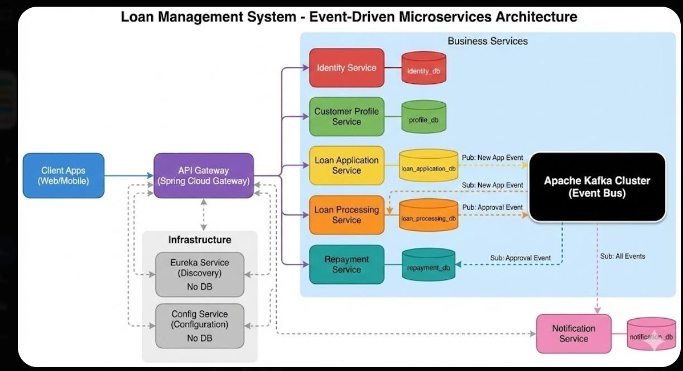

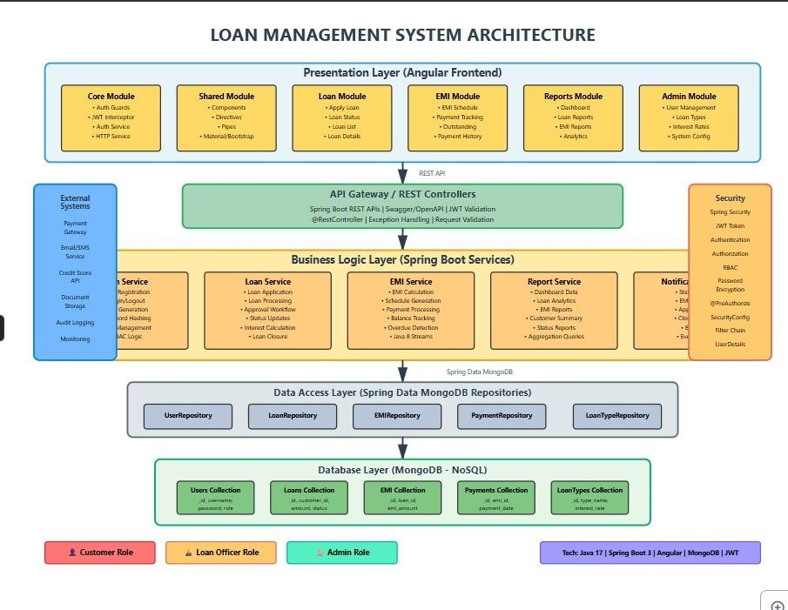

  - Business Objective
The Loan Management System is designed to digitize and automate the end- to-end loan lifecycle for banks, NBFCs, and financial institutions.
The system replaces manual and semi-automated workflows with a secure, scalable, and audit-ready platform.
Key business goals include:
    - Faster loan application processing
    - Transparent approval workflows
    - Accurate EMI computation and repayment tracking
    - Secure handling of sensitive financial data
    - Real-time dashboards and operational reports
    - Cloud-ready, API-first architecture
  - High-Level Features
    - Multi-role system: Admin, Loan Officer, Customer
    - Online loan application and tracking

    - Configurable loan types, interest rates, and tenures
    - Automated EMI schedule generation
    - Repayment tracking and loan closure
    - Secure authentication using JWT
    - Role-based authorization (RBAC)
    - Reporting and dashboard analytics
    - Production-ready REST APIs

Architecture Style
  - Architectural Pattern
The system follows a Microservices-Oriented Architecture combined with Layered Design Principles.
Key characteristics:
    - Loose coupling between services
    - Independent data ownership
    - REST-based inter-service communication
    - Stateless backend services
    - Frontend-backend separation (SPA + APIs)
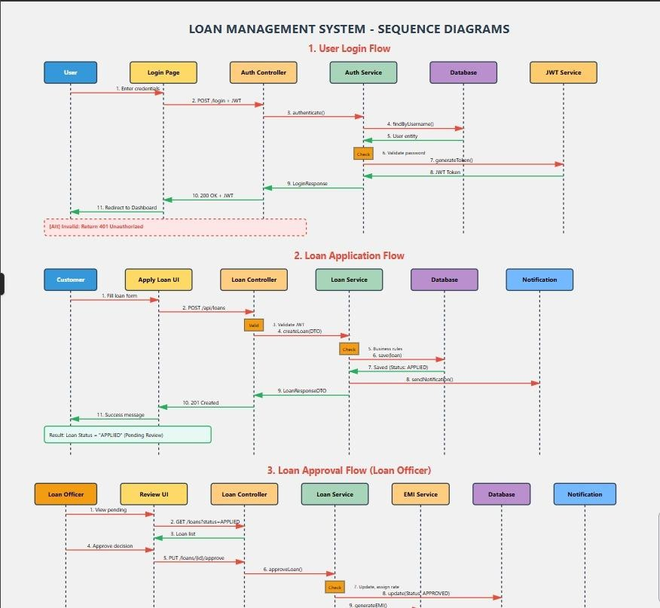

Core System Components

Frontend Layer
    - Single Page Application (SPA)
    - Handles UI rendering, form validation, and role-based navigation
    - Communicates with backend via secured REST APIs

Backend Layer
- Stateless REST services
- Implements business logic, validation, security, and workflows
- Exposes versioned APIs

Persistence Layer
- Independent databases per service
- Ensures data isolation and scalability

Security Layer
    - · JWT authentication
    - · Role-based authorization
    - · Encrypted password storage
    - · Secure API endpoints

Technology Stack

Backend
    - Java 17+
    - Spring Boot 3.x
    - Spring Web (REST APIs)
    - Spring Data JPA
    - Hibernate ORM
    - Spring Security with JWT
    - Swagger / OpenAPI
    - Maven

Frontend
    - Angular (latest)
    - TypeScript
    - Angular Material / Bootstrap
    - Reactive Forms
    - HTTP Interceptors
    - Route Guards

Database
    - PostgreSQL / MySQL
    - Separate schema per microservice

DevOps & Tools
- Git & GitHub
- Postman
- Environment-based configuration (dev/test/prod)

Testing
- JUnit 5
- Mockito
- Postman collections

Microservice Design

6.1 User Service
Responsibilities
- User registration and authentication
- Role and permission management
- JWT generation and validation
- Password hashing and security policies

APIs
- POST /auth/register
- POST /auth/login
- GET /users
- GET /users/{id}
- PUT /users/{id}
- DELETE /users/{id}

Database
- User table
- Role table
- User-Role mapping table

6.2 Product Service (Loan Service)
Responsibilities
- Loan type management
- Interest rate and tenure rules
- Loan application submission
- Loan status lifecycle management
APIs
- POST /loans/apply
- GET /loans/{id}
- GET /loans/customer/{customerId}
- PUT /loans/{id}/approve
- PUT /loans/{id}/reject

Database
- Loan table
- Loan type table
- Loan status history table

6.3 Order Service (EMI & Repayment Service)

Responsibilities
- EMI calculation
- EMI schedule generation
- Repayment tracking
- Outstanding balance computation
- Automatic loan closure

APIs
- · GET /emis/loan/{loanId}
- · POST /emis/pay
- · GET /repayments/customer/{customerId}

Database
- · EMI schedule table
- · Repayment table
- · Loan balance table

Data Design (Low-Level Design)

7.1 User Document
- userId
- name
- email
- password (hashed)
- role
- status
- createdAt

7.2 Product (Loan) Document
- · loanId
- · customerId
- · loanType
- · principalAmount
- · interestRate

- · tenure
- · status
- · approvalRemarks
7.3 Order (EMI) Document
- · emiId
- · loanId
- · dueDate
- · emiAmount
- · paidAmount
- · outstandingBalance
- · paymentStatus

API Design & Validation
- RESTful conventions followed
- DTOs used for request/response
- Input validation using @Valid
- Custom validators for:
- Loan amount limits
- Tenure constraints
- · EMI payment rules

Error Handling Strategy

Global Exception Handling
    - Centralized exception management using @ControllerAdvice
    - Custom exceptions:
    - ResourceNotFoundException
    - ValidationException
    - UnauthorizedAccessException
    - Standardized error response format:
    - timestamp
    - status
    - errorCode
    - message
    - Pat

Security Design
- JWT-based authentication
- Stateless session management
- Role-based access control
- Password hashing using BCrypt
- Secured endpoints with method-level authorization
- HTTP interceptors for token propagation

Non-Functional Requirements
- Scalability: Horizontally scalable services
- Security: Encrypted credentials and secure APIs
- Performance: Optimized queries and pagination
- Maintainability: Clean layered architecture
- Availability: Fault-tolerant stateless services
- Auditability: Complete loan lifecycle traceability

Testing Strategy

12.1 Unit Testing
- Service-layer tests using JUnit and Mockito
- Mocked repositories and external dependencies

12.2 API Testing
- Postman collections for all endpoints
- Authentication and authorization test cases

12.3 Validation & Security Testing
- Input validation tests

- Unauthorized access tests
- Token expiry handling

Conclusion
The Loan Management System demonstrates enterprise-level system design, secure full-stack development, and real-world financial workflows.
It is production-ready, cloud-deployable, and built using industry best practices, making it a strong representation of modern backend and frontend engineering capabilities.

