I really like the layout of this websites:

<http://www.principlesolutions.com/>

<http://www.dppit.com/>

<https://www.kforce.com/>

**MAIN GOAL OVERALL** is to get people to give us their home email and contact info. Home email addresses are the single most important thing that we need to obtain. I want to increase the amount of signups we get when people visit our site. Secondary goal is to have people follow us on Linkedin, Facebook. Third objective is to get hiring managers to contact us to learn more

**How will success be measured:**

*# of leads per job applications

*# of downloads or forms completed

*Visits to site

*Bounce rate/time on site

*+Rank on search engines

**Mobility goals:**

Faster page loads

Minimal content

Easy access features

Ability to respond

Need to be able to easily update the site. Do you have an instruction manual or something to include?

Need to keep people engaged. Goal is to increase the amount of time that a person spends on our page

Repeat traffic

I’d like the homepage to have a “video library” section to summarize things. Instead of having to write out a ton of text, I’d like to create videos that illustrate what I want to say. So I’d have videos titled “Why work with us”, “What differentiates us”, “what markets do we serve”, “How do I plan out the next steps in my career”, Frequently asked questions”, “Common objections for clients”……etc I’d like to have less text based and more video

Would like to have a “notify all” feature or something that would notify people when we add a blog, when we post a new job, new article, video…etc

ABSOLUTELY NEEDS TO be mobile friendly. Google ranks sites higher that are mobile friendly. People need to be able to apply to jobs via their mobile device

Website needs to be a “responsive” website

Content marketing. Three C’s….creat, capture, convert

Check out this site: Would the video be hard to put together that would be geared for potential clients: <http://sales-executives.com/> they said this product is good to create these videos? <http://www.softwarecasa.com/camtasia-studio.html?gclid=CjwKEAjw-vewBRDH1-b52Lig1hkSJACTPfVF7GQ_LcV0gaG3iNy4tHxowZg1tmPjrmWUQCqY58E-BBoChGbw_wcB>

“Plan your next promotion” needs to be on our homepage! This is geared towards candidates and it something we will use to differentialte. <http://vortexstaffing.com/career-agent>

Id like to have a small block of windows in which I can post videos. Maybe 4 vidoes that we would create that talk about what differentiates us, why companies should want to work with us…etc

I would like our website to be integrated with Hootsuite. That will be the social media platform that we will use to integrate all of the social media accounts we have. This is super imporatant

Need to see an increase in candidate applications to positions we have posted

We will definitely need a consultant login section on our site like this:: <https://www.kforce.com/ConsultantLogin.aspx> we are going to be doing a lot of contract staffing in 2016

Need to have as many analystics tied into the site as possible

Is there a way to set up the site to easily integrate with staffing software programs like:

**Yes! We can integrate with your staffing software.**

We have extensive experience integrate staffing websites with all the major industry ATS and staffing software systems, including:

* ABD (UltraStaff)
* Adapt
* AST
* Avionte
* Big Biller
* Bullhorn
* COATS
* eEmpACT
* Job Diva
* Maxhire
* Sendouts
* SkillMatch
* StaffSuite
* TempWorks
* TKO
* WinSearch

- See more at: <http://www.haleymarketing.com/services/web-development/#sthash.NhOxarDp.dpuf>

This is an essential checklist for staffing websites that I came across. This seems to give us a really good roadmap. Can you try to address as many of these as possible in the design?

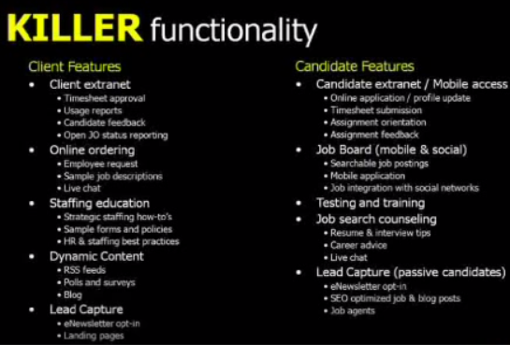­­

Can we integrate a live chat feature that would sync with yahoo messenger that would alert one of us if someone sends a chat inquiry? Like a follow me function to where it would ping anyone who is logged on to their yahoo IM? Also, when somene logs on to their Yahoo IM it would update on our site to say “online” for live chat?

Need to have a job board section that is our domain. I don’t want to switch to a 3rd party. Also need to be able to do customized searches “Enterprise Storage in Chicago”…etc

I saw this on this recruiting firms website and I wonder how that is beneficial.  What does us including the option to apply via Indeed.com, simplyhired.com, <http://www.jobspider.com/>, jobvertise.com, jognugget.com….etc

make things easier for people.  Apply to one of the positions on this site and see.

<https://premiereonboard.catsone.com/careers/index.php?m=portal&a=listings&portalID=5450>

Would like to have a testimonial section. Both for candidates and clients. For testimonies I would only like to use a persons first name, or initials or something. It would also list where they are located. In addition, and this is VERY IMPORTANT, I would like to have a “Verify this testimony” feature that someone can click on. At that point I would be notified and then I would reach out to the person that gave the testimony and ask them if they would be ok with speaking with someone to verify that their review was legit.

I would like to have the website integrated with desktop and mobile. Meaning, when we update information on our website I would like the mobile version to be updated as well. Can you integrate both experiences to do that? Otherwise we will have to update 2 different parts each time.

I’d like to use some unique nontraditional images on the site. I don’t want the whole site to have images of people crossing their arms and looking at you. That is boring. I want to have images of diamonds in the rough, bullseye, and things like that. A good example of this is below

<http://www.instaff.com/#screen4>

Should we design anything to work with apple watch? A lot of people will use that

Infographics

Large format dropdown for links. Like this (Industries): <http://www.principlesolutions.com/>

Is there a way (plug in) to integrate salesforce.com with our job board>?

I’d like all of our jobs to be posted on our domain to help with SEO

I also would like to allow people to apply to jobs by using their linkedin profile. This is a quick way for people to apply to jobs if they don’t have an updated resume. Can we offer a “quick apply” feature via Linkedin?

I would like our company linkedin page to be tethered to our blog/recent activity section. So when we post a new job or interviewing tips on our LI company page, it would also update on our website

Dynamic content for jobs, blogs, testimonials…..etc

Our referrals section is a major piece. I would like to have all of our jobs posted as well as the referral merchandise that we are offering if someone refers someone. Similar to what we have now but something that looks more professional. My idea is to have this feature similar to what a CDW extranet account does. It’s a way to earn revenue from inbound business. I want people going to our site all the time, even if they are looking for a new job, and checking the positions we have posted as well as the merchandise we offer.

Metadata