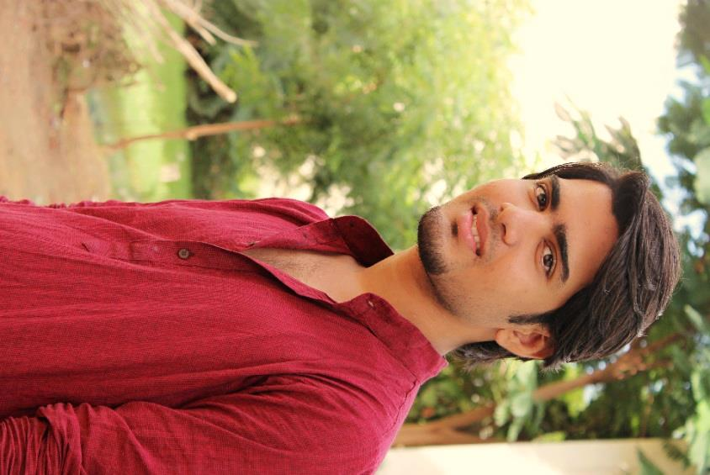**Yogesh T S**

Ph : 7373535614

Mail : [tsyogesh40@gmail.com](mailto:tsyogesh40@gmail.com)

**PHYSICAL DESCRIPTION**

Height : 5’9’’

Weight : 68

Color : Fair

Hair color : Black

Eye : Brownish Black

|  |  |  |
| --- | --- | --- |
| **OBJECTIVE** | | Aiming at a constant upgradation of both professionally as well as personally with highest emphasis on hard work in order to make significant contribution to the Industry and drive professional satisfaction. |
| **ACADEMIC PROFILE** | | |  |  |  |  |  | | --- | --- | --- | --- | --- | | Course | Name of Institute | University / Board | Year of passing | CGPA / Marks | | B.tech(IT) | Velammal college of engineering and technology | Anna University | 2018 | 8.06 | | HSC | Thiagarjar model Hr. sec school | Stateboard | 2014 | 92.6% | | SSLC | Thiagarjar model Hr. sec school | Stateboard | 2012 | 91% | |
| **CREDITS** | | * Achored in **PODIGAI TV** channel on the show named “ TMS TIMES”. * Undergone as a VJ and did a lot of recording and Live shows. * Acted as a Model in Advertisement. * Acted in 2 Tamil short films. * Have a special interest in modeling. |
| **COMMUNICATION SKILL** | | * Awarded Business English Certificate (BEC Vantage) with Grade by Cambridge University in ESOL international. * Passed Praveshika with second class certified by Dakshin Bharath Hindi Prachar Sabha |
| **LEADERSHIP TESTIMONIALS** | | * Served as a Student Chairman of IT symposium for the year 2016-2017. * Served as a Class Representative for the academic years 2012-2016. * Active Member of **Young Indians YUVA Chapel** – Confederation of Indian Industries.. |
| **HOBBIES** | | * Photography and Modeling * Web surfing * Mobile phone servicing |
| **PERSONAL DETAILS** | * Name : Yogesh T S * Father's Name : Sankarachary T R * Mother’s Name : Nagalammal T S * Gender : Male * Date of Birth : 03rd Dec 1996 * Nationality : Indian * Religion : Hindu * Languages Known : Sourashtra, Tamil, English, Hindi * Contact Address : 108 / 235 Sourashtra Teachers Colony,   Anuppanadi, Madurai- 625009. | |

**Declaration**

I hereby declare that information made above is true and correct to best of my knowledge and belief.

Your’s truly,

Yogesh TS