**ACTIVITY1**

**Requirements:**

You are required to deliver a REST service, that provides an interface for submitting a set of GitHub repositories (identified as a list of strings of the form  “username/repositoryname”). You service should identify the set of GitHub developers who have contributed to any of these repositories in 2018, and for this user set, provide an ordering that ranks these users according to one of the following criteria:

1. Total number of commit contributions to any project to which a user has a contributed.

2. Total number of commit contributions as above, but restricted to projects that are members of the original submitted set.

3. The number of known programming languages for each user (presuming that the languages of any repository committed to are known to the user)

4. The weekly commit rate of users (provide a weekly rank ordering) for the submitted project set, for 2018.

5. The average commit rate of each user to any project, for 2018.

6. The total number of collaborators in 2018 (ie. a count of other users who have contributed to any project that the user has contributed to).

Your rest service should email the results of calculation to the submitter once complete. You may design the REST API of your service as you see fit. You must describe it in your report. Your service must be capable of accepting concurrent requests.

You should provide a report detailing the architecture of your solution, and detailing results of the execution of your solution over a set of at least 5 repositories.

**Step 1**

Creating Model class to display the required values

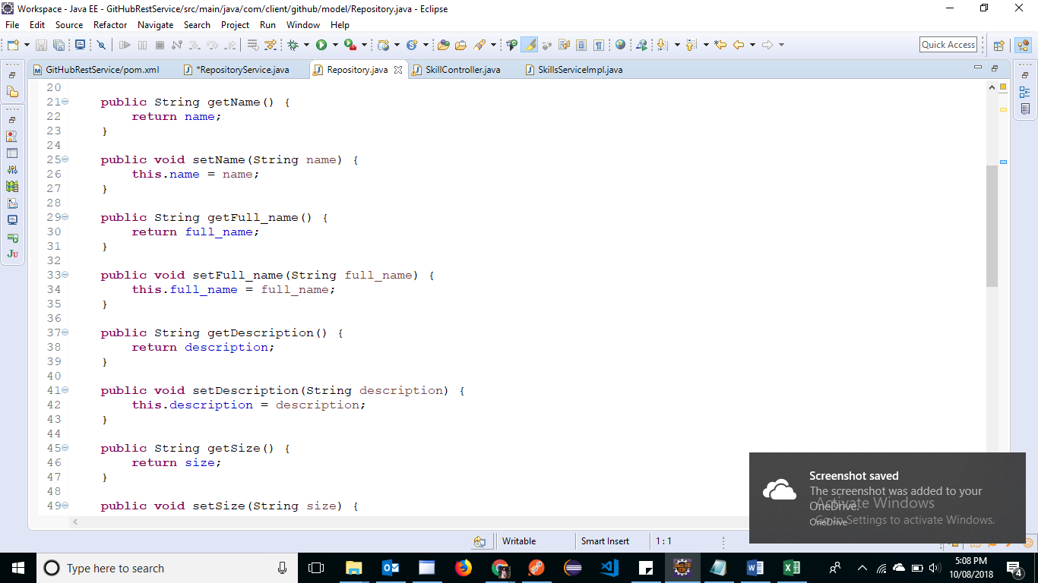

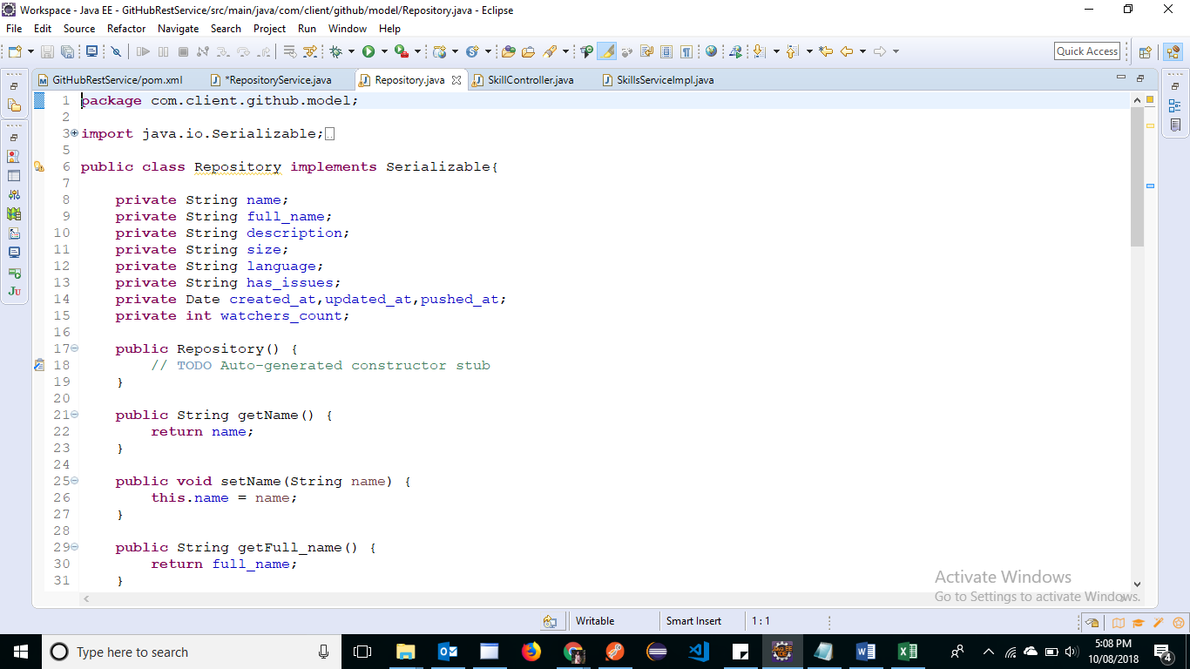

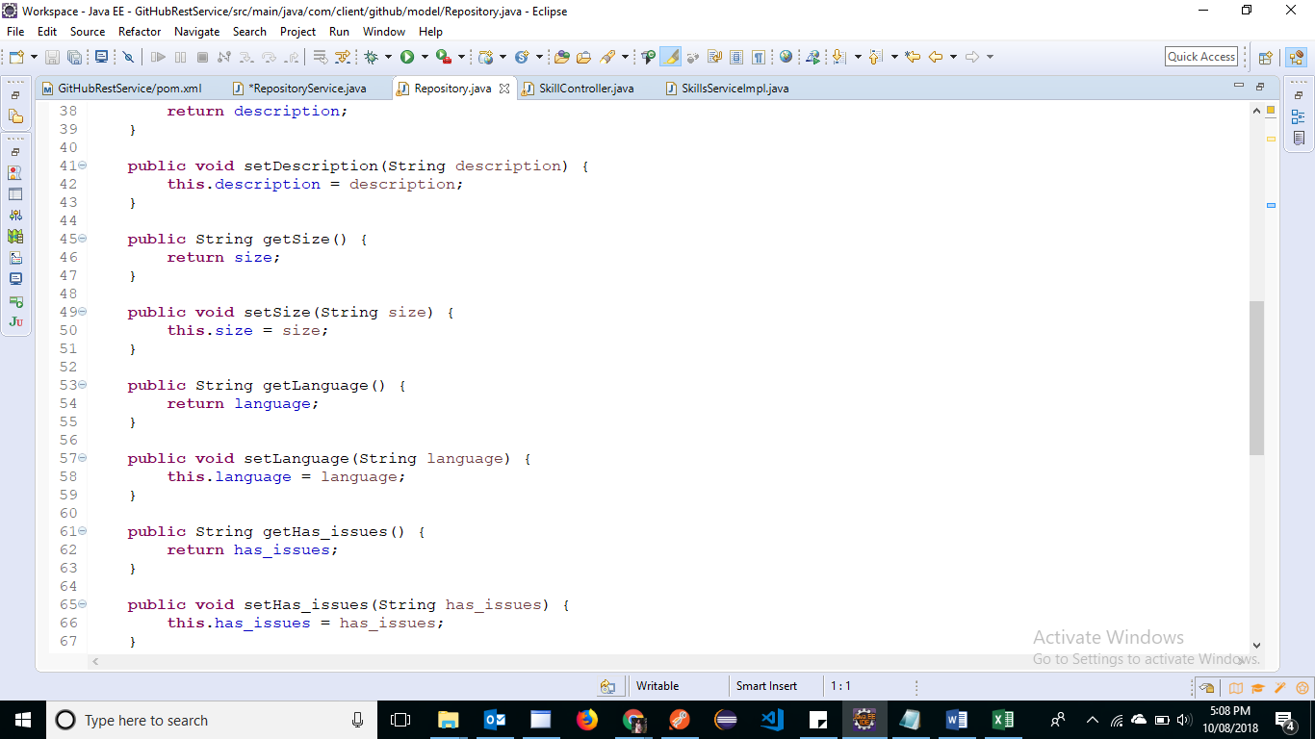

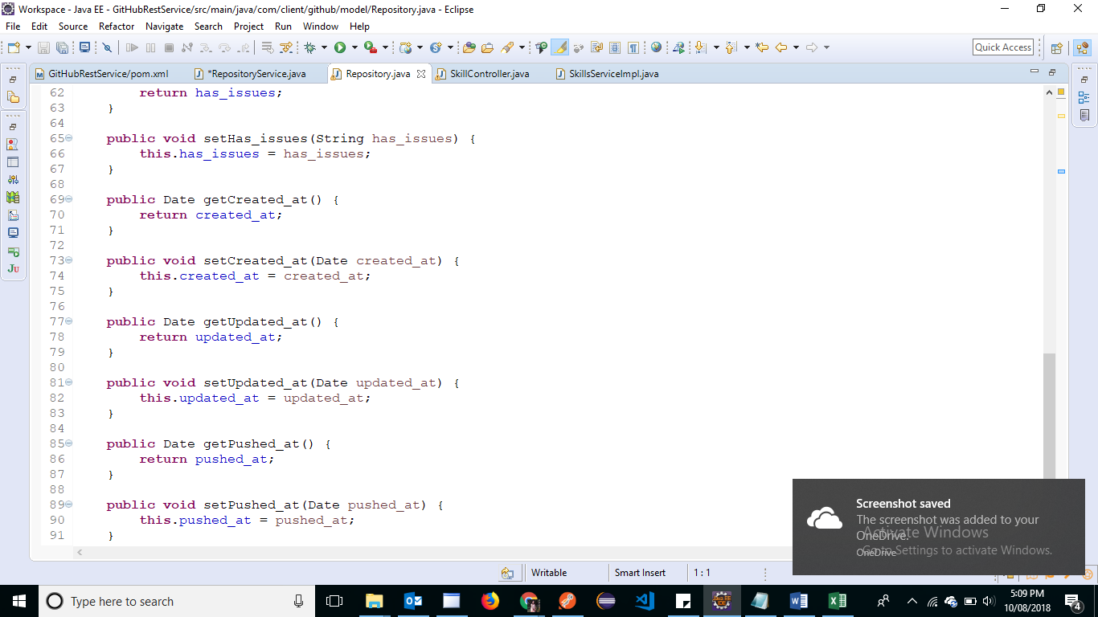

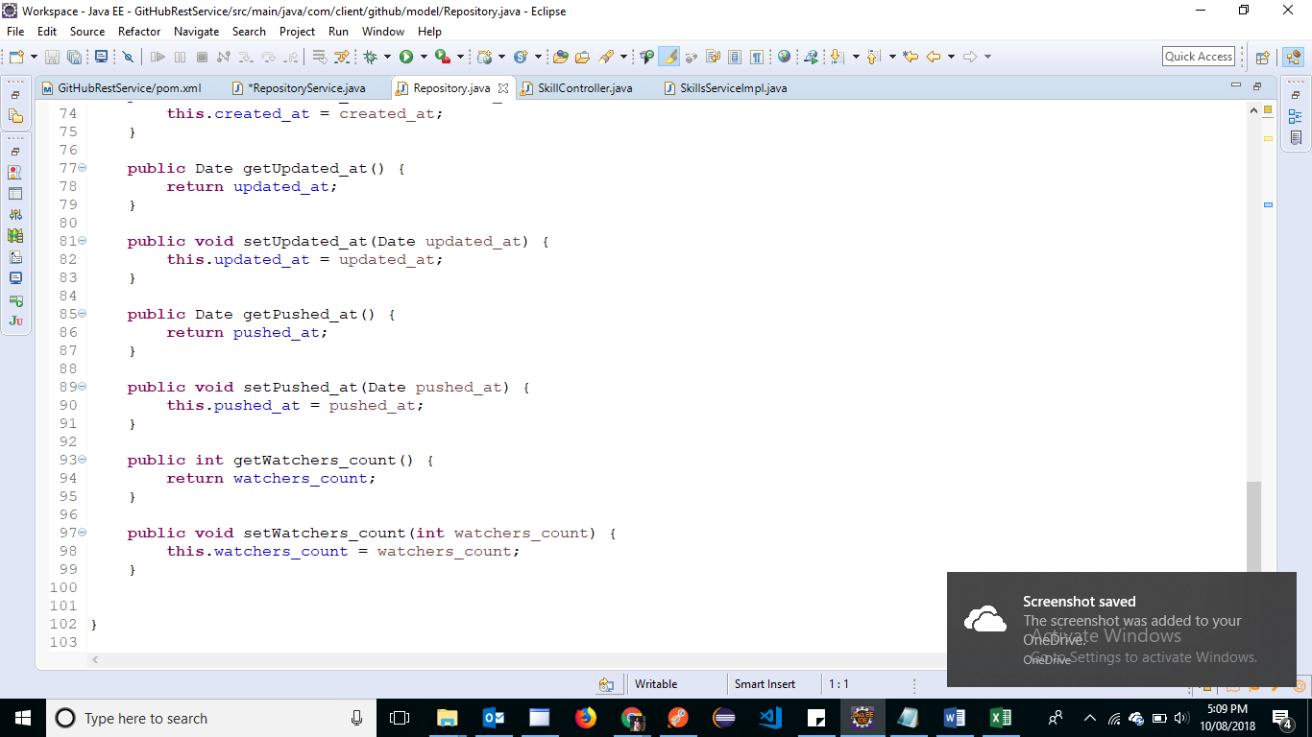

Step 2: Creating REST API

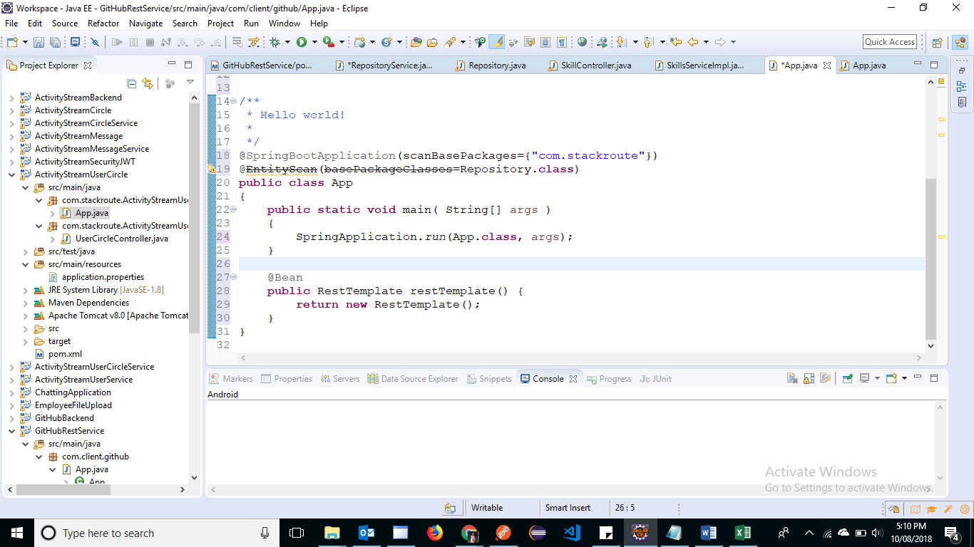

Step 3: Setting up server id and port no

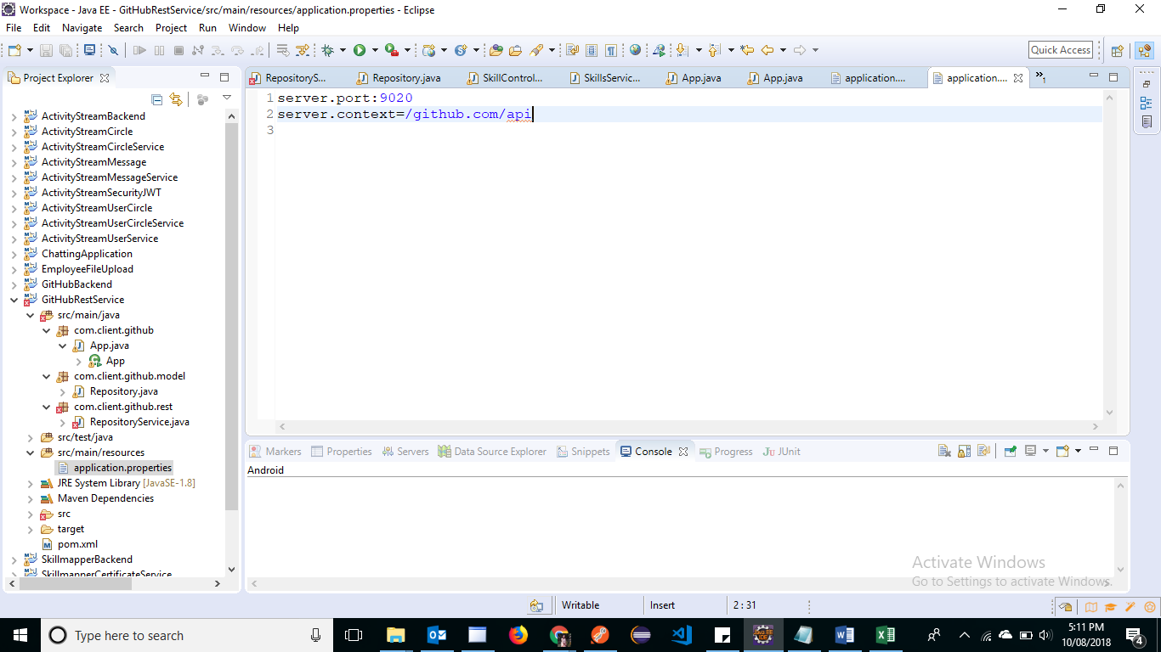

Step 3: Verifying the output via Postman

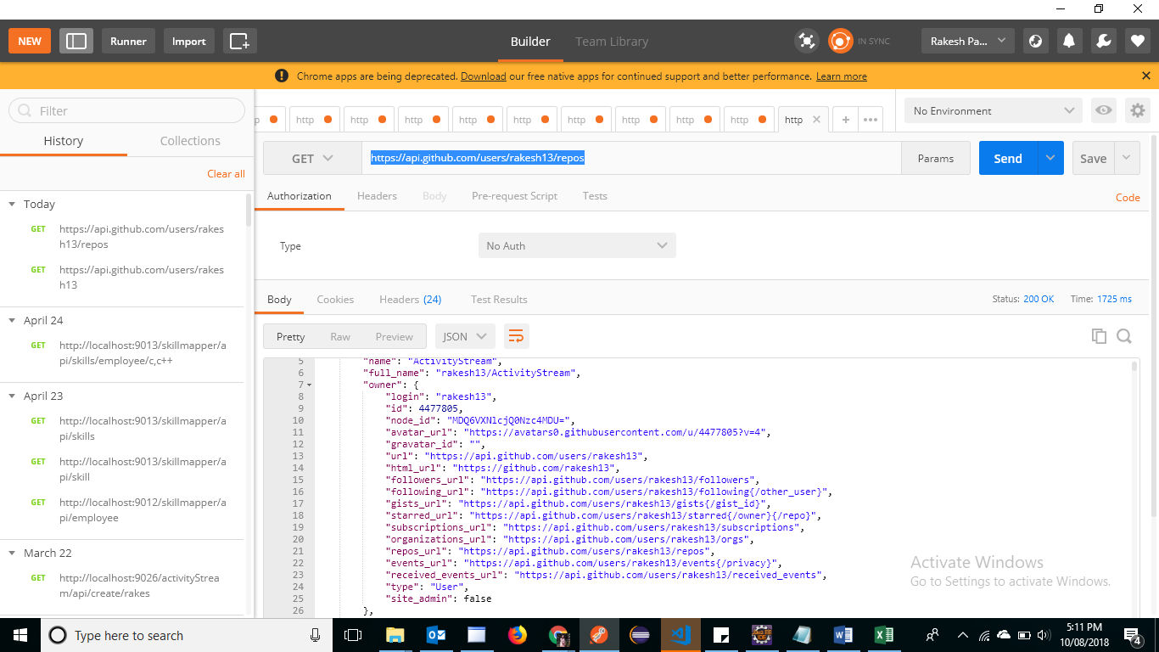

Step 5: Creating the UI using Angular 6 and Node server

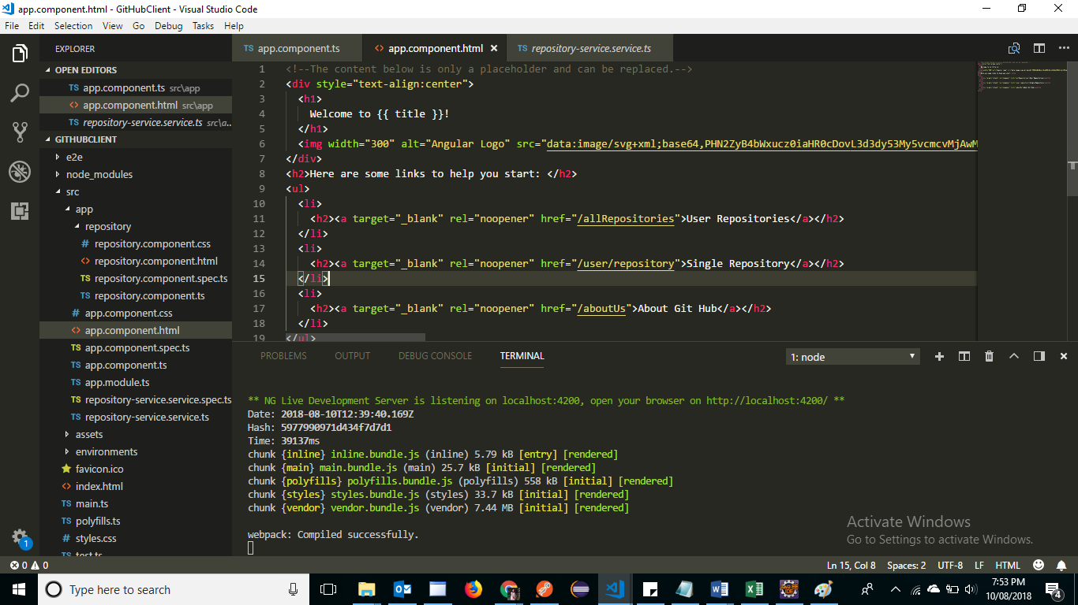

Step 6: Creating the model class in Angular

