**LOVELY PROFESSIONAL UNIVERSITY,**

Phagwara, Punjab



**DEPARTMENT OF COMPUTER SCIENCE**

# PROJECT OF CSE - SEM-4

**SRS DOCUMENT ON E-Commerce Website**

UNDER THE GUIDANCE OF PROJECT CANDIDATES

prof. Dr. Senthil Kumar J Kumar priyam

12218393

60

# DECLARATION STATEMENT

I hereby declare that the Software Requirements Specification (SRS) document entitled "E-commerce Website" presented at Lovely Professional University, Phagwara, Punjab, is an original work and has not been previously submitted for any other purpose.

I acknowledge that this document adheres to Lovely Professional University’s guidelines on academic integrity, plagiarism, and ethical standards. Hence, I affirm that all the information and analysis contained in this SRS are the result of my own research and effort.

I understand the significance of upholding intellectual property rights and ethical conduct, and I assure that the content of this SRS accurately reflects my genuine endeavour. I take full responsibility for the accuracy and integrity of the information provided in this document.

**Table of Contents**

**REVISION HISTORY........................................................................... ERROR! BOOKMARK NOT DEFINED. CLIENT APPROVAL........................................................................... ERROR! BOOKMARK NOT DEFINED**.

1.INTRODUCTION...............................................................................................................................3 1.1PURPOSE.......................................................................................................................................3

1.2 SCOPE...........................................................................................................................................4

1.3 DEFINITIONS, ACRONYMS, AND ABBREVIATIONS……………………………………..................................4

1.4REFERENCES..................................................................................................................................5 1.5OVERVIEW......................................................................................................................................5

2. GENERAL DESCRIPTION...................................................................................................................6

2.1 PRODUCTPERSPECTIVE.................................................................................................................6

2.2 PRODUCT FUNCTIONS .................................................................................................................7

2.3 USER CHARACTERISTICS ...............................................................................................................7

2.4 GENERAL CONSTRAINTS ...............................................................................................................8

2.5 ASSUMPTIONS AND DEPENDENCIES .............................................................................................8

3. SPECIFIC REQUIREMENTS................................................................................................................ 9

3.1 EXTERNAL INTERFACE REQUIREMENTS .............................................................................................. 9 3.1.1 User Interfaces................................................................................................................................. 9 3.1.2 Hardware Interfaces......................................................................................................................... 9 3.1.3 Software Interfaces.......................................................................................................................... 9 3.1.4 Communications Interfaces............................................................................................................ 10 3.2 FUNCTIONAL REQUIREMENTS........................................................................................................... 10 3.2.1 User Registration Login................................................................................................................... 10 3.2.2 Product Listings............................................................................................................................... 10 3.2.3 Purchasing Cart .............................................................................................................................. 10 3.2.4 Order Processing............................................................................................................................. 11 3.2.5 Payment Processing......................................................................................................................... 12 3.2.6 Customer Management .................................................................................................................. 12 3.2.7 NON-FUNCTIONAL REQUIREMENTS ............................................................................................... 13 3.3.1 Performance.................................................................................................................................... 13 3.3.2 Reliability.......................................................................................................................................... 13 3.3.3 Availability ....................................................................................................................................... 14 3.3.4 Security ........................................................................................................................................... 15 3.3.5 Maintainability ................................................................................................................................ 15 3.3.6 Portability ........................................................................................................................................ 16 3.4 DESIGN CONSTRAINTS ........................................................................................................................ 17 3.5 OTHER REQUIREMENTS ...................................................................................................................... 18 4. ANALYSIS MODELS................................................................................................................................ 18 4.1 DATA FLOW DIAGRAMS (DFD) ............................................................................................................ 18 5.GITHUB LINK……………………………………………………………………………………………………………..……………………….19 6.CLIENT APPROVAL PROOF…………..…………………………………………………….……………………………………………….22 7.A. APPENDICES ...................................................................................................................................... 23 A.1 APPENDIX 1 ........................................................................................................................................ 24

8.CONCLUSION……………………………………………………………………………………………………………………….……………….26

**REVISION HISTORY**

|  |  |  |  |
| --- | --- | --- | --- |
| **Version** | **Date** | **Description** | **Author** |
| 1.0 | 2024-03-24 | Initial Draft | priyam |
| 1.1 | 2042-04-01 | Added Requirement | priyam |
| 1.3 | 2024-04-11 | Added Appendices | priyam |

**CLIENT APPROVAL**

1. INTRODUCTION
   1. PURPOSE
   2. A chat app serves as a versatile platform for real-time communication, enabling users to exchange messages, multimedia content, and engage in conversations effortlessly. Whether for personal connections, professional collaborations, networking, customer support, community building, or entertainment, its purpose is to facilitate seamless interaction, bridge distances, and foster meaningful connections among individuals across various contexts.

1.2Responsive Design:

The platform will be designed with a responsive layout, ensuring compatibility across different devices and screen sizes for enhanced accessibility.

1.2Strong Customer Service:

Various channels for customer support, including live chat, email, and phone support, will be available to address customers enquiries and concerns promptly.

* 1. DEFINITIONS, ACRONYMS, AND ABBREVIATIONS

1.3.1 E-commerce:

The purchasing and selling of goods and services via the internet.

1.3.2 UI:

User Interface, the design and arrangement of a website or software program.

1.3.3 UX:

User Experience, the overall interaction a user has with a system or product.

1.3.4 SSL:

Secure Sockets Layer, ensures secure online communication.

1.3.5 API:

Application Programming Interface, a set of guidelines for creating and using software applications.

1.3.6 CMS:

Content Management System, used to manage digital content on websites.

1.3.7 GDPR:

General Data Protection Regulation, EU legislation covering privacy and data protection.

1.3.8 SQL:

Structured Query Language, used to administer relational databases.

1.3.9 CDN:

Content Delivery Network, a network of servers delivering web content.

1.3.10 HTTPS:

Hypertext Transfer Protocol Secure, provides secure network communication.

* 1. REFERENCES

1.4.1 google

1.4.2 chatGpt

1.4.3 friends

* 1. OVERVIEWS

A chat app serves as a versatile platform for real-time communication, enabling users to exchange messages, multimedia content, and engage in conversations effortlessly. Whether for personal connections, professional collaborations, networking, customer support, community building, or entertainment, its purpose is to facilitate seamless interaction, bridge distances, and foster meaningful connections among individuals across various contexts.

1. GENERAL DESCRIPTION

A chat app is a software application designed to enable real-time communication between users. It allows individuals to exchange text messages, multimedia content, and engage in conversations over the internet. Typically accessible across various platforms such as web browsers, mobile devices, and desktop applications, chat apps provide features like user authentication, contact management, group chats, and privacy settings. They serve purposes ranging from personal communication and professional collaboration to customer support and community building.

1. **SPECIFIC REQUIREMENTS**

3.1 EXTERNAL INTERFACE REQUIREMENTS

To ensure seamless operation and a positive user experience, the E-commerce Website will interact with various external components. These external interfaces include:

3.1.1 User Interfaces:

The website will be accessible via both desktop and mobile web browsers, offering a user-friendly interface. Responsive design principles will be implemented to support different screen sizes and resolutions. User authentication will be facilitated through third-party login providers such as Google, Facebook, or email accounts to enhance customer convenience and streamline the login process.

3.1.2 Hardware Interfaces:

The website will be accessible from standard hardware devices including computers, laptops, tablets, and smartphones. Future enhancements may involve integration with peripherals such as printers, scanners, or digital assistants to provide additional functionalities.

3.1.3 Software Interfaces:

Integration with secure payment gateways such as PayPal, Stripe, or banking APIs will facilitate online transactions and ensure secure payment processing. Website administrators will be able to monitor user behavior and track website performance through compatibility with web analytics solutions like Google Analytics or Adobe Analytics.

3.1.4 Communications Interfaces:

The website will utilize the HTTPS protocol to ensure data confidentiality and integrity during communication between the web server and users' browsers. Communication with users, including shipment alerts, order confirmations, and customer support requests, will be facilitated through integration with email service providers or messaging apps.

These external interface requirements will be implemented meticulously to enhance user security, usability, and the overall operation of the website.

3.2 FUNCTIONAL REQUIREMENTS

3.2.1 User Registration and Login:

* Users should be able to securely create an account by providing necessary details, including username, email address, and password.
* Password encryption must be utilized during the registration process to safeguard user credentials.
* Upon successful registration, users should be able to securely log in using their login credentials.
* Password encryption should also be implemented to protect user passwords from unauthorized access.
* Error handling mechanisms should be in place to notify users of any login or registration issues and provide assistance in resolving them.
* User authentication procedures adhering to industry-standard security guidelines should safeguard user accounts and sensitive data.
* High-quality images should accompany each product listing to offer users a visual representation of the items.
* Users should be able to add desired products to their shopping cart while browsing the website.

3.2 Reliability:

* Prioritize website reliability to ensure uninterrupted user access at all times.
* Implement robust error-handling procedures to detect and resolve any issues that may arise during website operation.
* Conduct regular maintenance and updates to address potential vulnerabilities or performance issues and minimize the risk of downtime.
* Implement backup and recovery mechanisms to restore the website to a functional state in case of data loss or system failure.
* Track website performance metrics and uptime using monitoring tools to detect and address reliability issues promptly.
* Implement redundancy mechanisms such as failover systems and redundant data storage to ensure continued operation and mitigate single points of failure.
* Utilize user feedback systems to identify and prioritize improvements based on user-reported reliability concerns.
* Maintain adherence to industry standards and reliability best practices such as ITIL or ISO 9001 to ensure consistent and dependable website functioning.

3.3.3 Accessibility:

* Ensure 24/7 website accessibility to allow users to access the platform and its services anytime, day or night.
* Schedule maintenance tasks during non-peak hours to minimize user disruption and ensure optimal accessibility during periods of high usage.
* Implement redundant infrastructure and failover systems to minimize downtime and ensure uninterrupted availability in case of hardware or software malfunctions.
* Utilize load balancing systems to distribute traffic among multiple servers and maintain steady performance during peak demand periods.
* Track website availability and uptime using monitoring technologies to detect and address any issues that may impair accessibility.
* Communicate scheduled maintenance tasks or unplanned downtime to users in advance to minimize user frustration.
* Engage in ongoing testing and optimization efforts to sustain high availability and deliver a smooth user experience under fluctuating traffic circumstances.
* Maintain adherence to industry standards and best practices for availability, such as the ITIL framework or ISO 27001, to ensure consistent and dependable website operation.

3.3.4 Security:

* Implement security measures to prevent unauthorized access and security breaches involving user data and payment information.
* Utilize encryption methods like HTTPS to secure user sessions and confidential data transferred between the user's browser and the website's servers.
* Implement secure authentication techniques like password hashing and multi-factor authentication to confirm users' identities and prevent illegal access to accounts.
* Use data encryption techniques to ensure confidentiality and integrity of stored user data and payment information.
* Conduct regular security audits and vulnerability assessments to identify and address potential security flaws or vulnerabilities in the website's code or infrastructure.
* Maintain compliance with data protection laws such as CCPA or GDPR to ensure ethical and lawful handling of user data.
* Implement access control techniques to limit access to sensitive website areas and prevent unauthorized viewing or alteration of sensitive data.
* Establish incident response protocols to promptly and efficiently address security issues such as data breaches or cyberattacks.
* Implement user education and awareness programs to promote secure website usage and reduce the risk of security issues caused by human error.

3.3.5 Maintainability:

* Design the website with maintainability in mind, making it easy to update and modify as needed to accommodate changes or additions.
* Use modular and well-structured code to facilitate maintenance and updates, allowing developers to make changes to individual components without affecting the overall functionality of the website.
* Provide clear and comprehensive documentation for the website's codebase, architecture, and configuration settings to enable future developers to understand and use the system effectively.
* Use version control systems like Git to facilitate collaboration among development teams and track changes to the website's codebase.
* Establish automated testing and deployment pipelines to expedite the deployment of updates and ensure that changes are thoroughly tested before being released to production.
* Conduct frequent code reviews and peer review sessions to identify and address any issues with code quality or technical debt that may affect maintainability.
* Promote the adoption of coding standards and best practices to maintain readability and consistency throughout the codebase.
* Continuously optimize and monitor the website to identify and address any performance or scalability issues that may arise in the future, ensuring that the website remains responsive and maintainable as it evolves.

3.3.6 Portability:

* Ensure compatibility with a variety of web browsers, including popular ones like Google Chrome, Mozilla Firefox, Apple Safari, and Microsoft Edge, to guarantee accessibility for all users.
* Utilize responsive design strategies to maximize the website's layout and functionality across various devices and screen sizes, such as desktop computers, tablets, and smartphones.
* Conduct compatibility testing to confirm that the website operates correctly on various operating systems and device combinations, ensuring a consistent user experience across platforms.

3.4 DESIGN CONSTRAINTS

3.4.1 The website design must adhere to industry standards and best practices for user interface (UI) and user experience (UX) design to ensure an aesthetically pleasing and simple-to-use interface for consumers.

3.4.2 Design components like font, color scheme, and layout should align with the organization's or brand's branding guidelines and visual identity to maintain a unified and professional image.

3.4.3 Accessibility standards such as WCAG (Web Content Accessibility Guidelines) should be followed to ensure that the website is accessible to people with disabilities or impairments.

3.4.4 Responsive design and cross-browser compatibility should be implemented to ensure the website works properly on various web browsers and devices, providing users with a consistent experience.

3.4.5 Performance optimization techniques like lazy loading and image compression should be utilized in the design to reduce page load times and increase website speed overall.

3.4.6 Security factors including data encryption and secure authentication procedures should be incorporated into the design to safeguard user data and prevent unauthorized access.

3.4.7 Prioritizing scalability and maintainability in the design will allow for future expansion and make it easier to update and modify the website as needed.

3.4.8 Modular and adaptable design will make it simple to incorporate new features or capabilities as needed to satisfy changing user and business requirements.

3.4.9 Usability testing and feedback channels should be included throughout the design process to ensure that the final design satisfies user and stakeholder needs.

3.5 OTHER REQUIREMENTS

3.5.1 The website must comply with all applicable laws and regulations, particularly those related to consumer protection and data protection, such as the CCPA and GDPR.

3.5.2 Features like shipping, inventory management, and payment processing may require integration with third-party services or APIs.

3.5.3 Support for multiple languages and currencies may be necessary to serve a diverse customer base and facilitate international transactions.

3.5.4 Backup and disaster recovery procedures should be established to guard against data loss and ensure business continuity in case of emergencies or system failures.

3.5.5 Regular monitoring and analytics tools should be used to measure website performance, user activity, and business indicators for data-driven decision-making and ongoing development.

3.5.6 Documentation and training materials should be provided to website administrators and employees to enable efficient administration and operation of the website.

3.5.7 Customer support should be accessible via email, live chat, or a helpdesk system to address user questions, concerns, or feedback.

3.5.8 Adherence to industry standards and best practices for web creation, such as SEO (Search Engine Optimization) rules and website accessibility requirements, should be followed to optimize the website's exposure and reach.

1. **ANALYSIS MODELS**
   1. LEVEL – ZERO DFD

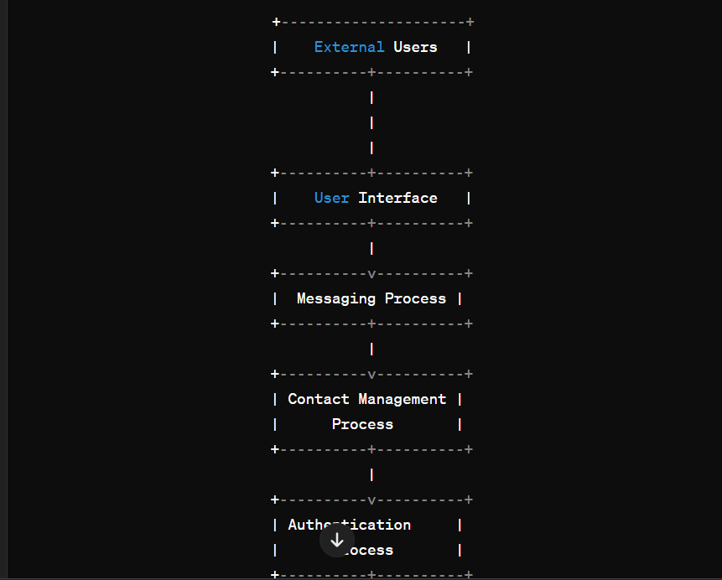

* 1. LEVEL – ONE DFD

* 1. LEVEL – TWO DFD

1. **CONCLUSION**

a chat app serves as a versatile platform for real-time communication, catering to various needs ranging from personal connections to professional collaborations and customer support. By facilitating seamless interaction through intuitive messaging features, robust authentication mechanisms, and efficient data management, chat apps bridge geographical barriers and foster meaningful connections among users worldwide. With continuous advancements in technology and user experience, chat apps continue to evolve, providing enhanced functionalities and ensuring a seamless communication experience across diverse contexts.

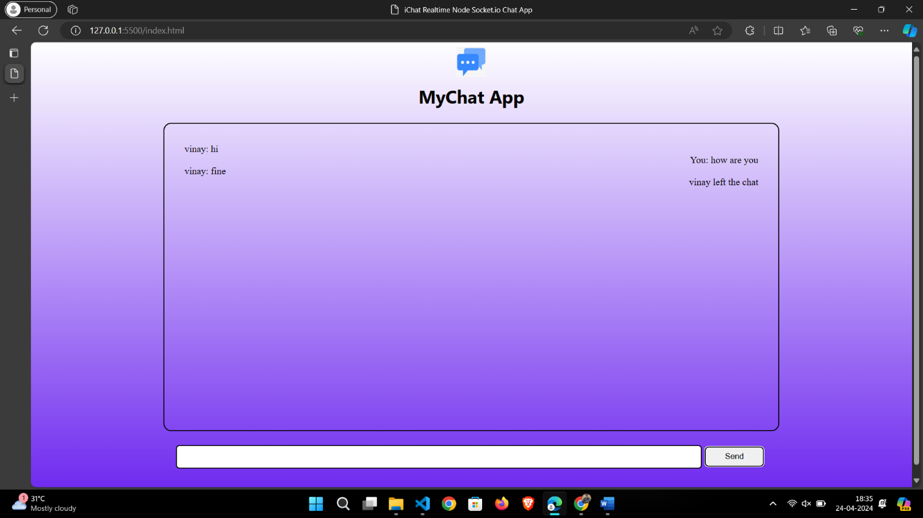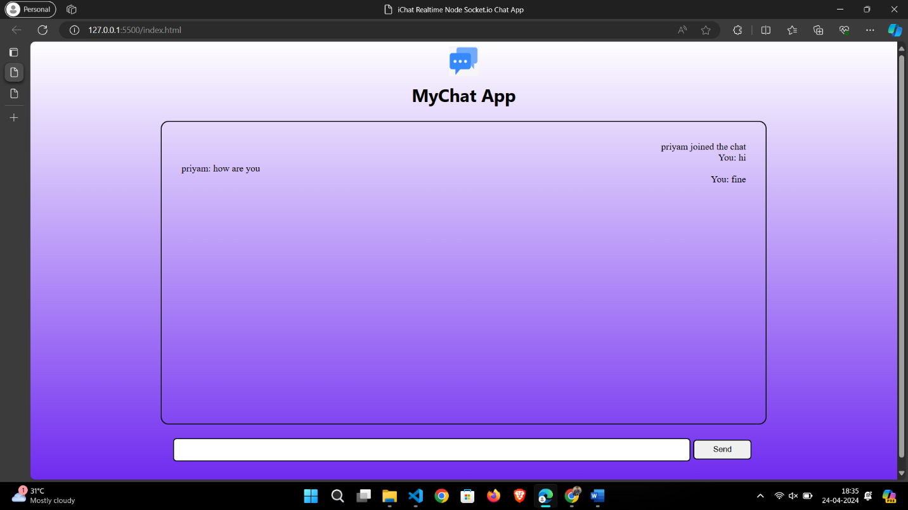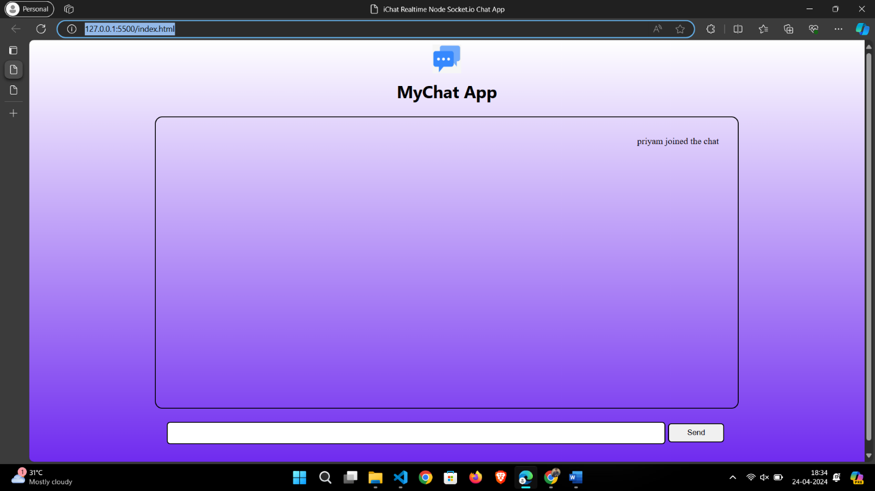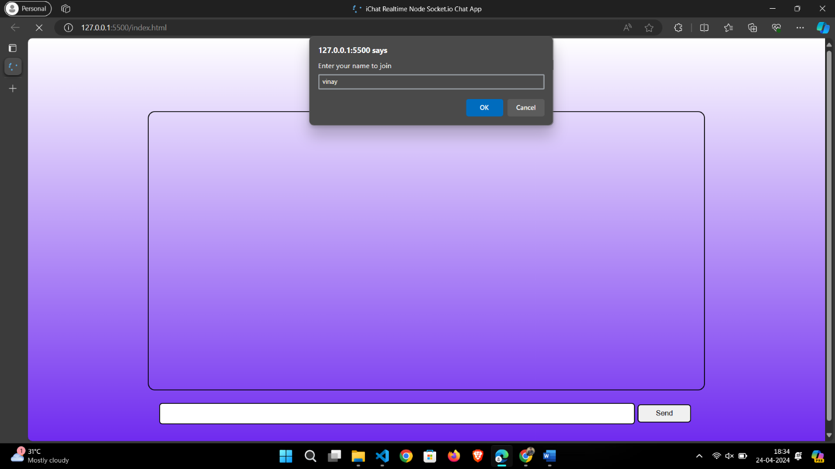

***Thanks!!***