Working with VPNs :-

Step1:-First we need to in install freeVPN/PaidVPN to see the uses of VPN.

Step2:-I am installing the freeVPN name is “ProtonVPN free” in the chrome browser.

Step3:-After installing the Protonvpn, we need to create the account.

Step4:-After creation, I opened the vpn and click on connect.When I connect the vpn my IP & location has been changed.
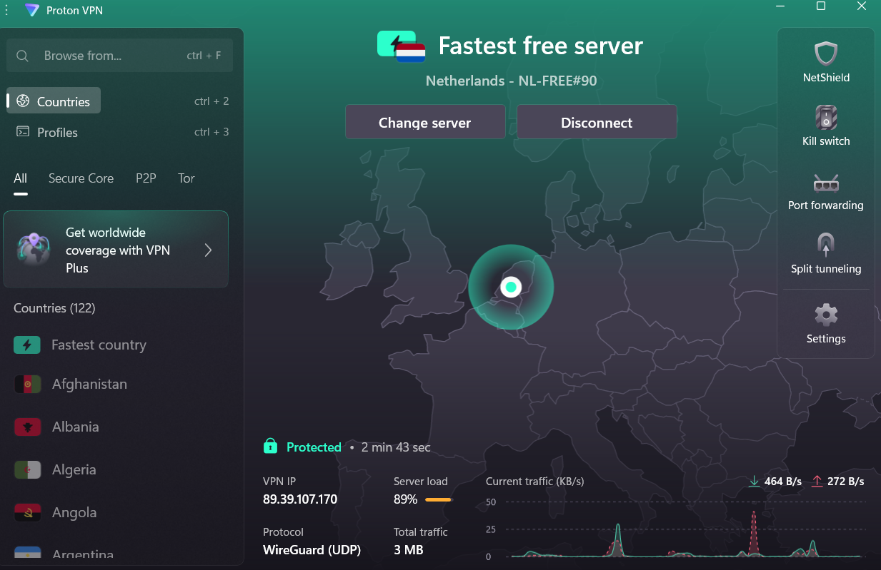

Step5:-Before the connecting vpn my Ip and Location is shown in below image.
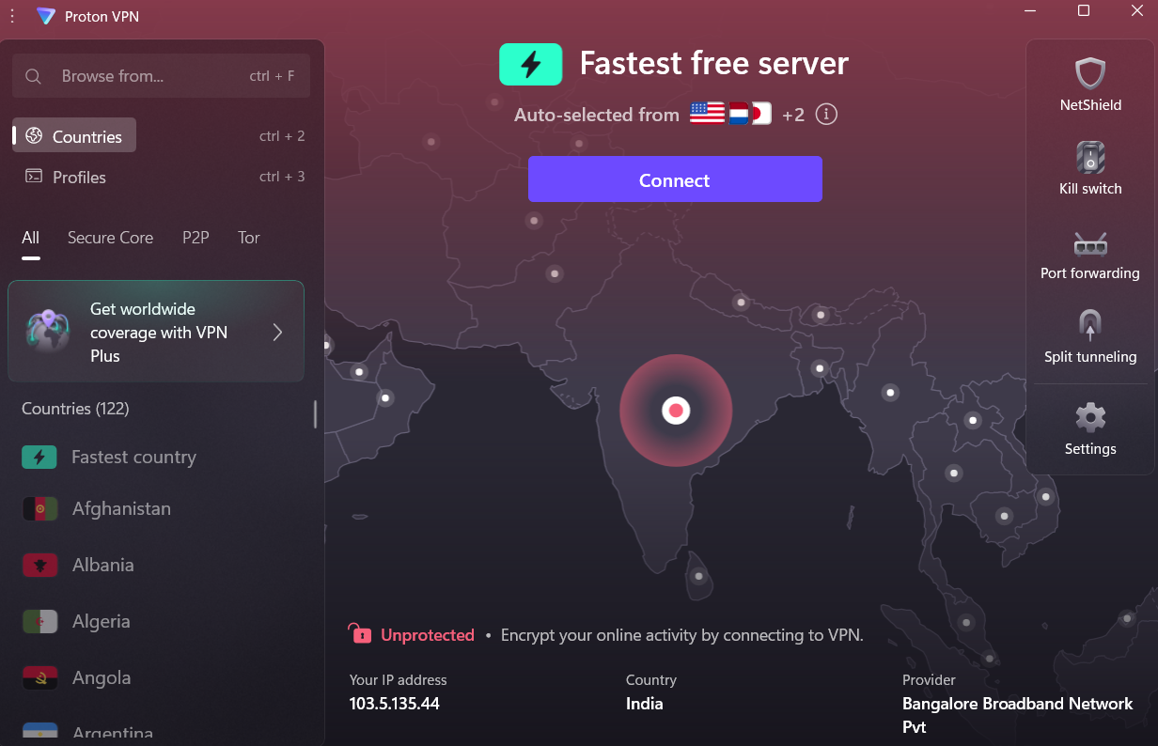

Step6:-To check that our IP have changed are not,for that I am using the “whatismyipaddress.com”.
-->Before the VPN connection my IP & location is
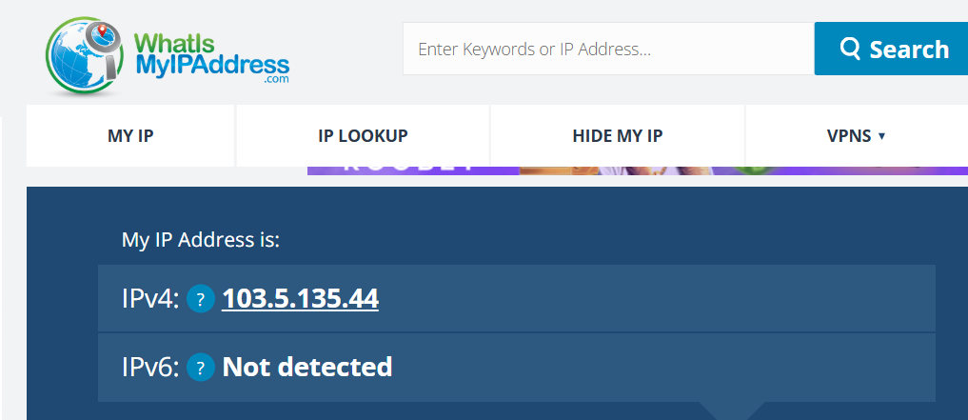
-->After the VPN connection my ip & location
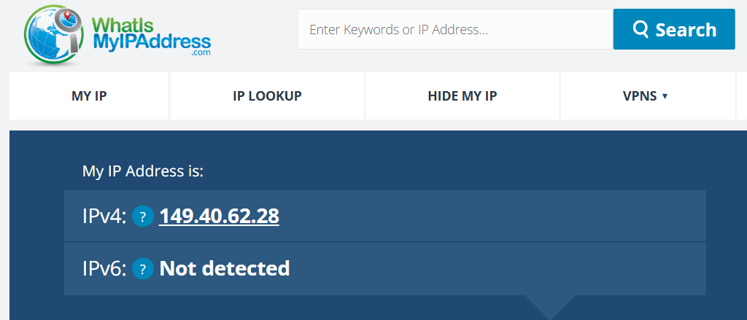
Step7:- When we use the VPN then “Connection is secure”.
Uses:-
-->It enhances online privacy and security by encrypting internet traffic, masking IP addresses, and providing secure access to online resources.
-->Data travels through a secure tunnel.
-->Staying safe on public Wi-Fi.
-->Stopping slow internet speeds.
-->Accessing blocked websites.
-->Finding better deals.
-->Avoiding location-based tracking.

