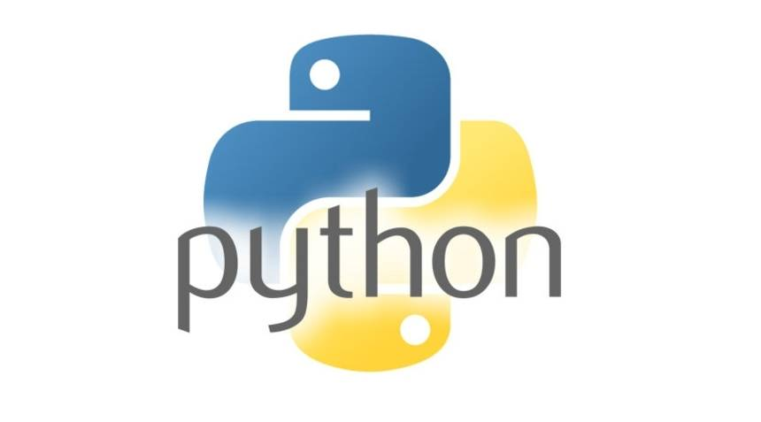

# DOCUMENTATION

**Presented by ): Kumarsen Parida.**

**SYLLABUS(0-1)**

* Computer System Overview
* Data Representation
* Insight into Program Execution
* Computation Thinking And Getting Started With Python
* Python Fundamentals
* Data Handling
* Conditional Statements
* Tinker
* Project

Computation Thinking ):

Computational thinking divided into four type , i.e. -

1. Decomposition
2. Pattern Recognition
3. Abstraction
4. Algorithms

1.Decomposition):

Decomposition means to divide or break the whole problem into several parts or divide into modules for better understanding and to solve the problem easily.

2.Pattern Recognition):

After decomposition of the whole problem into several parts , the process to recognize the similarity between two or more parts is otherwise called as Pattern Recognition.

3.Abstraction):

Abstraction means to hide unnecessary information from end user that means to give that much information which data is necessary to end user.

4.Algorithm):

Algorithm is the set of instruction or rules which is used to perform a specific task to get solution of program.

Getting Started with Python ):

Generally there is two way to get start with Python

* With installing python compiler like pycharm
* With installing python runner application like Anaconda Navigator(IDE)

To install the above apps we just need to search in Google and then have to download the app in pc and ready to get start after installing them.

Python Fundamentals):

1. Python Style rules and Conventions –

* Indentations :
  + 1. Same block of code will have same spaces (there is no curly braces rules in Python like other programming language).
    2. Use two blank-line(space) between top level definition.
    3. One blank-line between methods.
    4. White space around operations (like (a + b)).
* Statement Terminated : Statement terminated is just break statement inside a loop.
* Max length 79 Character : In python maximum length of any character is 79 character inside a program.
* Case sensitive: python is very case sensitive means there is no work-done if any mismatch occurs (i.e. Python != python).
* Doc-strings: It is used for comment passing inside the program , In python the statement pass inside (‘’’) is treated as comment (i.e. ‘’’ comment ‘’’).
* Naming convention: In python the naming convention Is in Camel-Case.

2.Literals: Literal is a raw data given in a variable or constant in Python.

3.Identifiers (variables): In Python, we don't assign values to the variables, whereas Python gives the reference of the object (value) to the variable , In python some of the variable objects are predefined and can be access-able by programmer i.e. python developers are already done the memory management , there is no required of another object to store the same element.

4.keywords: Keywords are the reserved words in Python. We cannot use a keyword as a variable name, function name or any other identifier. They are used to define the syntax and structure of the Python language. In Python, keywords are case sensitive.

5.Punctuation: punctuation is a pre-initialized string used as string constant. In Python, string. punctuation will give the all sets of punctuation.

6.Most programs today use a dialog box as a way of asking the user to provide some type of input . While python provides us two inbuilt functions to read the input from the key-board .

* + 1. raw_input(prompt):

It works in older version of python ( i.e. python 2.x). the return type of raw_input is always string .

* + 1. input(prompt)

It works in latest version of python. the return type of input need not be string only. Python will judge as to what data type will it fit the best.

In both of the case we have to use type-casting to other numeric data.

Data Handling ):

1. Data-type
2. Mutable and Immutable object
3. Operators
4. Expressions
5. Standard Python Libraries