Name- Kumar Vishal

Section-K18GR

Rollno.-34

OUTPUT:

QNo.-8

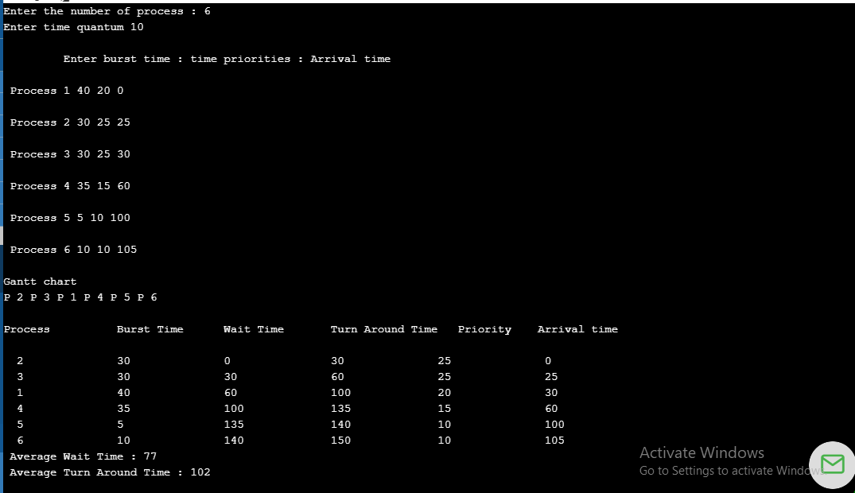

QNo.19

