# 软件服务用例模型（详细结构）

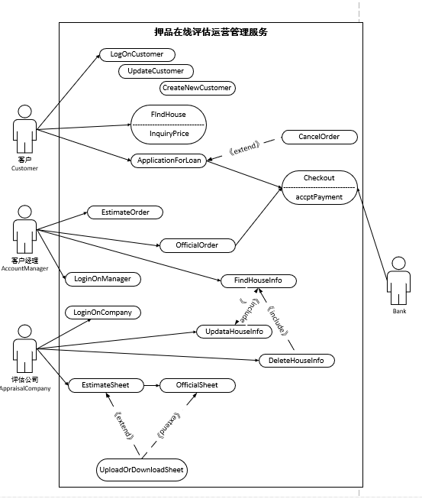

# Actors

TODO：

|  |  |
| --- | --- |
| Actor | AppraisalCompany |
| ID | A1 |
| Parents | user |
| semantics | |
| 对房屋进行勘察评估，出具相关报告。 | |

|  |  |
| --- | --- |
| Actor | AccountManager |
| ID | A2 |
| Parents | user |
| Semantics | |
| 为客户订单下单的人 | |

|  |  |
| --- | --- |
| Actor | Customer |
| ID | A3 |
| Parents | user |
| Semantics | |
| **登陆平台的顾客** | |

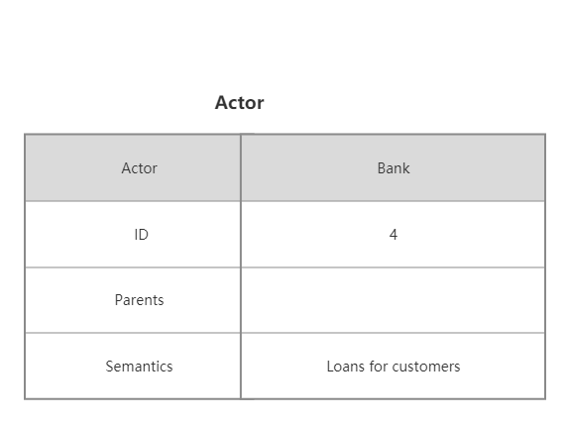

# Use Cases

TODO：

|  |  |
| --- | --- |
| Use case | Estimatesheet |
| Use case ID | UC1 |
| Actors | AppraisalCompany |
| preconditions | |
| 客户经理发送了预估订单 | |
| Segment | |
| 1 当评估公司下载预估单的时候触发。  2 评估公司人工审核填写预估报告 并上传。  3 交与客户经理再次审核。 | |
| Postconditions | |
| 预估单流程完成。 | |

|  |  |
| --- | --- |
| Use case | Officialsheet |
| Use case ID | UC2 |
| Actors | AppraisalCompany |
| preconditions | |
| 客户经理发送了正式下单 | |
| Segment | |
| 1 当评估公司开始处理正式订单时触发。  2 评估公司将确认无误的正式订单打印，并且派送纸质报告。 | |
| Postconditions | |
| 正式订单流程完成。 | |

|  |  |
| --- | --- |
| Use case | UploadOrDownloadSheet |
| Use case ID | UC3 |
| Actors | AppraisalCompany |
| preconditions | |
| 评估公司拥有对应文档。 | |
| Segment | |
| 上下传预估报告或正式报告 | |

|  |  |
| --- | --- |
| Use case | UpdataHouseInfo |
| Use case ID | UC4 |
| Actors | AppraisalCompany |
| Segment | |
| 上传房屋相关信息。 | |

|  |  |
| --- | --- |
| Use case | DeleteHouseInfo |
| Use case ID | UC5 |
| Actors | AppraisalCompany |
| Segment | |
| 删除房屋相关信息。 | |

|  |  |
| --- | --- |
| Use case | LoginOnManager |
| Use case ID | uc6 |
| Parents | ApplicationForLoan |
| Actors | AccountManager |
| Preconditions | |
| None. | |
| Flow of events | |
| 1.登录公司等待系统预警 | |

|  |  |
| --- | --- |
| Use case | FindHouseInfo |
| Use case ID | uc7 |
| Parents | ApplicationForLoan |
| Actors | AccountManager |
| Preconditions | |
| 客户申请贷款 | |
| Flow of events | |
| 1.查询房屋信息 | |

|  |  |
| --- | --- |
| Use case | EstimateOrder |
| Use case ID | uc8 |
| Parents | FindHouseInfo |
| Actors | AccountManager |
| Preconditions | |
| 登录查询房屋信息，并接收到预警 | |
| Flow of events | |
| 1.客户经理预估下单  2.系统根据派单规则自动派单 | |

|  |  |
| --- | --- |
| Use case | LoginOnManager |
| Use case ID | uc9 |
| Parents |  |
| Actors | AppraisalCampany |
| Preconditions | |
| 系统根据派单规则自动派单 | |
| Flow of events | |
| 1.预评估并上传预估单或用接口调取预估单 | |

|  |  |
| --- | --- |
| Use case | OfficialOrder |
| Use case ID | uc10 |
| Parents |  |
| Actors | AccountManager |
| Preconditions | |
| 贷款审查审批通过 | |
| Flow of events | |
| 1.上系统下单正式评估 | |

|  |  |
| --- | --- |
| Use case | LogOnCustomer |
| Use case ID | UC11 |
| Actor | Customer |
| **前提** | |
| **1. 这个顾客没有注册过这个软件** | |
| **第一种情况** | |
| 1. **当顾客打开首页用例开始** 2. **系统自动识别顾客** 3. **自动登录** | |
| **第二种情况** | **存在用户不能被识别**  **用户认证失败** |
|  |  |
| **结果** | |
| **1.顾客登录进入系统** | |

|  |  |
| --- | --- |
| Use case | CreateNewCustomer |
| Use case ID | UC12 |
| Actor | Customer |
| **前提** | |
| **1. 这个顾客没有注册过这个软件** | |
| **流程** | |
| 1. **当用户选择新用户时，用例开始** 2. **要求填写用户名和密码** 3. **顾客提交信息** 4. **系统检测用户名和密码是否可用** 5. **如果用户名和密码是无效的，系统要求重新填写用户名和密码** 6. **系统要求填写邮箱、电话号码、住址、银行卡** 7. **顾客提交信息** 8. **必填信息不可为空，否则无法提交** 9. **系统验证信息** 10. **系统分配给用户一个独立的id** | |
| **结果** | |
| 1. **新用户注册完毕** 2. **用户拥有用户名和密码** 3. **用户被分配id** | |

|  |  |
| --- | --- |
| Use case | UpdateCustomer |
| Use case ID | UC13 |
| Actor | Customer |
| **前提** | |
| **1. 这个顾客已注册过这个软件** | |
| **流程** | |
| 1. **当用户选择更改详细信息，用例开始** 2. **系统展示详细信息** 3. **用户改信息** 4. **系统友好提示用户是否确认修改** 5. **用户选择ok** | |
| **结果** | |
| **1.用户细节更新** | |

|  |  |
| --- | --- |
| Abstract Use case | FindHouse  InquiryPrice |
| Use case ID | UC4 |
| Actor | Customer |
| **前提** | |
| **无** | |
| **流程** | |
| 1. **顾客选择查询房屋价格** 2. **扫面房产证** 3. **系统自动估值** | |
| **结果** | |
| **估值成功** | |

|  |  |
| --- | --- |
| Abstract Use case | ApplicationForLoan |
| Use case ID | UC5 |
| Actor | Customer |
| **前提** | |
| **无** | |
| **流程** | |
| 1. **顾客选择申请贷款** 2. **提交房屋信息** 3. **提交申请** | |
| **结果** | |
| **申请成功或失败** | |

