**Results**

**Phase 1 Results**

**Model Description**

We used DeepLabV3+ with a ResNet backbone as the baseline semantic segmentation model. DeepLabV3+ is a CNN-based architecture designed to capture multi-scale contextual information using Atrous Spatial Pyramid Pooling (ASPP) and an encoder-decoder structure for precise segmentation boundaries.

* Backbone: ResNet (default from torchvision)
* Output classes: 19 (IDD semantic classes)
* Loss: CrossEntropyLoss
* Optimizer: Adam / SGD (as per config)
* Image size: 512×1024 (or as per your config)
* Training data: IDD-Segmentation (clear-weather only)
* Evaluation data: IDD-AW (fog, rain, lowlight, snow)

**Results (1% Test Data for Fast Evaluation)**

|  |  |
| --- | --- |
| **Weather Condition** | **mIoU Score** |
| FOG | **0.0791** |
| RAIN | **0.0624** |
| LOWLIGHT | **0.0278** |
| SNOW | **0.0584** |

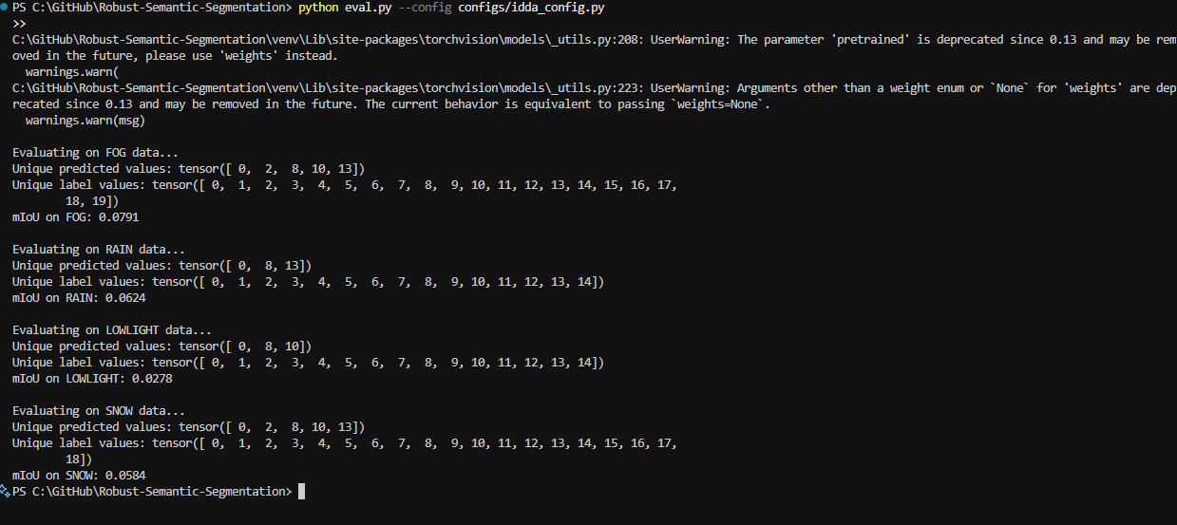

**Test results on IDDAW dataset (1% dataset used)**

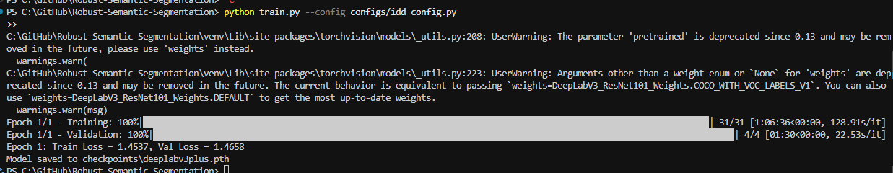

**Train results on IDD Segmentation dataset (1% dataset used)**

**Observations**

* The model performs very poorly in all adverse conditions, as expected.
* The highest degradation is observed in lowlight conditions (mIoU < 0.03).
* This phase clearly demonstrates the need for weather-aware training strategies, which are explored in subsequent phases.