MACHINE LEARNING PROJECT REPORT
AI Impact on Jobs: Layoff Risk Prediction Using Machine Learning
Supervised Machine Learning Classification with Interactive Streamlit Dashboard

Submitted By: Jayam Jain
Batch: [Add Batch]
Course / Subject: [Add Course Name]
Department: [Add Department]
College / University: [Add College / University]
Faculty / Guide: [Add Faculty Name]
Submission Date: 19 August 2026

Abstract
This project develops a supervised machine learning system for predicting the layoff-risk category associated with job profiles in the context of increasing artificial intelligence adoption. The supplied project contains 20,000 records and 16 columns, with Layoff_Risk as a three-class target containing High, Low, and Medium categories. The modelling workflow includes data inspection, an 80:20 stratified train-test split, numerical standardisation, categorical one-hot encoding, and comparison of multiple classification algorithms including Logistic Regression, Decision Tree, Random Forest, SVM, KNN, Naive Bayes, Gradient Boosting, AdaBoost, XGBoost, and tuned XGBoost. The reported results show baseline XGBoost achieving 94.625% test accuracy and tuned XGBoost achieving the strongest reported test accuracy of 95.975%, with a macro F1 of approximately 0.96. In addition to the notebook-based analysis, the project includes a Streamlit dashboard that loads the Excel dataset, trains four selected models, compares their accuracy, displays classification reports and confusion matrices, visualises feature importance for tree-based models, and provides an interactive risk-prediction interface with class probabilities. The system is intended for analytical decision support and not for making automatic employment decisions.

Table of Content
- 1. Introduction
- 2. Objectives
- 3. Dataset Description
- 4. Methodology
- 5. Applications
- 6. Functional Requirements
- 7. Non-Functional Requirements
- 8. Implementation Strategy
- 9. Streamlit Dashboard
- 10. Outcomes and Results
- 11. Limitations
- 12. Future Scope
- 13. Conclusion
- 14. References
- Appendix A – Model Evaluation Details
- Appendix B – Dashboard Component Summary

1. Introduction

1.1 Background
Artificial intelligence is increasingly being integrated into business processes, software systems, customer service, analytics, manufacturing, finance, retail, and other sectors. Alongside productivity benefits, organisations are changing job structures by automating tasks that were previously performed manually. The impact is not uniform: some roles are more exposed to routine automation, while others depend strongly on creativity, human interaction, specialised experience, or complementary AI skills.

1.2 Problem Statement
The project treats layoff-risk prediction as a multiclass classification problem. Given a job profile containing demographic, educational, occupational, organisational, task, automation, and AI-adoption characteristics, the system predicts one of three categories: High, Medium, or Low layoff risk.

1.3 Motivation
A descriptive analysis can identify individual patterns, but machine learning can combine many numerical and categorical attributes and learn nonlinear relationships. Comparing multiple algorithms under a common preprocessing framework provides evidence about which modelling assumptions are most suitable for the supplied tabular data.

1.4 Significance
The project can support workforce planning, reskilling discussions, career analysis, and research into relationships between automation, AI adoption, and employment-risk categories. The model must nevertheless be treated as a statistical tool: a predicted category is not proof that an individual will lose employment, and feature importance does not establish causality.

1.5 Report Organisation
The report follows the supplied ML Project Guidelines and the structure of the supplied sample documentation. It covers the problem, objectives, dataset, preprocessing, algorithms, validation, applications, functional and non-functional requirements, implementation, the Streamlit dashboard, results, limitations, future scope, conclusion, and references.

2. Objectives
- Inspect and document the structure, data types, missing values, duplicate records, and target distribution.
- Separate the Layoff_Risk target from predictor variables.
- Use an 80:20 stratified train-test split to preserve class proportions.
- Apply StandardScaler to numerical variables and OneHotEncoder to categorical variables.
- Build a reusable preprocessing structure using ColumnTransformer and Pipeline.
- Train and compare Logistic Regression, Decision Tree, Random Forest, SVM, KNN, Naive Bayes, Gradient Boosting, AdaBoost, XGBoost, and tuned XGBoost.
- Evaluate models using accuracy, precision, recall, F1-score, macro averages, classification reports, and confusion matrices where available.
- Use five-fold StratifiedKFold validation to assess XGBoost stability.
- Use RandomizedSearchCV to search XGBoost hyperparameters.
- Interpret the final model using transformed feature importance.
- Provide an interactive Streamlit interface for data overview, model comparison, and individual risk prediction.
- Document the complete workflow so that the analysis and dashboard can be reproduced and extended.

2.1 Success Criteria
The project is considered successful when the pipeline produces strong classification performance across the three risk classes, demonstrates reasonable validation stability, and provides a usable interface for exploring the results. The reported tuned XGBoost accuracy of 95.975% and the mean five-fold macro F1 of approximately 0.9404 satisfy the project's performance-oriented objectives. The Streamlit application further satisfies the practical objective of exposing the modelling workflow through an interactive interface.

3. Dataset Description

3.1 Dataset Overview
The project uses the AI Impact Jobs / Layoff Risk dataset. The supplied notebook documents 20,000 records and 16 columns. Fifteen columns act as predictors and Layoff_Risk is the target variable. The supplied Streamlit application loads a final Excel version named ai-impact-jobs-layoff-risk-dataset-final.xlsx .

3.2 Target Variable and Class Balance
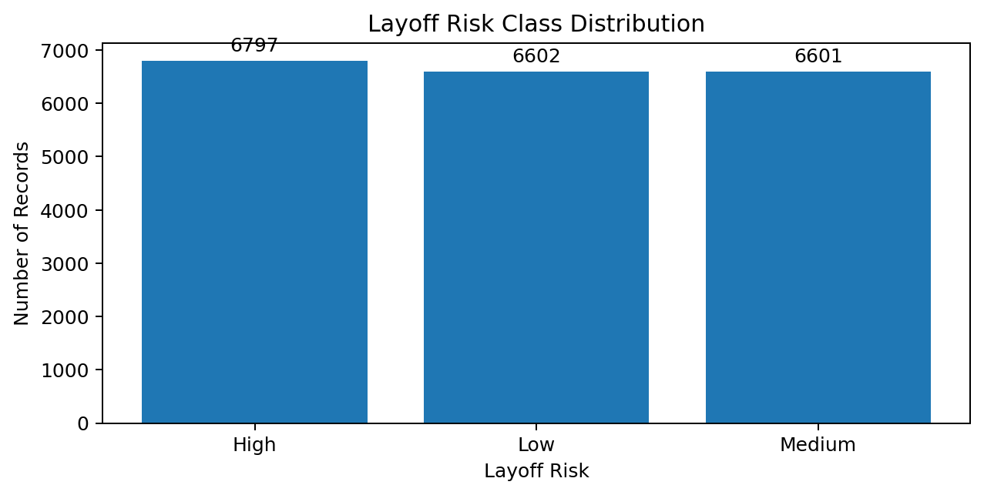
Figure 1: Distribution of Layoff_Risk target classes.
Layoff_Risk is a three-class categorical target containing High, Low, and Medium. The classes are approximately balanced, which means the project does not require an aggressive class-resampling strategy based solely on the observed class distribution.
Class | Records | Percentage
High | 6,797 | 33.98%
Low | 6,602 | 33.01%
Medium | 6,601 | 33.01%
Total | 20,000 | 100.00%
Table 1: Target-class distribution reported in the project.

3.3 Data Quality
The supplied project analysis reports no missing values and no duplicate rows in the working dataset. The Streamlit app also relies on a clean, structured dataset and derives numerical and categorical feature lists automatically using pandas. This allows the same dashboard code to work with compatible datasets containing the expected target and predictor structure.

3.4 Feature Representation
The predictors contain a mixture of numerical and categorical information. Examples represented in the project include age and experience measures, education, industry, job role, company size, job level, routine-task percentage, creativity requirement, task automation percentage, AI adoption level, training hours, digital skills, remote-work characteristics, and AI exposure characteristics. The exact transformed feature space is larger than the original column count because categorical variables are expanded through one-hot encoding.

4. Methodology

4.1 Overall Workflow
The methodology follows the sequence: data loading and inspection → target separation → exploratory analysis → stratified train-test split → numerical/categorical feature identification → preprocessing → model training → evaluation → cross-validation → hyperparameter tuning → final model selection → feature-importance interpretation → interactive dashboard integration.
Stage | Technique | Purpose
Data loading | Pandas / Excel or CSV loading | Read the project dataset
Data inspection | shape, info, describe, null and duplicate checks | Understand data quality
Target analysis | value_counts and visualisation | Understand class balance
Split | 80:20 train-test + stratify | Preserve class proportions
Numerical preprocessing | StandardScaler | Standardise numeric predictors
Categorical preprocessing | OneHotEncoder(handle_unknown='ignore') | Convert categories to numeric indicators
Feature combination | ColumnTransformer | Apply transformations by data type
Classification | Multiple ML algorithms | Compare modelling approaches
Validation | StratifiedKFold | Assess stability
Tuning | RandomizedSearchCV | Optimise XGBoost
Interpretation | Feature importance | Understand influential transformed features
Application | Streamlit | Expose results interactively

4.2 Train-Test Split
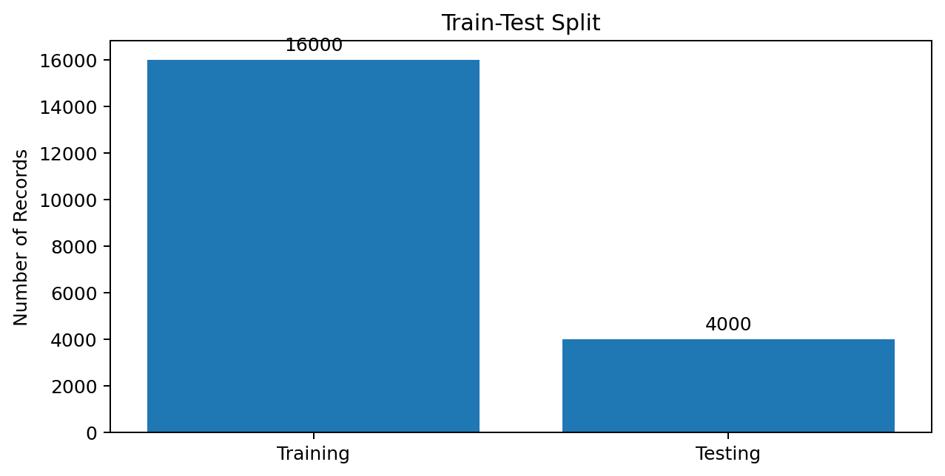
Figure 2: Training and testing records after the 80:20 stratified split.
The modelling workflow uses train_test_split with test_size=0.2, random_state=42, and stratify=y. This produces 16,000 training records and 4,000 testing records and keeps the relative distribution of High, Low, and Medium approximately consistent between the two subsets.

4.3 Numerical Preprocessing
StandardScaler is applied to numerical predictors. Scaling is particularly important for Logistic Regression, SVM, and KNN because their optimisation or distance calculations can be affected by differences in feature magnitude.

4.4 Categorical Preprocessing
Categorical predictors are transformed using OneHotEncoder with handle_unknown='ignore'. This converts each category into an indicator feature and reduces the risk of failure when a compatible future dataset contains a category that was not present during fitting.

4.5 ColumnTransformer and Pipeline
ColumnTransformer combines numerical and categorical preprocessing into a single transformation. In the notebook's advanced workflow, preprocessing is placed inside a Pipeline with XGBoost so that transformations are learned within the appropriate training portion during cross-validation. This is an important safeguard against preprocessing leakage.

4.6 Classification Algorithms

4.6.1 Logistic Regression
Logistic Regression is used as a linear multiclass baseline. It provides a simple and efficient reference against which more complex nonlinear models can be compared.

4.6.2 Decision Tree
Decision Tree recursively partitions the feature space through decision rules. It can capture nonlinear patterns but may have higher variance than ensemble methods.

4.6.3 Random Forest
Random Forest combines multiple decision trees using bagging and randomisation. The project uses 200 estimators, random_state=42, and parallel execution.

4.6.4 Support Vector Machine
The SVM experiment uses an RBF kernel. This enables nonlinear decision boundaries and benefits from the preceding numerical standardisation.

4.6.5 K-Nearest Neighbours
KNN predicts from nearby training observations. The project uses k=5. Because KNN is distance-based, scaling is essential.

4.6.6 Gaussian Naive Bayes
Gaussian Naive Bayes uses Bayes' theorem and a conditional-independence assumption. It is computationally simple but its assumptions may be restrictive.

4.6.7 Gradient Boosting
Gradient Boosting builds learners sequentially so that later learners concentrate on reducing previous errors.

4.6.8 AdaBoost
AdaBoost increases emphasis on observations that previous weak learners classified incorrectly.

4.6.9 XGBoost
XGBoost uses gradient-boosted decision trees and is particularly effective for structured tabular data. The supplied baseline uses 300 estimators, depth 6, learning rate 0.05, subsample 0.8, column subsampling 0.8, and a multiclass soft-probability objective.

4.6.10 Tuned XGBoost
RandomizedSearchCV is used to search XGBoost hyperparameters. The documented selected configuration is 400 estimators, max_depth=5, learning_rate=0.1, subsample=0.8, colsample_bytree=0.8, min_child_weight=7, and gamma=0.

4.7 Evaluation Metrics
Accuracy is the proportion of correctly classified observations. Precision measures how reliable a predicted class is, recall measures how many actual observations of a class are found, and F1-score combines precision and recall. Macro averages give High, Low, and Medium equal importance. Confusion matrices provide a direct view of class-level errors.

4.8 Advanced Machine Learning Techniques

4.8.1 Five-Fold Stratified Cross-Validation
The XGBoost workflow is validated using five-fold StratifiedKFold. The reported macro F1 values are 0.9288, 0.9426, 0.9432, 0.9425, and 0.9450. The mean is approximately 0.9404 and the standard deviation is approximately 0.0059, indicating relatively consistent performance across the folds.
Fold | Macro F1
1 | 0.9288
2 | 0.9426
3 | 0.9432
4 | 0.9425
5 | 0.9450
Mean | 0.9404
Std. Dev. | 0.0059

4.8.2 Randomized Hyperparameter Search
RandomizedSearchCV samples 20 combinations from the defined XGBoost parameter space rather than exhaustively testing every combination. Macro F1 is used for model selection. This provides a practical balance between search breadth and computational cost.
Parameter | Selected Value
n_estimators | 400
max_depth | 5
learning_rate | 0.1
subsample | 0.8
colsample_bytree | 0.8
min_child_weight | 7
gamma | 0

4.8.3 Feature Importance
After fitting the tuned XGBoost model, transformed feature names can be paired with model feature_importances_. The supplied results identify Routine_Task_Percentage as the strongest transformed feature. Feature importance should be interpreted as model association rather than causal influence.

5. Applications
- Workforce planning and scenario analysis.
- Reskilling and training prioritisation.
- Career and labour-market analysis.
- Research into relationships between AI adoption and job characteristics.
- Interactive exploration of model performance through the Streamlit dashboard.
- Individual profile analysis through the dashboard's prediction interface.

5.1 Responsible Use
Because employment-related predictions can have significant consequences, the system should not be used as an automatic hiring, firing, promotion, or termination mechanism. The dashboard should be used to demonstrate model behaviour and support analytical discussion. Real deployment would require validation of labels, fairness assessment, uncertainty analysis, human oversight, and monitoring.

6. Functional Requirements
ID | Requirement
FR-01 | Load the project dataset.
FR-02 | Inspect data structure and quality.
FR-03 | Separate Layoff_Risk from predictors.
FR-04 | Display class distribution.
FR-05 | Perform stratified train-test splitting.
FR-06 | Preprocess numerical and categorical features.
FR-07 | Train and compare classification algorithms.
FR-08 | Generate classification reports and accuracy.
FR-09 | Generate confusion matrices.
FR-10 | Perform XGBoost cross-validation.
FR-11 | Perform XGBoost hyperparameter tuning.
FR-12 | Display feature importance where supported.
FR-13 | Provide interactive risk prediction.
FR-14 | Display predicted risk and class probabilities.

7. Non-Functional Requirements
Requirement | Expected Behaviour
Performance | Dashboard should load and train the cached models without unnecessary repeated computation.
Usability | Users should access model information through tabs, metrics, charts, selectors, and sliders.
Reproducibility | The main model training uses random_state=42.
Maintainability | Loading and model training are separated into functions and cached.
Robustness | OneHotEncoder(handle_unknown='ignore') supports unseen categories.
Portability | Application uses Python, Streamlit, pandas, NumPy, Plotly, scikit-learn, and XGBoost.
Interpretability | Classification reports, confusion matrices, and feature importance are displayed.
Responsible use | Prediction output should be interpreted as a model estimate, not a guaranteed employment outcome.

8. Implementation Strategy

8.1 Notebook Pipeline
Stage | Implementation
Input | AI impact jobs dataset
Inspection | Pandas exploratory and data-quality checks
Target | Layoff_Risk
Split | 80:20 stratified split
Preprocessing | StandardScaler + OneHotEncoder + ColumnTransformer
Training | Multiple classification models
Validation | Five-fold StratifiedKFold for XGBoost
Tuning | RandomizedSearchCV
Selection | Tuned XGBoost
Interpretation | Feature importance
Figure 1: Overall machine-learning implementation pipeline.

8.2 Streamlit Integration
The uploaded app.py implements a separate interactive application layer over the same project concept. The application uses Streamlit for the interface, pandas and NumPy for data handling, Plotly Express for interactive visualisations, and scikit-learn/XGBoost for preprocessing and model training. The application is organised around three tabs: Data Overview, Model Comparison, and Predict Risk.

8.3 Caching Strategy
The dashboard uses @st.cache_data for load_data() and @st.cache_resource for train_models(). Data caching avoids repeatedly reading the Excel file during interaction, while resource caching avoids retraining the model set on every Streamlit rerun. This is an important implementation detail because Streamlit reruns the script in response to user interactions.

8.4 Model Pipeline in the Dashboard
The dashboard's train_models() function removes the Layoff_Risk target and Layoff_Probability from the predictor set, identifies numerical and categorical columns, builds a ColumnTransformer, performs an 80:20 stratified split, label-encodes the target, and trains four candidate models: Logistic Regression, Decision Tree, Random Forest, and XGBoost. For each model, the application stores its fitted pipeline, accuracy, classification report, and confusion matrix.

9. Streamlit Dashboard

9.1 Dashboard Overview
The uploaded Streamlit application is titled “AI Impact - Job Layoff Risk Classifier”. It is configured with a wide page layout and presents the machine-learning results through three functional tabs. The dashboard is therefore an interactive front end to the classification workflow rather than a separate modelling problem.

9.2 Data Overview Tab
The Data Overview tab displays three headline metrics: Records, Features, and Classes. It calculates the target distribution from Layoff_Risk and presents the distribution in both a bar chart and a donut-style pie chart using Plotly Express. An expandable Preview Data section displays the first 20 rows of the dataset.
Dashboard Component | Function
Records metric | Displays len(df)
Features metric | Displays df.shape[1] - 1
Classes metric | Displays number of unique Layoff_Risk classes
Bar chart | Shows count of each risk class
Pie chart | Shows risk-class share
Preview Data | Shows first 20 records in an expandable dataframe

9.3 Model Comparison Tab
The Model Comparison tab builds an accuracy dataframe from the four dashboard models and sorts it from highest to lowest accuracy. A Plotly bar chart displays the comparison. A selectbox allows the user to inspect one model at a time. For the selected model, the dashboard displays accuracy, a dataframe representation of the classification report, and an interactive confusion matrix.

9.4 Feature Importance in the Dashboard
When the selected model exposes feature_importances_, the application retrieves transformed feature names from the fitted preprocessing component and pairs them with the model's importance values. The top 15 features are then displayed as a horizontal Plotly bar chart. In the supplied application this feature-importance view is therefore available for tree-based models such as Decision Tree, Random Forest, and XGBoost, but not for Logistic Regression.

9.5 Predict Risk Tab
The Predict Risk tab allows the user to choose one of the four dashboard models and enter feature values. Numerical fields are presented as sliders whose lower and upper limits come from the minimum and maximum values in the loaded dataset, with the dataset median used as the default. Categorical fields are presented through select boxes populated from the observed unique values.

9.6 Prediction Output
When the user clicks “Predict Layoff Risk”, the entered values are converted into a one-row DataFrame using the original predictor column order. The selected fitted pipeline predicts the encoded class, which is converted back into the original risk label using LabelEncoder. The dashboard then displays the predicted risk and creates a probability bar chart showing the model's predicted probability for each risk class.

9.7 Streamlit Dashboard Workflow
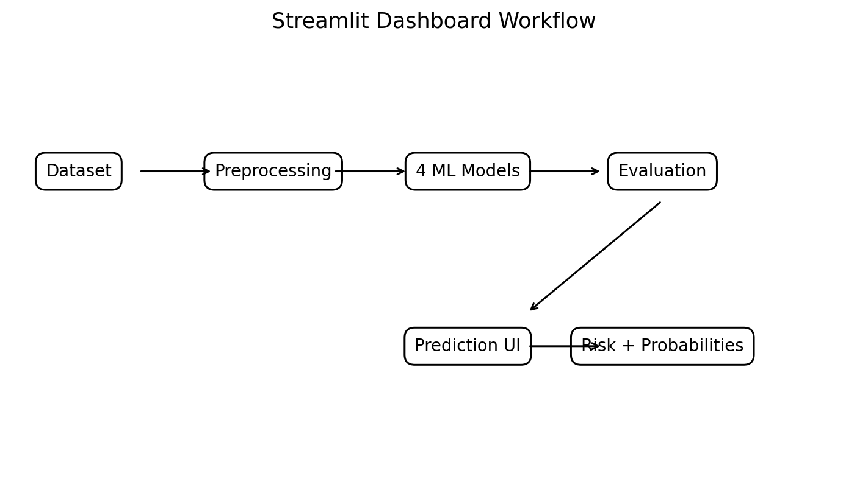
Figure 7: Streamlit dashboard workflow from data loading to prediction output.
Step | Dashboard Action | Output
1 | Load Excel dataset | DataFrame
2 | Identify target and predictors | X and y
3 | Identify numeric/categorical features | Feature lists
4 | Build ColumnTransformer | Preprocessing pipeline
5 | Split and encode target | Training/testing data
6 | Train four candidate models | Fitted pipelines
7 | Calculate evaluation metrics | Accuracy, report, confusion matrix
8 | Compare models | Accuracy chart
9 | Inspect model | Report + confusion matrix + feature importance
10 | Enter a job profile | Interactive input form
11 | Predict risk | High / Medium / Low
12 | Display probabilities | Prediction-confidence chart
Figure 2: Functional workflow of the uploaded Streamlit dashboard.

9.8 Libraries Used by the Dashboard
Library | Use in app.py
streamlit | Dashboard UI, tabs, metrics, inputs, caching, status messages
pandas | Dataset loading, DataFrames, reports, probability tables
numpy | Numerical-type detection and feature handling
plotly.express | Interactive bar, pie, image/confusion-matrix and importance charts
scikit-learn | Splitting, preprocessing, pipelines, classifiers, encoding and metrics
xgboost | XGBoost classifier

9.9 Deployment Requirements
The dashboard requires the application file, the referenced Excel dataset, and the Python dependencies imported by app.py. A deployment package should therefore include app.py, the exact dataset file expected by load_data(), a requirements.txt containing compatible versions of Streamlit, pandas, NumPy, Plotly, scikit-learn, and XGBoost, and a README.md describing how to start the application. The supplied project guidelines explicitly require app.py, requirements.txt, and README.md as deployment deliverables.

9.10 Important Implementation Observation
The notebook and dashboard use related but not completely identical model sets. The notebook/project analysis evaluates a wider model family, including SVM, KNN, Naive Bayes, Gradient Boosting, AdaBoost, and tuned XGBoost. The uploaded dashboard trains four models directly: Logistic Regression, Decision Tree, Random Forest, and baseline XGBoost. Therefore, the dashboard's “Model Comparison” should be understood as an interactive comparison of its four implemented models, while the report's complete model comparison covers the broader notebook experiment.

10. Outcomes and Results

10.1 Notebook Model Comparison
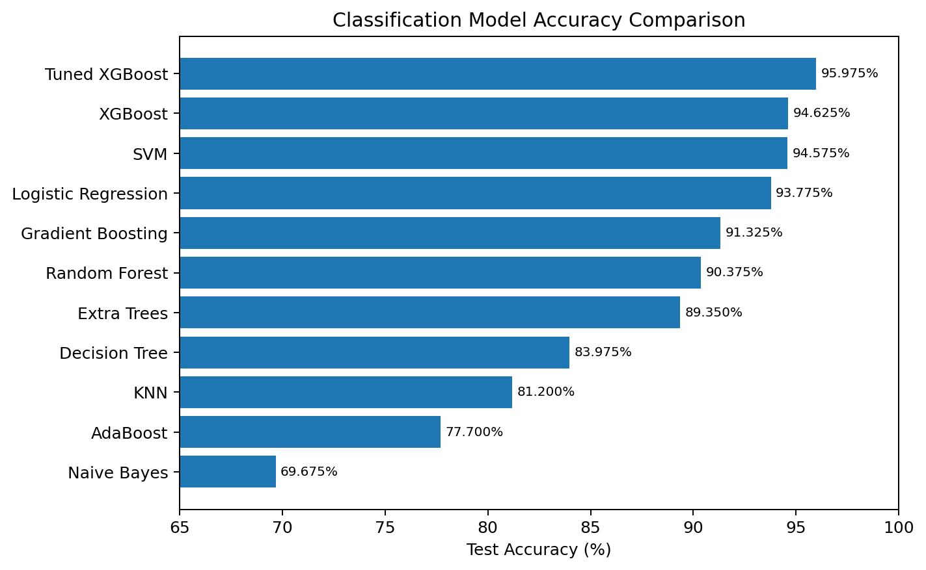
Figure 3: Test accuracy comparison across the evaluated classification models.
Model | Test Accuracy | Reported Macro F1 / Note
Tuned XGBoost | 95.975% | ≈0.96; strongest reported model
XGBoost | 94.625% | 0.9462
SVM (RBF) | 94.575% | Strong challenger
Logistic Regression | 93.775% | 0.9375
Gradient Boosting | 91.325% | Boosting baseline
Random Forest | 90.375% | 0.9035
Extra Trees | 89.350% | Additional tree ensemble
Decision Tree | 83.975% | 0.8389
KNN (k=5) | 81.200% | Distance-based model
AdaBoost | 77.700% | Lower-performing boosting model
Naive Bayes | 69.675% | Lowest reported accuracy
Table 5: Complete model comparison from the supplied project results.
The model comparison shows that tuned XGBoost is the strongest reported classifier. Baseline XGBoost is second, followed closely by SVM and Logistic Regression. The performance pattern indicates that nonlinear ensemble methods can capture useful relationships in the tabular feature space, while the linear model remains a strong and simpler alternative.

10.2 Detailed Baseline Metrics
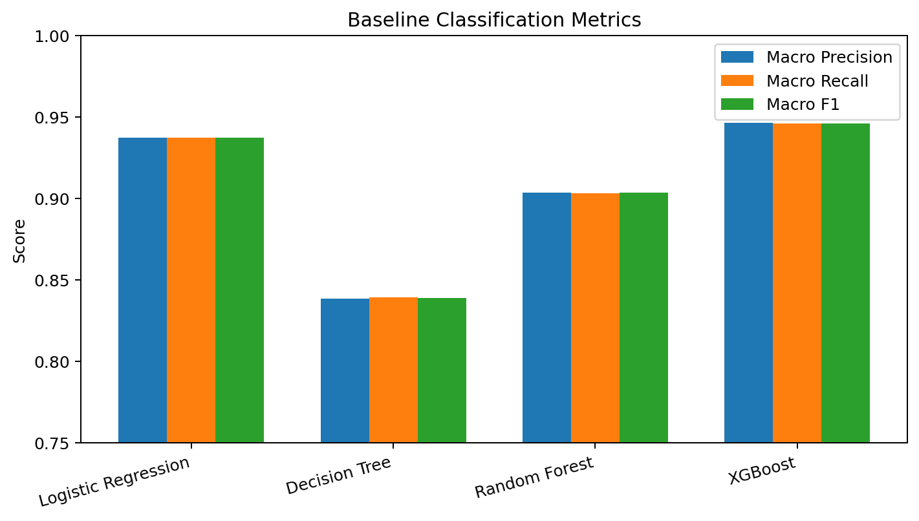
Figure 4: Macro precision, recall, and F1-score for the four baseline models.
Model | Class | Precision | Recall | F1 | Support
Logistic Regression | High | 0.9539 | 0.9596 | 0.9567 | 1360
 | Low | 0.9521 | 0.9485 | 0.9503 | 1320
 | Medium | 0.9066 | 0.9045 | 0.9056 | 1320
 | Macro Avg | 0.9375 | 0.9375 | 0.9375 | 4000
Decision Tree | High | 0.8747 | 0.8831 | 0.8789 | 1360
 | Low | 0.8772 | 0.8871 | 0.8821 | 1320
 | Medium | 0.7639 | 0.7477 | 0.7557 | 1320
 | Macro Avg | 0.8386 | 0.8393 | 0.8389 | 4000
Random Forest | High | 0.9257 | 0.9338 | 0.9297 | 1360
 | Low | 0.9305 | 0.9227 | 0.9266 | 1320
 | Medium | 0.8544 | 0.8538 | 0.8541 | 1320
 | Macro Avg | 0.9035 | 0.9034 | 0.9035 | 4000
XGBoost | High | 0.9624 | 0.9603 | 0.9614 | 1360
 | Low | 0.9640 | 0.9523 | 0.9581 | 1320
 | Medium | 0.9126 | 0.9258 | 0.9191 | 1320
 | Macro Avg | 0.9463 | 0.9461 | 0.9462 | 4000

10.3 Cross-Validation Results
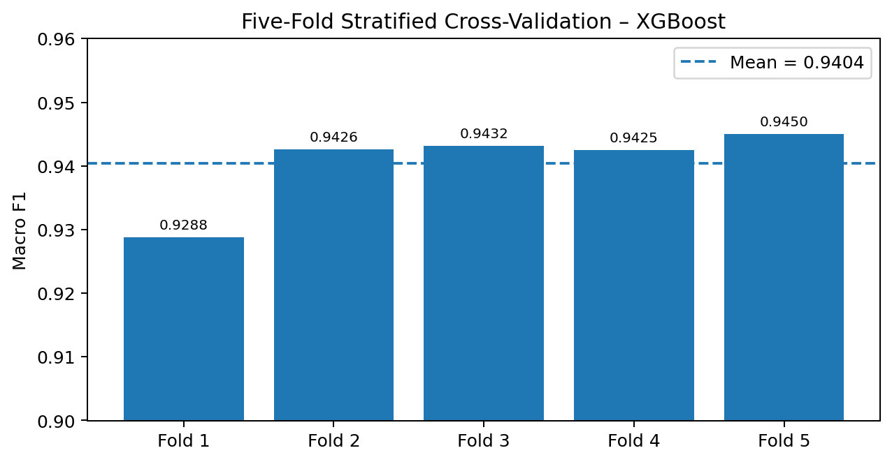
Figure 5: Five-fold stratified cross-validation macro F1 for XGBoost.
The five-fold stratified validation results for XGBoost are 0.9288, 0.9426, 0.9432, 0.9425, and 0.9450 macro F1. The mean of approximately 0.9404 and standard deviation of approximately 0.0059 indicate relatively stable performance across folds.

10.4 Hyperparameter Tuning Results
The tuned XGBoost configuration improves the reported test accuracy from 94.625% to 95.975%. This is an improvement of 1.35 percentage points. The selected parameters are 400 estimators, maximum depth 5, learning rate 0.1, subsample 0.8, column subsampling 0.8, minimum child weight 7, and gamma 0.

10.5 Feature Importance Results
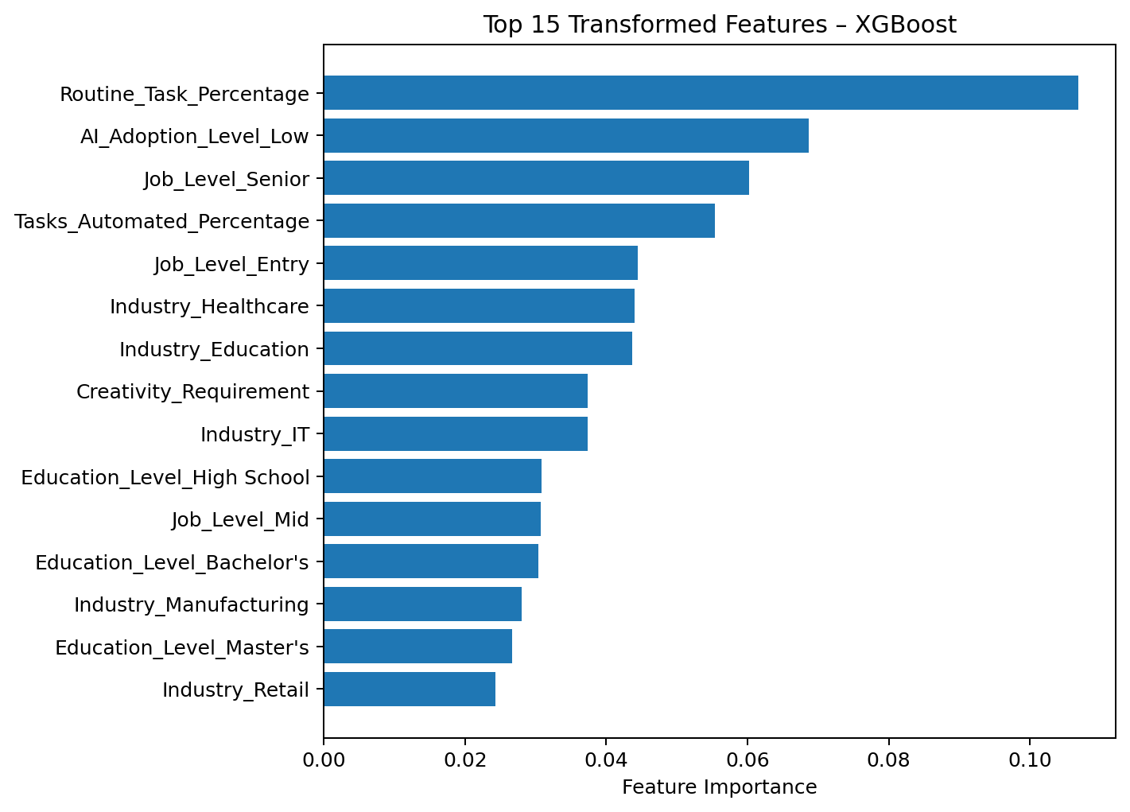
Figure 6: Top 15 transformed feature importances reported for XGBoost.
Rank | Transformed Feature | Importance
1 | Routine_Task_Percentage | 0.106839
2 | AI_Adoption_Level_Low | 0.068699
3 | Job_Level_Senior | 0.060202
4 | Tasks_Automated_Percentage | 0.055433
5 | Job_Level_Entry | 0.044420
6 | Industry_Healthcare | 0.043988
7 | Industry_Education | 0.043683
8 | Creativity_Requirement | 0.037369
9 | Industry_IT | 0.037323
10 | Education_Level_High School | 0.030852
11 | Job_Level_Mid | 0.030701
12 | Education_Level_Bachelor's | 0.030420
13 | Industry_Manufacturing | 0.028021
14 | Education_Level_Master's | 0.026699
15 | Industry_Retail | 0.024360

10.6 Dashboard Results and User Experience
The Streamlit dashboard converts the modelling results into an interactive workflow. Instead of requiring the user to execute notebook cells, the user can open the application, inspect the dataset overview, compare four implemented models, select a model for detailed inspection, view its classification report and confusion matrix, inspect feature importance where supported, and enter a new job profile to obtain a predicted risk class and class probabilities.

10.7 Key Findings
- Tuned XGBoost achieved the highest reported test accuracy of 95.975%.
- Baseline XGBoost achieved 94.625% accuracy and 0.9462 macro F1.
- SVM and Logistic Regression were close alternatives.
- The dataset is approximately balanced across High, Low, and Medium.
- Five-fold stratified validation produced a mean macro F1 of approximately 0.9404 for XGBoost.
- Routine_Task_Percentage was the most important transformed feature in the reported feature-importance ranking.
- The Medium class is comparatively harder for several baseline models.
- The Streamlit application makes model comparison and individual prediction accessible through a graphical interface.
- The dashboard and notebook have different model scopes: the dashboard implements four models while the notebook evaluates a broader set.

11. Limitations
- The supplied project files do not provide a verified external data source or a fully documented target-label generation process.
- The model learns associations and cannot establish that a feature causes layoffs.
- Performance may change on an external or future dataset.
- The dashboard trains models at runtime rather than loading a separately saved production model artefact.
- The dashboard currently uses baseline XGBoost rather than the tuned XGBoost configuration that achieved 95.975% in the notebook experiment.
- The dashboard's input controls derive ranges and categories from the loaded dataset, so the application depends on the dataset remaining available and structurally compatible.
- Employment-risk prediction is a high-impact use case and requires fairness, human oversight, and careful governance before real-world use.

11.1 Dashboard-Specific Edge Cases
- If the expected Excel file is missing, load_data() cannot load the dashboard.
- If Layoff_Risk or Layoff_Probability is absent when expected by the code, the training function may fail.
- If a categorical column contains problematic values or an incompatible data type, the preprocessing branch may require adjustment.
- If a future dataset changes feature names, the dashboard's input-generation logic may need to be updated.
- The dashboard shows prediction probabilities as a confidence-style chart; these should not automatically be interpreted as calibrated real-world probabilities.

12. Future Scope
- Save and load the complete preprocessing-plus-model pipeline rather than retraining every time the dashboard starts.
- Replace the dashboard's baseline XGBoost with the tuned XGBoost configuration after validating deployment behaviour.
- Add all notebook models to the Streamlit comparison so that the dashboard reflects the full experiment.
- Add cross-validation summaries and hyperparameter-search results to the dashboard.
- Add SHAP-based explanations for individual predictions.
- Add calibrated probability estimates and uncertainty communication.
- Add fairness and subgroup evaluation before any employment-related use.
- Add input validation and clearer warnings for values outside training ranges.
- Add CSV export of predictions and model-comparison results.
- Add model versioning, logging, drift monitoring, and automated retraining.
- Deploy the dashboard using a documented requirements.txt and README.md.
- Test the model on an independent external dataset and on future time-period data.

13. Conclusion
This project developed a complete supervised machine-learning workflow for predicting High, Medium, and Low layoff-risk categories from job-profile data. The project combines structured data inspection, stratified splitting, numerical scaling, categorical encoding, multiple classification algorithms, cross-validation, hyperparameter tuning, and feature-importance analysis. Tuned XGBoost achieved the strongest reported test accuracy of 95.975%, while baseline XGBoost achieved 94.625% and a macro F1 of 0.9462. The newly documented Streamlit dashboard extends the project from a notebook analysis into an interactive application by providing data overview, model comparison, confusion matrices, feature importance for supported models, and individual layoff-risk prediction with class probabilities. The project demonstrates the usefulness of machine learning for analytical workforce-risk research while emphasising that employment-related predictions require responsible interpretation, human oversight, fairness assessment, and validation on representative real-world data.

14. References
- Supplied ML Project Guidelines: ML Project Guidelines, including 15–20 page report structure and project deliverables.
- Supplied project dataset: ai-impact-jobs-layoff-risk-dataset.csv / final Excel dataset used by the Streamlit dashboard.
- Supplied project notebook: AI Impact on Jobs – Layoff Risk Prediction Using Machine Learning.
- Supplied Streamlit application: app.py – AI Impact - Job Layoff Risk Classifier.
- Pedregosa, F. et al. (2011). Scikit-learn: Machine Learning in Python. Journal of Machine Learning Research, 12, 2825–2830.
- Breiman, L. (2001). Random Forests. Machine Learning, 45, 5–32.
- Cortes, C. and Vapnik, V. (1995). Support-Vector Networks. Machine Learning, 20, 273–297.
- Friedman, J. H. (2001). Greedy Function Approximation: A Gradient Boosting Machine. Annals of Statistics, 29(5), 1189–1232.
- XGBoost documentation: Gradient-boosted decision-tree learning framework.
- Scikit-learn documentation: preprocessing, classification, model selection, metrics, pipelines and cross-validation.
- Streamlit documentation: application framework for interactive Python data applications.
- Plotly Express documentation: interactive data visualisation in Python.

Appendix A – Model Evaluation Details
Model | Configuration / Note | Test Accuracy
Logistic Regression | max_iter=1000 | 93.775%
Decision Tree | random_state=42 | 83.975%
Random Forest | n_estimators=200, random_state=42 | 90.375%
SVM | RBF kernel | 94.575%
KNN | n_neighbors=5 | 81.200%
Gaussian Naive Bayes | GaussianNB | 69.675%
Gradient Boosting | random_state=42 | 91.325%
AdaBoost | random_state=42 | 77.700%
XGBoost | 300 estimators, depth 6, learning rate 0.05 | 94.625%
Tuned XGBoost | 400 estimators, depth 5, learning rate 0.1, min_child_weight 7 | 95.975%

Appendix B – Dashboard Component Summary
Component | Implementation in app.py
Page configuration | st.set_page_config(page_title='Layoff Risk Classifier', layout='wide')
Data loader | @st.cache_data load_data(); reads final Excel dataset
Model trainer | @st.cache_resource train_models(df)
Preprocessing | ColumnTransformer with StandardScaler and OneHotEncoder
Target encoding | LabelEncoder
Dashboard models | Logistic Regression, Decision Tree, Random Forest, XGBoost
Data Overview | Metrics, bar chart, pie chart, data preview
Model Comparison | Accuracy bar chart, model selector, classification report, confusion matrix
Feature importance | Top 15 features for models exposing feature_importances_
Predict Risk | Model selector, numerical sliders, categorical selectboxes
Prediction | Predicted class using fitted pipeline
Probability output | Plotly bar chart of class probabilities

