Graphs:

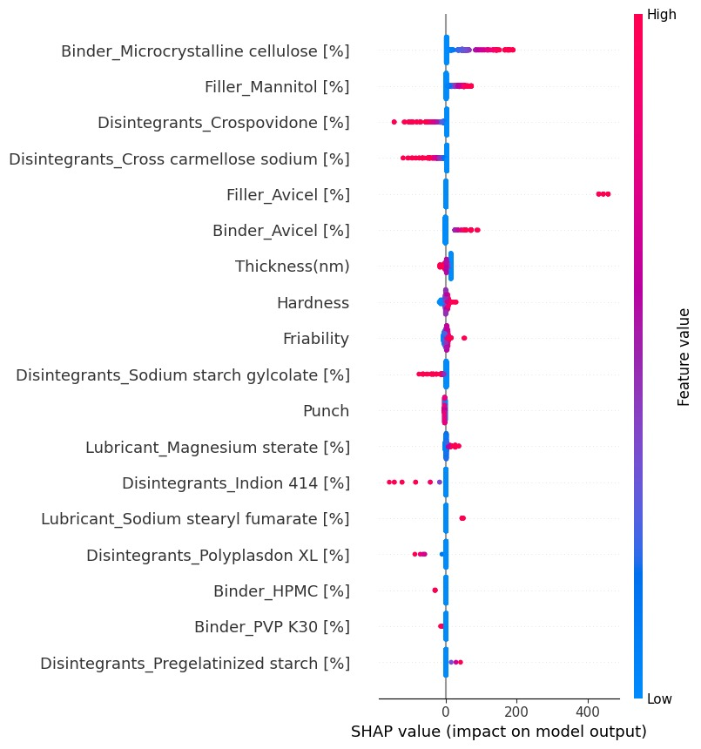

SHAP graph: tells about the importance of various feature in determining the output of the model

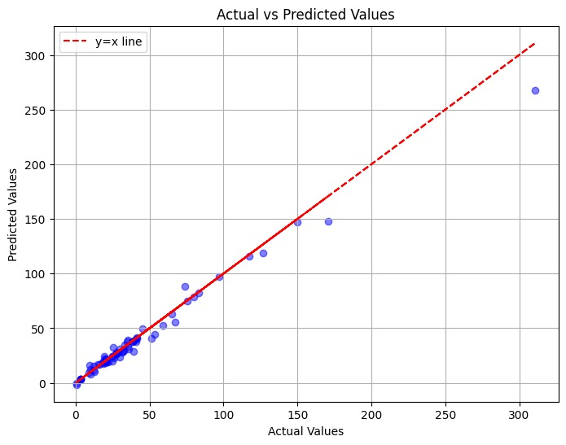

Scatter plot: tells about the accuracy of the graph, Higher the number of blue points near the red line , better accuracy

**Features**:

Disintegrants : Crospovidone, Cross carmellose sodium, Sodium starch gylcolate

Filler : Mannitol

Binder : Microcrystalline cellulose

Lubricant : Magnesium Stearate

**Analysis**

1. Decision tree regressor –
   1. Mean RMSE: 33.18
   2. Mean NRMSE: 10.0
   3. Mean R2 Score: 0.28
   4. Mean MAE: 13.28
   5. Mean MSE: 1156.34
2. Gradient Boost Regressor–
   1. Mean RMSE: 27.1
   2. Mean NRMSE: 9.0
   3. Mean R2 Score: 0.5
   4. Mean MAE: 12.81
   5. Mean MSE: 863.83
3. RandomForestRegressor -
   1. Mean RMSE: 25.98
   2. Mean NRMSE: 7.000000000000001
   3. Mean R2 Score: 0.57
   4. Mean MAE: 12.39
   5. Mean MSE: 745.91
4. ExtraTreesRegressor–
   1. Mean RMSE: 23.37
   2. Mean NRMSE: 7.000000000000001
   3. Mean R2 Score: 0.65
   4. Mean MAE: 9.55
   5. Mean MSE: 608.58
5. Lasso Model –
   1. Mean RMSE: 26.38
   2. Mean NRMSE: 8.0
   3. Mean R2 Score: 0.55
   4. Mean MAE: 13.38
   5. Mean MSE: 761.85
6. SVM –
   1. Mean RMSE: 30.04
   2. Mean NRMSE: 9.0
   3. Mean R2 Score: 0.4
   4. Mean MAE: 14.18
   5. Mean MSE: 970.99
7. DeepLearning –
   1. R-squared (R2): 0.7970290715928676
   2. Normalized RMSE (NRMSE): 6.2934255378
   3. MSE: 782.665782536721
   4. RMSE: 27.97616454299483
   5. MAE: 14.877540389696795
   6. RMSLE: 0.5925490786184029
   7. Mean Residual Deviance: 782.665782536721