**Exercise 3: Create a markdown cell for an introduction**

Jupyter note book are used in data science for recording experiments and projects. Jupyter lab is compatible with many files and data science languages.Jupyter implemented two process model with kernel and client and note book server is responsible for saving and loading the note books.

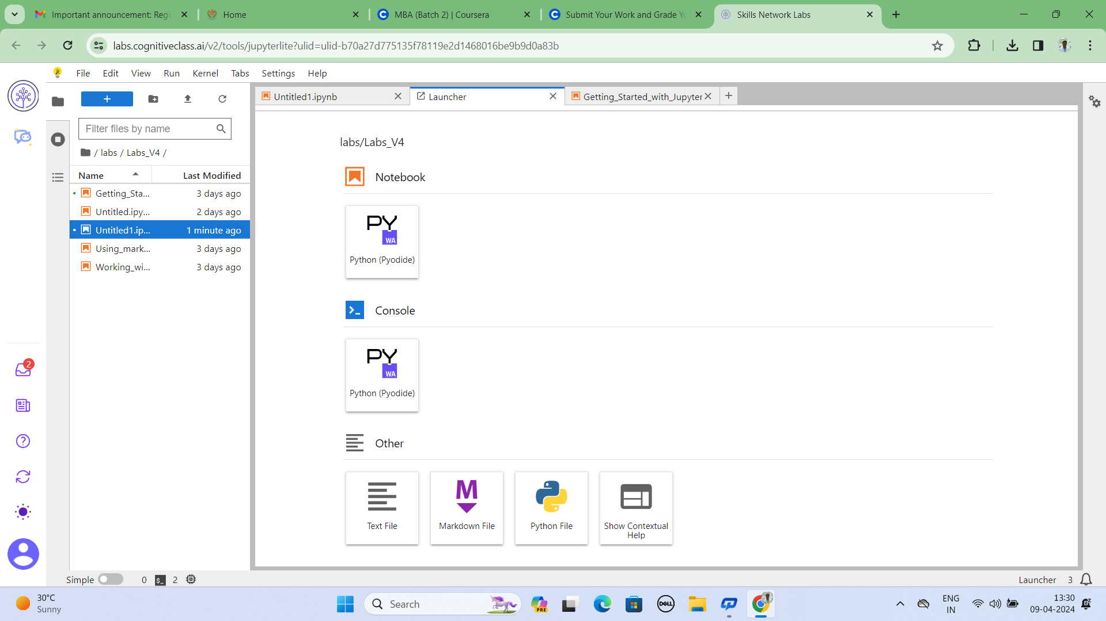

Cell Edit

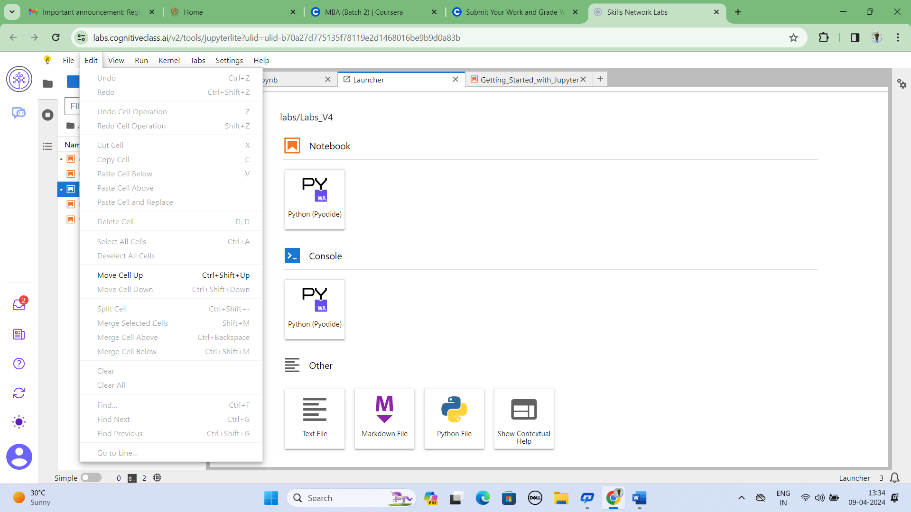

Operating system tools: Jupyter note book consist of Brower based application that allows to create document containing code, equation, visualization and text links …etc.

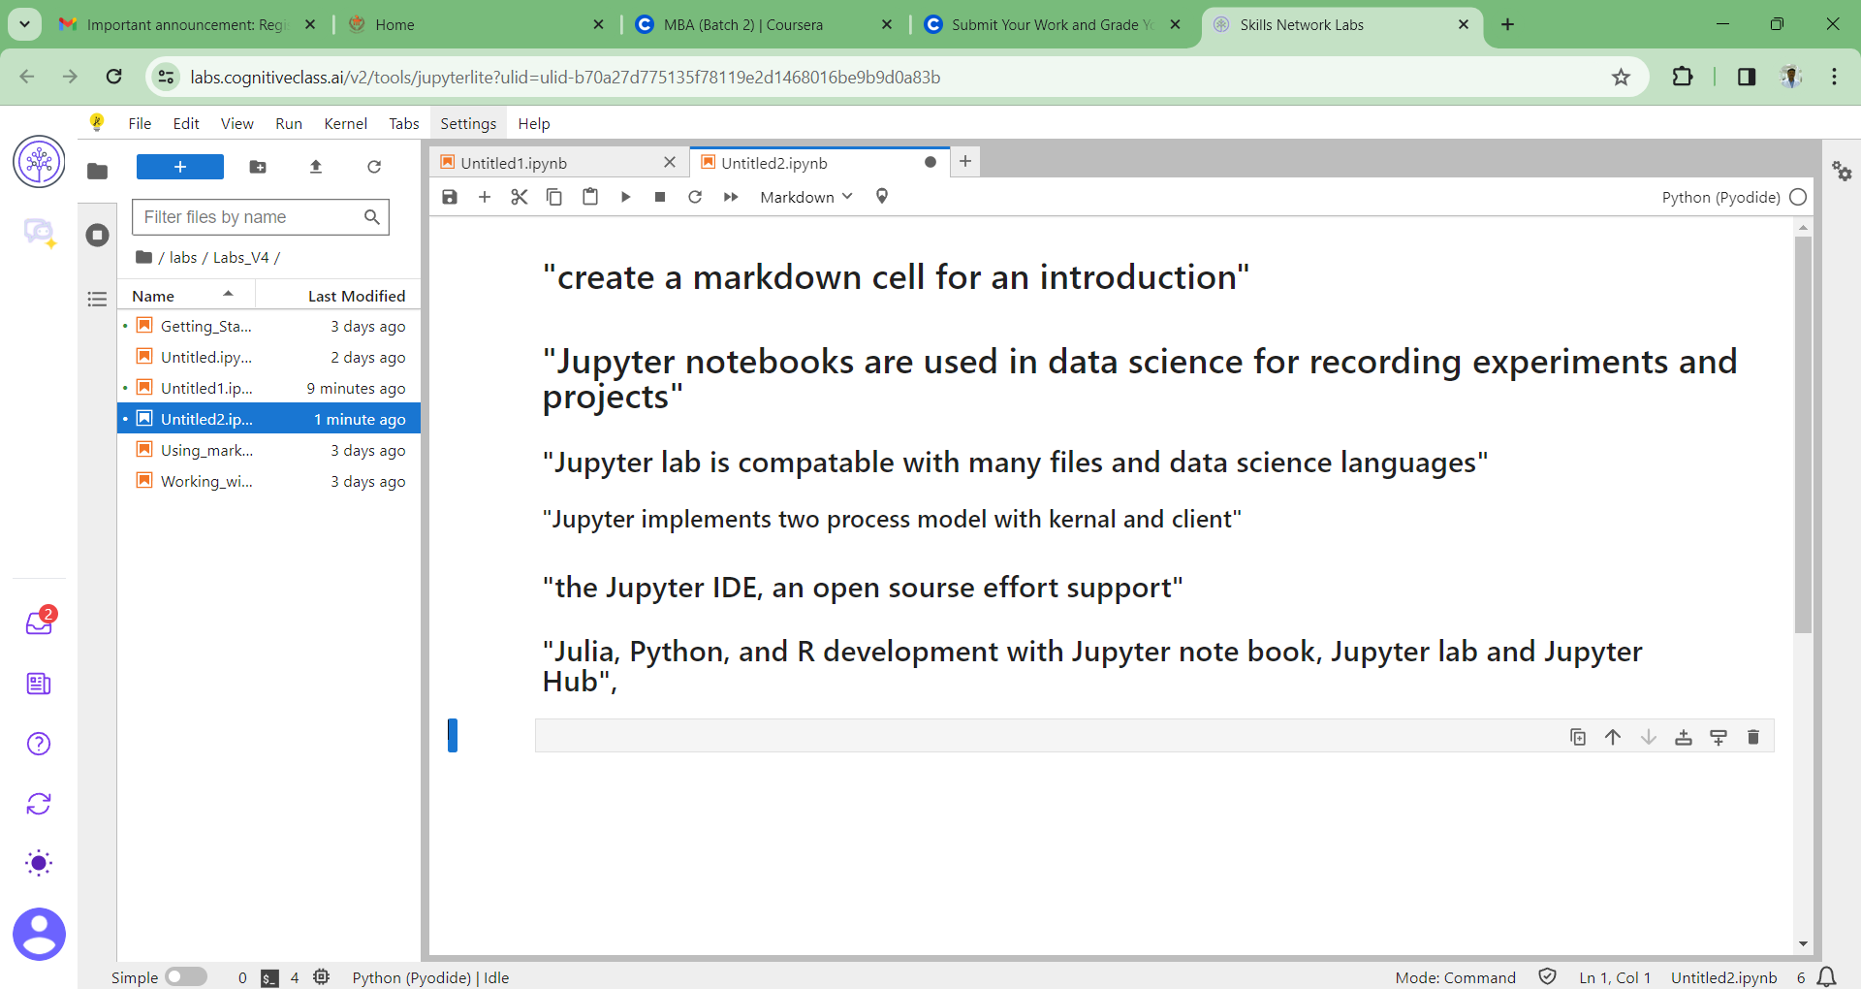

**Exercise 4: Create a markdown cell to list data science language**

Some of the popular language that data science scientist use are: Python, R, SQL, Scala, JAVA, C++ and Julia…etc





**Exercise 5: Create a markdown cell to list data science libraries**

Python lab expanded feature with some of Anaconda’s most extensive pre-installed python libraries “included Python scientific computing libraries like, Pandas, NumPy, SciPy and matplotlib"



**Exercise 6: Create a markdown cell with of data science tools**

Create a single column table in this cell with first row containing the header Data Science tools.The subsequently three to fourth rows in the table indicate four development environments open source tools used in data science.

Open source tools consist of Data management tools, such as My SQL(Ceph), Postgre SQL (CouchDB), Cassandra (mangoDB)..ect.

Operation system tools consist of open source tools that are programming by language such as Jupyter, Rstudio, Microsoft visualstudio, pycharm,spyder and Anaconda navigation

Data integrating and transformation tools have consist of open source tools for data interpreting such SparkSQL, Kubeflow, airflow, node-Red,, nifi and kafka.

Data visualization tools have open-source tools like Pixie dust, kibana, Hue, superset

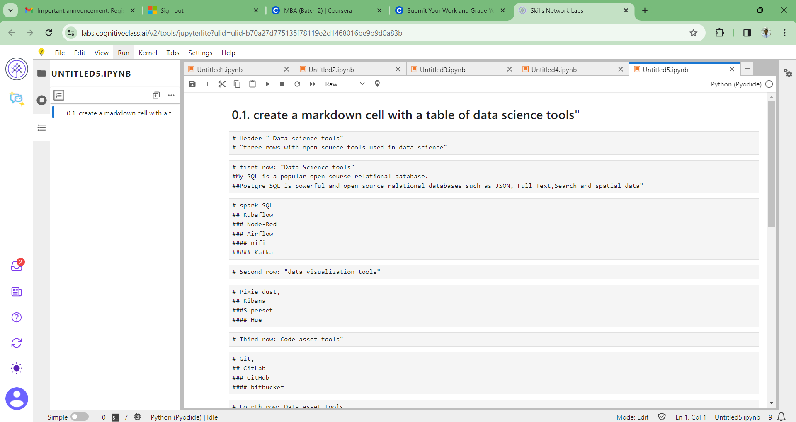

**Exercise 7: Create a markdown cell introducing arithmetic expression example**

Add a line in this cell with H3 style heading with text like:

Python function following in markdown cell:

Addition X=10, Y=50, X+y=Z

Multiplying X*y=Z

Dividing x/y=Z

