**Exercise 3: Create a markdown cell for an introduction**

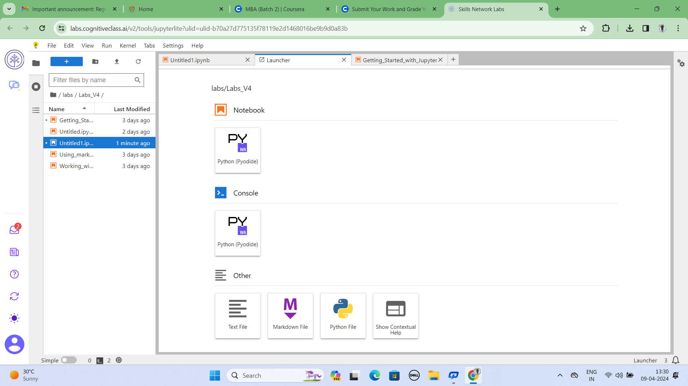

Cell Edit

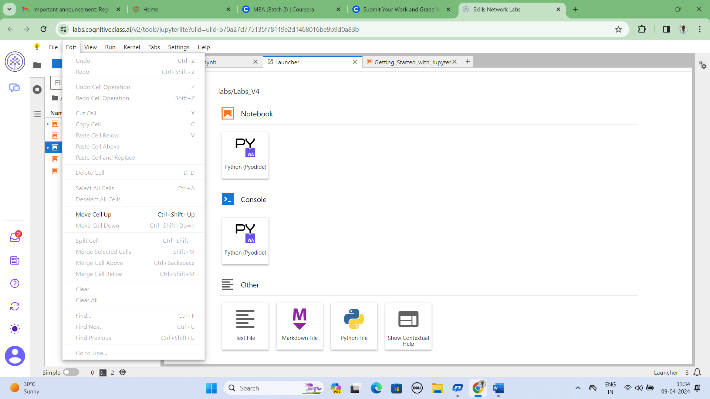

Operating system tools: Jupyter note book consist of Brower based application that allows to create document containing code, equation, visualization and text links …etc.

