**西 安 邮 电 大 学**

（计算机学院）

**Java语言程序设计**

**课内实验报告**

**实验名称:** **JavaFx基础**

**专业名称: 计算机科学与技术**

**班 级: 计科1602**

**学生姓名: 杨睿涛**

**学号（8位）: 04161059**

**指导教师: 张德慧**

**实验时间: 2018年11月26日**

**一. 实验目的及实验环境**

1了解JavaFX与Swing以及AWT的区别。

2熟悉JavaFX程序的基本结构及其启动方法。

3掌握使用布局面板对UI组件布局进行控制的方法。

4了解Color类和Font类的作用。

5 掌握Image和ImageView类的使用方法。

6 掌握形状类的使用方法。

**二. 实验内容**。

1 基本内容（实验前请及时熟悉如下相关内容）

1）使用JavaFX创建简单的GUI图形用户界面程序。

2）使用布局面板中的FlowPane、GridPane和BorderPane等管理UI组件布局。

3）使用Image和ImageView类显示图片。

4）使用Color类和Font类指定颜色和字体。

5）使用形状类画图、显示图形。

**（Y. Daniel Liang英文第10版可以在网络教学综合平台课程资源栏目中下载）**

**2 综合实验：**

**2.1 (Y. Daniel Liang英文第10版P578：14.1)** (Display images) Write a program that displays four images in a grid pane, as shown in Figure 14.43a.



**FIGURE 14.43 (a) Exercise 14.1 displays four images.**

**2.2 (Y. Daniel Liang英文第10版P579：14.4) 14.4 (Color and font) Write a program that displays five texts vertically, as shown in Figure 14.44a. Set a random color and opacity for each text and set the font of each text to Times Roman, bold, italic, and 22 pixels.**



**FIGURE 14.44 (a) Five texts are displayed with a random color and a specified font.**

**2.3(Y. Daniel Liang英文第10版P580：14.15) *14.15 (Display a STOP sign) Write a program that displays a STOP sign, as shown in Figure 14.47b. The octagon is in red and the sign is in white. (Hint: Place an octagon and a text in a stack pane.)**



**FIGURE 14.47 (b) Exercise 14.15 paints a STOP sign.**

**2.4 (Y. Daniel Liang英文第10版P583：14.26)** **14.26 (Use the ClockPane1 class) Write a program that displays two clocks. The hour, minute, and second values are 4, 20, 45 for the first clock and 22, 46, 15 for the second clock, as shown in Figure 14.51c.**



**FIGURE 14.51 (c) Exercise 14.26 displays two clocks.**

**2.5 附加题（供学有余力的同学选做，平时成绩有加分！**C:\Users\ZHANGD~1\AppData\Local\Temp\SGPicFaceTpBq\7180\009AB711.png**）**

**(Y. Daniel Liang英文第10版P578：14.3)** **\*14.3 (Display three cards) Write a program that displays three cards randomly selected from a deck of 52, as shown in Figure 14.43c. The card image files are named 1.png, 2.png, …, 52.png and stored in the image/card directory.**

**All three cards are distinct and selected randomly. Hint: You can select random cards by storing the numbers 1–52 to an array list, perform a random shuffle introduced in Section 11.12, and use the first three numbers in the array list as the file names for the image.**



***FIGURE 14.43 (c) Exercise 14.3*** ***(c) Three cards are randomly selected.***

**2.6 附加题（供学有余力的同学选做，平时成绩有加分！**C:\Users\ZHANGD~1\AppData\Local\Temp\SGPicFaceTpBq\7180\009AB711.png**）**

**(Y. Daniel Liang英文第10版P581：14.18) *14.18 (Plot the square function) Write a program that draws a diagram for the function f(x) = x2 (see Figure 14.48b).**

**Hint: Add points to a polyline using the following code:**

Polyline polyline = **new** Polyline( );

ObservableList<Double> list = polyline.getPoints( );

**double** scaleFactor = **0.0125**;

**for** (**int** x = **-100**; x <= **100**; x++) {

list.add(x + **200.0**);

list.add(scaleFactor * x * x);

}

1. **方案设计（核心代码和流程设计）**

2.1  
**public class** TestDisPlayPictures **extends** Application{  
 @Override  
 **public void** start(Stage primaryStage) {  
 **try** {Image image1 = **new** Image(**"file:E:\\pictures\\1.jpg"**);  
 ImageView imageView1 = **new** ImageView();  
 imageView1.setImage(image1);FlowPane root=**new** FlowPane();root.setHgap(10);  
 root.setVgap(15);root.getChildren().add(imageView1);  
 root.getChildren().add(imageView2);  
 root.getChildren().add(imageView3);  
 root.getChildren().add(imageView4);  
 *//创建场景，设置显示图片大小* Scene scene = **new** Scene(root,620,400);  
 *//将场景添加入stage中* primaryStage.setScene(scene);  
 *//显示场景* primaryStage.show();  
 } **catch**(Exception e) {  
 e.printStackTrace();  
 }  
 }  
}

2.2  
**public class** TestTextColor **extends** Application {  
 **public void** start(Stage primaryStage){  
 primaryStage.setTitle(**"TestTextColor"**);  
 Group root=**new** Group();  
 Text text1=**new** Text(10,50,**"java"**);  
 text1.setFont(Font.*font*(**"Times Roman"**, FontWeight.***BOLD***,FontPosture.***ITALIC***,22));  
 text1.setFill(Color.***BLUE***);  
 text1.setRotate(90);  
 root.getChildren().add(text1);  
 Scene scene=**new** Scene(root,300,200,Color.***WHITE***);  
 primaryStage.setScene(scene);  
 primaryStage.show();  
 }  
}

2.3  
**public class** TestDrawing **extends** Application {  
 **public void** start(Stage primaryStage){  
 primaryStage.setTitle(**" Drawing Octagon:"**);  
 StackPane root=**new** StackPane();  
 Polygon polygon=**new** Polygon(85, 15, 155, 15,225,85,225,155,155,225,85,225,15,155,15,85);  
 polygon.setFill(Color.***RED***);  
 root.getChildren().add(polygon);  
 Text text=**new** Text(105,105,**"STOP"**);  
 text.setFont(Font.*font*(**"宋体"**,50));  
 text.setFill(Color.***WHITE***);  
 root.getChildren().add(text);

2.4  
 **protected void** paintClock() {  
 **double** clockRadius=Math.*min*(**w**,**h**)*0.8*0.5;*//时钟  
 //时钟圆心* **double** centerX=**w**/2;  
 **double** centerY=**h**/2;  
 *//画时钟* Circle circle=**new** Circle(centerX,centerY,clockRadius);  
 circle.setFill(Color.***WHITE***);  
 circle.setStroke(Color.***BLACK***);  
  
 *//对时钟进行装饰* Text t1=**new** Text(centerX-5,centerY-clockRadius+12,**"12"**);  
 Text t2=**new** Text(centerX-clockRadius+3,centerY+5,**"9"**);  
 Text t3=**new** Text(centerX+clockRadius-10,centerY+3,**"3"**);  
 Text t4=**new** Text(centerX-3,centerY+clockRadius-3,**"6"**);  
 *//画秒针* **double** sLength=clockRadius*0.8;  
 **double** scondX=centerX+sLength*Math.*sin*(**second**\*(2*Math.***PI***/60));  
 **double** scondY=centerY-sLength*Math.*cos*(**second**\*(2*Math.***PI***/60));  
 Line sline=**new** Line(centerX,centerY,scondX,scondY);  
 sline.setStroke(Color.***RED***);*//秒针为红色  
 //画分针* **double** mLength=clockRadius*0.65;  
 **double** minuteX=centerX+mLength*Math.*sin*(**minute**\*(2*Math.***PI***/60));  
 **double** minuteY=centerY-mLength*Math.*cos*(**minute**\*(2*Math.***PI***)/60);  
 Line mline=**new** Line(centerX,centerY,minuteX,minuteY);  
 mline.setStroke(Color.***BLUE***);*//分针为蓝色  
 //画时针* **double** hLength=clockRadius*0.5;  
 **double** hourX=centerX+hLength*Math.*sin*((**hour**%12+**minute**/60.0)*(2*Math.***PI***/12));  
 **double** hourY=centerY-hLength*Math.*cos*((**hour**%12+**minute**/60)*(2*Math.***PI***/12));  
 Line hline=**new** Line(centerX,centerY,hourX,hourY);  
 hline.setStroke(Color.***BLACK***);*//时针为黑色* getChildren().clear();  
 *//将点数、秒针、分针、时针加进时钟* getChildren().addAll(circle,t1,t2,t3,t4,sline,mline,hline);  
 }  
}  
**public class** TestClock **extends** Application {  
 @Override  
 **public void** start(Stage primaryStage) {  
 FlowPane root=**new** FlowPane();  
 root.setHgap(20);  
 root.setVgap(20);  
  
 ClockPane clock1=**new** ClockPane(4,20,45);  
 root.getChildren().add(clock1);  
  
 ClockPane clock2=**new** ClockPane(22,46,15);  
 root.getChildren().add(clock2);  
  
 Scene scene=**new** Scene(root,500,250);  
 primaryStage.setTitle(**"ClockAnimation"**);  
 primaryStage.setScene(scene);  
 primaryStage.show();  
 }  
}

**四．测试数据及运行结果**

1. 正常测试数据（3组）及运行结果；

2.1

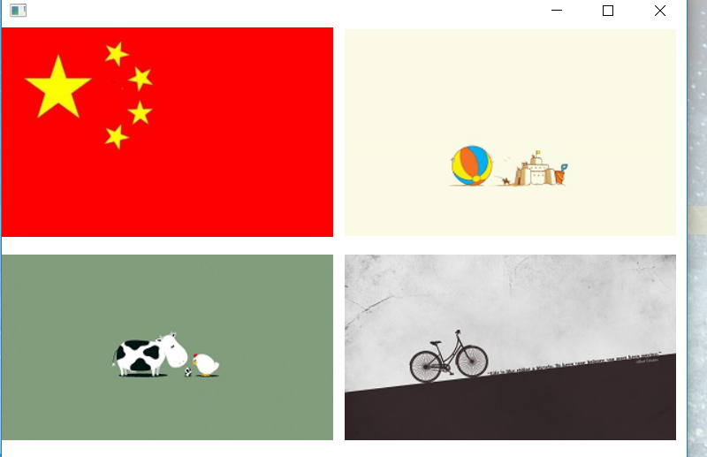

2.2

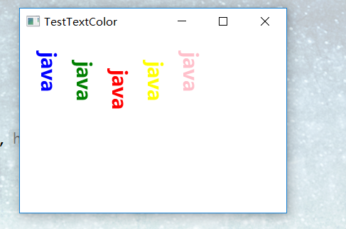

2.3

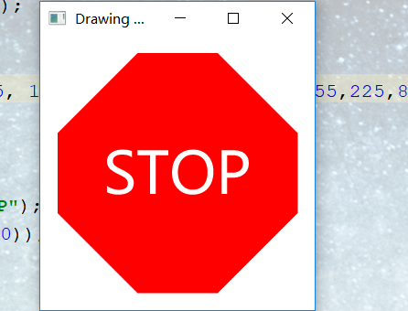

2.4

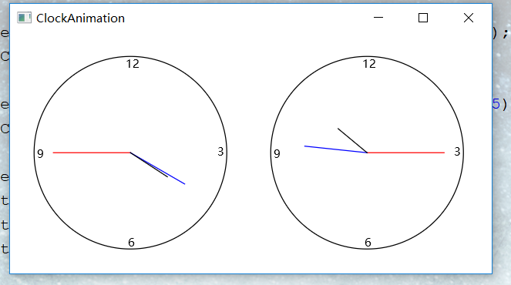

2．非正常测试数据（2组）及运行结果。

无

**五．总结**

1. 实验过程中遇到的问题及解决办法。

①对于类的定义和调用有些遗忘，通过查阅网站再次熟悉了相关用法。

②对于FlowPane、GridPane和BorderPane类、Image和ImageView类Color类和Font类的用法还不是很熟悉，通过查阅书本和网站逐步熟悉掌握用法。

1. 对设计及调试过程的心得体会。

Java语言的程序设计相对于C++语言程序设计有很大程度上的相似，所以在C++的基础上学习Java相对来说简单一些，但依旧有很多不同。Java的庞大类库以及快捷键方法在很大程度上使敲Java代码变得更加快捷方便快捷而且不易出错。此次上机就了解熟悉了FlowPane、GridPane和BorderPane

Image和ImageView类Color类和Font类等以及其相关用法。另外还了解到Alt加上Insert的快捷方式。

Java语言是如今应用广泛的语言，我们应该熟练掌握好Java语言的应用与开发。

**六．附录：**源代码（请把源代码按照实验内容附到其后）

2.1

**package** sample;  
**import** javafx.application.Application;  
**import** javafx.scene.Scene;  
**import** javafx.scene.image.Image;  
**import** javafx.scene.image.ImageView;  
**import** javafx.scene.layout.FlowPane;  
**import** javafx.scene.layout.GridPane;  
**import** javafx.stage.Stage;  
**public class** TestDisPlayPictures **extends** Application{  
 @Override  
 **public void** start(Stage primaryStage) {  
 **try** {  
 *//创建Image对象以及ImageView对象* Image image1 = **new** Image(**"file:E:\\pictures\\1.jpg"**);  
 Image image2 = **new** Image(**"file:E:\\pictures\\2.jpg"**);  
 Image image3 = **new** Image(**"file:E:\\pictures\\3.jpg"**);  
 Image image4 = **new** Image(**"file:E:\\pictures\\4.jpg"**);  
 ImageView imageView1 = **new** ImageView();  
 ImageView imageView2 = **new** ImageView();  
 ImageView imageView3 = **new** ImageView();  
 ImageView imageView4 = **new** ImageView();  
 imageView1.setImage(image1);  
 imageView2.setImage(image2);  
 imageView3.setImage(image3);FlowPane root=**new** FlowPane();root.setHgap(10);  
 root.setVgap(15);root.getChildren().add(imageView1);  
 root.getChildren().add(imageView2);  
 root.getChildren().add(imageView3);  
 root.getChildren().add(imageView4);Scene scene = **new** Scene(root,620,400);primaryStage.setScene(scene);primaryStage.show();  
 } **catch**(Exception e) {  
 e.printStackTrace();  
 }  
 }  
 **public static void** main(String[] args) {  
 *launch*(args);  
 }  
}

2.2

**package** sample;  
**import** javafx.application.Application;  
**import** javafx.scene.Group;  
**import** javafx.scene.Scene;  
**import** javafx.scene.layout.FlowPane;  
**import** javafx.scene.layout.Pane;  
**import** javafx.scene.layout.StackPane;  
**import** javafx.scene.paint.Color;  
**import** javafx.scene.text.Font;  
**import** javafx.scene.text.FontPosture;  
**import** javafx.scene.text.FontWeight;  
**import** javafx.stage.Stage;  
**import** javafx.scene.text.Text;  
**public class** TestTextColor **extends** Application {  
 **public void** start(Stage primaryStage){  
 primaryStage.setTitle(**"TestTextColor"**);  
 Group root=**new** Group();  
 Text text1=**new** Text(10,50,**"java"**);  
 text1.setFont(Font.*font*(**"Times Roman"**, FontWeight.***BOLD***,FontPosture.***ITALIC***,22));  
 text1.setFill(Color.***BLUE***);  
 text1.setRotate(90);  
 Text text2=**new** Text(50,60,**"java"**);  
 text2.setFont(Font.*font*(**"Times Roman"**, FontWeight.***BOLD***,FontPosture.***ITALIC***,22));  
 text2.setFill(Color.***GREEN***);  
 text2.setRotate(90);  
 Text text3=**new** Text(90,70,**"java"**);  
 text3.setFont(Font.*font*(**"Times Roman"**, FontWeight.***BOLD***,FontPosture.***ITALIC***,22));  
 text3.setFill(Color.***RED***);  
 text3.setRotate(90);  
 Text text4=**new** Text(130,60,**"java"**);  
 text4.setFont(Font.*font*(**"Times Roman"**, FontWeight.***BOLD***,FontPosture.***ITALIC***,22));  
 text4.setFill(Color.***YELLOW***);  
 text4.setRotate(90);  
 Text text5=**new** Text(170,50,**"java"**);  
 text5.setFont(Font.*font*(**"Times Roman"**, FontWeight.***BOLD***,FontPosture.***ITALIC***,22));  
 text5.setFill(Color.***PINK***);  
 text5.setRotate(90);  
 root.getChildren().add(text1);  
 root.getChildren().add(text2);  
 root.getChildren().add(text3);  
 root.getChildren().add(text4);  
 root.getChildren().add(text5);  
 Scene scene=**new** Scene(root,300,200,Color.***WHITE***);  
 primaryStage.setScene(scene);  
 primaryStage.show();  
 }  
 **public static void** main(String[] args) {  
 *launch*(args);  
 }  
}

2.3

**package** sample;  
**import** javafx.application.Application;  
**import** javafx.scene.Group;  
**import** javafx.scene.Scene;  
**import** javafx.scene.layout.StackPane;  
**import** javafx.scene.paint.Color;  
**import** javafx.scene.text.Font;  
**import** javafx.scene.text.Text;  
**import** javafx.stage.Stage;  
**import** javafx.scene.shape.Polygon;  
**public class** TestDrawing **extends** Application {  
 **public void** start(Stage primaryStage){  
 primaryStage.setTitle(**" Drawing Octagon:"**);  
 StackPane root=**new** StackPane();  
 Polygon polygon=**new** Polygon(85, 15, 155, 15,225,85,225,155,155,225,85,225,15,155,15,85);  
 polygon.setFill(Color.***RED***);  
 root.getChildren().add(polygon);  
 Text text=**new** Text(105,105,**"STOP"**);  
 text.setFont(Font.*font*(**"宋体"**,50));  
 text.setFill(Color.***WHITE***);  
 root.getChildren().add(text);  
 Scene scene=**new** Scene(root,240,240, Color.***WHITE***);  
 primaryStage.setScene(scene);  
 primaryStage.show();  
 }  
 **public static void** main(String[] args) {  
 *launch*(args);  
 }  
}

2.4

**package** sample;  
**import** javafx.application.Application;  
**import** javafx.scene.Scene;  
**import** javafx.scene.layout.FlowPane;  
**import** javafx.scene.layout.Pane;  
**import** javafx.scene.shape.Circle;  
**import** javafx.stage.Stage;  
**import** javafx.scene.paint.Color;  
**import** javafx.scene.shape.Line;  
**import** javafx.scene.text.Text;  
**import** java.util.Calendar;  
**import** java.util.GregorianCalendar;  
**class** ClockPane1 **extends** Pane {  
 **private int hour**;  
 **private int minute**;  
 **private int second**;  
 **private double w**=250,**h**=250;  
 **public** ClockPane1(**int** hour,**int** minute,**int** second) {*//构造函数初始化* **this**.**hour**=hour;  
 **this**.**minute**=minute;  
 **this**.**second**=second;  
 paintClock();  
 }**public int** getHour() {  
 **return hour**;  
 }**public void** setHour(**int** hour) {  
 **this**.**hour**=hour;  
 paintClock();  
 }**public int** getMinute() {  
 **return minute**;  
 }**public void** setMinute(**int** minute) {  
 **this**.**minute**=minute;  
 paintClock();  
 }**public int** getSecond() {  
 **return second**;  
 }**public void** setSecond(**int** second) {  
 **this**.**second**=second;  
 paintClock();  
 }  
 **public double** getW() {  
 **return w**;  
 }  
 **public void** setW(**double** w) {  
 **this**.**w**=w;  
 paintClock();  
 }  
 **public double** getH() {  
 **return h**;  
 }  
 **public void** setH(**double** h) {  
 **this**.**h**=h;  
 paintClock();  
 }**public void** setCurrentTime() {  
 Calendar calendar=**new** GregorianCalendar();  
 **this**.**hour**=calendar.get(Calendar.***HOUR_OF_DAY***);  
 **this**.**minute**=calendar.get(Calendar.***MINUTE***);  
 **this**.**second**=calendar.get(Calendar.***SECOND***);  
 paintClock();  
 }  
 **protected void** paintClock() {  
 **double** clockRadius=Math.*min*(**w**,**h**)*0.8*0.5;**double** centerX=**w**/2;  
 **double** centerY=**h**/2;Circle circle=**new** Circle(centerX,centerY,clockRadius);  
 circle.setFill(Color.***WHITE***);  
 circle.setStroke(Color.***BLACK***);Text t1=**new** Text(centerX-5,centerY-clockRadius+12,**"12"**);  
 Text t2=**new** Text(centerX-clockRadius+3,centerY+5,**"9"**);  
 Text t3=**new** Text(centerX+clockRadius-10,centerY+3,**"3"**);  
 Text t4=**new** Text(centerX-3,centerY+clockRadius-3,**"6"**);**double** sLength=clockRadius*0.8;  
 **double** scondX=centerX+sLength*Math.*sin*(**second**\*(2*Math.***PI***/60));  
 **double** scondY=centerY-sLength*Math.*cos*(**second**\*(2*Math.***PI***/60));  
 Line sline=**new** Line(centerX,centerY,scondX,scondY);  
 sline.setStroke(Color.***RED***);**double** mLength=clockRadius*0.65;  
 **double** minuteX=centerX+mLength*Math.*sin*(**minute**\*(2*Math.***PI***/60));  
 **double** minuteY=centerY-mLength*Math.*cos*(**minute**\*(2*Math.***PI***)/60);  
 Line mline=**new** Line(centerX,centerY,minuteX,minuteY);  
 mline.setStroke(Color.***BLUE***);**double** hLength=clockRadius*0.5;  
 **double** hourX=centerX+hLength*Math.*sin*((**hour**%12+**minute**/60.0)*(2*Math.***PI***/12));  
 **double** hourY=centerY-hLength*Math.*cos*((**hour**%12+**minute**/60)*(2*Math.***PI***/12));  
 Line hline=**new** Line(centerX,centerY,hourX,hourY);  
 hline.setStroke(Color.***BLACK***);getChildren().clear();getChildren().addAll(circle,t1,t2,t3,t4,sline,mline,hline);  
 }  
}  
**public class** TestClock **extends** Application {  
 @Override  
 **public void** start(Stage primaryStage) {  
 FlowPane root=**new** FlowPane();  
 root.setHgap(20);  
 root.setVgap(20);  
 ClockPane clock1=**new** ClockPane(4,20,45);  
 root.getChildren().add(clock1);  
 ClockPane clock2=**new** ClockPane(22,46,15);  
 root.getChildren().add(clock2);  
 Scene scene=**new** Scene(root,500,250);  
 primaryStage.setTitle(**"ClockAnimation"**);  
 primaryStage.setScene(scene);  
 primaryStage.show();  
 }  
 **public static void** main(String[] args) {  
 Application.*launch*(args);  
 }  
}