**西 安 邮 电 大 学**

（计算机学院）

**Java语言程序设计**

**课内实验报告**

**实验名称:** **事件驱动编程和JavaFX UI组件**

**专业名称: 计算机科学与技术**

**班 级: 计科1602**

**学生姓名: 杨睿涛**

**学号（8位）: 04161059**

**指导教师: 张德慧**

**实验时间: 2018年10月28日**

**一. 实验目的及实验环境**

1理解事件概念，了解事件驱动程序的基本工作原理。

2理解Java GUI事件处理机制，熟悉掌握常见事件处理的编程方法。

3了解Java GUI事件类的继承层次结构。

4理解匿名内部类，掌握应用匿名内部类作为监听器类的方法。

**二. 实验内容**。

1 基本内容（实验前请及时熟悉如下相关内容）

1）定义监听器类、向源对象注册监听器对象，然后编写代码来处理ActionEvent事件。

2）使用匿名内部类定义监听器类。

3）使用lambda表达式简化事件处理。

4）编写程序程序处理鼠标事件MouseEvent。

5）编写程序程序处理键盘事件KeyEvent。

6）使用标签、按钮、单选按钮、复选框实现GUI界面。

7）编程从文本域获取输入，在文本区域显示文本内容。

8）设计GUI界面，在其中使用组合框。

**2 综合实验：**

**2.1 (Y. Daniel Liang英文第10版P621：*15.4) (Create a simple calculator) Write a program to perform addition, subtraction, multiplication, and division, as shown in Figure 15.25a.**



**FIGURE 15.25 (a) Exercise 15.4 performs addition, subtraction, multiplication, and division on double numbers.**

**2.2 (Y. Daniel Liang英文第10版P622：*15.8)** **(Display the mouse position) Write two programs, such that one displays the mouse position when the mouse button is clicked (see Figure 15.26a) and the other displays the mouse position when the mouse button is pressed and ceases to display it when the mouse button is released.**



**FIGURE 15.26 (a) Exercise 15.8 displays the mouse position.**

**2.3 (Y. Daniel Liang英文第10版P622：**15.10)** **(Enter and display a string) Write a program that receives a string from the keyboard and displays it on a pane. The Enter key signals the end of a string.**

**Whenever a new string is entered, it is displayed on the pane.**

**2.4 (Y. Daniel Liang英文第10版P668：*16.1) (Use radio buttons) Write a GUI program as shown in Figure 16.36a. You can use buttons to move the message to the left and right and use the radio buttons to change the color for the message displayed.**



**FIGURE 16.36 (a) The <= and => buttons move the message, and the radio buttons change the color for the message.**

**2.5 (Y. Daniel Liang英文第10版P669：*16.5) (Convert numbers) Write a program that converts between decimal, hex, and binary numbers, as shown in Figure 16.37c. When you enter a decimal value in the decimalvalue text field and press the Enter key, its corresponding hex and binary numbers are displayed in the other two text fields. Likewise, you can enter values in the other fields and convert them accordingly. (Hint: Use the Integer.parseInt(s, radix) method to parse a string to a decimal and use Integer.toHexString(decimal) and Integer.toBinaryString(decimal) to obtain a hex number or a binary number from a decimal.)**



**FIGURE 16.37 (a) (c) The program converts between decimal, hex, and binary numbers.**

**2.6 (Y. Daniel Liang英文第10版P669：*16.6) (Demonstrate TextField properties) Write a program that sets the horizontal alignment and column-size properties of a text field dynamically, as shown in Figure 16.38a.**



**FIGURE 16.38 (a) You can set a text field’s properties for the horizontal alignment and column size dynamically.**

**2.7 (Y. Daniel Liang英文第10版P671：*16.13) (Compare loans with various interest rates) Rewrite Programming Exercise 5.21 to create a GUI, as shown in Figure 16.41b. Your program should let the user enter the loan amount and loan period in the number of years from text fields, and it should display the monthly and total payments for each interest rate starting from 5 percent to 8 percent, with increments of one-eighth, in a text area.**

**FIGURE 16.41 (b) The program displays a table for monthly payments and total payments on a given loan based on various interest rates.**

******2.8 (Y. Daniel Liang英文第10版P672：*16.16) (Use ComboBox and ListView) Write a program that demonstrates selecting items in a list. The program uses a combo box to specify a selection mode, as shown in Figure 16.43a. When you select items, they are displayed in a label below the list.**

**FIGURE 16.43 (a) You can choose single or multiple selection mode in a list.**

1. **方案设计（核心代码和流程设计）**

2.1

Button button=**new** Button(**"Add"**);  
 button.setMaxSize(Double.***MAX_VALUE***,Double.***MAX_VALUE***);  
  
 TextField textField = **new** TextField();  
 textField.setPrefColumnCount(3);  
 HBox.*setHgrow*(textField, Priority.***ALWAYS***);  
  
 button.setOnAction(event -> {  
 **float** temp1=Float.*parseFloat*(textField.getText())+Float.*parseFloat*(textField1.getText());  
 textField2.setText(temp1+**""**);  
 });

2.2

（1）  
 group.setOnMouseClicked(event -> {  
   
 **if**(event.getButton() == MouseButton.***PRIMARY***&&event.getClickCount()==1){  
 Text text=**new** Text(event.getX()+5,event.getY()-3,**"("**+event.getX()+**","**+event.getY()+**")"**);  
 Circle circle = **new** Circle();  
 circle.setCenterX(event.getX());  
 circle.setCenterY(event.getY());  
 circle.setRadius(2.0f);  
 group.getChildren().add(text);  
 group.getChildren().add(circle);  
 }  
 })；

2.3  
 textField.setFont(Font.*font*(20));  
 pane.getChildren().add(textField);  
 ToggleGroup toggleGroup=**new** ToggleGroup();  
 RadioButton button1=**new** RadioButton(**"Red"**);  
 button1.setToggleGroup(toggleGroup);  
   
 Button button6=**new** Button(**"<="**);  
  
 Button button7=**new** Button(**"=>"**);  
  
 HBox hBox1=**new** HBox(10,button1,button2,button3,button4,button5);  
 hBox1.setPadding(**new** Insets(5,10,10,40));  
 hBox1.setAlignment(Pos.***TOP_CENTER***);  
  
 Group group=**new** Group();  
 Text text;  
 text = **new** Text(30,85,**"Programming is fun!"**);  
 text.setFont(Font.*font*(20));  
  
 Rectangle rectangle=**new** Rectangle(10,30,380,100);  
 rectangle.setFill(Color.***WHITE***);  
  
 button1.setOnAction(event -> {  
 text.setFill(Color.***RED***);  
 })；  
 button7.setOnMouseClicked(**new** EventHandler<MouseEvent>() {  
 **int y**=30;  
 @Override  
 **public void** handle(MouseEvent event) {  
 text.setLayoutX(**y**+2);  
 text.setLayoutY(0);  
 **y**=**y**+2;  
 }  
 });

2.5  
 GridPane gridPane=**new** GridPane();  
 gridPane.setPadding(**new** Insets(20,10,10,20));  
 gridPane.setHgap(10);  
 gridPane.setVgap(10);  
 gridPane.add(text,0,0);  
 gridPane.add(textField,1,0);  
 gridPane.add(text1,0,1);  
 gridPane.add(textField1,1,1);  
 gridPane.add(text2,0,2);  
 gridPane.add(textField2,1,2);  
  
 textField.setOnAction(event -> {  
 String str=textField.getText();  
 **int** i=Integer.*valueOf*(str).intValue();  
 textField1.setText(Integer.*toHexString*(i));  
 textField2.setText(Integer.*toBinaryString*(i));  
 });

2.6  
   
 ToggleGroup toggleGroup=**new** ToggleGroup();  
 RadioButton radioButton=**new** RadioButton(**"Left"**);  
 radioButton.setToggleGroup(toggleGroup);  
  
 HBox hBox1=**new** HBox(5,radioButton,radioButton1,

radioButton2,text1,textField1);  
 hBox.setPadding(**new** Insets(5,0,0,0));  
 hBox1.setAlignment(Pos.***CENTER***);  
  
 radioButton.setOnAction(event -> {  
 String str=textField.getText();  
 textField.alignmentProperty().setValue(Pos.***CENTER_LEFT***);  
 });  
 textField1.setOnAction(event -> {  
 String str=textField1.getText();  
 **int** i=Integer.*parseInt*(str,10);  
 textField.setFont(Font.*font*(i));  
 });  
2.7  
   
 buttonShow.setOnAction((ActionEvent Event) -> {  
 **int** loanAmount = Integer.*valueOf*(loanField.getText());  
 **int** year = Integer.*valueOf*(yearField.getText());  
 calArea.setText(calculate(loanAmount, year));  
 });  
   
  
 **private** String calculate(**int** loanAmount, **int** year) {  
 StringBuilder str = **new** StringBuilder(**"Interest Rate "** + **"\t Monthly Payment"** + **"\tTotal Payment\n"**);  
  
 **double** monthlyPayment, totalPayment, monthlyRate;  
 **for**(**double** rate = 5.0; rate <= 8.0; rate += 0.125) {  
 monthlyRate = rate / 1200;  
 monthlyPayment = loanAmount * monthlyRate /  
 (1 - (Math.*pow*(1 / (1 + monthlyRate), year * 12)));  
 totalPayment = monthlyPayment * year * 12;  
  
 str.append(String.*format*(**"%5.3f%c %20.2f %20.2f\n"**, rate,  
 **'%'**, monthlyPayment, totalPayment));  
 }  
 System.***out***.println(str);  
 **return** str.toString();  
 }

2.8  
 **lv**.getSelectionModel().selectedItemProperty().addListener(  
 ov->{  
 setMode();  
 setText();  
 }  
 )  
 }  
  
 *// 定义SetMode函数* **public void** setMode(){  
 **if** (**cbo**.getValue().equals(**"SINGLE"**))  
 **lv**.getSelectionModel().setSelectionMode(SelectionMode.***SINGLE***);  
 **else  
 lv**.getSelectionModel().setSelectionMode(SelectionMode.***MULTIPLE***);  
 }

**四．测试数据及运行结果**

1. 正常测试数据（3组）及运行结果；

2.1

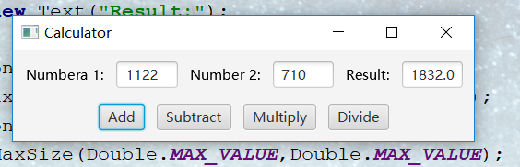

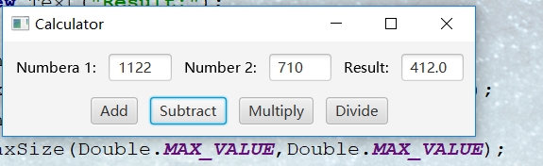

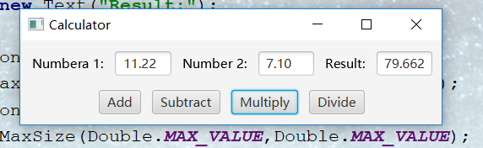

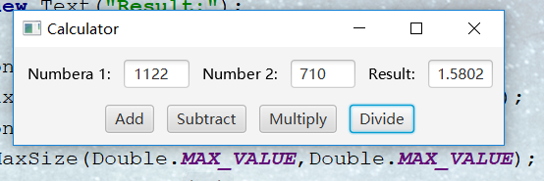

2.2

（1）

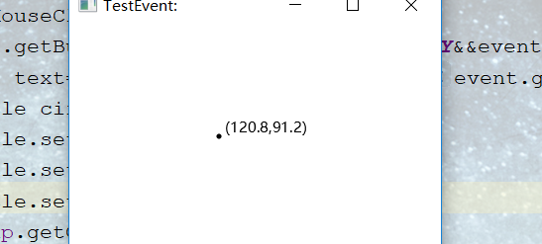

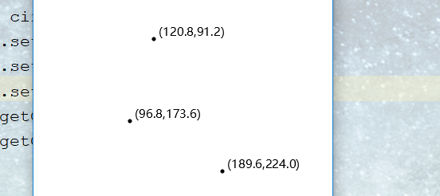

（2）

2.3

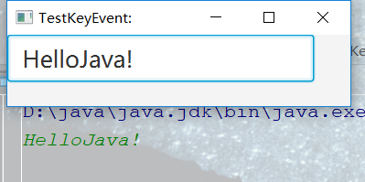

2.4

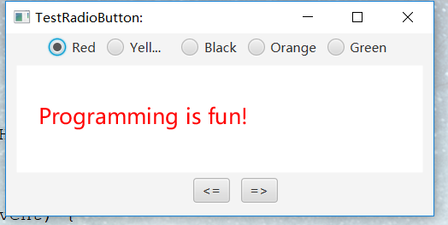

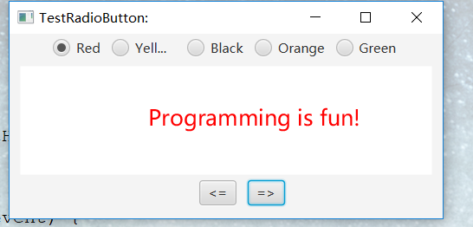

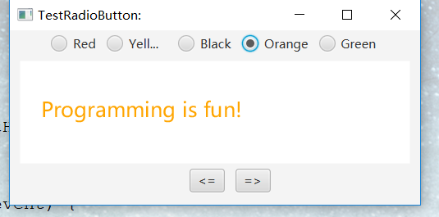

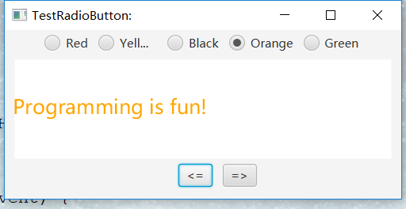

2.5

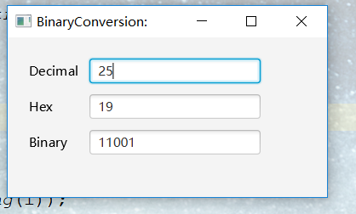

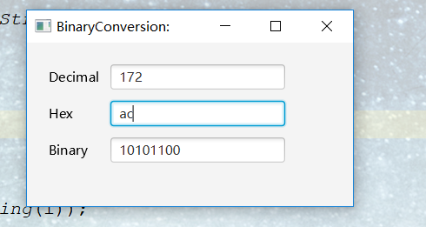

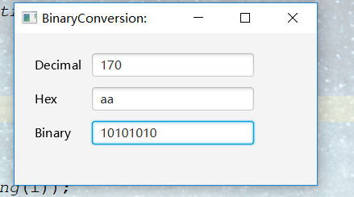

2.6

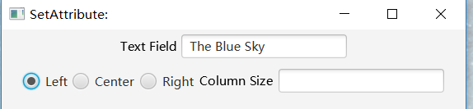

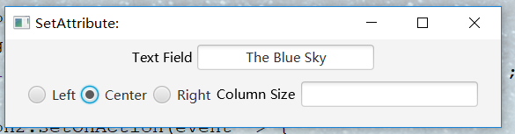

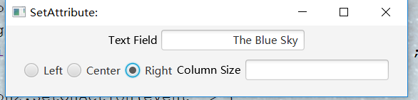

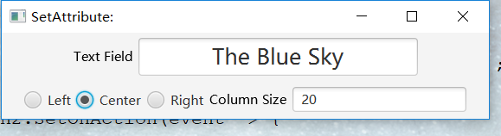

2.7

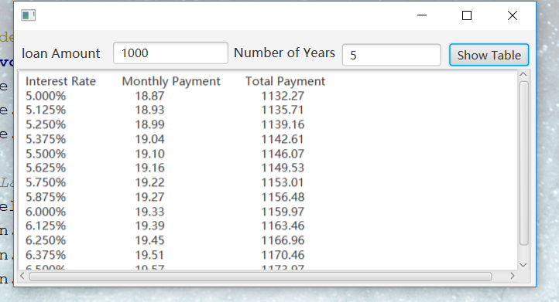

2.8

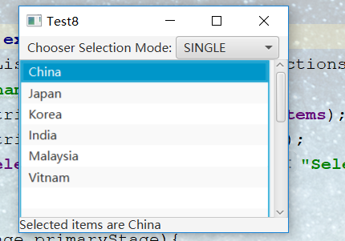

2．非正常测试数据（2组）及运行结果。

无

**五．总结**

1. 实验过程中遇到的问题及解决办法。

。

1. 对设计及调试过程的心得体会。

**六．附录：**源代码（请把源代码按照实验内容附到其后）

2.1

**package** sample;  
  
**import** javafx.application.Application;  
**import** javafx.geometry.Insets;  
**import** javafx.geometry.Pos;  
**import** javafx.scene.Scene;  
**import** javafx.scene.control.Button;  
**import** javafx.scene.control.TextField;  
**import** javafx.scene.layout.*;  
**import** javafx.scene.text.Text;  
**import** javafx.stage.Stage;  
  
  
**public class** TestHBox2 **extends** Application {  
 @Override  
 **public void** start(Stage primaryStage) {  
  
 BorderPane root=**new** BorderPane();  
 root.setPadding(**new** Insets(10,10,10,10));  
  
 Text text=**new** Text(**"Numbera 1:"**);  
 Text text1=**new** Text(**"Number 2:"**);  
 Text text2=**new** Text(**"Result:"**);  
  
 Button button=**new** Button(**"Add"**);  
 button.setMaxSize(Double.***MAX_VALUE***,Double.***MAX_VALUE***);  
 Button button1=**new** Button(**"Subtract"**);  
 button1.setMaxSize(Double.***MAX_VALUE***,Double.***MAX_VALUE***);  
 Button button2=**new** Button(**"Multiply"**);  
 button2.setMaxSize(Double.***MAX_VALUE***,Double.***MAX_VALUE***);  
 Button button3=**new** Button(**"Divide"**);  
 button3.setMaxSize(Double.***MAX_VALUE***,Double.***MAX_VALUE***);  
  
 TextField textField = **new** TextField();  
 textField.setPrefColumnCount(3);  
 HBox.*setHgrow*(textField, Priority.***ALWAYS***);  
  
 TextField textField1 = **new** TextField();  
 textField1.setPrefColumnCount(3);  
 HBox.*setHgrow*(textField1,Priority.***ALWAYS***);  
  
 TextField textField2 = **new** TextField();  
 textField2.setPrefColumnCount(3);  
 HBox.*setHgrow*(textField2,Priority.***ALWAYS***);  
  
 button.setOnAction(event -> {  
 **float** temp1=Float.*parseFloat*(textField.getText())+Float.*parseFloat*(textField1.getText());  
 textField2.setText(temp1+**""**);  
 });  
  
 button1.setOnAction(event -> {  
 **float** temp2=Float.*parseFloat*(textField.getText())-Float.*parseFloat*(textField1.getText());  
 textField2.setText(temp2+**""**);  
 });  
  
 button2.setOnAction(event -> {  
 **float** temp3=Float.*parseFloat*(textField.getText())*Float.*parseFloat*(textField1.getText());  
 textField2.setText(temp3+**""**);  
 });  
  
 button3.setOnAction(event -> {  
 **float** temp4=Float.*parseFloat*(textField.getText())/Float.*parseFloat*(textField1.getText());  
 textField2.setText(temp4+**""**);  
 });  
  
 HBox root1 = **new** HBox(10,text,textField,text1,textField1,text2,textField2);  
 root1.setAlignment(Pos.***CENTER***);  
  
 HBox root2 = **new** HBox(10,button,button1,button2,button3);  
 root2.setAlignment(Pos.***CENTER***);  
  
 root.setTop(root1);  
 root.setBottom(root2);  
  
 Scene scene = **new** Scene(root, 400, 80);  
 primaryStage.setTitle(**"Calculator"**);  
 primaryStage.setScene(scene);  
 primaryStage.show();  
 }  
  
 **public static void** main(String[] args) {  
 Application.*launch*(args);  
 }  
}

2.2

（1）

**package** sample;  
  
**import** javafx.application.Application;  
**import** javafx.scene.Scene;  
**import** javafx.scene.input.MouseButton;  
**import** javafx.scene.layout.Pane;  
**import** javafx.scene.paint.Color;  
**import** javafx.scene.shape.Circle;  
**import** javafx.scene.text.Text;  
**import** javafx.stage.Stage;  
  
**public class** TestMouseEvent1 **extends** Application {  
 **public void** start(Stage stage){  
 stage.setTitle(**"TestEvent:"**);  
 Pane group=**new** Pane();  
  
  
 group.setOnMouseClicked(event -> {  
   
 **if**(event.getButton() == MouseButton.***PRIMARY***&&event.getClickCount()==1){  
 Text text=**new** Text(event.getX()+5,event.getY()-3,**"("**+event.getX()+**","**+event.getY()+**")"**);  
 Circle circle = **new** Circle();  
 circle.setCenterX(event.getX());  
 circle.setCenterY(event.getY());  
 circle.setRadius(2.0f);  
 group.getChildren().add(text);  
 group.getChildren().add(circle);  
 }  
 });  
 Scene scene=**new** Scene(group,300,300,Color.***WHITE***);  
 stage.setScene(scene);  
 stage.show();  
 }  
  
 **public static void** main(String[] args) {  
 Application.*launch*(args);  
 }  
}

2.3

**package** sample;  
  
**import** javafx.application.Application;  
**import** javafx.scene.Scene;  
**import** javafx.scene.control.TextField;  
**import** javafx.scene.layout.Pane;  
**import** javafx.scene.text.Font;  
**import** javafx.stage.Stage;  
**import** java.util.Scanner;  
**import** java.lang.String;  
  
**public class** TestKeyEvent **extends** Application {  
 **public void** start(Stage stage){  
 stage.setTitle(**"TestKeyEvent:"**);  
 TextField textField=**new** TextField();  
 Pane pane=**new** Pane();  
 Scanner input=**new** Scanner(System.***in***);  
 String str=input.next();  
 textField.setText(str);  
  
 textField.setFont(Font.*font*(20));  
 pane.getChildren().add(textField);  
 Scene scene=**new** Scene(pane,300,200);  
 stage.setScene(scene);  
 stage.show();  
 }  
  
 **public static void** main(String[] args) {  
 *launch*(args);  
 }  
}

2.4

**package** sample;  
  
**import** javafx.application.Application;  
**import** javafx.event.EventHandler;  
**import** javafx.geometry.Insets;  
**import** javafx.geometry.Pos;  
**import** javafx.scene.Group;  
**import** javafx.scene.Scene;  
**import** javafx.scene.control.Button;  
**import** javafx.scene.control.RadioButton;  
**import** javafx.scene.control.TextField;  
**import** javafx.scene.control.ToggleGroup;  
**import** javafx.scene.input.MouseEvent;  
**import** javafx.scene.layout.HBox;  
**import** javafx.scene.layout.VBox;  
**import** javafx.scene.paint.Color;  
**import** javafx.scene.text.Font;  
**import** javafx.scene.text.Text;  
**import** javafx.stage.Stage;  
**import** javafx.scene.shape.Rectangle;  
  
  
**public class** TestRadioButton **extends** Application{  
 **public void** start(Stage primaryStage){  
 primaryStage.setTitle(**"TestRadioButton:"**);  
 VBox vBox=**new** VBox();  
  
 ToggleGroup toggleGroup=**new** ToggleGroup();  
 RadioButton button1=**new** RadioButton(**"Red"**);  
 button1.setToggleGroup(toggleGroup);  
 RadioButton button2=**new** RadioButton(**"Yellow"**);  
 button2.setToggleGroup(toggleGroup);  
 RadioButton button3=**new** RadioButton(**"Black"**);  
 button3.setToggleGroup(toggleGroup);  
 RadioButton button4=**new** RadioButton(**"Orange"**);  
 button4.setToggleGroup(toggleGroup);  
 RadioButton button5=**new** RadioButton(**"Green"**);  
 button5.setToggleGroup(toggleGroup);  
  
 Button button6=**new** Button(**"<="**);  
  
 Button button7=**new** Button(**"=>"**);  
  
 HBox hBox1=**new** HBox(10,button1,button2,button3,button4,button5);  
 hBox1.setPadding(**new** Insets(5,10,10,40));  
 hBox1.setAlignment(Pos.***TOP_CENTER***);  
  
 Group group=**new** Group();  
 Text text;  
 text = **new** Text(30,85,**"Programming is fun!"**);  
 text.setFont(Font.*font*(20));  
  
 Rectangle rectangle=**new** Rectangle(10,30,380,100);  
 rectangle.setFill(Color.***WHITE***);  
  
 button1.setOnAction(event -> {  
 text.setFill(Color.***RED***);  
 });  
 button2.setOnAction(event -> {  
 text.setFill(Color.***YELLOW***);  
 });  
 button3.setOnAction(event -> {  
 text.setFill(Color.***BLACK***);  
 });  
 button4.setOnAction(event -> {  
 text.setFill(Color.***ORANGE***);  
 });  
 button5.setOnAction(event -> {  
 text.setFill(Color.***GREEN***);  
 });  
  
 button6.setOnMouseClicked(**new** EventHandler<MouseEvent>() {  
 **int x**=30;  
 @Override  
 **public void** handle(MouseEvent event) {  
 text.setLayoutX(**x**-2);  
 text.setLayoutY(0);  
 **x**=**x**-2;  
 }  
 });  
 button7.setOnMouseClicked(**new** EventHandler<MouseEvent>() {  
 **int y**=30;  
 @Override  
 **public void** handle(MouseEvent event) {  
 text.setLayoutX(**y**+2);  
 text.setLayoutY(0);  
 **y**=**y**+2;  
 }  
 });  
  
 group.getChildren().add(hBox1);  
 group.getChildren().add(rectangle);  
 group.getChildren().add(text);  
  
 HBox hBox2=**new** HBox(10,button6 ,button7);  
 hBox2.setPadding(**new** Insets(5,10,10,40));  
 hBox2.setAlignment(Pos.***TOP_CENTER***);  
  
 VBox vBox1=**new** VBox();  
 vBox1.getChildren().add(group);  
 vBox1.getChildren().add(hBox2);  
  
 Scene scene=**new** Scene(vBox1,400,170,Color.***GRAY***);  
 primaryStage.setScene(scene);  
 primaryStage.show();  
 }  
  
 **public static void** main(String[] args) {  
 *launch*(args);  
 }  
}

2.5

**package** sample;  
  
**import** javafx.application.Application;  
**import** javafx.geometry.Insets;  
**import** javafx.scene.Scene;  
**import** javafx.scene.control.TextField;  
**import** javafx.scene.layout.GridPane;  
**import** javafx.scene.text.Text;  
**import** javafx.stage.Stage;  
  
**import** java.lang.String;  
  
**import** java.math.BigInteger;  
  
  
**public class** TestBinaryConversion **extends** Application {  
 **public void** start(Stage primaryStage){  
 primaryStage.setTitle(**"BinaryConversion:"**);  
 Text text=**new** Text(**"Decimal"**);  
 TextField textField=**new** TextField();  
 Text text1=**new** Text(**"Hex"**);  
 TextField textField1=**new** TextField();  
 Text text2=**new** Text(**"Binary"**);  
 TextField textField2=**new** TextField();  
  
 GridPane gridPane=**new** GridPane();  
 gridPane.setPadding(**new** Insets(20,10,10,20));  
 gridPane.setHgap(10);  
 gridPane.setVgap(10);  
 gridPane.add(text,0,0);  
 gridPane.add(textField,1,0);  
 gridPane.add(text1,0,1);  
 gridPane.add(textField1,1,1);  
 gridPane.add(text2,0,2);  
 gridPane.add(textField2,1,2);  
  
 textField.setOnAction(event -> {  
 String str=textField.getText();  
 **int** i=Integer.*valueOf*(str).intValue();  
 textField1.setText(Integer.*toHexString*(i));  
 textField2.setText(Integer.*toBinaryString*(i));  
 });  
  
 textField1.setOnAction(event -> {  
 String str=textField1.getText();  
 textField.setText(**new** BigInteger(str,16).toString()+**""**);  
 **int** i=Integer.*valueOf*(**new** BigInteger(str,16).toString());  
 textField2.setText(Integer.*toBinaryString*(i));  
 });  
  
 textField2.setOnAction(event -> {  
 String str=textField2.getText();  
 **int** i=Integer.*parseInt*(str,2);  
 textField.setText(i+**""**);  
 textField1.setText(Integer.*toHexString*(i));  
 });  
  
 Scene scene=**new** Scene(gridPane,300,150);  
 primaryStage.setScene(scene);  
 primaryStage.show();  
 }  
  
 **public static void** main(String[] args) {  
 *launch*(args);  
 }  
}

2.6

**package** sample;  
  
**import** javafx.application.Application;  
**import** javafx.geometry.Insets;  
**import** javafx.geometry.Pos;  
**import** javafx.scene.Scene;  
**import** javafx.scene.control.RadioButton;  
**import** javafx.scene.control.TextField;  
**import** javafx.scene.control.ToggleGroup;  
**import** javafx.scene.layout.HBox;  
**import** javafx.scene.layout.VBox;  
**import** javafx.scene.text.Font;  
**import** javafx.scene.text.Text;  
**import** javafx.stage.Stage;  
**import** javafx.geometry.*;  
  
**import** java.awt.*;  
  
**public class** TestSetAttribute **extends** Application {  
 **public void** start(Stage primaryStage){  
 primaryStage.setTitle(**"SetAttribute:"**);  
  
 Text text=**new** Text(**"Text Field"**);  
 TextField textField=**new** TextField(**"The Blue Sky"**);  
 HBox hBox=**new** HBox(5,text,textField);  
 hBox.setPadding(**new** Insets(5,0,0,0));  
 hBox.setAlignment(Pos.***CENTER***);  
  
 ToggleGroup toggleGroup=**new** ToggleGroup();  
 RadioButton radioButton=**new** RadioButton(**"Left"**);  
 radioButton.setToggleGroup(toggleGroup);  
 RadioButton radioButton1=**new** RadioButton(**"Center"**);  
 radioButton1.setToggleGroup(toggleGroup);  
 RadioButton radioButton2=**new** RadioButton(**"Right"**);  
 radioButton2.setToggleGroup(toggleGroup);  
  
 Text text1=**new** Text(**"Column Size"**);  
 TextField textField1=**new** TextField();  
  
 HBox hBox1=**new** HBox(5,radioButton,radioButton1,radioButton2,text1,textField1);  
 hBox.setPadding(**new** Insets(5,0,0,0));  
 hBox1.setAlignment(Pos.***CENTER***);  
  
 radioButton.setOnAction(event -> {  
 String str=textField.getText();  
 textField.alignmentProperty().setValue(Pos.***CENTER_LEFT***);  
 });  
 radioButton1.setOnAction(event -> {  
 String str=textField.getText();  
 textField.alignmentProperty().setValue(Pos.***CENTER***);  
 });  
 radioButton2.setOnAction(event -> {  
 String str=textField.getText();  
 textField.alignmentProperty().setValue(Pos.***CENTER_RIGHT***);  
 });  
 textField1.setOnAction(event -> {  
 String str=textField1.getText();  
 **int** i=Integer.*parseInt*(str,10);  
 textField.setFont(Font.*font*(i));  
 });  
  
  
 VBox vBox=**new** VBox(10,hBox,hBox1);  
 Scene scene=**new** Scene(vBox,450,80);  
 primaryStage.setScene(scene);  
 primaryStage.show();  
 }  
  
 **public static void** main(String[] args) {  
 Application.*launch*(args);  
 }  
}

2.7

**package** sample;  
  
**import** javafx.application.Application;  
**import** javafx.event.ActionEvent;  
**import** javafx.scene.Scene;  
**import** javafx.scene.control.*;  
**import** javafx.scene.layout.*;  
**import** javafx.scene.text.Font;  
**import** javafx.stage.Stage;  
  
**public class** TestButton **extends** Application {  
  
 @Override  
 **public void** start(Stage stage) **throws** Exception {  
 Pane pane = **new** Pane();  
 pane.setPrefHeight(265.0);  
 pane.setPrefWidth(539.0);  
   
 Label loan = **new** Label(**"loan Amount"**);  
 loan.setPrefHeight(22.0);  
 loan.setPrefWidth(94.0);  
 loan.setFont(Font.*font*(13.0));  
   
 TextField loanField = **new** TextField();  
 loanField.setPrefHeight(23.0);  
 loanField.setPrefWidth(119.0);  
   
 Label yearl = **new** Label(**"Number of Years"**);  
 yearl.setPrefHeight(18.0);  
 yearl.setPrefWidth(112.0);  
 yearl.setFont(Font.*font*(13.0));  
   
 TextField yearField = **new** TextField();  
 yearField.setPrefHeight(23.0);  
 yearField.setPrefWidth(102.0);  
   
 HBox hbox1 = **new** HBox();  
 hbox1.setLayoutX(8.0);  
 hbox1.setLayoutY(12.0);  
 hbox1.setPrefHeight(28.0);  
 hbox1.setPrefWidth(218.0);  
 hbox1.getChildren().addAll(loan, loanField);  
   
 HBox hbox2 = **new** HBox();  
 hbox2.setLayoutX(227.0);  
 hbox2.setLayoutY(14.0);  
 hbox2.setPrefHeight(23.0);  
 hbox2.setPrefWidth(241.0);  
 hbox2.getChildren().addAll(yearl, yearField);  
   
 Button buttonShow = **new** Button(**"Show Table"**);  
 buttonShow.setLayoutX(450.0);  
 buttonShow.setLayoutY(14.0);  
 buttonShow.setMnemonicParsing(**false**);  
   
 TextArea calArea = **new** TextArea();  
 calArea.setPrefHeight(223.0);  
 calArea.setPrefWidth(531.0);  
   
 ScrollPane scrollpane = **new** ScrollPane();  
 scrollpane.setLayoutX(3.0);  
 scrollpane.setLayoutY(40.0);  
 scrollpane.setPrefHeight(222.0);  
 scrollpane.setPrefWidth(531.0);  
 scrollpane.setContent(calArea);  
   
 buttonShow.setOnAction((ActionEvent Event) -> {  
 **int** loanAmount = Integer.*valueOf*(loanField.getText());  
 **int** year = Integer.*valueOf*(yearField.getText());  
 calArea.setText(calculate(loanAmount, year));  
 });  
   
 pane.getChildren().addAll(hbox1, hbox2,  
 buttonShow, scrollpane);  
 Scene scene = **new** Scene(pane);  
 stage.setScene(scene);  
 stage.show();  
 }  
  
 **private** String calculate(**int** loanAmount, **int** year) {  
 StringBuilder str = **new** StringBuilder(**"Interest Rate "** + **"\t Monthly Payment"** + **"\tTotal Payment\n"**);  
  
 **double** monthlyPayment, totalPayment, monthlyRate;  
 **for**(**double** rate = 5.0; rate <= 8.0; rate += 0.125) {  
 monthlyRate = rate / 1200;  
 monthlyPayment = loanAmount * monthlyRate /  
 (1 - (Math.*pow*(1 / (1 + monthlyRate), year * 12)));  
 totalPayment = monthlyPayment * year * 12;  
  
 str.append(String.*format*(**"%5.3f%c %20.2f %20.2f\n"**, rate,  
 **'%'**, monthlyPayment, totalPayment));  
 }  
 System.***out***.println(str);  
 **return** str.toString();  
 }  
 **public static void** main(String[] args) {  
 *launch*(args);  
 }  
}