西 安 邮 电 大 学
（计算机学院）
JAVA程序设计B
课内实验报告

实验名称: 继承与多态

专业名称: 计算机科学与技术
班 级: 计科1602
学生姓名: 杨睿涛
学号（8位）: 04161059
指导教师: 张德慧
实验时间: 2018-10-29

一. 实验目的及实验环境
- 理解Java异常的基本概念和处理机制。
- 掌握Java异常处理的方法（抛出和捕获异常；try、throw、throws、catch语句和finally的用法）
- 理解异常类的作用，掌握创建异常类的方法。

二. 实验内容
基本内容（实验前请及时熟悉如下相关内容）：
- Java的异常处理机制
- 异常类的应用
- 常见的异常(除数为零等)
- 多异常处理
- 由方法抛出异常
- 必须要捕获的异常

综合实验：
- 有数组a[ ]={10,20,30,40}，数组b={1,2,3,0}，设计一个程序，求数组c[ ]=a[i]/b[i]，i从0~4中选择。捕获可能出现的异常。

- 假设Sum类中有一个addContinue(int n) 方法，当n>0时，该方法返回1+2+…+n的和；当n<0时，方法抛出ArgumentException异常。ArgumentException类应该提供一个能够接受并保存n值的构造方法，以及一个能返回n值的实例方法。请定义Sum类及ArgumentException类，并编程测试它们。

- 由命令行输入整数n，计算n的阶乘并捕获可能出现的异常。

- 编写一个程序，提示用户读取两个整数，然后显示他们的和。程序应该在输入不正确时提示用户再次读取数字。

- 练习题11.1定义了带三条边的Triangle类。在三角形中，任意两边之和总大于第三边，三角形类Triangle必须遵从这一规则。创建一个IllegalTriangleException类，然后修改Triangle类的构造方法，如果创建的三角形边违反了这一规则，抛出一个IllegalTriangleException对象，如下所示：
/** Construct a triangle with the specified sides */
public Triangle(double side1, double side2, double side3)
throws IllegalTriangleException{
// Implement it
}

- 编写一个程序，他能导致JVM抛出一个OutOfMemoryError，然后捕获和处理这个错误。

三．方案设计（核心代码和流程设计）
累了，写不动了，看代码注释吧，又详细又方便

四．测试数据及运行结果
- 正常测试数据（3组）及运行结果；
    - Student -> Undergraduate + Graduate
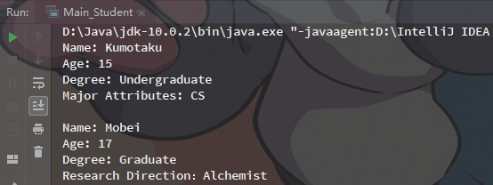

    - GeometricObject派生子类Triangle
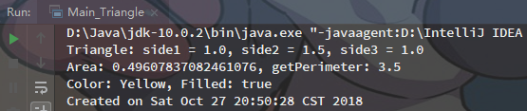

    - Person->Employee-> Faculty + Stuff (小图看不清，有需请移步源码)
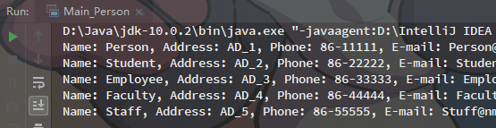
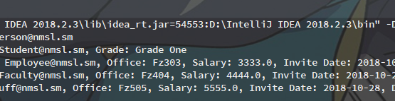
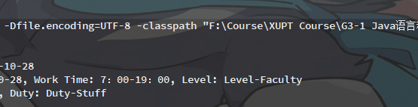

    - 用ArraysList重写Course类
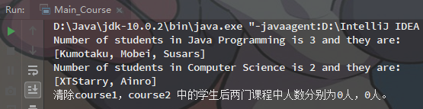

    - ArrayList
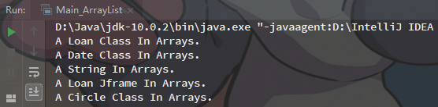

    - Account
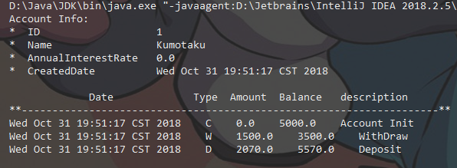

五．总结
- 实验过程中遇到的问题及解决办法。
问题挺多的，但通过百度和黑皮书学习了很多，解决了。解决以后回过头来看也就没什么难的了，都是很基础的内容。

- 对设计及调试过程的心得体会。
Java很方便，要学的还很多，请继续加油努力。

六．附录：源代码
本次试验报告所有源代码可在下述Github仓库中查阅。
github.com/Kumotaku/SchoolJavaCourse_Code
- Student -> Undergraduate + Graduate
public class Main_Student {
public static void main(String[] args){
Undergraduate stu1 = new Undergraduate("Kumotaku", 15, "Undergraduate", "CS");
Graduate stu2 = new Graduate("Mobei", 17, "Graduate", "Alchemist");
stu1.Print();
stu2.Print();
}
}

//抽象类父类Student
//抽象类只能被继承，不可被实例化
abstract class Student{
private int age;
private String name;
private String degree;

//Student的构造函数
public Student(String name, int age, String degree){
this.age = age;
this.name = name;
this.degree = degree;
}

//打印类Student中的成员信息
public void Print(){
System.out.println("Name: " + name + "\nAge: " + age + "\nDegree: " + degree);
}
}

//继承父类Student的“大学生”子类Undergraduate
class Undergraduate extends Student{
//包含一个私有成员：专业属性
private String MajorAttributes;

//构造父类及子类
public Undergraduate(String name, int age, String degree, String attribute) {
/*针对父类使用super(parameter1,parameter2,parameter3...)*/
super(name, age, degree);
this.MajorAttributes = attribute;
}

//打印父类及子类中的成员信息
public void Print(){
super.Print();
System.out.println("Major Attributes: " + MajorAttributes + "\n");
}
}

//继承父类Student的“研究生”子类Graduate
class Graduate extends Student{
//包含一个私有成员：研究方向
private String ResearchDirection;

//构造父类及子类
public Graduate(String name, int age, String degree, String attribute) {
super(name, age, degree);
this.ResearchDirection = attribute;
}

//打印父类及子类中的成员信息
public void Print(){
super.Print();
System.out.println("Research Direction：" + ResearchDirection + "\n");
}
}

- GeometricObject派生子类Triangle
import java.util.Date;

public class Main_Triangle {
public static void main(String[] args){
//按照题意有参实例化Triangle
Triangle triangle = new Triangle(1, 1.5, 1, "Yellow", true);
//输出依题意创建的triangle对象的信息
System.out.println(triangle.toString() +
"\nArea: " + triangle.getArea() + ", getPerimeter: " + triangle.getPerimeter() +
"\n" + triangle.toStringGeo());
}
}

//抽象父类GeometricObject
abstract class GeometricObject{
private String color;
private boolean filled;
private Date dateCreated;

//GeometricObject的无参构造方法，调用了Date类
public GeometricObject(){
dateCreated = new Date();
}

//GeometricObject的有参构造方法
//构造参数中不用传入Date
public GeometricObject(String color, boolean filled){
this.color = color;
this.filled = filled;
dateCreated = new Date();
}

//对外输出颜色
public String getColor(){
return color;
}

//对内获取颜色
public void setColor(String color){
this.color = color;
}

//对外输出填充情况
public boolean isFilled(){
return filled;
}

//对内获取填充情况
public void setFilled(boolean filled){
this.filled = filled;
}

//对外输出构造日期
public Date getDateCreated(){
return dateCreated;
}

//用于输出GeometricObject的字符串信息
public String toStringGeo(){
return "Color: " + color + ", Filled: " + filled + "\nCreated on " + dateCreated;
}
}

//由抽象父类GeometricObject派生的子类Triangle
class Triangle extends GeometricObject{
private double side1 = 1, side2 = 1, side3 = 1;

//Triangle的无参构造方法
public Triangle(){}

//Triangle的有参构造方法
public Triangle(double side1, double side2, double side3, String color, boolean filled){
super(color, filled);
this.side1 = side1;
this.side2 = side2;
this.side3 = side3;
}

//对外输出三边各自长度
public double getSide(String side){
if (side == "side1")
return side1;
else if (side == "side2")
return side2;
else
return side3;
}

//计算并对外输出面积
public double getArea(){
/**（海伦公式）
* p=(a+b+c)/2
* S=sqrt[p(p-a)(p-b)(p-c)]
*/
double temp = this.getPerimeter()/2;
return Math.sqrt(temp*(temp-side1)*(temp-side2)*(temp-side3));
}

//计算并对外输出周长
public double getPerimeter(){
return side1 + side2 + side3;
}

//用于输出Triangle的字符串信息
public String toString(){
return "Triangle: side1 = " + side1 + ", side2 = " + side2 + ", side3 = " + side3;
}
}

- Person->Employee-> Faculty + Stuff
public class Main_Person {
public static void main(String[] args){
Person person = new Person
("Person", "AD_1", "86-11111", "Person@nmsl.sm");
Student student = new Student
("Student", "AD_2", "86-22222", "Student@nmsl.sm",
"Grade One");
Employee employee = new Employee
("Employee", "AD_3", "86-33333", "Employee@nmsl.sm",
"Fz303", 3333, new MyDate("2018", "10", "28"));
Faculty faculty = new Faculty
("Faculty", "AD_4", "86-44444", "Faculty@nmsl.sm",
"Fz404", 4444, new MyDate("2018", "10", "28"),
"7：00-19：00", "Level-Faculty");
Staff staff = new Staff
("Staff", "AD_5", "86-55555", "Stuff@nmsl.sm",
"Fz505", 5555, new MyDate("2018", "10", "28"),
"Duty-Stuff");

System.out.println(person.toString() + "\n" +
student.toString() + ", " + student.getGrade() + "\n" +
employee.toString() + ", " + employee.getEmployee() + "\n" +
faculty.toString() + ", " + faculty.getEmployee() + ", " + faculty.getFaculty() + "\n" +
staff.toString() + ", " + staff.getEmployee() + ", " + staff.getStuff());
}
}

/* Class MyDate */
class MyDate{
private String year, month, day;

public MyDate(String year, String month, String day){
this.year = year;
this.month = month;
this.day = day;
}

public String getDate(){
return year + "-" + month + "-" + day;
}
}

/* 父类 Person */
class Person{
private String name, address, phone, email;

// Person 的构造方法
public Person(String name, String address, String phone, String email){
this.name = name;
this.address = address;
this.phone = phone;
this.email = email;
}

// Person 的对外传递方法
public String toString(){
return "Name: " + name + ", Address: " + address + ", Phone: " + phone + ", E-mail: " + email;
}
}

/* 父类 Person 的子类 Student */
class Student extends Person{
private String grade;

// Student 的构造方法
public Student(String name, String address, String phone, String email,
String grade) {
super(name, address, phone, email);
this.grade = grade;
}

// Student 的对外传递 Grade 的方法
public String getGrade(){
return "Grade: " + grade;
}
}

/* 父类 Person 的子类 Employee */
class Employee extends Person{
private String office;
private double salary;
private MyDate inviteDate;

//Employee 的构造方法
public Employee(String name, String address, String phone, String email,
String office, double salary, MyDate inviteDate) {
super(name, address, phone, email);
this.office = office;
this.salary = salary;
this.inviteDate = inviteDate;
}

public String getEmployee(){
return "Office: " + office + ", Salary: " + salary + ", Invite Date: " + inviteDate.getDate();
}
}

class Faculty extends Employee{
private String workTime, level;

//Faculty 的构造方法
public Faculty(String name, String address, String phone, String email,
String office, double salary, MyDate inviteDate, String workTime, String level) {
super(name, address, phone, email, office, salary, inviteDate);
this.workTime = workTime;
this.level = level;
}

//Faculty 的对外传递方法
public String getFaculty(){
return "Work Time: " + workTime + ", Level: " + level;
}
}

class Staff extends Employee{
private String duty;

//Staff 的构造方法
public Staff(String name, String address, String phone, String email,
String office, double salary, MyDate inviteDate, String duty) {
super(name, address, phone, email, office, salary, inviteDate);
this.duty = duty;
}

//Faculty 的对外传递方法
public String getStuff(){
return "Duty: " + duty;
}
}

- 用ArraysList重写Course类
import java.util.ArrayList;
public class Main_Course {
public static void main(String[] args){
Course course1 = new Course("Java Programming");
Course course2 = new Course("Computer Science");

course1.addStudents("Kumotaku");
course1.addStudents("Mobei");
course1.addStudents("Susars");

course2.addStudents("XTStarry");
course2.addStudents("Ainro");

System.out.println("Number of students in " + course1.getCourseName() +
" is " + course1.getNumberOfStudents() + " and they are: \n" + course1.students);
System.out.println("Number of students in " + course2.getCourseName() +
" is " + course2.getNumberOfStudents() + " and they are: \n" + course2.students);

course1.students.clear();
course2.students.clear();
System.out.println("清除course1，course2 中的学生后两门课程中人数分别为" +
course1.getNumberOfStudents() + "人，"+
course2.getNumberOfStudents() + "人。");
}
}

class Course {
private String courseName;
//改写数组的创建方法
ArrayList<String> students = new ArrayList<>();
private int numberOfStudents;

public Course(String courseName){
this.courseName = courseName;
}

//修改添加元素的方法：使用ArrayList方法修改掉数组方法
public void addStudents(String student){
students.add(student);
}

public ArrayList<String> getStudents() {
return students;
}

public int getNumberOfStudents(){
return students.size();
}

public String getCourseName(){
return courseName;
}

//JAVA 动态拓展数组 落实dropStudent 新增clear() 清除所有元素（学生）的功能
public void dropStudent(String student) {
// Left as an exercise in Exercise 9.9
students.remove(student);
}

public void clear(){
students.clear();
}
}

- ArrayList
import java.util.ArrayList;

public class Main_ArrayList {
public static void main(String[] args){
ArrayList<Object> obj = new ArrayList<>();
obj.add(new Loan());
obj.add(new Date());
obj.add("A String In Arrays.");
obj.add(new Jframe());
obj.add(new Circle());

for (int i = 0; i < 5; i ++){
System.out.println(obj.get(i).toString());
}
}
}

class Loan{
public String toString() {
return "A Loan Class In Arrays.";
}
}

class Date{
public String toString() {
return "A Date Class In Arrays.";
}
}

class Jframe{
public String toString() {
return "A Loan Jframe In Arrays.";
}
}

class Circle{
public String toString() {
return "A Circle Class In Arrays.";
}
}

- Account
import java.util.ArrayList;
import java.util.Date;

public class Main_Account {
public static void main(String[] args){
Account account = new Account(1, "Kumotaku", 5000);
System.out.println(account.toString());

// 测试：
account.withDraw(1500);
account.deposit(2070);

// 输出单账户存取纪录
System.out.println("\n\t\t\t Date\t\t\t Type Amount\tBalance\t description" +
"\n**--------------------------------------------------------------------**");
for (int i = 0; i < account.length(); i ++){
System.out.println(account.transactions.get(i).toString());
}
}
}

// 添加一个名为transactions的ArrayList类型的新数据域，用于为账户存储交易。
// 每笔交易都是一个Transaction类的实例。Transaction 类的定义如下图所示。
class Transaction{
/**
* date (Date) 交易日期
* type (char) 交易类型 "W"/"D"
* amount (double) 交易量
* balance (double) 交易后余额
* description (String) 交易描述
*/
private Date date;
private char type;
private double amount;
private double balance;
private String description;

// 创建含参构造方法
public Transaction(char type, double amount, double balance, String description){
this.type = type;
this.amount = amount;
this.balance = balance;
this.description = description;
date = new Date();
}

// 输出单条纪录
public String toString(){
return date.toString() + " " + type + " " + amount + " " + balance + " " + description;
}
}

class Account{
/**
* id (int) init = 0
* name (String) 客户名字
* balance (double) init = 0
* annualInterestRate (double) 当前利率 init = 0
* dateCreated (Date) 开户日期
*/
private int id = 0;
private String name = "NULL";
private double balance = 0;
private double annualInterestRate = 0;
private Date dateCreated;

//创建一个ArrayList transactions
ArrayList<Transaction> transactions = new ArrayList<>();

// 创建默认账户的无参构造方法
public Account(){
dateCreated = new Date();
// 将初始化信息存入ArrayList transactions
Transaction transaction = new Transaction('C', 0, 0, "Account Init");
transactions.add(transaction);
}

// 创建带特定id, name和初始余额的账户的构造方法
public Account(int id, String name, double balance){
this.id = id;
this.name = name;
this.balance = balance;
this.dateCreated = new Date();
// 将初始化信息存入ArrayList transactions
Transaction transaction = new Transaction('C', 0, balance, "Account Init");
transactions.add(transaction);
}

// 访问器
public int getId(){
return id;
}
public String getName(){
return name;
}
public double getBalance(){
return balance;
}
public double getAnnualInterestRate(){
return annualInterestRate;
}
public Date getDateCreated(){
return dateCreated;
}
public double getMonth1yInterestRate(){
return annualInterestRate/12;
}
public int length(){
return transactions.size();
}

// id、balance和annualInterestRate的修改器
public void setId(int id){
System.out.print("Enter new value：");
this.id = id;
System.out.println("Has been alter as " + this.id);
}
public void setName(String name){
System.out.print("Enter new value：");
this.name = name;
System.out.println("Has been alter as " + this.name);
}
public void setBalance(double balance){
System.out.print("Enter new value：");
this.balance = balance;
System.out.println("Has been alter as " + this.balance);
}
public void setAnnualInterestRate(double annualInterestRate){
System.out.print("Enter new value：");
this.annualInterestRate = annualInterestRate;
System.out.println("Has been alter as " + this.annualInterestRate);
}

// withDraw方法 从账户提取特定数额
public void withDraw(double value){
balance -= value;
// 将取款信息存入ArrayList transactions
Transaction transaction = new Transaction('W', value, balance, "WithDraw");
transactions.add(transaction);
}

// deposit方法 向账户存储特定数额
public void deposit(double value){
balance += value;
// 将存款信息存入ArrayList transactions
Transaction transaction = new Transaction('D', value, balance, "Deposit");
transactions.add(transaction);
}

//输出账户信息
public String toString(){
return "Account Info: \n* ID\t\t\t\t\t" + id +
"\n* Name\t\t\t\t\t" + name +
"\n* AnnualInterestRate\t" + annualInterestRate +
"\n* CreatedDate\t\t\t" + dateCreated.toString();
}
}

