PC · SINGLE PLAYER · FIRST-PERSON EXTRACTION
DEADEND DISTRICT
FIELD HANDBOOK

“Get in. Get loaded. Get out — if the dark lets you.”
The operative’s guide to moving, fighting, looting and surviving the District — every control, every system, and a few things the District would rather you didn’t know.
FIRST EDITION · 2026 · DEADEND DISTRICT

01 WELCOME, OPERATIVE
You are a scavenger working the edges of Deadend District — a dead stretch of tunnels, factories and flooded sewers that someone, somewhere, still pays to have emptied. You go in with what you can carry, take what you can find, and try to reach an extraction point before the things in the dark find you first.
This handbook walks you through everything: how to move and shoot, how to read the dark, how to pack your bag, who to talk to, and how to come home richer than you left. Read the first three sections before your first run — the rest you can flip back to whenever you need it.
HOW TO READ THIS BOOK Keys are shown like F . Orange boxes are field secrets — tricks the systems reward but never tell you. Red boxes are warnings. Green boxes are tips.
02 THE JOB — HOW A RUN WORKS
Deadend District is built around one loop. You start safe in the Hub, drop into a dangerous Sector, and the whole game is about getting back out with your pockets full.
- Gear up in the Hub. Pull gear from your stash and buy ammo, batteries and equipment from the trader. (Once you’ve earned a rechargeable battery you can also top up at the recharge station.)
- Take a job. Talk to the NPCs with a glowing icon to pick up quests, then head to the entry point to drop into a sector.
- Survive & loot. Slip past or put down the creatures that hunt the tunnels, and fill your bag with loot.
- Extract. Reach an Extraction Point and use it. Everything you carry is now banked — yours for good.
- Spend & repeat. Sell your haul, upgrade, take the next job, and go again.
THE CATCH If you die in a sector, you drop the loot you were carrying for that run. Your stash in the Hub and your overall progress are safe — so bank anything precious before a risky push.
03 CONTROLS
Deadend District plays on keyboard and mouse. Arrow keys mirror W A S D.
Movement
Control | Action
W A S D / Arrows | Move
Mouse | Look around
Left Shift | Sprint (drains stamina)
Left Ctrl | Crouch (quieter, harder to see)
Space | Jump
Q / E | Lean left / right (peek round cover)
Combat
Control | Action
Left Mouse | Fire
Right Mouse | Aim down sights
R | Reload
H | Hold the bolt open (manual)
1 2 3 | Select weapon slot
Mouse Wheel | Cycle weapons
Gear & Interaction
Control | Action
F | Interact / use (doors, ladders, loot, stash, trader, extraction)
T | Toggle flashlight
Tab | Open / close inventory
R (in inventory) | Rotate the held item
Right Mouse (item) | Context menu: Equip / Unequip, Split, Drop, Buy / Sell
Menus & Dialogue
Control | Action
Esc | Pause / back / release cursor
Space | Advance dialogue
Left Mouse | Select menu / dialogue choices
04 YOUR FIRST RUN
New to the District? You begin with empty pockets — here’s how your first hours go.
- You start with nothing. No gun, no flashlight, no money — just you and the dark. Everything you own, you’ll earn.
- Take your first job. Find the NPC with a glowing icon, press F , advance with Space . The first contract is simple: get into a sector and extract alive.
- Survive the first raid unarmed. With no weapon, don’t pick fights — slip past the mimics: move slow, crouch ( Left Ctrl ), stay in shadow, and reach the Extraction Point. Use it ( F ) to get out.
- Collect your reward. Back in the Hub the NPC hands you your flashlight. To power it, open your bag ( Tab ) and drag a battery into the flashlight — there is no reload key for the light, so when one dies you unload the dead battery here and slot a fresh one.
- Earn some credits. Take the next jobs: bring back sellable loot and sell it to the trader until you’ve saved around 150 credits.
- Buy a full loadout. A gun on its own won’t fire. At the trader buy a gun, a magazine, and a box of ammo to feed it.
- Load your magazine. In your bag, load the ammo into the magazine first, then drag the loaded mag onto the weapon (or press R ) to chamber it. Buy a second magazine too — with a spare loaded mag, R reloads in one tap instead of hand-loading the empty one every time.
- Now go to work. Head out armed: light up with T , aim with Right Mouse , fire with Left Mouse , reload with R , lean with Q / E .
- Loot, then leave. Fill your bag (manage it with Tab ) and reach an Extraction Point to bank it all. Repeat, taking bigger jobs.
05 STAYING ALIVE
Light & Shadow
Your flashlight ( T ) is the only way to see in the tunnels — but it’s also a beacon. Standing in light makes you easier to spot, and so does moving fast. Kill your light, crouch, and slip through the dark.
FIELD SECRET — THE DARK IS A TOOL Visibility is a real number the enemies read. Light and movement push it up; crouching and shadow push it down. When a mimic is close, kill the flashlight and crouch — you can vanish in plain sight.
Power Management
The flashlight runs on a battery that drains as you use it. For most of the game your batteries are disposable — one use, then dead — so carry spares and swap a fresh one in when the light goes. A rechargeable battery, and the recharge station that refills it, only turn up much later (you earn the battery from Vera). You manage it in your bag: drag a battery into the flashlight to power it, and when it dies, unload the spent one and slot a fresh battery in its place — there is no reload key for the light.
DON’T GET CAUGHT DARK A dead battery in a black tunnel is how runs end. Never push deep on a near-empty cell.
Stamina & Weight
Sprinting ( Left Shift ) burns stamina; run it dry and you’ll be winded until it recovers. Every item has weight, and a heavy bag slows you down and tires you faster. Pack smart — greed is heavy.
Health & Falls
Take too many hits and you go down. Falling from height hurts too, so don’t leap down shafts you could climb.
06 COMBAT
Gunplay is deliberate. Hold Right Mouse to aim for accuracy, tap Left Mouse in bursts to control recoil, and reload with R before a fight, not during one. Switch weapons with 1 – 3 or the mouse wheel. The bolt can be held open manually with H .
FIELD SECRET — CARRY TWO MAGAZINES Reloading with R only works if you have a loaded magazine in your bag. With a single mag you’ll have to hand-load it in the inventory after it empties — so keep a second, pre-filled mag and R swaps it in for you mid-fight.
07 YOUR BAG — INVENTORY & GEAR
Open the grid with Tab . Items take up space by shape, like puzzle pieces — rotate the held item with R to make it fit. Drag to rearrange. Right-click any item for its options: Equip / Unequip, Split a stack, or Drop it.
A gun needs a loaded magazine to fire. In your bag you load ammo into a magazine first, then drag the loaded mag onto the weapon (or press R ) to chamber it. Carry a second loaded mag and R swaps it in instantly — otherwise you’ll be hand-loading the empty one after every fight. The flashlight works the same way with batteries: drag one in to power it, and when it dies, unload the dead battery and slot a fresh one (there is no reload key for the light). Anything you want to keep forever goes in the Stash back in the Hub; the stash survives death, your backpack does not.
TIP — PACK THE BAG, NOT THE FLOOR Rotate awkward items and tuck small ones into gaps. More space packed = more loot per run.
08 WHAT HUNTS YOU — THE MIMIC
One thing stalks the tunnels of the District: the Mimic. It doesn’t patrol so much as hunt — a creature that tracks you by sight, light and sound and closes in the moment it senses you. You can put one down with a steady aim and a full magazine, but ammo is precious down here, so the smarter play is usually to never let it find you at all.
FIELD SECRET — GO DARK & SILENT The Mimic reacts to your light, your movement and your noise. Cut the flashlight, crouch-walk, and break its line of sight around corners. Make yourself boring and it loses you.
09 JOBS, PEOPLE & THE TRADER
Quests & NPCs
NPCs with a floating icon have work for you. Talk with F , advance lines with Space , and pick choices with the mouse. Active objectives show in your quest tracker, and the world remembers what you do — finishing one job can open up the next.
The Trader & Credits
The hub trader buys your loot and sells gear and ammo. Open the trade view, then right-click items to Sell from your bag or Buy from their stock. Selling earns credits; buying spends them and gives you a fresh item.
10 GETTING AROUND & GETTING OUT
Most doors open with F . Some are locked and need the right key — found in the world or bought — and some are one-way shortcuts you unlock from one side to save the long way back. Ladders are climbed with F .
You can save manually at the save terminals / flashdrive menu in the Hub. And the Extraction Point is the only thing that makes a run count — reach it, use it, and bank the haul.
11 FIELD TIPS & SECRETS
Everything below is true of how the District actually works. Veterans live by it.
- The dark hides you; the flashlight sells you out. Travel lit, fight dark.
- Crouch when something’s close. Sprinting and standing tall make noise and a bigger target.
- Weigh your greed. A heavy bag is a slow bag. Drop the low-value bulk.
- Don’t spray. Every magazine is hand-loaded, so make your shots count.
- Carry two mags. A loaded spare lets R reload instantly instead of hand-loading the empty one.
- Bank before you gamble. Stash anything you’d hate to lose before a deep run.
- Never enter near-empty. Carry spare batteries and swap a fresh one in when the light dies.
- Be silent for the Mimic. Light off, crouch, break line of sight.
- Keys pay twice. Unlocking a one-way shortcut turns a death-march into a stroll.
- Lean, don’t expose. Q / E let you shoot while keeping your body behind cover.
12 THE CONTRACT — WALKTHROUGH
You play Marcus, a scavenger working a contract in the District. The main job runs in eleven steps. Cross paths with Vera along the way and her story braids into yours — including the one key you can’t finish the job without.
SPOILERS AHEAD This chapter lays out the whole questline. Skip it if you’d rather find your own way through.
Main Job — Marcus
M1 First Look — your first extract raid, run unarmed: just get in and extract alive. Reward: the NPC gives you your flashlight.
M2 First Loot — collect 3 sellable items. “Pick up anything sellable.”
M3 Save Up — reach 150 credits and buy your first gun from the trader. “Arm yourself.”
M4 Survive Five — last 300 seconds in a sector. “Get comfortable with the dark.”
M5 First Kill — put down one enemy. Hidden beat: your first mimic kill silently wakes Vera.
M6 Find the Locked Door — push deeper until a locked door stops you. “Keep going deeper.”
M7 Use a Key — unlock any door; learn how keys work. “See if the key fits.”
M8 Find the Lab — reach the Lab 2A door. “Find the lab.”
M9 Enter the Lab — get inside Lab 2A. Locked until Vera gives you the Lab 2A key (her step V3).
M10 Get the Documents — collect everything inside. “Bring everything you find.”
M11 Extract Final — get it out alive. → Contract fulfilled: “You’re free.”
Side Story — Vera
V1 Vera Wakes — after your first mimic kill, talk to Vera. “So you found one of them.”
V2 Clear the Outer — kill 5 mimics. Reward: a rechargeable battery.
V3 Find the Source — reach the incubator room; Vera hands you the Lab 2A key. The key that unlocks M9.
V4 Break the Source — collect the incubator part. Reward: another rechargeable battery.
V5 Epilogue — after your final extraction, talk to Vera one last time. “What was in there?”
FIELD SECRET — THE JOB AND THE GIRL ARE LINKED You cannot enter Lab 2A (M9) without Vera’s key, and she only gives it once you reach the incubator with her (V3). Run Vera’s line before you push for the lab — and pocket two rechargeable batteries while you’re at it.

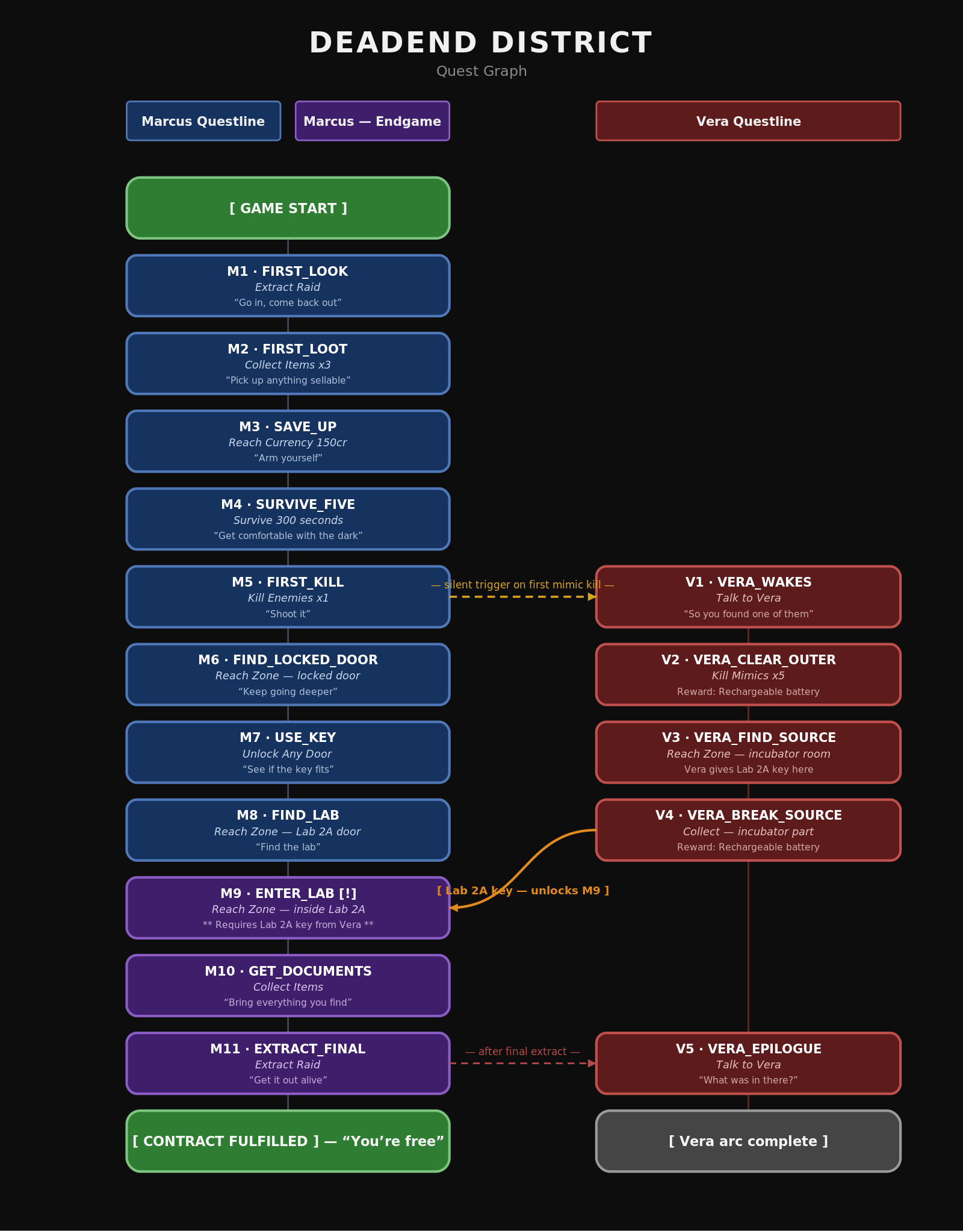
The full quest graph — Marcus’s contract and endgame (left) and Vera’s questline (right), with the three story crosslinks.

★ QUICK REFERENCE CARD
Tear-out controls summary — keep it handy.
All controls
Control | Action
W A S D / Arrows | Move
Mouse | Look
Left Shift | Sprint
Left Ctrl | Crouch
Space | Jump / advance dialogue
Q / E | Lean
Left Mouse | Fire / select
Right Mouse | Aim / item menu
R | Reload / rotate item
H | Hold bolt open
1 2 3 / Wheel | Switch weapon
F | Interact / use
T | Flashlight
Tab | Inventory
Esc | Pause / back
ONE RULE ABOVE ALL Get in. Get loaded. Get out. Loot you didn’t extract was never really yours.
DEADEND DISTRICT — FIELD HANDBOOK · First Edition 2026 · DeadEnd District

