1. Launching the app

<http://localhost:5000/>

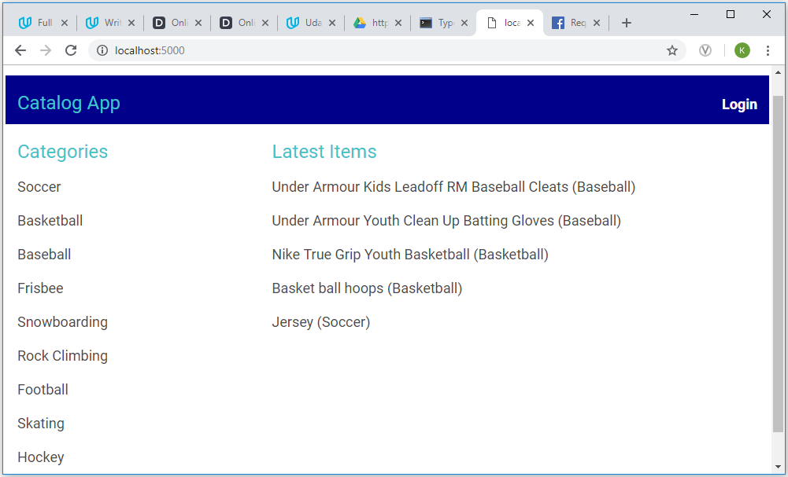

1. On latest item click

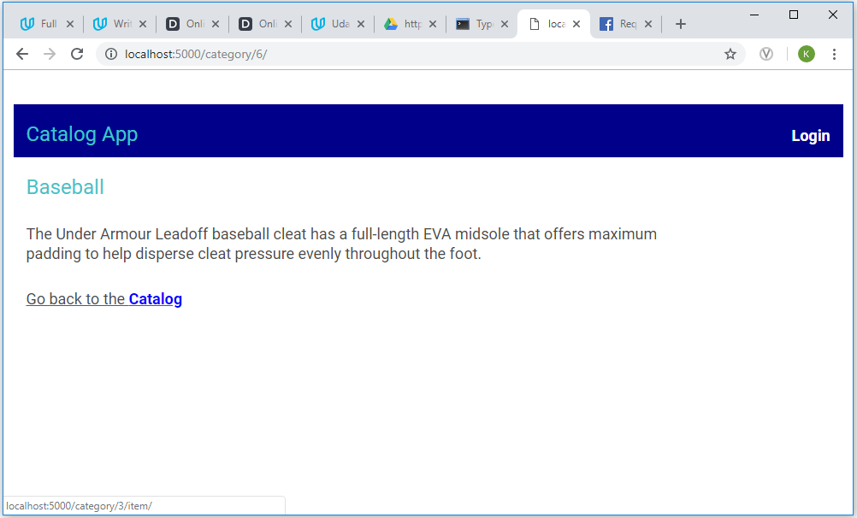

1. On a category selection – click on any category. Example: Baseball

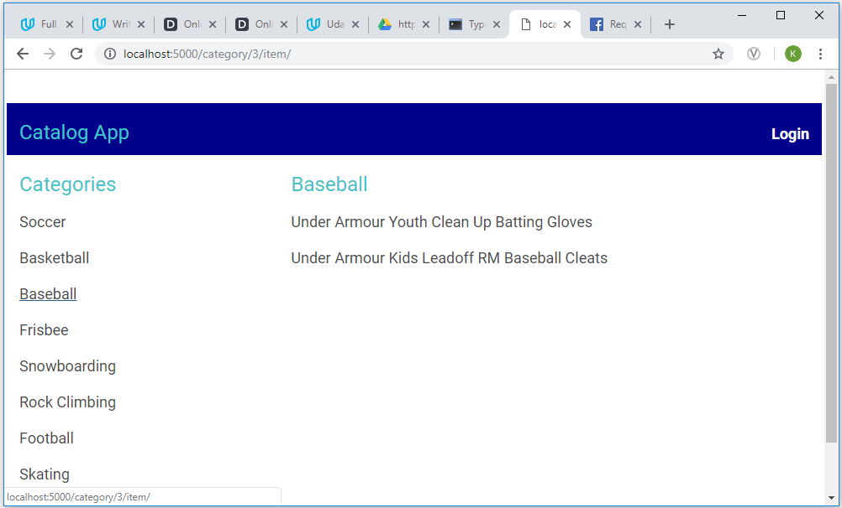

1. On a sports item selection – on click of any item under the selected category: Example: Under Armour Kids LeadOff RM Baseball Cleats

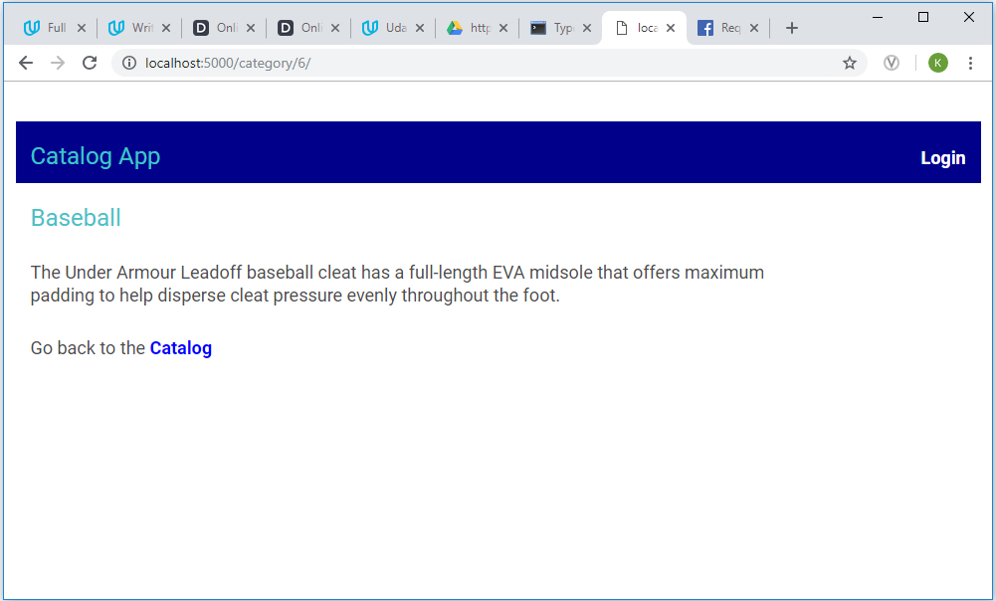

1. Login button – highlighted below

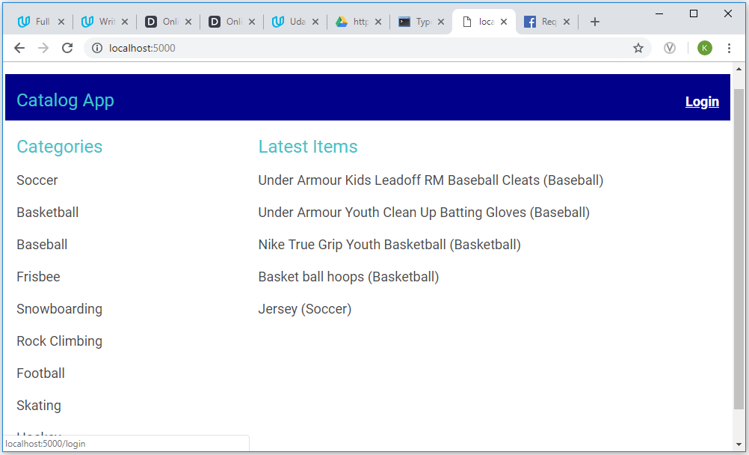

1. On Login button click

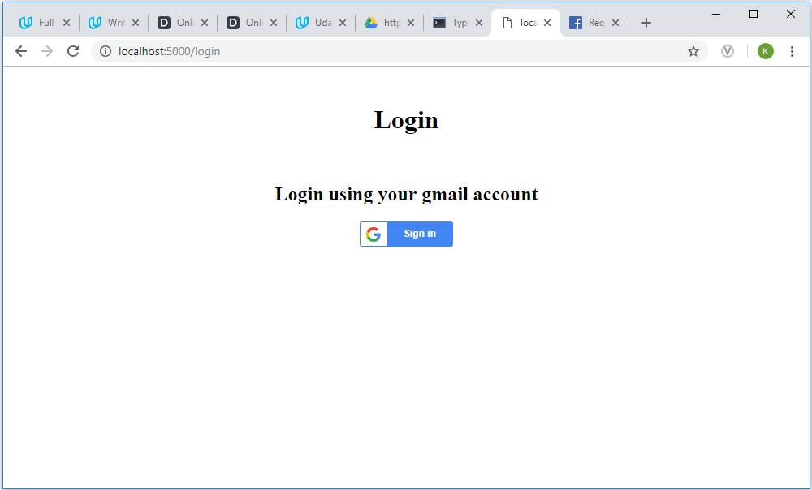

1. On Sign in button click and successful authentication

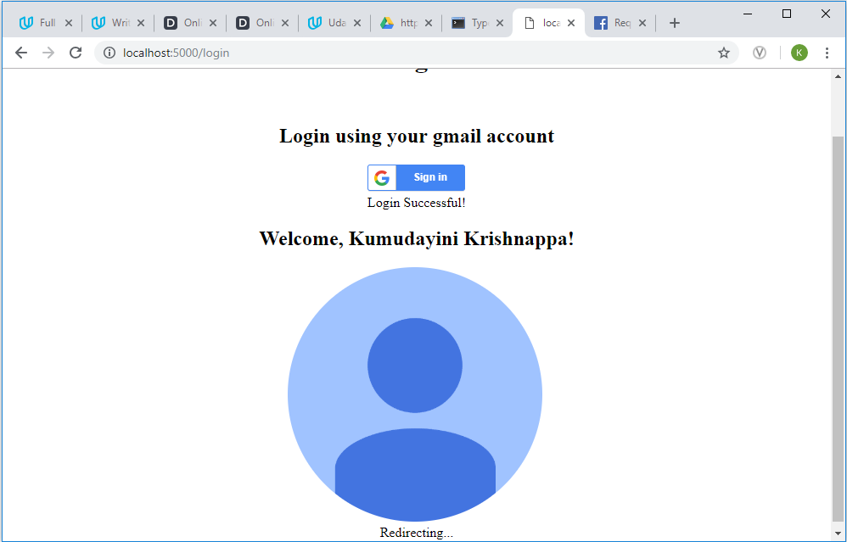

1. After successful login – Logout button highlighted below

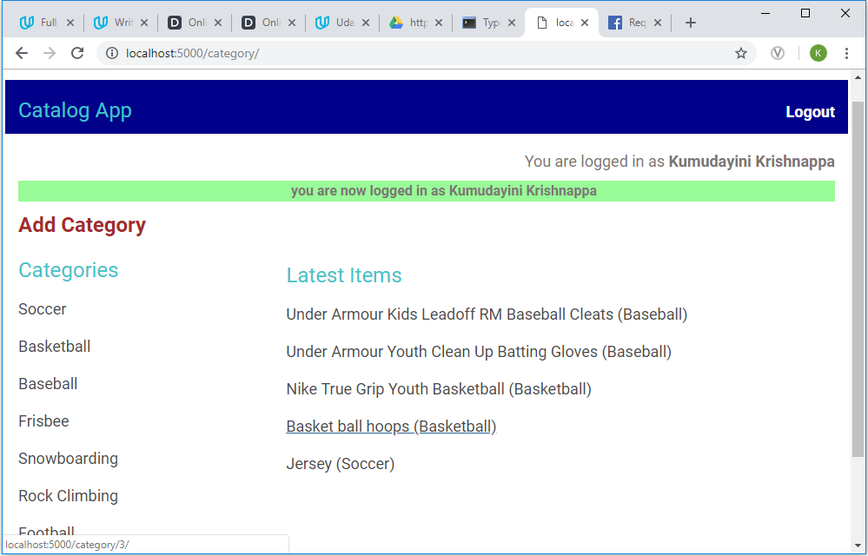

1. On Add Category button click – highlighted below

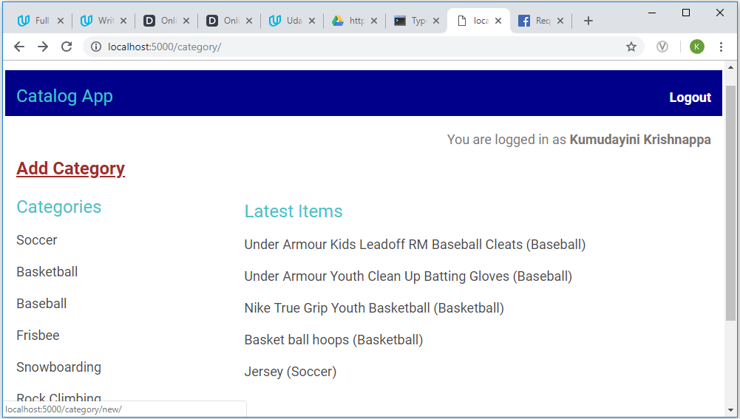

1. On add new category

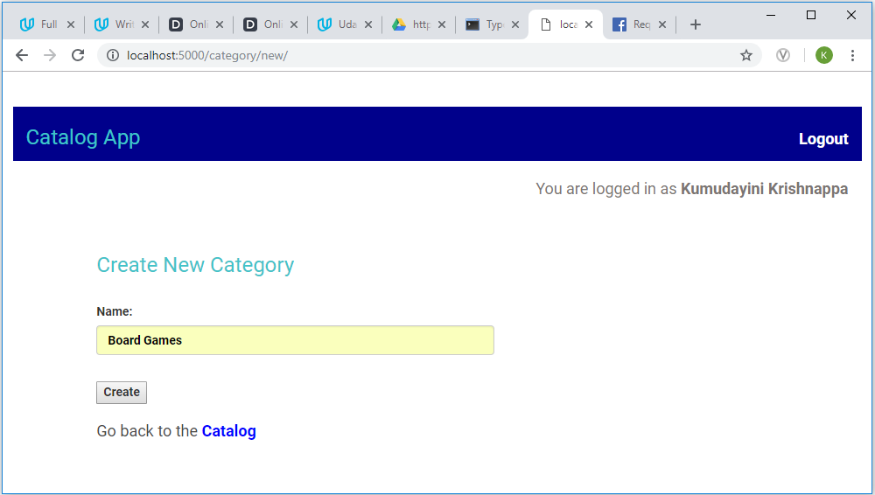

1. Successful message is flashed

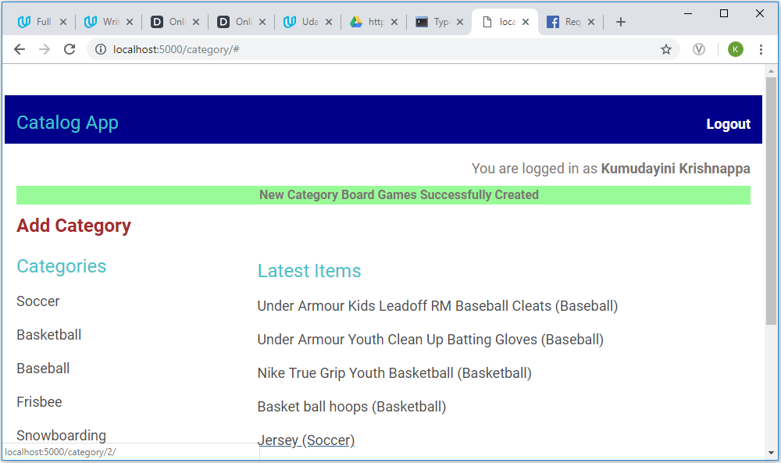

The new category is added at the end of the list of categories – as highlighted below

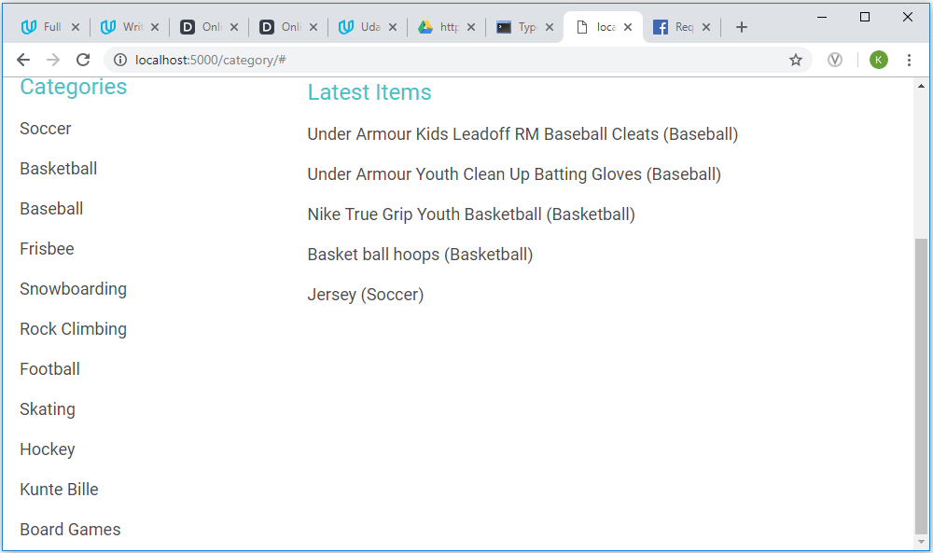

1. On the click of new category added

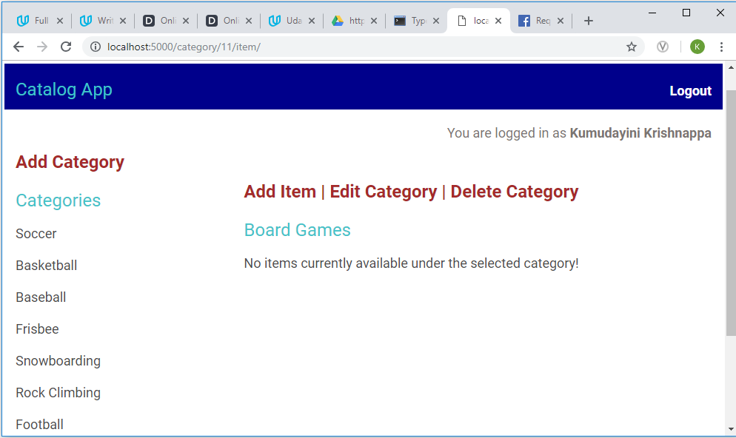

1. On click of Add Item button

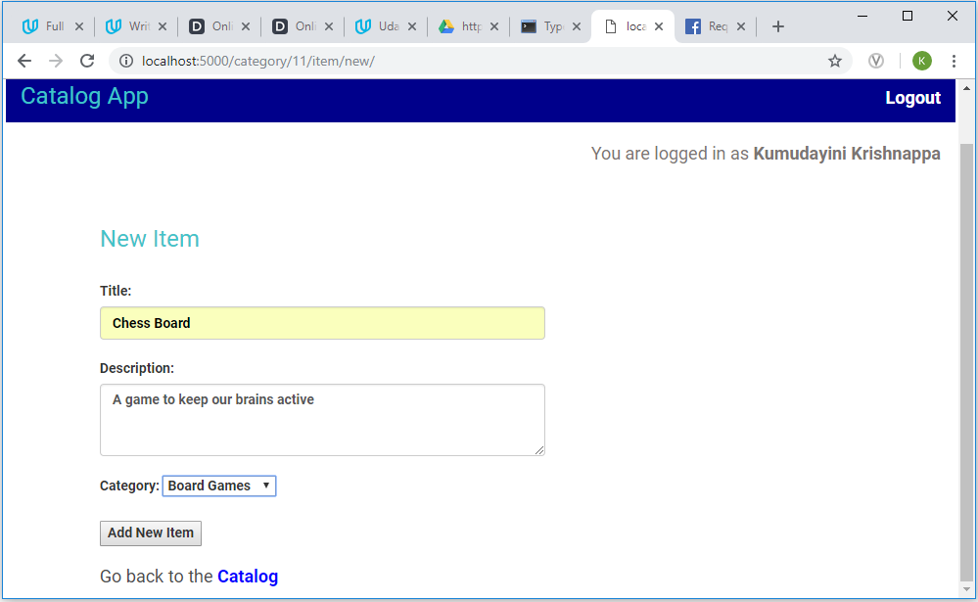

1. On Add New Item – successful addition of the new item under the latest items added

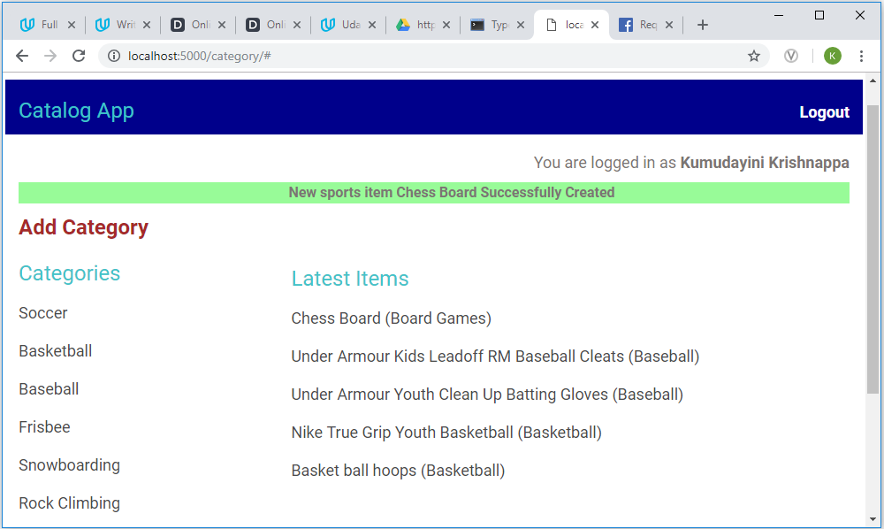

On the selection of the category under which the item is added.

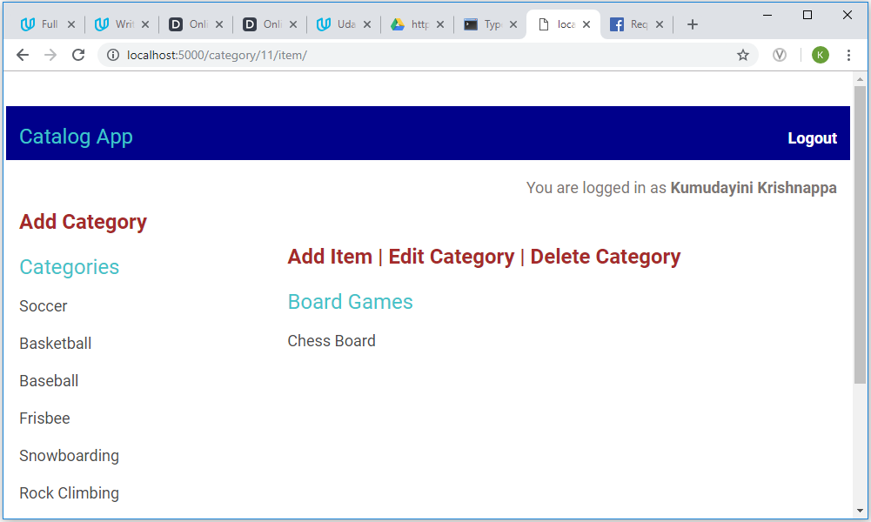

1. On click of the newly added item (only after login)

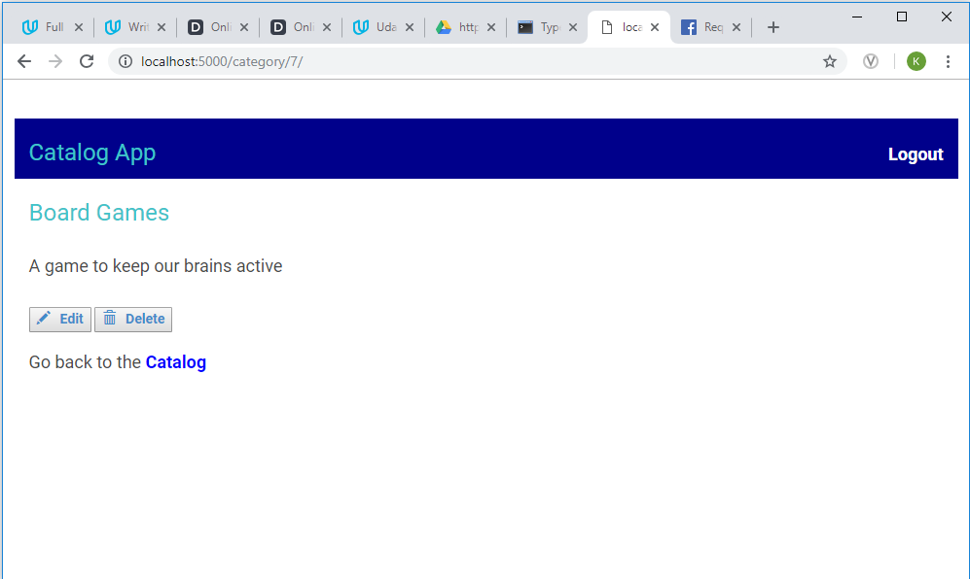

1. On click of Edit button.

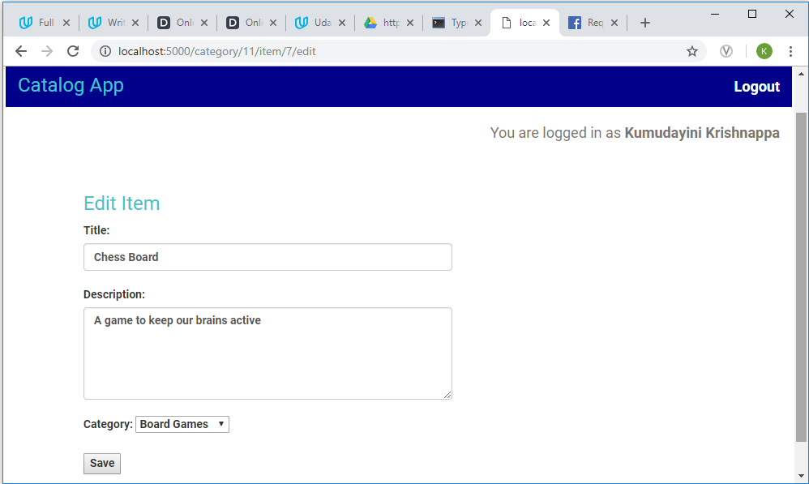

1. On click of Delete button.

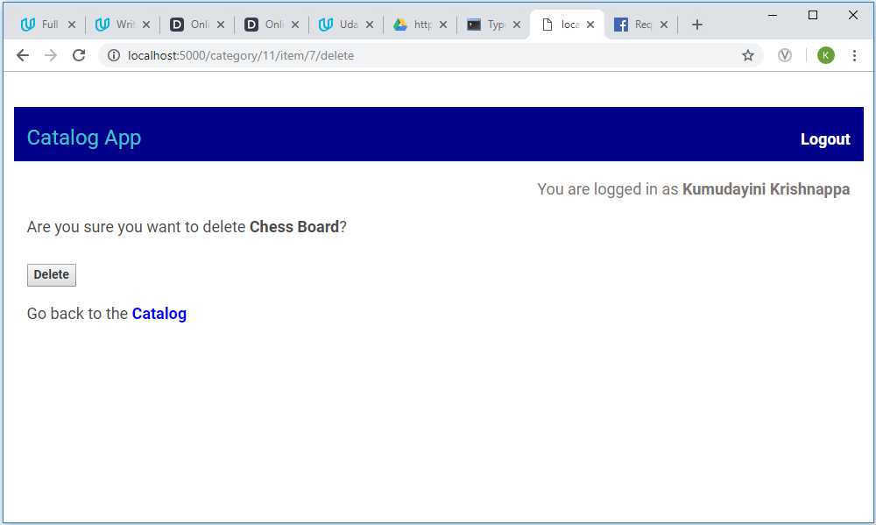

1. On click of Edit category.

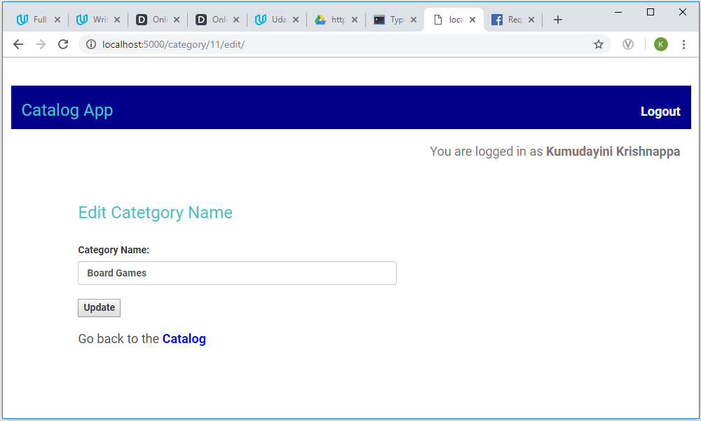

1. On click of Logout button.

