DevOps

Chapter 2
Linux Basics

History of Linux 1a:

Linux File Structure 1b:

File Structure of Linux as compared to the windows:

Windows | Linux
Folder | Directory
Administrator | Root User cd ~
File | File
Software | Package
C drive c:\ | Cd / (hard drive) Top level root directory (tree level)
Program Files | bin
Users | Home (it will have all new users)

File System hierarchy:

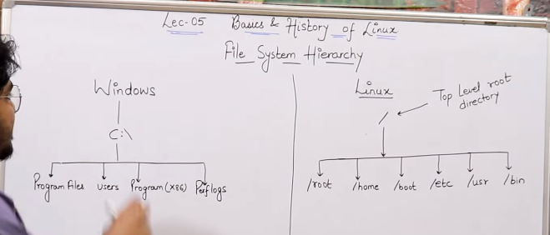
/home → home directory for other users (if you have created a user by default terminal will open here)

/root → it is by default login for administrator (if there is no user terminal will open in admin for example server)

/boot→ it have all the files to active your system once its shutdown it check all the function for example check the battery and then give you error (this is called POST = Power on Self Text)\

/etc → It contain all configuration files for example it has ssh finger print and other files. It has all hardware configuration.

/usr → By default packages are install in this directory.

/bin → (binary) All user + Administrator can use command and saved here (note Commands which by default saved when installing linux) Example ipconfig is default you cannot use iptellme

/sbin → (System Binary) All commands saved in this directory that Administrator can use.

/opt → Optional application software Package. For example Google Chrome or Skype (you can still change the directory to /usr)

/dev → its for peripheral devices and save its information for example mouse or printer.

Linux Commands and its Use Cases 1c:

How to create a file in Linux:

There are four ways to do it.

1 cat Command: (but you cannot edit file)

syntax: cat>filename (press enter)
Add content
-----------
-----------
-----------
then ctrl+d it will exit and save it.

Explanation: cat mean concatenation.
It can do four major tasks
1 Create file
2 Concatenate different files (Major role so it is not editor because it major role to concatenate)
3 Copy files
cat file1 > file2 (Not the original data of file2 will lost and file 1 data will copy and override)
4 tac ( to see the content from bottom to top).

Examples:

cat > file1 (here > sign tells whatever the input will go into the file1 and then ctrl+d will exit and save the content)111

how to add more content in already existing file

cat >> file1
then add you text and then (enter)
ctrl+d

how to add two files into one file

command: cat file1 file2 > MajorFile

now when you do ls -la you will see another file has created with name MajorFile

Now to reverse read the file we use “tac” command
tac MajorFile

2 touch: (Command)

it is used to created empty file.

[user@ip] touch file1 enter
[user@ip] ls -la

for creating the multiple files
fazi@ScriptOne:~/Desktop/LinuxBasics$ touch file2 file3 file4 file5

touch command provides Time Stamp with meta data
and it has three information in the meta data
1 Access Time
2 Modify Time
3 Change Time

How to change the timestamp of the filename

[user@ip] stat file2 (where stat is used to check the timestamp of your data)

Now how we can manually change the Access Time and Modify Time
Commands for this:
touch -a file1 (a for access time and it will change to current time you are working on)
touch -m file1 (m is for modified time and it will change to the current time you are working on)
Now for the change time it is obvious when you change the above two times “ChangeTime” will automatically change to the current time .

3 Vi/Vim (file editor)
Vi can be find in all linux versions. It is used to editing files and programs and mainly used to unix programs.

[user@ip] vi file1 (press enter)

you will get the new screen

step 1 : press I (I mean insert)
step 2 : add your contents
step3 : press esc so you can get out from insert
step4: then press :wq (where w is for save and q is for quit).
Step5: then you can do ls-la and then use cat command to see your file created by vi.
Note: Navigation in the file using vi can be done by “H J K L”
:w → To save
wq: → save and quit
:q → quit without save
;q! → force quit no save

4 nano (file editor)

nano is not found in all linux distributions.
[root@ip] nano file1 (press enter)
enter some contents

Then Ctrl+X to quit and then it will ask you to save then press Yy/Nn to save or not.

Now lets enter to a server using ssh.
I already have digital ocean server and I have saved the connection info. So lets connect.

Lets create a new user and give admin rights to it,
for this we use command : sudo su (super user do switch user).

fazi@MeanStackAppTesting:/etc/ssh$ (here fazi is the user name → MeanStackAppTesting is the computer name(server) where as $ sign show you dont have root or admin privileges.

root@MeanStackAppTesting:~# (here # sign shows you user have root privileges.

→ How to switch between user and root the commands are
1 root to user sudo su fazi
2 user to root su (enter) (or press ctrl+d to exit the current user)

What is MetaData?
The information of data of data.

GitHub Basics 2a:

Software Configuration Management / Source Code Management. It tracks the activity of the developer for the application.

The First System comes in the market there was CVCS (Centralized Version Control System).

Git (Distributed Version Control System). Linus Torvald made it in 2005.

What is Version Control:
Version control, also known as source control, is the practice of tracking and managing changes to software code.

Git Work on Linux Kernal. Git is software tool and version control system and you can install it on your computer.

GitHub is a service on server which gives you storage/repository to store you code. While git is a software which allows you to store code on github.

Benefits of Distributed Version Control System:
1 You have Local Repo and Clone.
2 You dont need internet all the time once the code is complete in your local repo then commit
3 Here you work on your hard disk not live server.
4 If server gets down its not a problem they have local copy and then can commit again and all the code gets on the Server Repository
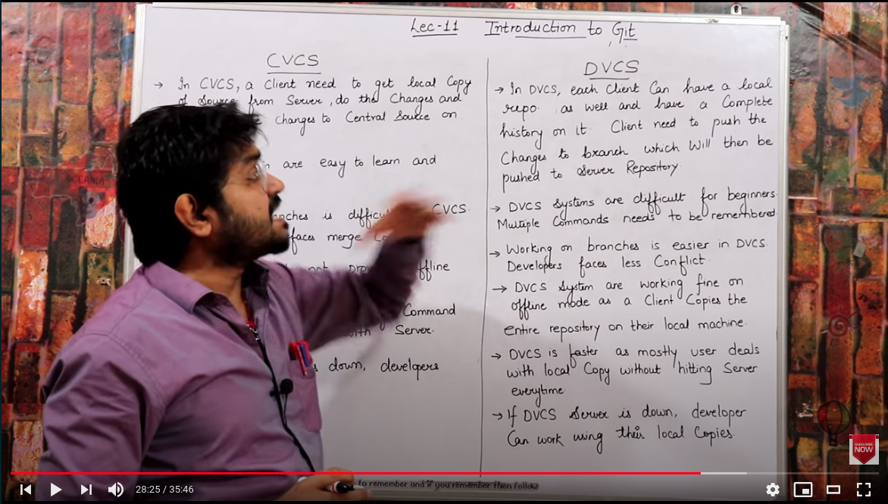

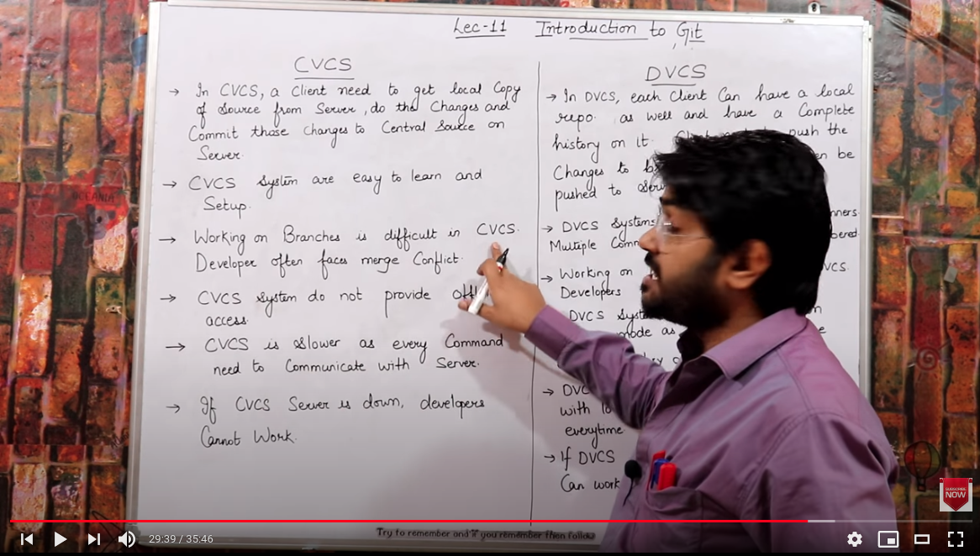

Git Stages 2b:
In Our Server/Local Machine when we create folder and when we open it in the terminal and run “git init” so it mean we are making a local repo and it will have three logical spaces. That we called Stages:

Stage1 : WorkSpace/Working Directory : (Here we read/write/delete/update/manage our code).

Stage2 : Staging Area : Once the code is complete (Error less) we then add it in the staging area and we can use the command “add”.Here you cannot change because it have your run ready code. Staging area is the area where you shortlist the things.

Satge3 : Local Repo : commit (save) is the final code that you save you into the local repository. It is simply the snapshots of your final code so you can see in future. It has unique commit ID with this ID you can retrieve your code and see what you have done in the past.

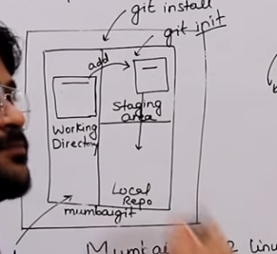

Once everything is done.

Now we need Central Repository to save our data. So multiple people can work on it.
So I am gonna choose github Repository (which is owned by Microsoft). GitLab is the open source version and free version for DCVCS.

Note: Local Repo has a branch called Master Branch.
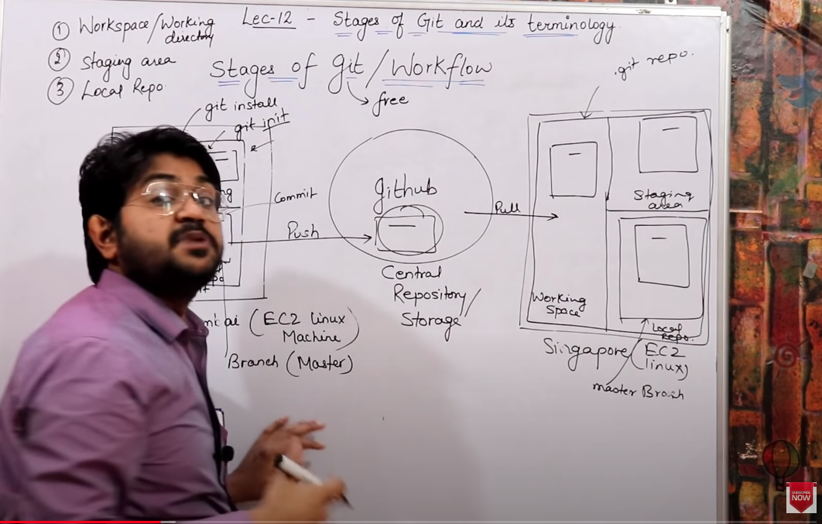
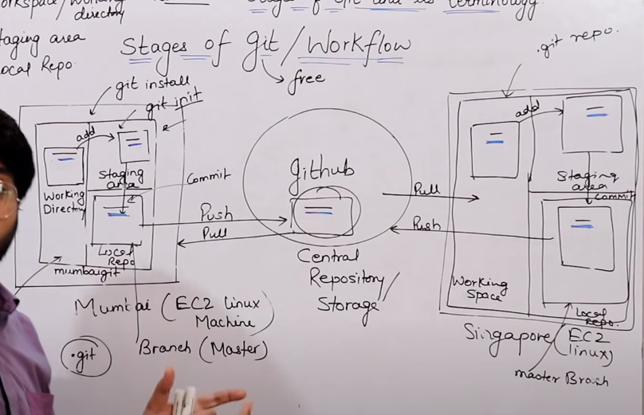
Note: Every Commit has its own id. And you can see that code with that id
Commit: Commit means to take code from staging area to local repo. And when you say git push it will save it to central repo.

GitHub Basics 2c: What is Dns?

