Meeting proceeding 3
Important deadline
Interim report submission: Dec, 12th
First version of report: Dec, 7th

Progress Showcase
UI team
- Currently finished a UI using python

Dataset team
- Have finish all the dataset test cases, but needs to indicate the category of test cases and make the cases more concise.

Backend team
- Have created a program that can run, but needs to clean up the comments
- Also need to make a diagram illustrating the software architecture

Things to do next
- Each group should work on different parts of the interim report:
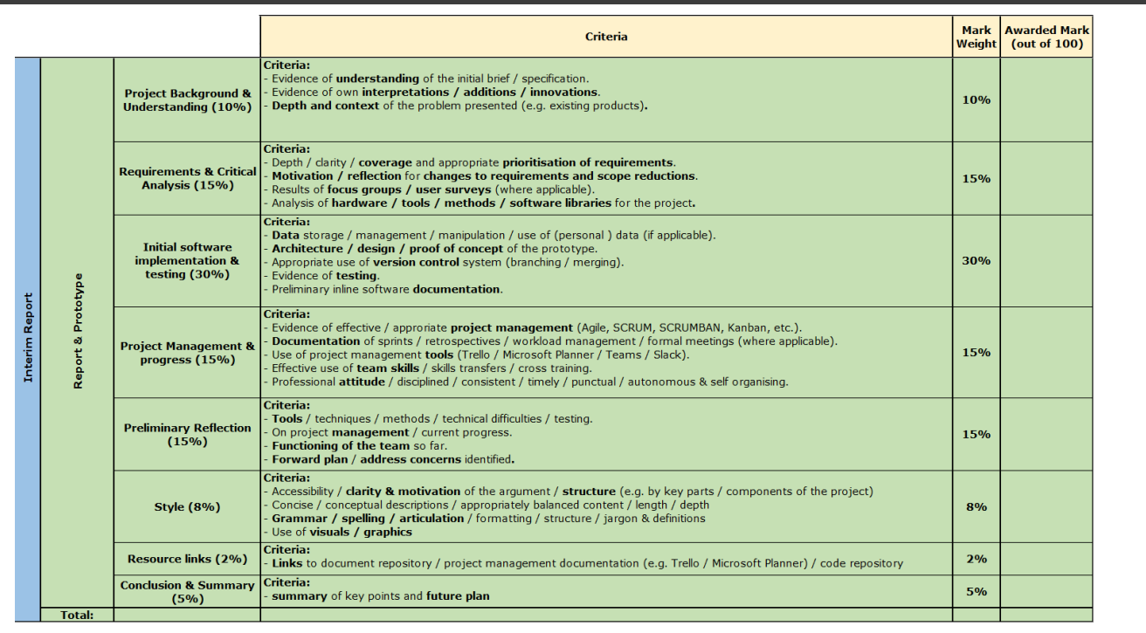
Background understanding and Project background: Can be revised from EOI ✔
Requirements & critical analysis: Can also be revised from EOI ✔
Initial software implementation and testing:
Dataset group: write a testing report (why you design this test case, how you compare the outputs)
Write a data storage report (how you stores the testing data)
Backend group: write a report about software architecture, remember to mention about the authorship of SheetMind
UI group: write a report about how the UI is implemented

Project Management : To be determined

Preliminary Reflect
Each group writes their own reflection report, including the task allocation,

Resource Link : Need to be done by backend group

