实验三 彩色图像处理

班级：__20智能03 _

学号：__2019202216

姓名：__李坤璘_____

一、实验目的
- 掌握常见的几种颜色模型及各种颜色空间之间的相互转换。
- 掌握彩色图像增强的方法，如直方图均衡化，彩色图像平滑、锐化等
- 掌握彩色图像分割的原理和方法。
二、实验环境
Python3.7以上版本，opencv相应版本的WIN XP或WIN2000计算机
三、相关知识
(1)图像各通道的分割与合并

有时候你需要分别在图像的B，G，R通道上工作，在这种情况下，需要将BGR图像分割成单通道图像，在其他情况下，你需要将这些单通道合并成BGR图像。可以通过cv.split函数来分割，cv.merge来合并：
b,g,r = cv.split(img)
img = cv.merge((b,g,r))
Or
b = img[:,:,0]

（2）cv.CvtColor：Opencv里的颜色空间转换函数
dst | = | cv.cvtColor( | src, code[, dst[, dstCn]] | )

参数：src--原图像

Code--转化的类型，可以有多个参数可选，如：cv2.COLOR_BGR2GRAY,cv2.COLOR_BGR2HSV等，具体参数参见opencv教程：OpenCV: Color Space Conversions https://docs.opencv.org/4.0.0/d8/d01/group__imgproc__color__conversions.html#ga4e0972be5de079fed4e3a10e24ef5ef0

dstCn--通道数：一般不写，参数说明,如果参数为0，会自动根据src和code来自动导出通道数
四、实验题目（要求写出程序或命令的注释，给出实验结果）

- 给定一幅彩色图像，分别显示RGB空间的各层，将RGB图像转换到HSI空间，显示HSI空间的各层。
- 给彩色图像添加椒盐噪声，使用中值滤波对彩色图像进行去噪，去噪后分别在RGB空间和HSI空间进行直方图均衡化和图像锐化，比较两个空间的增强效果。
- 给定一幅彩色图像，分别在RGB空间和HSI空间对彩色图像进行分割，要求：
- 在HSI空间进行分割时使用饱和度构建二值化模板，分别对色调层的高饱和区和亮度层的低饱和区进行分割，分割后将色调层和亮度层的分割轮廓合并到原图像的R层上，得到最终分割结果。
- 在RGB空间进行分割时，对不同区域进行采样，获取各个分割区域的彩色平均值，以得到的彩色平均值为中心，设置合适的阈值，计算图像中各像素的（R,G,B）值与中心像素的距离，以阈值为依据，分别对图像中的各个像素进行分类，按照分类结果进行分割。尝试改变阈值，比较分割效果。
- 比较在两个空间的分割效果。
五、实验代码
1.RGB与HIS转化
- import cv2
- import numpy as np
- from matplotlib import pyplot as plt

- # 手写RGB转HSI函数
- def RGB2HSI(img):
- esp = 1e-8
- # 为了计算转换成float32类型
- img = img.astype('float32')
- (R,G,B) = cv2.split(img)
- wid,len = img.shape[0],img.shape[1]
- # R,G,B = R/255,G/255,B/255
- '''''计算I'''
- I = (R+G+B)/3
- '''''计算S'''
- # 解决计算S时分母出现0的问题
- R_G_B = R+G+B+esp # 三层相加
- # R_G_B = np.where(R_G_B<=0,1e-8,R_G_B)
- # 找到Min,计算对应像素点的S
- Min = np.where(B>=G,G,B)
- Min = np.where(Min<=R,Min,R)
- S = 1-(3/(R_G_B))*Min
- '''''计算H'''
- # 求解夹角：分母添加1e-8是避免分母为0的情况
- angle = np.arccos((0.5*(R+R-G-B))/(np.sqrt((R-G)*(R-G)+(R-B)*(G-B)))+esp)

- # for i in range(0,wid):
- # for j in range(0,len):
- # if(B[i,j]>G[i,j]):
- # H[i,j] = 2*np.pi-angle[i][j]
- # else:
- # H[i,j] =angle[i][j]
- # H[i,j] =H[i,j]/(2*np.pi)
- # if(S[i,j]==0):
- # H[i,j] =0
- H = np.where(B>G,2*np.pi-angle,angle)
- H = H/(2*np.pi)
- H = np.where(S==0,0,H)
- # H = np.uint8(H*255)
- # S = np.uint8(S*255)
- # I = np.uint8(I*255)
- imgHSI = img.copy()
- H = cv2.normalize(H,None,0,1,cv2.NORM_MINMAX)
- S = cv2.normalize(S,None,0,1,cv2.NORM_MINMAX)
- I = cv2.normalize(I,None,0,1,cv2.NORM_MINMAX)
- imgHSI[:,:,0] = H*255
- imgHSI[:,:,1] = S*255
- imgHSI[:,:,2] = I*255
- imgHSI = np.uint8(imgHSI)
- return [imgHSI,H*255,S*255,I*255]

- def RGB222HSI(img):
- #保存原始图像的行列数
- row,col = img.shape[0],img.shape[1]
- #对原始图像进行复制
- hsi_img = img.copy()
- #对图像进行通道拆分
- B,G,R = cv2.split(img)
- #把通道归一化到[0,1]
- [B,G,R] = [ i/ 255.0 for i in ([B,G,R])]
- H = np.zeros((row, col)) #定义H通道
- I = (R + G + B) / 3.0 #计算I通道
- S = np.zeros((row,col)) #定义S通道
- for i in range(row):
- den = np.sqrt((R[i]-G[i])**2+(R[i]-B[i])*(G[i]-B[i]))
- thetha = np.arccos(0.5*(R[i]-B[i]+R[i]-G[i])/den) #计算夹角
- h = np.zeros(col) #定义临时数组
- #den>0且G>=B的元素h赋值为thetha
- h[B[i]<=G[i]] = thetha[B[i]<=G[i]]
- #den>0且G<=B的元素h赋值为thetha
- h[G[i]<B[i]] = 2*np.pi-thetha[G[i]<B[i]]
- #den<0的元素h赋值为0
- h[den == 0] = 0
- H[i] = h/(2*np.pi) #弧度化后赋值给H通道
- #计算S通道
- for i in range(row):
- min = []
- #找出每组RGB值的最小值
- for j in range(col):
- arr = [B[i][j],G[i][j],R[i][j]]
- min.append(np.min(arr))
- min = np.array(min)
- #计算S通道
- S[i] = 1 - min*3/(R[i]+B[i]+G[i])
- #I为0的值直接赋值0
- S[i][R[i]+B[i]+G[i] == 0] = 0
- #扩充到255以方便显示，一般H分量在[0,2pi]之间，S和I在[0,1]之间
- hsi_img[:,:,0] = H*255
- hsi_img[:,:,1] = S*255
- hsi_img[:,:,2] = I*255
- return hsi_img,H*255,S*255,I*255

- def RGB22HSI(img1):
- img1 = img1.astype('float32')
- b, g, r = img1[:, :, 0]/255.0, img1[:, :, 1]/255.0, img1[:, :, 2]/255.0

- I = (r+g+b)/3.0

- tem = np.where(b >= g, g, b)
- minValue = np.where(tem >= r, r, tem)
- S = 1 - (3 / (r + g + b)) * minValue

- num1 = 2*r - g - b
- num2 = 2*np.sqrt(((r - g) ** 2) + (r-b)*(g-b))
- deg = np.arccos(num1/num2)
- H = np.where(g >= b, deg, 2*np.pi - deg)

- resImg = np.zeros((img1.shape[0], img1.shape[1],img1.shape[2]), dtype=np.float)
- resImg[:, :, 0], resImg[:, :, 1], resImg[:, :, 2] = H*255, S*255, I*255
- resImg = resImg.astype('uint8')
- return resImg,H*255,S*255,I*255

- # 读入彩色图像(BGR排布)
- img = cv2.imread("C:\\tmp\\6.14.jpg") # 两朵花的图像
- (b,g,r) = cv2.split(img)
- # 转化成RGB排布的彩色图像
- imgRGB = cv2.cvtColor(img, cv2.COLOR_BGR2RGB)
- (R,G,B) = cv2.split(img)

- '''''分别显示RGB空间的各层'''
- plt.figure(1)
- plt.subplot(2,3,1),plt.imshow(imgRGB)
- plt.title('Normal'), plt.xticks([]), plt.yticks([])
- # Error是为了查看误将BGR图像作为RGB图像的后果
- plt.subplot(2,3,4),plt.imshow(img)
- plt.title('Error'), plt.xticks([]), plt.yticks([])
- plt.subplot(2,3,2),plt.imshow(R,cmap ='gray')
- plt.title('NormalR'), plt.xticks([]), plt.yticks([])
- plt.subplot(2,3,3),plt.imshow(G,cmap ='gray')
- plt.title('NormalG'), plt.xticks([]), plt.yticks([])
- plt.subplot(2,3,5),plt.imshow(B,cmap ='gray')
- plt.title('NormalB'), plt.xticks([]), plt.yticks([])
- # ErrorR是为了查看将单图层图像作为三图层不加cmap约束后果
- plt.subplot(2,3,6),plt.imshow(R)
- plt.title('ErrorR'), plt.xticks([]), plt.yticks([])

- '''''将RGB图像转换到HSI空间'''
- imgHSI,H,S,I = RGB2HSI(imgRGB)

- '''''显示HSI空间的各层'''
- plt.figure(2)
- plt.subplot(2,2,1),plt.imshow(imgHSI)
- plt.title('HSI'), plt.xticks([]), plt.yticks([])
- plt.subplot(2,2,2),plt.imshow(H,cmap ='gray')
- plt.title('H'), plt.xticks([]), plt.yticks([])
- plt.subplot(2,2,3),plt.imshow(S,cmap ='gray')
- plt.title('S'), plt.xticks([]), plt.yticks([])
- plt.subplot(2,2,4),plt.imshow(I,cmap ='gray')
- plt.title('I'), plt.xticks([]), plt.yticks([])
- '''''调用库函数转换HSV模型，检验自身所写的转换HSI代码效果方向正确'''
- imgHSV = cv2.cvtColor(img, cv2.COLOR_BGR2HSV)
- [h,s,v] = cv2.split(imgHSV)
- '''''显示HSV空间的各层'''
- plt.figure(3)
- plt.subplot(2,2,1),plt.imshow(imgHSV)
- plt.title('HSV'), plt.xticks([]), plt.yticks([])
- plt.subplot(2,2,2),plt.imshow(h,cmap ='gray')
- plt.title('H'), plt.xticks([]), plt.yticks([])
- plt.subplot(2,2,3),plt.imshow(s,cmap ='gray')
- plt.title('S'), plt.xticks([]), plt.yticks([])
- plt.subplot(2,2,4),plt.imshow(v,cmap ='gray')
- plt.title('V'), plt.xticks([]), plt.yticks([])
- plt.show()
2.彩色图像的去噪、直方图修正、锐化
- # 2.给彩色图像添加椒盐噪声，使用中值滤波对彩色图像进行去噪，去噪后分别在RGB空间和HSI空间进行直方图均衡化和图像锐化，比较两个空间的增强效果
- import cv2
- import numpy as np
- from matplotlib import pyplot as plt
- import random
- from math import cos

- # 手写生成椒盐噪声
- def pepper_salt(img,prob):
- wid,len = img.shape[0],img.shape[1]
- for i in range(0,wid):
- for j in range(0,len):
- rdm = random.random()
- if rdm < prob:
- img[i][j] = 0
- elif rdm > (1-prob):
- img[i][j] = 255
- return img
- # 手写RGB转HSI
- def RGB2HSI(img):
- esp = 1e-8
- # 为了计算转换成float32类型
- img = img.astype('float32')
- (R,G,B) = cv2.split(img)
- wid,len = img.shape[0],img.shape[1]
- # R,G,B = R/255,G/255,B/255
- '''''计算I'''
- I = (R+G+B)/3
- '''''计算S'''
- # 解决计算S时分母出现0的问题
- R_G_B = R+G+B # 三层相加
- # R_G_B = np.where(R_G_B<=0,1e-8,R_G_B)
- # 找到Min,计算对应像素点的S
- Min = np.where(B>=G,G,B)
- Min = np.where(Min<=R,Min,R)
- S = 1-(3/(R_G_B+esp))*Min
- '''''计算H'''
- # 求解夹角：分母添加1e-8是避免分母为0的情况
- angle = np.arccos((0.5*(R+R-G-B))/(np.sqrt((R-G)*(R-G)+(R-B)*(G-B))+esp))
- H = np.where(B>G,2*np.pi-angle,angle)
- H = H/(2*np.pi)
- H = np.where(S==0,0,H)
- # H = np.uint8(H*255)
- # S = np.uint8(S*255)
- # I = np.uint8(I*255)
- imgHSI = img.copy()
- H = cv2.normalize(H,None,0,1,cv2.NORM_MINMAX)
- S = cv2.normalize(S,None,0,1,cv2.NORM_MINMAX)
- I = cv2.normalize(I,None,0,1,cv2.NORM_MINMAX)
- imgHSI[:,:,0] = H*255
- imgHSI[:,:,1] = S*255
- imgHSI[:,:,2] = I*255
- imgHSI = np.uint8(imgHSI)
- return [imgHSI,H*255,S*255,I*255]
- # 手写HSI转RGB
- def HSI2RGB(img):
- eps = 1e-6
- img = (img).astype('float64') / 255.0
- for k in range(img.shape[0]):
- for j in range(img.shape[1]):
- h, s, i = img[k, j, 0], img[k, j, 1], img[k, j, 2]
- r, g, b = 0, 0, 0
- if 0 <= h < 2/3*np.pi:
- b = i * (1 - s)
- r = i * (1 + s * cos(h) / (cos(np.pi/3-h)+eps)) # 避免除0
- g = 3 * i - (b + r)
- elif 2/3*np.pi <= h < 4/3*np.pi:
- r = i * (1 - s)
- g = i * (1 + s * cos(h-2/3*np.pi) / (cos(np.pi - h)+eps))
- b = 3 * i - (r + g)
- elif 4/3*np.pi <= h <= 5/3*np.pi:
- g = i * (1 - s)
- b = i * (1 + s * cos(h - 4/3*np.pi) / (cos(5/3*np.pi - h)+eps))
- r = 3 * i - (g + b)
- img[k, j, 0], img[k, j, 1], img[k, j, 2] = r, g, b
- return (img * 255).astype('uint8')

- '''''显示原RGB图像的效果'''
- img = cv2.imread("C:\\tmp\\4.9.bmp") # 山峰图像
- img = cv2.cvtColor(img, cv2.COLOR_BGR2RGB)
- plt.figure(1)
- plt.subplot(3, 2, 1), plt.imshow(img)
- plt.title('origin'), plt.xticks([]), plt.yticks([])
- '''''对彩色图像添加椒盐噪声，使用中值滤波对整个彩色图像进行去噪'''
- noise = pepper_salt(img,0.02)
- clear1 = cv2.medianBlur(noise,ksize=3) #直接对整个彩色图像使用中值滤波
- clear2 = cv2.medianBlur(noise,ksize=7)
- plt.subplot(3, 2, 2), plt.imshow(noise)
- plt.title('add-noise'), plt.xticks([]), plt.yticks([])
- plt.subplot(3, 2, 3), plt.imshow(clear1)
- plt.title('all-clear(size=3)'), plt.xticks([]), plt.yticks([])
- plt.subplot(3, 2, 4), plt.imshow(clear2)
- plt.title('all-clear(size=7)'), plt.xticks([]), plt.yticks([])
- '''''分离三个色层，分别添加中值滤波'''
- [R,G,B] = cv2.split(noise) # 提取三个色层
- R_clear1 = cv2.medianBlur(R,ksize=3)
- G_clear1 = cv2.medianBlur(G,ksize=3)
- B_clear1 = cv2.medianBlur(B,ksize=3)
- R_clear2 = cv2.medianBlur(R,ksize=5)
- G_clear2 = cv2.medianBlur(G,ksize=5)
- B_clear2 = cv2.medianBlur(B,ksize=5)
- clear3 = cv2.merge([R_clear1,G_clear1,B_clear1])
- clear4 = cv2.merge([R_clear2,G_clear2,B_clear2])
- plt.subplot(3, 2, 5), plt.imshow(clear3)
- plt.title('split-clear(size=3)'), plt.xticks([]), plt.yticks([])
- plt.subplot(3, 2, 6), plt.imshow(clear4)
- plt.title('split-clear(size=5)'), plt.xticks([]), plt.yticks([])
- '''''在RGB空间进行直方图均衡化'''
- hist_r1 = cv2.equalizeHist(R_clear1)
- hist_g1 = cv2.equalizeHist(G_clear1)
- hist_b1 = cv2.equalizeHist(B_clear1)
- hist1 = cv2.merge([hist_r1,hist_g1,hist_b1])
- plt.figure(2)
- plt.subplot(3, 3, 1), plt.imshow(clear3) # clear3是三个图层均添加中值滤波去除噪声的图像
- plt.title('origin'), plt.xticks([]), plt.yticks([])
- plt.subplot(3, 3, 2), plt.imshow(hist1)
- plt.title('equalizeHist'), plt.xticks([]), plt.yticks([])
- plt.subplot(3, 3, 3) # 均衡化后的彩色直方图
- color = ('b', 'g', 'r')
- for i, col in enumerate(color):
- histr = cv2.calcHist([hist1], [i], None, [256], [0,256])
- plt.plot(histr, color=col)
- plt.title('equalizeHist'), plt.xticks([]), plt.yticks([])
- plt.subplot(3, 3, 4), plt.imshow(hist_r1,cmap='gray')
- plt.title('equalizeHist-r'), plt.xticks([]), plt.yticks([])
- plt.subplot(3, 3, 5), plt.imshow(hist_g1,cmap='gray')
- plt.title('equalizeHist-g'), plt.xticks([]), plt.yticks([])
- plt.subplot(3, 3, 6), plt.imshow(hist_b1,cmap='gray')
- plt.title('equalizeHist-b'), plt.xticks([]), plt.yticks([])
- plt.subplot(3, 3, 7), plt.imshow(R_clear1,cmap='gray')
- plt.title('origin-r'), plt.xticks([]), plt.yticks([])
- plt.subplot(3, 3, 8), plt.imshow(G_clear1,cmap='gray')
- plt.title('origin-g'), plt.xticks([]), plt.yticks([])
- plt.subplot(3, 3, 9), plt.imshow(B_clear1,cmap='gray')
- plt.title('origin-b'), plt.xticks([]), plt.yticks([])
- '''''在RGB空间进行图像锐化——拉普拉斯算子'''
- la = np.array([[0,-1,0],[-1,5,-1],[0,-1,0]],np.float32)# 拉普拉斯算子
- # laplacian1 = cv2.filter2D(clear3,-1,kernel=la)# 利用卷积进行锐化
- la_r1 = cv2.filter2D(R_clear1,-1,kernel=la)# 利用卷积进行锐化
- la_g1 = cv2.filter2D(G_clear1,-1,kernel=la)
- la_b1 = cv2.filter2D(B_clear1,-1,kernel=la)
- la1 = cv2.merge([la_r1,la_g1,la_b1])
- plt.figure(3)
- plt.subplot(3, 3, 1), plt.imshow(clear3) # clear3是三个图层均添加中值滤波去除噪声的图像
- plt.title('origin'), plt.xticks([]), plt.yticks([])
- plt.subplot(3, 3, 2), plt.imshow(la1)
- plt.title('laplacian'), plt.xticks([]), plt.yticks([])
- plt.subplot(3, 3, 4), plt.imshow(la_r1,cmap='gray')
- plt.title('la-r'), plt.xticks([]), plt.yticks([])
- plt.subplot(3, 3, 5), plt.imshow(la_g1,cmap='gray')
- plt.title('la-g'), plt.xticks([]), plt.yticks([])
- plt.subplot(3, 3, 6), plt.imshow(la_b1,cmap='gray')
- plt.title('la-b'), plt.xticks([]), plt.yticks([])
- plt.subplot(3, 3, 7), plt.imshow(R_clear1,cmap='gray')
- plt.title('origin-r'), plt.xticks([]), plt.yticks([])
- plt.subplot(3, 3, 8), plt.imshow(G_clear1,cmap='gray')
- plt.title('origin-g'), plt.xticks([]), plt.yticks([])
- plt.subplot(3, 3, 9), plt.imshow(B_clear1,cmap='gray')
- plt.title('origin-b'), plt.xticks([]), plt.yticks([])
- '''''---------------在HSI空间进行直方图均衡化和图像锐化（仅需处理亮度I）---------------'''
- imgHSI = cv2.cvtColor(clear3, cv2.COLOR_RGB2HSV)
- [H,S,I] = cv2.split(imgHSI)
- I = I.astype('uint8')
- histI = cv2.equalizeHist(I) # 对I进行直方图均衡化
- laI = cv2.filter2D(I,-1,kernel=la) # 对I添加拉普拉斯算子进行锐化
- histHSI,laHSI = clear3.copy(),clear3.copy()
- histHSI[:,:,0],histHSI[:,:,1],histHSI[:,:,2] = H,S,histI # 构建直方图修正后的彩色图像
- laHSI[:,:,0],laHSI[:,:,1],laHSI[:,:,2] = H,S,laI # 构建锐化后修正后的彩色图像
- hist2 = cv2.cvtColor(histHSI, cv2.COLOR_HSV2RGB)
- la2 = cv2.cvtColor(laHSI, cv2.COLOR_HSV2RGB)
- plt.figure(4)
- plt.subplot(1, 3, 1), plt.imshow(clear3) # clear3是三个图层均添加中值滤波去除噪声的图像
- plt.title('origin'), plt.xticks([]), plt.yticks([])
- plt.subplot(1, 3, 2), plt.imshow(hist2)
- plt.title('equalizeHist-I'), plt.xticks([]), plt.yticks([])
- plt.subplot(1, 3, 3), plt.imshow(la2)
- plt.title('laplacian-I'), plt.xticks([]), plt.yticks([])
- '''''比较两种锐化方式'''
- la1gray,la2gray,com = H.copy(),H.copy(),H.copy()
- la1gray,la2gray = cv2.cvtColor(la1, cv2.COLOR_RGB2GRAY),cv2.cvtColor(la2, cv2.COLOR_RGB2GRAY)
- com = np.abs(la1gray-la2gray)
- plt.figure(5)
- plt.subplot(2, 2, 1), plt.imshow(clear3) # clear3是三个图层均添加中值滤波去除噪声的图像
- plt.title('origin'), plt.xticks([]), plt.yticks([])
- plt.subplot(2, 2, 2), plt.imshow(la1)
- plt.title('la-GRB'), plt.xticks([]), plt.yticks([])
- plt.subplot(2, 2, 3), plt.imshow(la2)
- plt.title('la-I'), plt.xticks([]), plt.yticks([])
- plt.subplot(2, 2, 4), plt.imshow(com,cmap='gray')
- plt.title('compare'), plt.xticks([]), plt.yticks([])
- plt.show()
3.彩色图像分割
- import cv2
- import numpy as np
- from matplotlib import pyplot as plt

- img = cv2.imread("C:\\tmp\\6.10.jpg") # 一朵花的图像
- imgRGB = cv2.cvtColor(img, cv2.COLOR_BGR2RGB)
- imgHSI = cv2.cvtColor(img, cv2.COLOR_BGR2HSV)
- [R,G,B] = cv2.split(imgRGB)
- [H,S,I] = cv2.split(imgHSI)

- '''''------------------------------1.HSI空间进行分割----------------------------------'''
- '''''【使用饱和度构建二值化模板】'''
- threshold_S = 70 # 设定饱和度阈值为185
- ret1,th_S = cv2.threshold(S,threshold_S,255,cv2.THRESH_BINARY)# 饱和度小于185置0,大于185置255
- '''''对色调层的高饱和区按H值进行阈值分割'''
- th_H = H.copy()
- # th_H = cv2.bitwise_and(th_H,th_S)
- for i in range(th_H.shape[0]):
- for j in range(th_H.shape[1]):
- if th_S[i,j] == 0:
- th_H[i,j] = 255
- '''''对亮度层的低饱和区按I值进行阈值分割'''
- th_I = I.copy()
- for i in range(th_I.shape[0]):
- for j in range(th_I.shape[1]):
- if th_S[i,j] == 255:
- th_I[i,j] = 255
- # th_I = cv2.bitwise_and(th_I, th_S)
- '''''将色调层和亮度层的分割轮廓合并到原图像的 R 层上'''
- # res = cv2.add(th_I,th_H)
- th_I_and_H = cv2.addWeighted(th_I,0.5,th_S,0.5,0) # 分割后色调层与亮度层合并
- fix = cv2.addWeighted(th_I_and_H,0.7,R,0.3,0) # 分割轮廓合并到R层上
- '''''转化回彩色图像'''
- res = cv2.merge([fix,G,B])
- # 去除多余背景（依赖亮度）
- ress = res.copy()
- for i in range(th_H.shape[0]):
- for j in range(th_H.shape[1]):
- if I[i,j] <= 50:
- ress[i,j] = [0,0,0]
- '''''显示HSI空间进行分割的过程'''
- plt.subplot(2,5,1),plt.imshow(imgRGB)
- plt.title('Normal'), plt.xticks([]), plt.yticks([])
- plt.subplot(2,5,2),plt.imshow(R,cmap='gray')
- plt.title('R'), plt.xticks([]), plt.yticks([])
- plt.subplot(2,5,3),plt.imshow(th_S,cmap='gray')
- plt.title('binary-S'), plt.xticks([]), plt.yticks([])
- plt.subplot(2,5,4),plt.imshow(th_H,cmap='gray')
- plt.title('threshold-H'), plt.xticks([]), plt.yticks([])
- plt.subplot(2,5,5),plt.imshow(th_I,cmap='gray')
- plt.title('threshold-I'), plt.xticks([]), plt.yticks([])
- plt.subplot(2,5,6),plt.imshow(th_I_and_H,cmap='gray')
- plt.title('th_I + th_H'), plt.xticks([]), plt.yticks([])
- plt.subplot(2,5,7),plt.imshow(fix,cmap='gray')
- plt.title('th_I + th_H + R'), plt.xticks([]), plt.yticks([])
- plt.subplot(2,5,8),plt.imshow(res)
- plt.title('split-RGB'), plt.xticks([]), plt.yticks([])
- plt.subplot(2,5,9),plt.imshow(ress)
- plt.title('del-background'), plt.xticks([]), plt.yticks([])
- '''''【因饱和度分割效果不是最好，考虑到亮度与图像的色彩相互独立，因此尝试使用亮度构建二值化模板】'''
- threshold_I = 90
- ret2,th_i = cv2.threshold(I,threshold_I,255,cv2.THRESH_BINARY)
- '''''对色调层的高亮度区按H值进行阈值分割'''
- th_h = H.copy()
- for i in range(th_h.shape[0]):
- for j in range(th_h.shape[1]):
- if th_i[i,j] == 0:
- th_h[i,j] = 255
- '''''对饱和度层的低亮度区按S值进行阈值分割'''
- th_s = S.copy()
- for i in range(th_s.shape[0]):
- for j in range(th_s.shape[1]):
- if th_i[i,j] == 255:
- th_s[i,j] = 255
- # th_s = cv2.bitwise_and(th_s, th_i)
- '''''将色调层和饱和度层的分割轮廓合并到原图像的 R 层上'''
- th_s_and_h = cv2.addWeighted(th_s,0.5,th_h,0.5,0) # 分割后色调层与亮度层合并
- fix2 = cv2.addWeighted(th_s_and_h,0.7,R,0.3,0) # 分割轮廓合并到R层上
- '''''转化回彩色图像'''
- res2 = cv2.merge([fix2,G,B])
- res22 = res2.copy()
- # 去除背景，只保留高亮度区域提取的图像
- for i in range(th_H.shape[0]):
- for j in range(th_H.shape[1]):
- if th_i[i,j] == 0:
- res22[i,j] = [0,0,0]
- '''''显示HSI空间进行分割的过程'''
- plt.figure(2)
- plt.subplot(2,5,1),plt.imshow(imgRGB)
- plt.title('Normal'), plt.xticks([]), plt.yticks([])
- plt.subplot(2,5,2),plt.imshow(R,cmap='gray')
- plt.title('R'), plt.xticks([]), plt.yticks([])
- plt.subplot(2,5,3),plt.imshow(th_i,cmap='gray')
- plt.title('binary-i'), plt.xticks([]), plt.yticks([])
- plt.subplot(2,5,4),plt.imshow(th_h,cmap='gray')
- plt.title('threshold-h'), plt.xticks([]), plt.yticks([])
- plt.subplot(2,5,5),plt.imshow(th_s,cmap='gray')
- plt.title('threshold-s'), plt.xticks([]), plt.yticks([])
- plt.subplot(2,5,6),plt.imshow(th_s_and_h,cmap='gray')
- plt.title('th_s + th_h'), plt.xticks([]), plt.yticks([])
- plt.subplot(2,5,7),plt.imshow(fix2,cmap='gray')
- plt.title('th_s + th_h + R'), plt.xticks([]), plt.yticks([])
- plt.subplot(2,5,8),plt.imshow(res2)
- plt.title('split-RGB'), plt.xticks([]), plt.yticks([])
- plt.subplot(2,5,9),plt.imshow(res22)
- plt.title('del-background'), plt.xticks([]), plt.yticks([])
- '''''------------------------------2.RGB空间进行分割----------------------------------'''
- '''''【采用实验要求选取区域设置阈值】'''
- # 最终遍历出x:[100,340] y:[250,560]
- x1,x2 = 110,330
- y1,y2 = 260,550
- mask = np.zeros((x2-x1,y2-y1))
- for i in range(x1,x2):
- for j in range(y1,y2):
- mask[i-x1,j-y1] = R[i,j]
- plt.figure(3)
- plt.subplot(1,1,1),plt.imshow(mask,cmap='gray')
- plt.title('mask'), plt.xticks([]), plt.yticks([])
- mean_mask = np.mean(mask) # 区域的均值
- std_mask = np.std(mask) # 区域的标准差
- R1 = R.copy() # R1为分割后的R分量图像
- split_RGB = imgRGB.copy()
- for i in range(R1.shape[0]):
- for j in range(R1.shape[1]):
- # 符合条件的像素点如下
- if R[i,j] > (mean_mask-1.25*std_mask) and R[i,j] < (mean_mask+1.25*std_mask):
- R1[i,j] = R[i,j]
- else:
- R1[i,j] = 0 # 不符合条件直接置0
- split_RGB[i,j] = [0,0,0]
- plt.figure(3)
- plt.subplot(2,4,1), plt.imshow(R, cmap='gray')
- plt.title('NormalR'), plt.xticks([]), plt.yticks([])
- plt.subplot(2,4,2), plt.imshow(G, cmap='gray')
- plt.title('NormalG'), plt.xticks([]), plt.yticks([])
- plt.subplot(2,4,3), plt.imshow(B, cmap='gray')
- plt.title('NormalB'), plt.xticks([]), plt.yticks([])
- plt.subplot(2,4,5),plt.imshow(imgRGB)
- plt.title('Origin'), plt.xticks([]), plt.yticks([])
- plt.subplot(2,4,6),plt.imshow(mask, cmap='gray')
- plt.title('mask'), plt.xticks([]), plt.yticks([])
- plt.subplot(2,4,7),plt.imshow(R1,cmap='gray')
- plt.title('split-R'), plt.xticks([]), plt.yticks([])
- plt.subplot(2,4,8),plt.imshow(split_RGB)
- plt.title('split-RGB'), plt.xticks([]), plt.yticks([])
- '''''【采用位运算掩膜分割图像】'''
- # 图像颜色的限界
- l = np.array([9,9,9])
- h = np.array([14,14,15])
- # 位运算提取图像范围中的那部分
- Mask = cv2.inRange(imgRGB,l,h)
- iimg = imgRGB.copy()
- result = cv2.bitwise_not(iimg,iimg,mask=Mask)
- plt.figure(4)
- plt.subplot(1,2,1),plt.imshow(imgRGB)
- plt.title('Origin'), plt.xticks([]), plt.yticks([])
- plt.subplot(1,2,2),plt.imshow(result)
- plt.title('split'), plt.xticks([]), plt.yticks([])

- plt.show()
六、实验结果和实验分析
1.RGB与HSI的转换
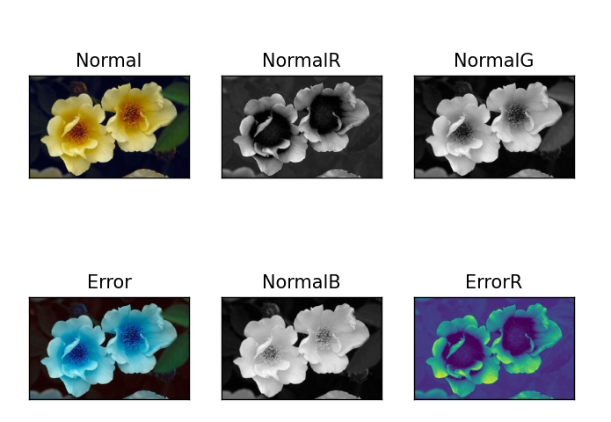
图1.1 显示 RGB 空间的各层
图1.1.1：正常RGB图像
图1.1.2 1.1.3 1.1.5：分别为R G B三层的灰度图
图1.1.4：误将BGR图像当做RGB图像输出的结果
图1.1.6：误将单层灰度图当做彩图格式输出，而且没有处理另外两层的结果：
图1.1.4与图1.1.6均为实验过程中出现的问题，特此记录
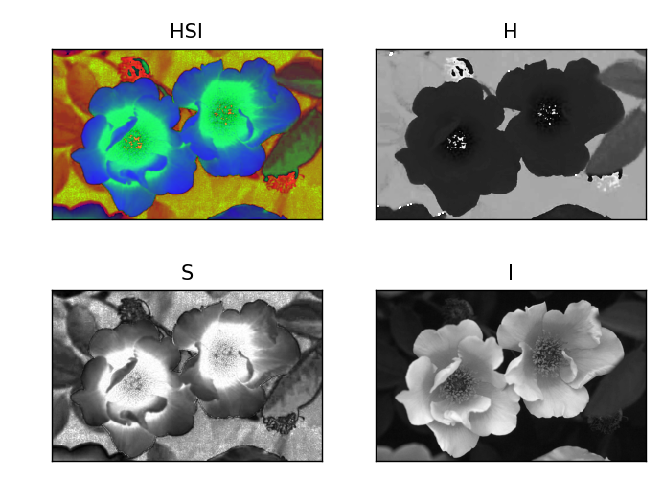
图1.2 显示HSI空间的各层
图1.1.1：正常HIS图像
图1.1.2 3 4：分别表示H S I层的图像，其中H代表色调，S代表饱和度，I代表亮度
为了验证书写的转换函数的正确性，又调用了opencv自带的RGB转HSV函数进行验证
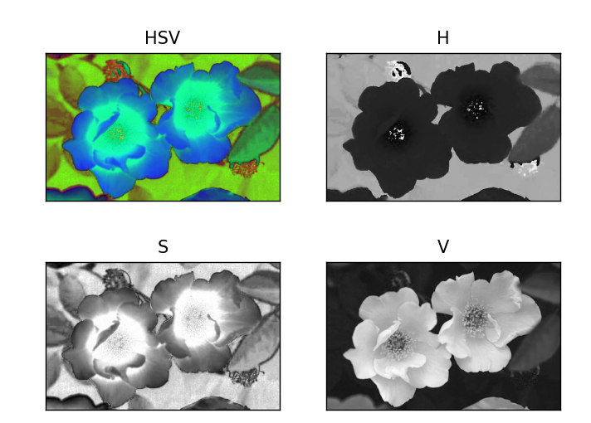
图1.3 显示HSV空间的各层
可以发现除了部分轮廓稍有区别，整体呈现效果一直，证明函数书写正确
2.彩色图像的去噪、直方图修正、锐化
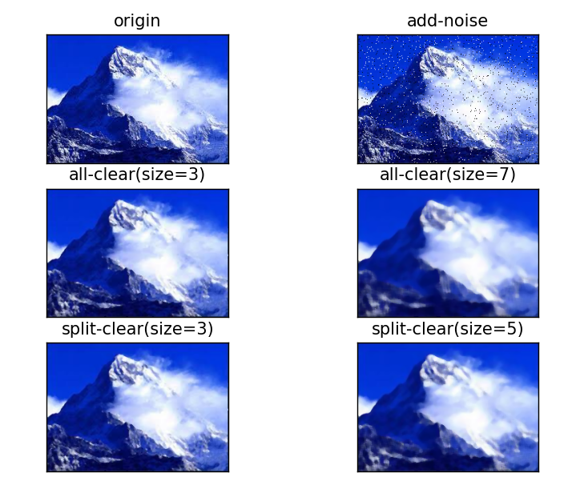
图2.1 彩色图像的去噪

图2.1.1与2.1.2分别为原图与添加椒盐噪声后的图像
图2.1.3与2.1.4为直接将某一位置的RGB值作为一个向量，以向量为单位添加中值滤波。
图2.1.5与2.1.6为将RGB三层拆开分别添加中值滤波后合并结果
可以发现两种添加中值滤波的方式均能有效处理椒盐噪声，且处理效果相同
采用5*5与7*7的模板均会使图像略微失真，3*3达到最好去燥效果

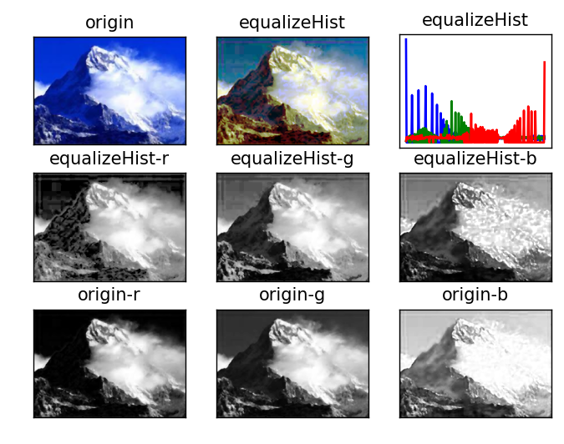
图2.2 RGB下的直方图修正
图2.2.1为原图像 图2.2.2为RGB三层均进行直方图修正后合并的图像
图2.2.3为直方图修正后的RGB直方图柱形图
图2.2.4 5 6分别为R G B层灰度图直方图修正后的结果
图2.2.7 8 9分别为R G B层灰度图原效果
可以发现，在RGB下进行直方图修正会将三层灰度值分布尽量平均，合并起来后会使其向量对在空间分布均匀，使颜色对比度增大（代价是可能会改变原图颜色）
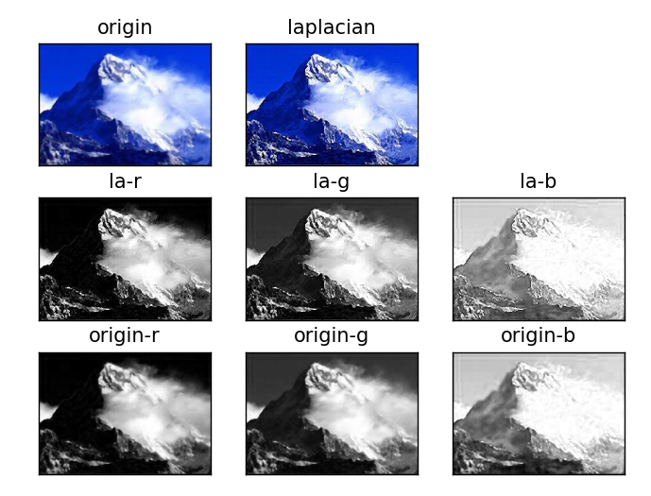
图2.3 RGB下的锐化（添加拉普拉斯算子）
图2.2.1为原图像 图2.2.2为RGB三层均进行锐化后合并的图像
图2.2.4 5 6分别为R G B层锐化的结果
图2.2.7 8 9分别为R G B层灰度图原效果
拉普拉斯算子与原图像进行卷积加强了图像边缘轮廓的细节，可以清楚看见，三层均将边缘凸显出来，合并后整体彩色图像得到明显的强化
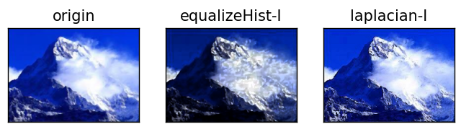
图2.4 HIS下对亮度进行直方图修正与锐化
分别为原图像、亮度直方图修正、亮度添加拉普拉斯算子的结果
因为亮度与图像的颜色是相对独立的，因此如果仅将亮度层进行图像增强，可以在保证图像颜色类型基本相似的基础上，增强图像中的细节。可以发现与细节增强明显，基本蓝白色调也没有因直方图修正而影响。

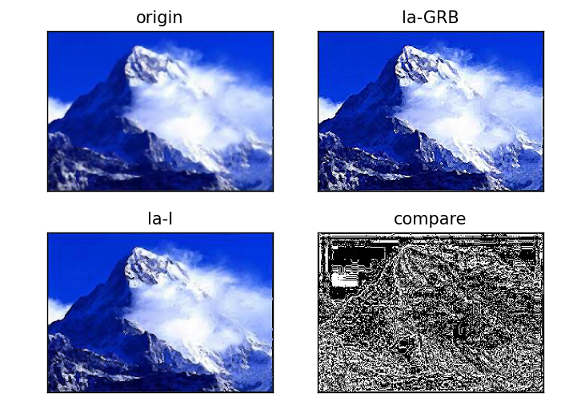
图2.5 两种图像类型的锐化程度对比

左上为原图像；右上为对R G B三层分别添加拉普拉斯算子
左下为仅对I层添加拉普拉斯算子；右下为两图相减结果。

两种方式均将图像的细节凸显出来，二者都起到较好的增强效果
右下图黑色区域为二者灰度值相同处，而白色区域又恰似图像中的边缘轮廓，可以发现二者虽然整体相似，但是在轮廓增强程度和位置仍是有些细微差距，但是在肉眼感观中无太大区别。如果是为了完整保留图像的色调，那采取I层增强是更好的方案；如果是为了计算量小，代码整洁，可采用R G B三层锐化。

3.彩色图像分割
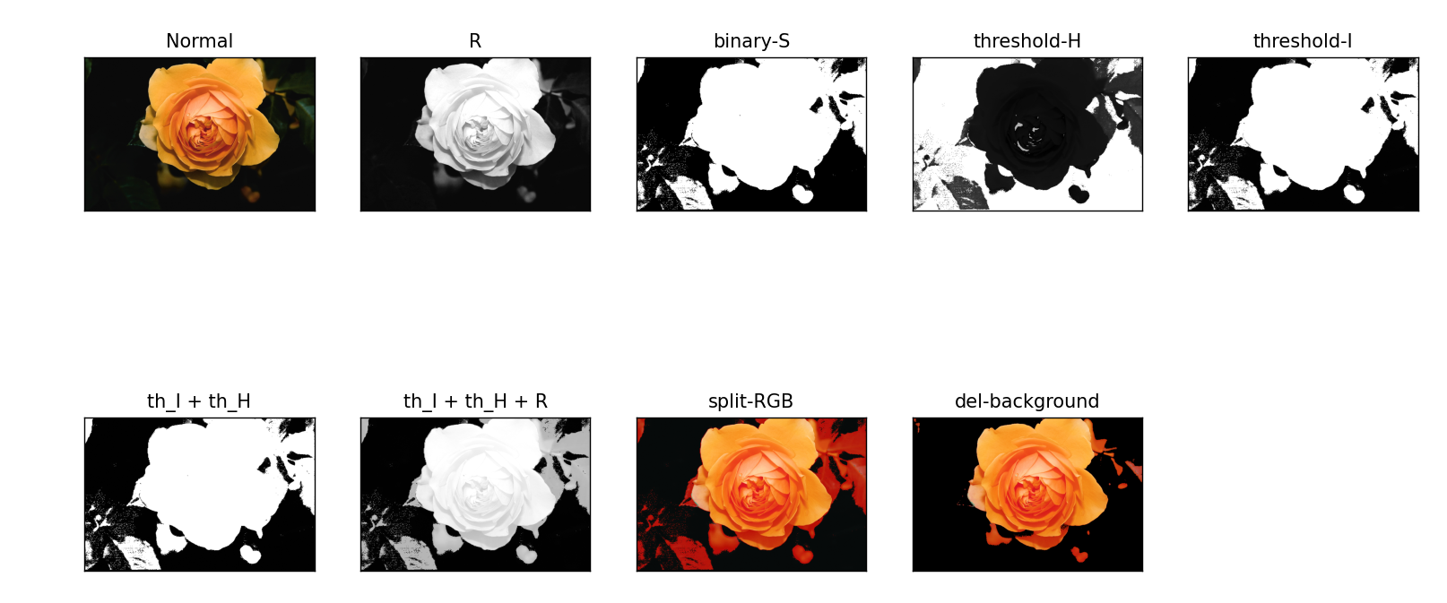
图3.1 HIS分割——使用饱和度构建二值化模板
Normal：原图像 R：R层灰度图
binary-S：饱和度小于70置0,大于70置255
threshold-H：对色调层的高饱和区按H值进行阈值分割
threshold-I：对亮度层的低饱和区按I值进行阈值分割'
th_I + th_H：分割后色调层与亮度层合并（等权相加）
th_I + th_h + R：将色调层和亮度层的分割轮廓合并到原图像的 R 层上
split-RGB：分割后的R层灰度图与原G B合并转化为RGB形式
del-background：去除多余背景（去除背景，只保留高亮度区域提取的图像）

以饱和度S层为模板构建二值图像，分别提取出H I层高饱和度/低饱和度的区域，再合并到R层图像上，本质就是将要分割出来的那一区域凸显出来，弱化或去除其他多余部分。但是由于不同颜色区域有时饱和度是类似的，且本图中要突出的区域相比其他区域是亮的，因此虽然本题分割效果较为明显，但是最后去除背景时仍是考虑到亮度阈值进行去除。因此联想到是否可以直接以亮度为模板，进行HSI空间的图像分割
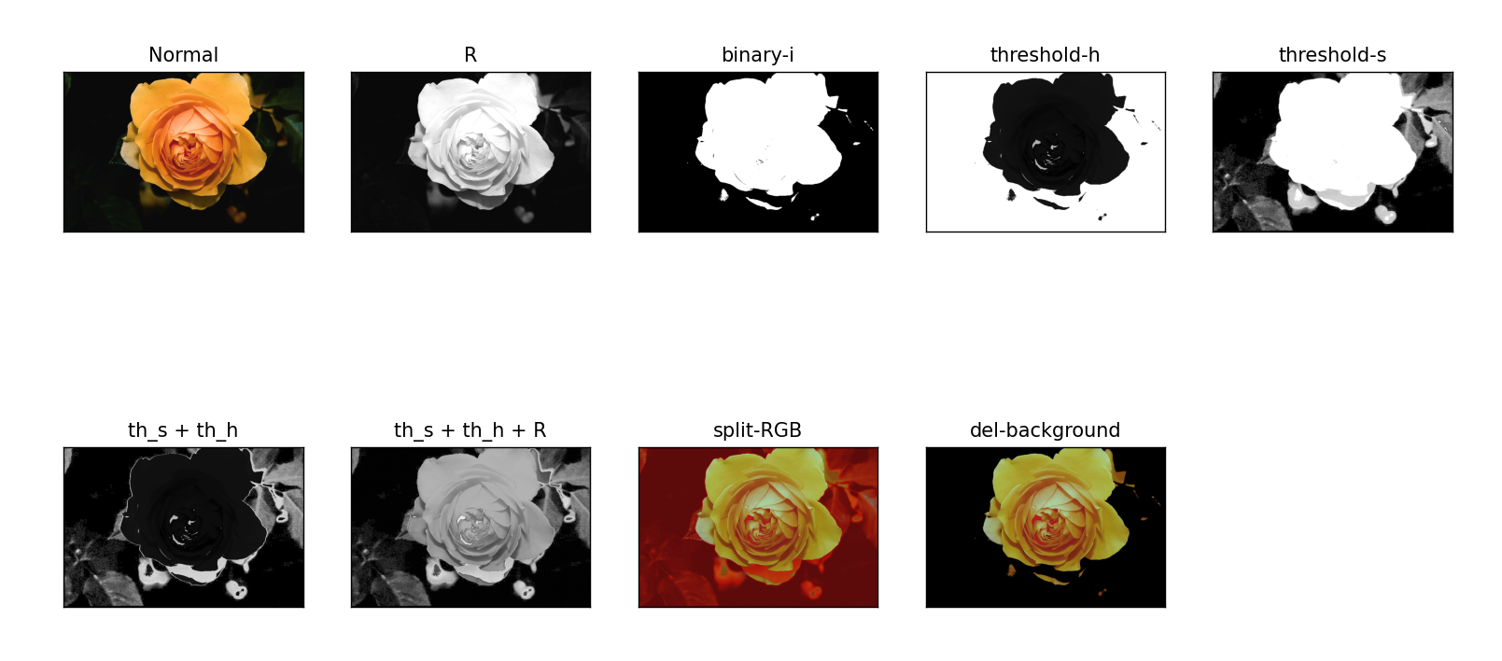
图3.2 HSI分割——使用亮度度构建二值化模板
Normal：原图像 R：R层灰度图
binary-i：亮度小于90置0,大于90置255
threshold-h：对色调层的高饱和区按H值进行阈值分割
threshold-s：对饱和度层的低饱和区按S值进行阈值分割'
th_s+ th_H：分割后色调层与饱和度层合并（等权相加）
th_s + th_h + R：将色调层和饱和度层的分割轮廓合并到原图像的 R 层上
split-RGB：分割后的R层灰度图与原G B合并转化为RGB形式
del-background：去除多余背景（去除背景，只保留高亮度区域提取的图像）

明显发现，在分割出中间花朵的结果中，采用亮度为模板的效果比饱和度相对理想一些，周围多余的树叶也起到了较好的清除效果（解决了部分背景叶子饱和度与花朵相同的问题）
个人认为，在实际的图像分割中，可以将三层均作为模板进行尝试，有时在不同的情况，可能相对会有一种是最好的分割结果。

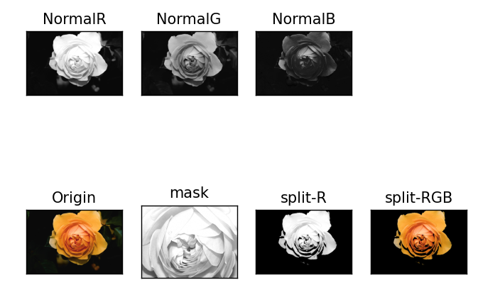
图3.3 RGB空间进行分割
图中mask为尝试出比较适合选取计算标准差与期望的区域。
基本思路为：符合R[i,j] > (mean_mask-1.25*std_mask) and R[i,j] < (mean_mask+1.25*std_mask)条件的像素点色彩值不变，其余部分进行背景删除。即在选取的区域里计算均值与标准差后，只保留该平均灰度值周围的像素点的灰度值，其余置0。由于要分割出的图像总体色彩值（灰度值）与周围背景不同，因此用此方法能够起到良好的分隔效果。
此外也尝试了采用掩膜位运算去进行图像的分隔（严格说是提取）
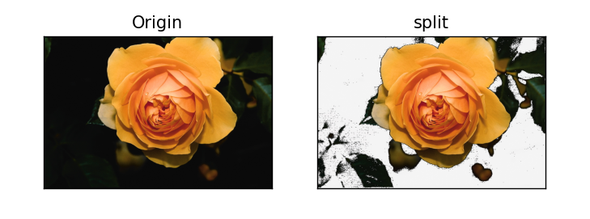
图2.4 采用位运算掩膜分割图像
可以发现也达到了基本要求，但整体效果并不是太理想，且通用性不高，仅在本题作为突发奇想的尝试

