1. Summarize the following items regarding the usage of networks.
1, Describe available specifications of the wired LAN/Wi-Fi connection in your PC.
Answer: My computer support both wired LAN and Wi-Fi connections. For Wi-Fi, it is equipped with Wi-Fi 6(802.11ax), which provides high-speed internet and stable connectivity with lower latency. The wired LAN interface supports a Gigabit Ethernet connection through a USB-C adapter, which can be user for a stable and fast connection.
2, Describe the procedure how you connect to the Wi-Fi based networks at Kyoto University (e.g., KUINS-Air, eduroam).
Answer: To connect to the Kyoto University’s Wi-Fi, just enable the Wi-Fi on my PC and select the KUINS-Air from the list of available networks and enter my student credentials to authenticate, For eduroam, select “eduroam” from the Wi-Fi list, then use my university email and password to login, maybe there are some application that I need to find from the university’s IT portal. And it is recognized across different institutions globally.
3, Describe the roles of VPN and show the procedure how you connect to the VPN of Kyoto University.
Answer: VPN(Virtual Private Network) allows secure remote access to university resources by encrypting data and providing a secure connection. To connect to Kyoto university’s VPN, download the university’s VPN client(such as Cisco Anyconnect), enter the VPN server address provided by the university, and log in with my university credentials. I can use this connection to access internet resources from outside the university network.

2. Make a brief summarization of the following Internet mechanisms.
1, TCP/IP
Answer: TCP/IP is a protocol suite for network communication. TCP ensures data is sent reliably, while IP handles the addressing and routing of packets.
2, The Domain Name System (DNS)
Answer: DNS translates domain names into IP addresses, allowing users to access websites with easy-to-remember names.

3, Describe what cryptography is used and the validity of the certificates used by the services provided by Kyoto University such as KULASIS and PandA.
Answer: Kyoto University services like KULASIS and PandA use SSL/TLS cryptography for secure communication. These certificates are typically issued by trusted Certificate Authorities (CAs) and have a validity period (e.g., one or two years) before renewal is required to maintain security.

4. Answer the following questions regarding E-mails.
1, Summarize how E-mail works
Answer: An email works by sending a message from the sender’s server to the recipient’s server, where it’s stored and accessed by the recipient.
2, Summarize important requirements for composing an adequate mail message.
Answer: Use a clear subject, greet the recipient, keep the message concise, and use polite language.
3, Write down a sample of adequate E-mail when you want to communicate with the instructor of “Practice of Basics Informatics ‒ E2” about your absence of a class. Please include the subject and the body message in the E-mail.
Answer:
Subject: Absence from Class - Practice of Basics Informatics - E2
Body: Dear Professor, I am writing to inform you that I will be unable to attend the upcoming class due to [reason]. I apologize for any inconvenience caused and will make sure to catch up on missed work. Thank you for your understanding.
Best regards,
[Name]

5. Summarize the key ideas of the public-key cryptography.
Answer: Public-key cryptography uses a pair of keys—one public and one private. The public key encrypts data, and only the matching private key can decrypt it, allowing secure communication.

6. Information security means to make sure of the “integrity”, “availability” and “confidentiality” of information systems. Describe each of the meanings of the “integrity”, “availability” and “confidentiality”, with an illustrative example.
Answer:
Integrity: means data is accurate and unaltered. Example: Ensuring that a bank transaction record remains unchanged during processing.
Availability: ensures that information and resources are accessible when needed. Example: A website remains operational for users even during high traffic.
Confidentiality: protects sensitive information from unauthorized access. Example: Only authorized staff can view patient records in a hospital system.
7, Complete the Information Security e-Learning of Kyoto University. Please refer to the following URL and try to use the English materials for the e-Learning:
1, Summarize important knowledge you have acquired regarding information security through the above e-Learning.
Answer: Through Kyoto University’s Information Security e-Learning, I learned key practices for protecting data, such as using strong passwords, recognizing phishing attempts, and maintaining software updates. Additionally, I gained awareness of data handling policies and the importance of securing personal devices to prevent unauthorized access.
2, Screenshot your score of the Information Security E-Learning Course of Kyoto University and attach it in your report.
Answer: 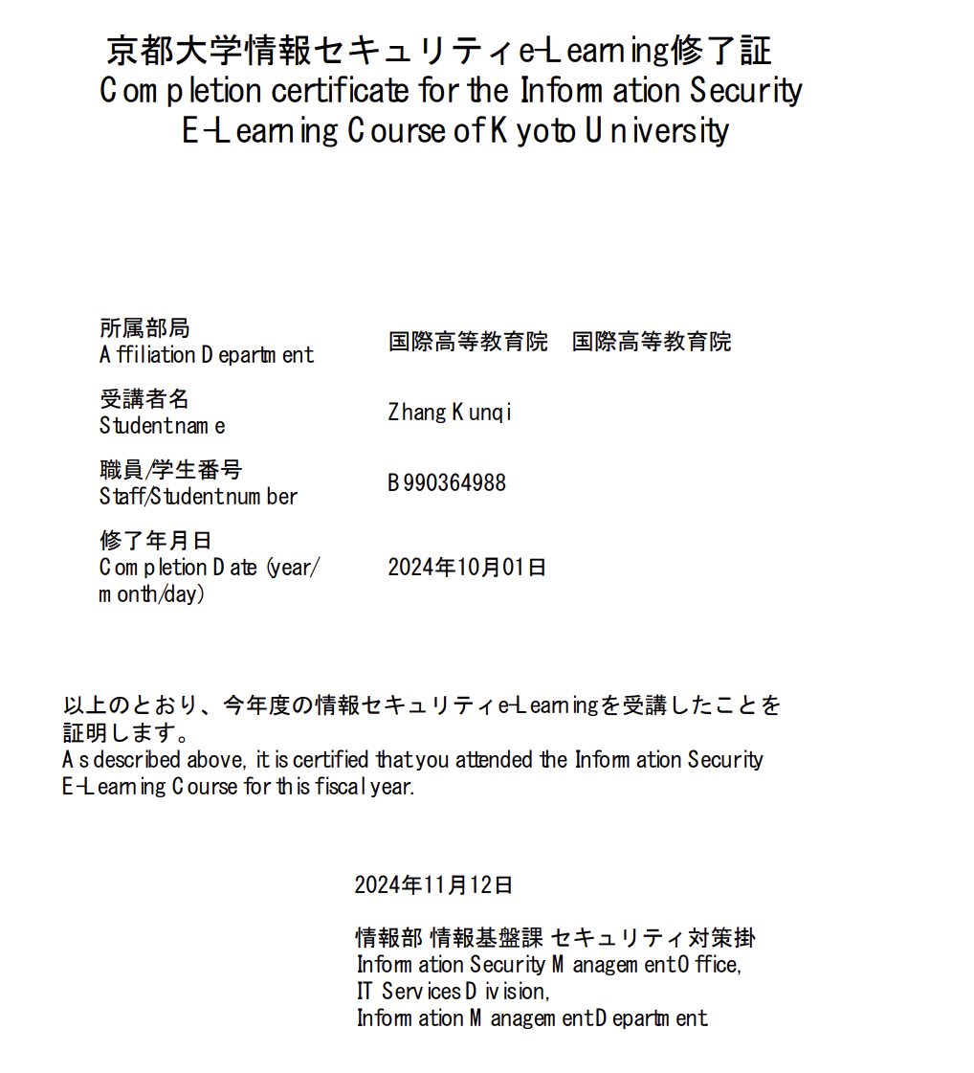

8, Describe the process of intellectual production and summarize your current level of necessary skills and your study goals for intellectual production.
Answer:
Intellectual production involves generating, researching, analyzing, and sharing knowledge or ideas. It includes stages like idea development, data collection, analysis, and presenting findings. My current skills are developing, especially in research and analytical techniques. My study goals are to improve my ability to conduct independent research, deepen my understanding of academic writing, and enhance data analysis skills.

