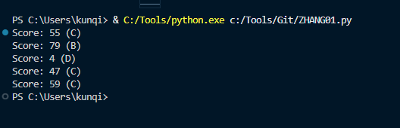
1, the first question ask for the five times loops for random scores number, and we need to show up the grade in the (), so I use def to make a method called task1(), and use for loop to generate 5 times result, and make 4 times situations for random numbers score, and I print them in the end of each loop
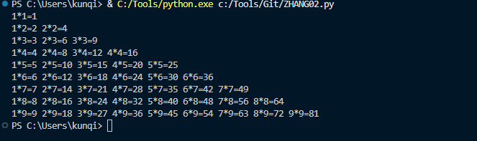
2, the second question I def a method called task2, and I use two loops together, the first loop we can image that is what the second number is , like 1*1 we will only get 1 equation in one row, and we can get 5 equations for the multiplication table of 5, and we start a new line with end = “”
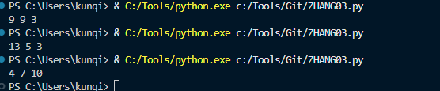
3, for the third question, I use while loop with the break condition “True”, that means this loop will break down if there is three numbers with sum of 21 are being generated, and I create a list called “nums” and use random.randint method with for loops, to generate 3 random numbers which is between 1 to 13, and if this condition is satisfied, we can use print to print them out, and to maker sure the form is satisfactory, I join the space into each of them, with map to change to string list.
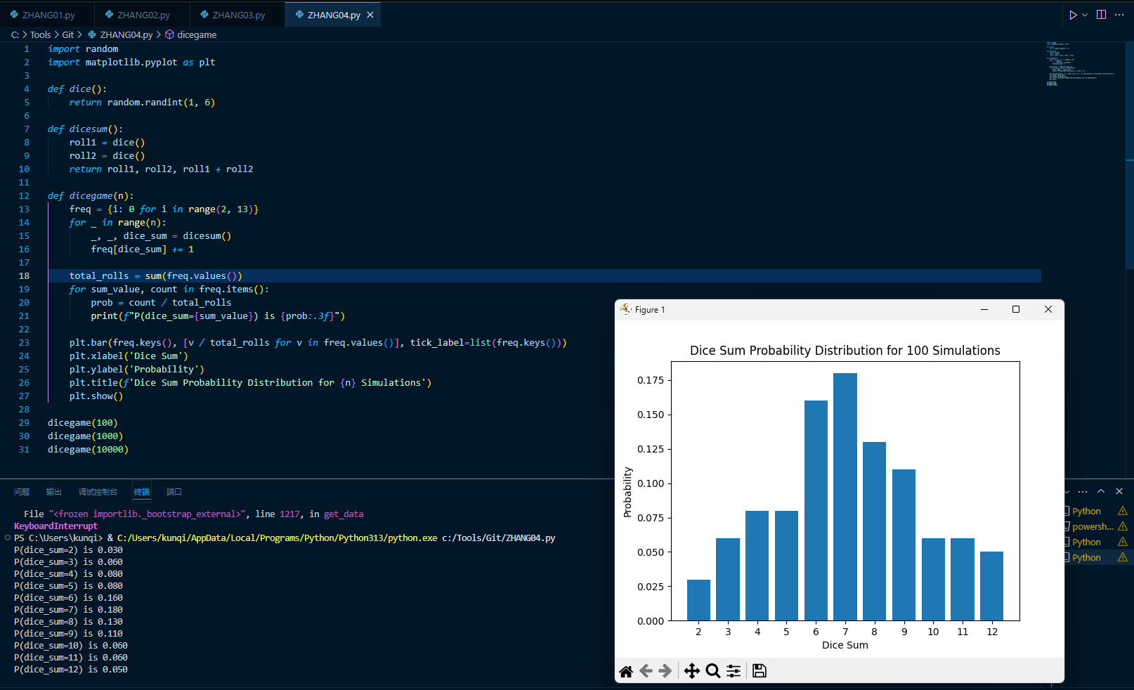
In this script, I simulate rolling two dice and calculate the probability distribution of their sums. The dice() function generates a random integer between 1 and 6 to simulate a die roll. The dicesum() function rolls two dice and returns their sum.
dicegame(n). It initializes a dictionary freq to store the frequency of each possible dice sum. Using a for loop, it rolls the dice n times, calculates their sum, and updates the corresponding value in the freq dictionary. After collecting all results, it calculates the total number of rolls and computes the probability of each sum by dividing its frequency by the total rolls. It prints the probabilities in a formatted string for better readability. Finally, the code uses matplotlib to plot a bar chart that visualizes the probability distribution, with the x-axis showing the dice sums and the y-axis representing their probabilities.

