IrDA PnP Issues and Windows 2000

1. Windows 2000 IrDA Architecture 2
1.1. Overview 2
2. Plug and Play Issues 3
2.1. Non-Plug and Play External Serial-Attached SIR Adapters 3
2.2. Non-PnP Internal SIR Adapters or Internal SIR Adapters Incorrectly Exposed as Serial Ports 4
2.3. PnP External Serial-Attached SIR Adapters 4
2.4. PnP Internal SIR Adapters 4
2.5. Non-PnP Bus-Attached FIR Adapters 4
2.6. PnP Bus-Attached FIR Adapters 5
3. System Vendor Requirements 5

1. Windows 2000 IrDA Architecture

1.1. Overview
The core IrDA protocol stack is implemented in the Windows® 2000 kernel mode module IrDA.SYS. The IrDA TinyTP layer is exposed to applications through Winsock with the support of the user space component WSHIRDA.DLL. The sole application interface to IrDA is through Winsock.

The interface between IrDA hardware (framers) and the core stack is through NDIS 4.0 miniport drivers that adhere to the conventions described in Infrared Extensions to the NDIS Version 4.0 Functional Specification. IrDA.SYS expects that the hardware and NDIS drivers deal with framing, transparency, and error detection and support media sense and speed change commands. Miniport drivers are responsible for discarding incoming frames with bad CRCs; these frames must never be forwarded to the protocol.

The IrDA stack is dynamically loadable, and is loaded by the Plug and Play system when a NDIS miniport is installed.

For most purposes, Windows 2000 treats IrDA NDIS miniports as network adapter drivers that bind only to the IrDA protocol. A Windows 2000 IrDA co-class installer displays these drivers to the user as IrDA adapters and handles IrDA-specific user interface and setup issues.

IrDA.SYS is the only protocol that opens IrDA NDIS miniport drivers.

The NDIS miniport driver and protocol stack install process is driven by system-supplied and vendor-supplied .INF files that adhere to the netcard INF and IrDA INF conventions for Windows 2000.

Windows 2000 ships one Microsoft-maintained NDIS miniport driver, IrSIR.SYS, which is used to communicate with existing external UART-attached SIR adapters and internal SIR IrDA adapters. Vendors should contact Microsoft to ensure that their SIR hardware is supported correctly through IrSIR.SYS.

High-quality vendor drivers and INFs can ship with Windows. Microsoft encourages this as it improves the user IrDA installation experience. For more information, send inquiries to ntirinfo@microsoft.com.

The Windows 2000 IrDA stack can support multiple IrDA adapters concurrently. Vendors who wish to exploit this feature should expose multiple NDIS adapters through their NDIS miniport driver. Each exposed adapter should represent a unique transceiver and supporting hardware, capable of running a separate IrLAP connection.

There are a number of Plug and Play issues that need to be considered by IrDA chipset vendors and vendors who ship integrated IrDA solutions. This document explores these issues.

Windows 2000 IrDA Architecture
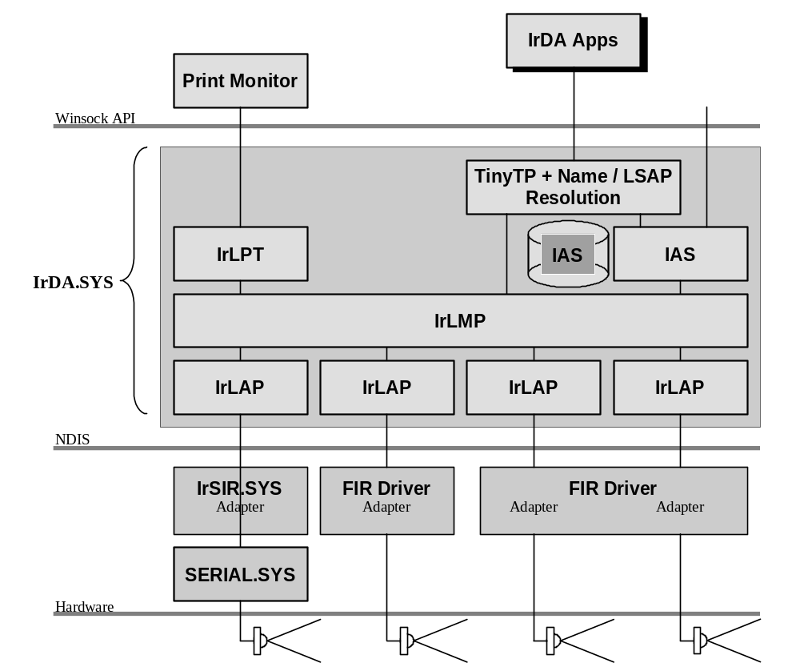

2. Plug and Play Issues

2.1. Non-Plug and Play External Serial-Attached SIR Adapters
These devices attach to an external serial port and do not support any Plug and Play (PnP) functionality. They are supported by the system-supplied driver, IrSIR.SYS. IrSIR uses the services provided by the Windows 2000 serial driver, SERIAL.SYS (or a compatible third-party serial driver) in order to access the serial port.

The external serial port is visible to the user under Device Manager, Ports (COM & LPT), but the port-specific settings are ignored. It is not be possible for a user to misconfigure the port so that IrDA does not work.

These devices must be manually installed through the Add New Hardware function of the Hardware Wizard. The user should select the IrDA adapter device type, select from a list supported adapter types, and then select the serial port (by name) that the adapter is attached to.

IrSIR opens the selected serial port by name. The resources required to support the port are not visible or configurable to the user through any IrDA adapter UI branch (only the serial port name is configurable).

Vendors who want support for their hardware in Windows should e-mail ntirinfo@microsoft.com with device-specific initialization and speed change procedures.

2.2. Non-PnP Internal SIR Adapters or Internal SIR Adapters Incorrectly Exposed as Serial Ports
This hardware would not be exposed as a Plug and Play device through the system BIOS, and would be detected and installed (or manually installed) as a regular serial port. A similar case exists where the IrDA UART is exposed as through the BIOS only as a conventional serial device, and is installed as such.

The user experience would be the same as in the previous case (Non-PnP SIR Speed External Serial Dongle).

This configuration is not recommended.

2.3. PnP External Serial-Attached SIR Adapters
There are no existing devices that support serial enumeration. This will not be supported.

2.4. PnP Internal SIR Adapters
This hardware is exposed as an IrDA SIR PnP device through the system BIOS (PNP0510 or PNP0511), and appears to Windows 2000 drivers as a conventional UART. The hardware is supported by the combination of the Windows 2000 IrSIR and SERIAL drivers.

This hardware does not appear under Device Manager, Ports (COM & LPT), because it is not exposed through the BIOS as a serial device. This means that SERIAL will not load automatically on this port, and it is otherwise invisible to users and application programs as a conventional serial port.

Once this hardware has been installed via the PnP mechanism, it appears to the user under Device Manager, Infrared adapters, with the driver IrSIR.SYS installed and using the resources that describe the underlying IrDA UART. IrSIR accomplishes this by loading SERIAL as lower filter driver.

The resources needed by the SIR IrDA UART must be exposed in the conventional PnP manner through the system BIOS. The PnP system attempts to find a set of non-conflicting resources. Built-in or OEM-bundled hardware must always supply suitable resource sets to allow all system hardware to work. Under Windows 2000, interrupts cannot be shared, so it is essential that SIR UART hardware be configurable to work on interrupts other the traditional 3 and 4, and that this be exposed through the BIOS.

Note that SIR exposed as requiring IRQs 3 and 4 may not work in many cases.

2.5. Non-PnP Bus-Attached FIR Adapters
All FIR hardware is required to also support SIR protocols and speeds. This requirement is usually met by exposing a UART for SIR, in addition to the DMA mechanism for FIR. (This makes for an unusually complex driver, installation and configuration.) It is important that both the SIR and FIR components are programmable, and that SIR supports interrupts other than 3 and 4 and can use at least the traditional I/O space of COM3 or COM4. This is necessary to avoid subtle and difficult-to-diagnose conflicts with conventional serial ports.

Non-PnP, in this case, means that the hardware does not respond to bus enumeration or is not exposed through the system BIOS. It’s doubtful that users would ever be successful installing hardware more primitive than this (hardware with numerous jumpers, for example).

This hardware must be supplied with a vendor driver and an installation INF. The INF must list the supported resource combinations, and must be able to program the hardware once the user has selected a non-conflicting set. Any other required parameters (like transceiver type) must be described by the INF and configurable by the user.

Once this hardware has been installed, it appears to the user under Device Manager, IrDA adapters, with the supplied vendor driver installed and using the resources that describe the underlying UART and FIR resources.

While it may be possible for the vendor driver to use SERIAL.SYS as a filter, this is not required.

This configuration is not recommended.

2.6. PnP Bus-Attached FIR Adapters
The same constraints that apply to non-PnP FIR adapters also apply to PnP FIR adapters. SIR and FIR components must be programmable, and SIR must support interrupts other than 3 and 4 and use at least the traditional I/O space of COM3 or COM4. It is important both that the hardware support this and that it is reported correctly though the system BIOS or described in an INF.

FIR PnP hardware must report a unique PnP identifier that correctly describes the chipset and transceiver combination. There are no existing standards for FIR PnP identifiers. (It might be useful for an organization like IrDA, or the chipset and transceiver vendors themselves, to publish known combinations of hardware and suitable PnP identifiers).

This hardware must be supplied with a vendor driver and an installation INF. The INF must list suitable supported SIR and FIR resource combinations in order to support the PnP of the driver.

Once this hardware has been installed, it appears to the user under Device Manager, Infrared adapters, with the supplied driver installed and using the resources that describe the underlying UART and FIR resources.

It is highly unlikely for a FIR device to use SERIAL.SYS as a filter. FIR devices generally overload the standard UART registers to provide FIR functionality, and having SERIAL as a filter precludes direct access to the hardware or IRQ.

PnP FIR hardware can be exposed with a unique FIR PnP identifier and a standard SIR PnP alias. If Windows 2000 can be match the provided PnP identifier to a FIR driver, that driver will be installed; otherwise, IrSIR.SYS will be installed.

FIR hardware that is incorrectly exposed as a serial port can only be supported by manual installation in the same way as the Internal SIR Adapters Incorrectly Exposed as Serial Ports case.

3. System Vendor Requirements
It is necessary for laptop and other vendors who bundle IrDA support to supply INFs that describe each system’s chipset and transceiver combination. Vendors can ship unique drivers, or they can reference a driver bundled with Windows.

For more information, e-mail ntirinfo@microsoft.com.

