**RSA Algorithm**

**Server**

import socket

import random

def modexp(base, exp, mod):

result = 1

base = base % mod

while exp > 0:

if exp % 2 == 1:

result = (result * base) % mod

exp = exp // 2

base = (base * base) % mod

return result

def decrypt(ciphertext, private_key):

d, n = private_key

decrypted_message = ''.join([chr(modexp(char, d, n)) for char in ciphertext])

return decrypted_message

def generate_keypair(p, q):

n = p * q

nn = (p - 1) * (q - 1)

j = 1

for i in range(1, n):

e = nn % i

if e != 0:

e = i

break

while True:

t = (e * j) % nn

if t == 1:

d = j

print(f"Prime Numbers are p= {p} and q= {q}")

print(f"Private key is {d}")

break

j += 1

public_key = (e, n)

private_key = (d, n)

return public_key, private_key

def generate_prime():

prime = [2, 3, 5, 7, 11, 13, 17, 19, 23, 29, 31, 37, 41, 43, 47, 53, 59, 61, 67, 71, 73, 79, 83, 89, 97]

u_n = random.sample(prime, len(prime))

p, q = u_n[1], u_n[2]

return p,q

**# Key generation**

p,q= generate_prime()

public_key, private_key = generate_keypair(p, q)

**# Socket setup**

server_socket = socket.socket(socket.AF_INET, socket.SOCK_STREAM)

server_socket.bind(('192.168.1.47', 8080))

server_socket.listen()

**# Wait for a connection**

client_socket, addr = server_socket.accept()

print(f"Connection from {addr}")

**# Send primes to the client**

primes_message = f"{p},{q}"

client_socket.send(primes_message.encode())

**# Receive and decrypt message**

encrypted_message = client_socket.recv(1024).decode()

print("Encrypted message : ",encrypted_message)

ciphertext = [int(char) for char in encrypted_message.split(',')]

decrypted_message = decrypt(ciphertext, private_key)

print("Received and decrypted message:", decrypted_message)

**# Clean up**

client_socket.close()

server_socket.close()

**Client**

import socket

def modexp(base, exp, mod):

result = 1

base = base % mod

while exp > 0:

if exp % 2 == 1:

result = (result * base) % mod

exp = exp // 2

base = (base * base) % mod

return result

def encrypt(message, public_key):

e, n = public_key

ciphertext = ','.join([str(modexp(ord(char), e, n)) for char in message])

return ciphertext

def generate_keypair(p, q):

n=p*q

nn=(p-1)*(q-1)

j=1

for i in range(1,n):

e=nn%i

if e!=0:

e=i

break

while True:

t=(e*j)%nn

if t==1:

d=j

break

j+=1

public_key = (e, n)

private_key = (d, n)

return public_key, private_key

client_socket = socket.socket(socket.AF_INET, socket.SOCK_STREAM)

client_socket.connect(('192.168.1.24', 8080))

**# Receive primes from the server**

primes_message = client_socket.recv(1024).decode()

p, q = map(int, primes_message.split(','))

**# Key generation using received primes**

public_key, private_key = generate_keypair(p, q)

print(f"public key is {public_key[0]} ")

message = str(input("Enter Plaintext: "))

**# Encrypt and send message**

encrypted_message = encrypt(message, public_key)

print("Encrypted Message: ",encrypted_message)

client_socket.send(encrypted_message.encode())

client_socket.close()

**Output**

**First run server program**

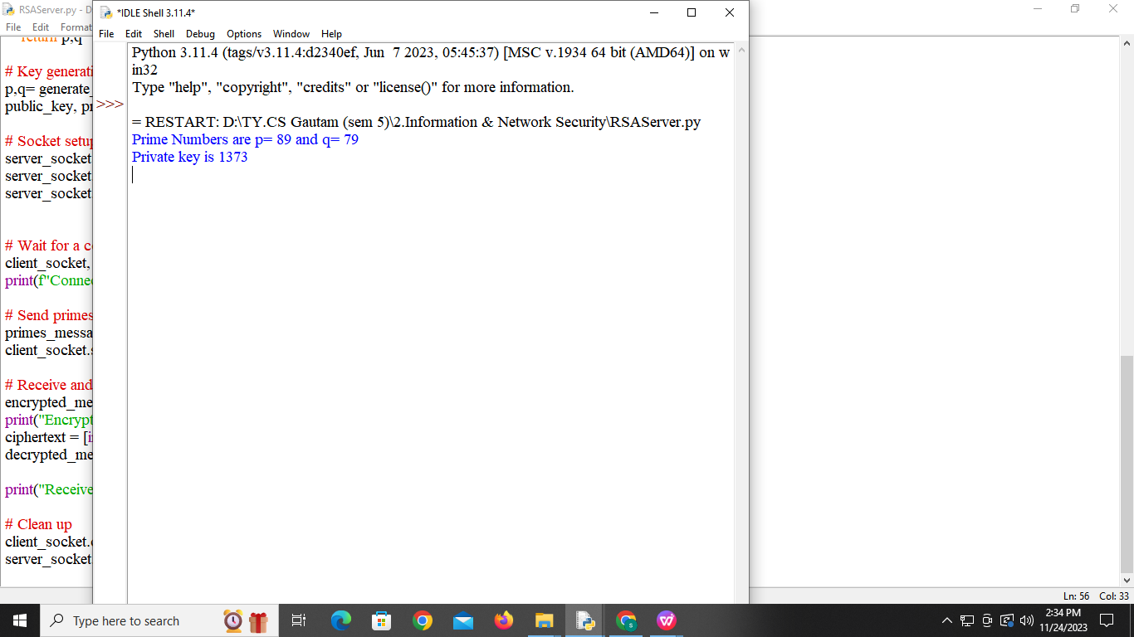

**Then Run client program**

**After execution of client program client connected to the server**

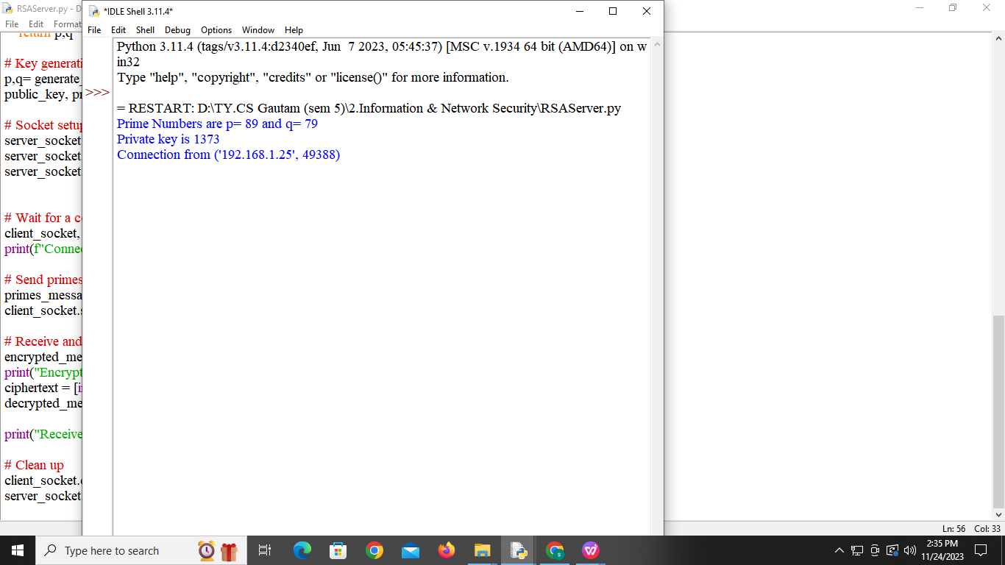

**Enter message into plain text from client side**

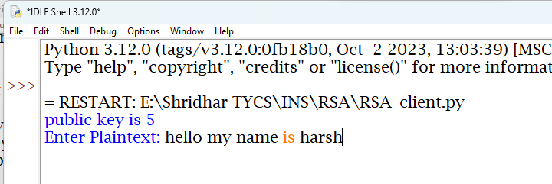

**Program encrypt the message into ASCCII code**

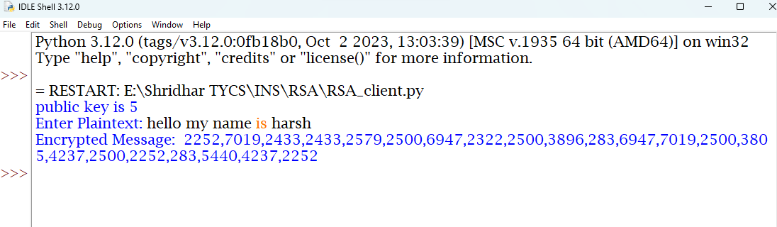

**Encrypted message pass to server and server decrypt that message into plain text**

