A

selling and by

Designed By:

Mr.Ganesh Dama dhuri.

Submitted To:

K.M.S.P. MANDAL’S
SANT RAWOOL MAHARAJ MAHAVIDYALAYA, KUDAL

(NAAC Re-Accreditation “B” Grade
In the partial fulfillment of
B.Sc. Computer Science (Sem VI )

Under Guidance of:

Asst. Prof. Santosh R.Chougule(M.C.A)

Through:

THE HEAD, DEPARTMENT OF COMPUTER SCIENCE,
S.R.M. COLLEGE, KUDAL
PROJECT REPORT
2022-23

DECLARATION

To, The Head,

Department of Computer Science,

S. R. M. College, Kudal.

Respected Sir,

We undersigned, hereby declare that the project on “Vehicle
Breakdown Assistant Help” is developed under the guidance of our
lecturer Asst. Prof. Santosh R. Chougule .

The conclusion in this report is based on the data, which is collected by
me. I am declaring that this is our original work. I have not copied any
materials related to my project.

We do undersign that if my work is found to be copied, then I am liable to
as per the university rule.

DATE:

PLACE: KUDAL

(Mr. Ganesh Dama Dhuri)


K.M.S.P. MANDAL’S

SANT RAWOOL MAHARAJ MAHAVIDYALAYA ,
KUDAL .

NAAC RE-ACCREDITATION “B” GRADE

CERTIFICATE

This is to certify that Mr.Ganesh Dama Dhuri having Exam
Seat number -------------------------------- have satisfactorily carried
out his project work entitled.

Vehicle Breakdown Assistant Help

As per the syllabus prescribed for B.Sc. Computer Science (Sem VI)
of Mumbai University, Mumbai.

It is also certifying that this is his own work completed during the
academic year 2022- 23. The work done is satisfactory and is presented
as per the specifications.

Project Guide External Examiner Head of Department

DATE:

ACKNOWLEDGEMENT

I would like to express my special thanks and gratitude to my
project guide Asst.Prof.S.R.Chougule , for their guidance and
support in completing this project .

Secondly, I would also like to thank my parents and friends who
helped me a lot in finishing this project within the limited time.
Just because of them I was able to create my project and make it
a good and enjoyable experience.

Thanks again to all who helped me during the project.

Thank You

Mr.Ganesh Dame Dhuri.

INDEX

Sr No |  | Title |  |  | Page No.
1 |  | INTRODUCTION |  |  | 9
1 |  | 1.Background |  |  | 10
1 |  | 2.Objective |  |  | 10
1 |  | 3. Purpose and Scope, Applicability |  |  | 12
1 |  | 1.3.1 |  | Purpose | 12
1 |  | 1.3.2 |  | Scope | 12
1 |  | 1.3.3 |  | Applicability | 12
1 |  | 1.3.4 |  | Achievements | 12
1 |  | 1.3.5 |  | Organization od Report | 12
2 |  | SUREVEY OF TECHNOLOGIES |  |  | 13-18
3 |  | REQUIREMENTS AND ANALYSIS |  |  | 19
 |  | 1. Problem Definition |  |  | 20
 |  | 2. Requirements Specification |  |  | 21
 |  | 3. Planning and Scheduling |  |  | 22
 |  | 4. Software and Hardware Requirements |  |  | 23
 |  | 5. Preliminary Product Description |  |  | 24
 |  | 6. Conceptual Models |  |  | 24
 |  | System design |  |  | 25
 |  | 1 | ER-Diagram |  | 26
 |  | 2 | Class Diagram |  | 27
 |  | 3 | Use case Diagram |  | 28
 |  | 4 | Sequence Diagram |  | 29
 |  | 5 | Flow chart Diagram |  | 30
 |  | 6 | Data Flow Diagram |  | 31
 |  | 7 | Component Diagram |  | 32
 |  | 8 | Activity Diagram |  | 33
 |  | 9 | Deployment Diagram |  | 34
4 | Result and disscusion |  |  |  | 35
 | 4.1 Basics Models |  |  |  | 36
 | 4.2 Data Design |  |  |  | 36
 | 4.2.1 | Schema Design |  |  | 36
 | 4.2.2 | Database Schema |  |  | 37
 | 4.2.3 | Algorithms design |  |  | 40
 | 4.3 User Interface design |  |  |  | 40
 | 4.4 Security Issues |  |  |  | 51
 | 4.5 Test Cases Design |  |  |  | 52
5 | IMPLIMENTATION AND TESTING |  |  |  | 53
 | 5.1 Implementation Approaches |  |  |  | 54
 | 5.2 Testing Approach |  |  |  | 57
 | 5.2.1 | Unit Testing |  |  | 57
 | 5.2.2 | Integrated testing |  |  | 57
 | 5.4 Modification And improvement |  |  |  | 57
6 | CONCLUSION |  |  |  | 59
 | 6.1 Future scope of the project |  |  |  | 60
 | 6.2 Reference and bioliogygraphy |  |  |  | 61

CAPTER 1
INTRODUCTION

1.1 Background

In the existing system process of buying and selling product was done
manually by visiting to company. It is hard to long distance customer to go
in company for buying product or contact with company. Also its hard for
Admin to manage all the system data.

In the proposed system all the data is maintained in the database
which is safe and easy to retrieve. Propose system provides various services
such as online shopping which allows users to buy, order products and view
services also sending message and contact with company from anywhere
through the system.

Also Provide benefits for admin such as selling product, through the
proposed system admin can easily add new product, delete ,update info &
check Payments and message from customers Also manage users.

1.2 Objectives

1) To let people, know more about company and product sell by company also know the service provide by company
2) Can place the order from anywhere and anytime.
3) Easy to maintain the order, stock, employee details by the admin.
4) To reduce the paper work.
5) Easy to customer for buy product from anywhere.
6) Admin gets a proper report of his sales and profit.
7) Customer can view his order list
8) To make advertise about company

1.3 Purpose, Scope, and Applicability

1.3.1 Purpose
Mainly this system is introduced for famous the company for their work. Also Admin sell product online, also maintain all the data online. Buying and selling is done online.

Existing system is not as much as faster, means the admin take products order or by using phone calls or face to face meetings also selling product manually its very time consuming. For buying product or contact for any service or contact through phone calls in existing system. But every time it was not possible to customer to go in company for purchasing product. Cost issue also there means, every client can’t know the cost of particular order.

To solve this all Problem and for this purpose this website is develop , so that user can buy product and get service also get Product amount details.

1.3.2 Scope

1) Reliable security system helps user to buying security product like electronic product .
2) From this system user can buy product, Add to cart product, Place order and buy the product.
3) Also user can send enquiry message to admin.
4) Admin can manage all the data like add, update, delete Product and
category.
5)Keeping Records of Total sales.
6) Provides Backup of data. This allows storing large data.

1.3.3 Applicability

Sells and services is essential part for this project. Advertisement is very
essential part for this project. Because admin have many orders. So
automatically profit has been done. Also admin can manage all the data
like add update delete product and category.

Customer’s point of view benefits are:
1) Easily book order.
2) Customer can buy product, add to cart product, Make Payment.
3) Because of online booking system cost and time saves.
4) Easily contact to admin using message or contact number also send
enquiry message to admin
5) Customer can view price details and description of Project.

Admin’s point of view benefits are:
1) Admin can easily get orders.
2) If admin is busy on that day so there is no any other order is placed. If
timing get adjust then only he can accept the order.

1.3.4 Achievements
Within the duration of completion of the project, I achieved wide range
of knowledge of Problem analysis, Designing variety of models,
Analysing software and hardware requirement, dealing with client and
so on.

Achievements of the proposed system
1. User Friendly:
The proposed system is user friendly because the retrieval and storing of
data is fast and data is maintained efficiently. Moreover the graphical
user interface is provided in the proposed system, which provides user
to deal with the system very easily.

2. Very less paper work:
The proposed system requires very less paper work. All the data is feed
into the computer immediately and reports can be generated through
computers. Moreover work become very easy because there is no need
to keep data on papers.

3. Computer operator control:
Computer operator control will be there so no chance of errors.
Moreover storing and retrieving of information is easy. So work can be
done speedily and in time.

1.3.5 Organization of Report

The report is divided into seven parts. Each part deals with the
different aspects of project. In semester V, I am completing first four
chapter and remaining chapters will be completed in this semester. In
semester-V, I am completing introduction, survey of technologies,
Requirement gathering and analysing and designing part in ‘Project
Dissertation’.

Each part has various chapters explaining in detail

Chapter 1:
This part discusses the important introductory concepts behind project like
background, objective, purpose, scope, applicability, achievement.

Chapter 2:
This part discusses the technology and software development lifecycle
model.

Chapter 3:
This part discusses the requirement and analysis such a problem definition,
requirement specification, planning and scheduling, software and hardware
requirement, preliminary product description and conceptual model.

Chapter 4:
This part discusses the system design in which discuss basic modules, data
design (schema design, Data integrity and constraint), procedural design
(logic diagram, data structure, algorithm design), user interface design,
security issues and test case design

Chapter 5: Will include implementation and testing in which
implementation approaches, Details and code efficiency, testin
approaches, modifications and improvement, test cases will discuss.

CHAPTER 2
SURVEY OF TECHNOLOGIE

Selecting technologies to develop any application is the very first step
in order to complete an application successfully. A study of resources
availability that may affect the ability to achieve an acceptable system. This
evaluation determines whether the technology needed for the proposed
system is available or not. This system can be made in any language that
support good user interface and easy database handling. Technical needs
may include:

1] Front-End Selection

There are many front-end technologies are available such as .Net
technologies, Java, Cordova, android studio, Bootstrap and HTML. In this I
am selecting HTML and Bootstrap as a front-end technology for the web
platform. HTML and Bootstrap is used to create Webpages.

HTML and Bootstrap has some advantages as follows: -

Advantage of HTML
• Every browser supports HTML language.
• It is easy to learn and use.
• It is by default in every window so you don’t need to purchase extra
software.

Advantage of Bootstrap
• Speed of development.
• Responsiveness
• Consistency
• Customizable

2] Selection of backend technology: -

Back-End means a language that is used for database management.
Back- End should have following qualities:

• Multiple user support.
• Provide inherent feature for security.

• Efficient data retrieval and maintenance.
• Stored procedures.
• Operating System compatible.
• Easy to install.
• Various drivers must be available.
• Efficient data handling.
• Easy to implement with Front-End.

So, I am selecting MySQL database server as a back-end technology.
MySQL database provides more features than oracle and other database.
MySQL database is the most secure and reliable database management
system.

3] Selection of Scripting language:

One of the easiest languages for building websites is PHP scripting
language, which allows developers to quickly grasp on web development.
PHP is very similar to html and css therefore if a developer knows how to
write code in html and css, they can quickly learn PHP scripting language
too.

Software Process Models

A software process model is a simplified representation of a software
process. Each model represents a process from a specific perspective.

We’re going to take a quick glance about very general process models. These
generic models are abstractions of the process that can be used to explain
different approaches to the software development. They can be adapted and
extended to create more specific processes.

Here, for the existing system we use following Software process models:

• Waterfall Model

Here I am selecting Waterfall model as a process model for developing
my project.

Waterfall Model

The waterfall model is a sequential approach, where each
fundamental activity of a process represented as a separate phase, arranged
in linear order. In the waterfall model, you must plan and schedule all of
the activities before starting working on them (plan-driven process).
Plan-driven process is a process where all the activities are planned first,
and the progress is measured against the plan. While the agile process,
planning is incremental and it’s easier to change the process to reflect
requirement changes.

The sequential phases in Waterfall model are:

Requirement Gathering and analysis:

All possible requirements of the system to be developed are captured in
this phase and documented in requirement specification documentation.

System Design:

The requirement specifications from first phase are studied in this phase
and system design is prepared. System Design helps in specifying hardware
and system requirements and also helps in defining overall system
architecture.

Implementation:

With inputs from system design, the system is first developed in small
programs called units, which are integrated in the next phase. Each unit is
developed and tested for its functionality which is referred to as Unit Testing.

Integration and Testing:

All the units developed in the implementation phase are integrated into a
system after testing of each unit. Post integration the entire system is tested
for any faults and failures.

Deployment of system:
Once the functional and non-functional testing is done, the product is
deployed in the customer environment or released into the market.

Maintenance:
There are some issues which come up in the client environment. To fix
those issues patches are released. Also, to enhance the product some better
versions are released. Maintenance is done to deliver these changes in the
customer environment. All these phases are cascaded to each other in which
progress is seen as flowing steadily downwards like a waterfall through the
phases. The next phase is started only after the defined set of goals are

achieved for previous phase and it is signed off, so the name "Waterfall
Model". In this model phases do not overlap.

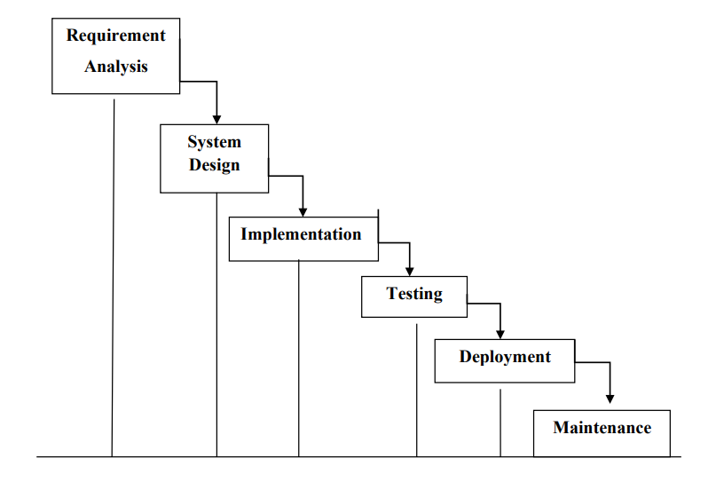
Waterfall Model Application

Every software developed is different and requires a suitable SDLC
approach to be followed based on the internal and external factors. Some
situations where the use of Waterfall model is most appropriate are:

• Requirements are very well documented, clear and fixed.
• Product definition is stable.
• Technology is understood and is not dynamic.
• There are no ambiguous requirements.
• The project is short.

Chapter 3
Requirements and Analysis

1.Problem Definition

Mainly this system is introduced for famous the admin for their
work. Also book his orders online so that, his time and efforts for booking
orders will be reduced. Nowadays, system works not as much as faster
means, the admin take his order by using calling, meeting. But every time it
was not possible for admin to attend call or fixed meeting. Also cost issues
there means, every client can’t know the cost of particular order. So,
sometimes client reject order after discussion related that particular order.
Also its very difficult to admin maintain sell product. After online buying
selling customers are increase. There is no need to customer going in
company they can place there order from anywhere.

2.Requirements Specification:

FEASIBILITY STUDY

Feasibility of a new system means ensuring that the new system,
which we are going to implement, is efficient and affordable. There are
various types of feasibility to be determined. They are,

- ECONOMICALLY FEASIBILITY
Development of this application is highly economically feasible. The only thing to be done is making an environment with an effective supervision.
It is cost effective in the sense that has eliminated the paper work completely. The system is also time effective because the calculations are automated which are made at the end of the month or as per the user requirement.
- TECHNICAL FEASIBILITY
The technical requirement for the system is economic and it does not use any other additional Hardware and software. Technical evaluation must also assess whether the existing systems can be upgraded to use the new technology and whether the organization has the expertise to use it.

- OPERATIONAL FEASIBILITY
The system working is quite easy to use and learn due to its simple but attractive interface. User requires no special training for operating the system. Technical performance include issues such as determining whether the system can provide the right information for the Department personnel user details, and whether the system can be organized so that it always delivers this information at the right place and on time using intranet services. Acceptance revolves around the current system and its personnel.

- SOCIAL FEASIBILITY
Social Feasibility is a determination of a whether a proposed project will be acceptable to the people or not.

- MANAGEMENT FEASIBILITY
It is a determination of whether a proposed project will be acceptable to management

- REQUIREMENT GATHERING
This activity consists of following sub-activities:-

1] On-site observation:
For this, I am visiting the photo studio and take all necessary
information from different stakeholder.

2] Off-side observation:
Some time I am collecting user requirements through another
person, who is not belonging from client side or development side. After
collecting all information and requirements of my project I am dividing that
requirements into functional requirements and non-functional requirements.

Functional Requirement:
1. Registration and login for the both parties i.e. admin and customer.
2. Provide search facility.
3. Provide customer support.
4. User can give feedback.
5. User place order.
6. For communication in between two parties email facility and message box are provided.
7. Provide online bill.
8. Customer can give feedback to admin for their work.

Non-functional Requirement:
1. Performance
2. Security

2.1 Data transfer
2.2 Data storage
3. Safety
4. Maintainability

Planning and Scheduling

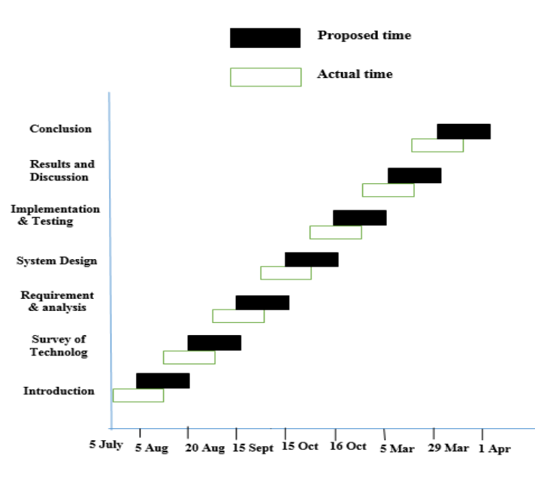
5 20 20 5 19 5 25 8
july july August sept sept oct oct november

System Requirement

Software:

Front End: HTML/PHP

Back End: SQL-Server 2017

Operating System: Windows 7 and Above

Hardware:

  - Processor: Intel Core i3

  - Memory: 2 GB RAM

  - Storage Device: 20GB Hard Disk Space

Preliminary Product Description

In Requirement Specification section, I am listing all the
functional and non-functional requirements of my project. In general, those
requirements are as follows:

1] All functionalities in existing system must be covering in proposed
system.
2] Proposed system’s appearance and looks must be attractive and proper.
At very beginning of this document I am listing all objectives of

proposed system. Have to complete that all objectives up to end. This
project has so many functionalities as follows :-

1] Register and Login to system
2] Buy and Sell products Online
3] Create report and View report
4] Stock Details
5] View photos
6] Update schedule
7] View schedule
8] Give feedback

Conceptual Models

In this section, I am covering class diagram, ER diagram and use case
diagram. These diagrams shows all entities related to my project and their
functioning which are helpful for understanding my project working.

In this section, I am covering class diagram, ER diagram and use case
diagram. These diagrams shows all entities related to my project and theirs
functioning which are helpful for understanding my project working

CHAPTER 4
SYSTEM DESIGN

Entity Relationship (ER)

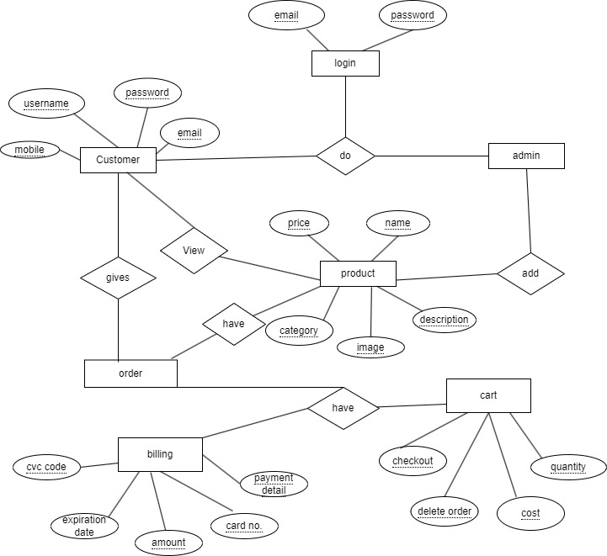

Class diagram

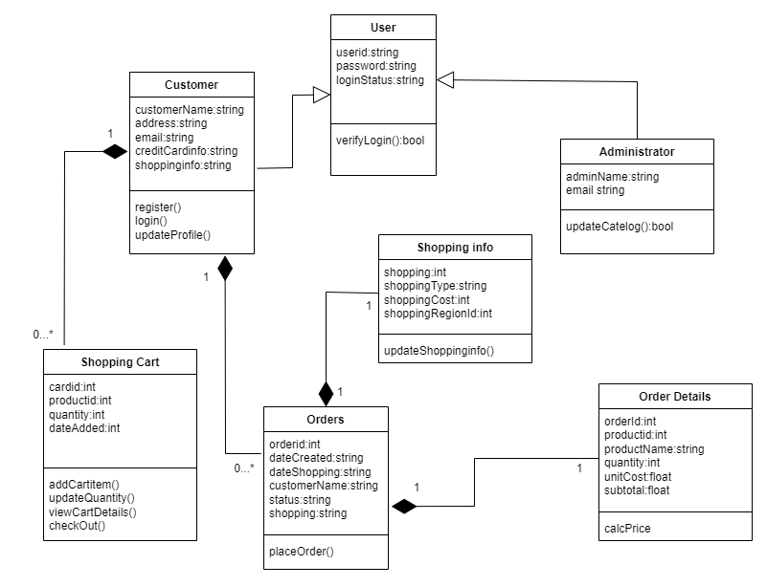

Use case Diagram-

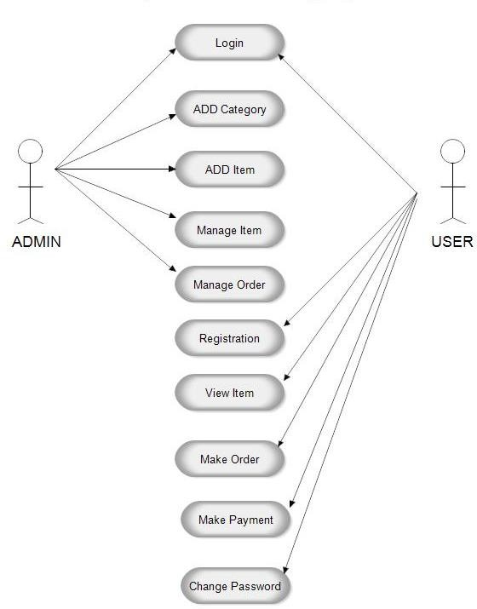

Sequence diagram :

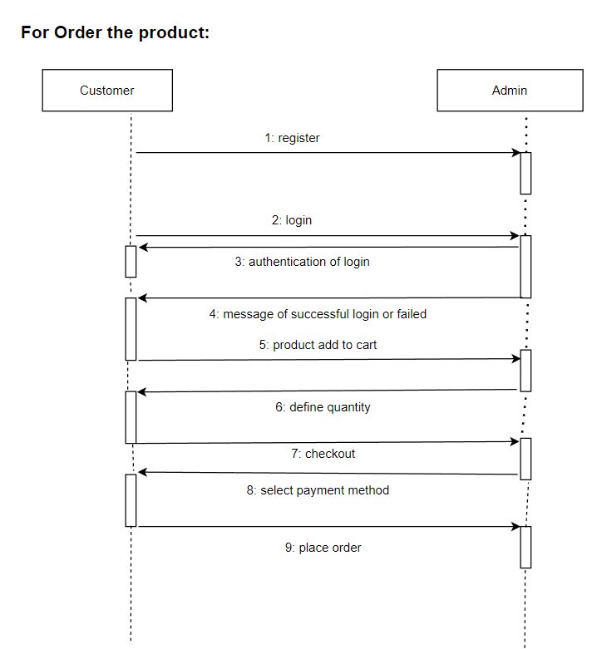

Data Flow

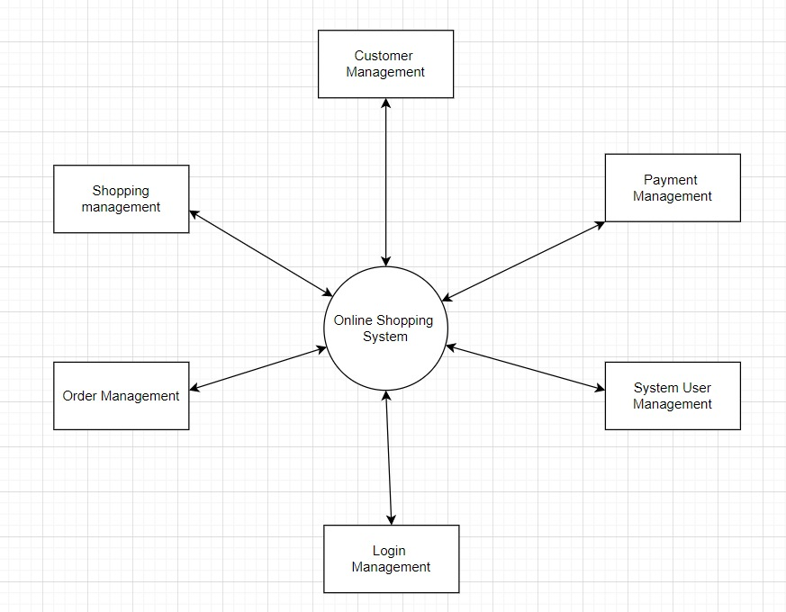

COMPONANT DIAGRAM

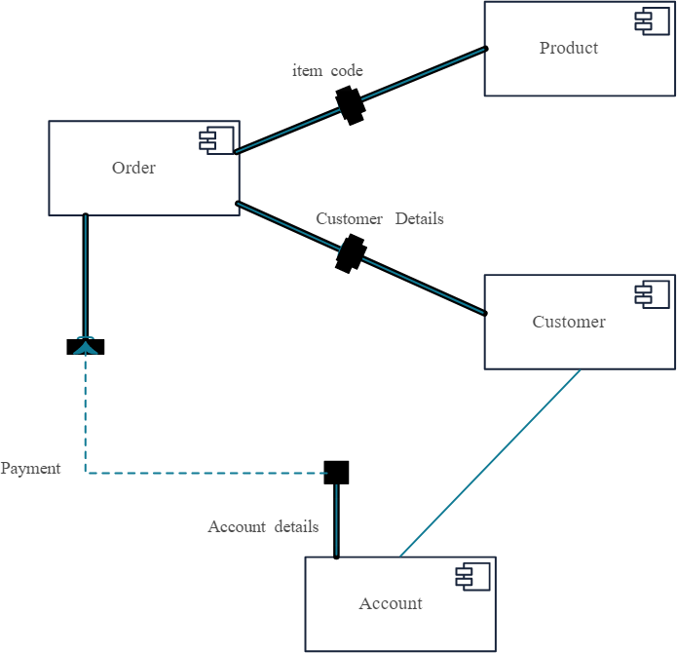

Activity Diagram
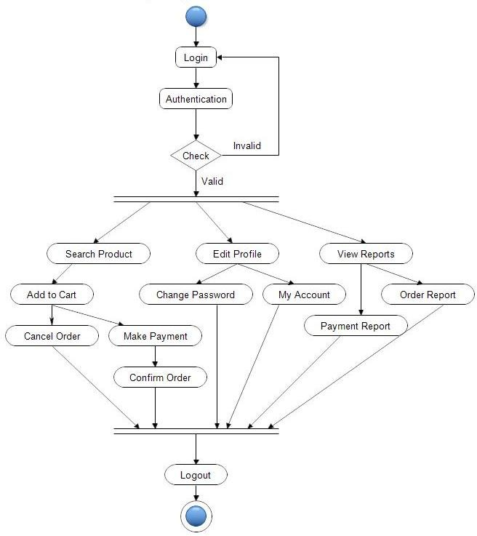

DEPLOYMENT DIAGRAM :

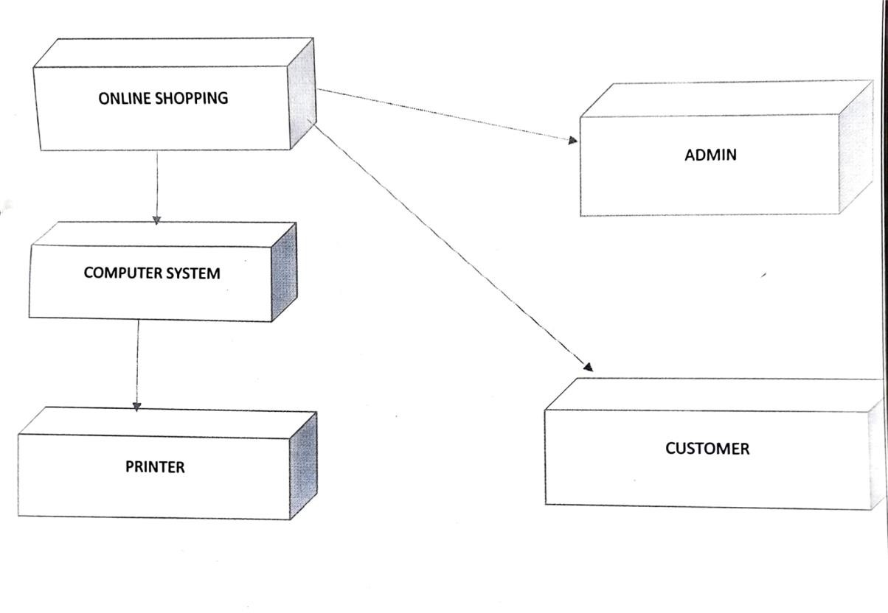

CHAPTER 5
RESULT AND DISCUSSION

4.1 Basic Modules:
This program is a menu driven program. When we click the main
menu the different forms will be enabled. The program consists of the
following modules:

- Admin
Admin is one of the important modules in each and every application.
Through this module admin can easily make the changes on the places on
the website. Updation is important thing for every application. Admin
can update the information which was already displayed in the website
depends upon the changes. Then they can add new product easily, and also
upload the new images related to the product. Admin can easily update the
product. All these things must have some updating; these updating will
easily done by using admin module Customer.
In this module administrator can maintain a database for the clients
who are place order and their details such as client name, address, business
period, booking details, invoice no., cost. These details are used for future
references.

4.2 Data Design:
In data design we can discuss about how data is organized, managed
and manipulated. In my project, I am trying to manage all data in
efficient manner. I am storing data in database, so for properly managing
that data I will consider normalization concept of database. Now, we can
see schema design, logic diagrams and algorithm design for my project.

4.2.1 Schema Design:
Under this point, we can see database table for different entities. In
schema design we can see structure of database table which contains
table name, column name and its data type.

Database Schema

Database:

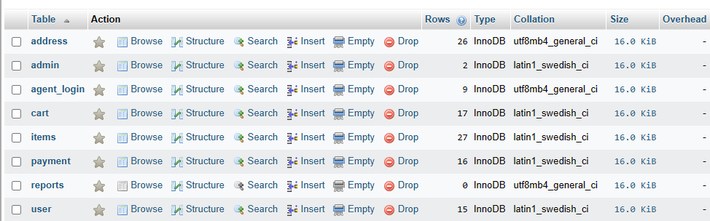
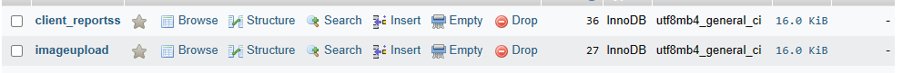

User table:
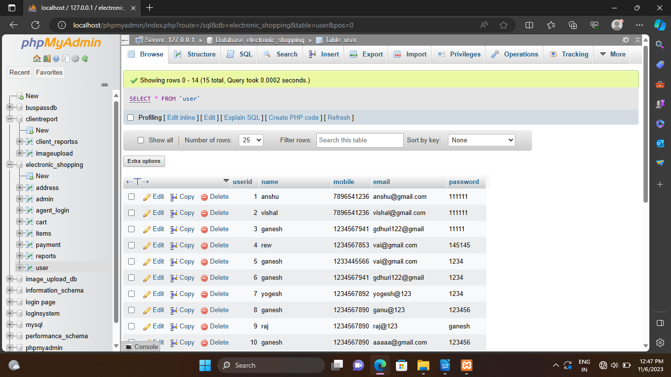

Admin :

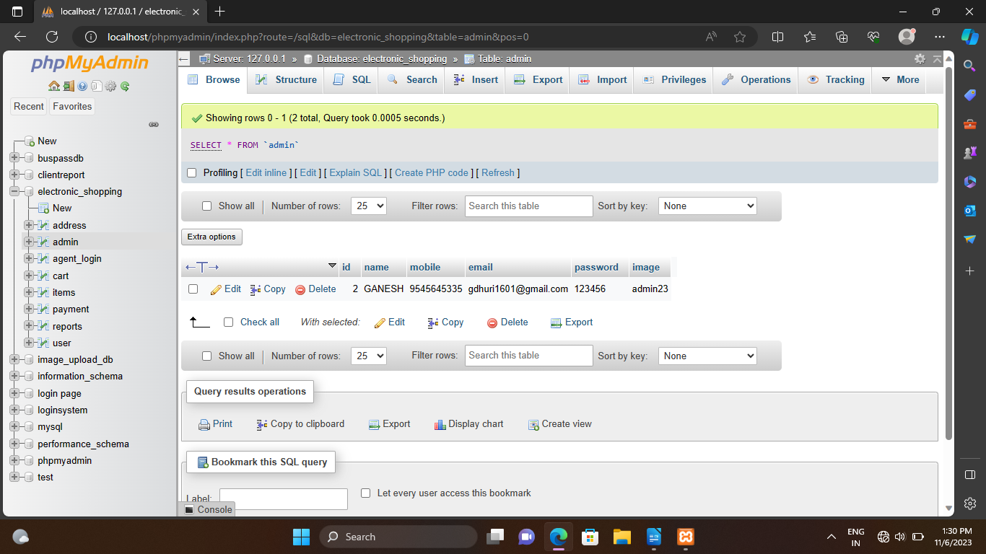

Product table:
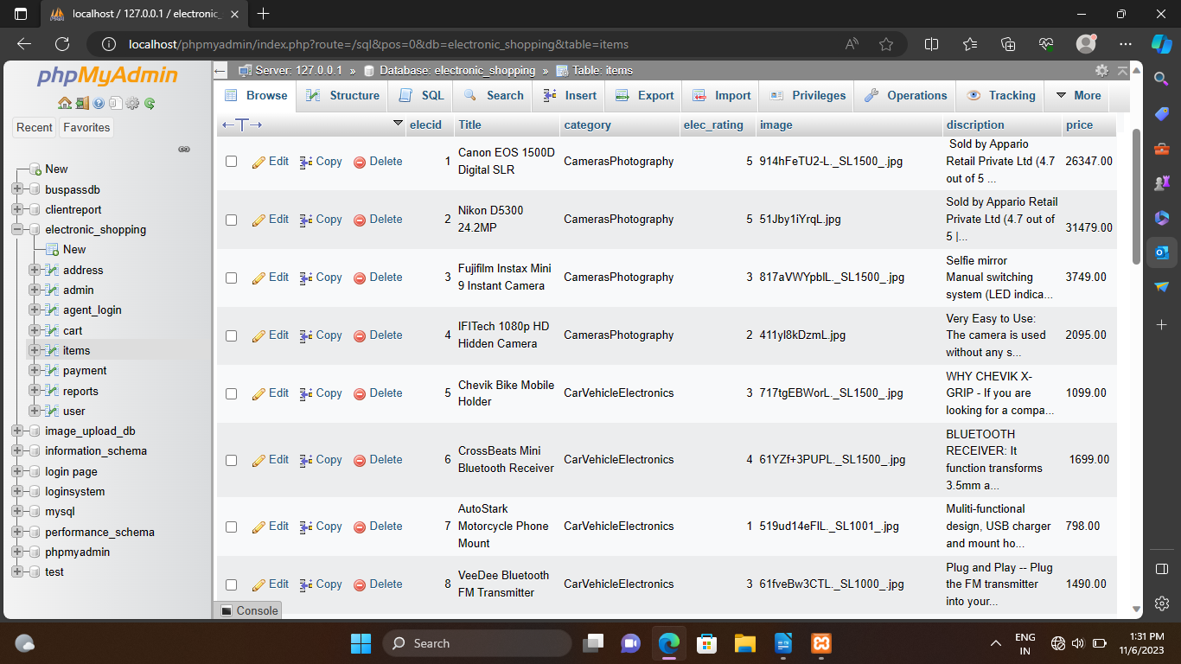
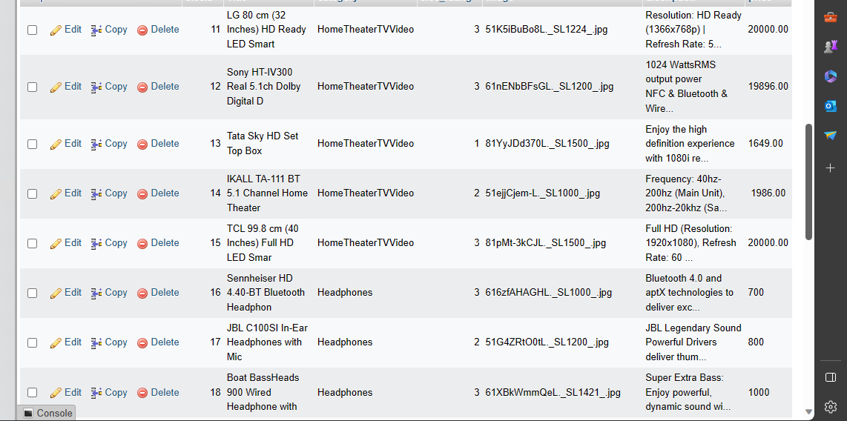

Cart table:

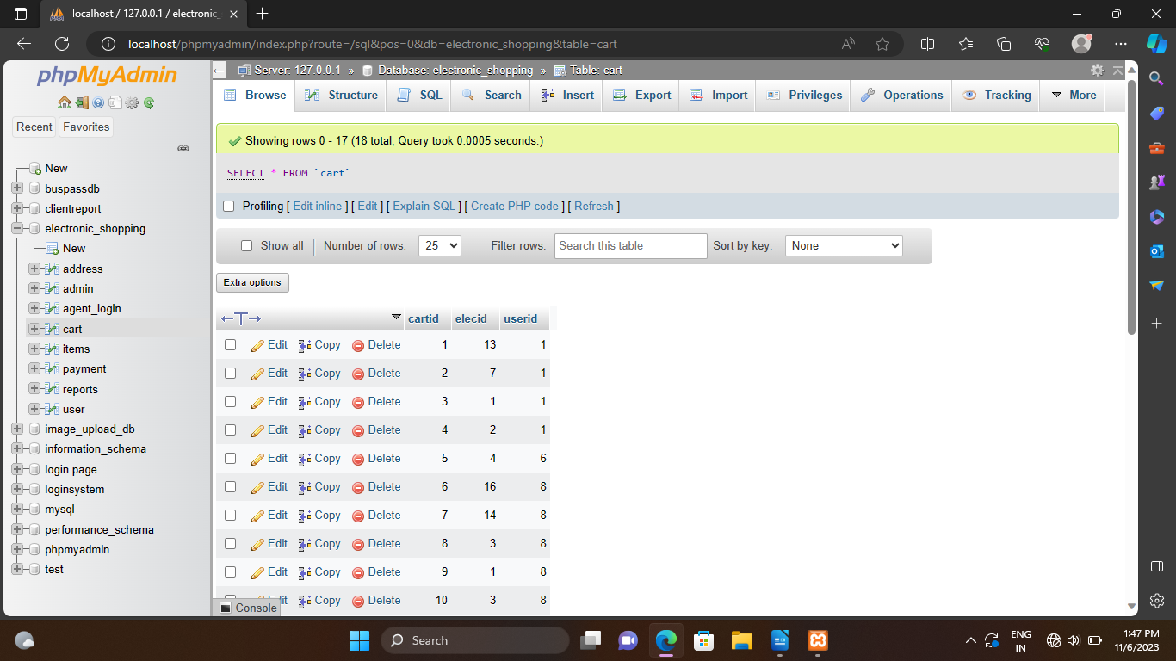

Agent tabel :

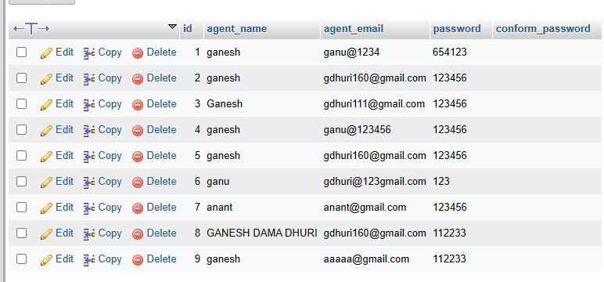

Payment :

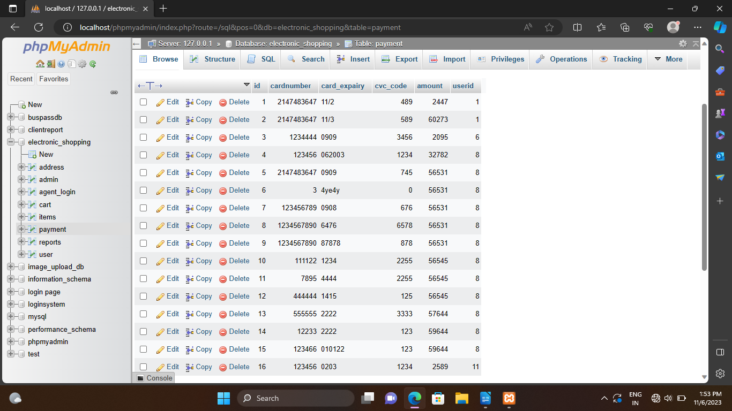

user report :

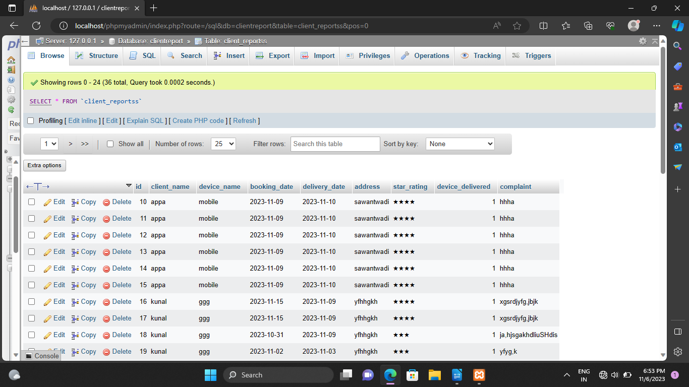

image upload by agent :

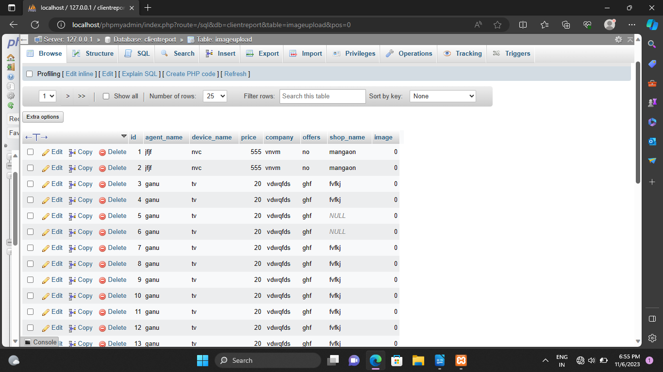

Algorithms Design:

In this section, we can discuss about input, output and processing
logic behind that activity. Here we discuss on input, output and logic of
“Login Form”. In UI design section, I can attach login form design. So if
you want to see that form then referred UI design section.
In login form there are fields such as username and password.
When we registered to system at that time we got username and
password. When we entered that username and password in login form
field then system checks that values with registered username and
password. If both values are matched then system give access of next
page. If that values are mismatch then system displays error message.

For login form actual algorithm designing is as follows :

1] Open login form.
2] Entered registered username and password on proper field If there in no
any account for login then register for new account. and generate
username and password. and then login.
3] System check that user entered valid value or not (i.e. required data type,
required length etc)
4] If values are valid then check with registered value of username and
password in database
5] If and only if both values are equal then give access of next page
6] If any one value is mismatched with stored value then show error
message Similarly, we can design algorithm for all functional points
which can required validation.

For buying Product actual algorithm designing is as follows:

1] View Product.
2] Add to cart product.
3] To buy Product, First login

4] Buy Product
5] Place order

4.4 User Interface Design :
Here we can see some interface which can provide all necessary
functionalities to user of system. Also we can see some major form
design of project.

Main interface (Home Page)

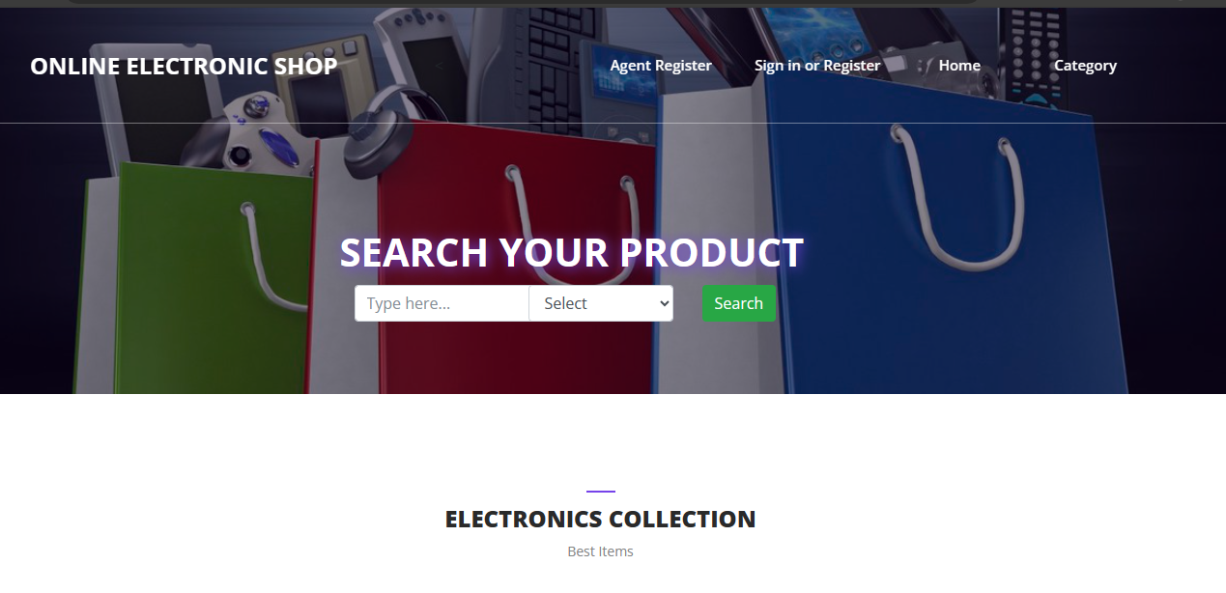

Services section:
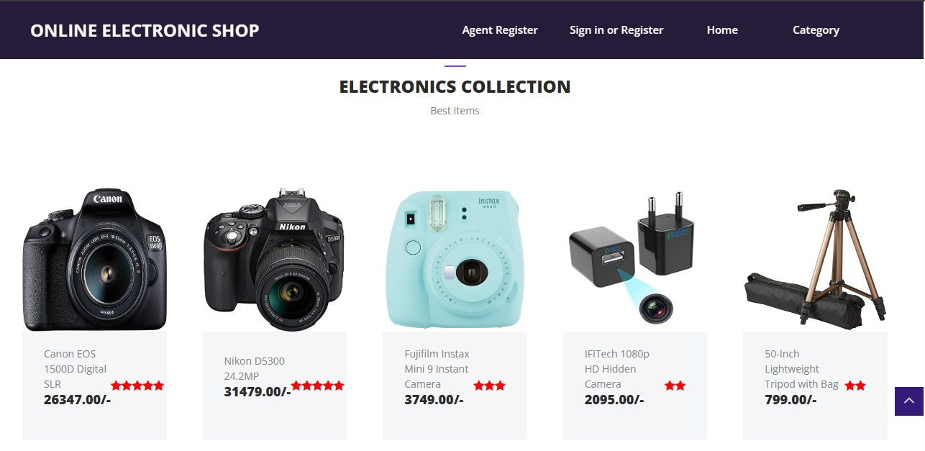

Registration Page:

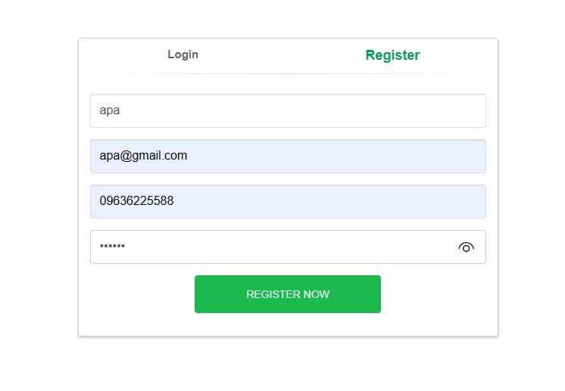

Registration Successfully :
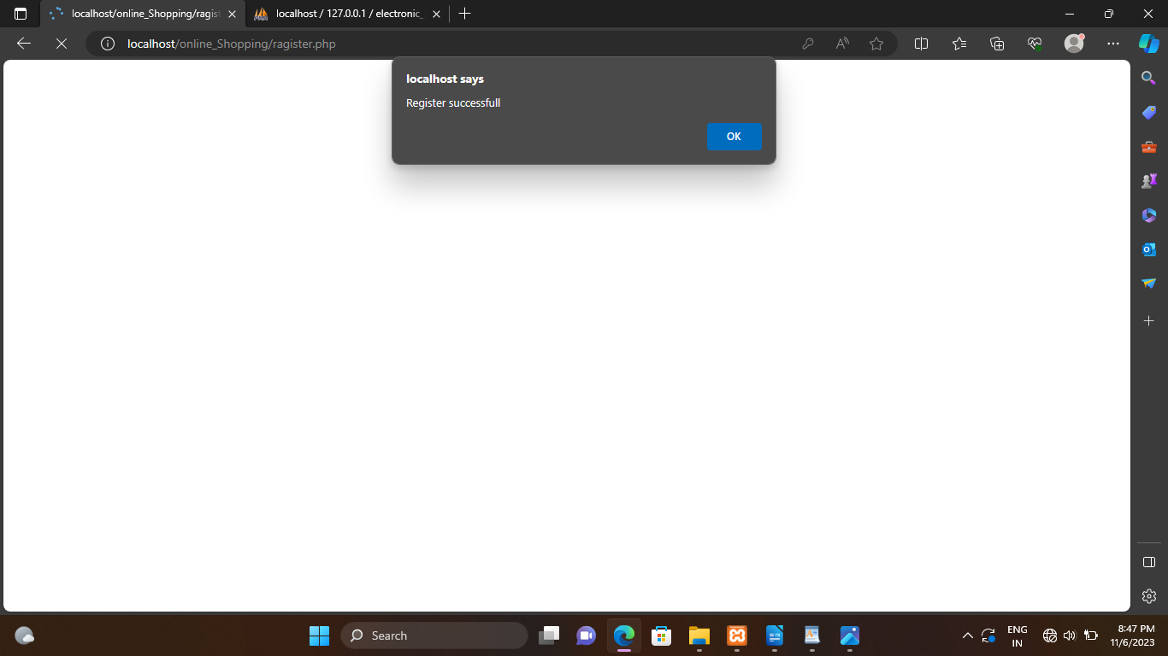

Login form :

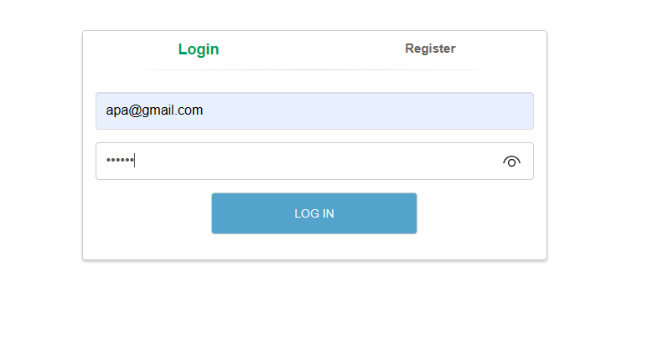

Category Of Product :

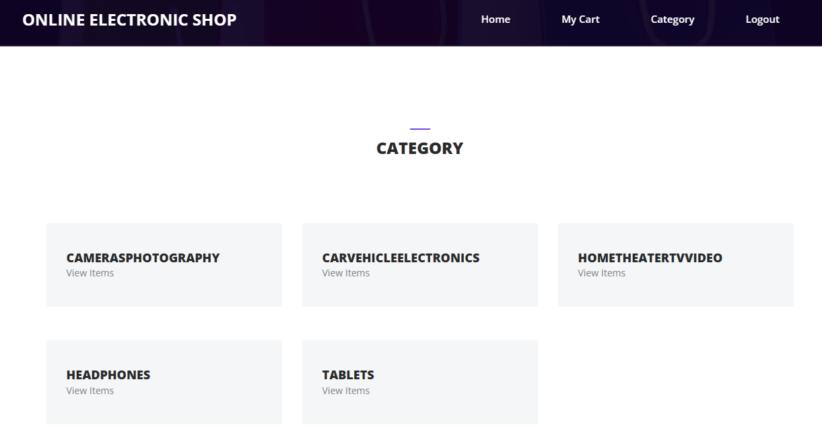

Cameraphotography :
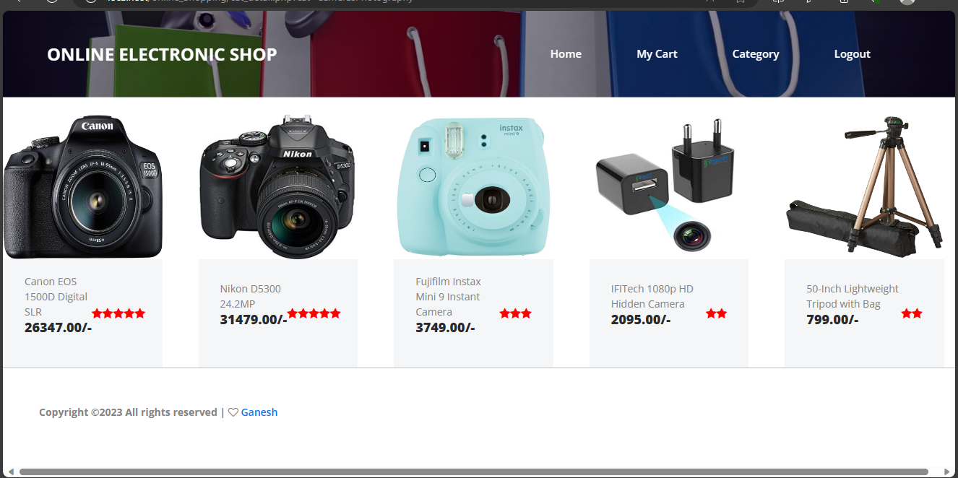

Carvehicalelectronics :

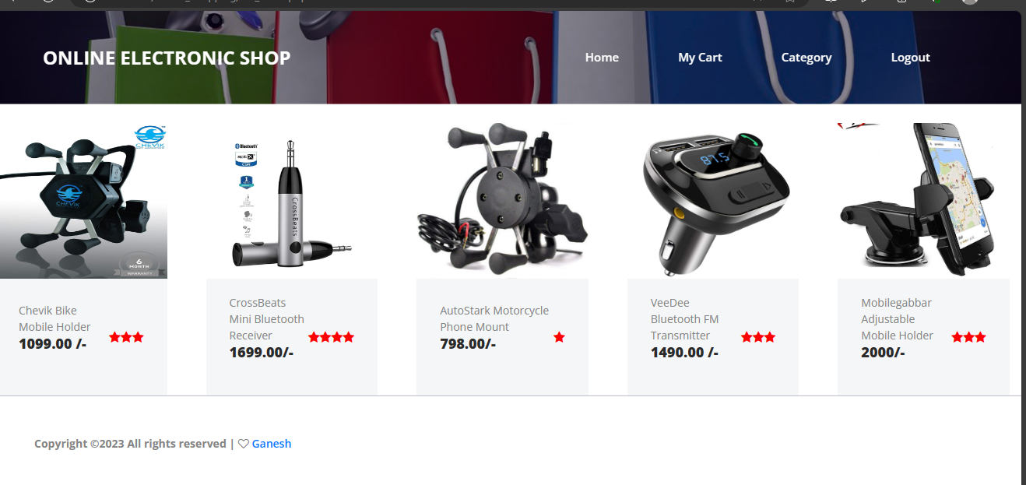

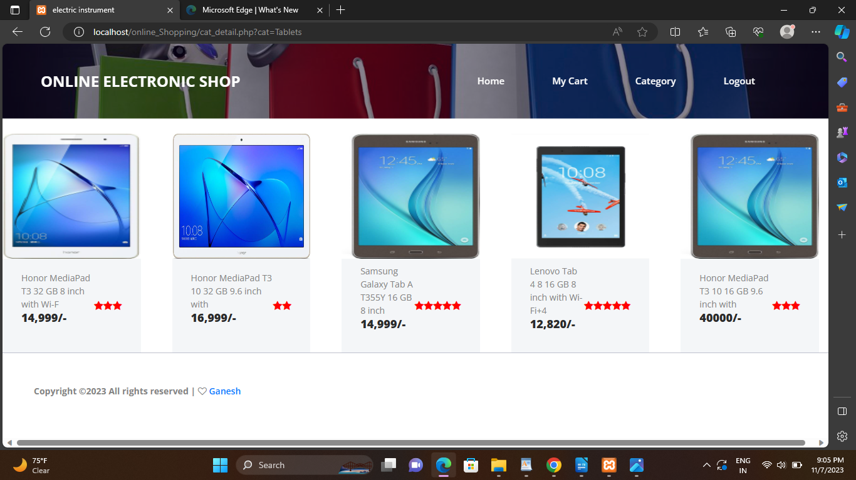
Tablets :

Headphones :

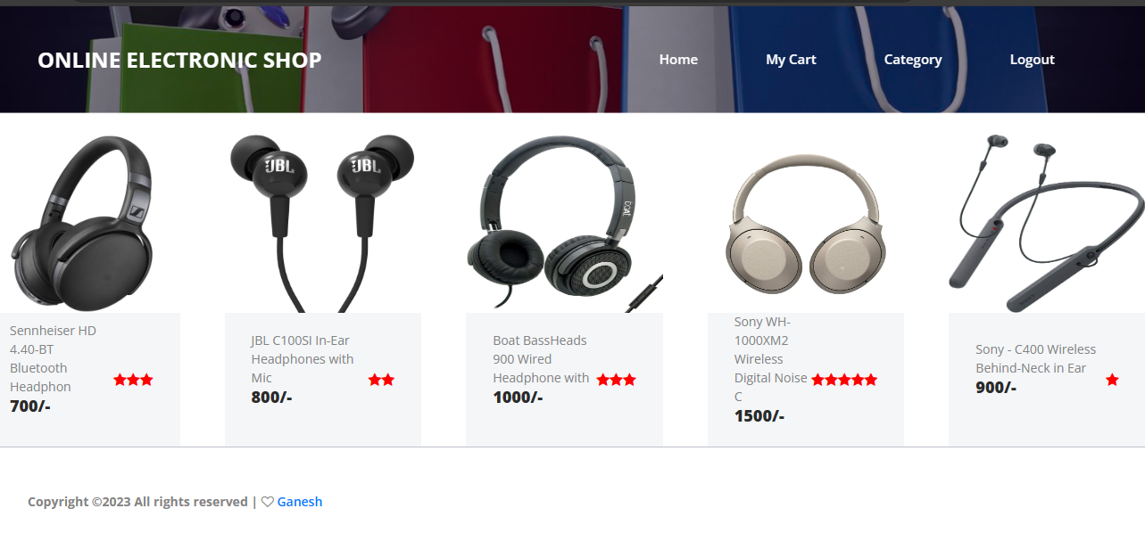

Add to cart :

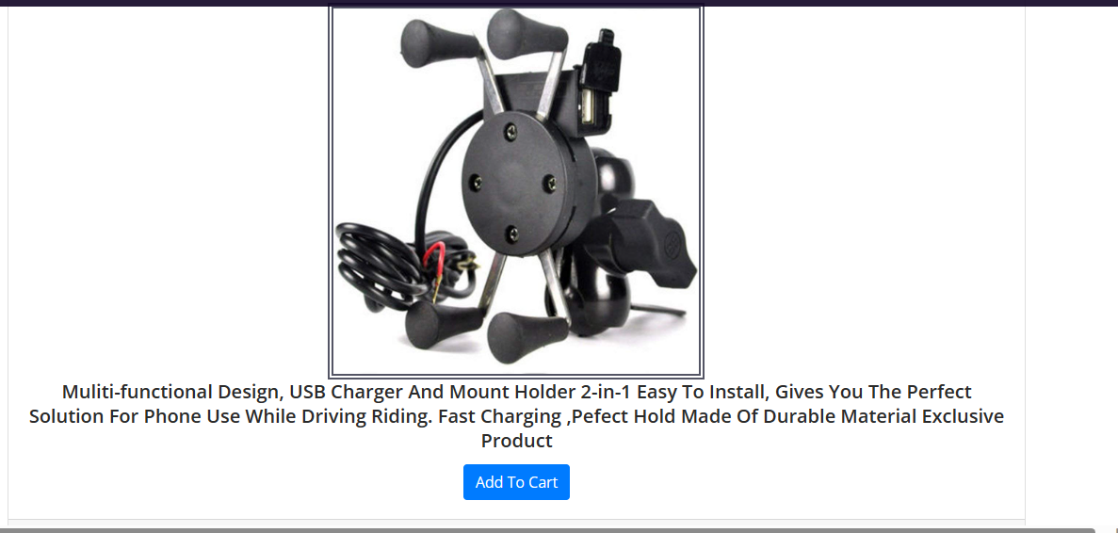

My Cart :
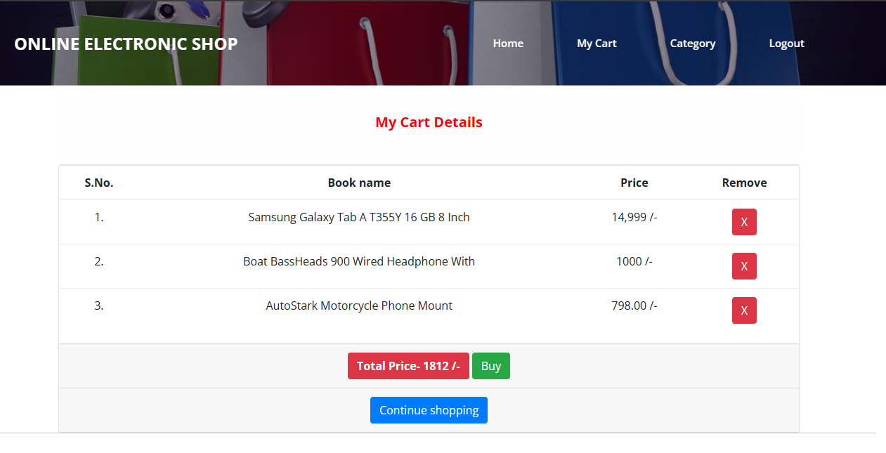
Buy the product :

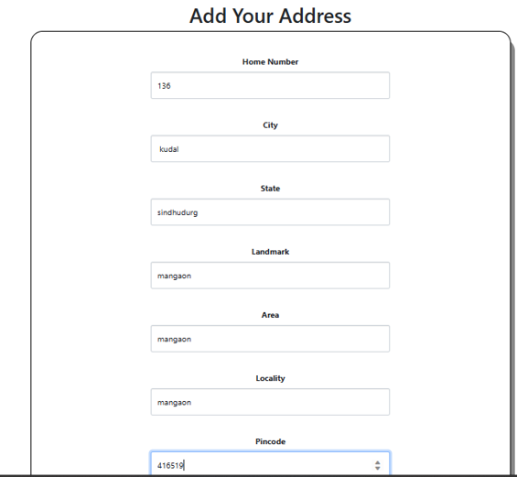
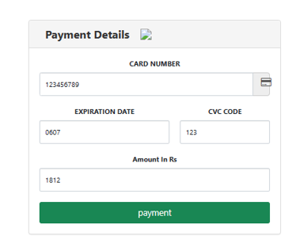

User report
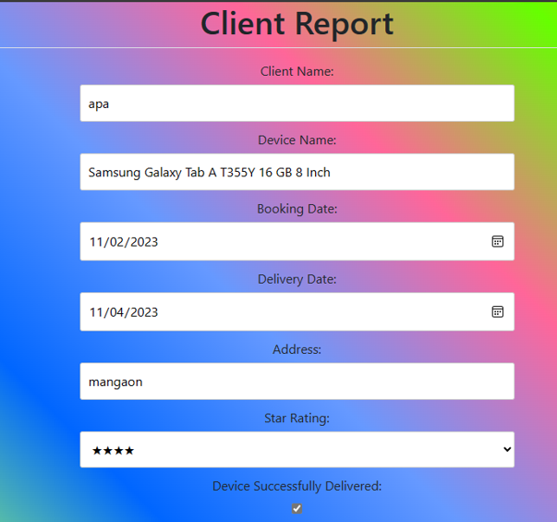

Agent Register

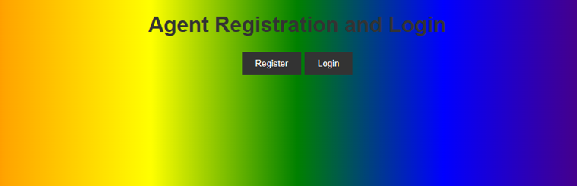
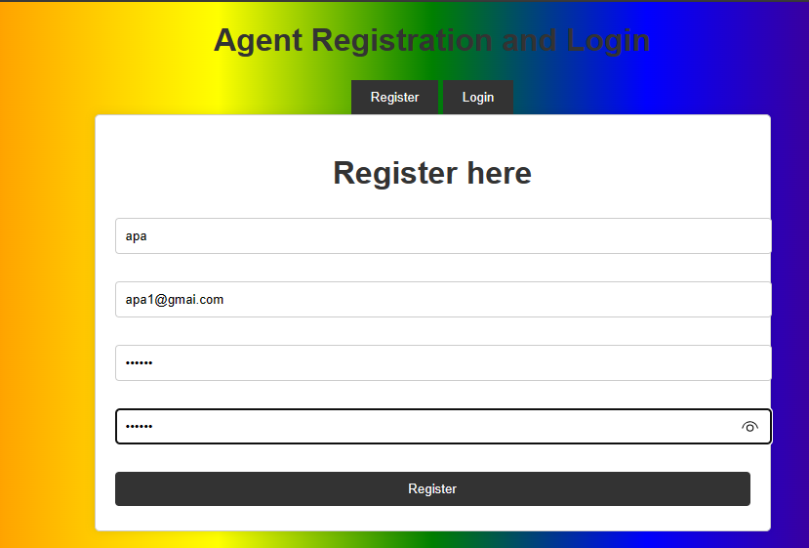

Registration successful

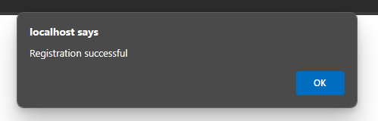

Sign in

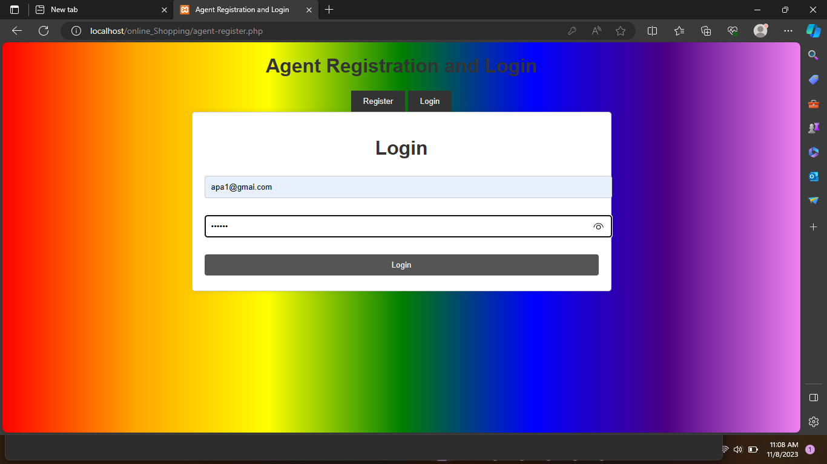

after the login agent share the devices information

after the login agent share the devices information

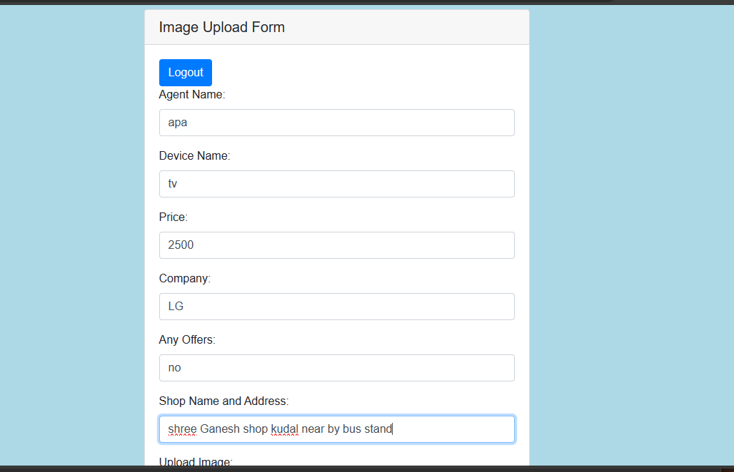

Admin Login

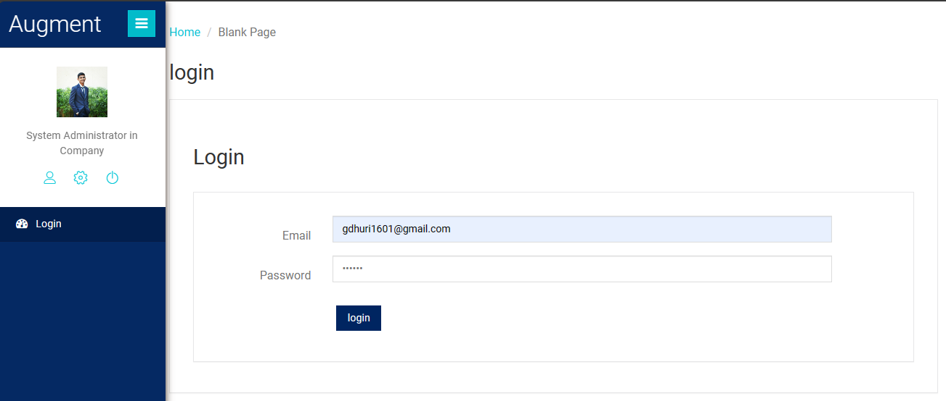

Product Added Successfully :

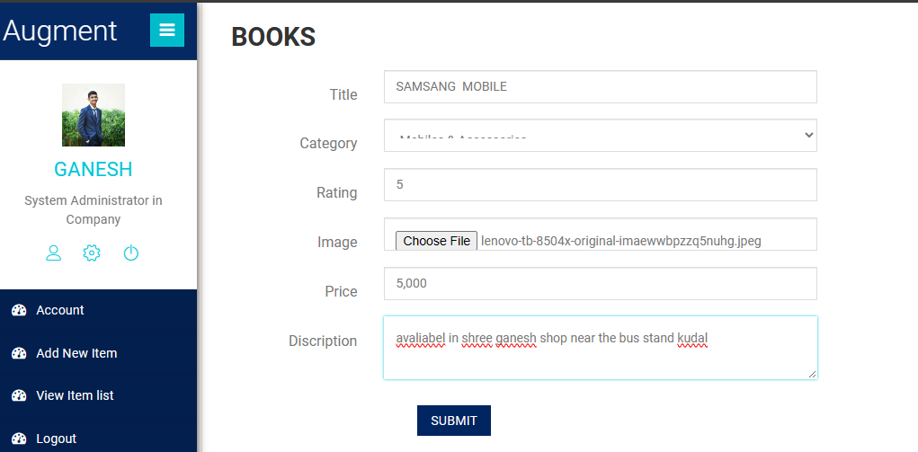

Product Added Successfully :

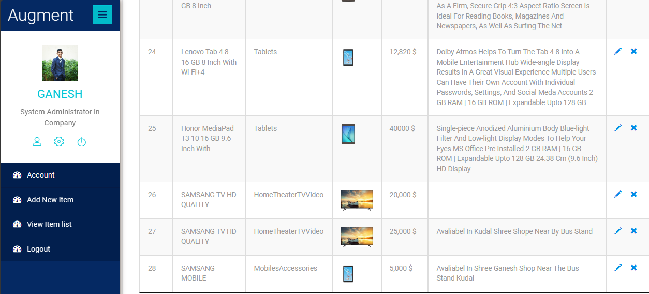

User Profile :

Security Issues
There are some limitations for the current system to which solutions can
be provided as a future development:

- The Website is not accessible to everyone. It can be deployed on a web server so that everybody who is connected to the Internet can use it.
Test Cases Design:

The process or method of finding errors in software application so that the application functions according to the end user’s requirement is called software testing. A test cases is a set of conditions under which a tester will determine whether an application is working correctly or not.

Test case is an object for execution for other modules in the architecture does not represent any interaction by itself. A test case is a set of sequential steps to execute a test operating on a set of predefined inputs to produce certain expected outputs. There are two types of test cases: -manual and automated. A manual test case is executed manually while an automated test case is executed using automation.

In system testing, test data should cover the possible values of each parameter based on the requirements. Since testing every value is impractical, a few values should be chosen from each equivalence class. An equivalence class is a set of values that should all be treated the same.

Ideally, test cases that check error conditions are written separately
from the functional test cases and should have steps to verify the error
messages and logs. Realistically, if functional test cases are not yet
written, it is ok for testers to check for error conditions when performing
normal functional test cases. It should be clear which test data, if any is
expected to trigger errors.

Test Cases Design:

Scenario Name: Customer Login Tester

Name: Dhuri Ganesh Dama

Sr.  No | Test case  Id | Test case  name | Test case  Description | Step | Expected  Result | Actual  Result | Test case  Status  Pass/Fail
1. | T1 | Validate login | To verify that login name on login page | Enter the Email Id  And  Password  Click on login  button | Login successful or an error message “Invalid login or password” must be displayed | Value are accepted | pass
2. | T2 | Validate  Password | To verify that password on login page | Enter the password and Email Id and click on login button | An error message “invalid password” must be displayed | Value are accepted | pass

Scenario Name: Add to cart system test

Name: Ganesh Dama Dhuri
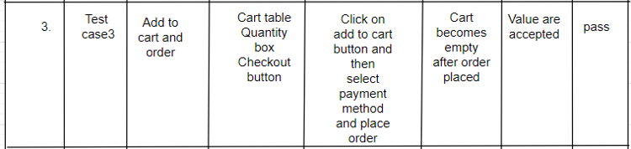

CHAPTER 6
IMPLEMENTATION AND
TESTING

Implementation Approaches
System implementation is the important stage of project when the
theoretical design is tuned into practical system. The main stages in the
implementation are as follows:

1. Planning
2. Training
3. System testing and
4. Change over Planning
Planning is the first task in the system implementation. At the time of implementation of any system people from different departments and system analysis involve. They are confirmed to practical problem of controlling various activities of people outside their own data processing departments. The line managers controlled through an implementation coordinating committee. The committee considers ideas, problems and complaints of user department, it must also consider:
1. The implication of system environment
2. Self-selection and allocation for implementation tasks
3. Consultation with unions and resources available
4. Standby facilities and channels of communication Electronic instruments website, will implement product details, admin handle user details, separate login details, order details.

