1. **Add Excel sheet Book.csv**

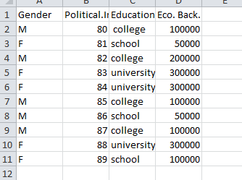

1. **Create one variable to store the table**

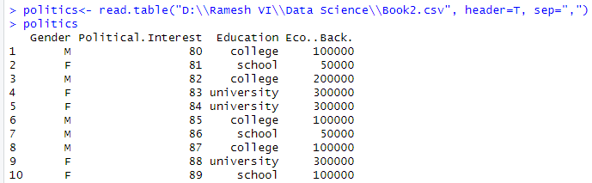

1. **Attach the Political.Interest with Gender**

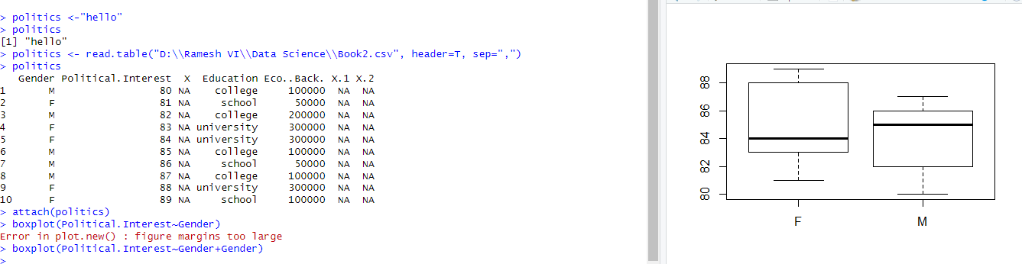

**Plot:**



1. **Result=aov (Political.Interest ~ Gender)**

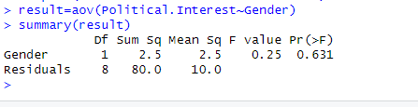

1. **Add Education column to boxplot**

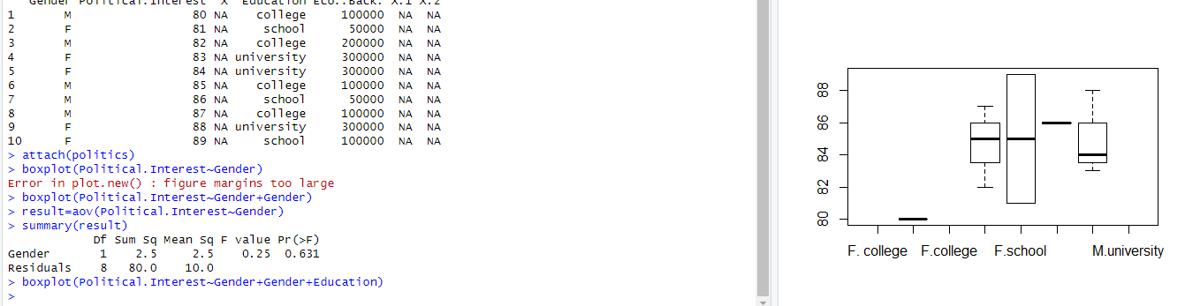

**Plot:**



1. **Add Gender column with result**

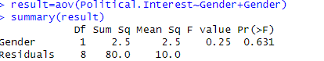

1. **Add Education column with result**

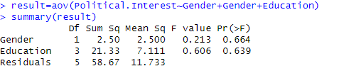

1. **Add Eco.Back. column with result**

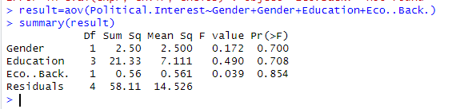

1. **Add Education and Eco..Back column in boxplot**



