1. Airpassengers

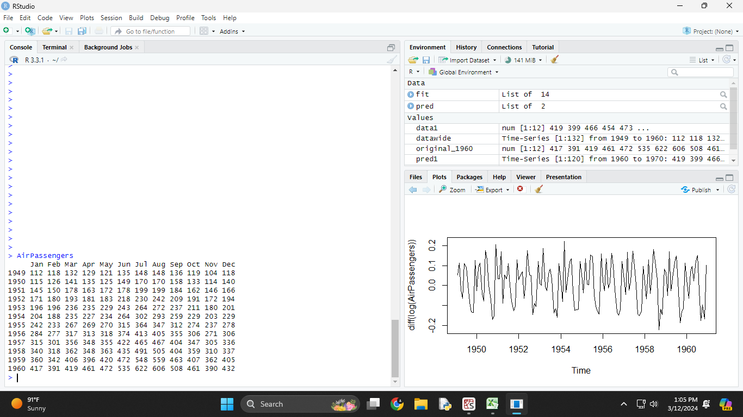

1. plot(AirPassengers)

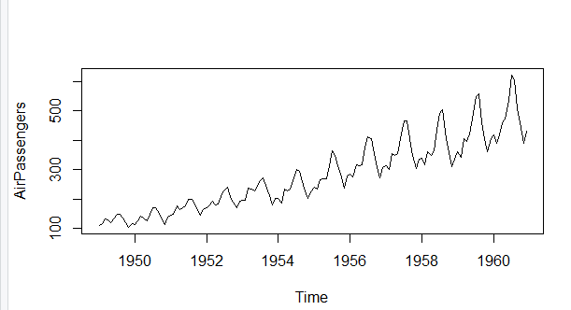

1. plot(diff(log(AirPassengers)))

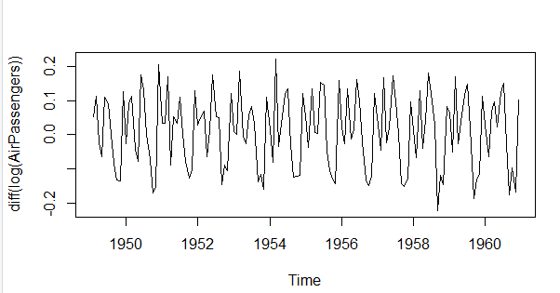

1. class(AirPassengers)



1. start(AirPassengers)



1. end(AirPassengers)



1. frequency(AirPassengers)



1. boxplot(AirPassengers)

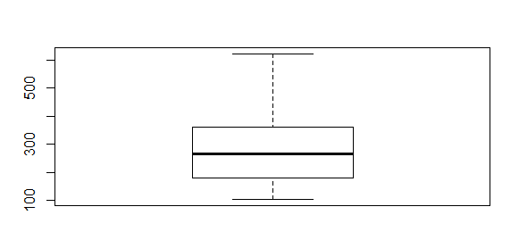

1. summary(AirPassengers)



1. acf(AirPassengers)

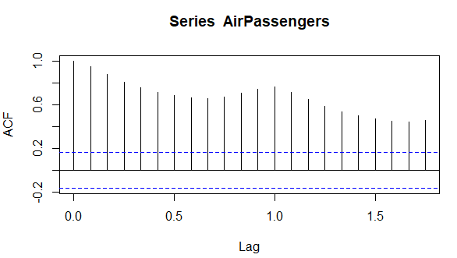

1. acf(diff(log(AirPassengers)))

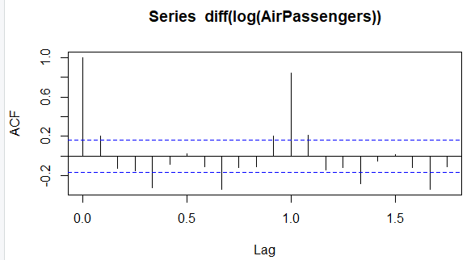

1. pacf(diff(log(AirPassengers)))

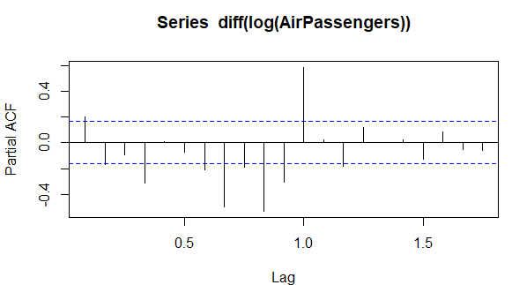

1. fit<-arima(log(AirPassengers),c(0,1,1),seasonal=list(order=c(0,1,1),period=12))

pred <- predict(fit,n.ahead =10*12)

pred1<-2.718^pred$pred

pred1

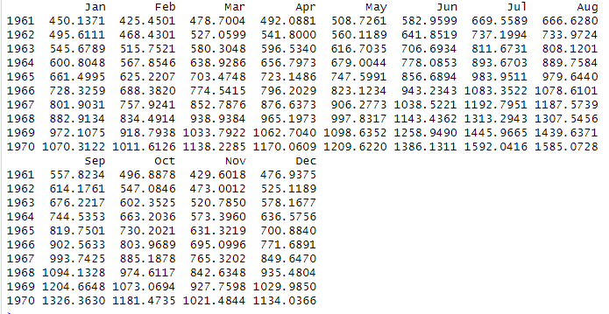

1. datawide<-ts(AirPassengers,frequency = 12,start=c(1949,1),end = c(1959,12))

datawide

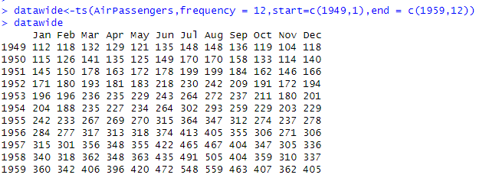

1. fit<-arima(log(datawide),c(0,1,1),seasonal=list(order=c(0,1,1),period=12))

pred <- predict(fit,n.ahead = 10*12)

pred1<-2.718^pred$pred

pred1

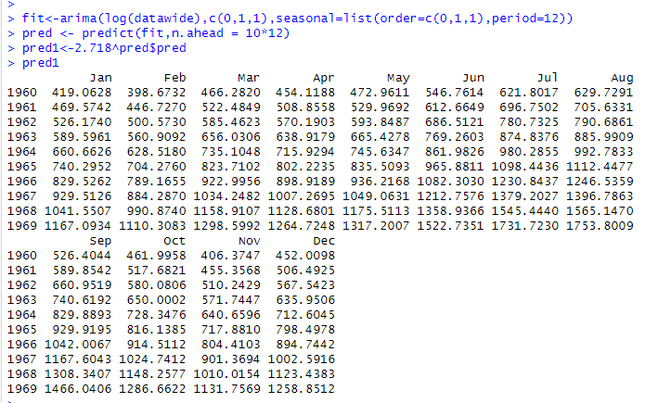

1. data1<-head(pred1,12)

data1

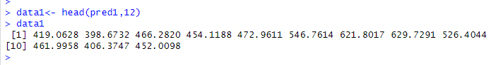

1. predicted_1960<-round(data1,digits=0)

predicted_1960



1. original_1960<-tail(AirPassengers,12)

original_1960

