* **K-means Clustering**

1. **Using Iris dataset**

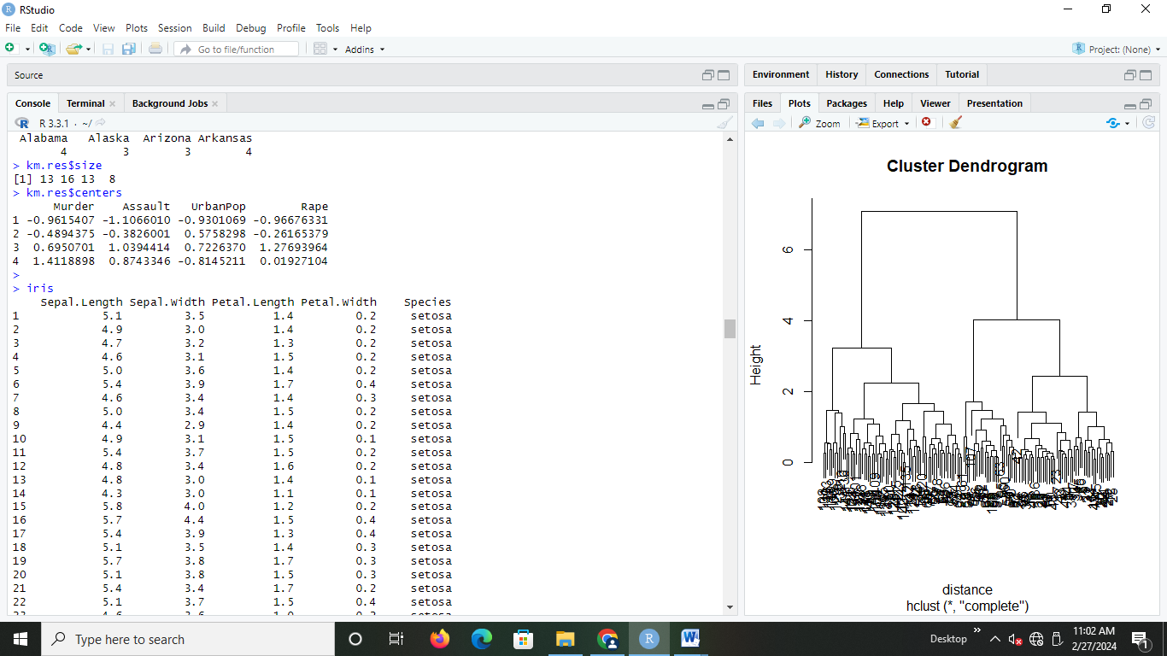

1. **Iriscopy=iris**

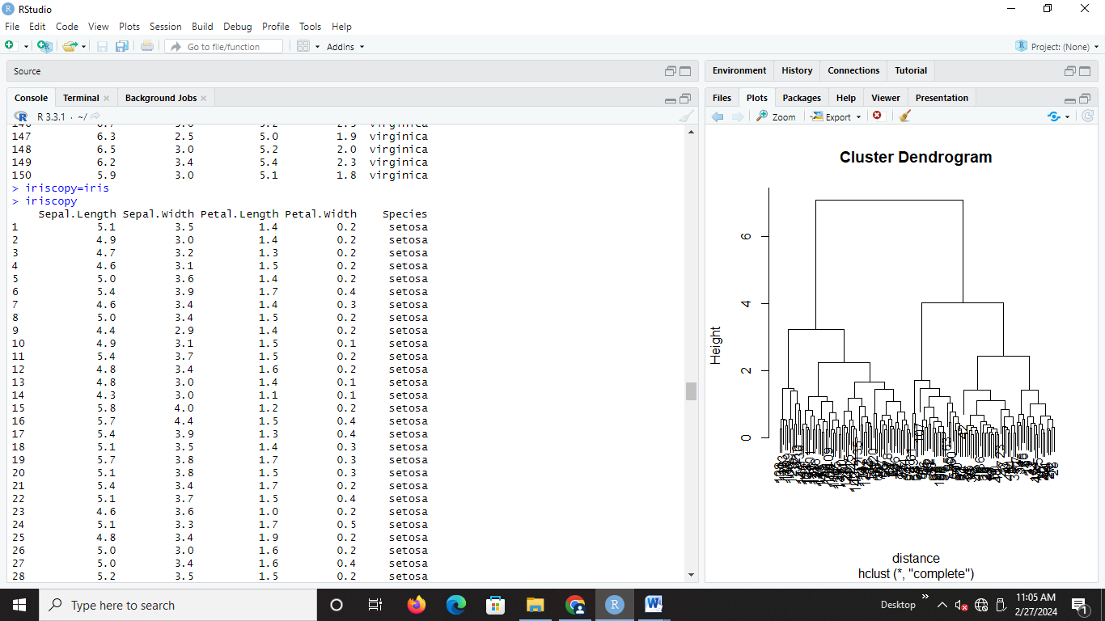

1. **Iriscopy$Species<-NULL**

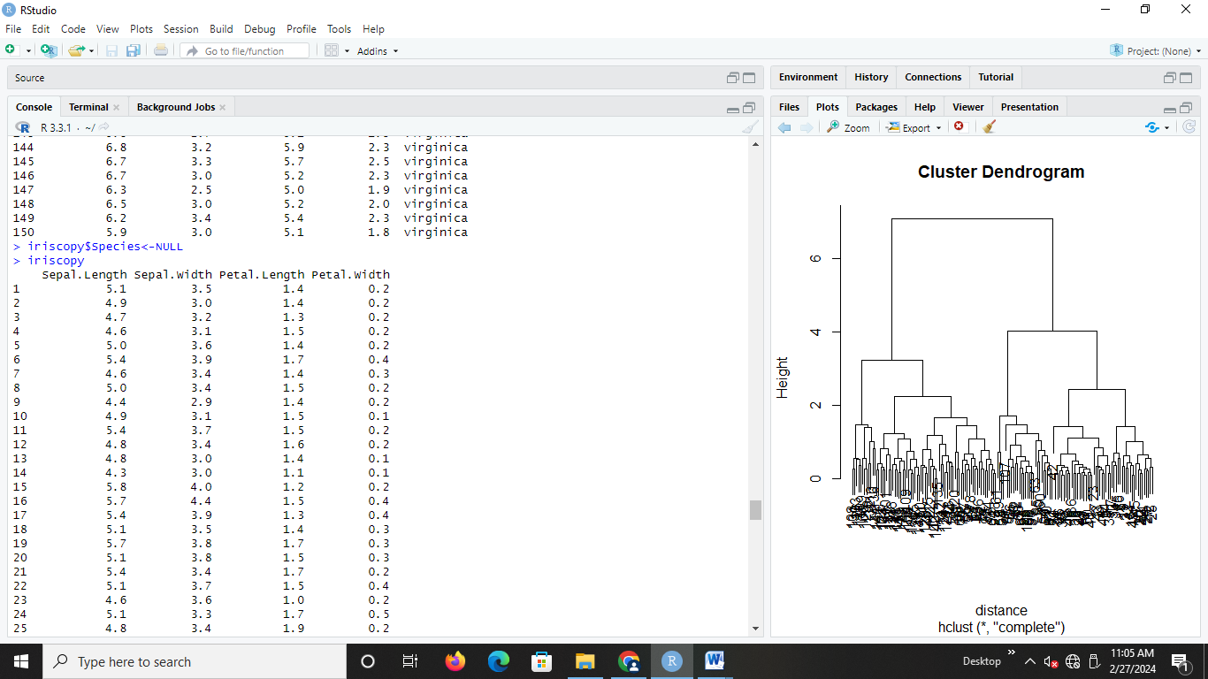

1. **result=kmeans(iriscopy,3)**

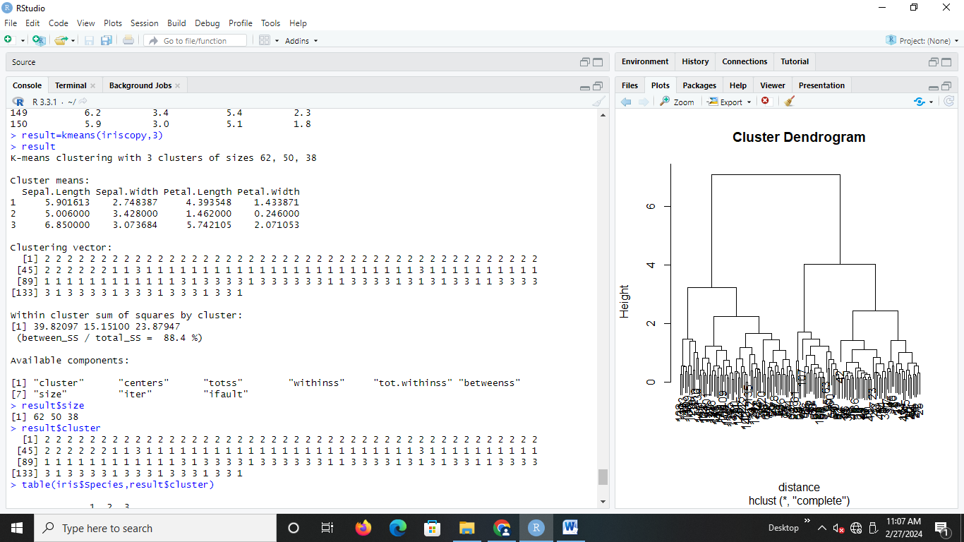

1. **result$size**

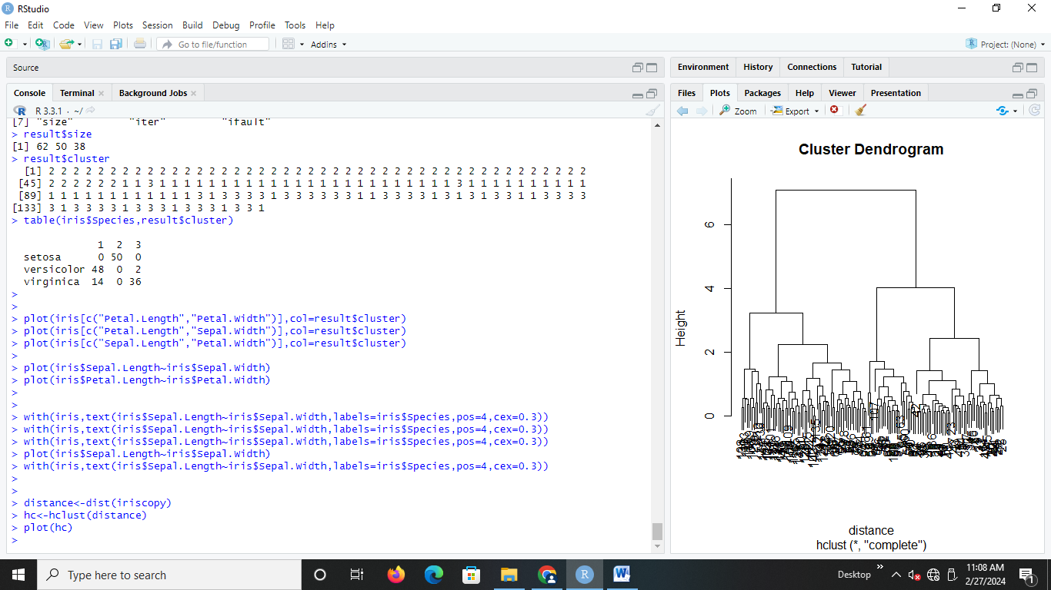

1. **result$cluster**



1. **table (iris$Species,result$cluster)**

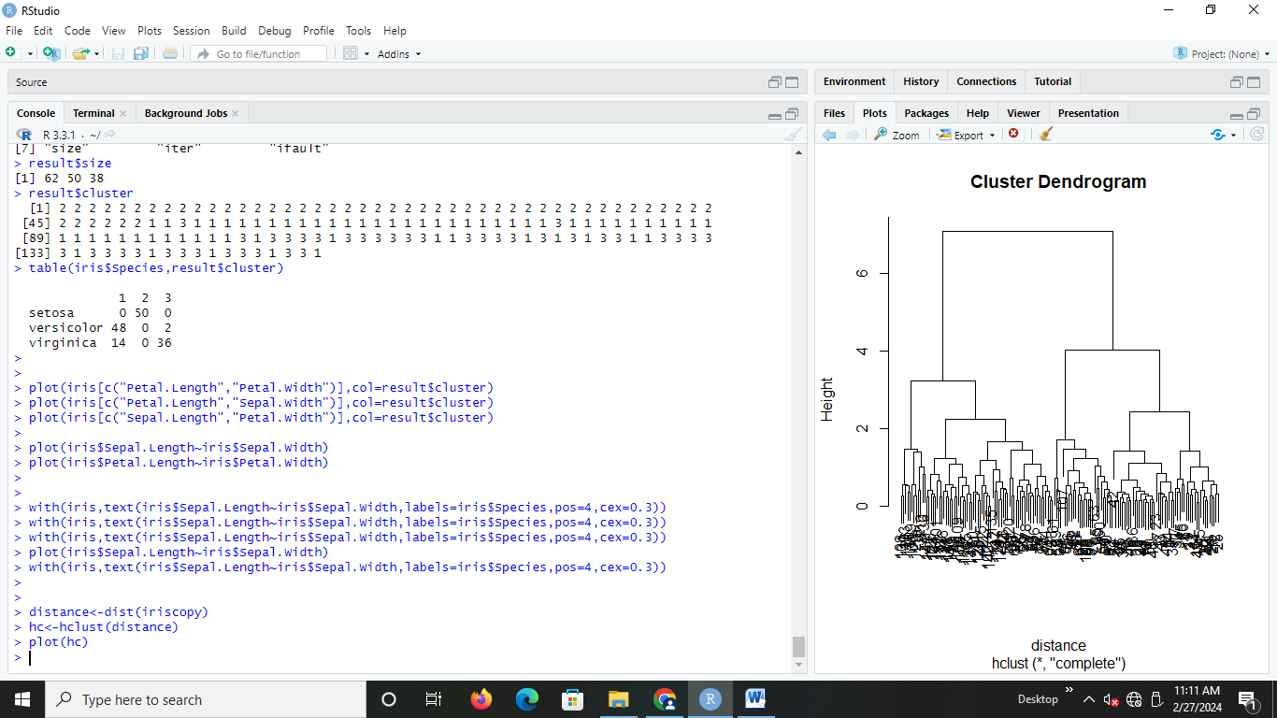

1. **plot(iris[c("Petal.Length","Petal.Width")],col=result$cluster)**

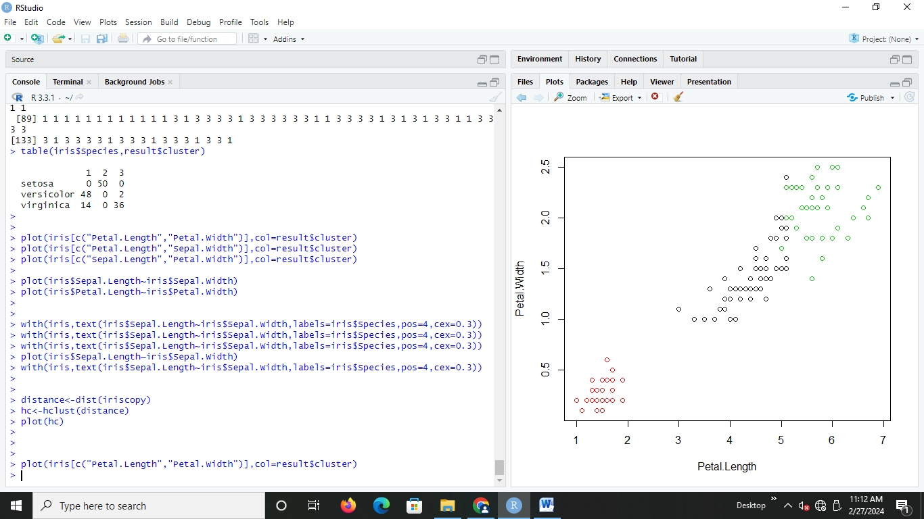

1. **plot(iris[c("Petal.Length","Sepal.Width")],col=result$cluster)**

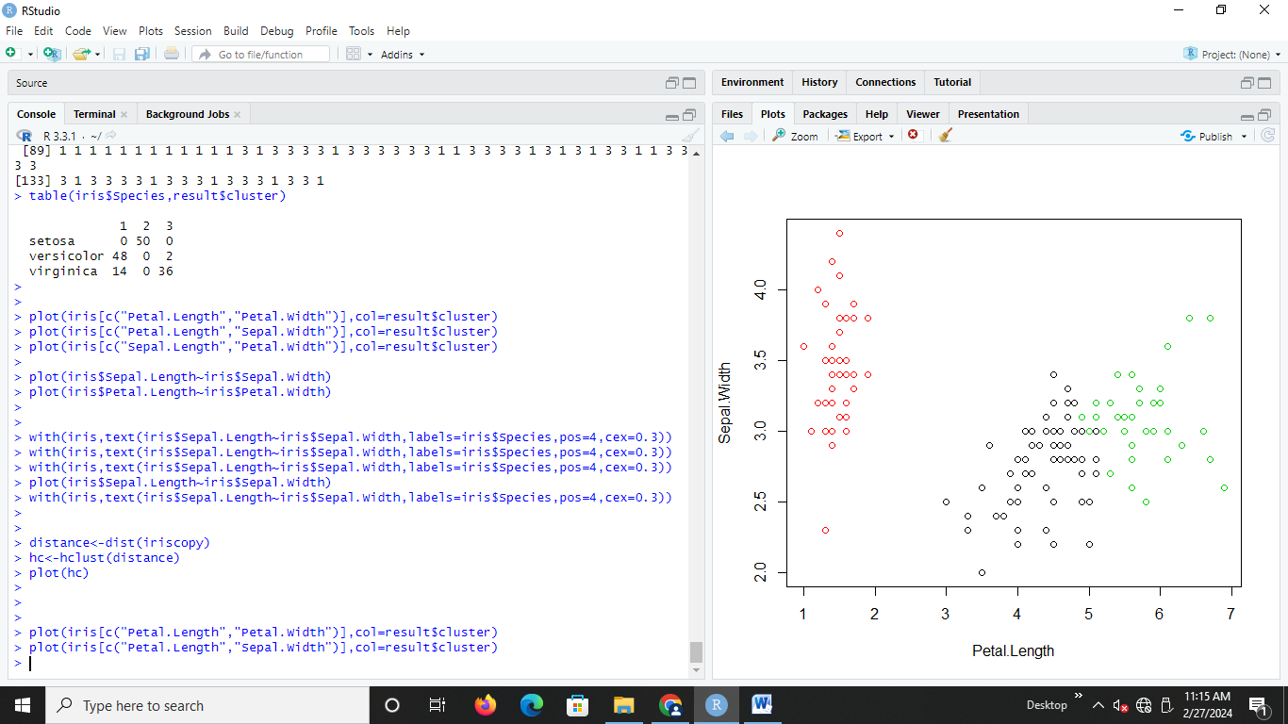

1. **plot(iris[c("Sepal.Length","Petal.Width")],col=result$cluster)**

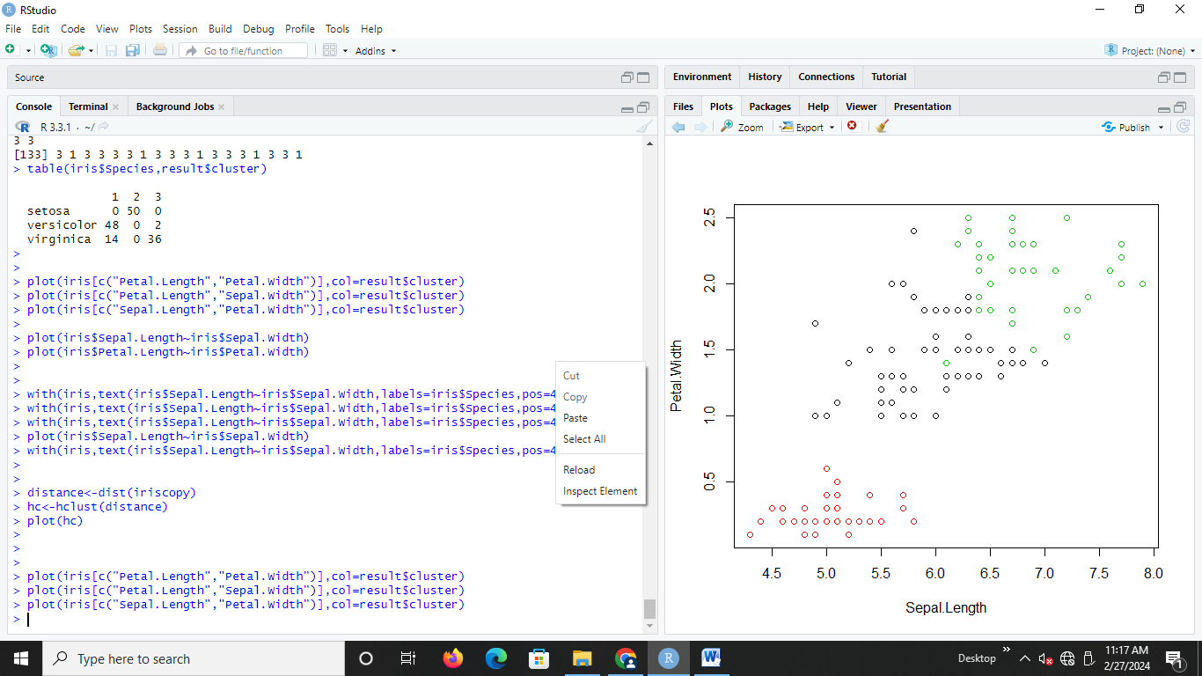

1. **plot(iris$Sepal.Length~iris$Sepal.Width)**

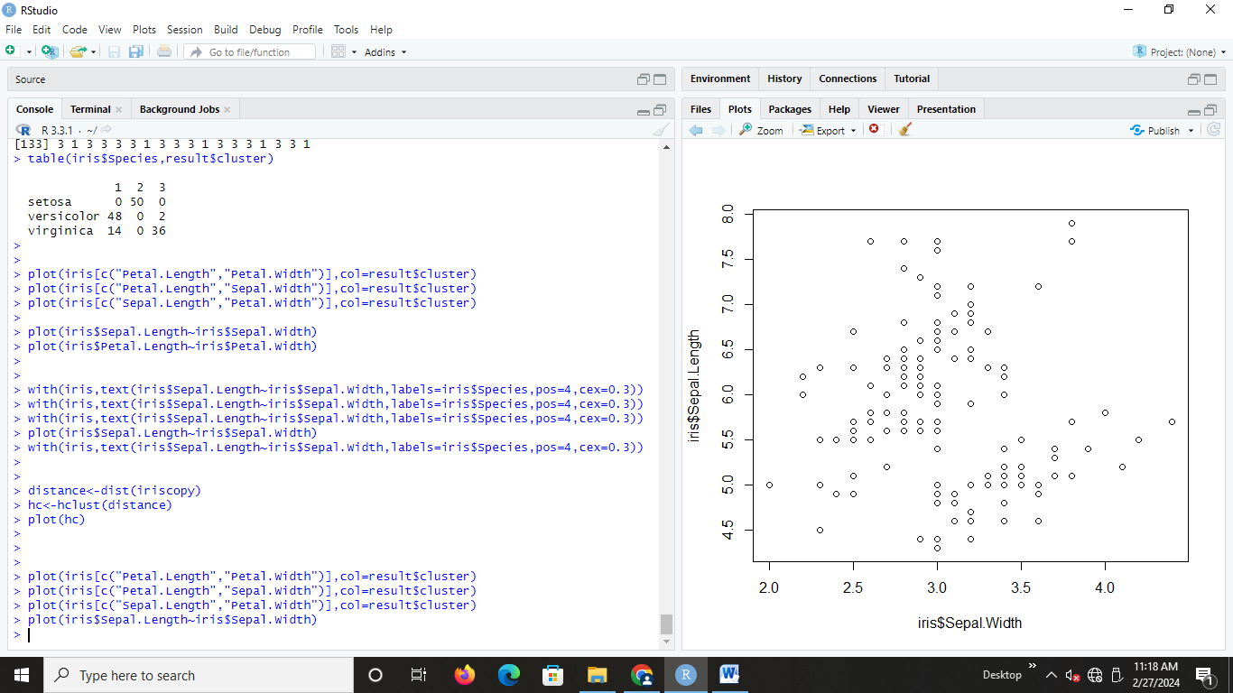

1. **with(iris,text(iris$Sepal.Length~iris$Sepal.Width,labels=iris$Species,pos=4,**

**cex=0.3))**

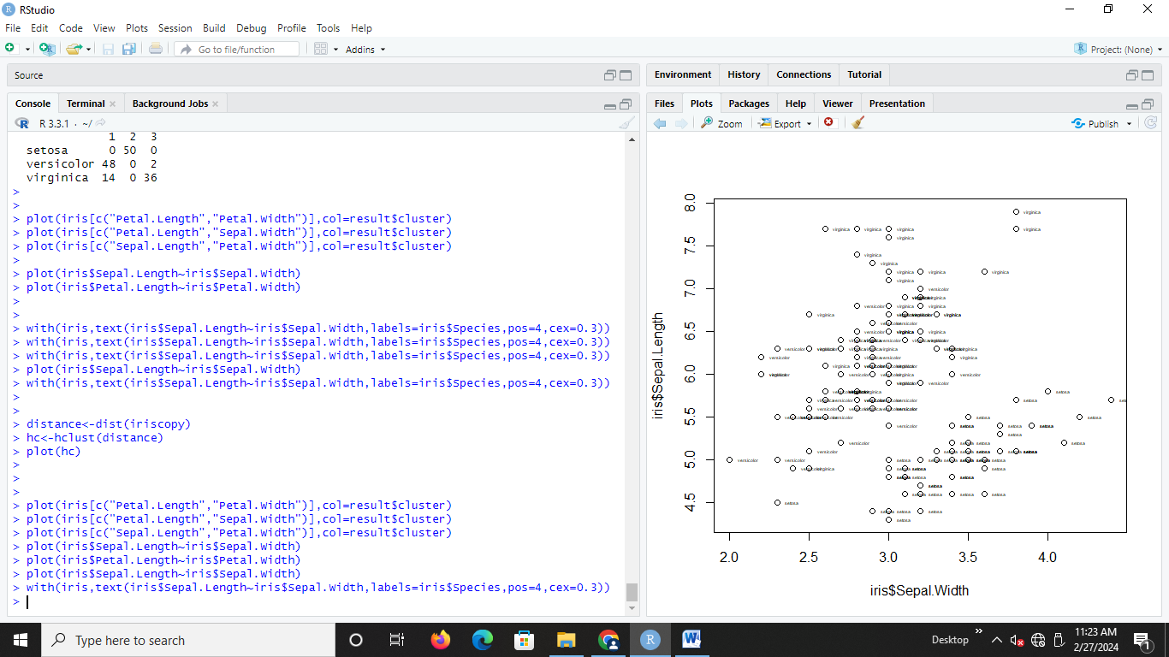

1. **plot(iris$Petal.Length~iris$Petal.Width)**

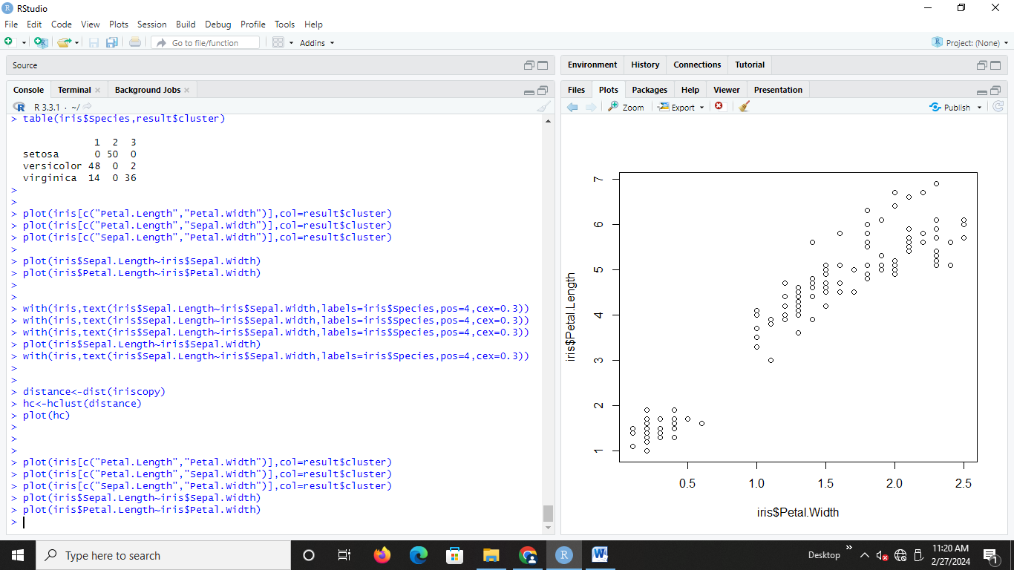

1. **distance<-dist(iriscopy)**

**hc<-hclust(distance)**

**plot (hc)**

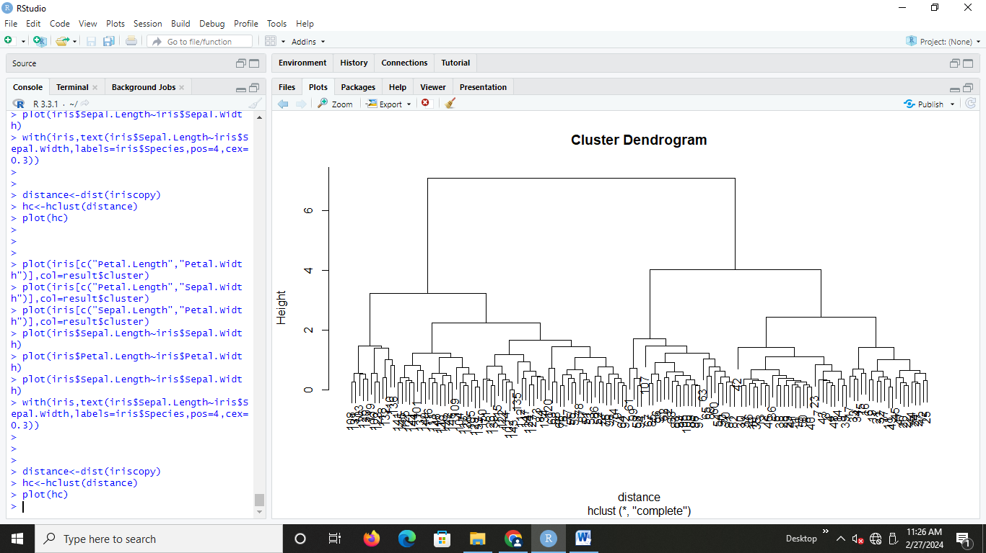

1. **Using airquality dataset**

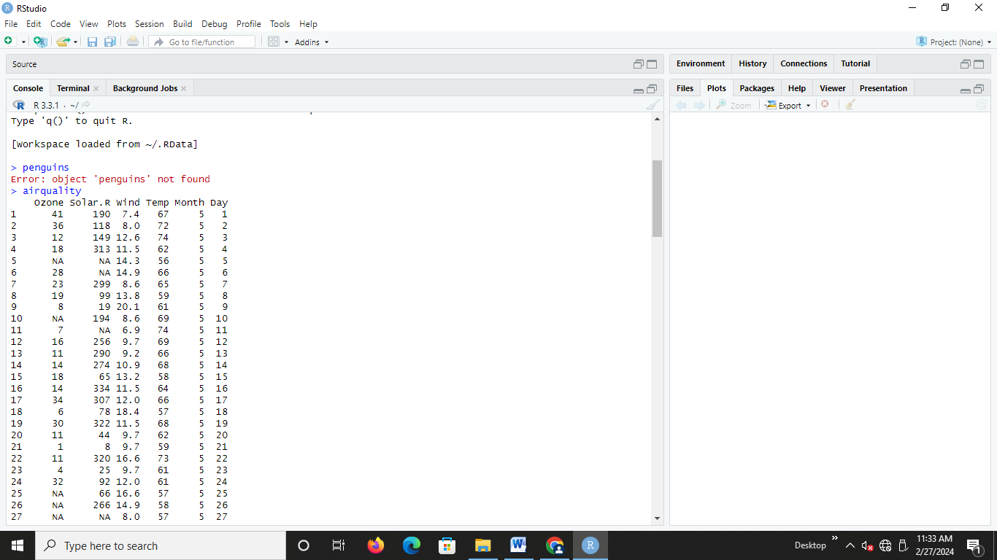

1. **airquality2=airquality**

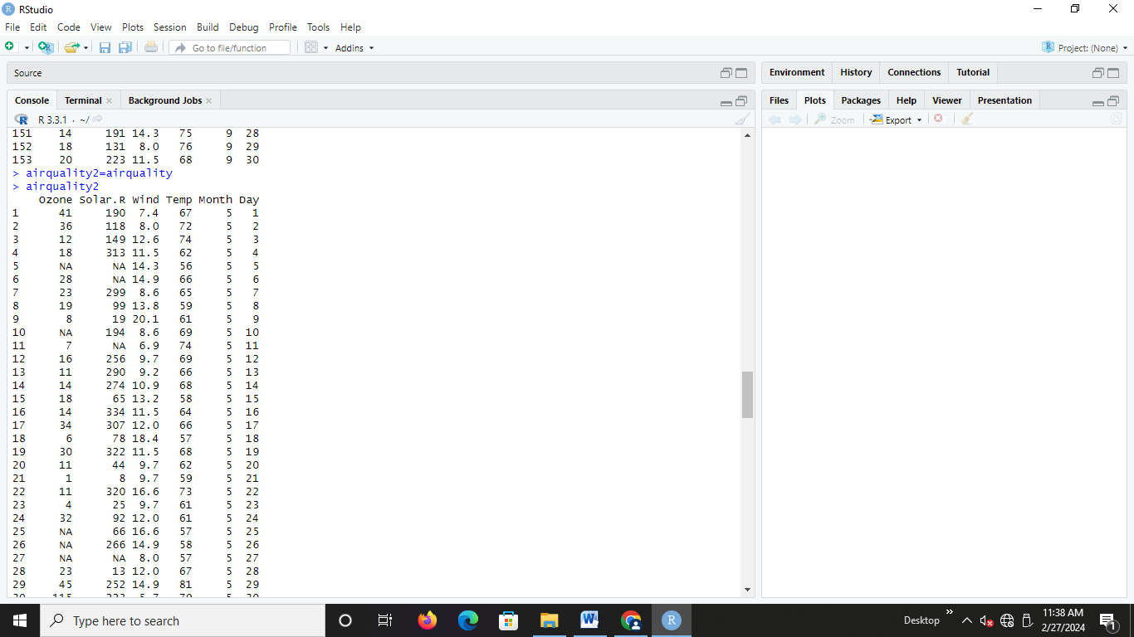

1. **airquality2$day<-NULL**

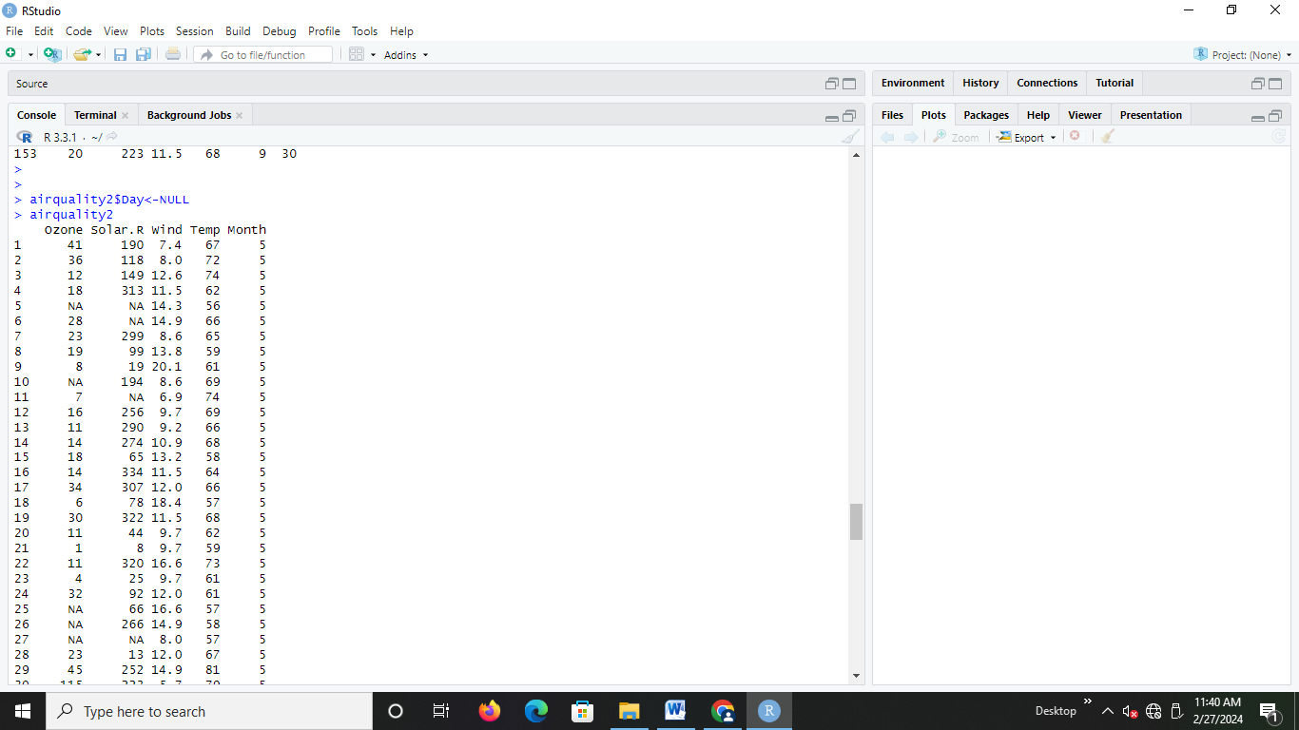

1. **summary(airquality)**

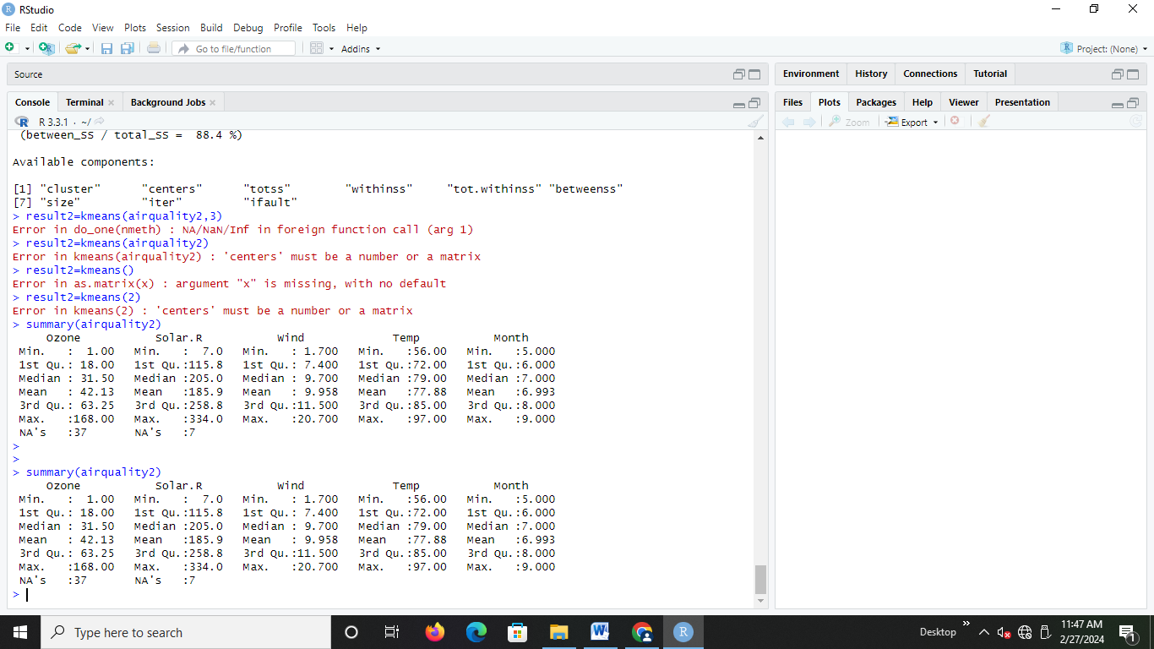

1. **data(airquality)**

**str(airquality)**

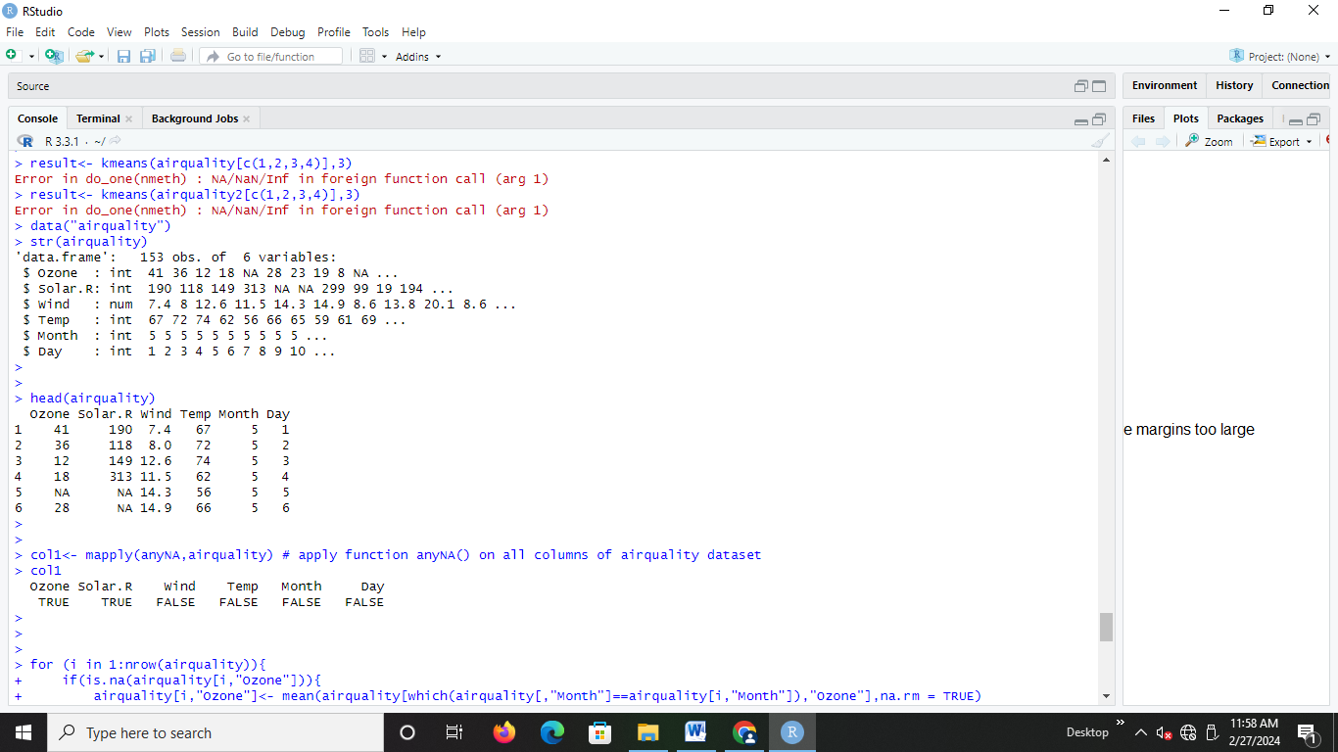

1. **head(airquality)**



1. **col1<- mapply(anyNA,airquality) # apply function anyNA() on all columns of airquality dataset**

**col1**

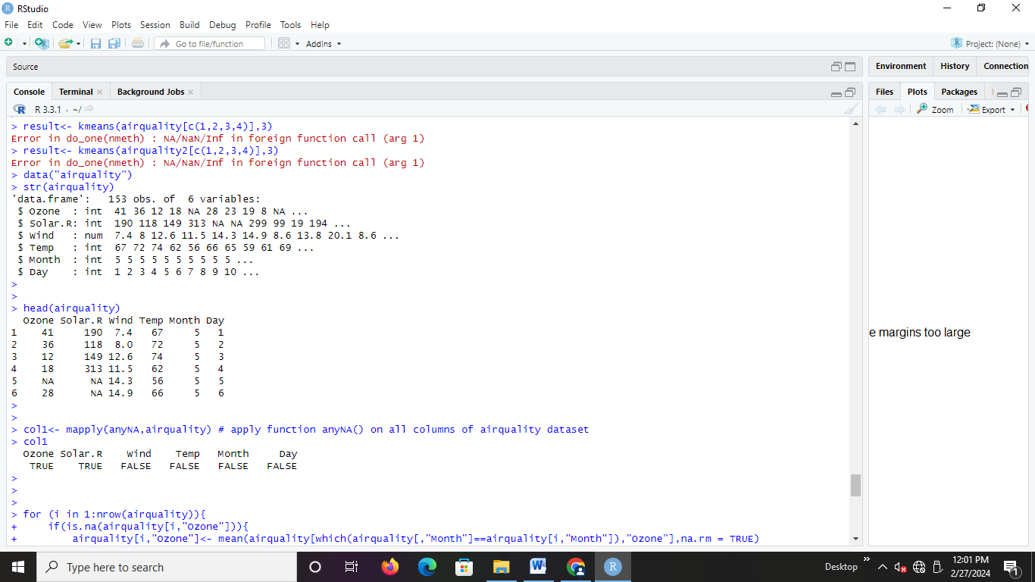

1. **result<- kmeans(airquality[c(1,2,3,4)],3)**



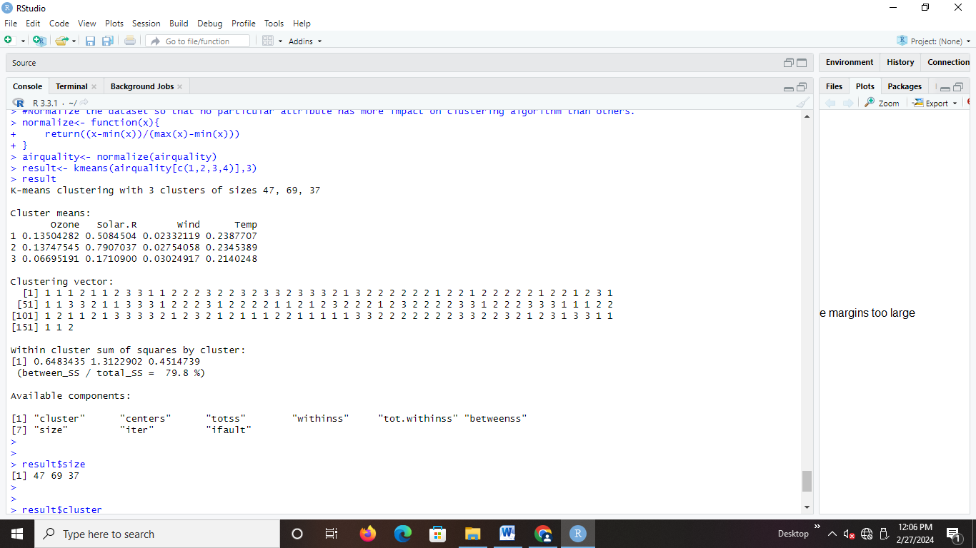

1. **result$centers**

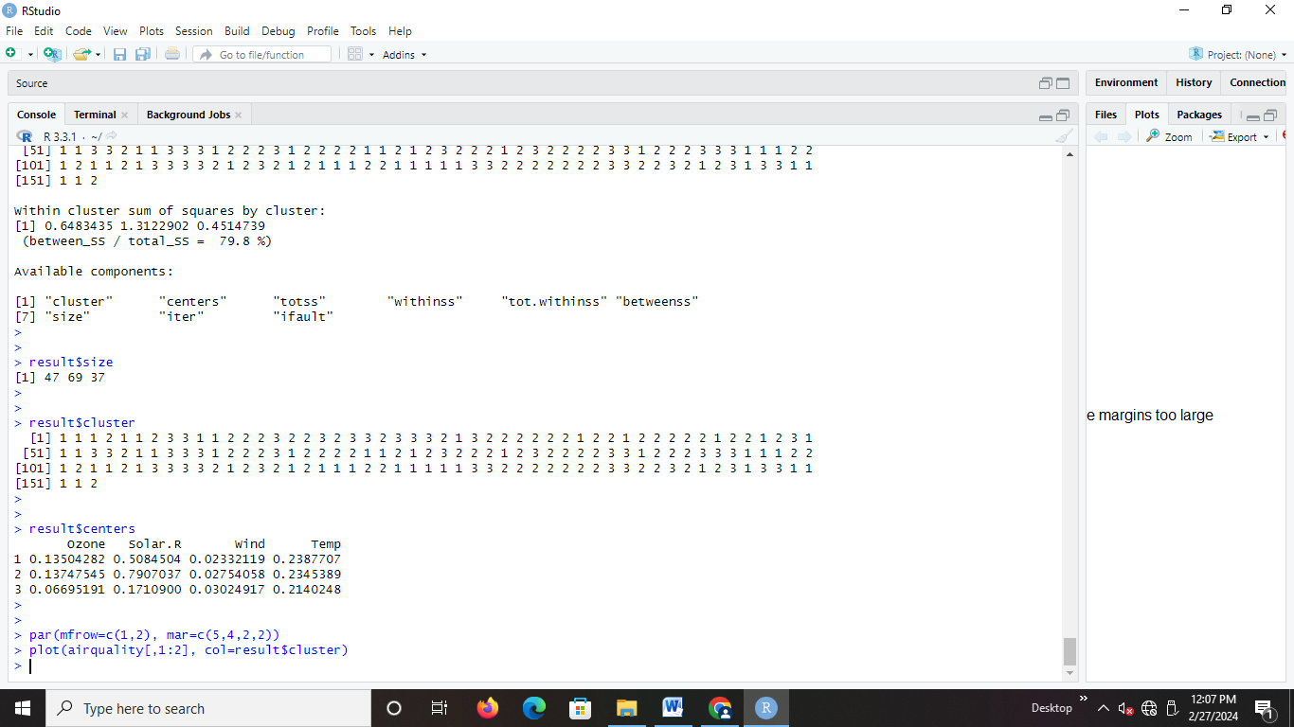

1. **result$size**

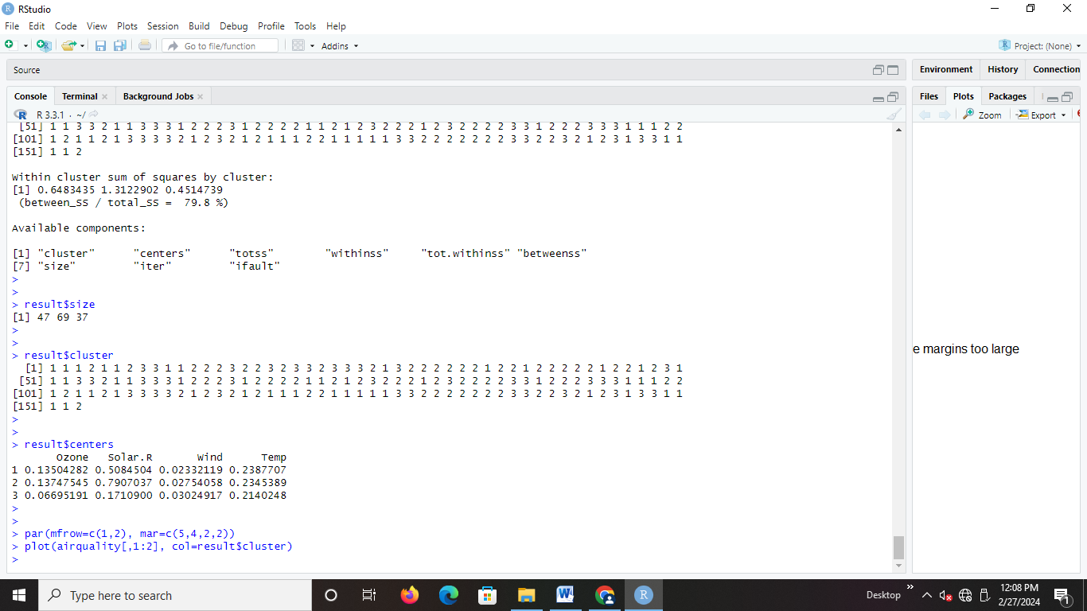

1. **result$cluster**



1. **par(mfrow=c(1,2), mar=c(5,4,2,2))**

**plot(airquality[,1:2], col=result$cluster)**

