**Practical No.01**

* **Types of Sensors**

1. **Temperature Sensor**

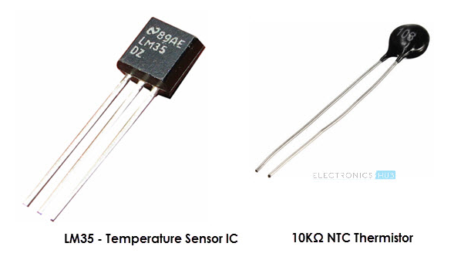

1. **Proximity sensor**

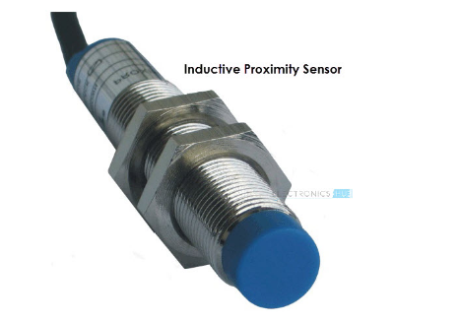

1. **Infrared sensor**

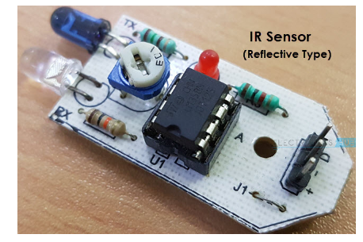

1. **Ultrasonic sensor**

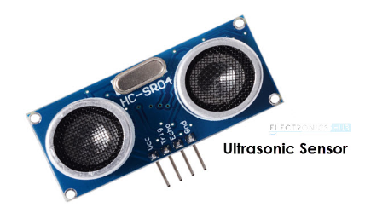

1. **Light sensor**

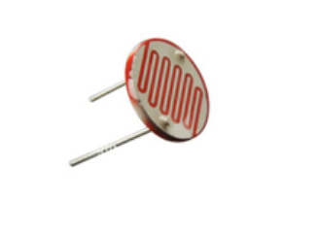

1. **Smoke and gas sensor**

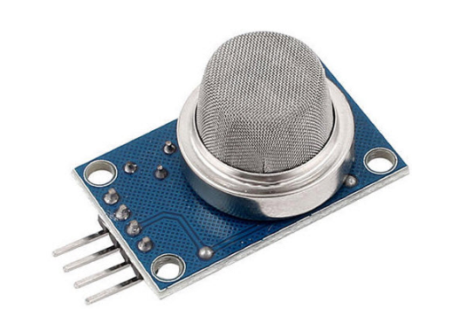

1. **Alcohol sensor**

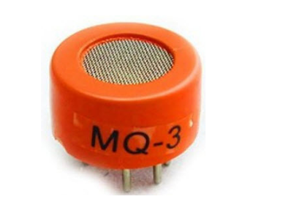

1. **Touch sensor**

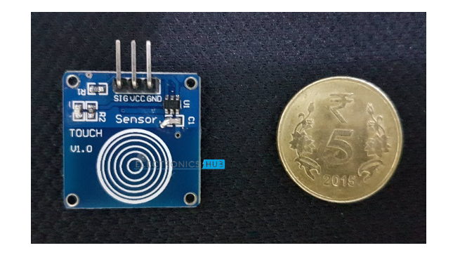

1. **Color sensor**

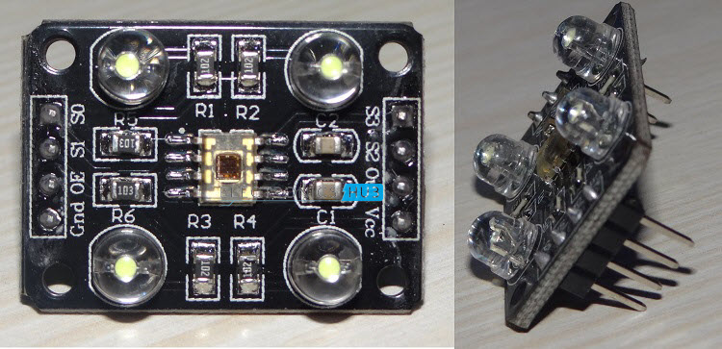

1. **Humidity sensor**

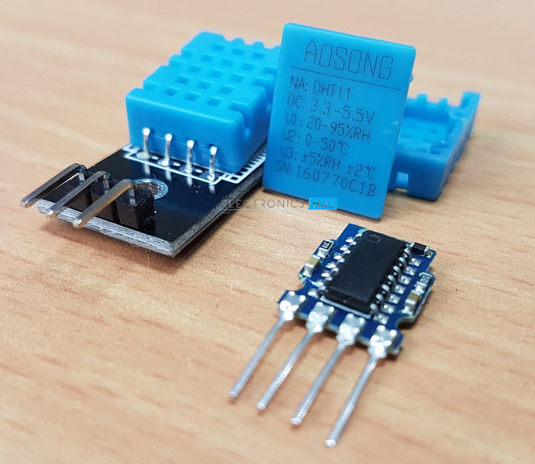

1. **Tilt sensor**

