**Practical No.05**

* **Understanding, Reading and Analyzing Routing Table of a network.**

1. **Add 3 Routers 1841**

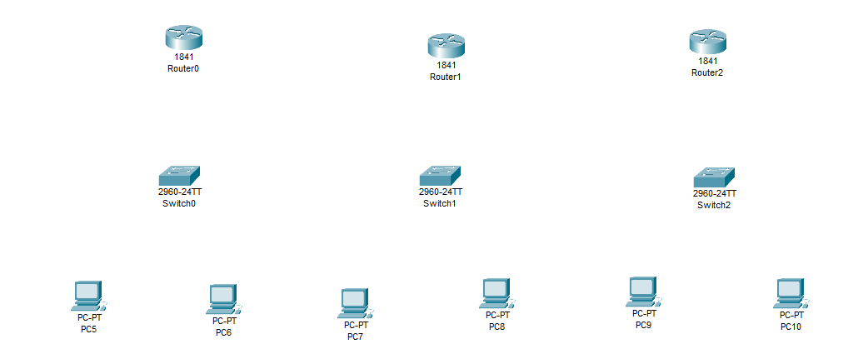

1. **Add 1 switch to each router (2960 -24TT)**



1. **Add 2 pc’s to each router**



1. **Add WIC-2T for each router**

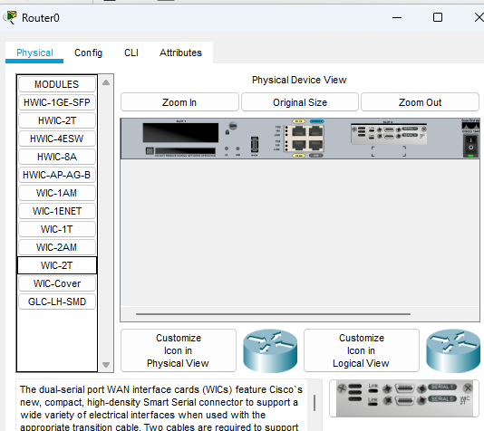

1. **Add IP address to Router0**

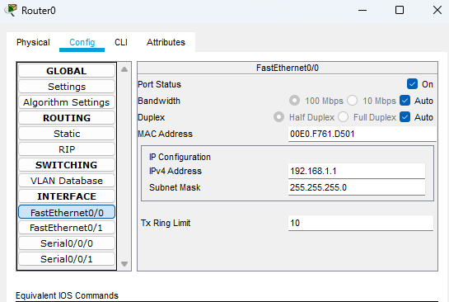

1. **Add IP address to Router1**

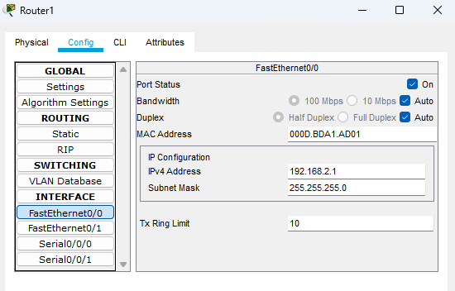

1. **Add IP address to Router2**

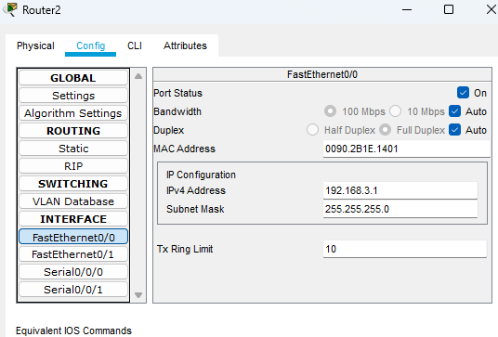

1. **Add RIP to Router0**

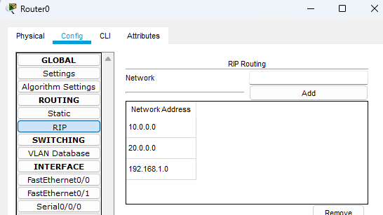

1. **Add RIP to Router1**

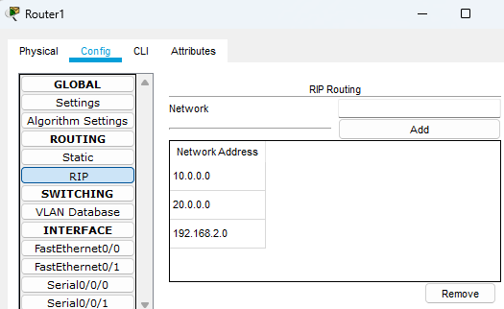

1. **Add RIP to Router2**

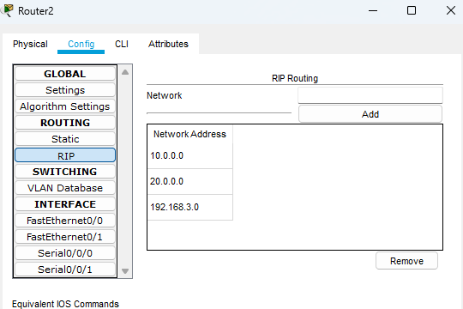

1. **All available route for Router0**

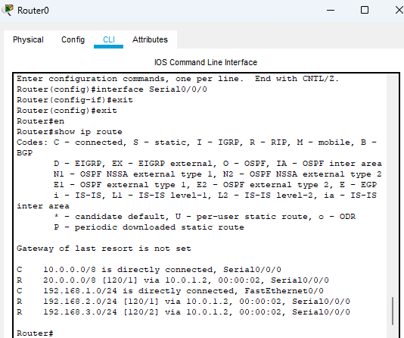

1. **All available route for Router1**

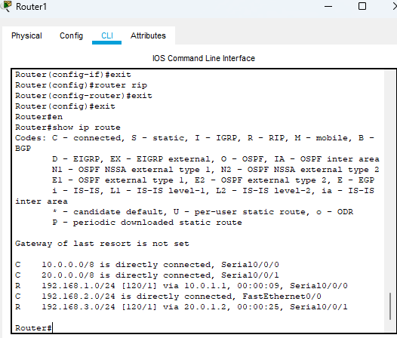

1. **All available route for Router2**

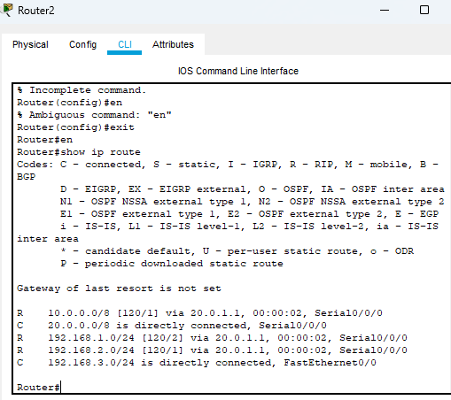

1. **All pc’s with its IP address**

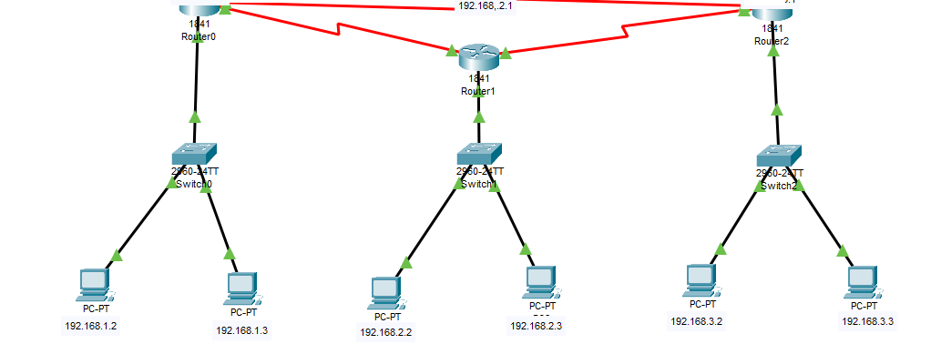

1. **Simulation**

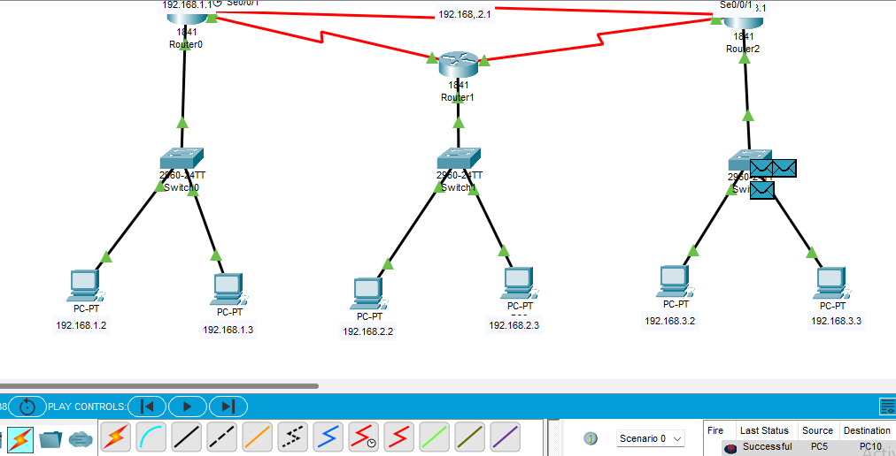

1. **Simulation event list**

