**Practical No.06**

* **Create a basic MANET implementation simulation for Packet animation and Packet Tracer**

1. **Add home appliances**

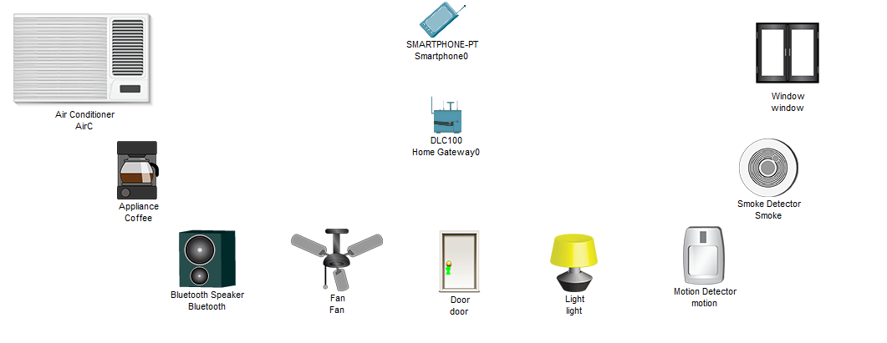

1. **Do below for all appliances**

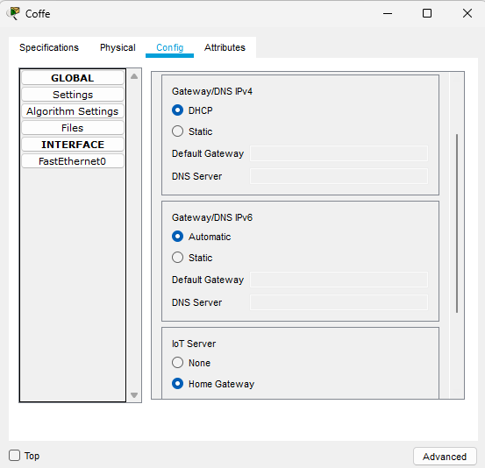

1. **Copy SSID of HomeGateway Disable the authentication**

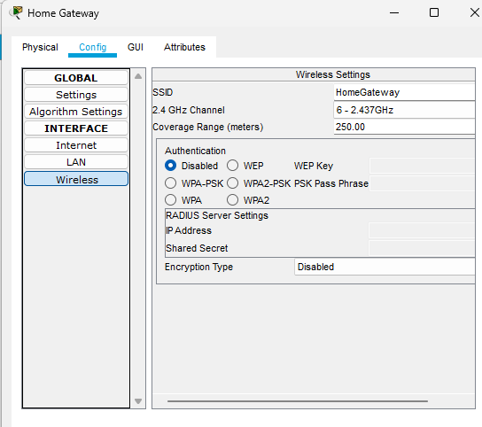

1. **Paste the HomeGateway SSID in Smartphone**

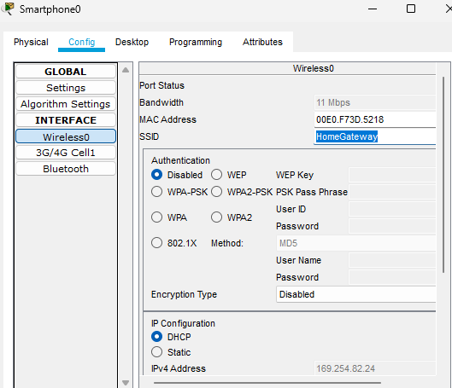

1. **Go to all appliance and select advanced-I/O config –network dapter**

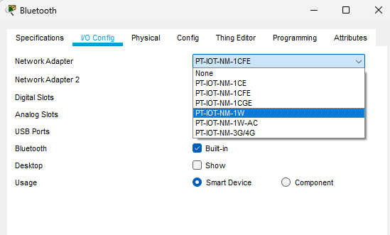

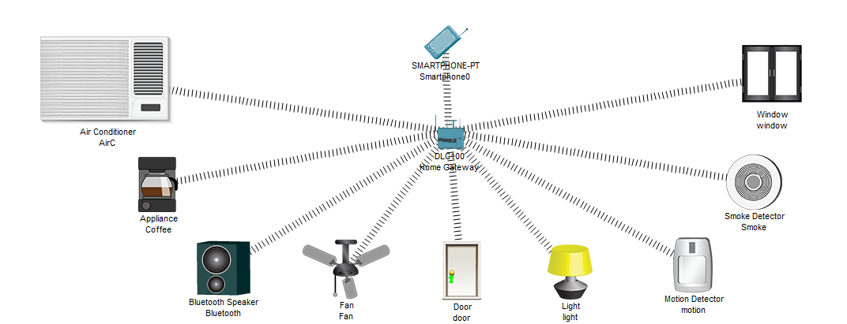

1. **Go to smartphone desktop then copy the Server Address**

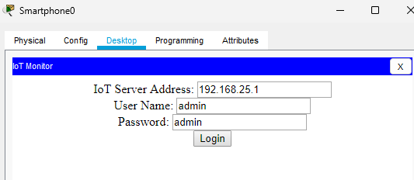

1. **Paste the Address in WebServer**

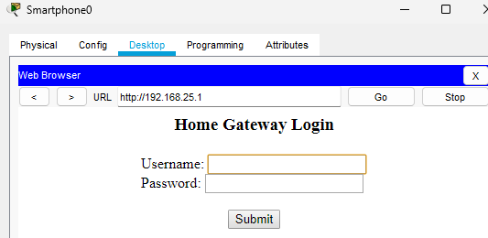

1. **After submit the username and password**

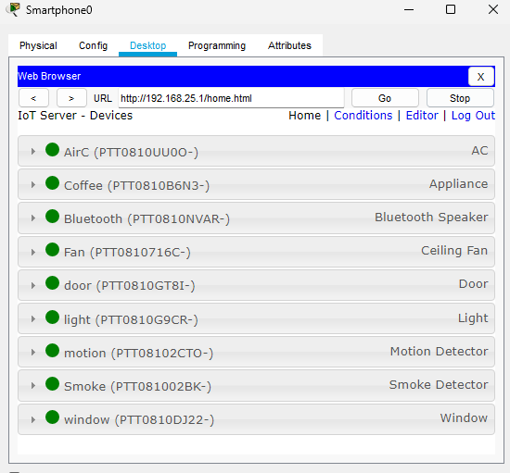

1. **Then go to Condition Add Condition**

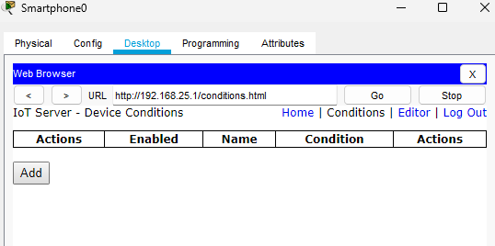

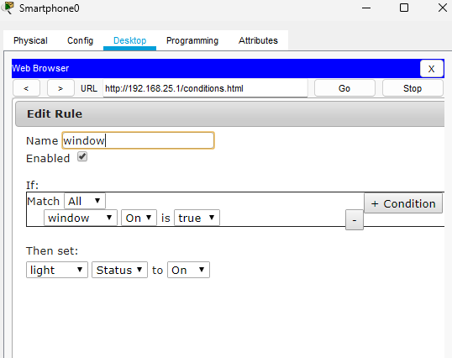

**Output:**

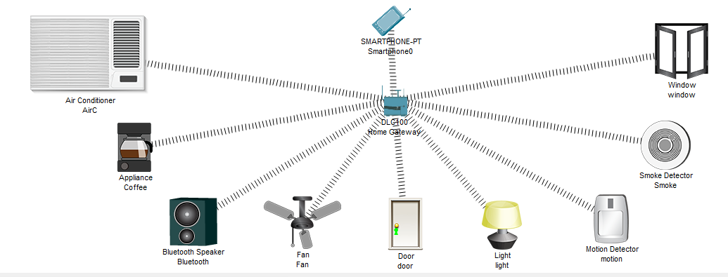**11) Add condition for door when door is open then fan is high**

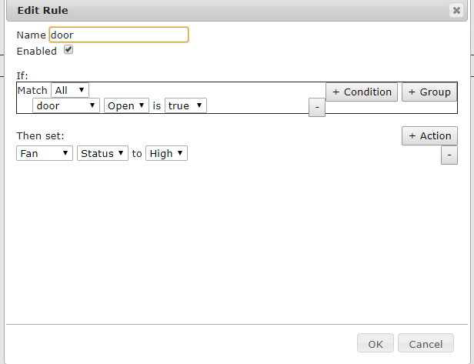

**Output**

