**Practical No.10**

1. **Take 1 smartphone, 1 router, 1 home router, 1 Hub, 1 CO server, 1 server, 1 cell tower**

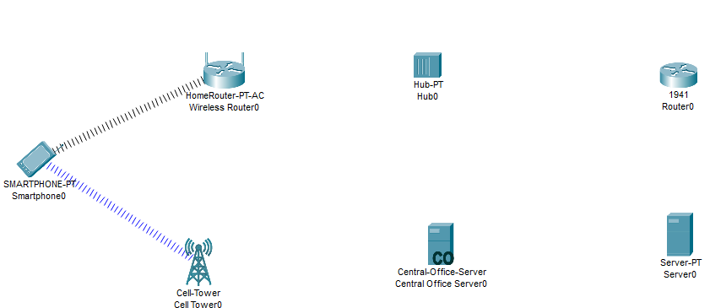

1. **Connect with particular wire**

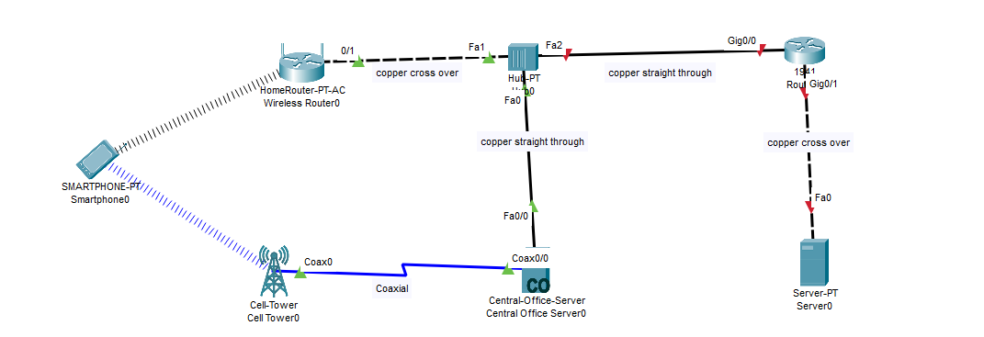

1. **Router-config-GigabitEthernet0/0 10.0.0.1**

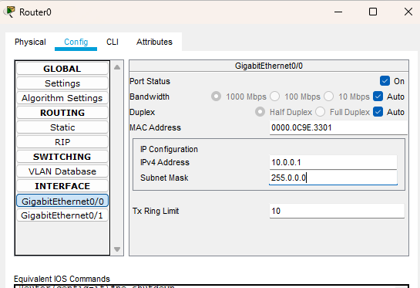

1. **HomeRouter-config-internet-static**

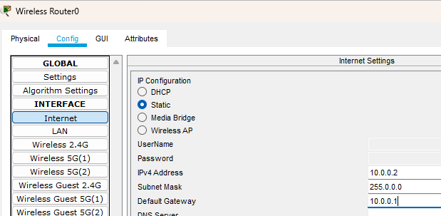

1. **SmartPhone-desktop-ip config-static**

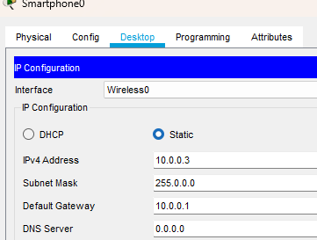

1. **Router-GgE 0/1-IP 20.0.0.1**

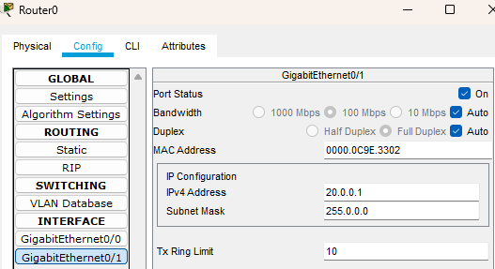

1. **Server –desktop-Ip config-static**

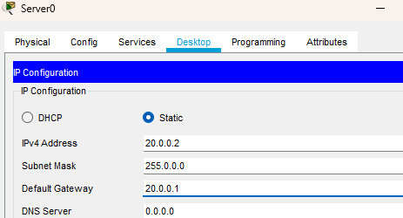

1. **Smartphone –desktop-cmd-ping 20.0.0.1**

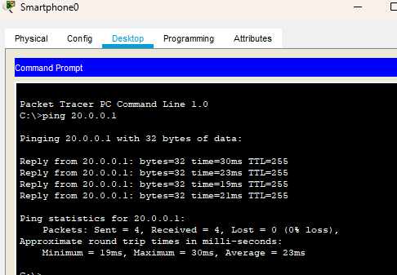

1. **Smartphone-desktop-web browser 20.0.0.2**

