**Practical No.08**

1. **Add router WRT300N and 2 pc’s**

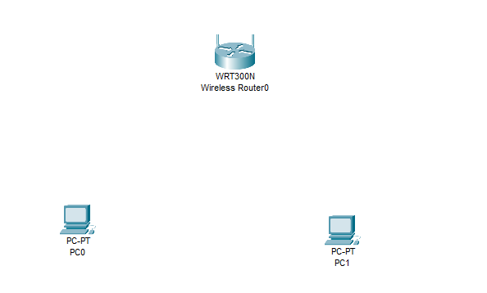

1. **Add port both pc**

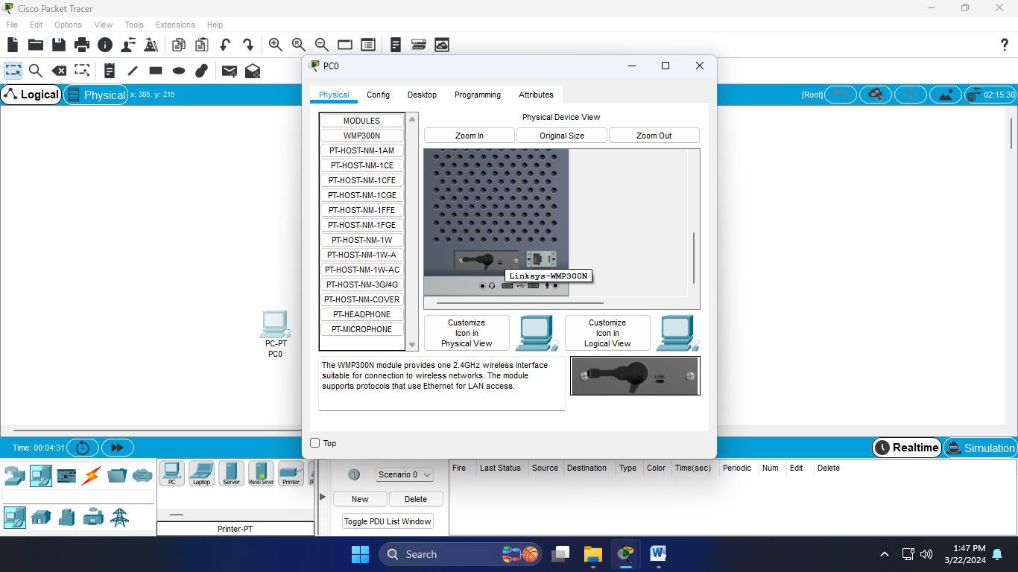

1. **After adding port**

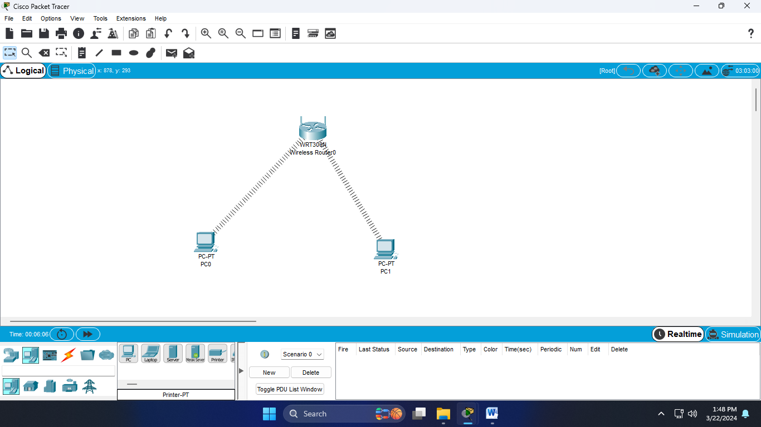

1. **Open pc-config- copy the mac address**

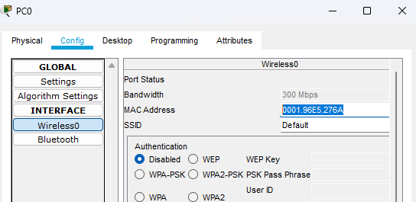

1. **Add colon after two character**



1. **Open router-GUI- wireless-Wireless MAC filter-Enabale-Change the mac address same method for second pc**

