CheckBox

Code:-

package com.example.checkbox  
  
import androidx.appcompat.app.AppCompatActivity  
import android.os.Bundle  
import android.widget.*  
  
class MainActivity : AppCompatActivity() {  
 override fun onCreate(savedInstanceState: Bundle?) {  
 super.onCreate(savedInstanceState)  
 setContentView(R.layout.*activity_main*)  
  
  
 var c1: CheckBox=findViewById(R.id.*chk1*)  
 var c2: CheckBox=findViewById(R.id.*chk2*)  
 var c3: CheckBox=findViewById(R.id.*chk3*)  
 var c4: CheckBox=findViewById(R.id.*chk4*)  
  
 var amount=0;  
 var btn: Button=findViewById(R.id.*btn1*)  
 btn.setOnClickListener **{** var builder:StringBuilder=StringBuilder()  
 if(c1.*isChecked*)  
 {  
 amount=amount + 45;  
 builder.append(c1.*text*)  
 }  
 if(c2.*isChecked*)  
 {  
 amount=amount + 50;  
 builder.append(" "+c2.*text*)  
 }  
 if(c3.*isChecked*)  
 {  
 amount=amount + 35;  
 builder.append(" "+c3.*text*)  
 }  
 if(c4.*isChecked*)  
 {  
 amount=amount + 45;  
 builder.append(" "+c4.*text*)  
  
 }  
 Toast.makeText(*applicationContext*,"Total Price is..."+amount,Toast.*LENGTH_LONG*).show()  
 amount==0;  
  
 var builder1:StringBuilder=StringBuilder()  
 var btn1:Button=findViewById(R.id.*btn1*)  
 btn1.setOnClickListener **{** builder1.append(" ")  
 **}  
 }** }  
}

Output:-

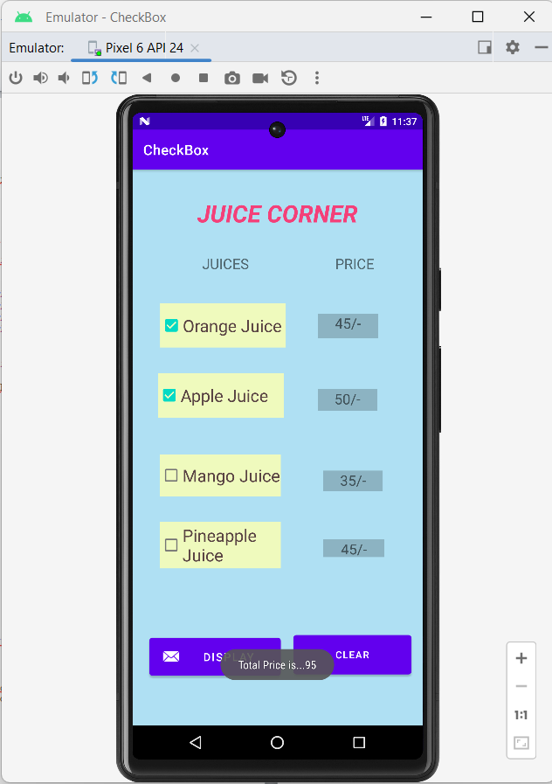

RadioButton and RadioGroup

Code:-

package com.example.radiobutton  
  
import androidx.appcompat.app.AppCompatActivity  
import android.os.Bundle  
import android.widget.Button  
import android.widget.RadioButton  
import android.widget.RadioGroup  
import android.widget.Toast  
  
class MainActivity : AppCompatActivity() {  
 override fun onCreate(savedInstanceState: Bundle?) {  
 super.onCreate(savedInstanceState)  
 setContentView(R.layout.*activity_main*)  
  
 var grp1:RadioGroup=findViewById(R.id.*rgroup1*)  
 var grp2:RadioGroup=findViewById(R.id.*rgroup2*)  
  
 var btn:Button=findViewById(R.id.*button1*)  
  
 btn.setOnClickListener **{** var id1:Int=grp1.*checkedRadioButtonId* var id2:Int=grp2.*checkedRadioButtonId* var grp1rb:RadioButton=findViewById(id1)  
  
 var grp2rb:RadioButton=findViewById(id2)  
  
 Toast.makeText(*applicationContext*,"Gender is...."+grp1rb.*text*+" and Payment Method is..."+grp2rb.*text*,Toast.*LENGTH_LONG*).show()  
 **}** }  
}

Output:-

