**Write a program for generating derivation sequence / language for the given sequence of productions**

Input:

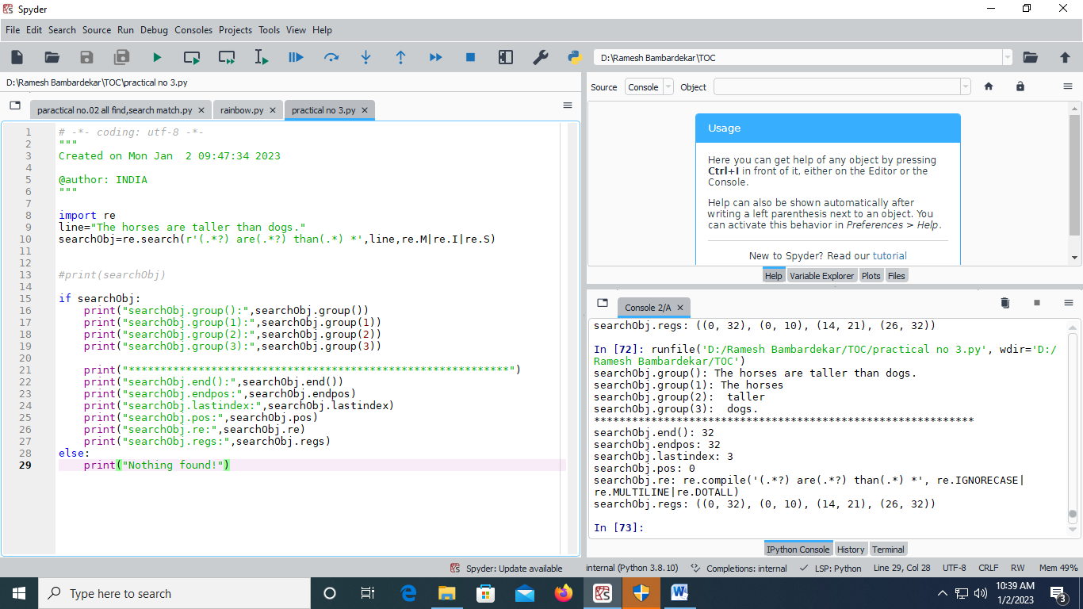

Output:

